Image-Based 3D Rendering for Thai Arts and Culture: Novel-View Synthesis of the Thai Wooden Frog (Kob Mai)
Progress Report - Updated 31 August 2026

Zwe Nyan Win
Vincent Mary School of Engineering, Science and Technology
Suvarnabhumi Campus, Assumption University of Thailand
Samut Prakan, Thailand
zwenyanwin001@gmail.com
Zin Me Me That
Vincent Mary School of Engineering, Science and Technology
Suvarnabhumi Campus, Assumption University of Thailand
Samut Prakan, Thailand
u6611706@au.edu

Abstract-This report records the 31 August 2026 checkpoint for image-based 3D rendering of the Thai wooden frog, kob mai. Since the previous version the physical object has been acquired and photographed, so results are now reported for the frog itself rather than for a synthetic proxy. A closed turntable ring of 36 photographs at 10-degree increments was captured, together with nine further photographs from approximately 60 degrees of elevation. Learned monocular depth (Depth Anything V2 Small) has been run on these photographs, and the single-image pipeline is now evaluated by hold-out: photographs are withheld from the pipeline, the view at each withheld angle is synthesised from the nearest photograph that was retained, and both that synthesis and the nearest retained photograph are scored against the withheld one. Over 30 positions at 60-degree capture spacing the synthesised view is structurally closer to the withheld photograph than frame-switching is, by +0.024 SSIM (95% CI +0.014 to +0.035); no PSNR difference at any spacing clears its confidence interval. Learned depth raises render quality over the analytic proxy by +1.66 dB at the closest spacing. Separately, the same photographs were reconstructed as an explicit closed surface using Apple Object Capture, giving 25,008 vertices and 49,999 triangles in 80 s; rendered through the same renderer this retains 43.1% of its triangles at 180 degrees of rotation against 0.8% for the single-image relief, which quantifies the relief limitation on this object. A workshop station remains outstanding.
Keywords—Thai arts and culture, image-based rendering, novel view synthesis, 3D reconstruction, monocular depth estimation, texture mapping, wooden frog, kob mai

Introduction

The Selected Topic: the Thai Wooden Frog
The subject chosen within Thai arts and culture is the Thai wooden frog, known in Thai as kob mai. It is a frog or toad carved from a single piece of hardwood, hollowed to form a resonating chamber, with a row of ridges cut across its back. Drawing the supplied wooden beater along those ridges produces a rasping, repeated croak that closely imitates a real frog; striking the body gives a separate wooden knock. It therefore belongs to the same instrument family as the guiro, sounded by scraping rather than by striking alone.
The object is worth study for two reasons. First, it is a genuine woodcarving craft: the form, the finish and the cut of the ridges are all hand work, and the instrument is strongly associated with the woodcarving trade of northern Thailand and sold throughout Thai handicraft markets. Second, it is one of the most widely recognised Thai souvenir objects among visitors, which makes it immediately legible to a workshop audience without requiring any background explanation.
It is also well suited to this particular technical problem. The frog is small, rigid, opaque and matte, it has pronounced surface relief in the carved ridges, and it can be placed on a turntable and photographed from any angle. Those properties matter: they make it a far more tractable subject for geometry recovery than a large or unavailable artefact, and they open the door to genuine multi-view capture rather than reconstruction from a single found photograph.

Scope of This Report
This document is a dated checkpoint. Section II reviews the image-based rendering material on which the pipeline is built. Section III sets out the pipeline stage by stage, including the changes forced by real photographs. Section IV reports the capture, the hold-out evaluation of the single-image path, and a separate explicit reconstruction from the same photographs, and states plainly which differences are supported by their error bars and which are not.

Literature Review

Image-Based Rendering
Image-based rendering covers techniques that synthesise new views of a scene from a set of photographs, instead of modelling and shading a scene from scratch as in traditional graphics [1]. The established way to organise these methods is by how much geometry they use [4]. At one extreme, light field and lumigraph rendering store a dense sample of rays and interpolate between them with no geometric model at all [2], [3]. In the middle, view interpolation and layered depth images rely on implicit geometry in the form of correspondence or per-pixel depth. At the other extreme, methods that recover an explicit surface and texture it from the source photographs, such as view-dependent texture mapping [5], use geometry directly and can therefore work from far fewer input images.
The pipeline described here sits at the explicit-geometry end of that spectrum. This is a deliberate choice driven by capture cost: light field methods need hundreds of densely sampled views, which is not practical for a student project with a handheld camera, whereas an explicit textured proxy can be rendered convincingly from a small number of photographs. Neural radiance fields [6] occupy a newer position in the same design space, trading a long per-object optimisation for very high visual quality; they remain a possible extension but are not the current approach, since they require both multi-view input and a GPU at render time.

Recovering the Geometric Proxy
Two routes to the proxy are relevant. Monocular depth estimation predicts a depth map from a single photograph using a network trained across many scenes [7], [8]. It requires only one image, but the depth it produces is relative rather than metric, and it recovers only the visible surface. Structure-from-motion instead recovers camera poses and a point cloud from many overlapping views of one rigid object [9], giving true multi-view geometry and a complete surface, at the cost of a controlled capture session. Both are in scope here and are discussed in Section III-F.

Methodology: the 3D Rendering Pipeline
The pipeline takes photographs of a physical object and produces synthesised views of it from viewpoints that were never photographed. It has four stages: acquisition, depth estimation, surface reconstruction, and novel-view rendering. Table I maps each stage onto the course material it draws on.
- Pipeline stages and the corresponding course topics
No. | Pipeline stage | Method | Ch.
1 | Acquisition and segmentation | Otsu + morphology | 2, 3
2 | Depth estimation | relative depth | 12
3 | Surface reconstruction | height-field mesh | 13
4 | Projection | K[R|t]X | 2
5 | Hidden-surface removal | culling + painter | 14
6 | Texture mapping | affine warp | 3, 14
7 | Shading | Lambertian n.l | 2
- Chapter numbers follow Szeliski, 2nd edition. Chapter 14 is image-based rendering.

Stage 1: Acquisition
Photographs of the object are captured on a turntable against a plain background, and the object is separated from that background. Segmentation applies Otsu thresholding, morphological closing and opening, retention of the largest connected component, and contour filling. The channel that Otsu operates on had to change once real photographs were available. Brightness alone fails, because a real backdrop is never evenly lit: across the captured frames the corner regions span roughly 55 to 199 grey levels, so a single global threshold cuts through the background rather than around the object, and on one frame it inverted entirely, selecting the backdrop while reporting a plausible 70.6% foreground. Saturation is far more stable, because a neutral backdrop stays desaturated under any illumination while the wood keeps its hue; measured Otsu separability is 0.82-0.93 on saturation against 0.60-0.73 on brightness. The implementation segments on whichever channel Otsu separates more cleanly. For the elevated photographs a third case arises: an underexposed dark backdrop acquires a colour cast and reads as saturated as the wood (66.6 against 67.6), and the frame contains three regions rather than two, so no single-channel threshold separates them. The product of saturation and value does, because only the object is both saturated and bright (8.7 for the backdrop, 5.2 for the table, 34.8 for the frog).

Stage 2: Depth Estimation
A relative depth map is estimated from a single photograph using the pretrained Depth Anything V2 Small model. This has now been run on the captured photographs; it requires no GPU, taking about three seconds per frame on the laptop's integrated accelerator. One correction was necessary. The mesh stage writes depth directly into the vertex z coordinate and the renderer places the camera on the low-z side, so a larger value denotes a greater distance; monocular networks of this family predict the inverse, with the nearest surface scoring highest. Used unaltered, every raised feature becomes a depression and the relief renders hollow. Rather than assume a checkpoint's convention, the orientation is measured: the object stands in front of its backdrop, so whichever side of the segmentation mask carries the smaller values is the near side. The map is flipped when that test says so, which for this model it does. Depth remains relative rather than metric, so relief scale is still set by inspection.

Stage 3: Surface Reconstruction
The depth map is converted into a triangulated height-field mesh. A regular grid is laid over the segmented region, one vertex is emitted per grid sample that falls inside the object, and each set of four neighbouring vertices becomes two triangles, provided all four lie inside the silhouette. Texture coordinates come directly from the source image, so the original photograph becomes the texture map. A relief scaling parameter controls depth exaggeration. The result is written as a standard OBJ file with an accompanying MTL material, which makes it viewable in any 3D tool.
This yields a relief, not a closed solid: it represents the surface visible from the camera and not the far side of the object. That is the fundamental limitation of single-image reconstruction and is the main reason for the multi-view extension described below.

Stage 4: Novel-View Rendering
This is the Chapter 14 stage. Given the textured proxy, a view from an arbitrary camera is synthesised as follows. Object vertices are transformed into camera coordinates by a rotation and translation, then projected with the pinhole model x = K [R | t] X, where the intrinsic matrix K is built from a chosen field of view and the principal point is placed at the image centre. Perspective division gives image coordinates.
Hidden surfaces are removed in two steps. Back-facing triangles are culled using the sign of the projected signed area, and the survivors are drawn in order of decreasing camera depth, so nearer triangles overwrite farther ones. This is the painter's algorithm, chosen over a per-pixel depth buffer because the proxy is a height field and therefore free of the interpenetrating geometry that would defeat a pure depth ordering.
Each visible triangle is textured by an affine warp. The triangle's texture coordinates and its projected image coordinates define a unique affine map, which is applied to the source photograph over the triangle's bounding box and composited through a filled-triangle mask. Shading is Lambertian: the face normal is computed in camera space, oriented toward the camera, and the diffuse term is the clamped dot product of that normal with the light direction, combined with an ambient floor. Because the whole stage is expressed through the projection, transformation and reflectance models from the course, no external rendering engine is required — only OpenCV and NumPy.

Extension: Multi-View Capture and Explicit Reconstruction
The wooden frog is small, rigid and physically obtainable, which made a controlled multi-view session practical, and that session has now been carried out. The object was placed on a marked turntable and rotated in 10-degree increments through a full revolution under fixed lighting and locked exposure, with the camera stationary, giving a closed ring of 36 photographs; nine further photographs were taken at 45-degree increments from approximately 60 degrees of elevation. These photographs support structure-from-motion and hence a complete surface rather than a single-sided relief. Section IV-D reports a reconstruction built from them, kept separate from the single-image pipeline and compared against it on the same input.

Results and Analysis
Results are reported as of 31 August 2026. Table II states the status of each component. Unlike the previous version, the measurements below come from photographs of the physical frog. Two protocols are used and are not interchangeable: the single-image path is evaluated by hold-out, against photographs it never saw, while the explicit reconstruction in Section IV-D is measured against photographs that were themselves used to build it, and is therefore a measure of fit rather than of prediction.
- Work status at this checkpoint
No. | Component | Status | Evidence
1 | Topic selected (wooden frog) | Done | this report
2 | Turntable capture, 36 + 9 photos | Done | Table IV
3 | Segmentation on real photographs | Done | 36/36 clean
4 | Novel-view renderer | Done | Sec. IV-A
5 | Learned depth on frog photos | Done | Sec. IV-C
6 | Hold-out evaluation (PSNR/SSIM) | Done | Table III
7 | Explicit reconstruction / workshop | Done / pending | Sec. IV-D
- Status verified on 31 August 2026. Pending items are not estimated.

Renderer Validation
The renderer is exercised by every measurement in this section. Its stages are unchanged from the previous version: pinhole projection, back-face culling on the sign of the projected signed area, far-to-near ordering, per-triangle affine texture mapping and Lambertian shading, implemented on OpenCV and NumPy with no external rendering engine. Two convention faults were found and corrected during this checkpoint, both of the same kind as the earlier Y-axis and Lambertian-sign fixes: the depth orientation described in Section III-B, and the triangle winding of imported reconstruction meshes, which is ordered opposite to the culling test used here and caused the renderer to draw the interior of an imported surface. Both were found by inspecting a full rotation; neither was visible in still frames.
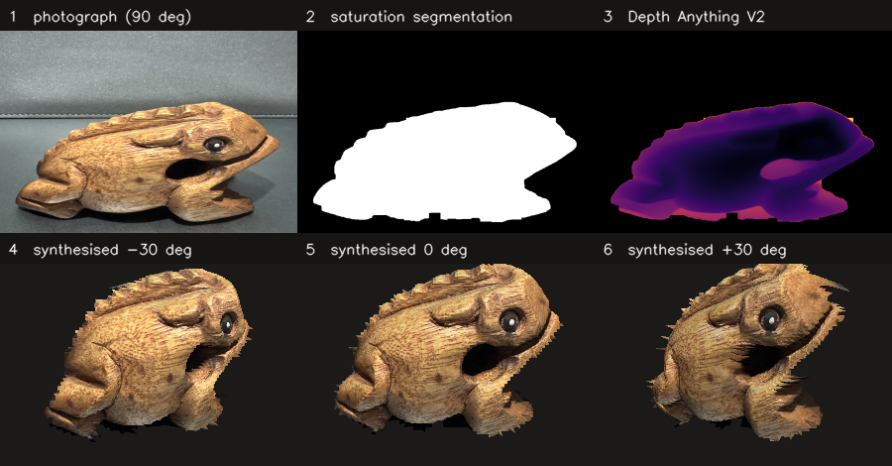
- The pipeline on a real photograph of the frog: the captured frame, the segmentation mask, the relative depth predicted by Depth Anything V2, and three views synthesised from the resulting textured relief. The depth map is shown in the pipeline's own convention, in which darker is nearer.

Capture
Photographs were taken with the object on a marked turntable and the camera fixed, so that the lighting stays with the room rather than with the object. Exposure, focus and white balance were locked once per ring and not re-locked within a ring. The ring comprises 36 photographs at 10-degree increments, closing back on its start mark; a further nine were taken at 45-degree increments from approximately 60 degrees of elevation. One frame of the ring was re-shot because the operator's hand entered the frame, and the replacement is used throughout. All 36 ring photographs segment with no background in the image corners, and so do the nine elevated photographs once the saturation-value product of Section III-A is used.

Hold-out Evaluation of the Single-Image Path
The renderer had not previously been scored against anything real. Photographs are withheld from the pipeline; for each withheld angle the mesh reconstructed from the nearest retained photograph is rotated to that angle and rendered; and the result is scored against the withheld photograph. Each position is scored a second time against the nearest retained photograph itself, unaltered, which is what a viewer that simply snapped to the closest frame would display. That baseline column is what makes the first meaningful: a synthesis that cannot beat showing the closest photograph has not earned its reconstruction stage. A render and a photograph share no intrinsics, so both are reduced to the object's silhouette and normalised for position and scale; both columns receive identical treatment, so absolute values are conservative but the comparison between them is like for like.
Table III reports the outcome. Because each position carries both scores, the paired difference is the appropriate statistic, and it is reported with a 95% confidence interval. Only one difference clears its interval: at 60-degree capture spacing the synthesised view is structurally closer to the withheld photograph than frame-switching, by +0.0243 SSIM (95% CI +0.0139 to +0.0348, n=30). No PSNR difference at any spacing is distinguishable from zero. PSNR and SSIM disagree for a reason worth stating: the baseline is a real photograph at the wrong angle, and PSNR rewards its sharp pixels, whereas SSIM compares structure and the synthesised view is at the right angle. For novel-view synthesis structure is the relevant property, but the honest summary is that the two methods are close at every spacing measured.
Learned depth is nonetheless a clear improvement on the analytic proxy used in the previous version: render quality rises by +1.66 dB at 20-degree spacing and +1.64 dB at 40 degrees, falling to -0.10 dB at 90 degrees where the relief has little of the object left to show. An earlier draft of this evaluation claimed that learned depth moved a PSNR crossover to 40 degrees. Re-running after one further photograph was added changed that same figure from +0.03 dB to -0.23 dB, which is to say the claim was smaller than the measurement noise. It is withdrawn, and recorded here because the correction is the reason confidence intervals are now reported throughout.
- Hold-out evaluation against withheld photographs
Spacing | n | PSNR render / base (dB) | SSIM difference (95% CI)
20 deg | 18 | 15.03 / 15.22 | +0.0092 (-0.0018, +0.0203)
40 deg | 27 | 14.83 / 15.06 | +0.0084 (-0.0047, +0.0214)
60 deg | 30 | 13.76 / 13.55 | +0.0243 (+0.0139, +0.0348) significant
90 deg | 32 | 12.06 / 12.30 | +0.0033 (-0.0082, +0.0148)
- Paired per-position differences with 95% confidence intervals. Only the 60-degree SSIM difference excludes zero; no PSNR difference at any spacing does.
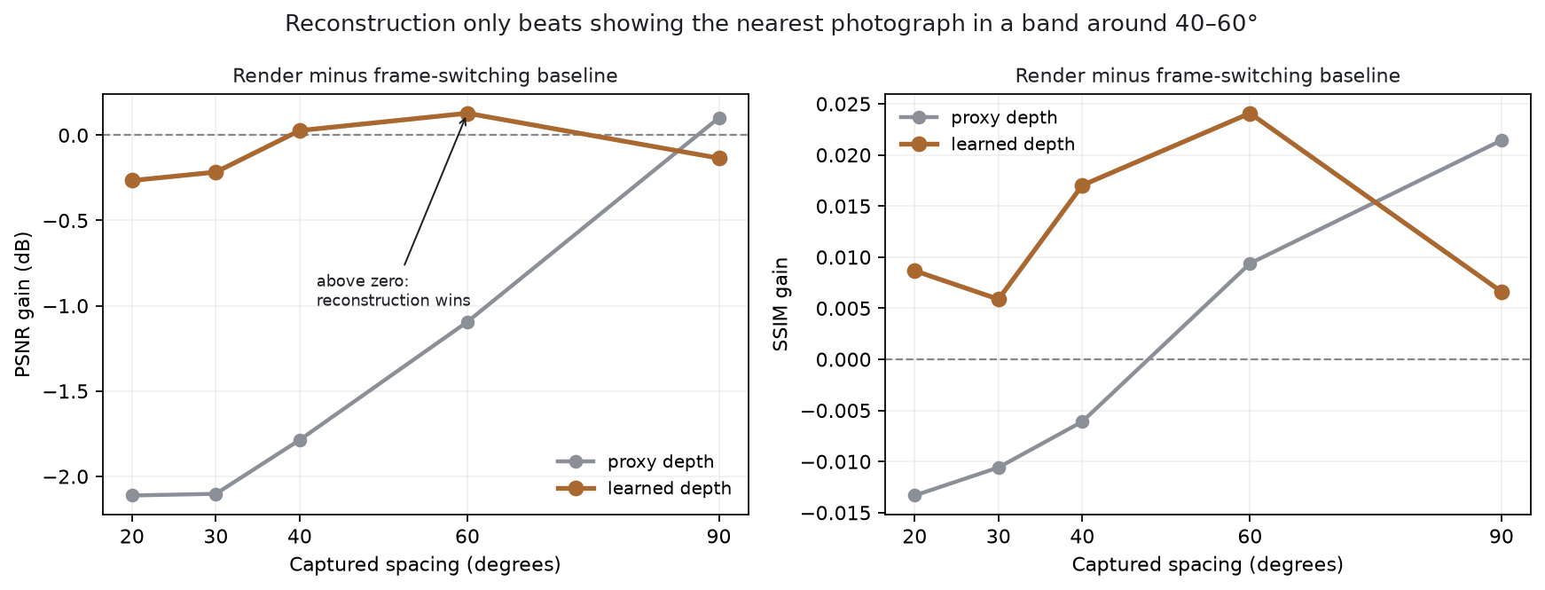
- Difference between the synthesised view and the frame-switching baseline, against capture spacing, for the analytic proxy and for learned depth. Above zero the synthesis wins. Only the 60-degree SSIM difference clears its confidence interval.

Explicit Reconstruction, Compared on the Same Photographs
The same photographs were reconstructed as an explicit closed surface using Apple Object Capture [10], a commercial photogrammetry engine, driven from a short command-line tool. All 45 photographs were accepted, none rejected or skipped, and the engine did not report incomplete stitching. The result is a textured mesh of 25,008 vertices and 49,999 triangles produced in 80 s on the same laptop, with no GPU rental and no cloud service. It is reported here as a comparison and never as a replacement: the image-based pipeline in Section III remains the contribution, and this answers the adjacent question of what recovering explicit geometry from the same photographs actually buys.
What it buys is coverage, and the difference is not marginal. Rendered through the same renderer, the single-image relief retains 35 of its 4,426 triangles at 180 degrees of rotation, that is 0.8%: walking behind it leaves almost nothing. The reconstructed surface retains 21,541 of 49,999, or 43.1%, because it is closed. This quantifies on this object the limitation that Section III-C states in principle, and it is the reason a turntable capture was worth the session. Two qualifications. The engine is undocumented and must be described as a black box rather than as classical multi-view stereo. And its output cannot be compared with the hold-out scores above: every photograph scored against it also went into building it, so any such figure measures fit, not prediction.
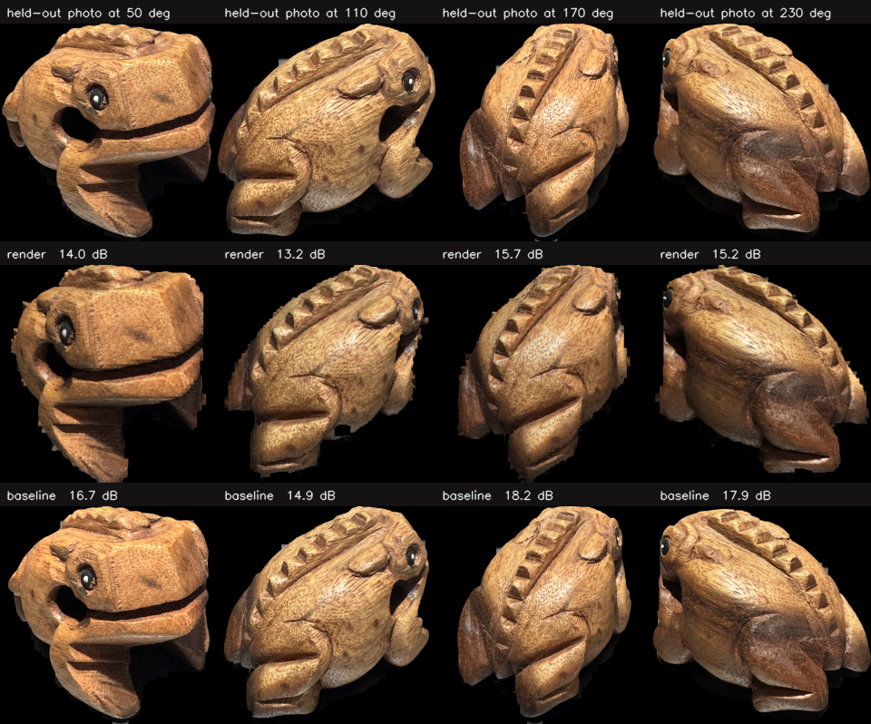
- What the hold-out scores compare, at four withheld angles: the withheld photograph, the view synthesised for that angle, and the nearest retained photograph that a frame-switching viewer would show.
- Capture and reconstruction, measured 31 August 2026
No. | Measurement | Value | Notes
1 | Turntable photographs | 36 + 9 | 10 deg ring, 60 deg elev.
2 | Frames segmenting cleanly | 36 / 36 | no corner contamination
3 | Relief mesh, one photograph | 4,426 tri | Depth Anything V2
4 | Reconstructed mesh, 45 photos | 49,999 tri | Object Capture, 80 s
5 | Relief triangles kept at 180 deg | 0.8% | 35 of 4,426
6 | Mesh triangles kept at 180 deg | 43.1% | 21,541 of 49,999
- Measured on the project laptop, CPU and integrated accelerator only. Triangle retention is counted after back-face culling at 300 x 300 px.

Known Limitations
Five limitations are recognised at this checkpoint.
- Single-image reconstruction gives only a relief. Measured on this object it retains 0.8% of its triangles at 180 degrees, so the single-image path is confined to a narrow arc. The explicit reconstruction of Section IV-D removes this limitation at the cost of a reconstruction stage.
- The advantage over frame-switching is small. Only the 60-degree SSIM difference clears its confidence interval, and no PSNR difference does. At the spacings a dense capture actually provides, showing the nearest photograph is close to as good.
- Rendering is not interactive. At 420 x 420 the renderer averages a fraction of a second per view, which suits offline animation but not a live frame rate. A workshop station would need mesh reduction or a vectorised rasteriser.
- Segmentation assumes a plain, unpatterned background. Three channels are now needed to cover the captured conditions, and an attempt to photograph the object in an uncontrolled setting failed outright, with the mask selecting the surface the object rested on.
- Depth is relative, not metric. Neither the monocular network nor the photogrammetry engine establishes true scale, so relief exaggeration is set by inspection and no measurement in this report is in physical units.

Conclusion
This report has set out the selected topic within Thai arts and culture, the Thai wooden frog, and the image-based rendering pipeline built around it. The pipeline recovers an explicit textured geometric proxy from photographs and synthesises novel views of it using the projection, hidden-surface, texture-mapping and reflectance models from the course, which places it at the explicit-geometry end of the image-based rendering spectrum described in Chapter 14. Szeliski's Exercise 14.1 describes precisely this construction, two triangles per pixel quad with projective texture mapping, and suggests implementing it on a graphics system; here the projection, hidden-surface and shading stages are written directly.
At the 31 August 2026 checkpoint the pipeline runs end to end on photographs of the physical frog. A closed 36-photograph turntable ring was captured and segments cleanly throughout; learned monocular depth has been run on it; and the single-image path has been evaluated against withheld photographs with confidence intervals reported. The measured picture is a modest one: the synthesised view is structurally closer to a withheld photograph than frame-switching at 60-degree spacing, and indistinguishable from it elsewhere. Against that, an explicit reconstruction from the same photographs retains 43.1% of its geometry at 180 degrees where the relief retains 0.8%, which is the clearest statement of what the extra capture buys. The immediate next step is the workshop station, which is the remaining deliverable and which the current per-view render time does not yet support.

References
- Z. Wang, A. C. Bovik, H. R. Sheikh, and E. P. Simoncelli, "Image quality assessment: From error visibility to structural similarity," IEEE Trans. Image Process., vol. 13, no. 4, pp. 600-612, 2004.
- R. Szeliski, Computer Vision: Algorithms and Applications, 2nd ed. Cham, Switzerland: Springer, 2022, ch. 14.
- M. Levoy and P. Hanrahan, "Light field rendering," in Proc. 23rd Annu. Conf. Computer Graphics and Interactive Techniques (SIGGRAPH), 1996, pp. 31–42.
- S. J. Gortler, R. Grzeszczuk, R. Szeliski, and M. F. Cohen, "The lumigraph," in Proc. SIGGRAPH, 1996, pp. 43–54.
- H.-Y. Shum and S. B. Kang, "A review of image-based rendering techniques," in Proc. SPIE Visual Communications and Image Processing, vol. 4067, 2000, pp. 2–13.
- P. E. Debevec, C. J. Taylor, and J. Malik, "Modeling and rendering architecture from photographs: A hybrid geometry- and image-based approach," in Proc. SIGGRAPH, 1996, pp. 11–20.
- B. Mildenhall, P. P. Srinivasan, M. Tancik, J. T. Barron, R. Ramamoorthi, and R. Ng, "NeRF: Representing scenes as neural radiance fields for view synthesis," in Proc. European Conf. Computer Vision (ECCV), 2020, pp. 405–421.
- R. Ranftl, K. Lasinger, D. Hafner, K. Schindler, and V. Koltun, "Towards robust monocular depth estimation: Mixing datasets for zero-shot cross-dataset transfer," IEEE Trans. Pattern Analysis and Machine Intelligence, vol. 44, no. 3, pp. 1623–1637, 2022.
- L. Yang, B. Kang, Z. Huang, Z. Zhao, X. Xu, J. Feng, and H. Zhao, "Depth Anything V2," in Advances in Neural Information Processing Systems (NeurIPS), 2024.
- J. L. Schönberger and J.-M. Frahm, "Structure-from-motion revisited," in Proc. IEEE Conf. Computer Vision and Pattern Recognition (CVPR), 2016, pp. 4104–4113.
- Apple Inc., "Creating 3D objects from photographs," Apple Developer Documentation, RealityKit Object Capture. [Online]. Available: https://developer.apple.com/documentation/realitykit/creating-3d-objects-from-photographs

