



**Development and Evaluation for Amazing Sport Yoga**

Unit 1: Programming



Zwe Hset naing

HND 29th Batch

Youth International University

Contents

Implementation the algorithms using an IDE 3

The whole code for the system 3

Result of the code 12

The Debugging process and the debugging facilities available in the IDE 20

Debugging 20

Debugging Facilities 20

Breakpoint 20

Debugging toolbar 21

View variable 21

Call stack inspection 22

P6. The coding standard used in code 23

Coding Standard 23

Error Handling 23

Name Conventions 23

Indentation and Spacing 24

The features of the IDE to manage the development process 25

The debugging process can be used to help develop more secure, robust applications 26

Early Problem Identification and Fixing 26

Better Quality of Code 26

Increased Safety 26

Stability and Dependability 26

The Use of an IDE for development of applications contrasted with not using an IDE 27

IDE 27

Effect when using IDE 27

Effect Without IDE 27

Comparison of IDE 28

The role and purpose of a coding standard and it is necessary in a team as well as for the individual. 29

The role and purpose of a coding standard as a team 29

Consistency 29

Readability and Sustainability 29

The role and purpose of a coding standard as an individual 29

Consistency in Personal Code 29

Readability and Maintainability 30

References 31

# 

# Implementation the algorithms using an IDE

The Yoga Class is developed to manage training plan, cost, customer’s data and yoga poses by the admin.

The whole code for the system

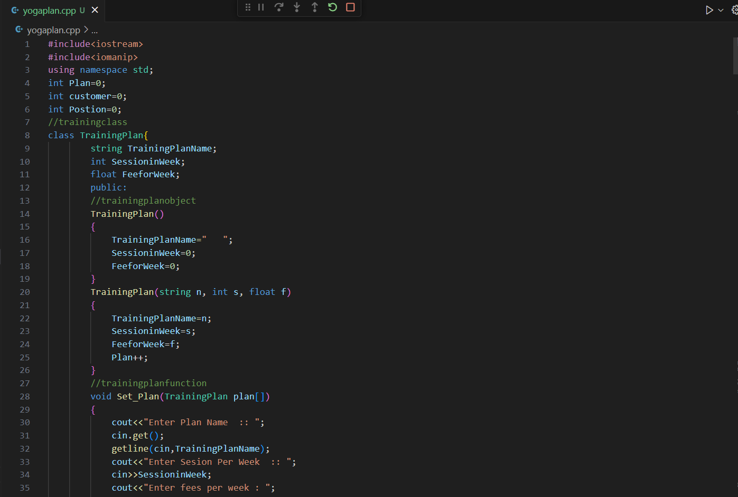

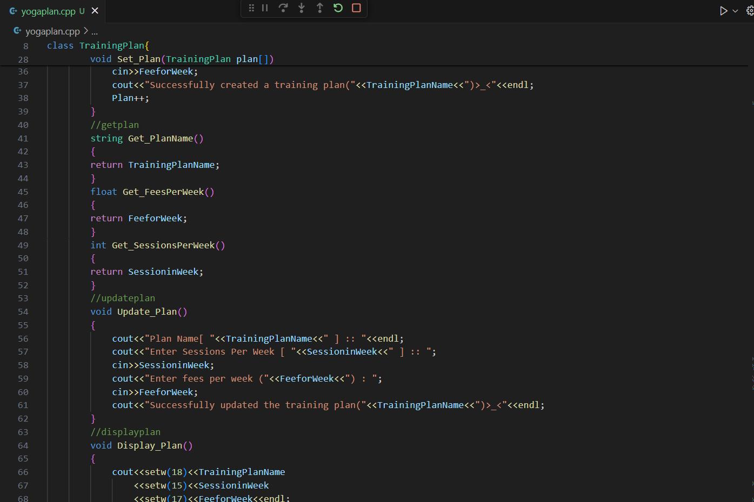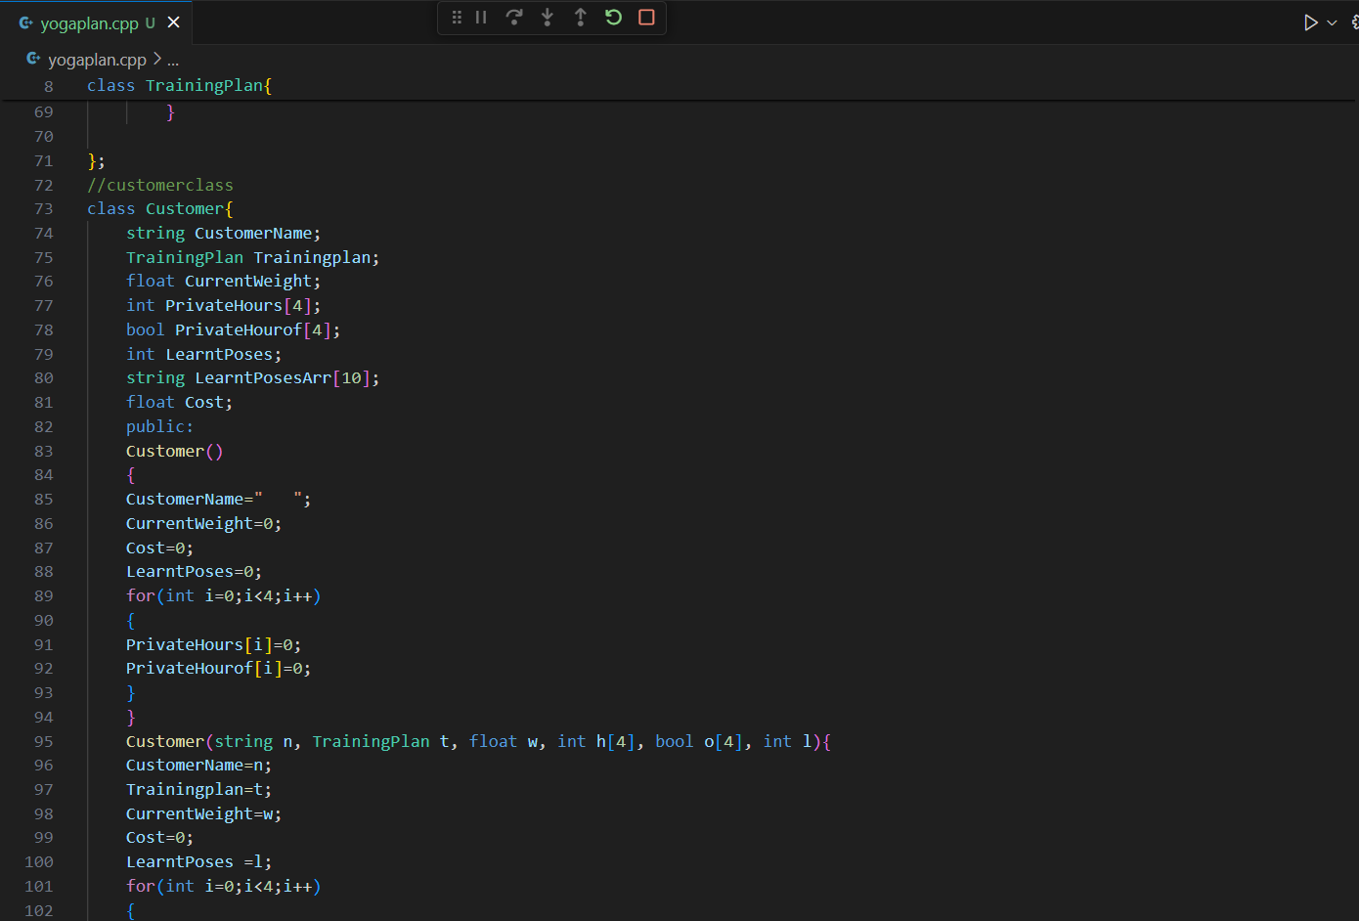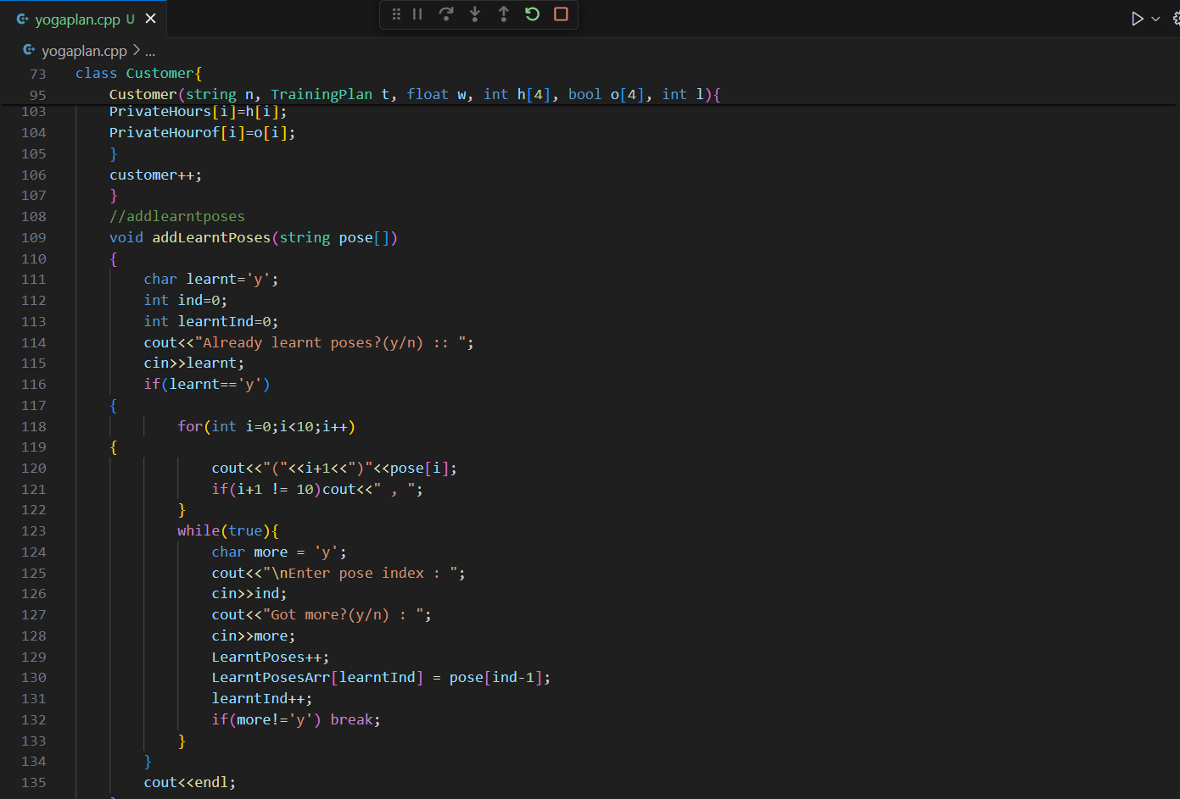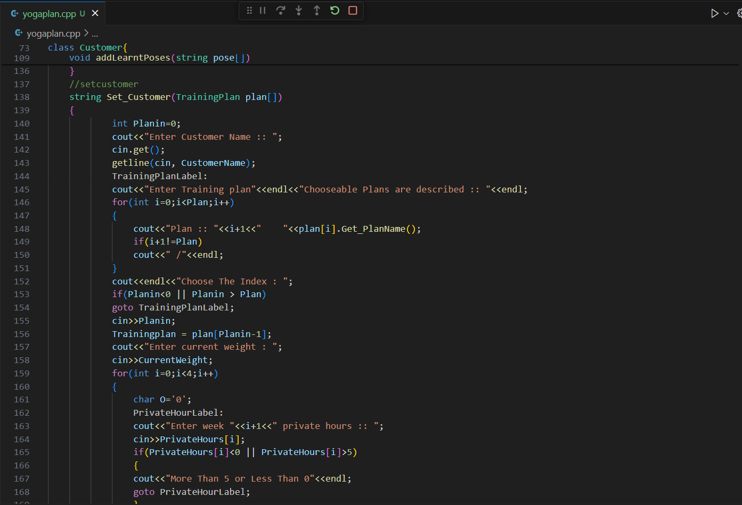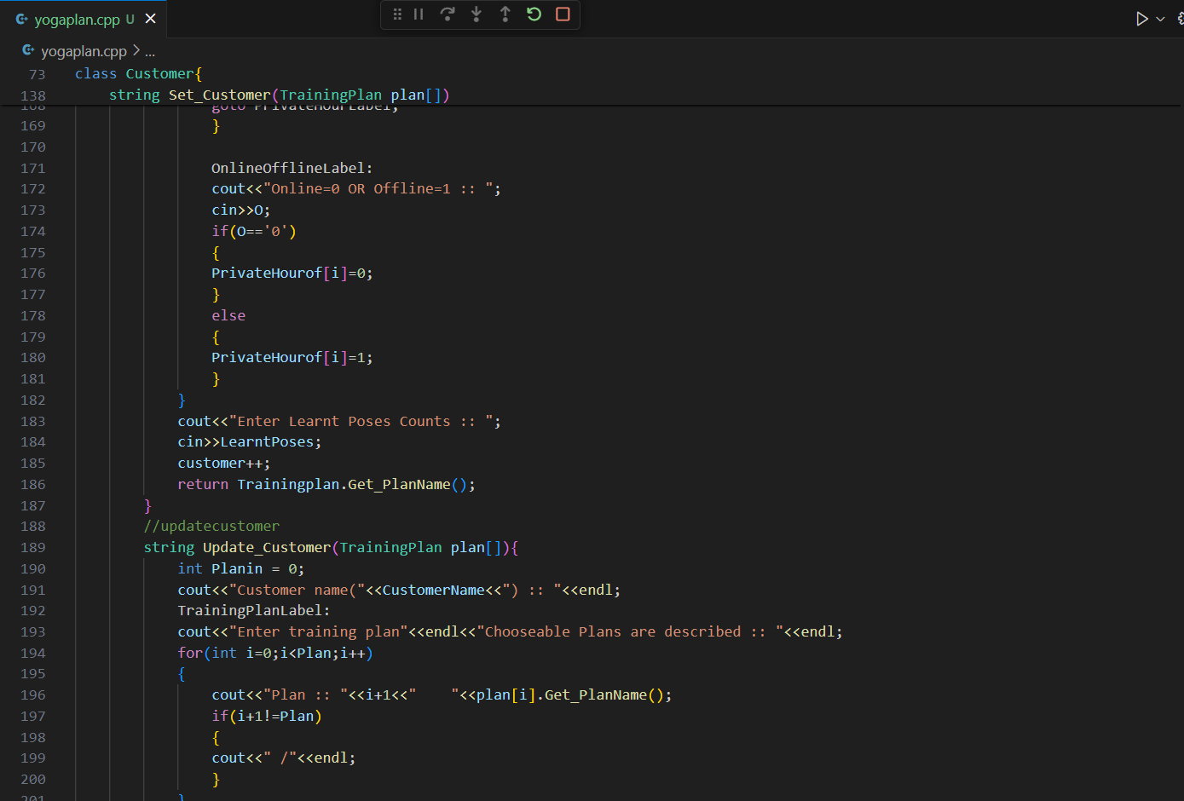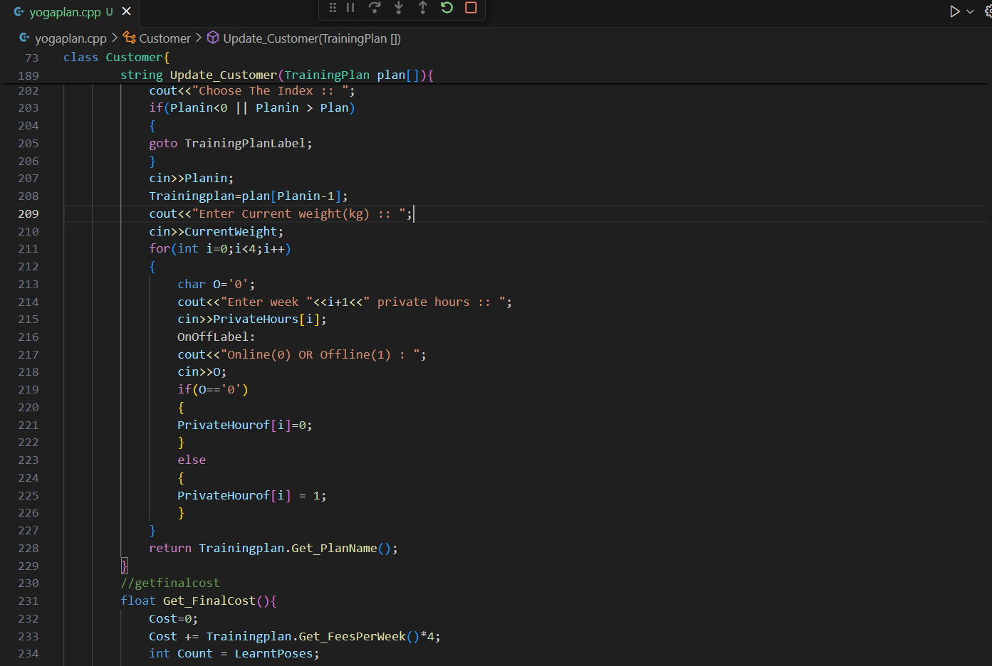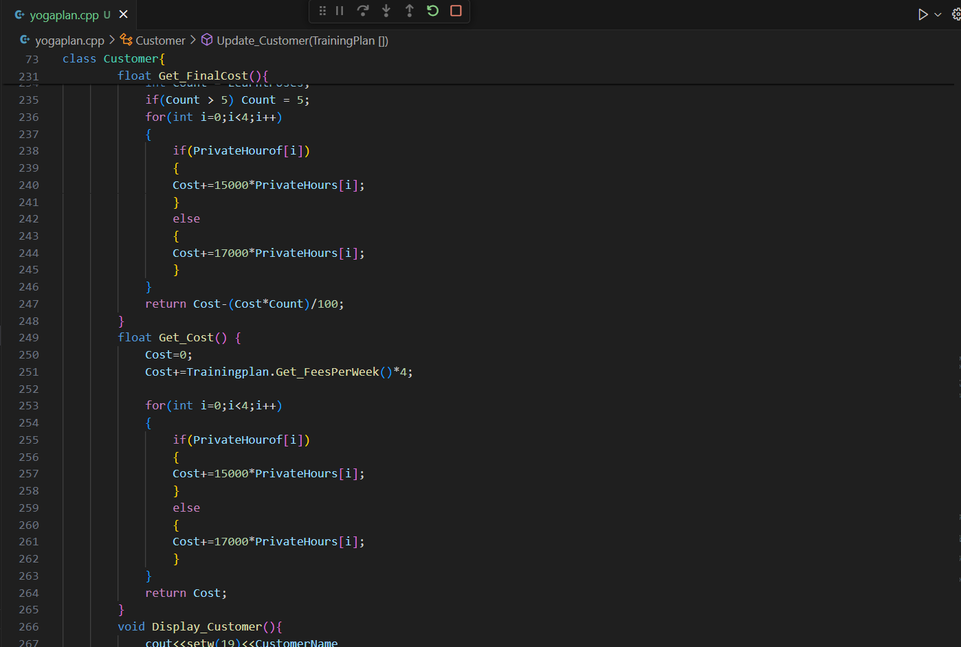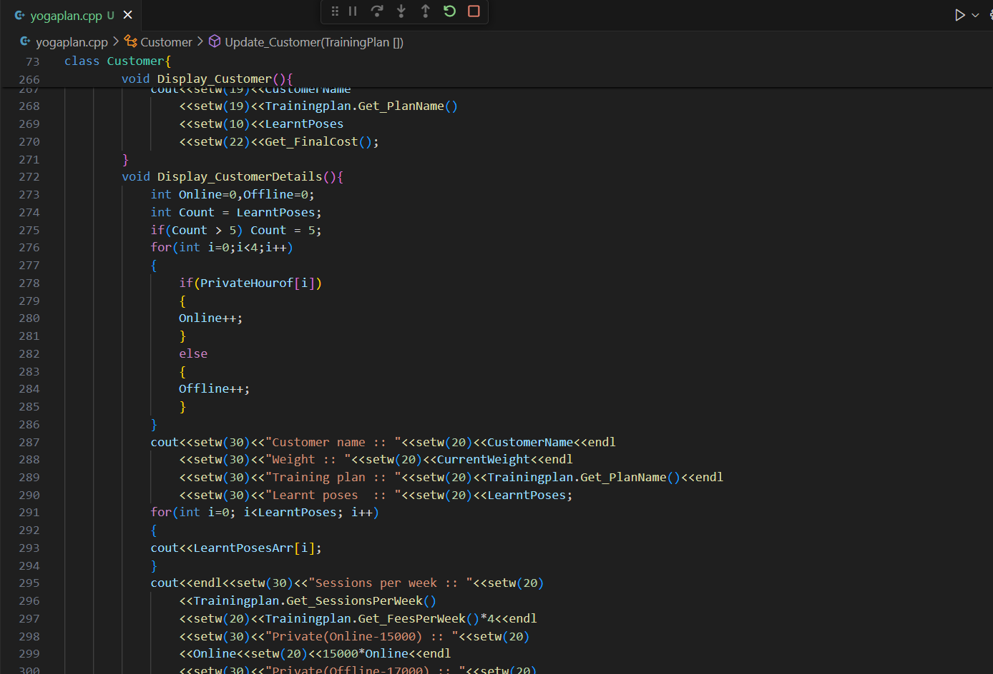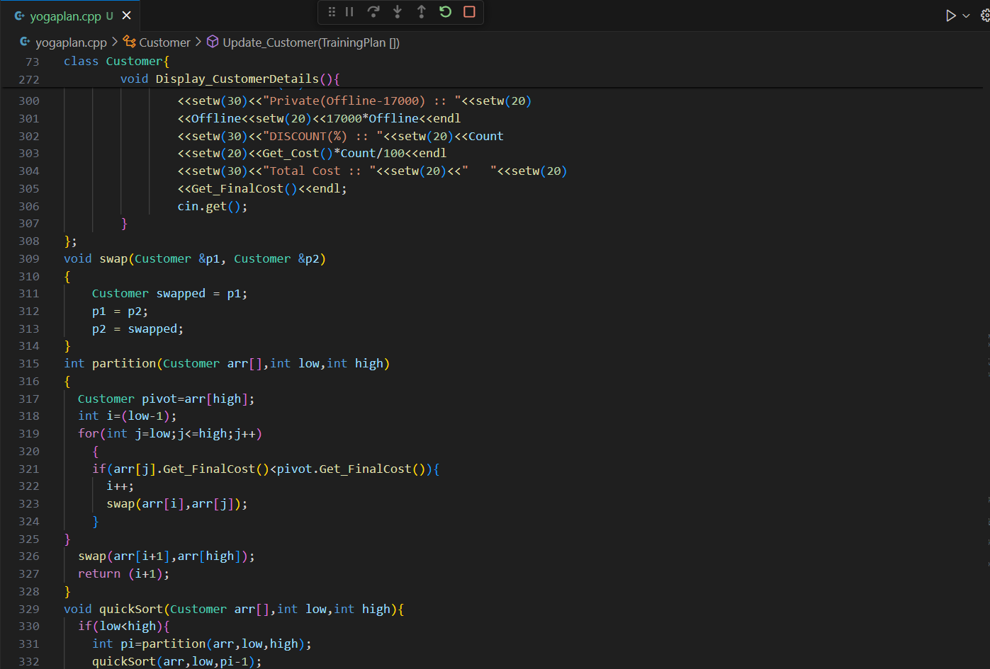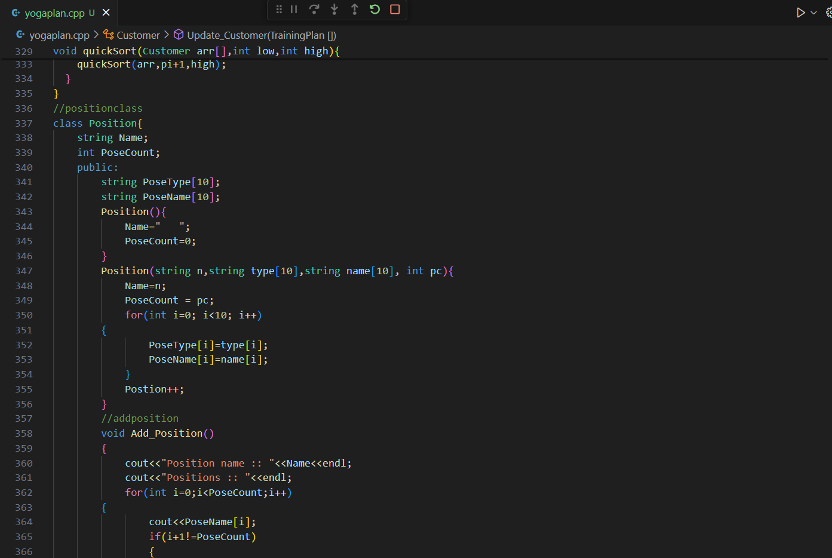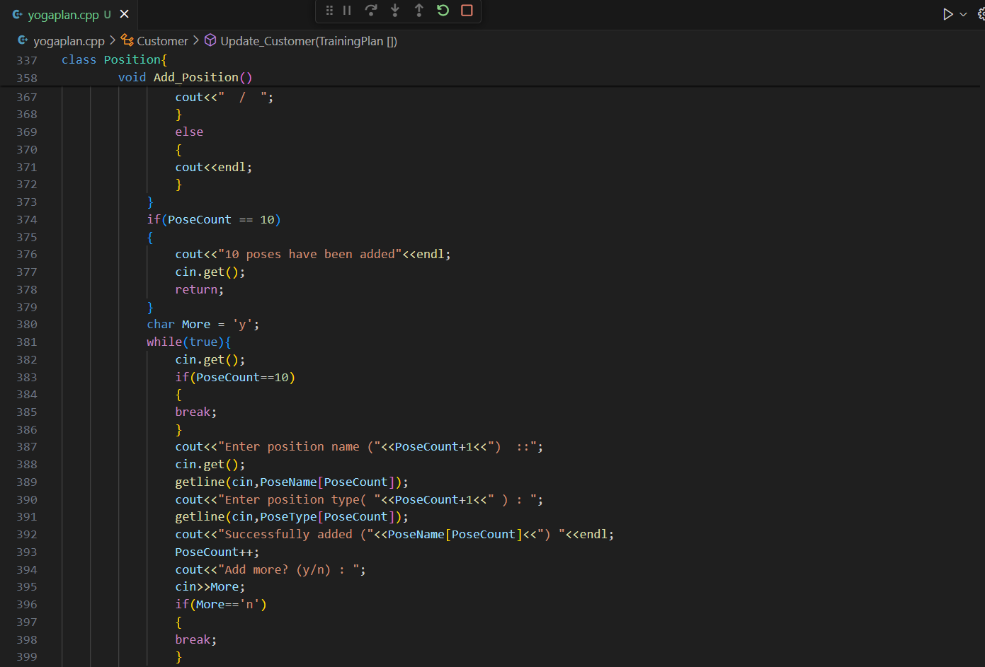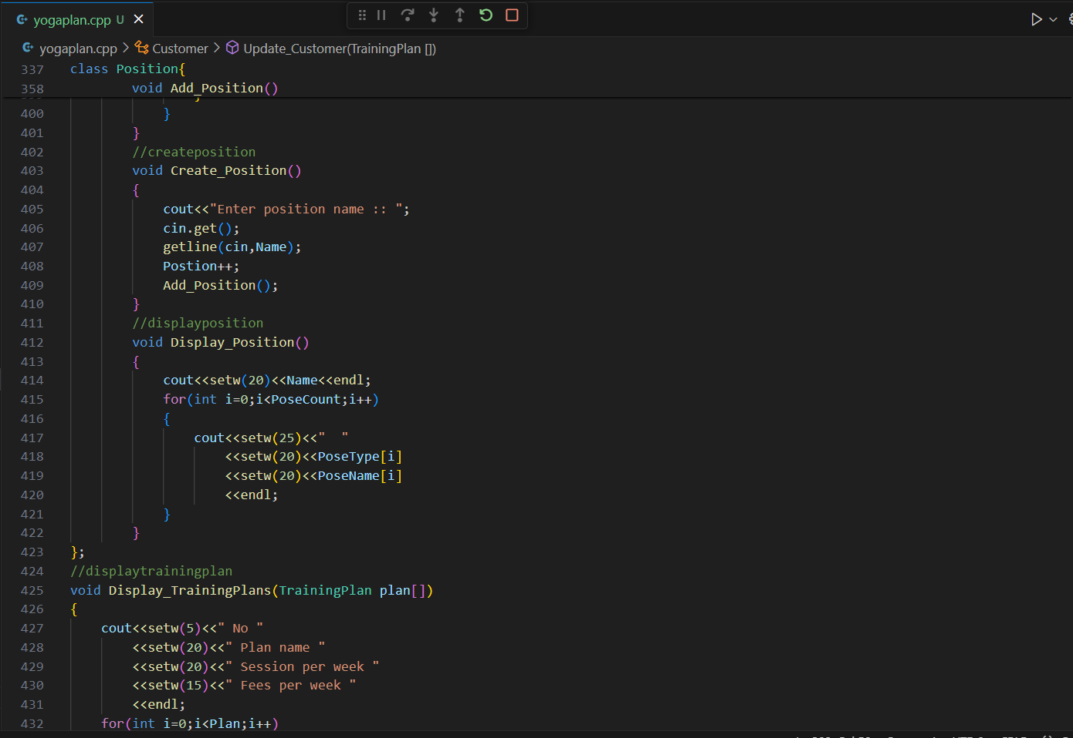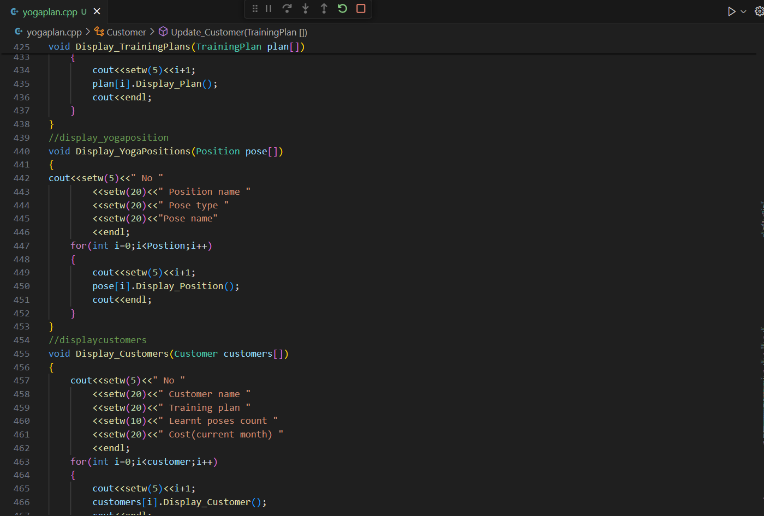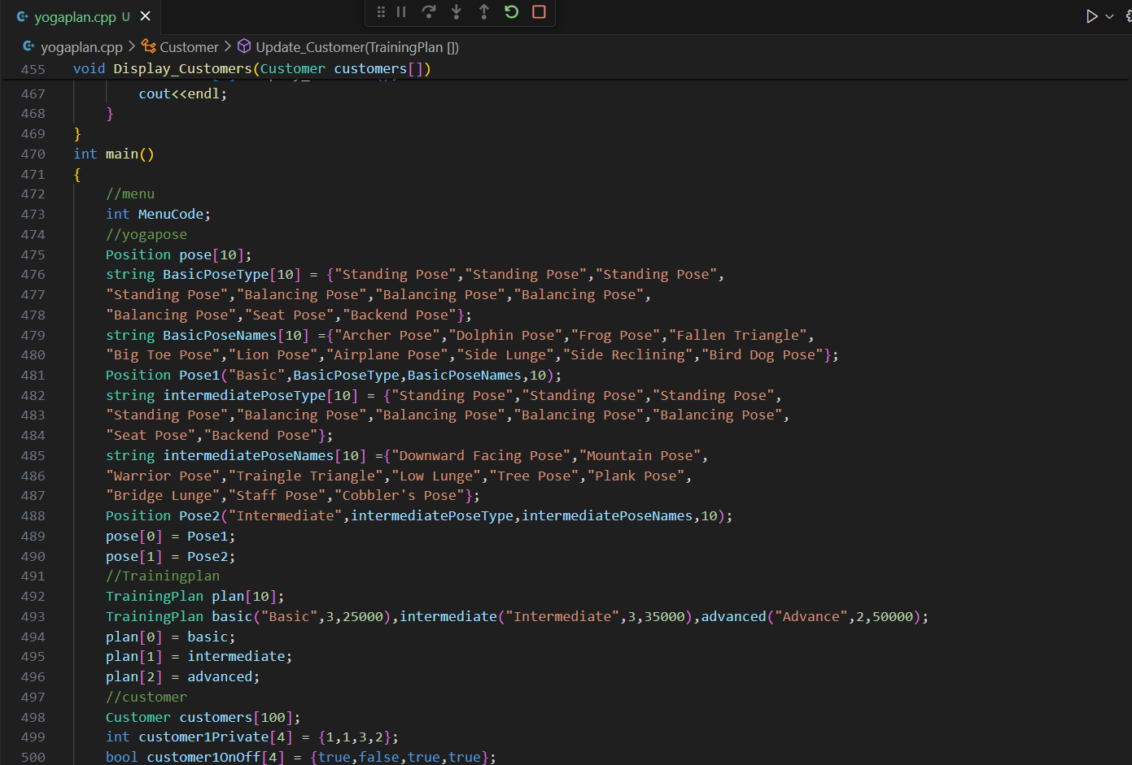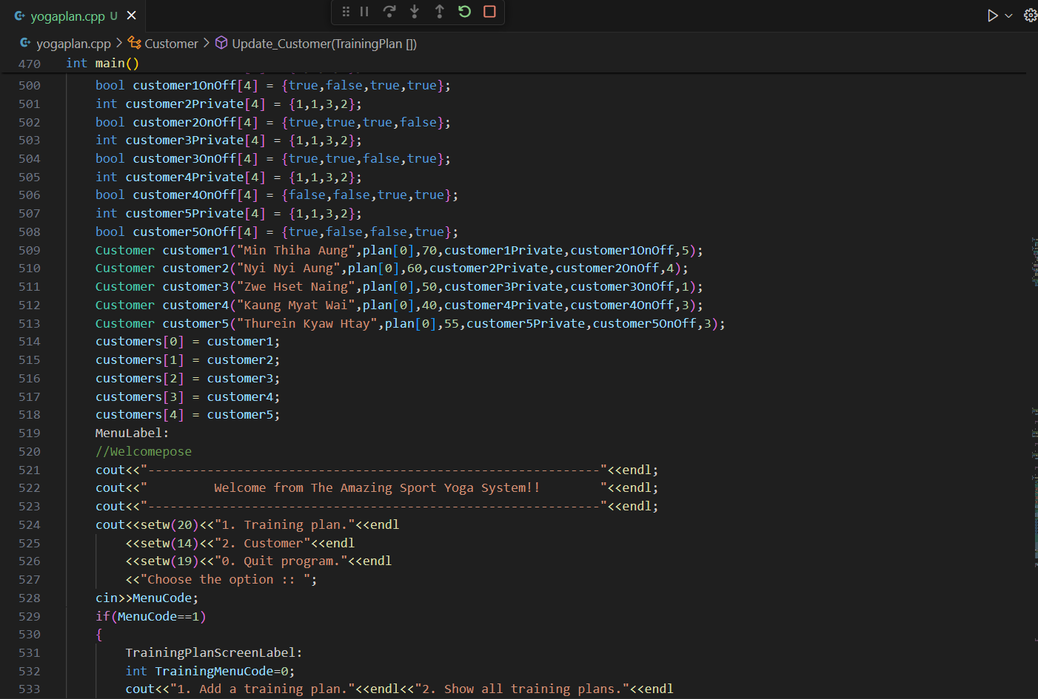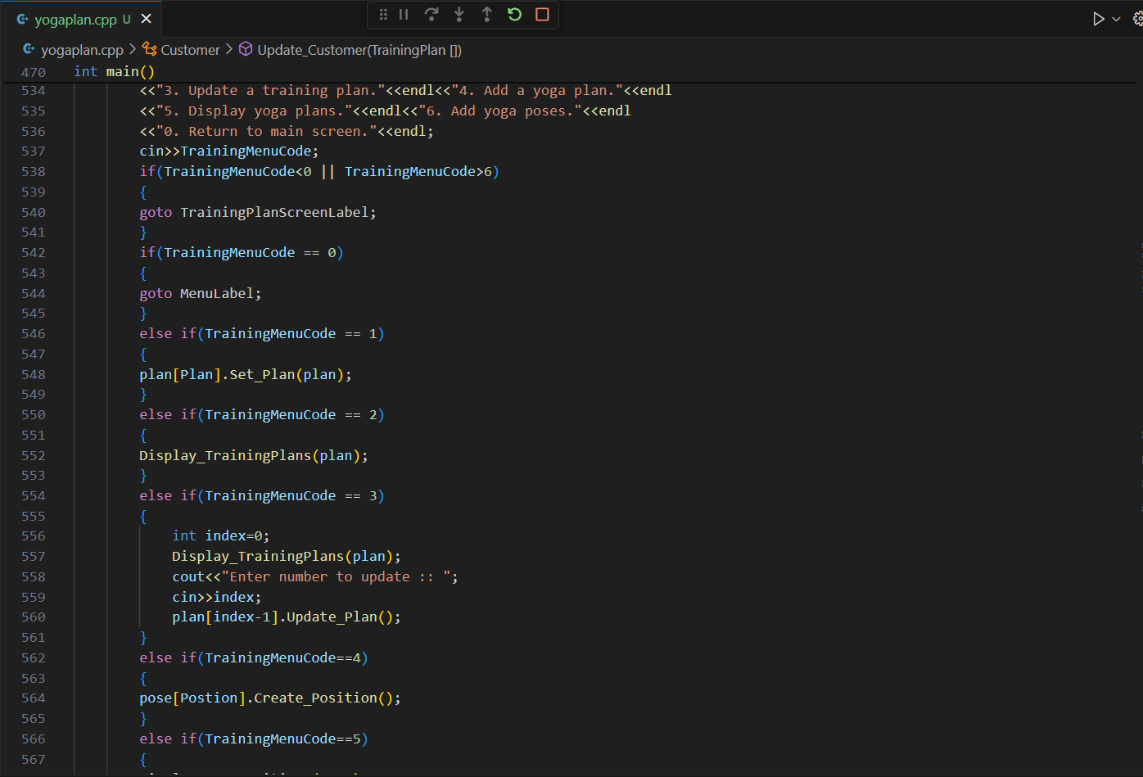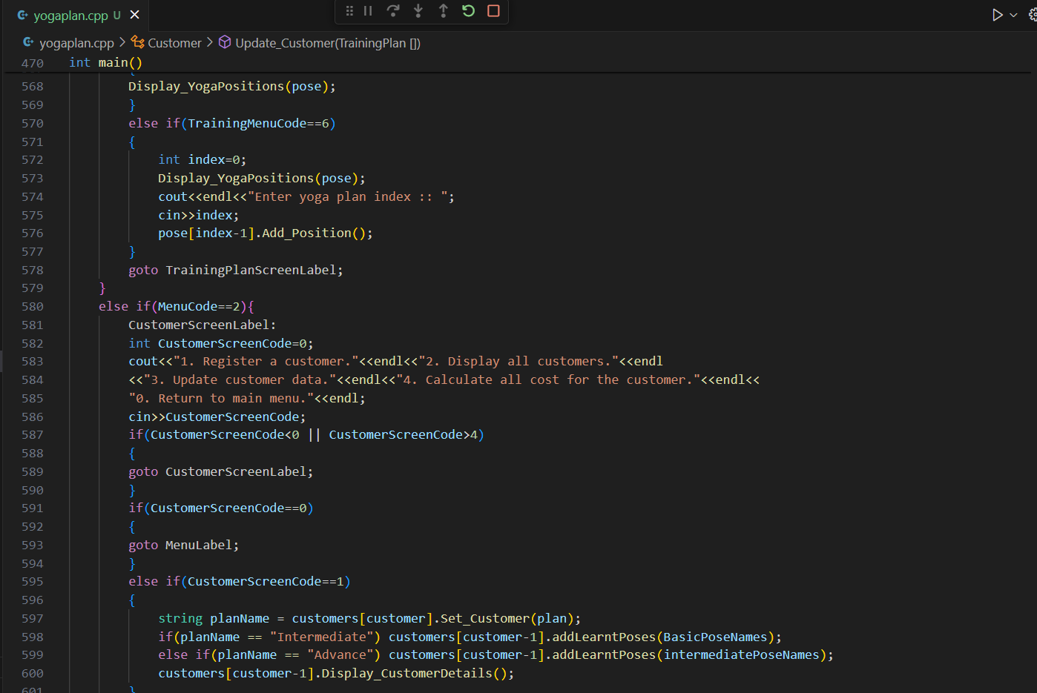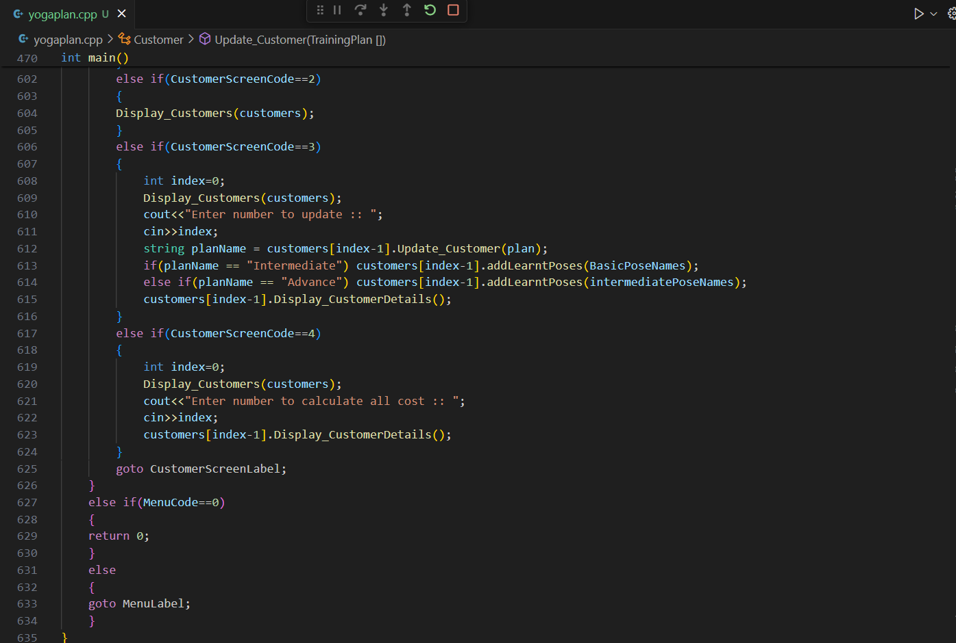

## Result of the code

## 

When the admin opens the system, welcome post will appear. Under the Amazing Sport Yoga System, the choose able option is described.

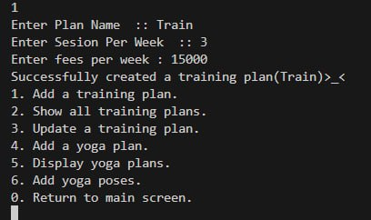

When the admin chooses the option ‘1’, the system will give ‘6’ options to manage the training plan. If the admin chooses the option ‘1’, the system will give the training adding function. In that function, the admin can add plan name, session per week and fees per week.

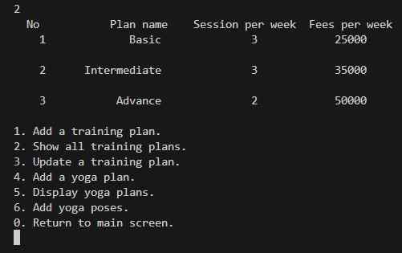

If the admin chooses the option ‘2’, the system will show the all training plans.

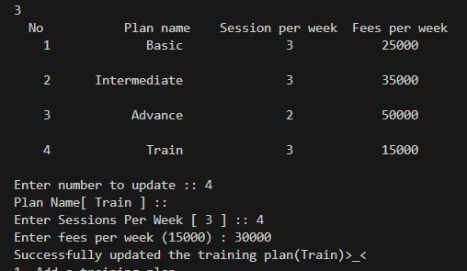

When the admin chooses the option ‘3’, the system will give the training plan updating function to edit the training plan. In that function, the admin can enter session per week and fee per week.

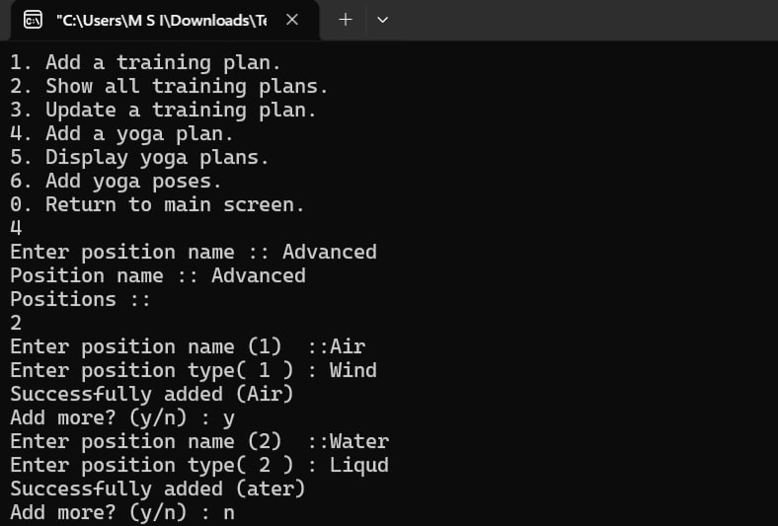

When the admin chooses the option ‘4’, the system will give yoga plan adding function to add the yoga plan.

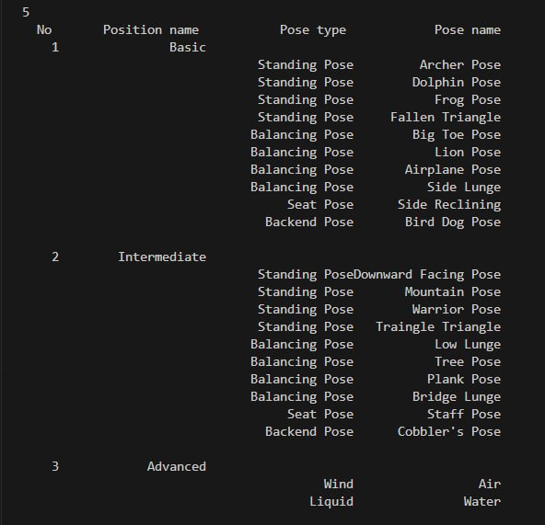

If the admin chooses the option ‘5’, the system will show yoga plans.

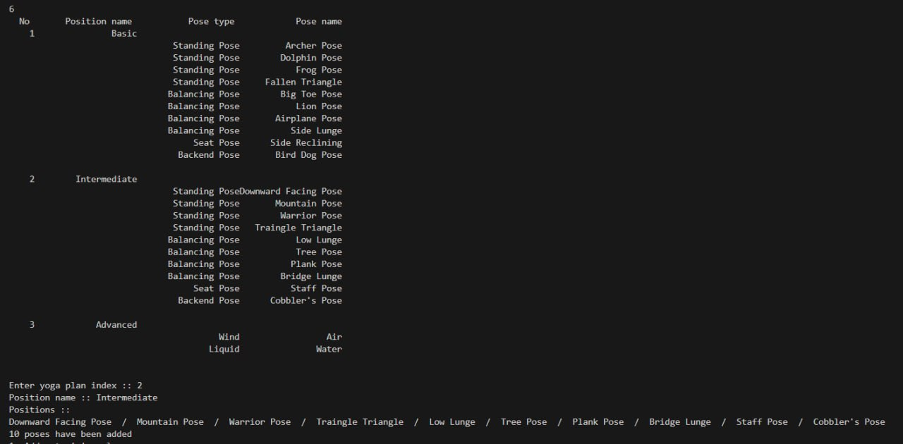

When the admin chooses the option ‘6’, the system will give yoga pose adding to add the yoga pose.

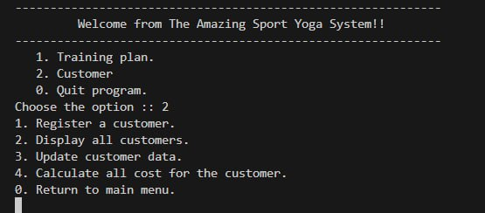

When the admin chooses the option ‘2’, the system will give ‘4’ options to manage the customer’s data.

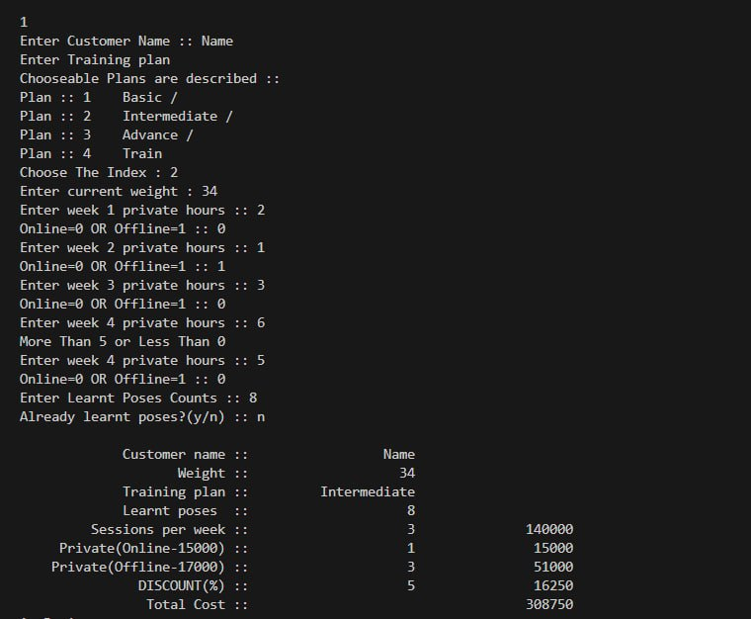

When the admin chooses the option ‘1’, the system will give the register function to store customer ‘data.

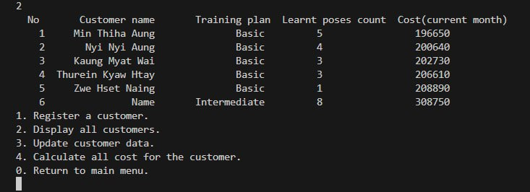

When the admin chooses the option ‘2’, the system will show the customer’s data.

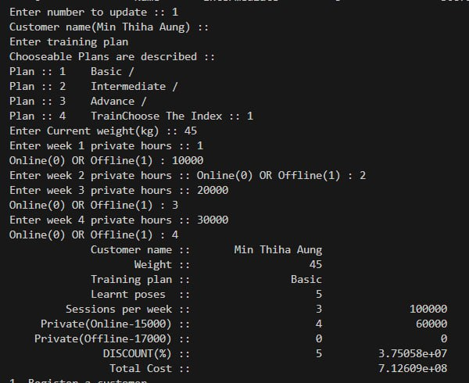

If the admin chooses the option ‘3’, the system will give the updating function for the customer.

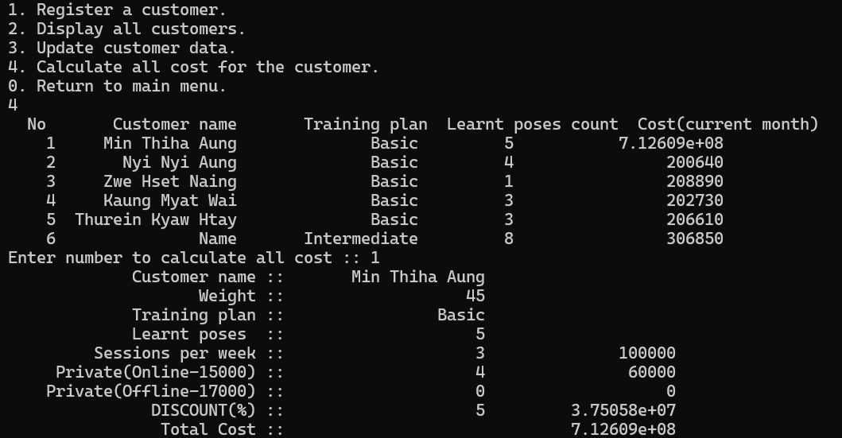

When the admin chooses the option ‘4’, the system will calculate the customers cost and show.

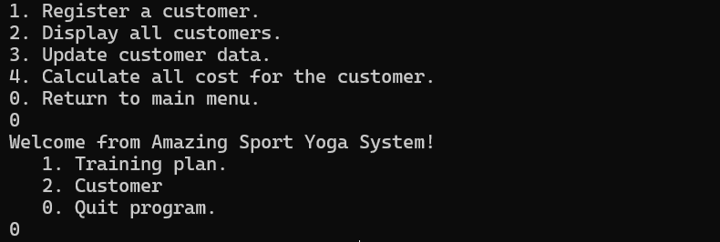

At the end of the system, the admin choose option ‘0’ and close the system.

# The Debugging process and the debugging facilities available in the IDE

## Debugging

Debugging in an activity of diagnosing a computer program or system and eliminating errors also termed as bugs. This crucial part of software development is all about making sure that the software works as designed, containing no bugs that make the whole program behave incorrectly, crash, or experience various other troubles. Debugging can be described in a number of steps, some of which are discussed here-The flow chart below shows the most common steps during the debugging process. The first is to replicate the problem so that it can be analysed and reconstructed in order to study cases.

## Debugging Facilities

Debugging facilities comprise the functionalities, characteristics, and surroundings within a development tool or platform that help the developer diagnose, understand, or eradicate faults in the code. Without these facilities, debugging can be vitally inefficient and ineffective because developers need to understand how the software they’re creating works in order to correct problems they might have introduced in its construction.

### Breakpoint

A breakpoint, a kind of watchpoint, is an important feature that is used for paused program execution at a certain point. This is useful to the developers to observe the status of the program at that point of time, the value of the variables, completed or outstanding processes, or memory consumption and others. The continuity of the program also gives developers the ability to forecast where a particular bug is likely to occur, thus debugging becomes easier at these paused states.

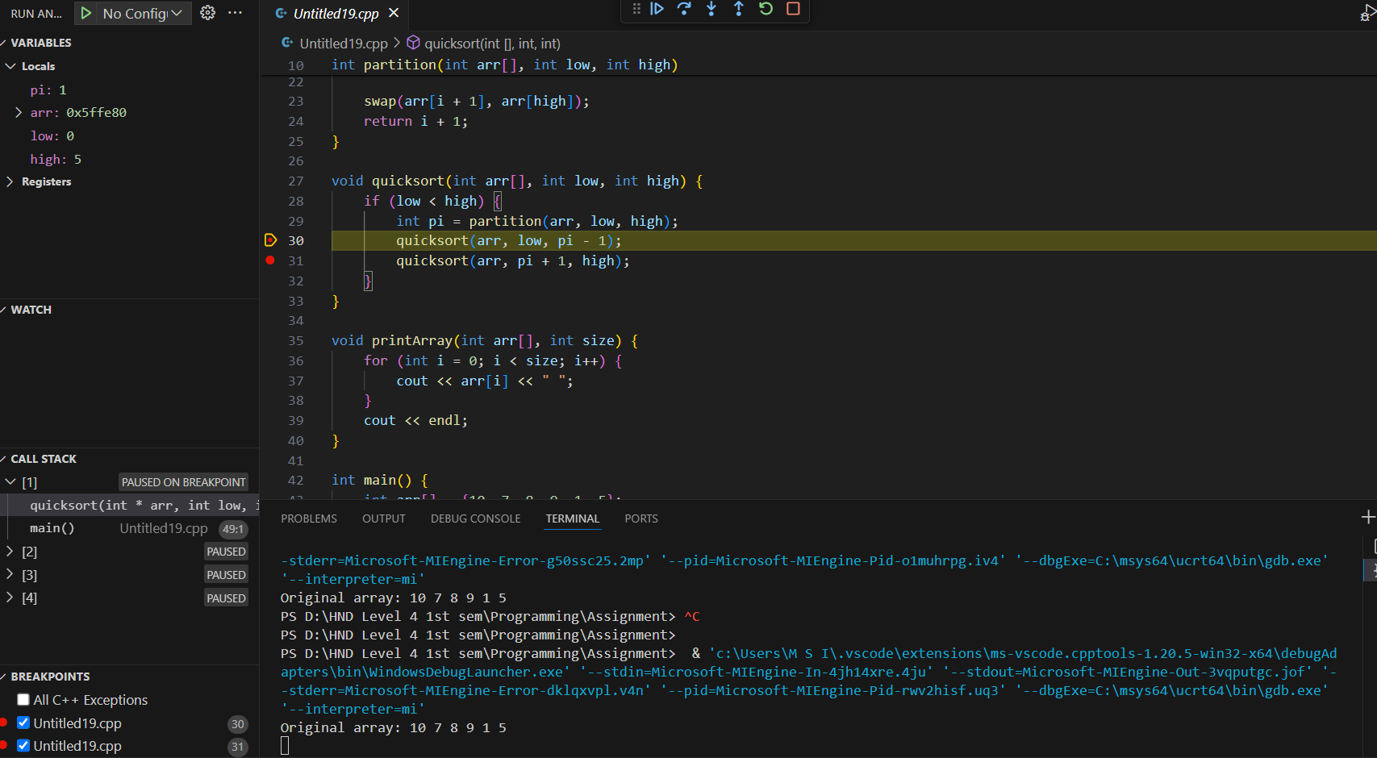

Figure. Breakpoint

### Debugging toolbar

A debug toolbar is an enhanced output window that is commonly incorporated into environments where application development is being done and offers an opportunity to communicate with the application in real life. It offers the developers a command prompt in which they can type commands and view their results precisely like how they can run the application, view variable values, and evaluate expressions. Debug console is part of IDE’s or debugging utilities. It provides a good deal of tools for the use in debug option.



Figure. Debugging Toolbar

### View variable

Looking at variables at certain times during the debugging process is a crucial factor of any application, to determine the state or the problem of the application. In this connection, Integrated Development Environments (IDEs) available for programming languages as well as the debugging tools available can show or alter the variables in several different manners.



Figure. Variables

### Call stack inspection

To be more specific, call stack debugging is one of the most critical factors while debugging since it enables developers to perceive the supposed sequence of numerous function/method calls leading to a specific phase of program execution.

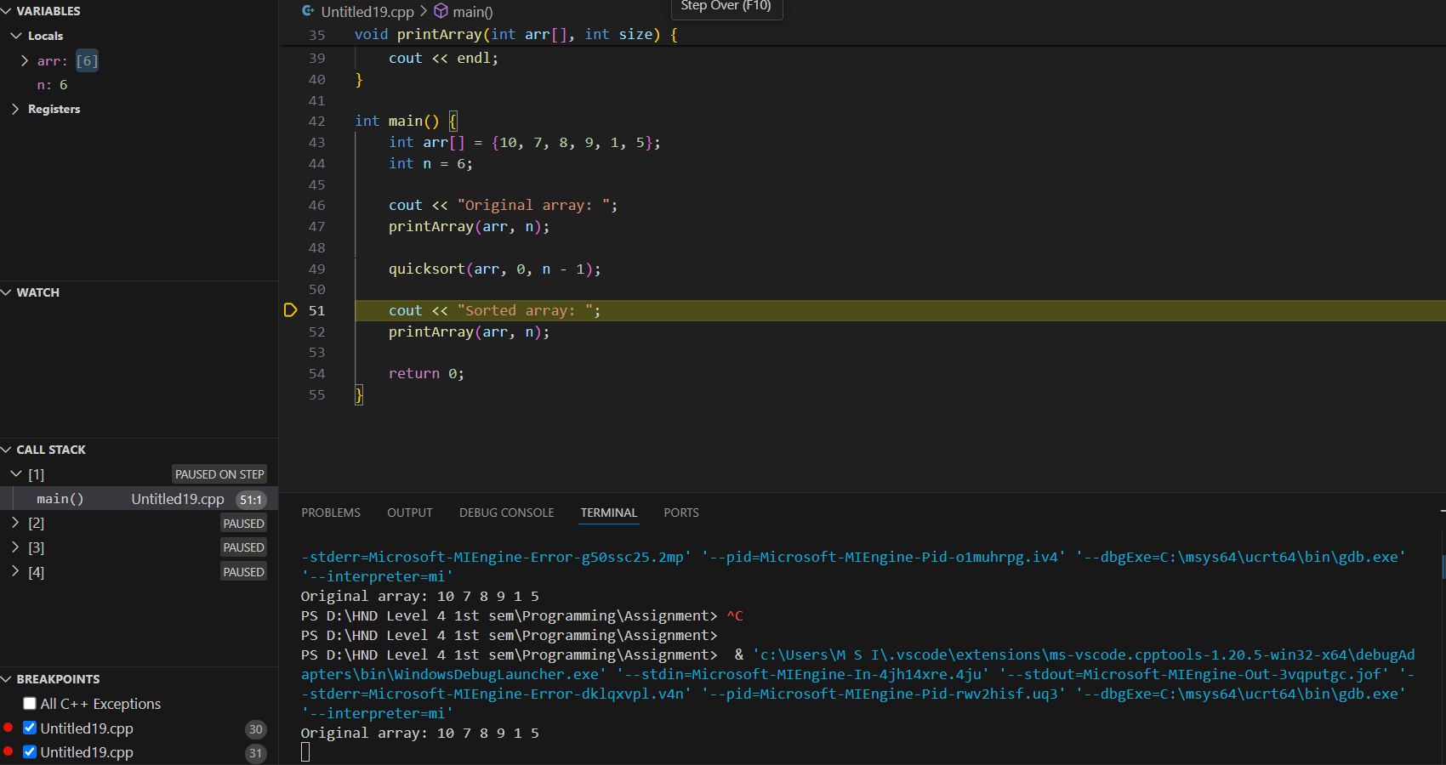

Figure. Call stack inspection

# The coding standard used in code

## Coding Standard

Coding standards are great practices which are very useful for maintaining general style of code, making a code readable and easy to maintain with different team members or developers. They include; naming conventions in code, indention, commenting, error handling among others.

## Error Handling

The conclusions regarding the alterations done to the code by the author in accord with the recommendations made for improving the error handling are as follows. The author of the provided code was using “goto” instructions in order to handle errors; To amend this fact, the use of loops and conditionals were used instead of the aforementioned “goto” instructions. Some improvements include the addition of input validation for added accessibility to users while incorporating meaningful error messages to avoid confusion. Preferentially, exceptions are used only where necessary for handling scenarios that are beyond the normal operations of the application, and comments are added to explain the structure and purpose of error handling.

For instance, while implementing the decision of setting up the training plan, the code applies tests checking whether the input value, such as sessions per week and fees per week, as are positive numbers, and if it fails, the user is forced to re-enter the correct values. Likewise, there are checks for the customer details, whereby the necessary attributes are set, such as the plan index, the current weight, and the hours that are private to the customer. Some of these improvements include the following: These changes help make the code better, minimizing potential issues that can occur with ease dragging and dropping of controls on the users’ part.

## Name Conventions

Variables and functions also have names since naming conventions are indispensable in programming to avoid the creation of unreadable and unmanageable scripts. From the provided C++ code, it is clearly observed that proper naming conventions are maintained for better understanding of the code different from the general convention. The class naming convention where names such as TrainingPlan or Customer, or Position use, to mention but a few, are written in CamelCase so that each new word begins with a capital letter and is easily recognizable as a class name. Functions, that use, has a lower-case letter for the first character with subsequent characters capitalized in order to distinguish between methods and classes. Since constants are also being used here though in box form and their representations are fixed, they should also follow the format to show the constant nature of the symbol.

Moreover, descriptive naming is very important. The naming conventions like “trainingPlanName”, “sessionsPerWeek”, and “feesPerWeek” directly explain the general field of usage for these variables, as compared with naming which may look quite random and can turn the intent of a certain variable into a misinterpretation.

## Indentation and Spacing

Basically, indentation and spacing should apply for the purpose other than making the software code more aesthetically pleasing by separating indentation and spacing into two groups. As to commenting, the standard is followed that comments are placed above the code being commented on and are indented one level, normally four space characters, then the code that is at the next level down from the commenting code. This visibility also conveys the pattern and structure of programming in terms of how the code flows through it. Also, the logical organization of the blank lines has also been employed in the correct manner, for instance separating different methods or major segments of given code for better code comprehensibility.

# The features of the IDE to manage the development process

At first the developer declares the header and namespace. And then developer build swap function. The swap function uses a temporary variable called temp to swap the values of two integers. At second stage, the developer build partition with using “for” looping and if. The partition function is used to divide the array into two arrays which are bigger than pivot and smaller than pivot. At third stage, the developer build quicksort function. The quicksort function is used to arrange the integer from smaller to larger. At this function, the function use partition and quicksort functions. The developer build printArray function using “for” looping. The printArray is used to show the array. At the final stage, the developer declare array in integer form and initialize it. The developer assigns constant value “6” into “n”. After that, the developer use printArray to show the original array. And then the developer use quicksort to sort the integers from the array. At the final task, the developer use printArray to show the sorted array.

## The whole code of quicksort

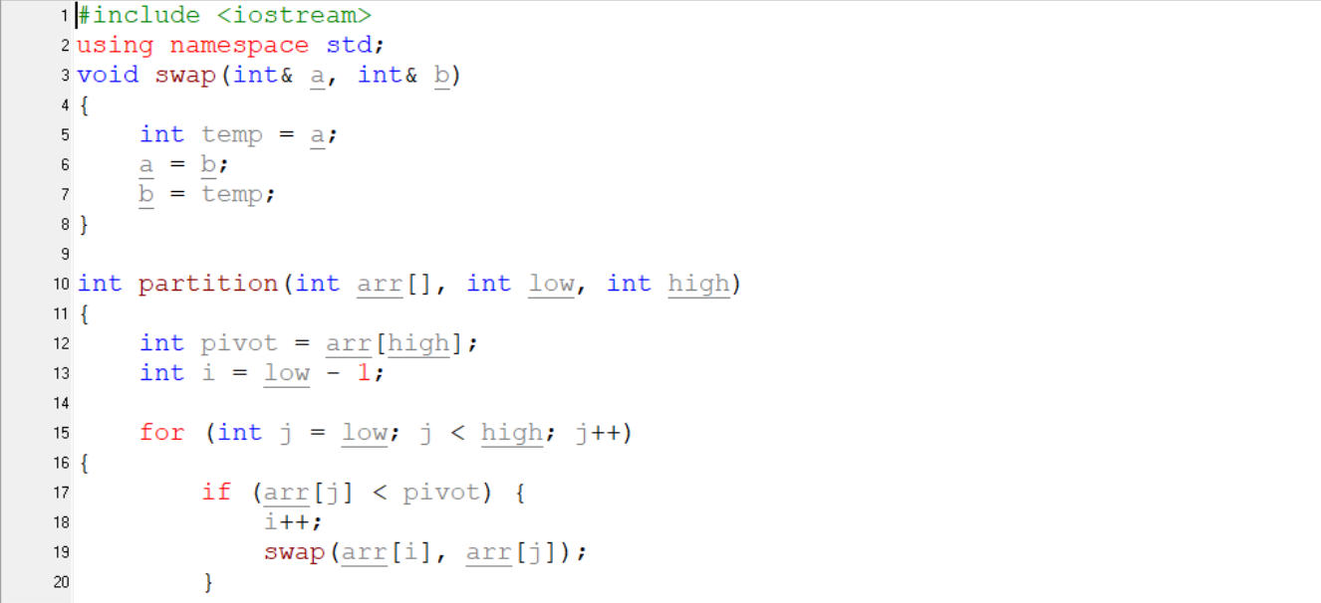

Figure. Quicksort

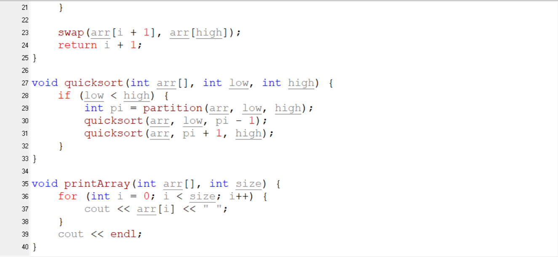

Figure. Quicksort

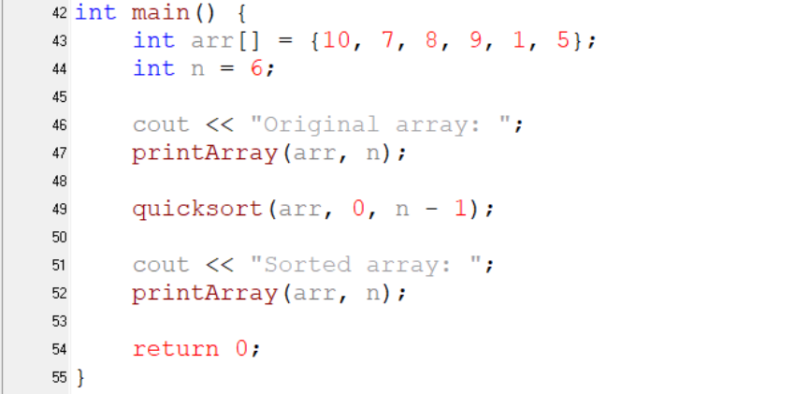

Figure. Quicksort

## Possible Error

It's important to make sure these components are handled appropriately to prevent issues if you make changes to the code, especially around important regions like the array size, pivot selection, or boundary conditions.

Array Size Calculation makes ensuring that, particularly in cases when the array varies, the array size is accurately determined or provided to functions. Your main function's code is more flexible as it uses to dynamically calculate the array size.

Choosing a Pivot

The effectiveness of Quicksort depends on the pivot choice. In the partition function of the developer, the pivot is selected as the final component. When applied to arrays that have previously been sorted, this method might result in worst-case performance. Developers can use a more complex pivot selection

## Using Quicksort in the program

## 

Figure. Implementation of the Quicksort algorithm in the program

The developer use quicksort function in the program. This quicksort function is described. And then connect the Customer class to work the quicksort function.

## Debugging the quicksort

## 

Figure. Debugging Quick Sort Step.1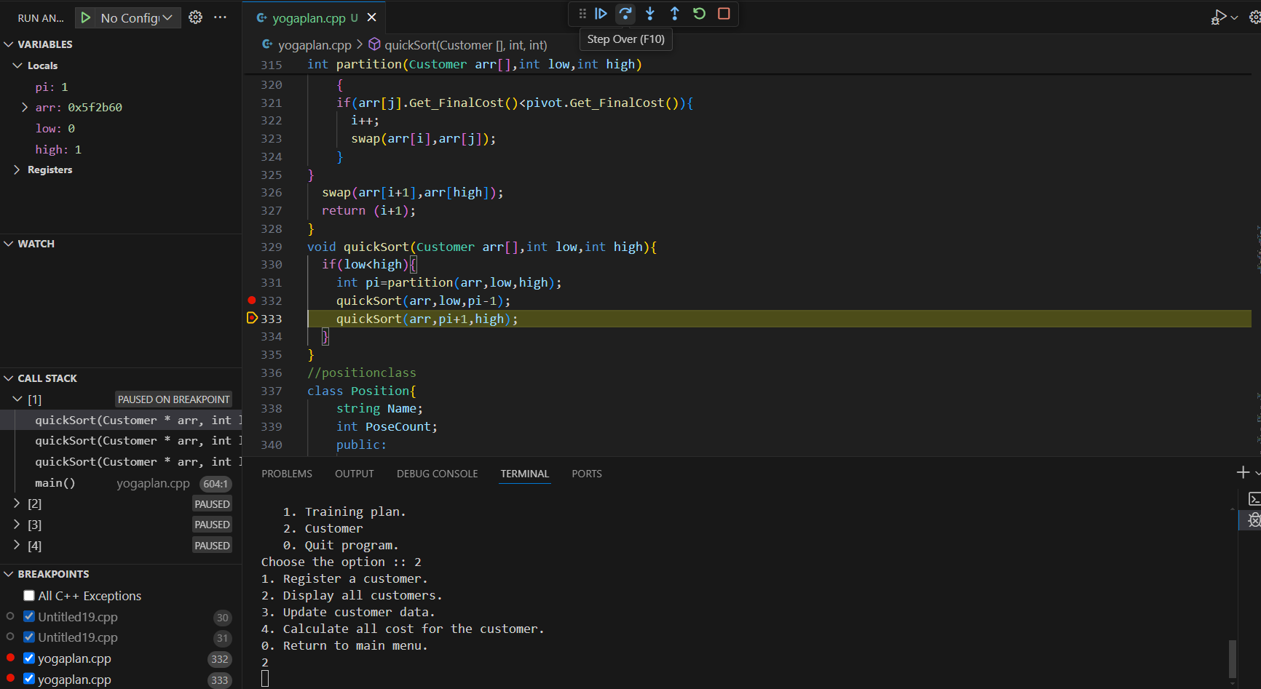

Figure. Debugging Quick Sort Step.2

## 

Figure. Debugging Quick Sort Step.3

At the debugging process, the system debug the quicksort function to correct and no error. And then, the system check the usage of quicksort at the end of the debugging.

## Usage of Version Control

## 

Figure. Home Page of GitHub

## 

Fig. Creating Repository

## 

Figure. New Repository

# The debugging process can be used to help develop more secure, robust applications

The process of debugging has several advantages that are very helpful in creating safe and reliable programs.

Early Problem Identification and Fixing

Early in the development cycle, defects may be found and fixed by developers thanks to debugging. Bugs that are discovered early in the manufacturing process are easier to correct and take less money and effort to fix than those that are discovered later. Developers may stop small defects from growing into larger ones that could jeopardize the stability and security of their applications by identifying them early on.

## Better Quality of Code

Debugging on a regular basis contributes to great code quality. It guarantees that the code complies with standards and best practices, which makes it easier to understand, maintain, and make cleaner. Robust and secure applications are enhanced by high-quality code, which is less prone to faults and vulnerabilities.

## Increased Safety

Improving application security is mostly dependent on debugging. Developers may protect the program from possible attacks by detecting and resolving security flaws including buffer overflows, SQL injections, and cross-site scripting (XSS). Additionally, debugging aids with input data validation, guaranteeing that malicious or unexpected inputs are handled by the program in a way that maintains security.

## Stability and Dependability

Debugging ensures that every component of the code functions correctly, which enhances the stability and dependability of programs. It assists in locating and resolving concurrency problems, memory leaks, and runtime faults that might result in program crashes or unpredictable behavior. Applications that are dependable improve user experience and foster user trust.

# The Use of an IDE for development of applications contrasted with not using an IDE

## IDE

An Integrated Development Environment (IDE) is a full-featured software suite that combines several tools and features into a single application to streamline software development. The fundamental component of an IDE is a source code editor, a specialized text editor for creating and modifying code that frequently has capabilities like real-time error detection, syntax highlighting, and code completion. A compiler or interpreter is also usually included into an IDE, which allows programming languages to be translated into machine-readable code or to be executed directly from the code.

## Effect when using IDE

The software development process is greatly impacted by the use of an Integrated Development Environment (IDE), which promotes learning, increases productivity, and improves code quality. With capabilities like code completion, syntax highlighting, and real-time error detection, integrated development environments (IDEs) improve the coding process and enable developers to produce code more quickly and mistake-free. These tools assist developers maintain organized and effective codebases by offering static code analysis and refactoring capabilities, which enhance code quality. Integrated debugging tools make it possible to identify and fix problems more successfully, which increases the software's dependability.

## Effect Without IDE

Without an Integrated Development Environment (IDE), creating software presents a number of difficulties that have an impact on learning, productivity, code quality, and teamwork. Developers must expend more manual labor while developing, modifying, and debugging code if they are not using an integrated development environment (IDE) with features like code completion, syntax highlighting, and real-time error detection. This may result in longer development cycles and an increased likelihood of faults that are more difficult to find and correct without the use of automated techniques. Without integrated version control systems, teamwork becomes more difficult and developers must manually handle code changes, which can result in inefficiencies and disputes.

## Comparison of IDE

In the world of software development, Dev C++ and Visual Studio Code (VSCode) have different functions. Dev C++ is an integrated development environment (IDE) that is primarily meant for C and C++ programming. It offers basic tools like a text editor with syntax highlighting, a built-in compiler (MinGW), and basic debugging capabilities. Dev C++ is commonly used by beginners and students because of its ease of installation, simplicity, and direct support for C++ development tasks. On the other hand, it lacks the broad language support and extensive customization found in more versatile editors.

The decision between Dev C++ and VSCode is influenced by various factors, including programming language specialization, development environment requirements, desired level of customization.

# The role and purpose of a coding standard and it is necessary in a team as well as for the individual

Coding standards are essential to software development because they guarantee the readability, consistency, and maintainability of the code. Developers can more readily comprehend and make changes to one other's code when coding techniques and style are consistent, which promotes productive teamwork and cross-project cooperation. Standardized practices help improve code readability, which facilitates comprehension and debugging.

## The role and purpose of a coding standard as a team

Together, coding standards provide as a fundamental collection of rules and best practices that guarantee efficiency, coherence, and consistency all the way through the software development lifecycle.

Consistency

Coding standards create consistency between team members in the way that code is written, formatted, and organized. This uniformity facilitates mutual code comprehension among developers, lessens ambiguity during code reviews, and fosters a coherent codebase.

### Readability and Sustainability

Coding standards improve readability of code by specifying naming conventions, formatting guidelines, and best practices for organizing code. Not only does this make code easier to read at first, but it also makes it easier to maintain and change over time. Developers don't need to understand various styles or methodologies to discover and alter code portions rapidly.

## The role and purpose of a coding standard as an individual

Following coding standards as an individual developer improves efficacy and professionalism in a number of ways.

### Consistency in Personal Code

The developer can keep personal codebase consistent by adhering to coding standards. Developer may make sure that your code is readable and understood and other people by adhering to established rules for naming conventions, formatting, and organization.

### Readability and Maintainability

It is simpler to read, comprehend, and update code that is clear and consistent. Following coding standards helps and others understand the logic and flow of your code more quickly, which saves time on debugging and change.

# References

<https://aws.amazon.com/what-is/debugging/>