**26. Технология Windows Presentation Foundation**

Задание 1. Создать XML файл “Записная книжка” состоящий из записей (Фамилия, дата рождения, номер телефона).

Решение:

<Window x:Class="NotebookApp.MainWindow"

xmlns="http://schemas.microsoft.com/winfx/2006/xaml/presentation"

xmlns:x="http://schemas.microsoft.com/winfx/2006/xaml"

Title="Записная книжка" Height="350" Width="525">

<Grid>

<Label Content="Фамилия" HorizontalAlignment="Left" VerticalAlignment="Top" Margin="10,10,0,0"/>

<TextBox x:Name="LastNameTextBox" HorizontalAlignment="Left" Height="23" Margin="133,10,0,0" VerticalAlignment="Top" Width="200"/>

<Label Content="Дата рождения" HorizontalAlignment="Left" VerticalAlignment="Top" Margin="10,40,0,0"/>

<DatePicker x:Name="BirthDatePicker" HorizontalAlignment="Left" Margin="133,41,0,0" VerticalAlignment="Top" Width="200"/>

<Label Content="Номер телефона" HorizontalAlignment="Left" VerticalAlignment="Top" Margin="10,70,0,0"/>

<TextBox x:Name="PhoneNumberTextBox" HorizontalAlignment="Left" Height="23" Margin="133,70,0,0" VerticalAlignment="Top" Width="200"/>

<Button Content="Сохранить" HorizontalAlignment="Left" VerticalAlignment="Top" Width="75" Margin="10,100,0,0" Click="SaveButton_Click"/>

</Grid>

</Window>

using System;

using System.Windows;

using System.Xml.Linq;

namespace NotebookApp

{

public partial class MainWindow : Window

{

public MainWindow()

{

InitializeComponent();

}

private void SaveButton_Click(object sender, RoutedEventArgs e)

{

string lastName = LastNameTextBox.Text;

DateTime birthDate = BirthDatePicker.SelectedDate.HasValue ? BirthDatePicker.SelectedDate.Value : DateTime.Now;

string phoneNumber = PhoneNumberTextBox.Text;

if (string.IsNullOrWhiteSpace(lastName) || string.IsNullOrWhiteSpace(phoneNumber))

{

MessageBox.Show("Пожалуйста, заполните все поля.");

return;

}

Contact contact = new Contact

{

LastName = lastName,

BirthDate = birthDate,

PhoneNumber = phoneNumber

};

SaveContactToXml(contact);

}

private void SaveContactToXml(Contact contact)

{

string filePath = "Notebook.xml";

XElement contactElement = new XElement("Contact",

new XElement("LastName", contact.LastName),

new XElement("BirthDate", contact.BirthDate.ToString("yyyy-MM-dd")),

new XElement("PhoneNumber", contact.PhoneNumber)

);

XDocument xDocument;

if (System.IO.File.Exists(filePath))

{

xDocument = XDocument.Load(filePath);

xDocument.Root.Add(contactElement);

}

else

{

xDocument = new XDocument(new XElement("Notebook", contactElement));

}

xDocument.Save(filePath);

MessageBox.Show("Контакт успешно сохранен.");

}

}

}

Анализ результатов:

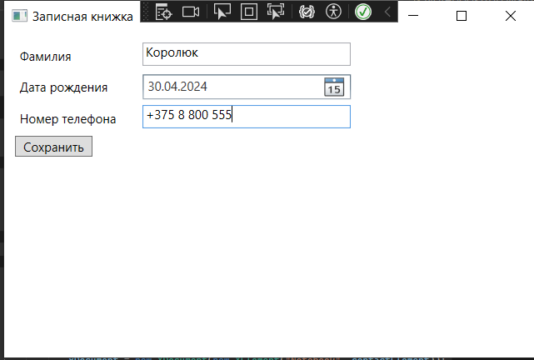

Рисунок 26.1 – Результат задания