Вычислительная Математика
Лабораторная Работа

Масеко Звелаке 5130904/30003

Вариант №16

Задача 3

решить систему дифференциальных уравнений.
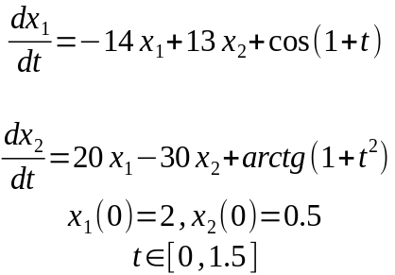
Следующими способами с одним и тем же шагом печати

- по программе RKF45 с EPS = 0.0001
- методом Рунге-Кутты 2-й степени точности

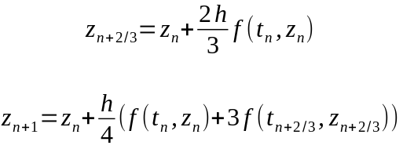
с двумя постоянными шагами интегрирования
- h_{int} = 0.075
- любой другой, позволяющий получить качественно верное решение

H_INT = 0.075
RKF45 | РУНГЕ_КУТТЫ ВТОРОЙ СТЕПЕНИ f(t,x)
t = 0,013890, x = [ 1,759914e+00 7,620155e-01 ]  t = 0,086769, x = [ 1,203839e+00 9,038369e-01 ]  t = 0,179633, x = [ 8,665289e-01 6,779649e-01 ]  t = 0,225563, x = [ 7,428968e-01 5,845340e-01 ]  t = 0,377118, x = [ 4,570072e-01 3,684528e-01 ]  t = 0,488234, x = [ 3,266281e-01 2,712485e-01 ]  t = 0,591008, x = [ 2,425069e-01 2,094893e-01 ]  t = 0,693782, x = [ 1,813759e-01 1,656005e-01 ]  t = 0,784619, x = [ 1,403826e-01 1,366951e-01 ]  t = 0,875457, x = [ 1,077465e-01 1,143553e-01 ]  t = 0,967384, x = [ 8,084215e-02 9,622255e-02 ]  t = 1,063107, x = [ 5,738559e-02 8,091310e-02 ]  t = 1,153820, x = [ 3,839228e-02 6,858205e-02 ]  t = 1,245121, x = [ 2,154919e-02 5,796925e-02 ]  t = 1,332517, x = [ 7,233522e-03 4,888073e-02 ]  t = 1,416258, x = [ -5,190678e-03 4,115556e-02 ]  t = 1,500000, x = [ -1,642129e-02 3,411281e-02 ] | t = 0,0000, x = [2,193686e+00 , -9,206509e-01]  t = 0,0750, x = [3,330441e+00 , -3,972005e+00]  t = 0,1500, x = [6,663106e+00 , -1,122485e+01]  t = 0,2250, x = [1,536505e+01 , -2,907441e+01]  t = 0,3000, x = [3,740043e+01 , -7,348508e+01]  t = 0,3750, x = [9,270247e+01 , -1,843502e+02]  t = 0,4500, x = [2,311213e+02 , -4,613901e+02]  t = 0,5250, x = [5,772949e+02 , -1,153896e+03]  t = 0,6000, x = [1,442828e+03 , -2,885087e+03]  t = 0,6750, x = [3,606738e+03 , -7,213008e+03]  t = 0,7500, x = [9,016575e+03 , -1,803277e+04]  t = 0,8250, x = [2,254122e+04 , -4,508212e+04]  t = 0,9000, x = [5,635288e+04 , -1,127055e+05]  t = 0,9750, x = [1,408820e+05 , -2,817639e+05]  t = 1,0500, x = [3,522050e+05 , -7,044099e+05]  t = 1,1250, x = [8,805124e+05 , -1,761025e+06]  t = 1,2000, x = [2,201281e+06 , -4,402562e+06]  t = 1,2750, x = [5,503203e+06 , -1,100641e+07]  t = 1,3500, x = [1,375801e+07 , -2,751601e+07]  t = 1,4250, x = [3,439502e+07 , -6,879003e+07]  t = 1,5000, x = [8,598754e+07 , -1,719751e+08]
RKF45 – f(t,x) | [8,598754e+07 , 1,719751e+08]

Матрица однородной системы

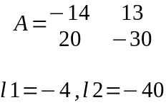

ограничение на шаг для однородной системы
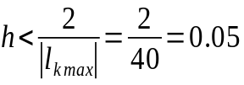

выбранный оптимальный шаг

RKF45 | f(t,x)
HINT = 0.025
t = 0,000, x = [1,672195e+00 , 7,719013e-01]
t = 0,075, x = [1,162637e+00 , 8,394523e-01]
t = 0,150, x = [8,837664e-01 , 6,837123e-01]
t = 0,225, x = [6,866696e-01 , 5,409336e-01]
t = 0,300, x = [5,390455e-01 , 4,301024e-01]
t = 0,375, x = [4,267182e-01 , 3,457734e-01]
t = 0,450, x = [3,404066e-01 , 2,814675e-01]
t = 0,525, x = [2,733888e-01 , 2,320727e-01]
t = 0,600, x = [2,207056e-01 , 1,937578e-01]
t = 0,675, x = [1,786880e-01 , 1,636750e-01]
t = 0,750, x = [1,446221e-01 , 1,397115e-01]
t = 0,825, x = [1,165028e-01 , 1,203017e-01]
t = 0,900, x = [9,285238e-02 , 1,042883e-01]
t = 0,975, x = [7,258558e-02 , 9,081878e-02]
t = 1,050, x = [5,490987e-02 , 7,926851e-02]
t = 1,125, x = [3,925115e-02 , 6,918344e-02]
t = 1,200, x = [2,519831e-02 , 6,023719e-02]
t = 1,300, x = [8,472282e-03 , 4,969187e-02]
t = 1,375, x = [-2,806760e-03 , 4,262514e-02]
t = 1,450, x = [-1,313320e-02 , 3,617327e-02]
RKF45 – f(t,x) | [3,102859e-03 , 1,928703e-03]

Код проаграммы

import library.FuncInterf;
import java.lang.Math;

public class TeskThreeB{
public static void main(String[] args){
FuncInterf func;
double h = 0.025;//0.049, 0.0495, 0.034
double h_print = 0.075;
double next_print = 0.0;
int N = 2;
double[] xvec = new double[N]; //представление вектора z
double[] dxvec = new double[N]; //представление вектора f(t,z)
double tIn = 0.0;
double tOut = 1.5;

double[] rkf45Result = new double[N];
rkf45Result[0] = -1.642129e-02;
rkf45Result[1] = 3.411281e-02;
double eps = 1.2e-7;

xvec[0] = 2;
xvec[1] = 0.5;

System.out.println("HINT = " + h);
func = (n,t, x, dx) -> {
if (n != x.length || n != dx.length){
return -1;
}
double y = -14 * x[0] + 13 * x[1] + Math.cos(1 + t);
double y2 = 20 * x[0] - 30 * x[1] + Math.atan(1 + (t * t));
dx[0] = y;
dx[1] = y2;
return 0;
};

double[] z_intermediate = new double[N]; //временный вектор, для хранения компонентов первого вычисления
double[] F1 = new double[N];
double P_coef;
while(tIn <= tOut){
func.f(N,tIn,xvec,F1);//первое вычисление f(t,z)
P_coef = 2.0 * h / 3.0;
for (int k = 0; k < N; ++k){
z_intermediate[k] = xvec[k] + P_coef * F1[k];
}

P_coef = h / 4.0;

func.f(N,tIn + h * (2.0 / 3.0),z_intermediate,dxvec);//второе вычисление f(t,z)
for (int k = 0; k < N; ++k){
xvec[k] = xvec[k] + P_coef * (F1[k] + 3 * dxvec[k]);
}//окончательные компоненты текщей итерации

if(tIn >= next_print){
System.out.printf("t = %.3f, x = [%e , %e]\n",tIn,xvec[0],xvec[1]);
next_print += h_print;
}
tIn += h;

}
System.out.printf("вектор погрешности\t[%e , %e]\n",Math.abs(xvec[0] - rkf45Result[0]), Math.abs(xvec[1] - rkf45Result[1]));

if(Math.abs(xvec[0] - rkf45Result[0]) <= eps || Math.abs(xvec[1] - rkf45Result[1]) <= eps){
System.out.println("there is some satisfaction");
}
}
}

