Index

Login…………………………………………………………………………..2

Quality Building Material ………………………………………………3

* Add Stock
* Order Stock
* Promotion

Add Stock……………………………………………………………………………4

* Stock Code, Description, Usage, Quantity, Price

Order Stock……………………………………………………………………………………….5

* Order ID, Supplier ID, Stock Code, Description, Quantity

Promotion………………………………………………………………………………………6

* Promotion ID, Stock Code, New Price, Date

Point Of Sale ………………………………………………………………………..7

* Adding Stock …………………………………………………………………8
* Billing ……………………………………………………………………….9
* Quotes ……………………………………………………………………….10
* Reports ……………………………………………………………………….11

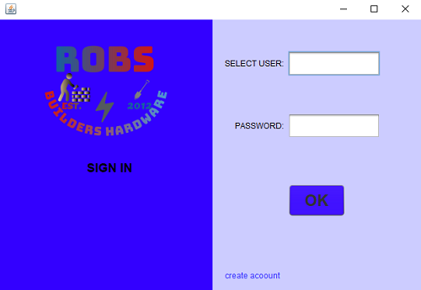

This is the Login form, which requires Password and Selected user: Cashier or Stock Manager, it cannot be both at the same time and the password differs.

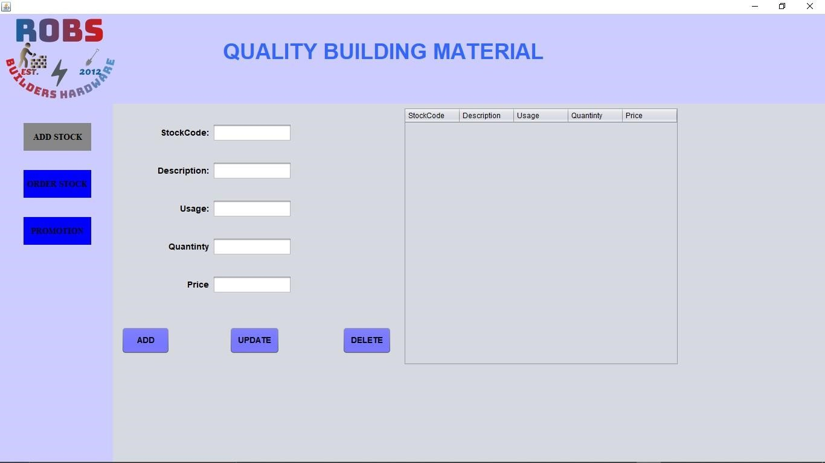

Welcome to Robs Builders Hardware. If you want to Add your material to the stock you simply click the ADD Stock textfiled which will display to you the above picture where you will have to specify the stock code of your material, give a brief description ,specify the usage , give the quantity and price .When you click the ADD button that means your material stock will be added to the in the table , and same with UPDATE AND DELETE.

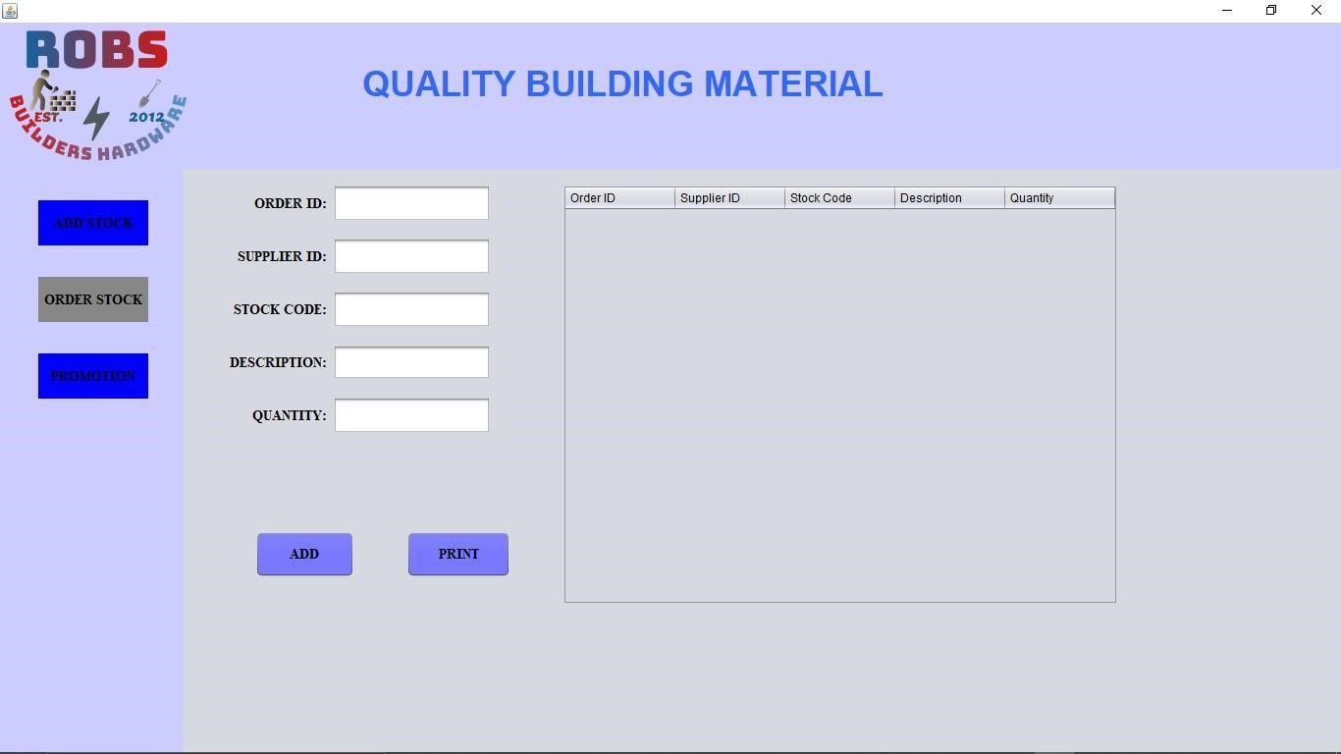

At Robs you can also Order certain stock of your choice whereby you just Click Order Stock and the above picture will be displayed with immediate effect with certain details that you need to fill up so that you successfully order your stock, these include the Order ID, Supplier ID, The Stock code, Description and give the Quantity. To add your Ordered Stock you click the ADD Button, this will add the details u have specified in the table. And with the Print Button, it simply just prints out the information.

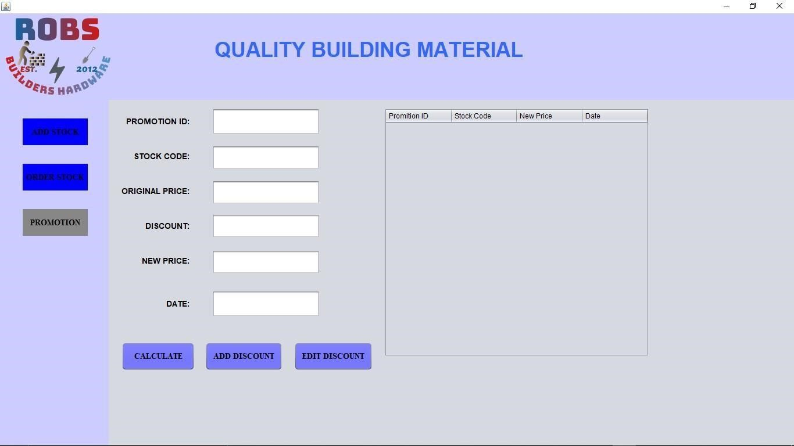

Lastly when you click Promotion you get this kind of picture showing different things needed when one does promotion. He or she will need to specify the Promotion ID, Stock Code, Original Price, AND the

Discount with new price and the date. You simply click the Calculate button to calculate the Discount and Go to ADD Discount button for additions of Discounts and you can also Edit your Discount by simply clicking the EDIT Discount button.

POS Landing Page

1. Adding stock to be billed

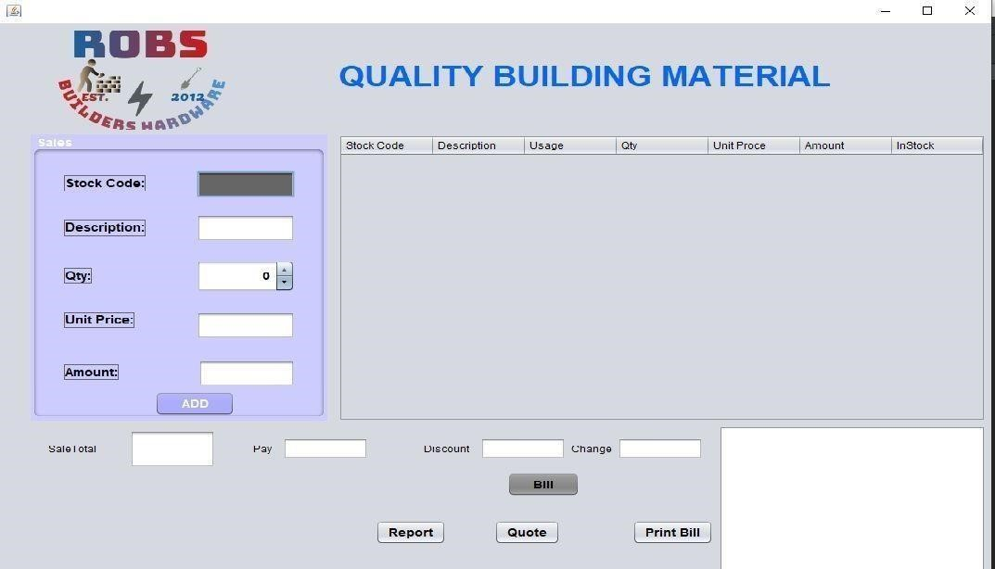

To begin processing sales, all you need is a stock code of that particular stock item you want to process. This code will be put in the stock code textfield in the Sales panel. After inserting the code, you have to press the **enter key** of your computer and the details pertaining that particular stock item will be shown in the textfields of the sales panel.

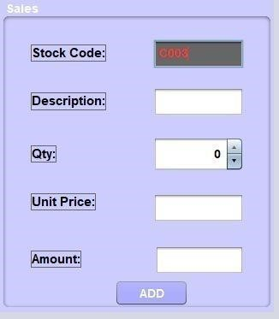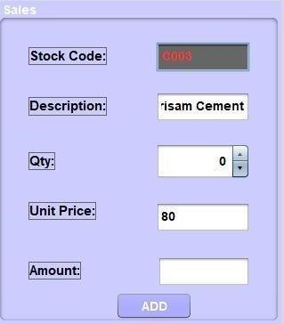

* After the Stock Code details have been retrieved from the database, you then have to specify the quantity of the stock items you want to buy in the **Qty** and press the **Add** button.

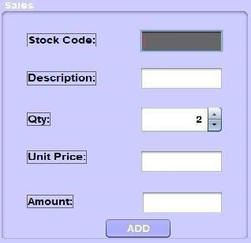

* The **ADD** button will post the values in the table next to the **Sales** label.

# Billing

In the Bills panel, the **Sale Total** field will be automatically filled for you.

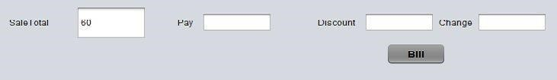

* Here, you only have to fill up the billing amount of money you`re using to pay in the **Pay** textfield and press the **Bill** button. Your change will be calculated.

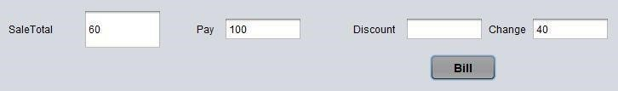

* A slip containing the transaction details will be printed in the textarea on bottom right corner of your application.

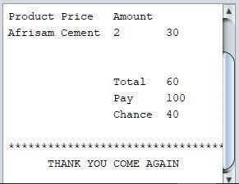

* If you want to print the information in the slip you can press the **Print Bill** button on the left

of the textarea..

# Quotes

* To process quotations, you simply have to click the **Quote** button next to the Print **Bill**

button we just talked about..

* A quotes new window will appear after pressing the **Quote** button.

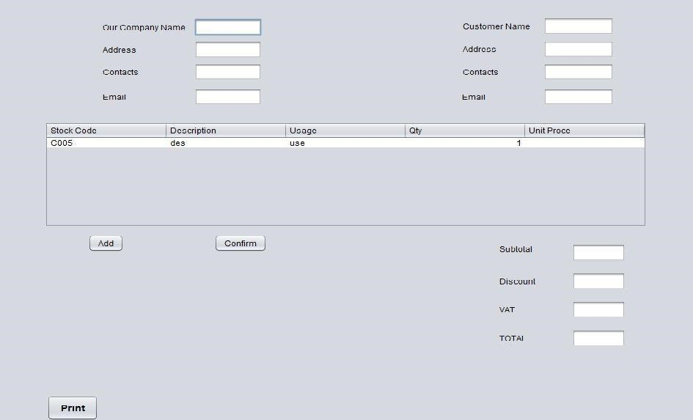

* Here, you fill up your company and customer information in the respective textfields provided.

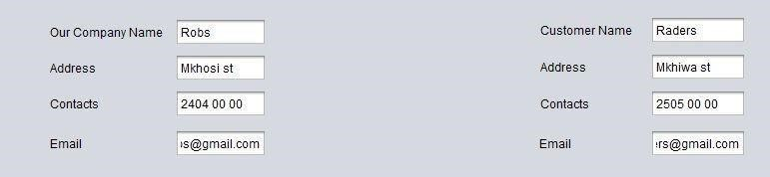

●



button below the table to retrieve stock



In the table, you have to press the **Add**  information from the database that you can use to quote.

* After adding the records, you now have to click in the particular stock item of your interest



and press the



**Confirm**



button

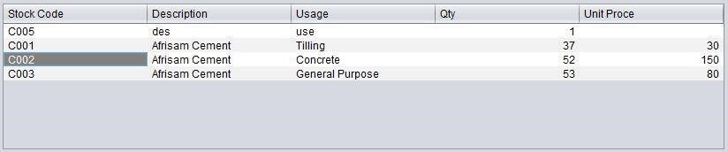

* Confirm button will show a window to tell you that confirmation was successfull. Click **OK**

.

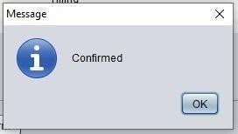

* After this you can then proceed to press the **Print**   button at the bottom of the window to show you a textbased version of the quotation that you can print.

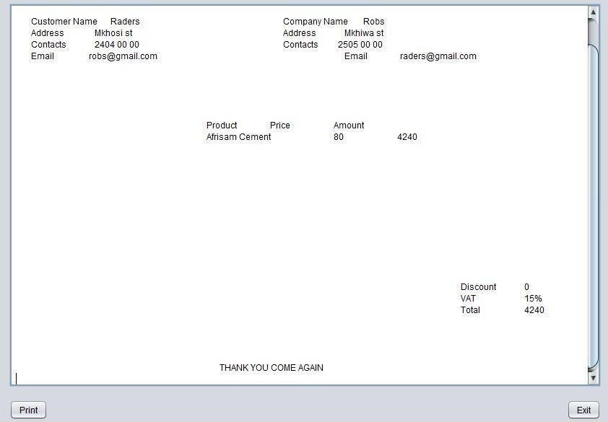

* Here, the **Print** button at the bottom of the window will help you print the document and if you dont wish to proceed with printing it, the **Exit** button will help you exit the application.

4. Reports.

* To process your daily reports, you simply press the **Report**   button from the

Point Of Sale window next to the **Quote** button.

* A new window for showing all the transaction records done on the Point Of Sale will be shown.

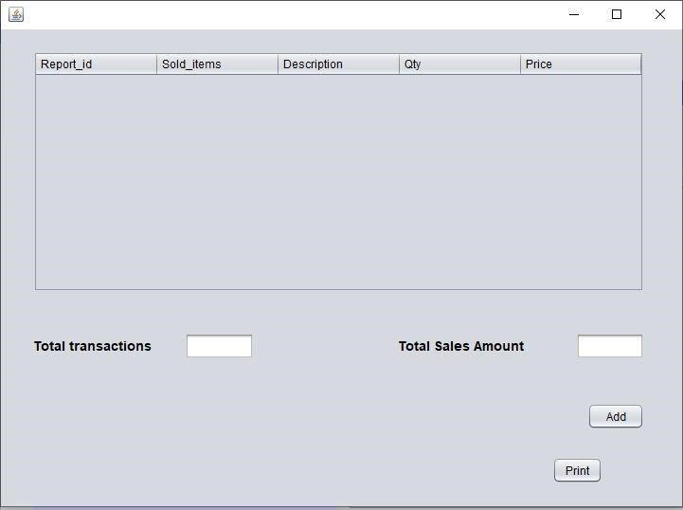

* Here, again you press the **Add**  button to retrieve the records from the database.

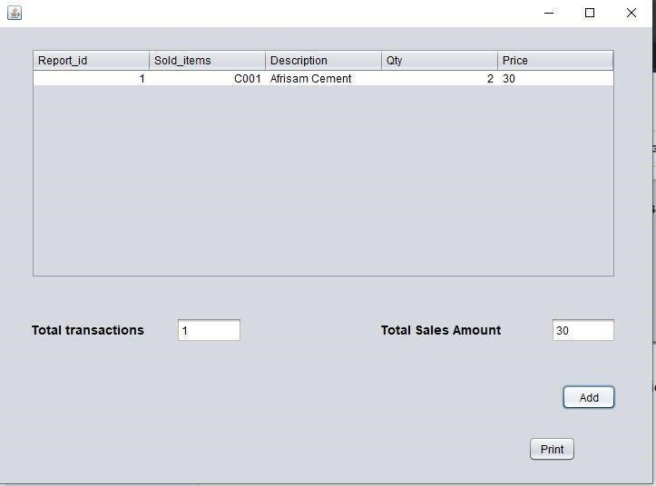

* To print the report, press the **Print** button at the bottom right corner of the window.