SKS SA 411

Senzo Zwelihle Masango

Senzo Masango

[Company name]  [Company address]

* Introduction
* Body
* Methodology
* Type of Research
* Interview
* Questionnaire
* Various web sources
* statistical analysis
* Findings
* Conclusion
* Bibliography

**Introduction**

To simplify artificial intelligence is the sub-field of computer science, the main goal is to enable the development computers that are able to do things normally done by people, it produces new intelligent machines that respond in a manner similar to human intelligence, there are two types of AI…Narrow AI and General AI

Artificial intelligence(AI) includes the following

* Robotics
* Speech recognition
* Image recognition
* Language
* Expert systems

these tasks are performed by a program or machine the same way humans would. Artificial intelligence dates back all the way to the 1950’s

**Body**

To elaborate on the statement made in the introduction about the different types of Artificial intelligence Narrow AI is where we have been and General AI is where we’re going

Narrow AI- Narrow AI is the only form of Artificial Intelligence that humanity has achieved so far. This is AI that is good at performing a single task, such as playing chess or Go, making purchase suggestions, sales predictions and weather forecasts. Computer vision, natural language processing are still at the current stage narrow AI. Speech and image recognition are narrow AI, even if their advances seem fascinating.

General AI- General AI, also known as human-level AI or strong AI, is the type of Artificial Intelligence that can understand and reason its environment as a human would

These AI can be grouped as followed

*Reactive machines-

*Limited memory-

*Theory of mind-

*Self awareness-

Examples of artificial intelligence include virtual assistance,self driving cars, smart home devices, security and surveillance

* To future touch on the examples mentioned Tesla also uses AI for its cars as this uses deep learning to provide road information and to see what objects are in the road to further maximize the use of “Autopilot” which means the car can drive itself. The neuro processor can produce up to 300+ tflops (graphical calculation power) on each of its cars

**Advantages**

* AI would have a low error rate compared to humans, if coded properly. They would have incredible precision, accuracy, and speed.
* They won't be affected by hostile environments, thus able to complete dangerous tasks, explore in space, and endure problems that would injure or kill us.
  + This can even mean mining and digging fuels that would otherwise be hostile for humans.
* Replace humans in repetitive, tedious tasks and in many laborious places of work.
* Predict what a user will type, ask, search, and do. They can easily act as assistants and cna recommend or direct various actions.
* Organized and manages records.
* Interact with humans for entertainment or a task as avatars or robots.
  + An example of this is AI for playing many videogames.
* They can think logically without emotions, making rational decisions with less or no mistakes.
* Can assess people.
  + This can be for medical purposes, such as health risks and emotional state. Can simulate medical procedures and give info on side effects.
    - Robotic radiosurgery, and other types of surgery in the future, can achieve precision that humans can't.
* They don't need to sleep, rest, take breaks, or get entertained, as they don't get bored or tired.

**Disadvantages**

* Can cost a lot of money and time to build, rebuild, and repair. Robotic repair can occur to reduce time and humans needing to fix it, but that'll cost more money and resources.
* It's questionable: is it ethically and morally correct to have androids, human-like robots, or recreate intelligence, a gift of nature that shouldn't be recreated? This is a discussion about AI that's popular in the days.
* Storage is expansive, but access and retrieval may not lead to connections in memory as well as humans could.
  + They can learn and get better with tasks if coded to, but it's questionable as to if this can ever become as good as humans can do such.
    - They cannot work outside of what they were programmed for.
  + They could never, or, at least, seemingly never with our technological perceptions, receive creativity that humans have.
    - This can prevent sympathizing with emotions for human contact, such as in being nurses. This can also reduce wisdom can understanding.
    - This can prevent common sense occurring. Even if coded with common sense and to learn, it seems hard for them to get as much common sense that humans could.
* Robots, with them replacing jobs, can lead to severe unemployment, unless if humans can fix the unemployment with jobs AI can't do or severely change the government to communism.

**Methodology**

Im going to do investigate on Artificial intelligence and find out how much of a role it really plays in our lives and if we do need artificial intelligence and how it affects our lives and overall the advantages and disadvantages of AI and the growth it has had over the past few years dating back to 1950 to the present

Machines and programs are becoming more and more clever

**Type of research**

**Interview**

Elon Musk-Guest

”Musk is one of the high-profile investors, alongside Facebook’s Mark Zuckerberg and the actor Ashton Kutcher, in Vicarious, a company aiming to build a computer that can think like a person, with a neural network capable of replicating the part of the brain that controls vision, body movement and language”.

“With artificial intelligence we are summoning the demon. In all those stories where there’s the guy with the pentagram and the holy water, it’s like – yeah, he’s sure he can control the demon. Doesn’t work out,” said Musk”

**Questionnaire**

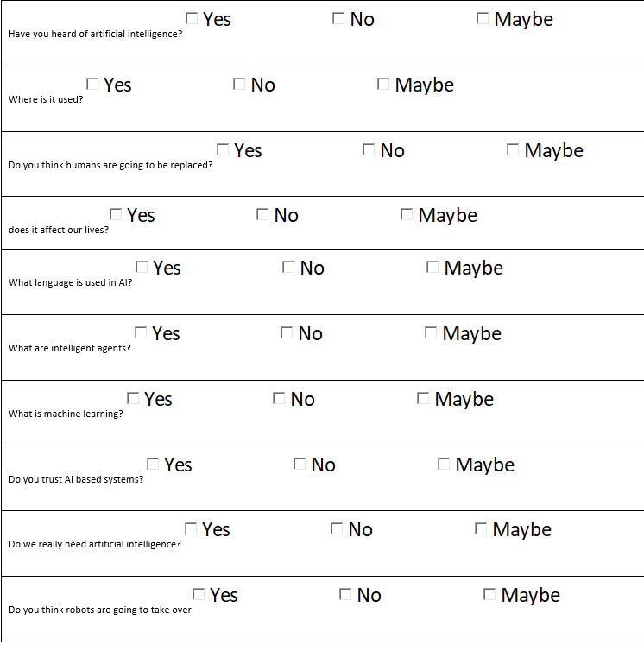

**Web sources**

|  |  |
| --- | --- |
| Name of website: | The Guardian |
| Date created: | Monday 24 October 2004 |
| Author: | Samuel Gibbs |
| Link: | https://www.theguardian.com/technology/2014/oct/27/elon-musk-artificial-intelligence-ai-biggest-existential-threat |

**Statistical analysis**

According to the statistic shows the growth of the artificial intelligence software market worldwide from 2019 to 2025. According to the market research firm Tractica, in 2019, the [global AI software market](https://www.tractica.com/research/artificial-intelligence-market-forecasts/) is expected to grow approximately 154 percent from 2018 levels

**Findings**

In my findings I found out that AI plays a major role in our lives and make things in essence easier and faster, work is increasing and life is getting tougher yet technology is growing at a vast rate and AI is taking over and improving our lives when it comes to health care,business,education and business.

* **Health care**: analyzing patient data and conducting predictive analysis.
* **Agriculture**: precision agriculture that helps save natural resources.
* **Business processes**: AI has the ability to make almost everything better, faster and cheaper.
* **Education**: Analyzing study data and providing teachers and students with tips on how to study better.

**Conclusion**

In this document investigation was done on the topic Artificial Intelligence and how much of an impact it plays in our lives, I based systems are growing rapidly and are prone to take over and making daily life easier, from virtual assistance like Siri to self drive cars like tesla

**Bibliography**

<https://www.computerworld.com/article/2906336/what-is-artificial-intelligence.html>

<https://bdtechtalks.com/2017/05/12/what-is-narrow-general-and-super-artificial-intelligence/>

<https://beebom.com/examples-of-artificial-intelligence/>

<https://www.lasserouhiainen.com/7-questions-artificial-intelligence/>

<https://www.researchgate.net/post/What_are_the_advantages_and_disadvantages_of_artificial_intelligence>

<https://www.digitalcameraworld.com/features/what-is-an-ai-powered-camera>