# Voyages:

*Experience the inescapable rich romantic spirit of the Rhine, with ancient castles and grand palaces, medieval towns with half timbred houses, famous Franconia wines, robust beers, as you sail along the breath-taking Rhine and the peaceful, meandering Main.*

What does this package include:

* 14-night Voyage package includes:
* 14-night Voyage in a river view stateroom on the stunning *River countess.*
* All meals on-board prepared using the finest and freshest ingredients
* Complimentary fine wine, beer and soft drinks during dinner, bottled water in your stateroom; and 24-hour specialty coffees and teas.
* 12 Shore excursions, fully hosted by English speaking local guides
* State of the Art *Quietvox* portable audio headset system on all shore excursions.

## Combination Voyage:

Travel along three majestic Rivers – the legendary Rhine, the meandering Main and the enchanting Danube – where you’ll be inspired at every turn

|  |  |  |  |  |
| --- | --- | --- | --- | --- |
| Name | Surname | Department | Leave | Salary |
| Thuli | Makuwe | Accounts | 8 | R7000.00 |
| Linda | Thoane | Production | 9 | R6000.00 |
| Dennis | Dube | Costing | 5 | R4500.00 |
| Tumi | Pooe | IT | 7 | R8000.00 |
| Adri | Coetzee | Training | 6 | R9000.00 |

|  |  |  |  |
| --- | --- | --- | --- |
| Fruit | Vegetables | Meat | Fish |
| Apples | Cabbage | Chicken | Hake |
| Mangoes | Carrots | Beef | Sole |
| Peach | Green Beans | Pork | Prawns |
| Grapes | Tomatoes | Lamb | Kingklip |

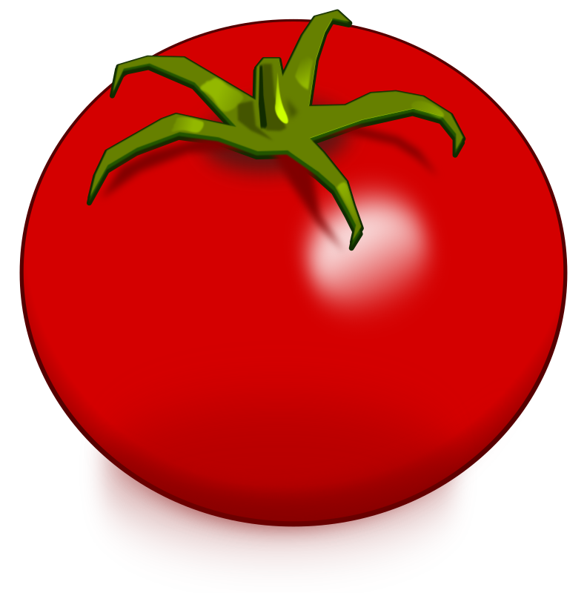

Katlego Nemo