AI Infrastructure: The Picks-and-Shovels Play Beyond the Model Race
Zak Whatmough · Sector: Technology / Infrastructure · March 2026 RISK-REWARD INCREASINGLY FAVOURABLE
As hyperscaler capex accelerates toward $600bn in 2026, the structural beneficiaries are not the model makers — but the enablers: power, cooling, and networking infrastructure, which trade at a material discount to their end-demand.

INVESTMENT THESIS  – Capex visibility: The Big-5 hyperscalers have committed $600–690bn in 2026 capex, ~75% directed to AI infrastructure. Vertiv reports order backlog growth of +35% YoY — providing multi-year, contracted revenue for enabling suppliers.  – Power as binding constraint: US data-centre electricity demand is projected to reach 76GW in 2026 — up from 25GW in 2022 (S&P Global). Morgan Stanley estimates a 49GW grid shortfall by 2028. This cannot be resolved by software — it must be built.  – Mispriced enablers: Vertiv (VRT) and Quanta (PWR) trade at 22–23x forward P/E — industrial-sector multiples — despite AI-linked revenue growing 15–18% annually. AI-facing peers trade at 35–45x: a ~40–50% valuation discount with equivalent demand exposure.  MARKET CONTEXT  AI server rack power density has increased ~7–10× since 2020 — from under 10kW per rack to 100kW+ for modern GPU clusters — forcing a fundamental redesign of data-centre infrastructure. This is not a software problem.  Five hyperscalers will spend $600–690bn in 2026 capex; Goldman Sachs projects $1.15tn cumulatively 2025–27. AI capex contributed more to US GDP growth in H1 2025 than consumer spending. The investment opportunity is the gap between this structural demand and the market’s still-industrial pricing of the enablers.  RERATING CATALYSTS  – Q1 2026 earnings: Backlog-to-revenue conversion prints from VRT, GEV, and PWR confirm demand continuation.  – Hyperscaler PPAs: Long-term power purchase agreements quantify locked-in demand for grid suppliers.  – Multiple re-rating: Market recognition that enabler revenue is AI-linked, not industrial — the primary return driver. | VALUATION DISPERSION — ENABLERS vs PEERS  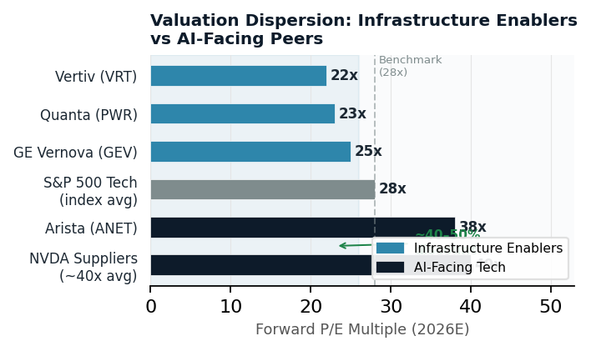  KEY METRICS  49 GW Projected US grid shortfall by 2028 (Morgan Stanley)  $1.15tn Cumulative hyperscaler capex 2025–27E (Goldman Sachs)  ~40% Enabler valuation discount vs AI-facing peers (consensus)  POWER CONSTRAINT — DEMAND vs GRID CAPACITY  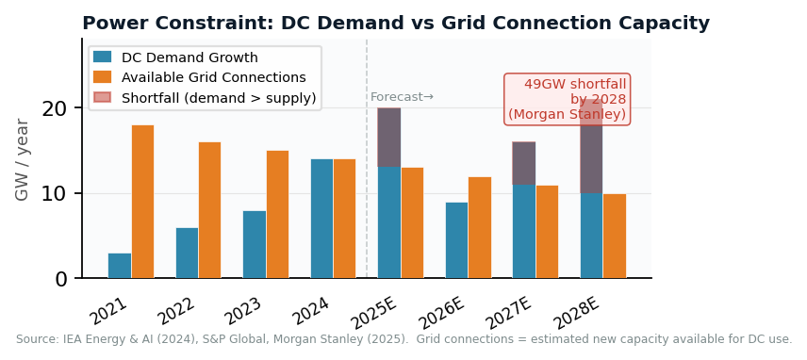

KEY RISKS  – AI monetisation lag: If hyperscaler ROI disappoints, spending could reverse sharply, causing demand destruction across the enabling supply chain.  – Grid permitting delays: US interconnection queue holds ~2,600GW of backlogged projects; regulatory bottlenecks could slow DC expansion independent of capital.  – Export controls / geopolitics: Semiconductor restrictions could disrupt supply chains and dampen compute demand forecasts in key markets.  – Efficiency improvements / overbuild: If AI model efficiency improves faster than expected — as demonstrated briefly by DeepSeek in early 2025 — compute demand could undershoot, causing overbuild across the supply chain. | CONCLUSION  Risk-reward increasingly favourable relative to hyperscaler equities  The enabling infrastructure layer trades at a structural discount to its end-demand despite locked-in revenue characteristics (long-cycle contracts, confirmed order backlogs). The return catalyst is multiple re-rating — from industrial to AI-infrastructure pricing — not earnings surprise alone.  Watch: Q1 2026 earnings from VRT, GEV, and PWR. Exit condition: material capex guidance cuts from more than two hyperscalers in the same quarter.  Key names: Vertiv (VRT) · GE Vernova (GEV) · Quanta (PWR) · Arista (ANET)

