European Equities: Structural Discount or Opportunity Before Capital Rotation?
Zak Whatmough · Sector: European Equities / Global Allocation · March 2026 RE-RATING CATALYST BUILDING
MSCI Europe trades at a 38% forward P/E discount to the S&P 500 — near historic extremes. The gap is partly structural (sector composition) and partly cyclical (record positioning extremes). With fiscal regime shift and ECB easing underway, markets price in persistent decline at the moment the macro backdrop is turning.

INVESTMENT THESIS  – Historic valuation extreme: MSCI Europe trades at 13x 2026E earnings vs S&P 500 at 21x — a 38% discount against a 20-year average of ~15%. Europe is priced for structural decline; the asymmetry is significant if the discount mean-reverts even partially.  – Discount is mechanically explained: Approximately 60% of the P/E gap is attributable to index composition: US carries 30% Technology weighting vs Europe’s 8%. Financials (18%) and Industrials (14%) dominate MSCI Europe — lower-multiple sectors by definition. Sector-adjusted, European equities trade closer to a 20% discount.  – Re-rating thesis, not earnings thesis: Europe does not need to outgrow the US. Markets price changes in expectations, not levels. EPS revisions have inflected positively for the first time since 2022. A modest expectation reset from an extreme position drives material multiple expansion — the primary return driver here.  MARKET CONTEXT  Capital flows have been self-reinforcing: $450bn+ net flowed into US equity ETFs in 2023–24 vs ~$28bn into European equivalents (BofA Global Research). Performance attracts flows; flows drive performance. This mechanical cycle has stretched positioning to historic extremes, creating the conditions for reversal.  US technology outperformance explains much of the headline discount, but equity duration matters: US tech is long-duration (cash flows priced far out), most sensitive to rate cuts. European cyclicals are short-duration — they benefit more when inflation stabilises and the rate cycle turns. The ECB is 100–150bps ahead of the Fed in cutting.  RERATING CATALYSTS  – Fiscal regime break: Germany’s €500bn infrastructure and defence commitment marks a structural end to post-GFC fiscal austerity — directly benefiting Industrials, Construction, and Defence, sectors where MSCI Europe is overweight.  – Positioning reversal: BofA FMS Dec 2025: record global underweight of European equities. Any rebalancing toward historical allocation — even partial — represents a mechanical flow tailwind independent of fundamentals.  – Narrative inflection: As EPS revisions turn positive and fiscal spend becomes visible in earnings, the index narrative shifts from “structural decline” to “cyclical recovery.” Multiple expansion follows narrative, not just earnings. | FORWARD P/E SPREAD — 20-YEAR HISTORY  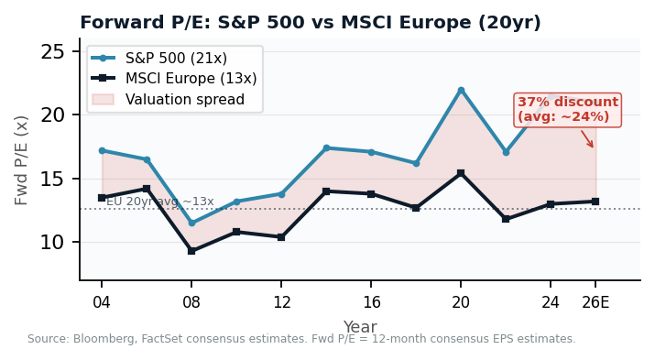  KEY METRICS  38% MSCI Europe discount to S&P 500 fwd P/E (20yr avg: ~15%)  €500bn German fiscal commitment (defence + infrastructure, Feb 2026)  Record Global fund mgr underweight of European equities (BofA FMS)  SECTOR COMPOSITION — US vs EUROPE  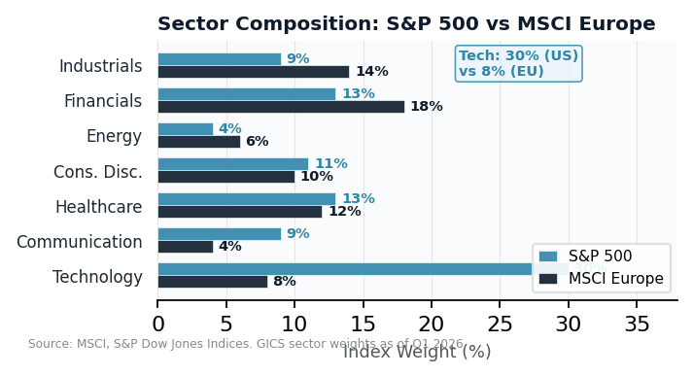

KEY RISKS  – Earnings growth differential: If US technology sustains 15–20% annual EPS growth vs European 4–6%, the valuation gap is fundamentally justified. Re-rating is structurally capped without earnings convergence.  – Trade war / tariff exposure: US tariffs on European autos and industrials introduce direct earnings downside. Germany’s auto sector faces structural demand pressure from Chinese EV competition independently of tariffs.  – EUR/USD headwind: European returns for global investors are FX-dependent. A stronger dollar — sustained by US rate differentials — reduces USD returns from European allocations and dampens reallocation incentives.  – Political execution risk: €500bn German package requires coalition durability. French fiscal fragmentation and Italian debt remain systemic tail risks threatening the expansion thesis. | CONCLUSION  Europe is not a value trap — it is priced like one  The bull case does not require European economic outperformance. It requires only that expectations stabilise from deeply depressed levels. A reversion to the 20-year average P/E spread (15% vs current 38%) — with no earnings growth — implies MSCI Europe re-rating from 13x to ~17x: approximately 30% upside from multiple expansion alone.  Watch: ECB rate path, German fiscal execution, BofA FMS European allocation. Exit: EPS revisions negative, or EUR/USD below 1.00 on sustained trade escalation.  Key names: EZU · ASML · SIE · AIR · DBK

