**TASKS, FUNCTIONALITIES AND BUSINESS RULE BASED ON FEEDBACK FROM TEAM OF MIC**

# Add Membership

## Plan details and contributions not visible on overview for members with +5 dependants.

We need price of different plan of below member categories

|  |  |  |
| --- | --- | --- |
| **Plan** | **Member Category** | **Price** |
| Silver Plan | M6 - Member with six dependants | 1770 |
| Silver Plan | M7 - Member with seven dependants | 1965 |
| Silver Plan | M8 - Member with eight dependants | 2160 |
| Gold Plan B | M6 - Member with six dependants | 2615 |
| Gold Plan B | M7 - Member with seven dependants | 2855 |
| Gold Plan B | M8 - Member with eight dependants | 3095 |
| Gold Plus Plan | M6 - Member with six dependants | 2995 |
| Gold Plus Plan | M7 - Member with seven dependants | 3270 |
| Gold Plus Plan | M8 - Member with eight dependants | 3545 |

## Gold A (entry plan)

|  |
| --- |
| M6 - Member with six dependants 1770 |
| M7 - Member with seven dependants 1965 |
| M8 - Member with eight dependants 2160 |
|  |

## Group name cannot be edited. (Employer Group)

* Membership number will not change during change group name of a member.
* Group name will be changing on 1st day of the month.
* Group name cannot be changed if the invoice has been generated for the group for particular month.

# Benefits

## Benefits are not prorated for members joining after January. Our financial year is from January to December

* If any member joins in the middle of the year, then their benefits will be valid till 31st December of that year.
* The benefit amount will be calculating prorate.
  + Example: If a person joined on the month March and the benefit amount is 1920 (1920 per beneficiary, within GP and Specialist limit) then the benefit amount will be allocated to member is 1600.
  + Formula: (Benefit amount / 12) * number of remaining months of the year
* The date of joining/registration will be 1st of the month only.

# Claim

## cannot process claims for individual members

* It is working fine for us.

# Claim => Clinical Details

## Beneficiary and discipline do not auto populate on the documents tab

* Beneficiary will auto populate if there is only one beneficiary in claim.

## Invoice number does not auto populate in the treatment tab from Document tab

* <https://itpluspoint.in/sp_artwork/MedicalClaims/Html/MIC_22/fileclaim_documents.html>
* Document type “Invoice” will rename with “Account / Invoice Number”.
* Document number of document type “Invoice” needs to auto-populate in the treatment tab.
* Only one invoice nan be captured for a claim in document section.

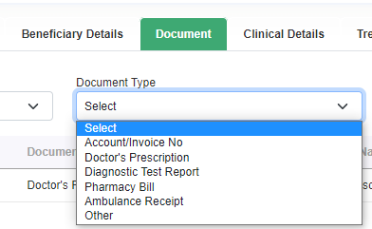

## Private Hospital claims can be processed for SILVER Plan members. SILVER Plan does not cover Private hospitals admission but public hospitals (Raleigh Fitkin Memorial Hosp and Good shepard Hospital). Gold and Gold Plus member can eligible for both Private and Public Hospital

* <https://itpluspoint.in/sp_artwork/MedicalClaims/Html/MIC_22/createserviceprovider_details.html>
* Two new practice type "Private Hospital" and "Public Hospital" will add.

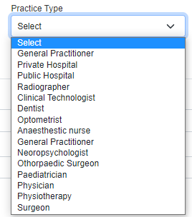

## Any admissions below half a day are calculated to be half a day, above half a day to 24 hours is a day

* <https://itpluspoint.in/sp_artwork/MedicalClaims/Html/MIC_22/fileclaim_treatment.html>
* Quantity field will be added on the UI.
* Quantity will not be calculated based on from date time and to date time.
* From date time and to date time are not mandatory field.
* From date time and to date time will be in between admitted date time and Discharge date time.
* Tariff amount is formula field – Tariff Unit Price x Quantity.
* Claim amount is formula field – Claim Amount per Unit x Quantity.
* Paid amount will be lowest amount between Tariff amount and Claim amount.
* Default value of “Qty” will be 1 (One)

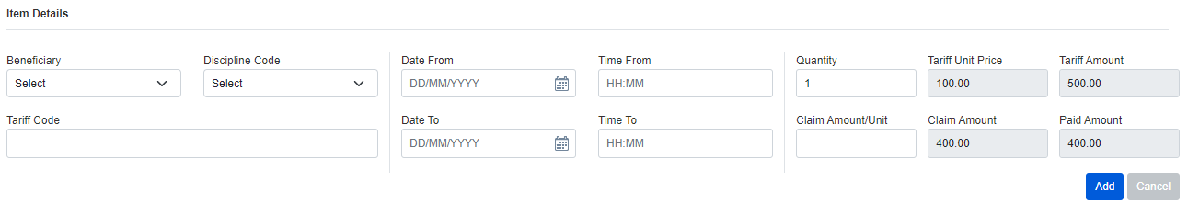

## Theatre fees are paid per minute. Service providers provide number of minutes and total charged, we therefore have to specify the number of minutes for generation of payment using price per minute

* https://itpluspoint.in/sp_artwork/MedicalClaims/Html/MIC_23/fileclaim_treatment.html
* Same as reference number 4.4

## Rejected items in a claim are included in the total claim, therefore Benefits are over utilized.

* We will check and resolve.

## Some ICD 10 codes were not found. E.g R30.0

* The ICD code provided by MIC team has not updated in UAT2 environment. It will be reflecting once the ICD code be updated in UAT2 environment

# Terminated members

## System does not provide suspension/ termination date

* <https://itpluspoint.in/sp_artwork/MedicalClaims/Html/MIC_22/Membership.html> (Use change status option)
* Termination type will be two types “Non-payment of membership fees” and “Member requested for withdraw membership” and “deceased members”.  
  + **Non-payment of membership fees**
    - Termination date will be always last day of the month.
    - Effective termination date will be 3 months before of termination date.Which will be captured by user entry field. **Example**: If the termination date is 31st August, then the Effective termination date will be 31st May.
    - Claim can not be accepted after effective termination date. As per above example the system will not accept the claim after 31st May. Is there a Message pop up. “Member terminated”?

Nikita : When user clicks on >membership details< when making a claim, a pop-up message will come up to mention that the “member is terminated”.

* + **Member requested for withdraw membership**
    - Termination date and Effective termination date will be same.**Example**: If the termination date is 31st August, then the Effective termination date will be same as termination date which will be 31st August. Is there a Message pop up. “Member terminated”?
  + **Deceased members**
    - Claims made until date of death can be processed. Claims made after the date of death CAN NOT be processed. Is there a Message to pop up”Service date after deceased date”  
        
      Nikita: “service date” will be added to the >membership details< when filing a claim on the system. Consider the ‘service date’ to validate with ‘termination date.’
    - Benefit prorate will not apply for deceased members–

Note: Above point not yet confirmed from MIC team

Nikita : Benefit prorate will not apply for deceased members. Confirmed.

* 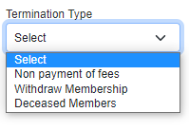Terminated member can be reinstated (Activated).
* https://itpluspoint.in/sp_artwork/MedicalClaims/Html/MIC_23/Membership.html
* Terminate or Suspend Member

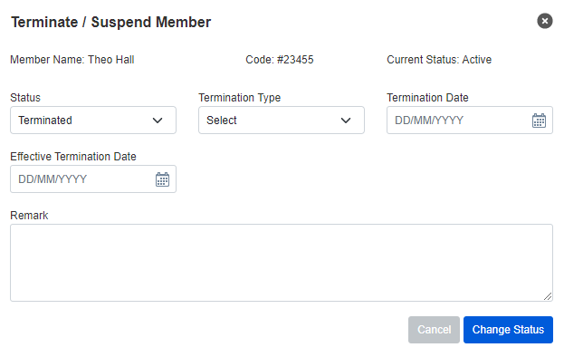

## Benefits do not prorate up to termination date

* Calculation of Benefit amount on termination of a member

**Per month Benefit amount**= Benefit amount / 12

**Gross Benefit amount** = Number of months till terminate x Per month Benefit amount

**Net Benefit amount (This will be re-allocated to the member)**= Gross Benefit Amount – Benefit Amount Used

**Example:**

**Benefit:**1920 per beneficiary, within GP and Specialist limit

**Benefit Amount:** 1920.00

**Assumption:** the effective termination date is 31st May and the Benefit amount has used 300.00.

**Per month Benefit amount**= 1920.00 / 12 = 160.00

**Gross Benefit amount** = 5 x 160.00 = 800.00

**Net Benefit amount (This amount will be re-allocated to the member)** = 800.00 – 300.00 = 500

## How to reinstate suspended/ terminated members

* D
* Calculation of Benefit amount on reinstate of a terminated member

**Per month Benefit amount**= Benefit amount / 12

**Gross Benefit amount** = Number of months till December from registration monthx Per month Benefit amount

**Net Benefit amount (This will be re-allocated to the member)** = Gross Benefit Amount – Benefit Amount Used

**Example:**

**Benefit:**1920 per beneficiary, within GP and Specialist limit

**Benefit Amount:** 1920.00

**Assumption:** the registration date is 1stApril and the Benefit amount has used 300.00.

**Per month Benefit amount**= 1920.00 / 12 = 160.00

**Gross Benefit amount** = 9 x 160.00 = 1440.00

**Net Benefit amount (This amount will be re-allocated to the member)** = 1440.00 – 300.00 = 1140

* **Reinstate Member**

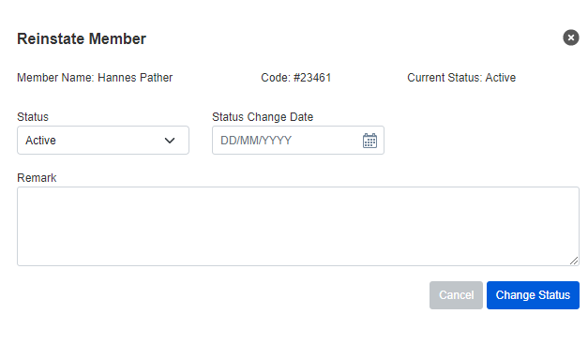

## Claims with treatment date before and after termination date cannot be filed

* After termination, Claim can be accepted till effective date of termination.
* The benefit amount during claimwill be maximum as per calculation define in point 5.2.

# Receipt generation

## Amount overridden, cannot enter amount received

* New UI for list of receipt <https://itpluspoint.in/sp_artwork/MedicalClaims/Html/MIC_22/account_receipt.html>
* New / Updated to accept payment and generate receipt <https://itpluspoint.in/sp_artwork/MedicalClaims/Html/MIC_22/generatereceipt.html>
* Paid amount can be more or less than Amount Due.
* If user will pay less amount, then the balance amount will be added in next month invoice amount.
* If user will pay more amount, then the surplus amount will be deducted from next month invoice amount.
* 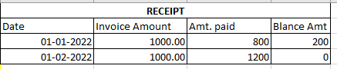
* Receipt cannot be generated against Invoice.
* View and Print Receipt: Invoice number will be removed from receipt. <https://itpluspoint.in/sp_artwork/MedicalClaims/Html/MIC_22/invoice_receipt.html>
* Amount due will display in member overview UI. The due amount can be paid from overview UI using “Pay” button. <https://itpluspoint.in/sp_artwork/MedicalClaims/Html/MIC_22/membership_overview.html>
* Reversal of payments- how to reverse or reallocate payment in case wrongfully allocated 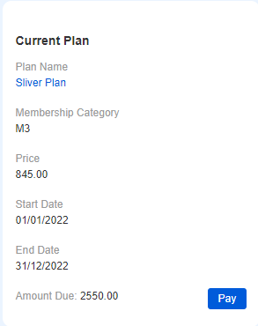

Nikita: “cancel receipt”, mention reason for cancellation > reasons: manually input ; and create another receipt to resolve error.

* Amount due will display in Group overview UI. The due amount can be paid from overview UI using “Pay” button.  
  https://itpluspoint.in/sp_artwork/MedicalClaims/Html/MIC_22/group_overview.html

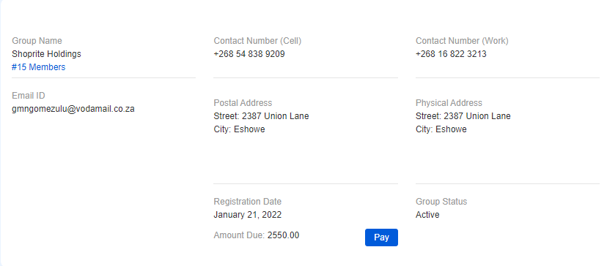

## Amount overridden, cannot enter amount received

* Refer abovepoint 6.1

# Notifications

## Notifications were not received

* google has stopped the service to send email from third party applications so emails will not be sent through MIC using Gmail id. So, we had requested to provide us the details of email which will be using to send email from MIC website.
* MIC team needs to provide email setting to send email. Nothing to do anything
* Email to be used :[no-reply@swazihmo.co.sz](mailto:no-reply@swazihmo.co.sz). Nikita will provide the setting of email.

# Suspended Member

## Member suspension

* Member can be suspended anytime.
* Suspended member cannot be claim.
* During suspension of member, Calculation of benefit will not be done like termination.

# Miscellaneous Points

## Member Registration, Plan and Benefit

* Effective date of plan / Registration date will be 1st day of the month.
* Plan and member category can be changed only 1st month of the year which is January; It can be happened before generate invoice for the month of January.
* The benefit amount will be reset on generate of invoice for the month of January which is 1st Month of the year.
* Invoice generation is done at the end of the month for the following month.  
  Eg: January invoices are generated on 31st of December
* There will be a waiting period set in. Group members – 1 month. Individual members – 3 months.
* Anyone can join anytime during the year. Prorates will apply on benefits from the joining date (being the first payment made).  
    
  Eg. Mary joins on 5th April 2020 and pays for the month of April. Then prorates will apply from the month of April to December. Mary will be under a waiting period of 3 months from April (which was paid for) to June. There after Benefits will apply. Benefits will be prorated from 1st April – 31st December (it begins from April as she has paid for the month of April).The invoices will start generating from May.
* Benefit exclusion of Member will be in service provider panel.
* Service Date ( Claim date) need to be captured during file a claim