Process Flow – Draft supplier offfer, product match

**Document Control & History**

|  |  |  |  |  |
| --- | --- | --- | --- | --- |
| **Version** | **Date** | **Author** | **Reviewer / Approved By** | **Details** |
| V1.0 | 08th May, 2021 | Anupama Mohapatra |  | Draft Supplier Offer – Product Match |
|  |  |  |  |  |

1. End-to-End Process Flow for Draft Supplier Product Match
   1. **Flow Chart**

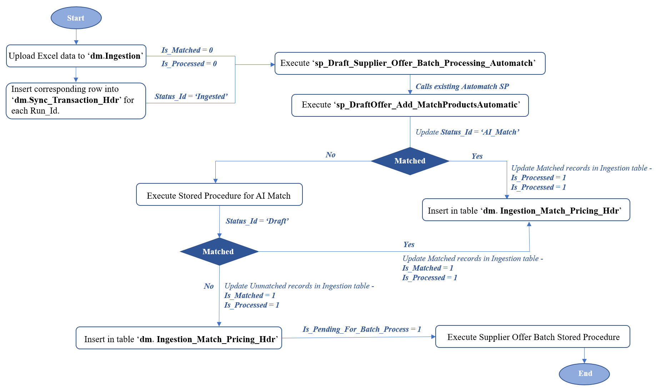

***Note:*** *At present, we will focus on the highlighted part of the process.*



* 1. **Process Description**:
     1. Upload data from excel file into dm.Ingestion table
        1. Set ‘*Is_Matched = 0*’ and ‘*Is_Processed = 0*’
     2. Insert corresponding row for each distinct Run_Id in Ingestion table, into dm.Sync_Transaction_Hdr table.
        1. set Status_Id as ‘*Ingested*’.
     3. Execute Stored Procedure ‘sp_Draft_Supplier_Offer_Batch_Processing_Automatch’
        1. This SP currently not present. Will be developed.
        2. It will generate the input ‘IngestRecordIdList’ that will be processed using ‘sp_DraftOffer_Add_MatchProductsAutomatic’.
        3. Call and execute ‘sp_DraftOffer_Add_MatchProductsAutomatic’ for each record to Automatch against eSymphony records.
        4. Update ‘*Is_Matched = 1*’ and ‘*Is_Processed = 1*’ for all matched records in dm.Ingestion table
           1. For all matched records, a new record will be inserted in table ‘dm. Ingestion_Match_Pricing_Hdr’
           2. All Automatched records can be viewed in ‘Matched’ UI
        5. No change to Unmatched records in dm.Ingestion, ‘*Is_Matched = 0*’ and ‘*Is_Processed = 0*’.
        6. Finally, Update Status_Id = ‘*AI_Matched*’ in dm.Sync_Transaction_Hdr table.
     4. All unmatched records with Status_Id = ‘*AI_Matched*’ and ‘*Is_Matched = 0*’ and ‘*Is_Processed = 0*’ are processed using ‘Stored Procedure for AI Match’
        1. After AI Match SP has completed executing, Update Status_Id = ‘*Draft*’ in dm.Sync_Transaction_Hdr table.
        2. For all matched records, a new record will be inserted in table ‘dm. Ingestion_Match_Pricing_Hdr’
           1. Set ‘*Is_Matched = 1*’ and ‘*Is_Processed = 1*’ in Ingestion table
           2. These records can be viewed in ‘Matched’ UI
        3. Also, for all unmatched records, a new record will be inserted in table ‘dm. Ingestion_Match_Pricing_Hdr’
           1. Set ‘*Is_Matched = 1*’ and ‘*Is_Processed = 1*’ in Ingestion table
           2. These records can be viewed in ‘Unmatched’ UI
     5. Finally, all records in table ‘dm. Ingestion_Match_Pricing_Hdr’, that have ‘*Is_Pending_For_Batch_Process = 1’* are processed by ‘Supplier Offer Batch Stored Procedure’.