## Introduction

Do you want to show the latest news in-game? This package allows you to show an RSS or Atom feed in the new Unity UI system. It was developed to be customizable and extendable, the look of the UI can be totally changed.

### Features

* Loading RSS and Atom feed asynchronically
* Automatic updates timed by an interval
* Build on the new Unity UI and its look is customizable
* Default UI-Prefabs will size to fit its content
* Possibility to truncate description to a certain length
* Possibility to strip out HTML-Tags
* Build to be customizable and extendable

### Limitations

* HTML is not supported. The only working tags are which the standard UI Text component of Unity supports.
* There is no ability to combine multiple news feeds in one control.
* Is built on the System.Xml namespace to parse news feeds.

## Getting started

There is a SampleScene (1) in the project. It consists of one prefab “NewsChannelView” (2). This prefab can be easily used in any of your scene. The prefab can be modified completely over the inspector (3).

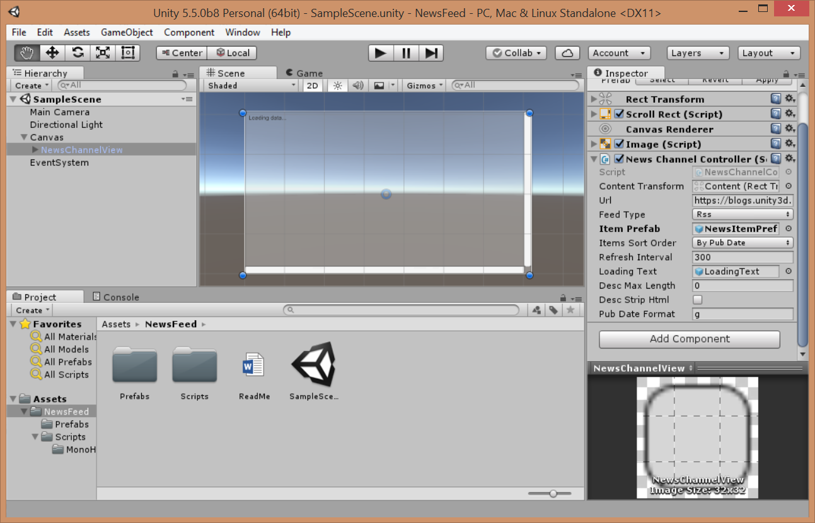

### Prefabs

|  |  |
| --- | --- |
| NewsChannelView | Prefab contains a fully set up UI-Control to view a news channel. This is an example how it can be done. Must be added to a Canvas to work. |
| NewsItemPrefab1  NewsItemPrefab2  NewsItemPrefab3 | Prefab to show one RSS feed item or one Atom feed entry. These are three example show how it can be done. |

## News Channel Controller

Component to load a news feed and bind it to UI. Is added to prefab “NewsChannelView”

### Property

|  |  |
| --- | --- |
| Content Transform | All News Item will be added to this Rect Transform as children. |
| Url | Url to the RSS or Atom feed. |
| Feed Type | Defines whether the url refers to a RSS or Atom feed. |
| Item Prefab | Defines the UI-prefab for the news items. This prefab must contain the component “News Item Controller”. There are already 3 ready prefab in the project. |
| Items Sort Order | Are the news item by publish date or how they appear in the file. |
| Refresh Interval | The news feed will be update automatically in this interval. The interval is defined is seconds. Setting the interval to zero is switching to automatic update off. |
| Loading Text | Game Object that will be visible while loading the news feed. (Optional) |
| Desc Max Length | If the description/summary of a news item is longer than this length, it will be truncated. Setting this property to zero will turn this feature off. |
| Desc Strip Html | If this is set true, html tags will be stripped out of the description/summary of news items. |
| Pub Date Format | This property describe how the publish date will be format. It is equivalent to DateTime.ToString Method in .NET. For example: “d MMM yyyy HH:mm” |

## News Item Controller

Component to define which properties (title, summary, author and publish date) of a RSS feed item or Atom feed entry to bind to which UI Text component. This is used to create to NewsItemPrefab’s.

### Property

|  |  |
| --- | --- |
| Title Text | Defines the UI-Text for the title (Optional*) |
| Desc Text | Defines the UI-Text for the description resp. summary (Optional*) |
| Pub Date Text | Defines the UI-Text for the publish date (Optional*) |
| Author Text | Defines the UI-Text for the author’s name (Optional*) |

* If the properties are not set, the information is not shown!

## News Item Link

This component transform an UI component to a hyperlink which will open the news item’s link. It is only working if it is added in a child of a GameObject which has the component NewsItemController. Alternatively a UI-Button can be used. (Invoke the method OpenLink on NewsItemController)

### Property

|  |  |
| --- | --- |
| Colored Text | If the property is set to an UI-Text, the text color will change when to mouse hovers. (Optional) |
| Hover Color | The color while the mouse is hovering on the text. |
| Normal Color | The color while the mouse is somewhere else. |