基于DeepSeek大模型与MySQL的

公交安全管理系统实验
建议学时：16学时
- 实验任务

任务描述
本实验基于MySQL关系型数据库，构建一个完整的包含后台数据库、数据库访问程序以及前台网页的公交安全管理系统。实验涵盖从运用规范化理论设计数据库模式、实现完整性约束与索引优化，到借助DeepSeek大模型辅助生成前后端代码，并实现AI自然语言数据库查询功能的全流程。通过本任务，掌握数据库系统全栈设计与实现的能力，重点在于深入理解数据库规范化设计、完整性约束与性能优化，并实践利用AI工具提升开发效率。。
- 实现MySQL后台数据库
数据库的有关语义如下：
  - 公交公司有若干个车队，每个车队下有若干条线路；
  - 公交公司有若干辆汽车，每辆车属于一条线路；
  - 每个车队有一名队长，他只有管理工作，不开车；
  - 每条线路有若干名司机，其中有一名路队长，除开车外，还承担管理工作；每名司机只在一条线路上开车；
  - 司机开车时会产生违章，包含：闯红灯、未礼让斑马线、压线、违章停车等；
  - 队长、路队长负责将司机的违章信息输入到系统，包含：司机、车辆、车队、线路、站点、时间、违章等。
- 前台网页
开发一个公交安全管理系统来对数据库进行访问，使用Python Flask Web框架，功能如下：
- 录入司机基本信息，如工号、姓名、性别等；
- 录入汽车基本信息，如车牌号、座数等；
- 录入司机的违章信息；
- 查询某个车队下的司机基本信息；
- 查询某名司机在某个时间段的违章详细信息；
- 查询某个车队在某个时间段的违章统计信息，如：2次闯红灯、4次未礼让斑马线等。
- 通过AI自然语言查询/修改数据库信息（DeepSeek大模型驱动）
- 注意事项
- 后台数据库和前台程序必须使用大模型，如千问，豆包、deepseek、chatgpt、gemini等；
- 在数据库的设计过程中需要运用规范化理论，避免出现插入异常、删除异常、数据冗余等问题；
- 必须设定关系的完整性规则，如实体完整性（例如设置主码），参照完整性（例如设置外码和对应的主码），用户自定义完整性（例如性别只能为“男”或“女”）;
- 使用索引来加快查询的速度；使用视图、函数、存储过程来简化系统的设计；
- 使用数据库设计工具，例如：ERWin，PowerDesigner;
- 实习重点在于后台数据库的设计，对于前台程序的开发，能够实现系统功能即可，不要把大量时间花费在界面设计和不必要的代码上。
- 系统集成DeepSeek AI，实现自然语言转SQL的智能查询功能

学习目标
完成本任务的学习后，你应当能：
- 理解关系数据库规范化理论，并能应用于设计无冗余、低耦合的数据库模式；
- 掌握在openGauss数据库中定义实体完整性、参照完整性与用户自定义完整性的方法；
- 能够熟练使用数据库设计工具（如ERWin、PowerDesigner）进行概念模型与物理模型设计；
- 掌握运用SQL语句创建索引、视图、存储过程及函数以优化查询与简化应用逻辑；
- 掌握AI自然语言转SQL（NL2SQL）技术的实现方法；
- 能够利用大模型辅助生成符合业务需求的数据操作与前后端基础代码；
- 掌握一个完整数据库应用系统的开发流程，从前端界面交互到后端业务逻辑与数据库访问；
- 具备根据业务语义进行数据查询、统计与分析，并解决实际管理问题的能力。

- 任务准备

前置知识
本实验案例需要提前学习关系数据库系统、SQL基础、数据库规范化设计理论、openGauss数据库、香橙派鲲鹏Pro开发板、后端与前端全栈开发基础、Linux操作以及数据库应用系统开发流程。可通过如下途径进行学习：
- 关系数据库系统基础
理解数据库基本概念，如实体、属性、关系、模式，熟悉关系模型和SQL的常用语法，能够使用openGauss数据库创建数据库、表，进行基本的增删改查操作。
- 数据库设计理论
了解概念模型E-R图的绘制方法，掌握数据库规范化理论中一范式、二范式、三范式的核心思想及其作用，能够使用ERWin、PowerDesigner等工具设计数据库。
- api调用方式
掌握DeepSeek API的调用方式，在数据库设计、代码生成和自然语言查询等环节中借助AI工具提升效率。。
- 后端编程
掌握后端编程语言Python或Java的基础语法，了解连接和操作数据库的基本方法JDBC、Psycopg2等驱动或框架。
- 前端开发
具备简单的网页开发知识，了解HTML、CSS及JavaScript的基础，或掌握基本Web框架Flask、Spring Boot用于构建简单的数据交互界面。
- 大模型辅助开发
掌握大模型DeepSeek、ChatGPT、Gemni、GraphRAG等工具。在数据库设计阶段辅助生成E-R图、SQL的DDL、DML语句，并按照规范化理论优化数据库。在后端和前端开发阶段生成后端数据库连接、数据操作的核心代码框架，提供前端页面的基础HTML/JavaScript代码。在系统调试与优化阶段解释SQL错误、分析查询性能，并对现有代码进行注释、重构或优化建议。

实验环境准备
- 一、 软件基础设施与核心语言
本实验的底层运行平台为 Windows 11 操作系统。核心开发语言选定为 Python 3.11，这是一个兼顾稳定与性能的版本，能够完美支持后续安装的各类现代库。推荐使用的集成开发环境（IDE）为 VS Code 或 PyCharm，这两者均具备强大的 Python 调试能力和插件生态。
二、 后端架构与数据库管理
- Web 框架：采用 Flask 3.0.0。作为轻量级的 Python Web 框架，Flask 提供了极高的灵活性，适合快速构建 API 接口以及处理业务逻辑。
- 数据库系统：使用 MySQL 8.0。该数据库需在本地环境进行部署，默认监听 3306 端口。
- 驱动与安全：为了让 Python 程序能够操作 MySQL，环境要求安装 PyMySQL 1.1.0 驱动；同时安装 cryptography 41.0.7 库，以支持数据库连接过程中的加密身份验证，确保数据交互的安全。
- 三、 前端技术与数据可视化
- 基础技术栈：前端界面完全基于 HTML5、CSS3 和原生 JavaScript 构建，不依赖于复杂的现代前端框架（如 Vue 或 React），这有助于更直观地理解 Web 通信机制。
- 动态图表：引入了专业的开源图表库 ECharts 5.4.3。它将负责将后端处理后的数据（如公交运行指标或安全统计）转化为动态、交互式的可视化图表。
- 四、 AI 大模型集成
实验引入了当前先进的 DeepSeek API，具体调用 deepseek-chat 模型。该模型将作为系统的智能大脑，负责处理自然语言交互、数据分析建议或其他智能化任务。
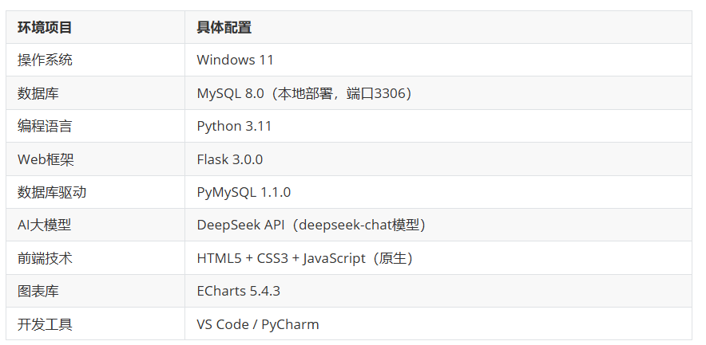
五、 详细搭建流程（Step-by-Step）
环境基础安装：
下载并安装 Python 3.11，安装时务必勾选“Add Python to PATH”。
安装 MySQL 8.0 服务，设置好 root 密码，并确保服务已在本地 3306 端口启动。
依赖库批量安装：
打开终端（cmd 或 PowerShell），执行以下精确版本的安装命令，确保环境的一致性：
Bash
pip install flask==3.0.0 pymysql==1.1.0 cryptography==41.0.7 requests==2.31.0
注：requests 库在此处主要用于发起 API 请求，与 DeepSeek 进行通信。
数据库初始化：
利用 MySQL 管理工具（如 Navicat 或命令行）导入项目提供的 bus_safety_system.sql 脚本。这一步会建立名为“公交安全系统”所需的全部数据表、索引及初始测试数据。
API 密钥配置：
获取 DeepSeek 提供的 API Key，并将其配置到项目的环境变量或配置文件中，以激活系统的 AI 功能。
DeepSeek API 使用与 OpenAI 兼容的 API 格式，通过修改配置，您可以使用 OpenAI SDK 来访问 DeepSeek API，或使用与 OpenAI API 兼容的软件。

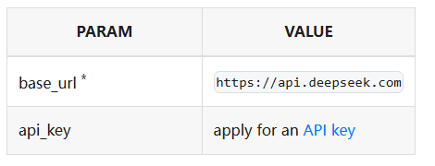
deepseek-chat 和 deepseek-reasoner 对应模型版本不变，为 DeepSeek-V3.2 (128K 上下文长度)，与 APP/WEB 版不同。deepseek-chat 对应 DeepSeek-V3.2 的非思考模式，deepseek-reasoner 对应 DeepSeek-V3.2 的思考模式。

在创建 API key 之后，你可以使用以下样例脚本的来访问 DeepSeek API。样例为非流式输出，您可以将 stream 设置为 true 来使用流式输出
# Please install OpenAI SDK first: `pip3 install openai`
import os
from openai import OpenAI
client = OpenAI(
api_key=os.environ.get('DEEPSEEK_API_KEY'),
base_url="https://api.deepseek.com")
response = client.chat.completions.create(
model="deepseek-chat",
messages=[
{"role": "system", "content": "You are a helpful assistant"},
{"role": "user", "content": "Hello"},
],
stream=False
)
print(response.choices[0].message.content)

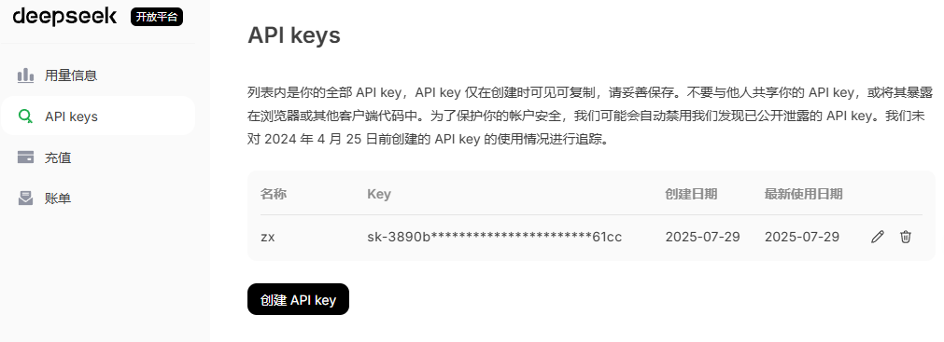
- 任务实施

实验要点
- E-R图设计与关系模式转换：绘制出E-R图并转换成关系模式，同时注意优化关系模式使其尽可能符合高的范式；
- 后台数据库搭建：创建连接池并完善相关操作（取连接、还连接、查询数据、更新修改数据）；在控制台程序connection中完成表的创建；
- 业务功能实现：完成实验要求中各功能的代码段；
- 前台网页搭建：实现前台网页的搭建；
- 实验报告编写。

关键步骤
步骤一：E-R图设计与关系模式转换。
- E-R图设计
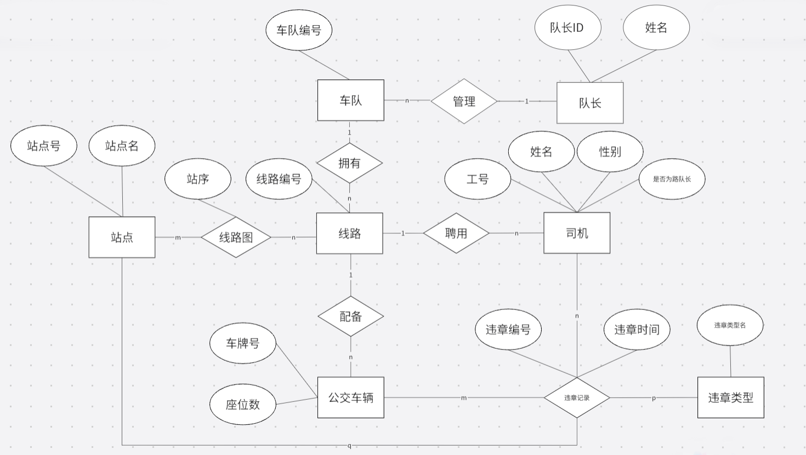
- 将E-R图转换成关系模式
加粗部分为主键，斜体为外键
- 将实体转换成关系模式
车队表（车队编号）
车队长表（队长ID，姓名）
线路表（线路号）
公交车辆表（车牌号，座位数）
司机表（工号，姓名，性别，是否为路队长）
站点表（站点号，站点名）
违章类型表（违章类型名称）
- 将联系转换成关系模式
- 1：n联系
对于1：n联系，我们通常不为联系单独建表，而是将“1”端的主键加入到“n”端实体对应的表中，作为外键。
车队表（车队编号， 队长ID）
线路表（线路号， 所属车队号）
车辆表（车牌号，座位数， 所属线路号）
司机表（工号，姓名，性别， 所属线路号）
- m：n联系
对于m：n联系，如果有一个属性是“只有当这两个实体结合在一起时才有意义”，那么这个属性应该直接挂在“联系（菱形）”上。
线路图表（线路号， 站点号，站序） //线路号+站点号联合构成主键
违章情况表（违章编号， 违章司机， 违章车辆， 违章类型， 违章地点，违章时间）
- 最终结果
车队表（车队编号， 队长ID）
线路表（线路号， 所属车队号）
车辆表（车牌号，座位数， 所属线路号）
司机表（工号，姓名，性别， 所属线路号, 是否为路队长）
违章情况表（违章编号， 违章司机， 违章车辆， 违章类型， 违章地点，违章时间）
站点表（站点号，站点名， 所属线路号）
线路图表（线路号， 站点号，站序） //线路号+站点号联合构成主键
违章类型表（违章类型名称）
步骤二：后台数据库搭建。
- 数据库配置
本系统使用PyMySQL连接MySQL数据库，配置信息如下：。
# 数据库配置（app.py）
import pymysql
from pymysql.cursors import DictCursor

DB_CONFIG = {
'host': 'localhost',
'port': 3306,
'user': 'root',
'password': 'root',
'database': 'bus_safety_system',
'charset': 'utf8mb4',
'cursorclass': DictCursor
}

def get_db():
"""获取数据库连接"""
return pymysql.connect(**DB_CONFIG)
说明：每次需要数据库操作时调用`get_db()`获取连接，操作完毕在`finally`块中通过`conn.close()`关闭连接，确保资源不泄漏
- 任务板块一：创建数据库表
以下是创建数据库表的核心SQL语句（bus_safety_system.sql）
  - 员工表 — 存储所有员工基础信息
CREATE TABLE employee (
employee_id INT PRIMARY KEY AUTO_INCREMENT COMMENT '员工ID',
emp_code VARCHAR(20) NOT NULL UNIQUE COMMENT '员工工号',
name VARCHAR(50) NOT NULL COMMENT '姓名',
gender ENUM('男', '女') NOT NULL COMMENT '性别',
id_card VARCHAR(18) NOT NULL UNIQUE COMMENT '身份证号',
phone VARCHAR(11) COMMENT '联系电话',
address VARCHAR(200) COMMENT '家庭住址',
hire_date DATE NOT NULL COMMENT '入职日期',
status ENUM('在职', '离职', '休假') NOT NULL DEFAULT '在职' COMMENT '员工状态',
created_at TIMESTAMP DEFAULT CURRENT_TIMESTAMP,
updated_at TIMESTAMP DEFAULT CURRENT_TIMESTAMP ON UPDATE CURRENT_TIMESTAMP,
-- 用户自定义完整性约束
CONSTRAINT chk_id_card CHECK (LENGTH(id_card) = 18),
CONSTRAINT chk_phone CHECK (phone IS NULL OR LENGTH(phone) = 11)
) ENGINE=InnoDB COMMENT='员工基础信息表';
- 车队表
CREATE TABLE fleet (
fleet_id INT PRIMARY KEY AUTO_INCREMENT COMMENT '车队ID',
fleet_code VARCHAR(20) NOT NULL UNIQUE COMMENT '车队编号',
fleet_name VARCHAR(100) NOT NULL COMMENT '车队名称',
captain_id INT COMMENT '队长ID（员工ID）',
description VARCHAR(500) COMMENT '车队描述',
created_at TIMESTAMP DEFAULT CURRENT_TIMESTAMP,
updated_at TIMESTAMP DEFAULT CURRENT_TIMESTAMP ON UPDATE CURRENT_TIMESTAMP
) ENGINE=InnoDB COMMENT='车队信息表';
- 路线表
CREATE TABLE route (
route_id INT PRIMARY KEY AUTO_INCREMENT COMMENT '线路ID',
route_code VARCHAR(20) NOT NULL UNIQUE COMMENT '线路编号',
route_name VARCHAR(100) NOT NULL COMMENT '线路名称',
fleet_id INT NOT NULL COMMENT '所属车队ID',
start_station VARCHAR(100) COMMENT '起点站',
end_station VARCHAR(100) COMMENT '终点站',
total_distance DECIMAL(10,2) COMMENT '总里程（公里）',
ticket_price DECIMAL(5,2) COMMENT '票价（元）',
status ENUM('运营中', '停运', '调整中') NOT NULL DEFAULT '运营中',
created_at TIMESTAMP DEFAULT CURRENT_TIMESTAMP,
updated_at TIMESTAMP DEFAULT CURRENT_TIMESTAMP ON UPDATE CURRENT_TIMESTAMP
) ENGINE=InnoDB COMMENT='公交线路表';
- 司机表（员工表的扩展，采用继承设计，符合3NF）
CREATE TABLE driver (
driver_id INT PRIMARY KEY COMMENT '司机ID（与员工ID相同）',
license_no VARCHAR(20) NOT NULL UNIQUE COMMENT '驾驶证号',
license_type ENUM('A1', 'A3', 'B1') NOT NULL DEFAULT 'A3',
license_expire_date DATE NOT NULL COMMENT '驾照有效期',
route_id INT COMMENT '所属线路ID',
is_route_captain TINYINT(1) NOT NULL DEFAULT 0 COMMENT '是否为路队长',
driving_years INT COMMENT '驾龄（年）',
created_at TIMESTAMP DEFAULT CURRENT_TIMESTAMP,
updated_at TIMESTAMP DEFAULT CURRENT_TIMESTAMP ON UPDATE CURRENT_TIMESTAMP,
CONSTRAINT chk_driving_years CHECK (driving_years IS NULL OR driving_years >= 0)
) ENGINE=InnoDB COMMENT='司机信息表（员工扩展）';
- 车辆表
CREATE TABLE bus (
bus_id INT PRIMARY KEY AUTO_INCREMENT COMMENT '车辆ID',
plate_number VARCHAR(10) NOT NULL UNIQUE COMMENT '车牌号',
bus_code VARCHAR(20) NOT NULL UNIQUE COMMENT '车辆编号',
model VARCHAR(50) COMMENT '车型',
brand VARCHAR(50) COMMENT '品牌',
seats INT COMMENT '座位数',
purchase_date DATE COMMENT '购置日期',
route_id INT COMMENT '所属线路ID',
status ENUM('运营中', '维修中', '报废', '备用') NOT NULL DEFAULT '运营中',
CONSTRAINT chk_seats CHECK (seats IS NULL OR seats > 0)
) ENGINE=InnoDB COMMENT='公交车辆表';
（6）站点表
CREATE TABLE station (
station_id INT PRIMARY KEY AUTO_INCREMENT COMMENT '站点ID',
station_code VARCHAR(20) NOT NULL UNIQUE COMMENT '站点编号',
station_name VARCHAR(100) NOT NULL COMMENT '站点名称',
address VARCHAR(200) COMMENT '详细地址',
longitude DECIMAL(10,7) COMMENT '经度',
latitude DECIMAL(10,7) COMMENT '纬度',
has_shelter TINYINT(1) DEFAULT 1 COMMENT '是否有候车亭'
) ENGINE=InnoDB COMMENT='公交站点表';
（7）线路站点关联表（m:n关系）
CREATE TABLE route_station (
route_id INT NOT NULL,
station_id INT NOT NULL,
sequence_no INT NOT NULL COMMENT '站点顺序',
direction ENUM('上行', '下行') NOT NULL DEFAULT '上行',
distance_from_start DECIMAL(10,2) COMMENT '距起点距离',
PRIMARY KEY (route_id, station_id, direction),
CONSTRAINT chk_sequence CHECK (sequence_no > 0)
) ENGINE=InnoDB COMMENT='线路站点关联表';
（8）违章类型表
CREATE TABLE violation_type (
type_id INT PRIMARY KEY AUTO_INCREMENT,
type_code VARCHAR(20) NOT NULL UNIQUE COMMENT '违章代码',
type_name VARCHAR(100) NOT NULL COMMENT '违章名称',
description VARCHAR(500) COMMENT '违章描述',
penalty_points INT DEFAULT 0 COMMENT '扣分',
fine_amount DECIMAL(10,2) DEFAULT 0.00 COMMENT '罚款金额',
severity ENUM('轻微', '一般', '严重', '特别严重') NOT NULL DEFAULT '一般',
CONSTRAINT chk_penalty_points CHECK (penalty_points >= 0),
CONSTRAINT chk_fine_amount CHECK (fine_amount >= 0)
) ENGINE=InnoDB COMMENT='违章类型表';
（9）违章记录表（核心业务表）
CREATE TABLE violation_record (
record_id INT PRIMARY KEY AUTO_INCREMENT,
driver_id INT NOT NULL COMMENT '违章司机ID',
bus_id INT NOT NULL COMMENT '违章车辆ID',
fleet_id INT NOT NULL COMMENT '所属车队ID',
route_id INT NOT NULL COMMENT '所属线路ID',
station_id INT COMMENT '违章发生站点ID',
violation_type_id INT NOT NULL COMMENT '违章类型ID',
violation_time DATETIME NOT NULL COMMENT '违章发生时间',
violation_location VARCHAR(200) COMMENT '违章地点描述',
recorded_by INT NOT NULL COMMENT '记录人ID',
record_time DATETIME NOT NULL DEFAULT CURRENT_TIMESTAMP,
video_url VARCHAR(500) COMMENT '违章视频URL',
remarks VARCHAR(500) COMMENT '备注说明',
status ENUM('待处理', '已确认', '已申诉', '已撤销') NOT NULL DEFAULT '待处理'
) ENGINE=InnoDB COMMENT='违章记录表';
添加外键约束（参照完整性）
-- 车队表外键：队长必须是员工
ALTER TABLE fleet ADD CONSTRAINT fk_fleet_captain
FOREIGN KEY (captain_id) REFERENCES employee(employee_id)
ON DELETE SET NULL ON UPDATE CASCADE;

-- 线路表外键：线路属于车队
ALTER TABLE route ADD CONSTRAINT fk_route_fleet
FOREIGN KEY (fleet_id) REFERENCES fleet(fleet_id)
ON DELETE RESTRICT ON UPDATE CASCADE;

-- 司机表外键
ALTER TABLE driver
ADD CONSTRAINT fk_driver_employee
FOREIGN KEY (driver_id) REFERENCES employee(employee_id)
ON DELETE CASCADE ON UPDATE CASCADE,
ADD CONSTRAINT fk_driver_route
FOREIGN KEY (route_id) REFERENCES route(route_id)
ON DELETE SET NULL ON UPDATE CASCADE;

-- 车辆表外键
ALTER TABLE bus ADD CONSTRAINT fk_bus_route
FOREIGN KEY (route_id) REFERENCES route(route_id)
ON DELETE SET NULL ON UPDATE CASCADE;

-- 违章记录表外键
ALTER TABLE violation_record
ADD CONSTRAINT fk_vr_driver FOREIGN KEY (driver_id) REFERENCES driver(driver_id),
ADD CONSTRAINT fk_vr_bus FOREIGN KEY (bus_id) REFERENCES bus(bus_id),
ADD CONSTRAINT fk_vr_fleet FOREIGN KEY (fleet_id) REFERENCES fleet(fleet_id),
ADD CONSTRAINT fk_vr_route FOREIGN KEY (route_id) REFERENCES route(route_id),
ADD CONSTRAINT fk_vr_station FOREIGN KEY (station_id) REFERENCES station(station_id),
ADD CONSTRAINT fk_vr_type FOREIGN KEY (violation_type_id) REFERENCES violation_type(type_id),
ADD CONSTRAINT fk_vr_recorder FOREIGN KEY (recorded_by) REFERENCES employee(employee_id);
创建索引（加速查询）
-- 员工表索引
CREATE INDEX idx_employee_name ON employee(name);
CREATE INDEX idx_employee_status ON employee(status);

-- 线路表索引
CREATE INDEX idx_route_fleet ON route(fleet_id);

-- 司机表索引
CREATE INDEX idx_driver_route ON driver(route_id);

-- 车辆表索引
CREATE INDEX idx_bus_route ON bus(route_id);

-- 违章记录表索引（核心查询优化）
CREATE INDEX idx_vr_driver ON violation_record(driver_id);
CREATE INDEX idx_vr_fleet ON violation_record(fleet_id);
CREATE INDEX idx_vr_violation_time ON violation_record(violation_time);

-- 复合索引（常用查询组合）
CREATE INDEX idx_vr_fleet_time ON violation_record(fleet_id, violation_time);
CREATE INDEX idx_vr_driver_time ON violation_record(driver_id, violation_time);
创建视图（简化查询）
-- 视图1：司机完整信息视图
CREATE OR REPLACE VIEW v_driver_info AS
SELECT
d.driver_id, e.emp_code, e.name AS driver_name, e.gender,
e.phone, e.hire_date, d.license_no, d.license_type,
d.driving_years, d.is_route_captain, d.route_id,
r.route_code, r.route_name, f.fleet_id, f.fleet_name
FROM driver d
INNER JOIN employee e ON d.driver_id = e.employee_id
LEFT JOIN route r ON d.route_id = r.route_id
LEFT JOIN fleet f ON r.fleet_id = f.fleet_id;

-- 视图2：违章记录详细视图
CREATE OR REPLACE VIEW v_violation_detail AS
SELECT
vr.record_id, vr.violation_time, vr.violation_location,
vr.status AS record_status, vr.remarks,
e_driver.name AS driver_name, b.plate_number,
f.fleet_name, r.route_code, s.station_name,
vt.type_name AS violation_name, vt.penalty_points,
vt.fine_amount, vt.severity,
e_recorder.name AS recorder_name
FROM violation_record vr
INNER JOIN employee e_driver ON vr.driver_id = e_driver.employee_id
INNER JOIN bus b ON vr.bus_id = b.bus_id
INNER JOIN fleet f ON vr.fleet_id = f.fleet_id
INNER JOIN route r ON vr.route_id = r.route_id
LEFT JOIN station s ON vr.station_id = s.station_id
INNER JOIN violation_type vt ON vr.violation_type_id = vt.type_id
INNER JOIN employee e_recorder ON vr.recorded_by = e_recorder.employee_id;

-- 视图3：司机违章统计视图
CREATE OR REPLACE VIEW v_driver_violation_stats AS
SELECT
d.driver_id, e.emp_code, e.name AS driver_name,
r.route_name, f.fleet_name,
COUNT(vr.record_id) AS total_violations,
SUM(vt.penalty_points) AS total_penalty_points,
SUM(vt.fine_amount) AS total_fine_amount
FROM driver d
INNER JOIN employee e ON d.driver_id = e.employee_id
LEFT JOIN route r ON d.route_id = r.route_id
LEFT JOIN fleet f ON r.fleet_id = f.fleet_id
LEFT JOIN violation_record vr ON d.driver_id = vr.driver_id AND vr.status != '已撤销'
LEFT JOIN violation_type vt ON vr.violation_type_id = vt.type_id
GROUP BY d.driver_id, e.emp_code, e.name, r.route_name, f.fleet_name;
创建存储过程
-- 存储过程1：添加违章记录
DELIMITER //
CREATE PROCEDURE sp_add_violation_record(
IN p_driver_id INT, IN p_bus_id INT, IN p_station_id INT,
IN p_violation_type_id INT, IN p_violation_time DATETIME,
IN p_violation_location VARCHAR(200), IN p_recorded_by INT,
IN p_remarks VARCHAR(500),
OUT p_result INT, OUT p_message VARCHAR(200)
)
BEGIN
DECLARE v_fleet_id INT;
DECLARE v_route_id INT;

-- 获取司机所属的线路和车队
SELECT r.fleet_id, d.route_id INTO v_fleet_id, v_route_id
FROM driver d INNER JOIN route r ON d.route_id = r.route_id
WHERE d.driver_id = p_driver_id;

IF v_route_id IS NULL THEN
SET p_result = -2;
SET p_message = '司机不存在或未分配线路';
ELSE
INSERT INTO violation_record (
driver_id, bus_id, fleet_id, route_id, station_id,
violation_type_id, violation_time, violation_location,
recorded_by, remarks
) VALUES (
p_driver_id, p_bus_id, v_fleet_id, v_route_id, p_station_id,
p_violation_type_id, p_violation_time, p_violation_location,
p_recorded_by, p_remarks
);
SET p_result = LAST_INSERT_ID();
SET p_message = '违章记录添加成功';
END IF;
END //
DELIMITER ;

-- 存储过程2：查询司机违章历史
DELIMITER //
CREATE PROCEDURE sp_get_driver_violations(
IN p_driver_id INT, IN p_start_date DATE, IN p_end_date DATE
)
BEGIN
SELECT vr.record_id, vr.violation_time, vt.type_name,
vt.severity, vt.penalty_points, vt.fine_amount,
b.plate_number, r.route_code, s.station_name,
vr.status, e.name AS recorder_name
FROM violation_record vr
INNER JOIN violation_type vt ON vr.violation_type_id = vt.type_id
INNER JOIN bus b ON vr.bus_id = b.bus_id
INNER JOIN route r ON vr.route_id = r.route_id
LEFT JOIN station s ON vr.station_id = s.station_id
INNER JOIN employee e ON vr.recorded_by = e.employee_id
WHERE vr.driver_id = p_driver_id
AND (p_start_date IS NULL OR DATE(vr.violation_time) >= p_start_date)
AND (p_end_date IS NULL OR DATE(vr.violation_time) <= p_end_date)
ORDER BY vr.violation_time DESC;
END //
DELIMITER ;
创建自定义函数
-- 函数1：获取司机总违章次数
DELIMITER //
CREATE FUNCTION fn_get_driver_violation_count(p_driver_id INT)
RETURNS INT DETERMINISTIC READS SQL DATA
BEGIN
DECLARE v_count INT;
SELECT COUNT(*) INTO v_count FROM violation_record
WHERE driver_id = p_driver_id AND status != '已撤销';
RETURN IFNULL(v_count, 0);
END //
DELIMITER ;

-- 函数2：获取司机总扣分
DELIMITER //
CREATE FUNCTION fn_get_driver_penalty_points(p_driver_id INT)
RETURNS INT DETERMINISTIC READS SQL DATA
BEGIN
DECLARE v_points INT;
SELECT SUM(vt.penalty_points) INTO v_points
FROM violation_record vr
INNER JOIN violation_type vt ON vr.violation_type_id = vt.type_id
WHERE vr.driver_id = p_driver_id AND vr.status != '已撤销';
RETURN IFNULL(v_points, 0);
END //
DELIMITER ;

-- 函数3：检查员工是否有管理权限
DELIMITER //
CREATE FUNCTION fn_has_management_authority(p_employee_id INT)
RETURNS TINYINT(1) DETERMINISTIC READS SQL DATA
BEGIN
DECLARE v_is_captain INT DEFAULT 0;
DECLARE v_is_route_captain INT DEFAULT 0;
SELECT COUNT(*) INTO v_is_captain FROM fleet WHERE captain_id = p_employee_id;
SELECT COUNT(*) INTO v_is_route_captain FROM driver
WHERE driver_id = p_employee_id AND is_route_captain = 1;
RETURN (v_is_captain > 0 OR v_is_route_captain > 0);
END //
DELIMITER ;
创建触发器
-- 触发器：确保每条线路只有一个路队长
DELIMITER //
CREATE TRIGGER trg_before_driver_update
BEFORE UPDATE ON driver FOR EACH ROW
BEGIN
DECLARE v_existing_captain INT;
IF NEW.is_route_captain = 1 AND OLD.is_route_captain = 0 THEN
SELECT driver_id INTO v_existing_captain FROM driver
WHERE route_id = NEW.route_id AND is_route_captain = 1
AND driver_id != NEW.driver_id LIMIT 1;
IF v_existing_captain IS NOT NULL THEN
SIGNAL SQLSTATE '45000'
SET MESSAGE_TEXT = '该线路已有路队长，请先取消原路队长资格';
END IF;
END IF;
END //
DELIMITER ;
步骤三：业务功能实现
Flask Web应用架构
本系统采用Flask框架构建后端，主要代码在app.py中，包含以下模块
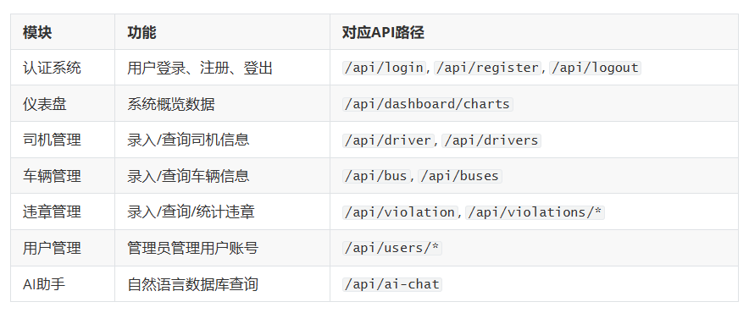
认证系统实现
系统使用SHA-256哈希加盐方式存储密码，并实现了登录失败锁定机制：
def hash_password(password, salt=None):
"""密码哈希函数"""
if salt is None:
salt = secrets.token_hex(32)
password_hash = hashlib.sha256((password + salt).encode()).hexdigest()
return password_hash, salt

def verify_password(password, password_hash, salt):
"""验证密码"""
computed_hash, _ = hash_password(password, salt)
return computed_hash == password_hash

def login_required(f):
"""登录验证装饰器"""
@wraps(f)
def decorated_function(*args, **kwargs):
if 'user_id' not in session:
return redirect(url_for('login_page'))
return f(*args, **kwargs)
return decorated_function
功能1：录入司机信息
@app.route('/api/driver', methods=['POST'])
def add_driver():
"""添加司机"""
data = request.json
conn = get_db()
try:
with conn.cursor() as cursor:
# 插入员工表
cursor.execute("""
INSERT INTO employee (emp_code, name, gender, id_card, phone, address, hire_date)
VALUES (%s, %s, %s, %s, %s, %s, %s)
""", (data['emp_code'], data['name'], data['gender'], data['id_card'],
data.get('phone'), data.get('address'), data['hire_date']))

employee_id = cursor.lastrowid

# 插入司机表
cursor.execute("""
INSERT INTO driver (driver_id, license_no, license_type,
license_expire_date, driving_years, route_id)
VALUES (%s, %s, %s, %s, %s, %s)
""", (employee_id, data['license_no'], data['license_type'],
data['license_expire_date'], data.get('driving_years', 0),
data.get('route_id') or None))

# 自动为新司机创建用户账号（默认密码：123456）
default_password = '123456'
password_hash, salt = hash_password(default_password)
cursor.execute("""
INSERT INTO user_credentials (employee_id, username, password_hash, salt, role, is_active)
VALUES (%s, %s, %s, %s, 'driver', 1)
""", (employee_id, data['emp_code'], password_hash, salt))

conn.commit()
return jsonify({'success': True, 'message': '司机添加成功，默认密码：123456'})
except Exception as e:
conn.rollback()
return jsonify({'success': False, 'message': str(e)})
finally:
conn.close()
功能2：录入车辆信息
@app.route('/api/bus', methods=['POST'])
def add_bus():
"""添加车辆"""
data = request.json
conn = get_db()
try:
with conn.cursor() as cursor:
cursor.execute("""
INSERT INTO bus (plate_number, bus_code, model, brand, seats,
purchase_date, route_id, status)
VALUES (%s, %s, %s, %s, %s, %s, %s, %s)
""", (data['plate_number'], data['bus_code'], data.get('model'),
data.get('brand'), data.get('seats'), data.get('purchase_date'),
data.get('route_id') or None, data.get('status', '运营中')))
conn.commit()
return jsonify({'success': True, 'message': '车辆添加成功'})
except Exception as e:
conn.rollback()
return jsonify({'success': False, 'message': str(e)})
finally:
conn.close()
功能3：录入违章信息
@app.route('/api/violation', methods=['POST'])
def add_violation():
"""添加违章记录"""
data = request.json
conn = get_db()
try:
with conn.cursor() as cursor:
# 获取司机所属车队和线路
cursor.execute("""
SELECT r.fleet_id, d.route_id
FROM driver d INNER JOIN route r ON d.route_id = r.route_id
WHERE d.driver_id = %s
""", (data['driver_id'],))
driver_info = cursor.fetchone()

if not driver_info:
return jsonify({'success': False, 'message': '司机不存在或未分配线路'})

# 插入违章记录
cursor.execute("""
INSERT INTO violation_record (driver_id, bus_id, fleet_id, route_id,
station_id, violation_type_id, violation_time, violation_location,
recorded_by, remarks, video_url)
VALUES (%s, %s, %s, %s, %s, %s, %s, %s, %s, %s, %s)
""", (data['driver_id'], data['bus_id'], driver_info['fleet_id'],
driver_info['route_id'], data.get('station_id') or None,
data['violation_type_id'], data['violation_time'],
data.get('violation_location'), data['recorded_by'],
data.get('remarks'), data.get('video_url')))
conn.commit()
return jsonify({'success': True, 'message': '违章记录添加成功'})
except Exception as e:
conn.rollback()
return jsonify({'success': False, 'message': str(e)})
finally:
conn.close()
功能4：查询车队司机信息
@app.route('/api/drivers/by-fleet/<int:fleet_id>')
def get_drivers_by_fleet(fleet_id):
"""查询某车队下的司机"""
conn = get_db()
try:
with conn.cursor() as cursor:
cursor.execute("""
SELECT d.driver_id, e.emp_code, e.name, e.gender, e.phone,
d.license_no, d.license_type, d.driving_years,
d.is_route_captain, r.route_code, r.route_name
FROM driver d
INNER JOIN employee e ON d.driver_id = e.employee_id
LEFT JOIN route r ON d.route_id = r.route_id
LEFT JOIN fleet f ON r.fleet_id = f.fleet_id
WHERE f.fleet_id = %s
ORDER BY r.route_code, e.emp_code
""", (fleet_id,))
return jsonify({'success': True, 'data': cursor.fetchall()})
finally:
conn.close()
功能5：查询司机违章详情
@app.route('/api/violations/by-driver')
def get_violations_by_driver():
"""查询司机在指定时间段的违章"""
driver_id = request.args.get('driver_id')
start_date = request.args.get('start_date')
end_date = request.args.get('end_date')

conn = get_db()
try:
with conn.cursor() as cursor:
cursor.execute("""
SELECT vr.record_id, vr.violation_time, vr.violation_location,
vr.status, vr.remarks, vr.video_url,
e.name AS driver_name, b.plate_number, r.route_code,
s.station_name, vt.type_name AS violation_name,
vt.penalty_points, vt.fine_amount, vt.severity,
er.name AS recorder_name
FROM violation_record vr
INNER JOIN employee e ON vr.driver_id = e.employee_id
INNER JOIN bus b ON vr.bus_id = b.bus_id
INNER JOIN route r ON vr.route_id = r.route_id
LEFT JOIN station s ON vr.station_id = s.station_id
INNER JOIN violation_type vt ON vr.violation_type_id = vt.type_id
INNER JOIN employee er ON vr.recorded_by = er.employee_id
WHERE vr.driver_id = %s
AND DATE(vr.violation_time) >= %s
AND DATE(vr.violation_time) <= %s
ORDER BY vr.violation_time DESC
""", (driver_id, start_date, end_date))
data = cursor.fetchall()

# 计算统计
total_points = sum(r.get('penalty_points', 0) or 0 for r in data)
total_fine = sum(r.get('fine_amount', 0) or 0 for r in data)

return jsonify({
'success': True, 'data': data,
'stats': {'count': len(data), 'total_points': total_points, 'total_fine': total_fine}
})
finally:
conn.close()
功能6：车队违章统计
@app.route('/api/violations/stats-by-fleet')
def get_violation_stats_by_fleet():
"""查询车队违章统计"""
fleet_id = request.args.get('fleet_id')
start_date = request.args.get('start_date')
end_date = request.args.get('end_date')

conn = get_db()
try:
with conn.cursor() as cursor:
cursor.execute("""
SELECT vt.type_name, vt.severity,
COUNT(*) AS count,
SUM(vt.penalty_points) AS total_points,
SUM(vt.fine_amount) AS total_fine
FROM violation_record vr
INNER JOIN violation_type vt ON vr.violation_type_id = vt.type_id
WHERE vr.fleet_id = %s
AND DATE(vr.violation_time) >= %s
AND DATE(vr.violation_time) <= %s
AND vr.status != '已撤销'
GROUP BY vt.type_id, vt.type_name, vt.severity
ORDER BY count DESC
""", (fleet_id, start_date, end_date))
data = cursor.fetchall()
return jsonify({'success': True, 'data': data})
finally:
conn.close()
步骤四：DeepSeek AI接入与自然语言数据库查询
这是本系统的核心创新功能——通过DeepSeek大模型实现自然语言查询/修改数据库。用户只需用中文描述想要的操作，系统会自动将自然语言转换为SQL并执行。
DeepSeek API配置
# DeepSeek API配置
DEEPSEEK_API_KEY = "你自己的api-key"
DEEPSEEK_API_URL = https://api.deepseek.com/v1/chat/completions
数据库表结构描述（供AI生成SQL使用）
为了让AI准确生成SQL，我们将完整的数据库表结构以结构化文本的形式注入到System Prompt中：
DB_SCHEMA_DESC = """
【数据库名】bus_safety_system（MySQL）

【数据库表结构】
1. employee（员工基础信息表）
- employee_id INT PRIMARY KEY AUTO_INCREMENT
- emp_code VARCHAR(20) UNIQUE -- 员工工号
- name VARCHAR(50) -- 姓名
- gender ENUM('男','女') -- 性别
...

2. fleet（车队信息表）
- fleet_id INT PRIMARY KEY AUTO_INCREMENT
- fleet_code VARCHAR(20) UNIQUE
- fleet_name VARCHAR(100)
- captain_id INT -- 关联employee.employee_id
...

（完整结构省略，包含全部9张表和4个视图的完整字段描述）

【常用视图】
- v_driver_info: 司机完整信息（含员工信息+线路+车队）
- v_violation_detail: 违章记录详情（含所有关联信息）
- v_driver_violation_stats: 司机违章统计
- v_fleet_violation_stats: 车队违章统计
"""
NL2SQL系统提示词设计

NL2SQL_SYSTEM_PROMPT = """你是一个专业的SQL生成助手，负责将用户的自然语言请求转换为MySQL SQL语句并解读执行结果。

""" + DB_SCHEMA_DESC + """

【你的工作流程】
1. 分析用户意图，判断是查询(SELECT)还是修改(INSERT/UPDATE/DELETE)操作
2. 生成对应的SQL语句，用 ```sql ... ``` 包裹
3. 在SQL之后简要说明这条SQL的作用

【重要规则】
- 只生成与公交安全管理系统相关的SQL
- 禁止生成DROP TABLE、DROP DATABASE、TRUNCATE等破坏性操作
- 禁止修改表结构（ALTER TABLE）
- 每次只生成一条SQL语句
- 使用中文别名让结果更易读
"""
调用DeepSeek API（非流式模式用于NL2SQL）
def call_deepseek_non_stream(messages, temperature=0.3, max_tokens=2000):
"""调用DeepSeek API（非流式），返回完整回复内容"""
import requests as req
try:
response = req.post(
DEEPSEEK_API_URL,
headers={
'Content-Type': 'application/json',
'Authorization': f'Bearer {DEEPSEEK_API_KEY}'
},
json={
'model': 'deepseek-chat',
'messages': messages,
'temperature': temperature,
'max_tokens': max_tokens,
'stream': False
},
timeout=60
)
if response.status_code == 200:
result = response.json()
if 'choices' in result and len(result['choices']) > 0:
return result['choices'][0]['message']['content']
return None
except Exception as e:
print(f"[AI] DeepSeek非流式调用错误: {str(e)}")
return None
从AI回复中提取SQL语句
def extract_sql_from_response(ai_response):
"""从AI回复中提取SQL语句"""
import re
pattern = r'```sql\s*\n?(.*?)\n?\s*```'
matches = re.findall(pattern, ai_response, re.DOTALL | re.IGNORECASE)
if matches:
sql = matches[0].strip()
if sql.endswith(';'):
sql = sql[:-1].strip()
return sql
return None
SQL安全检查
def is_dangerous_sql(sql):
"""检查SQL是否包含危险操作"""
dangerous_keywords = [
'DROP TABLE', 'DROP DATABASE', 'TRUNCATE', 'ALTER TABLE',
'CREATE TABLE', 'CREATE DATABASE', 'GRANT', 'REVOKE'
]
sql_upper = sql.upper().strip()
for keyword in dangerous_keywords:
if keyword in sql_upper:
return True
return False
执行自然语言生成的SQL
def execute_nl_sql(sql):
"""执行自然语言生成的SQL并返回结果"""
conn = get_db()
try:
with conn.cursor() as cursor:
cursor.execute(sql)
if sql.strip().upper().startswith('SELECT'):
rows = cursor.fetchall()
# 处理日期和Decimal序列化
for row in rows:
for key, val in row.items():
if isinstance(val, (datetime, date)):
row[key] = val.isoformat()
elif isinstance(val, Decimal):
row[key] = float(val)
return {'success': True, 'type': 'query', 'data': rows, 'count': len(rows)}
else:
conn.commit()
affected = cursor.rowcount
return {'success': True, 'type': 'modify', 'affected_rows': affected}
except Exception as e:
conn.rollback()
return {'success': False, 'error': str(e)}
finally:
conn.close()
AI聊天API入口（核心调度逻辑）
@app.route('/api/ai-chat', methods=['POST'])
def ai_chat():
"""AI聊天API - 流式输出，支持自然语言数据库查询"""
data = request.json
user_message = data.get('message', '').strip()
history = data.get('history', [])

# 判断是否是数据库查询/修改意图
db_keywords = [
'查询', '查找', '搜索', '显示', '列出', '统计', '分析',
'修改', '更新', '删除', '添加', '插入', '新增',
'司机', '车队', '线路', '车辆', '违章', '站点', '车牌',
'工号', '姓名', '电话', '驾驶证', '扣分', '罚款'
]
has_db_intent = any(kw in user_message for kw in db_keywords)

if has_db_intent:
# ===== 自然语言数据库查询模式 =====
# Step 1: 调用DeepSeek生成SQL
nl2sql_messages = [{'role': 'system', 'content': NL2SQL_SYSTEM_PROMPT}]
if history:
nl2sql_messages.extend(history[-10:])
nl2sql_messages.append({'role': 'user', 'content': user_message})

ai_response = call_deepseek_non_stream(nl2sql_messages)

# Step 2: 提取SQL
sql = extract_sql_from_response(ai_response)

if sql:
# 安全检查
if is_dangerous_sql(sql):
return _send_response("安全警告：检测到危险操作，已拒绝执行。")

# Step 3: 执行SQL
exec_result = execute_nl_sql(sql)

# Step 4: 组合最终回复（AI解释 + 执行结果表格）
if exec_result['success']:
if exec_result['type'] == 'query':
table_str = format_query_result_as_table(exec_result['data'])
result_text = ai_response + "\n\n---\n**执行结果**（共 " + \
str(exec_result['count']) + " 条记录）：\n\n" + table_str
else:
result_text = ai_response + "\n\n---\n**执行成功**：影响了 " + \
str(exec_result['affected_rows']) + " 条记录。"
else:
result_text = ai_response + "\n\n---\n**执行出错**：" + exec_result['error']

return _send_nl2sql_response(user_message, result_text, history)

# ===== 普通聊天流式模式 =====
return _stream_chat(user_message, history, SYSTEM_PROMPT)
流式聊天输出（普通对话）
def _stream_chat(user_message, history, system_prompt):
"""普通聊天的流式输出"""
messages = [{'role': 'system', 'content': system_prompt}]
if history:
messages.extend(history[-20:])
messages.append({'role': 'user', 'content': user_message})

def generate():
import requests as req
response = req.post(
DEEPSEEK_API_URL,
headers={
'Content-Type': 'application/json',
'Authorization': f'Bearer {DEEPSEEK_API_KEY}'
},
json={
'model': 'deepseek-chat',
'messages': messages,
'temperature': 0.7,
'max_tokens': 8000,
'stream': True # 启用流式输出
},
timeout=60,
stream=True # 流式接收
)
full_content = ""
for line in response.iter_lines():
if line:
line = line.decode('utf-8')
if line.startswith('data: '):
data_str = line[6:]
if data_str == '[DONE]':
yield f"data: {json.dumps({'done': True}, ensure_ascii=False)}\n\n"
break
try:
chunk_data = json.loads(data_str)
delta = chunk_data['choices'][0].get('delta', {})
content = delta.get('content', '')
if content:
full_content += content
yield f"data: {json.dumps({'content': content}, ensure_ascii=False)}\n\n"
except Exception:
continue

return Response(stream_with_context(generate()), mimetype='text/event-stream')
前端AI助手界面
前端通过JavaScript的fetch API接收SSE（Server-Sent Events）流式数据，并实现了Markdown表格渲染：
// 发送消息（ai-assistant.js）
async function sendMessage() {
const response = await fetch('/api/ai-chat', {
method: 'POST',
headers: { 'Content-Type': 'application/json' },
body: JSON.stringify({ message: message, history: chatHistory })
});

// 使用ReadableStream读取SSE流式数据
const reader = response.body.getReader();
const decoder = new TextDecoder();
while (true) {
const { done, value } = await reader.read();
if (done) break;
const chunk = decoder.decode(value, { stream: true });
// 解析SSE数据并更新DOM...
}
}

// Markdown表格渲染
function renderMarkdownTables(text) {
const tableRegex = /(\|[^\n]+\|\s*\n\|[\s\-:|]+\|\s*\n(?:\|[^\n]+\|\s*\n?)*)/g;
return text.replace(tableRegex, function(tableStr) {
// 解析表头和数据行，构建HTML表格
let html = '<div class="ai-table-wrapper"><table class="ai-result-table">';
// ... 构建表格HTML
return html;
});
}
自然语言查询功能示例
用户可以直接在AI助手中输入自然语言来查询或修改数据库
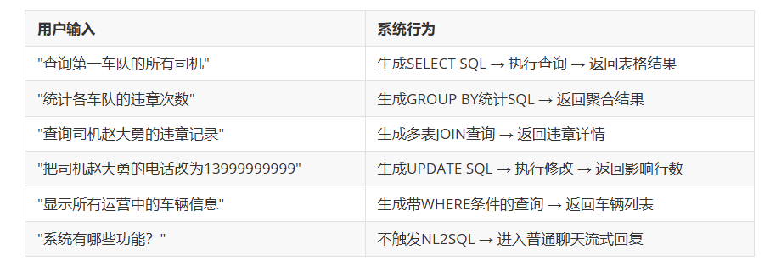
步骤五：前台网页搭建
系统概览页面
系统概览（Dashboard）页面展示了以下数据图表：
- 近30天违章趋势折线图
- 违章类型分布饼图
- 车辆状态分布饼图
- 车队违章排名柱状图
- 违章严重程度分布
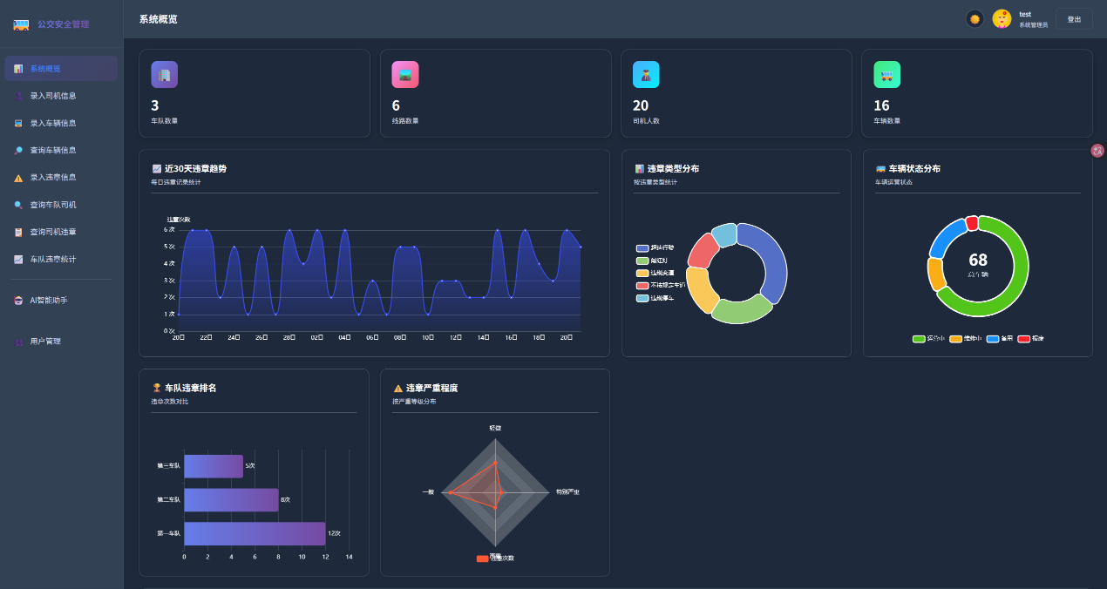
使用ECharts 5.4.3实现所有图表渲染。

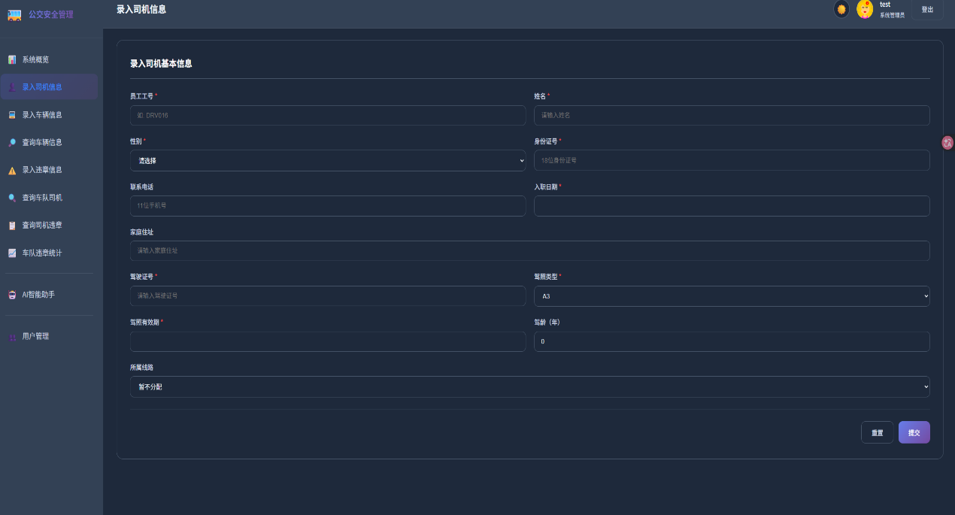
司机信息录入页面
提供表单界面，支持录入司机工号、姓名、性别、身份证号、电话、地址、入职日期、驾驶证号、驾照类型、驾照有效期、驾龄、所属线路等信息

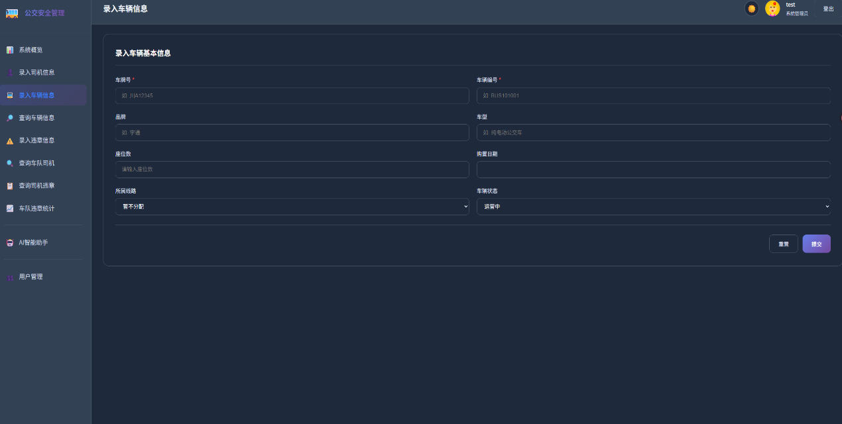
车辆信息录入页面
提供表单界面，支持录入车牌号、车辆编号、车型、品牌、座位数、购置日期、所属线路、车辆状态等信息。

违章信息录入页面

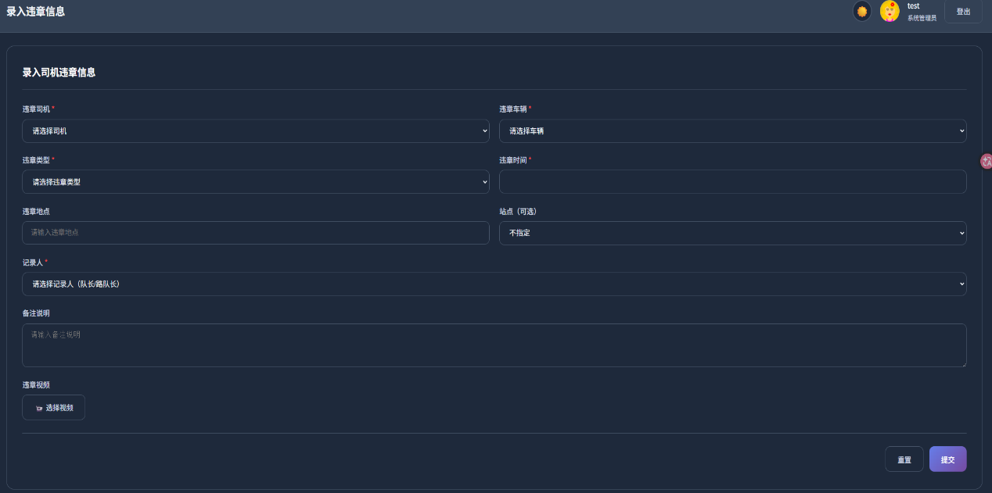
支持选择司机、车辆、违章类型、站点、记录人，并可上传违章视频（最大100MB）
司机违章查询页面
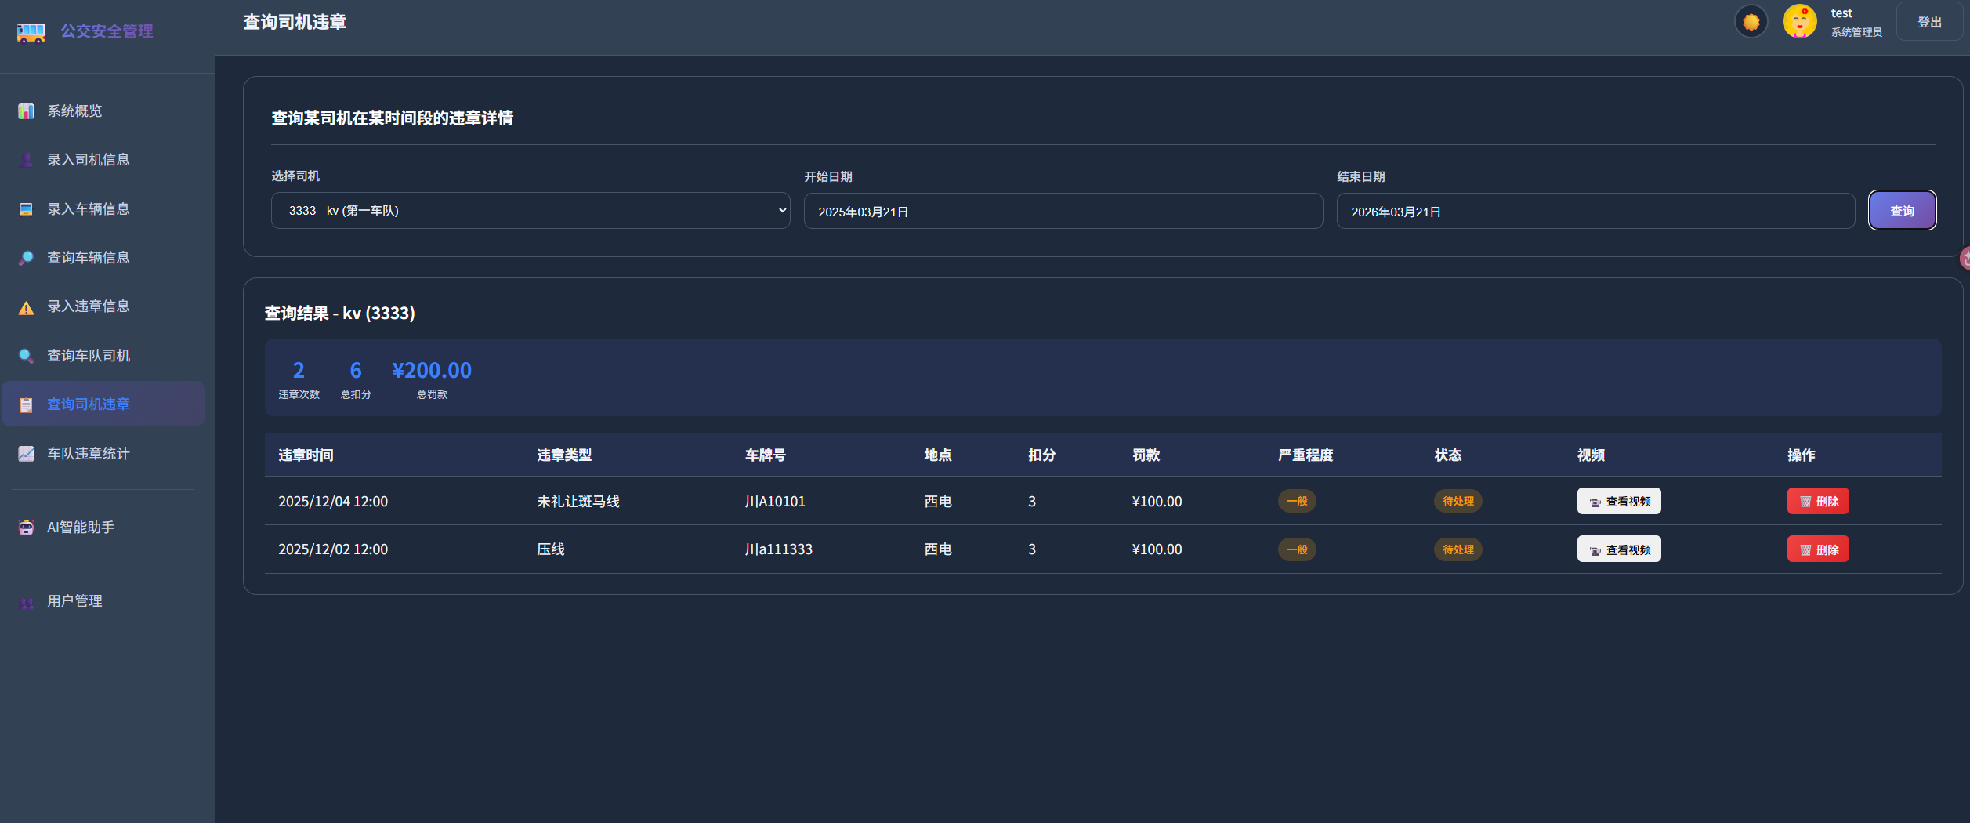
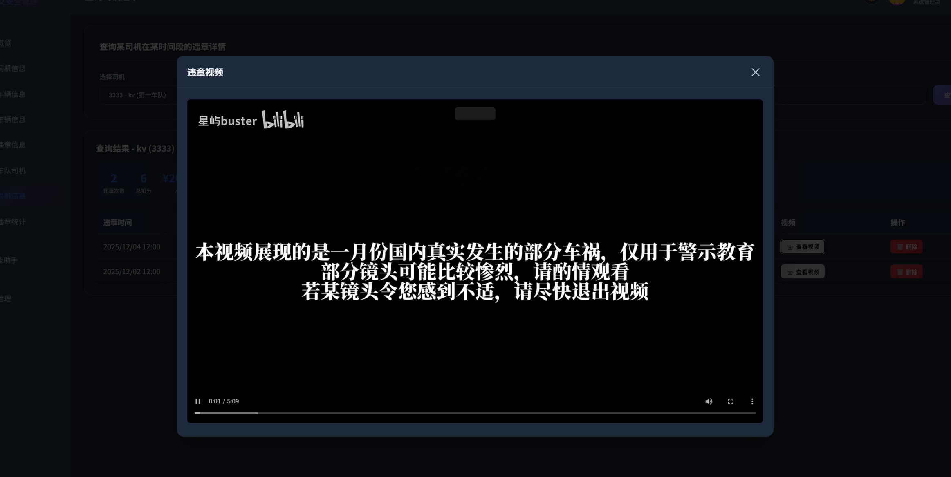

选择司机和时间范围，查询详细的违章记录，包含违章类型、扣分、罚款等信息，并可点击查看违章视频
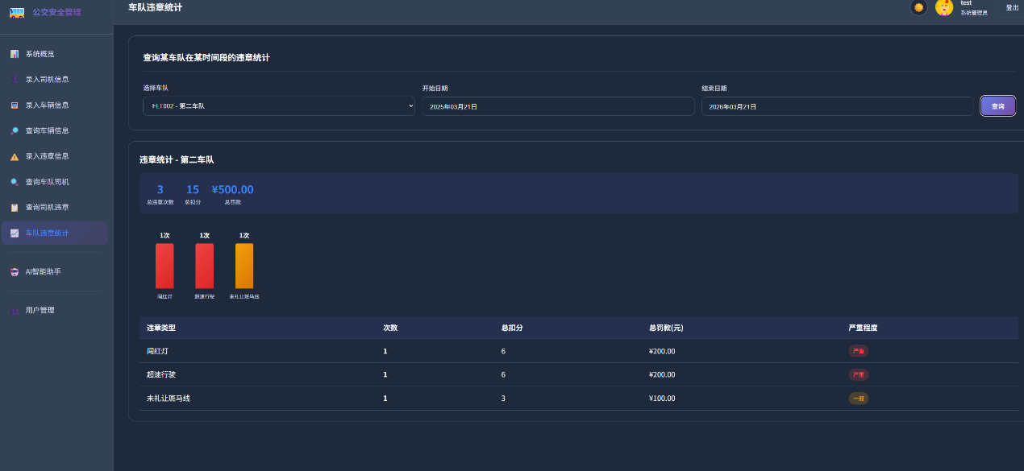
车队违章统计页面
选择车队和时间范围，展示该车队各类违章的统计信息，如"2次闯红灯、4次未礼让斑马线"等。
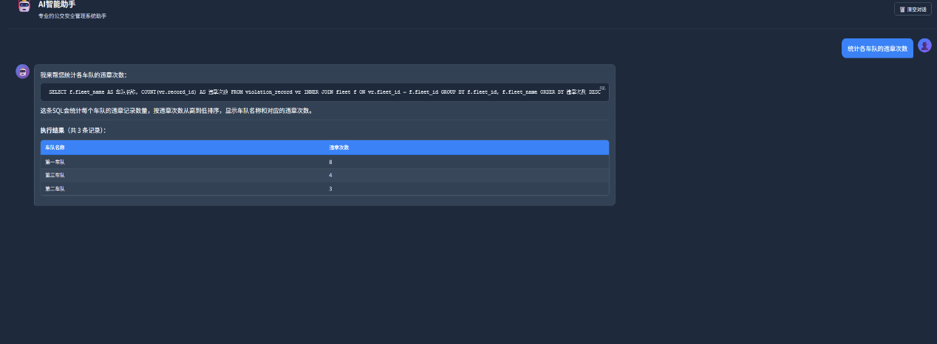
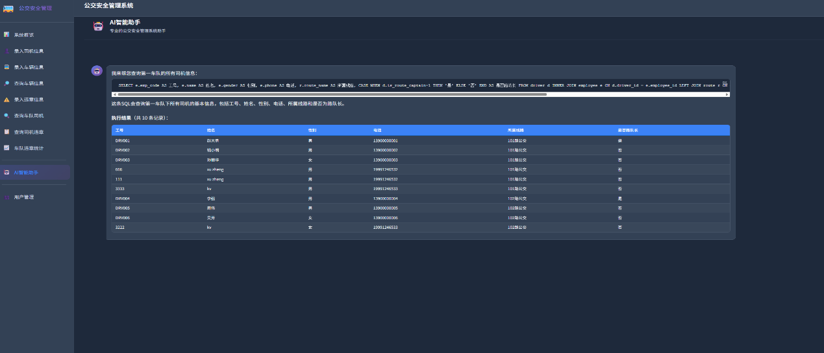
AI智能助手页面（自然语言查询）
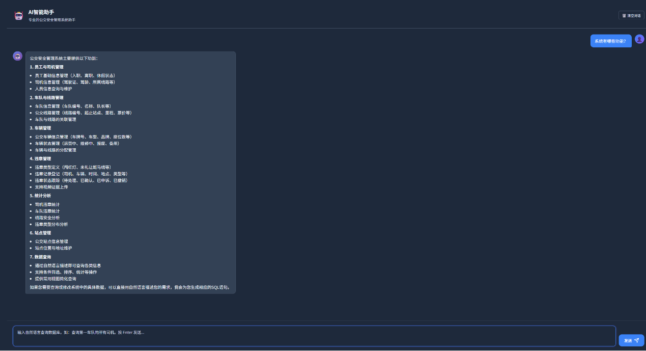
AI助手页面支持用户使用自然语言查询数据库，系统会自动将自然语言转换为SQL执行并以表格形式展示结果
步骤五：实验报告编写。
- 大模型说明
大模型的名称及版本，用于后续的哪些部分，并且在后续的每个部分展示大模型的使用方法。
- 需求分析（系统数据和功能）
数据字典。
- 概念结构设计（E-R图设计）
ER图需要与数据库语义一致，可用Erwin，可使用多种大模型生成E-R图。
- 逻辑结构设计（E-R图转换为关系模型）
关系模型给出表名，列名，列类型，主码，外码，其他约束，进行范式分析。索引、视图、存储过程等。
- 程序开发环境及应用环境
列出操作系统、编程语言、开发工具。
- 应用程序设计中遇到的问题及解决方法
数据库设计中的问题，程序设计中的问题。
- 总结
课程、实验收获，课程、实验建议等。
- 附录：建立数据库和应用程序的主要代码
只列出主要代码，需要有注释。

- 任务拓展
本公交安全管理系统可以参考实际公交安全运营管理系统进行拓展：
1. AI自然语言数据库查询（已实现）：通过集成DeepSeek大模型，支持用户使用自然语言查询和修改数据库信息，大幅降低了数据库操作的门槛。
2. 违章视频管理（已实现）：为每条违章记录关联视频证据，支持视频文件上传（最大100MB）、存储和在线预览。
3. 用户权限管理（已实现）：实现了admin/captain/driver三级角色权限体系，支持账号锁定、密码重置等功能。
4. 深色/浅色主题切换（已实现）：支持深色和浅色两种主题模式的切换。
5. 处罚管理：根据违章类型自动匹配处罚规则（扣分、罚款、停驾等），生成处罚通知单并跟踪处理状态。
6. 培训管理：针对累计扣分达阈值的司机，自动生成培训计划并记录培训考勤与考核结果。
7. 违章地图可视化：将违章地点在电子地图上展示，支持按时间/类型聚类显示及热力图分析。

---
- 实验总结
通过本次基于MySQL的公交安全管理系统实验，完成了以下关键学习目标：
1. 深入理解数据库规范化设计方法：运用规范化理论（3NF）设计了包含9张核心表、6个视图、6个存储过程、5个自定义函数和2个触发器的完整数据库方案，有效避免了数据冗余和操作异常。
2. 熟练掌握MySQL数据库完整性与性能优化：在MySQL中定义了实体完整性（PRIMARY KEY）、参照完整性（FOREIGN KEY，含级联操作）和用户自定义完整性（CHECK约束、ENUM类型），并运用索引（包括复合索引）、视图、存储过程来优化查询与简化逻辑。
3. 全面掌握Web全栈开发方法：使用Python Flask框架构建后端RESTful API，采用原生HTML/CSS/JavaScript构建前端单页应用（SPA），实现了包含登录注册、仪表盘、CRUD操作、文件上传等完整功能的Web系统。
4. 创新性地集成DeepSeek大模型实现NL2SQL：通过调用DeepSeek API，将完整的数据库Schema注入System Prompt，实现了自然语言到SQL的转换。系统支持查询操作（SELECT）和修改操作（INSERT/UPDATE/DELETE），并具备SQL安全检查机制，能防止破坏性操作。
5. 熟练掌握大模型辅助高效开发方法：在数据库设计、后端API开发、前端界面搭建等各环节中有效利用DeepSeek大模型辅助代码生成，显著提升了开发效率
- 附录
- app.py源码
公交安全管理系统 - Flask Web应用
from flask import Flask, render_template, request, jsonify, session, redirect, url_for, send_from_directory
import pymysql
from pymysql.cursors import DictCursor
from datetime import datetime, date, timedelta
from decimal import Decimal
from functools import wraps
import os
import hashlib
import secrets
from werkzeug.utils import secure_filename
app = Flask(__name__)
app.config['JSON_AS_ASCII'] = False
app.config['SECRET_KEY'] = os.urandom(24) # 用于session加密
# 文件上传配置
UPLOAD_FOLDER = os.path.join(os.path.dirname(__file__), 'static', 'uploads')
VIDEO_FOLDER = os.path.join(UPLOAD_FOLDER, 'videos')
ALLOWED_VIDEO_EXTENSIONS = {'mp4', 'avi', 'mov', 'wmv', 'flv', 'mkv', 'webm'}
MAX_VIDEO_SIZE = 100 * 1024 * 1024 # 100MB
# 确保上传目录存在
os.makedirs(VIDEO_FOLDER, exist_ok=True)
app.config['UPLOAD_FOLDER'] = UPLOAD_FOLDER
app.config['VIDEO_FOLDER'] = VIDEO_FOLDER
app.config['MAX_CONTENT_LENGTH'] = MAX_VIDEO_SIZE
# 数据库配置
DB_CONFIG = {
'host': 'localhost',
'port': 3306,
'user': 'root',
'password': 'root',
'database': 'bus_safety_system',
'charset': 'utf8mb4',
'cursorclass': DictCursor
}
def get_db():
"""获取数据库连接"""
return pymysql.connect(**DB_CONFIG)
def json_serial(obj):
"""JSON序列化辅助函数"""
if isinstance(obj, (datetime, date)):
return obj.isoformat()
if isinstance(obj, Decimal):
return float(obj)
raise TypeError(f"Type {type(obj)} not serializable")
def login_required(f):
"""登录验证装饰器"""
@wraps(f)
def decorated_function(*args, **kwargs):
if 'user_id' not in session:
return redirect(url_for('login_page'))
return f(*args, **kwargs)
return decorated_function
def admin_required(f):
"""管理员权限验证装饰器"""
@wraps(f)
def decorated_function(*args, **kwargs):
if 'user_id' not in session:
# 对于API请求返回JSON，对于页面请求返回重定向
​ if request.path.startswith('/api/'):
​ return jsonify({'success': False, 'message': '未登录'}), 401
​ return redirect(url_for('login_page'))
​ if session.get('role') != 'admin':
​ return jsonify({'success': False, 'message': '需要管理员权限'}), 403
​ return f(*args, **kwargs)
​ return decorated_function

def hash_password(password, salt=None):
"""密码哈希函数"""
if salt is None:
salt = secrets.token_hex(32)
password_hash = hashlib.sha256((password + salt).encode()).hexdigest()
return password_hash, salt

def verify_password(password, password_hash, salt):
"""验证密码"""
computed_hash, _ = hash_password(password, salt)
return computed_hash == password_hash
# ==================== 页面路由 ====================
@app.route('/')
@login_required
def index():
"""首页"""
return render_template('index.html', user=session.get('user'))
@app.route('/login')
def login_page():
"""登录页面"""
# 如果已登录，直接跳转到首页

​ if 'user_id' in session:
​ return redirect(url_for('index'))
​ return render_template('login.html')
@app.route('/register')
def register_page():
"""注册页面"""
# 如果已登录，直接跳转到首页
​ if 'user_id' in session:
​ return redirect(url_for('index'))
​ return render_template('register.html')
# ==================== 认证API ====================
@app.route('/api/login', methods=['POST'])
def login():
"""用户登录"""
data = request.json
username = data.get('username')
password = data.get('password')
remember_me = data.get('remember_me', False)

if not username or not password:
return jsonify({'success': False, 'message': '用户名和密码不能为空'})

conn = get_db()
try:
with conn.cursor() as cursor:
# 查询用户凭证表
​ cursor.execute("""
​ SELECT uc.user_id, uc.employee_id, uc.username, uc.password_hash,
​ uc.salt, uc.role, uc.is_active, uc.locked_until, uc.login_attempts,
​ e.name
​ FROM user_credentials uc
​ INNER JOIN employee e ON uc.employee_id = e.employee_id
​ WHERE uc.username = %s AND uc.is_active = 1
​ LIMIT 1
​ """, (username,))
​ user = cursor.fetchone()
​ if not user:
​ return jsonify({'success': False, 'message': '用户名或密码错误'})
# 检查账号是否被锁定
​ if user['locked_until'] and user['locked_until'] > datetime.now():
​ return jsonify({'success': False, 'message': f"账号已被锁定，请在{user['locked_until'].strftime('%Y-%m-%d %H:%M:%S')}后重试"})
​

# 验证密码

​ if not verify_password(password, user['password_hash'], user['salt']):

# 增加失败次数

​ new_attempts = user['login_attempts'] + 1
​ locked_until = None
​

# 连续失败5次锁定30分钟

​ if new_attempts >= 5:
​ locked_until = datetime.now() + timedelta(minutes=30)
​ cursor.execute("""
​ UPDATE user_credentials
​ SET login_attempts = %s, locked_until = %s
​ WHERE user_id = %s
​ """, (new_attempts, locked_until, user['user_id']))
​ conn.commit()
​ return jsonify({'success': False, 'message': '密码错误次数过多，账号已被锁定30分钟'})
​ else:
​ cursor.execute("""
​ UPDATE user_credentials
​ SET login_attempts = %s
​ WHERE user_id = %s
​ """, (new_attempts, user['user_id']))
​ conn.commit()
​ return jsonify({'success': False, 'message': f'用户名或密码错误（还可尝试{5-new_attempts}次）'})
​

# 登录成功，重置失败次数和更新最后登录时间

​ cursor.execute("""
​ UPDATE user_credentials
​ SET login_attempts = 0, locked_until = NULL, last_login = NOW()
​ WHERE user_id = %s
​ """, (user['user_id'],))
​ conn.commit()
​

# 设置session

​ session['user_id'] = user['user_id']
​ session['employee_id'] = user['employee_id']
​ session['username'] = user['username']
​ session['name'] = user['name']
​ session['role'] = user['role']
​ session.permanent = remember_me
​
​ return jsonify({
​ 'success': True,
​ 'message': '登录成功',
​ 'user': {
​ 'username': user['username'],
​ 'name': user['name'],
​ 'role': user['role']
​ }
​ })
​ except Exception as e:
​ return jsonify({'success': False, 'message': f'登录失败: {str(e)}'})
​ finally:
​ conn.close()

@app.route('/api/register', methods=['POST'])
def register():
"""用户注册"""
data = request.json

# 验证必填字段

​ required_fields = ['emp_code', 'name', 'gender', 'id_card', 'hire_date', 'password']
​ for field in required_fields:
​ if not data.get(field):
​ return jsonify({'success': False, 'message': f'{field}不能为空'})
# 验证密码长度

​ if len(data['password']) < 6:
​ return jsonify({'success': False, 'message': '密码至少需要6位'})
​

# 验证身份证号和手机号格式

​ if len(data['id_card']) != 18:
​ return jsonify({'success': False, 'message': '身份证号必须为18位'})
​
​ if data.get('phone') and len(data['phone']) != 11:
​ return jsonify({'success': False, 'message': '手机号必须为11位'})
​
​ conn = get_db()
​ try:
​ with conn.cursor() as cursor:

# 检查工号是否已存在

​ cursor.execute("SELECT employee_id FROM employee WHERE emp_code = %s", (data['emp_code'],))
​ if cursor.fetchone():
​ return jsonify({'success': False, 'message': '该工号已被注册'})
​

# 检查身份证号是否已存在

​ cursor.execute("SELECT employee_id FROM employee WHERE id_card = %s", (data['id_card'],))
​ if cursor.fetchone():
​ return jsonify({'success': False, 'message': '该身份证号已被注册'})
​

# 插入员工表

​ cursor.execute("""
​ INSERT INTO employee (emp_code, name, gender, id_card, phone, address, hire_date, status)
​ VALUES (%s, %s, %s, %s, %s, %s, %s, '在职')
​ """, (
​ data['emp_code'],
​ data['name'],
​ data['gender'],
​ data['id_card'],
​ data.get('phone'),
​ data.get('address'),
​ data['hire_date']
​ ))
​
​ employee_id = cursor.lastrowid
​

# 创建用户凭证

​ password_hash, salt = hash_password(data['password'])
​ avatar = data.get('avatar') # 获取头像（可选）
​ cursor.execute("""
​ INSERT INTO user_credentials (employee_id, username, password_hash, salt, role, avatar, is_active)
​ VALUES (%s, %s, %s, %s, 'employee', %s, 1)
​ """, (employee_id, data['emp_code'], password_hash, salt, avatar))
​
​ conn.commit()
​
​ return jsonify({
​ 'success': True,
​ 'message': '注册成功，请使用您设置的密码登录',
​ 'employee_id': employee_id
​ })
​ except Exception as e:
​ conn.rollback()
​ return jsonify({'success': False, 'message': f'注册失败: {str(e)}'})
​ finally:
​ conn.close()

@app.route('/api/logout', methods=['POST'])
def logout():
"""用户登出"""
session.clear()
return jsonify({'success': True, 'message': '已成功登出'})

@app.route('/api/current-user')
@login_required
def get_current_user():
"""获取当前登录用户信息"""

# 从数据库获取完整用户信息，包括头像

​ conn = get_db()
​ try:
​ with conn.cursor() as cursor:
​ cursor.execute("""
​ SELECT avatar FROM user_credentials WHERE user_id = %s
​ """, (session.get('user_id'),))
​ user_data = cursor.fetchone()
​
​ return jsonify({
​ 'success': True,
​ 'user': {
​ 'user_id': session.get('user_id'),
​ 'username': session.get('username'),
​ 'name': session.get('name'),
​ 'role': session.get('role'),
​ 'avatar': user_data['avatar'] if user_data else None
​ }
​ })
​ except Exception as e:
​ return jsonify({
​ 'success': True,
​ 'user': {
​ 'user_id': session.get('user_id'),
​ 'username': session.get('username'),
​ 'name': session.get('name'),
​ 'role': session.get('role'),
​ 'avatar': None
​ }
​ })
​ finally:
​ conn.close()

# ==================== 仪表盘API ====================

@app.route('/api/dashboard/charts')
@login_required
def get_dashboard_charts():
"""获取仪表盘图表数据"""
conn = get_db()
try:
with conn.cursor() as cursor:

# 1. 近30天违章趋势

​ cursor.execute("""
​ SELECT DATE(violation_time) as date, COUNT(*) as count
​ FROM violation_record
​ WHERE violation_time >= DATE_SUB(CURDATE(), INTERVAL 30 DAY)
​ GROUP BY DATE(violation_time)
​ ORDER BY date
​ """)
​ trend_data = cursor.fetchall()
​

# 2. 违章类型分布

​ cursor.execute("""
​ SELECT vt.type_name, COUNT(*) as count
​ FROM violation_record v
​ INNER JOIN violation_type vt ON v.violation_type_id = vt.type_id
​ GROUP BY v.violation_type_id, vt.type_name
​ ORDER BY count DESC
​ LIMIT 10
​ """)
​ type_data = cursor.fetchall()
​

# 3. 车辆状态分布

​ cursor.execute("""
​ SELECT status, COUNT(*) as count
​ FROM bus
​ GROUP BY status
​ """)
​ bus_status_data = cursor.fetchall()
​

# 4. 车队违章排名

​ cursor.execute("""
​ SELECT f.fleet_name, COUNT(v.record_id) as count
​ FROM fleet f
​ LEFT JOIN violation_record v ON f.fleet_id = v.fleet_id
​ GROUP BY f.fleet_id, f.fleet_name
​ ORDER BY count DESC
​ """)
​ fleet_ranking_data = cursor.fetchall()
​

# 5. 违章严重程度分布

​ cursor.execute("""
​ SELECT vt.severity, COUNT(*) as count
​ FROM violation_record v
​ INNER JOIN violation_type vt ON v.violation_type_id = vt.type_id
​ GROUP BY vt.severity
​ """)
​ severity_data = cursor.fetchall()
​
​ return jsonify({
​ 'success': True,
​ 'data': {
​ 'trend': [{'date': row['date'].isoformat(), 'count': row['count']} for row in trend_data],
​ 'violationType': [{'name': row['type_name'], 'value': row['count']} for row in type_data],
​ 'busStatus': [{'name': row['status'], 'value': row['count']} for row in bus_status_data],
​ 'fleetRanking': [{'name': row['fleet_name'], 'value': row['count']} for row in fleet_ranking_data],
​ 'severity': [{'name': row['severity'], 'value': row['count']} for row in severity_data]
​ }
​ })
​ except Exception as e:
​ return jsonify({'success': False, 'message': f'获取图表数据失败: {str(e)}'})
​ finally:
​ conn.close()

# ==================== 用户管理API（仅管理员） ====================

@app.route('/api/users')
@admin_required
def get_all_users():
"""获取所有用户（仅管理员）"""
conn = get_db()
try:
with conn.cursor() as cursor:
cursor.execute("""
SELECT user_id, employee_id, username, name, gender, phone,
hire_date, employee_status, role, avatar, is_active,
last_login, login_attempts, locked_until, created_at
FROM v_user_info
ORDER BY created_at DESC
""")
users = cursor.fetchall()

# 处理日期序列化

​ for user in users:
​ for key in ['hire_date', 'last_login', 'locked_until', 'created_at']:
​ if user.get(key):
​ user[key] = user[key].isoformat()
​
​ return jsonify({'success': True, 'data': users})
​ except Exception as e:
​ return jsonify({'success': False, 'message': f'获取用户列表失败: {str(e)}'})
​ finally:
​ conn.close()

@app.route('/api/users/<int:user_id>', methods=['GET'])
@admin_required
def get_user(user_id):
"""获取单个用户信息"""
conn = get_db()
try:
with conn.cursor() as cursor:
cursor.execute("""
SELECT * FROM v_user_info WHERE user_id = %s
""", (user_id,))
user = cursor.fetchone()

if not user:
return jsonify({'success': False, 'message': '用户不存在'})

# 处理日期序列化

​ for key in ['hire_date', 'last_login', 'locked_until', 'created_at', 'updated_at']:
​ if user.get(key):
​ user[key] = user[key].isoformat()
​
​ return jsonify({'success': True, 'data': user})
​ except Exception as e:
​ return jsonify({'success': False, 'message': f'获取用户信息失败: {str(e)}'})
​ finally:
​ conn.close()

@app.route('/api/users/<int:user_id>', methods=['PUT'])
@admin_required
def update_user(user_id):
"""更新用户信息（仅管理员）"""
data = request.json
conn = get_db()
try:
with conn.cursor() as cursor:

# 更新用户凭证表

​ if 'role' in data or 'is_active' in data or 'avatar' in data:
​ update_fields = []
​ params = []
​
​ if 'role' in data:
​ update_fields.append('role = %s')
​ params.append(data['role'])
​
​ if 'is_active' in data:
​ update_fields.append('is_active = %s')
​ params.append(1 if data['is_active'] else 0)
​
​ if 'avatar' in data:
​ update_fields.append('avatar = %s')
​ params.append(data['avatar'])
​
​ params.append(user_id)
​
​ cursor.execute(f"""
​ UPDATE user_credentials
​ SET {', '.join(update_fields)}
​ WHERE user_id = %s
​ """, params)
​
​ conn.commit()
​ return jsonify({'success': True, 'message': '用户信息更新成功'})
​ except Exception as e:
​ conn.rollback()
​ return jsonify({'success': False, 'message': f'更新失败: {str(e)}'})
​ finally:
​ conn.close()

@app.route('/api/users/<int:user_id>', methods=['DELETE'])
@admin_required
def delete_user(user_id):
"""删除用户（仅管理员）"""

# 不允许删除自己

​ if user_id == session.get('user_id'):
​ return jsonify({'success': False, 'message': '不能删除自己的账号'})
​
​ conn = get_db()
​ try:
​ with conn.cursor() as cursor:
​ cursor.execute("DELETE FROM user_credentials WHERE user_id = %s", (user_id,))
​ conn.commit()
​ return jsonify({'success': True, 'message': '用户已删除'})
​ except Exception as e:
​ conn.rollback()
​ return jsonify({'success': False, 'message': f'删除失败: {str(e)}'})
​ finally:
​ conn.close()

@app.route('/api/users/<int:user_id>/reset-password', methods=['POST'])
@admin_required
def admin_reset_password(user_id):
"""管理员重置用户密码"""
data = request.json
new_password = data.get('new_password')

if not new_password or len(new_password) < 6:
return jsonify({'success': False, 'message': '新密码至少需要6位'})

conn = get_db()
try:
with conn.cursor() as cursor:
password_hash, salt = hash_password(new_password)
cursor.execute("""
UPDATE user_credentials
SET password_hash = %s, salt = %s, login_attempts = 0, locked_until = NULL
WHERE user_id = %s
""", (password_hash, salt, user_id))
conn.commit()
return jsonify({'success': True, 'message': '密码重置成功'})
except Exception as e:
conn.rollback()
return jsonify({'success': False, 'message': f'重置失败: {str(e)}'})
finally:
conn.close()

@app.route('/api/users/unlock/<int:user_id>', methods=['POST'])
@admin_required
def unlock_user(user_id):
"""解锁用户账号"""
conn = get_db()
try:
with conn.cursor() as cursor:
cursor.execute("""
UPDATE user_credentials
SET login_attempts = 0, locked_until = NULL
WHERE user_id = %s
""", (user_id,))
conn.commit()
return jsonify({'success': True, 'message': '账号已解锁'})
except Exception as e:
conn.rollback()
return jsonify({'success': False, 'message': f'解锁失败: {str(e)}'})
finally:
conn.close()

@app.route('/api/avatars')
def get_avatars():
"""获取可用的头像列表（公开访问，注册页面需要）"""
import os
avatars_dir = os.path.join(app.static_folder, 'avatars')
try:
if os.path.exists(avatars_dir):
avatar_files = [f for f in os.listdir(avatars_dir) if f.endswith(('.png', '.jpg', '.jpeg', '.gif'))]
return jsonify({'success': True, 'avatars': sorted(avatar_files)})
else:
return jsonify({'success': False, 'message': '头像目录不存在', 'avatars': []})
except Exception as e:
return jsonify({'success': False, 'message': f'获取头像列表失败: {str(e)}', 'avatars': []})

@app.route('/api/profile', methods=['PUT'])
@login_required
def update_profile():
"""用户更新自己的资料"""
data = request.json
user_id = session.get('user_id')

conn = get_db()
try:
with conn.cursor() as cursor:

# 允许用户修改头像

​ if 'avatar' in data:
​ cursor.execute("""
​ UPDATE user_credentials
​ SET avatar = %s
​ WHERE user_id = %s
​ """, (data['avatar'], user_id))
​
​ conn.commit()
​ return jsonify({'success': True, 'message': '资料更新成功'})
​ except Exception as e:
​ conn.rollback()
​ return jsonify({'success': False, 'message': f'更新失败: {str(e)}'})
​ finally:
​ conn.close()

@app.route('/api/change-password', methods=['POST'])
@login_required
def change_password():
"""用户修改自己的密码"""
data = request.json
old_password = data.get('old_password')
new_password = data.get('new_password')

if not old_password or not new_password:
return jsonify({'success': False, 'message': '旧密码和新密码不能为空'})

if len(new_password) < 6:
return jsonify({'success': False, 'message': '新密码至少需要6位'})

conn = get_db()
try:
with conn.cursor() as cursor:

# 验证旧密码

​ cursor.execute("""
​ SELECT password_hash, salt FROM user_credentials WHERE user_id = %s
​ """, (session['user_id'],))
​ user = cursor.fetchone()
​
​ if not user or not verify_password(old_password, user['password_hash'], user['salt']):
​ return jsonify({'success': False, 'message': '原密码错误'})
​

# 更新密码

​ password_hash, salt = hash_password(new_password)
​ cursor.execute("""
​ UPDATE user_credentials
​ SET password_hash = %s, salt = %s
​ WHERE user_id = %s
​ """, (password_hash, salt, session['user_id']))
​ conn.commit()
​
​ return jsonify({'success': True, 'message': '密码修改成功，请重新登录'})
​ except Exception as e:
​ conn.rollback()
​ return jsonify({'success': False, 'message': f'修改失败: {str(e)}'})
​ finally:
​ conn.close()

# ==================== API路由 ====================

# ---------- 基础数据查询 ----------

@app.route('/api/fleets')
def get_fleets():
"""获取所有车队"""
conn = get_db()
try:
with conn.cursor() as cursor:
cursor.execute("""
SELECT f.fleet_id, f.fleet_code, f.fleet_name,
e.name AS captain_name,
(SELECT COUNT(*) FROM route r WHERE r.fleet_id = f.fleet_id) AS route_count,
(SELECT COUNT(*) FROM driver d INNER JOIN route r ON d.route_id = r.route_id WHERE r.fleet_id = f.fleet_id) AS driver_count
FROM fleet f
LEFT JOIN employee e ON f.captain_id = e.employee_id
ORDER BY f.fleet_code
""")
return jsonify({'success': True, 'data': cursor.fetchall()})
finally:
conn.close()

@app.route('/api/routes')
def get_routes():
"""获取所有线路"""
fleet_id = request.args.get('fleet_id')
conn = get_db()
try:
with conn.cursor() as cursor:
sql = """
SELECT r.route_id, r.route_code, r.route_name, r.fleet_id,
f.fleet_name, r.start_station, r.end_station, r.status
FROM route r
INNER JOIN fleet f ON r.fleet_id = f.fleet_id
"""
if fleet_id:
sql += " WHERE r.fleet_id = %s"
cursor.execute(sql + " ORDER BY r.route_code", (fleet_id,))
else:
cursor.execute(sql + " ORDER BY f.fleet_code, r.route_code")
return jsonify({'success': True, 'data': cursor.fetchall()})
finally:
conn.close()

@app.route('/api/drivers')
def get_drivers():
"""获取所有司机"""
fleet_id = request.args.get('fleet_id')
conn = get_db()
try:
with conn.cursor() as cursor:
sql = """
SELECT d.driver_id, e.emp_code, e.name, e.gender, e.phone,
e.hire_date, d.license_no, d.license_type, d.driving_years,
d.is_route_captain, d.route_id, r.route_code, r.route_name,
f.fleet_id, f.fleet_name
FROM driver d
INNER JOIN employee e ON d.driver_id = e.employee_id
LEFT JOIN route r ON d.route_id = r.route_id
LEFT JOIN fleet f ON r.fleet_id = f.fleet_id
"""
if fleet_id:
sql += " WHERE f.fleet_id = %s"
cursor.execute(sql + " ORDER BY r.route_code, e.emp_code", (fleet_id,))
else:
cursor.execute(sql + " ORDER BY f.fleet_name, r.route_code, e.emp_code")

data = cursor.fetchall()

# 处理日期序列化

​ for row in data:
​ if row.get('hire_date'):
​ row['hire_date'] = row['hire_date'].isoformat()
​ return jsonify({'success': True, 'data': data})
​ finally:
​ conn.close()

@app.route('/api/buses')
def get_buses():
"""获取所有车辆"""
route_id = request.args.get('route_id')
status = request.args.get('status')
conn = get_db()
try:
with conn.cursor() as cursor:
sql = """
SELECT b.bus_id, b.plate_number, b.bus_code, b.model, b.brand,
b.seats, b.status, b.route_id, r.route_code, r.route_name,
b.purchase_date, b.last_maintenance_date, b.next_maintenance_date
FROM bus b
LEFT JOIN route r ON b.route_id = r.route_id
"""
conditions = []
params = []

if route_id:
conditions.append("b.route_id = %s")
params.append(route_id)

if status:
conditions.append("b.status = %s")
params.append(status)

if conditions:
sql += " WHERE " + " AND ".join(conditions)

sql += " ORDER BY r.route_code, b.plate_number"

cursor.execute(sql, tuple(params) if params else None)
return jsonify({'success': True, 'data': cursor.fetchall()})
finally:
conn.close()

@app.route('/api/violation-types')
def get_violation_types():
"""获取所有违章类型"""
conn = get_db()
try:
with conn.cursor() as cursor:
cursor.execute("""
SELECT type_id, type_code, type_name, penalty_points,
fine_amount, severity
FROM violation_type ORDER BY type_id
""")
data = cursor.fetchall()
for row in data:
if row.get('fine_amount'):
row['fine_amount'] = float(row['fine_amount'])
return jsonify({'success': True, 'data': data})
finally:
conn.close()

@app.route('/api/stations')
def get_stations():
"""获取所有站点"""
conn = get_db()
try:
with conn.cursor() as cursor:
cursor.execute("SELECT station_id, station_code, station_name FROM station ORDER BY station_code")
return jsonify({'success': True, 'data': cursor.fetchall()})
finally:
conn.close()

# ---------- 功能1：录入司机信息 ----------

@app.route('/api/driver', methods=['POST'])
def add_driver():
"""添加司机"""
data = request.json
conn = get_db()
try:
with conn.cursor() as cursor:

# 插入员工表

​ cursor.execute("""
​ INSERT INTO employee (emp_code, name, gender, id_card, phone, address, hire_date)
​ VALUES (%s, %s, %s, %s, %s, %s, %s)
​ """, (data['emp_code'], data['name'], data['gender'], data['id_card'],
​ data.get('phone'), data.get('address'), data['hire_date']))
​
​ employee_id = cursor.lastrowid
​

# 插入司机表

​ cursor.execute("""
​ INSERT INTO driver (driver_id, license_no, license_type, license_expire_date,
​ driving_years, route_id)
​ VALUES (%s, %s, %s, %s, %s, %s)
​ """, (employee_id, data['license_no'], data['license_type'],
​ data['license_expire_date'], data.get('driving_years', 0),
​ data.get('route_id') or None))
​

# 自动为新司机创建用户账号

# 默认密码：123456

​ default_password = '123456'
​ password_hash, salt = hash_password(default_password)
​ cursor.execute("""
​ INSERT INTO user_credentials (employee_id, username, password_hash, salt, role, is_active)
​ VALUES (%s, %s, %s, %s, 'driver', 1)
​ """, (employee_id, data['emp_code'], password_hash, salt))
​
​ conn.commit()
​ return jsonify({'success': True, 'message': '司机添加成功，默认密码：123456', 'id': employee_id})
​ except Exception as e:
​ conn.rollback()
​ error_msg = str(e)

# 解析MySQL错误，返回友好提示

​ if '1062' in error_msg or 'Duplicate entry' in error_msg:
​ if 'emp_code' in error_msg:
​ error_msg = '该工号已存在，请使用其他工号'
​ elif 'id_card' in error_msg:
​ error_msg = '该身份证号已被使用，请检查身份证号是否正确'
​ elif 'license_no' in error_msg:
​ error_msg = '该驾驶证号已存在'
​ else:
​ error_msg = '数据重复，请检查输入信息'
​ elif '1048' in error_msg or 'cannot be null' in error_msg:
​ error_msg = '必填字段不能为空，请检查所有必填项'
​ elif '1452' in error_msg:
​ error_msg = '线路不存在，请选择有效的线路'
​ return jsonify({'success': False, 'message': error_msg})
​ finally:
​ conn.close()

# ---------- 功能2：录入车辆信息 ----------

@app.route('/api/bus', methods=['POST'])
def add_bus():
"""添加车辆"""
data = request.json
conn = get_db()
try:
with conn.cursor() as cursor:
cursor.execute("""
INSERT INTO bus (plate_number, bus_code, model, brand, seats,
purchase_date, route_id, status)
VALUES (%s, %s, %s, %s, %s, %s, %s, %s)
""", (data['plate_number'], data['bus_code'], data.get('model'),
data.get('brand'), data.get('seats'), data.get('purchase_date'),
data.get('route_id') or None, data.get('status', '运营中')))

conn.commit()
return jsonify({'success': True, 'message': '车辆添加成功', 'id': cursor.lastrowid})
except Exception as e:
conn.rollback()
error_msg = str(e)

# 解析MySQL错误，返回友好提示

​ if '1062' in error_msg or 'Duplicate entry' in error_msg:
​ if 'plate_number' in error_msg:
​ error_msg = '该车牌号已存在，请检查车牌号是否正确'
​ elif 'bus_code' in error_msg:
​ error_msg = '该车辆编号已存在，请使用其他编号'
​ else:
​ error_msg = '数据重复，请检查输入信息'
​ elif '1048' in error_msg or 'cannot be null' in error_msg:
​ error_msg = '必填字段不能为空，请检查所有必填项'
​ elif '1452' in error_msg:
​ error_msg = '线路不存在，请选择有效的线路'
​ return jsonify({'success': False, 'message': error_msg})
​ finally:
​ conn.close()

@app.route('/api/bus/<int:bus_id>', methods=['GET'])
def get_bus(bus_id):
"""获取单个车辆信息"""
conn = get_db()
try:
with conn.cursor() as cursor:
cursor.execute("""
SELECT b.bus_id, b.plate_number, b.bus_code, b.model, b.brand,
b.seats, b.status, b.route_id, b.purchase_date,
r.route_code, r.route_name
FROM bus b
LEFT JOIN route r ON b.route_id = r.route_id
WHERE b.bus_id = %s
""", (bus_id,))
bus = cursor.fetchone()
if bus:
return jsonify({'success': True, 'data': bus})
else:
return jsonify({'success': False, 'message': '车辆不存在'})
finally:
conn.close()

@app.route('/api/bus/<int:bus_id>', methods=['PUT'])
def update_bus(bus_id):
"""更新车辆信息"""
data = request.json
conn = get_db()
try:
with conn.cursor() as cursor:
cursor.execute("""
UPDATE bus
SET plate_number = %s, bus_code = %s, model = %s, brand = %s,
seats = %s, purchase_date = %s, route_id = %s, status = %s
WHERE bus_id = %s
""", (data['plate_number'], data['bus_code'], data.get('model'),
data.get('brand'), data.get('seats'), data.get('purchase_date'),
data.get('route_id') or None, data.get('status', '运营中'), bus_id))

conn.commit()
return jsonify({'success': True, 'message': '车辆信息更新成功'})
except Exception as e:
conn.rollback()
error_msg = str(e)

# 解析MySQL错误，返回友好提示

​ if '1062' in error_msg or 'Duplicate entry' in error_msg:
​ if 'plate_number' in error_msg:
​ error_msg = '该车牌号已被其他车辆使用'
​ elif 'bus_code' in error_msg:
​ error_msg = '该车辆编号已被其他车辆使用'
​ else:
​ error_msg = '数据重复，请检查输入信息'
​ elif '1048' in error_msg or 'cannot be null' in error_msg:
​ error_msg = '必填字段不能为空'
​ elif '1452' in error_msg:
​ error_msg = '线路不存在，请选择有效的线路'
​ return jsonify({'success': False, 'message': error_msg})
​ finally:
​ conn.close()

# ---------- 视频上传功能 ----------

def allowed_video_file(filename):
"""检查是否为允许的视频文件"""
return '.' in filename and filename.rsplit('.', 1)[1].lower() in ALLOWED_VIDEO_EXTENSIONS

@app.route('/api/upload-video', methods=['POST'])
def upload_video():
"""上传违章视频"""
if 'video' not in request.files:
return jsonify({'success': False, 'message': '没有上传文件'})

file = request.files['video']

if file.filename == '':
return jsonify({'success': False, 'message': '没有选择文件'})

if not allowed_video_file(file.filename):
return jsonify({'success': False, 'message': '不支持的视频格式，仅支持: ' + ', '.join(ALLOWED_VIDEO_EXTENSIONS)})

try:

# 生成唯一文件名

​ timestamp = datetime.now().strftime('%Y%m%d_%H%M%S')
​ random_str = secrets.token_hex(4)
​ original_ext = file.filename.rsplit('.', 1)[1].lower()
​ filename = f"violation_{timestamp}_{random_str}.{original_ext}"
​

# 保存文件

​ filepath = os.path.join(app.config['VIDEO_FOLDER'], filename)
​ file.save(filepath)
​

# 返回相对URL

​ video_url = f'/static/uploads/videos/{filename}'
​
​ return jsonify({
​ 'success': True,
​ 'message': '视频上传成功',
​ 'video_url': video_url,
​ 'filename': filename
​ })
​ except Exception as e:
​ return jsonify({'success': False, 'message': f'上传失败: {str(e)}'})

# ---------- 功能3：录入违章信息 ----------

@app.route('/api/violation', methods=['POST'])
def add_violation():
"""添加违章记录"""
data = request.json
conn = get_db()
try:
with conn.cursor() as cursor:

# 获取司机所属车队和线路

​ cursor.execute("""
​ SELECT r.fleet_id, d.route_id
​ FROM driver d
​ INNER JOIN route r ON d.route_id = r.route_id
​ WHERE d.driver_id = %s
​ """, (data['driver_id'],))
​
​ driver_info = cursor.fetchone()
​ if not driver_info:
​ return jsonify({'success': False, 'message': '司机不存在或未分配线路'})
​

# 插入违章记录

​ cursor.execute("""
​ INSERT INTO violation_record (driver_id, bus_id, fleet_id, route_id,
​ station_id, violation_type_id, violation_time, violation_location,
​ recorded_by, remarks, video_url)
​ VALUES (%s, %s, %s, %s, %s, %s, %s, %s, %s, %s, %s)
​ """, (data['driver_id'], data['bus_id'], driver_info['fleet_id'],
​ driver_info['route_id'], data.get('station_id') or None,
​ data['violation_type_id'], data['violation_time'],
​ data.get('violation_location'), data['recorded_by'],
​ data.get('remarks'), data.get('video_url')))
​
​ conn.commit()
​ return jsonify({'success': True, 'message': '违章记录添加成功', 'id': cursor.lastrowid})
​ except Exception as e:
​ conn.rollback()
​ return jsonify({'success': False, 'message': str(e)})
​ finally:
​ conn.close()

# ---------- 功能4：查询车队司机 ----------

@app.route('/api/drivers/by-fleet/<int:fleet_id>')
def get_drivers_by_fleet(fleet_id):
"""查询某车队下的司机"""
conn = get_db()
try:
with conn.cursor() as cursor:
cursor.execute("""
SELECT d.driver_id, e.emp_code, e.name, e.gender, e.phone,
e.id_card, e.hire_date, e.status AS emp_status,
d.license_no, d.license_type, d.license_expire_date,
d.driving_years, d.is_route_captain,
r.route_code, r.route_name
FROM driver d
INNER JOIN employee e ON d.driver_id = e.employee_id
LEFT JOIN route r ON d.route_id = r.route_id
LEFT JOIN fleet f ON r.fleet_id = f.fleet_id
WHERE f.fleet_id = %s
ORDER BY r.route_code, e.emp_code
""", (fleet_id,))

data = cursor.fetchall()
for row in data:
for key in ['hire_date', 'license_expire_date']:
if row.get(key):
row[key] = row[key].isoformat()
return jsonify({'success': True, 'data': data})
finally:
conn.close()

# ---------- 功能5：查询司机违章详情 ----------

@app.route('/api/violations/by-driver')
def get_violations_by_driver():
"""查询司机在指定时间段的违章"""
driver_id = request.args.get('driver_id')
start_date = request.args.get('start_date')
end_date = request.args.get('end_date')

if not all([driver_id, start_date, end_date]):
return jsonify({'success': False, 'message': '缺少必要参数'})

conn = get_db()
try:
with conn.cursor() as cursor:
cursor.execute("""
SELECT vr.record_id, vr.violation_time, vr.violation_location,
vr.status, vr.remarks, vr.video_url,
e.name AS driver_name, e.emp_code,
b.plate_number, r.route_code,
s.station_name,
vt.type_name AS violation_name, vt.penalty_points,
vt.fine_amount, vt.severity,
er.name AS recorder_name
FROM violation_record vr
INNER JOIN driver d ON vr.driver_id = d.driver_id
INNER JOIN employee e ON d.driver_id = e.employee_id
INNER JOIN bus b ON vr.bus_id = b.bus_id
INNER JOIN route r ON vr.route_id = r.route_id
LEFT JOIN station s ON vr.station_id = s.station_id
INNER JOIN violation_type vt ON vr.violation_type_id = vt.type_id
INNER JOIN employee er ON vr.recorded_by = er.employee_id
WHERE vr.driver_id = %s
AND DATE(vr.violation_time) >= %s
AND DATE(vr.violation_time) <= %s
ORDER BY vr.violation_time DESC
""", (driver_id, start_date, end_date))

data = cursor.fetchall()
for row in data:
if row.get('violation_time'):
row['violation_time'] = row['violation_time'].isoformat()
if row.get('fine_amount'):
row['fine_amount'] = float(row['fine_amount'])

# 计算统计

​ total_points = sum(r.get('penalty_points', 0) or 0 for r in data)
​ total_fine = sum(r.get('fine_amount', 0) or 0 for r in data)
​
​ return jsonify({
​ 'success': True,
​ 'data': data,
​ 'stats': {
​ 'count': len(data),
​ 'total_points': total_points,
​ 'total_fine': total_fine
​ }
​ })
​ finally:
​ conn.close()

@app.route('/api/violation/<int:record_id>', methods=['DELETE'])
def delete_violation(record_id):
"""删除违章记录"""
conn = get_db()
try:
with conn.cursor() as cursor:

# 先检查记录是否存在

​ cursor.execute("SELECT record_id FROM violation_record WHERE record_id = %s", (record_id,))
​ if not cursor.fetchone():
​ return jsonify({'success': False, 'message': '违章记录不存在'})
​

# 删除记录

​ cursor.execute("DELETE FROM violation_record WHERE record_id = %s", (record_id,))
​ conn.commit()
​
​ return jsonify({'success': True, 'message': '违章记录已删除'})
​ except Exception as e:
​ conn.rollback()
​ return jsonify({'success': False, 'message': f'删除失败: {str(e)}'})
​ finally:
​ conn.close()

# ---------- 功能6：查询车队违章统计 ----------

@app.route('/api/violations/stats-by-fleet')
def get_violation_stats_by_fleet():
"""查询车队违章统计"""
fleet_id = request.args.get('fleet_id')
start_date = request.args.get('start_date')
end_date = request.args.get('end_date')

if not all([fleet_id, start_date, end_date]):
return jsonify({'success': False, 'message': '缺少必要参数'})

conn = get_db()
try:
with conn.cursor() as cursor:
cursor.execute("""
SELECT vt.type_name, vt.severity,
COUNT(*) AS count,
SUM(vt.penalty_points) AS total_points,
SUM(vt.fine_amount) AS total_fine
FROM violation_record vr
INNER JOIN violation_type vt ON vr.violation_type_id = vt.type_id
WHERE vr.fleet_id = %s
AND DATE(vr.violation_time) >= %s
AND DATE(vr.violation_time) <= %s
AND vr.status != '已撤销'
GROUP BY vt.type_id, vt.type_name, vt.severity
ORDER BY count DESC
""", (fleet_id, start_date, end_date))

data = cursor.fetchall()
for row in data:
if row.get('total_fine'):
row['total_fine'] = float(row['total_fine'])

# 总计

​ total_count = sum(r['count'] for r in data)
​ total_points = sum(r.get('total_points', 0) or 0 for r in data)
​ total_fine = sum(r.get('total_fine', 0) or 0 for r in data)
​
​ return jsonify({
​ 'success': True,
​ 'data': data,
​ 'stats': {
​ 'total_count': total_count,
​ 'total_points': total_points,
​ 'total_fine': total_fine
​ }
​ })
​ finally:
​ conn.close()

# ---------- 获取管理人员列表（队长和路队长） ----------

@app.route('/api/managers')
def get_managers():
"""获取有管理权限的人员（队长和路队长）"""
conn = get_db()
try:
with conn.cursor() as cursor:
cursor.execute("""
SELECT e.employee_id, e.emp_code, e.name, '队长' AS role, f.fleet_name AS dept
FROM employee e
INNER JOIN fleet f ON e.employee_id = f.captain_id
UNION
SELECT e.employee_id, e.emp_code, e.name, '路队长' AS role, r.route_name AS dept
FROM employee e
INNER JOIN driver d ON e.employee_id = d.driver_id
INNER JOIN route r ON d.route_id = r.route_id
WHERE d.is_route_captain = 1
ORDER BY role, dept
""")
return jsonify({'success': True, 'data': cursor.fetchall()})
finally:
conn.close()

# ========== AI智能助手API ==========

# DeepSeek API配置

DEEPSEEK_API_KEY = "sk-00b42e6023f2492cadb7a1a4e7b17e27"
DEEPSEEK_API_URL = "https://api.deepseek.com/v1/chat/completions"

# 数据库表结构描述（供AI生成SQL使用）

DB_SCHEMA_DESC = """
【数据库名】bus_safety_system（MySQL）

【数据库表结构】

1. employee（员工基础信息表）
- employee_id INT PRIMARY KEY AUTO_INCREMENT -- 员工ID
- emp_code VARCHAR(20) UNIQUE -- 员工工号
- name VARCHAR(50) -- 姓名
- gender ENUM('男','女') -- 性别
- id_card VARCHAR(18) UNIQUE -- 身份证号
- phone VARCHAR(11) -- 联系电话
- address VARCHAR(200) -- 家庭住址
- hire_date DATE -- 入职日期
- status ENUM('在职','离职','休假') -- 状态

2. fleet（车队信息表）
- fleet_id INT PRIMARY KEY AUTO_INCREMENT -- 车队ID
- fleet_code VARCHAR(20) UNIQUE -- 车队编号
- fleet_name VARCHAR(100) -- 车队名称
- captain_id INT -- 队长ID（关联employee.employee_id）
- description VARCHAR(500) -- 描述

3. route（公交线路表）
- route_id INT PRIMARY KEY AUTO_INCREMENT -- 线路ID
- route_code VARCHAR(20) UNIQUE -- 线路编号（如101路）
- route_name VARCHAR(100) -- 线路名称
- fleet_id INT -- 所属车队ID（关联fleet.fleet_id）
- start_station VARCHAR(100) -- 起点站
- end_station VARCHAR(100) -- 终点站
- total_distance DECIMAL(10,2) -- 总里程
- ticket_price DECIMAL(5,2) -- 票价
- status ENUM('运营中','停运','调整中')

4. driver（司机信息表，继承employee）
- driver_id INT PRIMARY KEY -- 司机ID（=employee_id）
- license_no VARCHAR(20) UNIQUE -- 驾驶证号
- license_type ENUM('A1','A3','B1') -- 驾照类型
- license_expire_date DATE -- 驾照有效期
- route_id INT -- 所属线路ID（关联route.route_id）
- is_route_captain TINYINT(1) -- 是否路队长(0/1)
- driving_years INT -- 驾龄

5. bus（公交车辆表）
- bus_id INT PRIMARY KEY AUTO_INCREMENT -- 车辆ID
- plate_number VARCHAR(10) UNIQUE -- 车牌号
- bus_code VARCHAR(20) UNIQUE -- 车辆编号
- model VARCHAR(50) -- 车型
- brand VARCHAR(50) -- 品牌
- seats INT -- 座位数
- purchase_date DATE -- 购置日期
- route_id INT -- 所属线路ID
- status ENUM('运营中','维修中','报废','备用')

6. station（公交站点表）
- station_id INT PRIMARY KEY AUTO_INCREMENT
- station_code VARCHAR(20) UNIQUE -- 站点编号
- station_name VARCHAR(100) -- 站点名称
- address VARCHAR(200)

7. violation_type（违章类型表）
- type_id INT PRIMARY KEY AUTO_INCREMENT
- type_code VARCHAR(20) UNIQUE -- 违章代码
- type_name VARCHAR(100) -- 违章名称（闯红灯/未礼让斑马线/压线/违章停车等）
- penalty_points INT -- 扣分
- fine_amount DECIMAL(10,2) -- 罚款
- severity ENUM('轻微','一般','严重','特别严重')

8. violation_record（违章记录表）
- record_id INT PRIMARY KEY AUTO_INCREMENT
- driver_id INT -- 违章司机ID
- bus_id INT -- 违章车辆ID
- fleet_id INT -- 所属车队ID
- route_id INT -- 所属线路ID
- station_id INT -- 违章站点ID
- violation_type_id INT -- 违章类型ID
- violation_time DATETIME -- 违章时间
- violation_location VARCHAR(200) -- 违章地点
- recorded_by INT -- 记录人ID
- status ENUM('待处理','已确认','已申诉','已撤销')
- remarks VARCHAR(500)
- video_url VARCHAR(500)

【常用视图】

- v_driver_info: 司机完整信息（含员工信息+线路+车队）
- v_violation_detail: 违章记录详情（含所有关联信息）
- v_driver_violation_stats: 司机违章统计
- v_fleet_violation_stats: 车队违章统计
"""

# 自然语言转SQL的系统提示词

NL2SQL_SYSTEM_PROMPT = """你是一个专业的SQL生成助手，负责将用户的自然语言请求转换为MySQL SQL语句并解读执行结果。

""" + DB_SCHEMA_DESC + """

【你的工作流程】
用户会用自然语言描述想要查询或修改的数据库操作，你需要：

1. 分析用户意图，判断是查询(SELECT)还是修改(INSERT/UPDATE/DELETE)操作
2. 生成对应的SQL语句
3. 将SQL语句用特殊标记包裹，格式为：```sql\nSQL语句\n```
4. 在SQL之后，简要说明这条SQL的作用

【重要规则】

- 只生成与公交安全管理系统相关的SQL
- SELECT查询可以直接执行
- INSERT/UPDATE/DELETE修改操作也可以执行，但要在SQL前提醒用户这是修改操作
- 禁止生成DROP TABLE、DROP DATABASE、TRUNCATE等破坏性操作
- 禁止修改表结构（ALTER TABLE）
- 每次只生成一条SQL语句
- SQL语句末尾不要加分号
- 使用中文别名让结果更易读
- 如果用户请求不明确，请主动询问补充信息
- 如果用户的请求与数据库操作无关（如闲聊、问系统功能），正常回复即可，不需要生成SQL

【示例】
用户："查询第一车队的所有司机"
回复：我来帮您查询第一车队的所有司机信息：

```sql
SELECT e.emp_code AS 工号, e.name AS 姓名, e.gender AS 性别, e.phone AS 电话, r.route_name AS 所属线路, CASE WHEN d.is_route_captain=1 THEN '是' ELSE '否' END AS 是否路队长 FROM driver d INNER JOIN employee e ON d.driver_id = e.employee_id LEFT JOIN route r ON d.route_id = r.route_id LEFT JOIN fleet f ON r.fleet_id = f.fleet_id WHERE f.fleet_name LIKE '%第一车队%'
```

这条SQL会查询第一车队下所有司机的基本信息，包括工号、姓名、性别、电话、所属线路和是否为路队长。

用户："把司机赵大勇的电话改为13999999999"
回复：这是一条**修改操作**，将更新司机赵大勇的电话号码：

```sql
UPDATE employee SET phone = '13999999999' WHERE name = '赵大勇'
```

这条SQL会将姓名为"赵大勇"的员工电话修改为13999999999。
"""

# 普通聊天系统提示词

SYSTEM_PROMPT = """你是一个专业的公交安全管理系统智能助手。你的任务是帮助用户理解和使用公交安全管理系统。

【系统功能】

1. **司机管理**
- 录入司机信息（工号、姓名、驾驶证等）
- 自动创建用户账号（默认密码：123456）
- 查询车队司机信息

2. **车辆管理**
- 录入车辆信息（车牌号、车型、所属车队等）
- 车辆维护记录管理

3. **违章记录管理**
- 录入违章信息（司机、车辆、类型、时间、地点等）
- **支持上传违章视频**（最大100MB，支持MP4/AVI/MOV等格式）
- 实时视频预览
- 查询司机违章详情
- **弹窗查看违章视频**
- 车队违章统计分析

4. **用户管理**（仅管理员）
- 查看所有用户
- 编辑用户角色和状态
- 重置密码
- 解锁账号

5. **AI自然语言查询**（新功能）
- 支持使用自然语言查询数据库信息
- 支持使用自然语言修改数据库数据
- AI会自动将自然语言转换为SQL并执行
- 示例查询："查询第一车队的所有司机"、"统计各车队违章次数"
- 示例修改："把司机赵大勇的电话改为13999999999"

【用户角色】

- **admin（管理员）**：所有权限
- **captain（车队队长）**：管理车队和违章记录
- **driver（司机）**：查看自己的信息和违章记录

【使用指南】

1. **登录**：使用工号或用户名登录，默认密码123456
2. **录入司机**：填写司机信息后自动创建账号
3. **录入违章**：选择司机、车辆、类型，可上传视频证据
4. **查询违章**：选择司机和时间范围，可点击查看视频
5. **用户管理**：管理员可管理所有用户账号
6. **自然语言查询**：在AI助手中直接输入自然语言描述即可查询或修改数据库

【注意事项】

- 视频文件不能超过100MB
- 支持深色/浅色主题切换
- 所有数据实时保存到MySQL数据库

请用友好、专业的语气回答用户问题，提供清晰的操作步骤和实用建议。"""

def call_deepseek_non_stream(messages, temperature=0.3, max_tokens=2000):
"""调用DeepSeek API（非流式），返回完整回复内容"""
import requests as req
try:
response = req.post(
DEEPSEEK_API_URL,
headers={
'Content-Type': 'application/json',
'Authorization': f'Bearer {DEEPSEEK_API_KEY}'
},
json={
'model': 'deepseek-chat',
'messages': messages,
'temperature': temperature,
'max_tokens': max_tokens,
'stream': False
},
timeout=60
)
if response.status_code == 200:
result = response.json()
if 'choices' in result and len(result['choices']) > 0:
return result['choices'][0]['message']['content']
return None
except Exception as e:
print(f"[AI] DeepSeek非流式调用错误: {str(e)}")
return None

def extract_sql_from_response(ai_response):
"""从AI回复中提取SQL语句"""
import re

# 匹配 ```sql ... ``` 代码块中的SQL

​ pattern = r'```sql\s*\n?(.*?)\n?\s*```'
​ matches = re.findall(pattern, ai_response, re.DOTALL | re.IGNORECASE)
​ if matches:
​ sql = matches[0].strip()

# 移除末尾分号

​ if sql.endswith(';'):
​ sql = sql[:-1].strip()
​ return sql
​ return None

def is_dangerous_sql(sql):
"""检查SQL是否包含危险操作"""
dangerous_keywords = [
'DROP TABLE', 'DROP DATABASE', 'TRUNCATE', 'ALTER TABLE',
'CREATE TABLE', 'CREATE DATABASE', 'GRANT', 'REVOKE',
'DROP INDEX', 'DROP VIEW', 'DROP PROCEDURE', 'DROP FUNCTION'
]
sql_upper = sql.upper().strip()
for keyword in dangerous_keywords:
if keyword in sql_upper:
return True
return False

def is_modification_sql(sql):
"""检查SQL是否是修改操作"""
sql_upper = sql.upper().strip()
return sql_upper.startswith(('INSERT', 'UPDATE', 'DELETE'))

def execute_nl_sql(sql):
"""执行自然语言生成的SQL并返回结果"""
conn = get_db()
try:
with conn.cursor() as cursor:
cursor.execute(sql)
# 判断是否是SELECT查询
​ if sql.strip().upper().startswith('SELECT'):
​ rows = cursor.fetchall()
# 处理日期和Decimal序列化
​ for row in rows:
​ for key, val in row.items():
​ if isinstance(val, (datetime, date)):
​ row[key] = val.isoformat()
​ elif isinstance(val, Decimal):
​ row[key] = float(val)
​ return {'success': True, 'type': 'query', 'data': rows, 'count': len(rows)}
​ else:
​ conn.commit()
​ affected = cursor.rowcount
​ return {'success': True, 'type': 'modify', 'affected_rows': affected}
​ except Exception as e:
​ conn.rollback()
​ return {'success': False, 'error': str(e)}
​ finally:
​ conn.close()

def format_query_result_as_table(data):
"""将查询结果格式化为Markdown表格"""
if not data:
return "查询结果为空，没有找到匹配的数据。"
# 获取列名
​ columns = list(data[0].keys())
# 构建表头
​ header = "| " + " | ".join(str(col) for col in columns) + " |"
​ separator = "| " + " | ".join("---" for _ in columns) + " |"
# 构建数据行（最多显示50行）
​ rows = []
​ for row in data[:50]:
​ row_str = "| " + " | ".join(str(row.get(col, '')) for col in columns) + " |"
​ rows.append(row_str)
​ table = header + "\n" + separator + "\n" + "\n".join(rows)

​ if len(data) > 50:
​ table += f"\n\n... 共 {len(data)} 条记录，仅显示前50条"
​ return table
@app.route('/api/ai-chat', methods=['POST'])
def ai_chat():
"""AI聊天API - 流式输出，支持自然语言数据库查询"""
from flask import Response, stream_with_context
import json
import re
​ try:
​ data = request.json
​ user_message = data.get('message', '').strip()
​ history = data.get('history', [])

​ if not user_message:
​ return jsonify({'success': False, 'message': '消息不能为空'})

# 判断是否是数据库查询/修改意图的关键词

​ db_keywords = [
​ '查询', '查找', '搜索', '查看', '显示', '列出', '统计', '分析',
​ '修改', '更新', '更改', '删除', '移除', '添加', '插入', '新增',
​ '多少', '哪些', '哪个', '谁', '几个', '几条', '有没有',
​ '司机', '车队', '线路', '车辆', '违章', '站点', '车牌',
​ '工号', '姓名', '电话', '驾驶证', '扣分', '罚款'
​ ]
# 检查用户消息是否包含数据库操作意图
​ has_db_intent = any(kw in user_message for kw in db_keywords)
​ if has_db_intent:
# ===== 自然语言数据库查询模式 =====
​ print(f"[AI-NL2SQL] 检测到数据库查询意图: {user_message[:50]}...")
# Step 1: 调用DeepSeek生成SQL

​ nl2sql_messages = [
​ {'role': 'system', 'content': NL2SQL_SYSTEM_PROMPT}
​ ]
# 添加历史上下文
​ if history:
​ nl2sql_messages.extend(history[-10:])
​ nl2sql_messages.append({'role': 'user', 'content': user_message})
​ ai_response = call_deepseek_non_stream(nl2sql_messages, temperature=0.3, max_tokens=2000)
​ if not ai_response:
# 降级到普通聊天流式模式
​ return _stream_chat(user_message, history, SYSTEM_PROMPT)
# Step 2: 提取SQL
​ sql = extract_sql_from_response(ai_response)
​ if sql:
# 安全检查
​ if is_dangerous_sql(sql):
​ result_text = "**安全警告**：检测到危险操作，已拒绝执行。\n\n系统不允许执行DROP、TRUNCATE、ALTER等破坏性操作。"
​ return _send_nl2sql_response(user_message, result_text, history)
​ print(f"[AI-NL2SQL] 生成SQL: {sql}")
# Step 3: 执行SQL
​ exec_result = execute_nl_sql(sql)
# Step 4: 组合最终回复
​ if exec_result['success']:
​ if exec_result['type'] == 'query':
# 查询结果
table_str = format_query_result_as_table(exec_result['data'])
​ result_text = ai_response + "\n\n---\n**执行结果**（共 " + str(exec_result['count']) + " 条记录）：\n\n" + table_str
​ else:
# 修改结果
result_text = ai_response + "\n\n---\n**执行成功**：影响了 " + str(exec_result['affected_rows']) + " 条记录。"
​ else: result_text = ai_response + "\n\n---\n**执行出错**：" + exec_result['error'] + "\n\n请检查查询条件是否正确。
​return _send_nl2sql_response(user_message, result_text, history)
​ else:# AI没有生成SQL（可能是普通对话），直接返回AI的回复
​ return _send_nl2sql_response(user_message, ai_response, history)
# ===== 普通聊天流式模式 =====
​ return _stream_chat(user_message, history, SYSTEM_PROMPT)
​ except Exception as e:
​ print(f"[AI] 系统错误: {str(e)}")
​ import traceback
​ traceback.print_exc()
​ return jsonify({'success': False, 'message': f'系统错误: {str(e)}'})

def _send_nl2sql_response(user_message, result_text, history):
"""发送NL2SQL的非流式结果（用SSE格式包装以兼容前端）"""
from flask import Response
import json
​ def generate():
# 一次性发送全部内容
​ yield f"data: {json.dumps({'content': result_text}, ensure_ascii=False)}\n\n"
# 更新历史
​ new_history = list(history)
​ new_history.append({'role': 'user', 'content': user_message})
​ new_history.append({'role': 'assistant', 'content': result_text})
​ yield f"data: {json.dumps({'done': True, 'history': new_history[-20:]}, ensure_ascii=False)}\n\n"

​ return Response(
​ generate(),
​ mimetype='text/event-stream',
​ headers={
​ 'Cache-Control': 'no-cache',
​ 'X-Accel-Buffering': 'no'
​ }
​ )
def _stream_chat(user_message, history, system_prompt):
"""普通聊天的流式输出"""
from flask import Response, stream_with_context
import json
​ messages = [{'role': 'system', 'content': system_prompt}]
​ if history:
​ messages.extend(history[-20:])
​ messages.append({'role': 'user', 'content': user_message})

​ print(f"[AI] 正在调用DeepSeek API（流式模式）...")
​ print(f"[AI] 用户消息: {user_message[:50]}...")

​ def generate():
​ import requests as req

​ try:
​ response = req.post(
​ DEEPSEEK_API_URL,
​ headers={
​ 'Content-Type': 'application/json',
​ 'Authorization': f'Bearer {DEEPSEEK_API_KEY}'
​ },
​ json={
​ 'model': 'deepseek-chat',
​ 'messages': messages,
​ 'temperature': 0.7,
​ 'max_tokens': 8000,
​ 'stream': True
​ },
​ timeout=60,
​ stream=True
​ )
​ if response.status_code != 200:
​ error_msg = f'AI服务错误 ({response.status_code})'
​ yield f"data: {json.dumps({'error': error_msg}, ensure_ascii=False)}\n\n"
​ return
​ full_content = ""
​ for line in response.iter_lines():
​ if line:
​ line = line.decode('utf-8')
​ if line.startswith('data: '):
​ data_str = line[6:]
​ if data_str == '[DONE]':
​ history.append({'role': 'user', 'content': user_message})
​ history.append({'role': 'assistant', 'content': full_content})
​ yield f"data: {json.dumps({'done': True, 'history': history[-20:]}, ensure_ascii=False)}\n\n"
​ break
​ try:
​ chunk_data = json.loads(data_str)
​ if 'choices' in chunk_data and len(chunk_data['choices']) > 0:
​ delta = chunk_data['choices'][0].get('delta', {})
​ content = delta.get('content', '')
​ if content:
​ full_content += content
​ yield f"data: {json.dumps({'content': content}, ensure_ascii=False)}\n\n"
​ except json.JSONDecodeError:
​ continue
​ print(f"[AI] 流式输出完成，总长度: {len(full_content)} 字符")
​ except Exception as e:
​ print(f"[AI] 流式输出错误: {str(e)}")
​ yield f"data: {json.dumps({'error': str(e)}, ensure_ascii=False)}\n\n"
​ return Response(
​ stream_with_context(generate()),
​ mimetype='text/event-stream',
​ headers={
​ 'Cache-Control': 'no-cache',
​ 'X-Accel-Buffering': 'no'
​ }
​ )
if __name__ == '__main__':
app.run(debug=True, host='0.0.0.0', port=5000)

- bus_safety_system.sql
-- ============================================================
-- 公交安全管理系统数据库设计
-- 数据库: bus_safety_system
-- 作者: AI Assistant
-- 创建日期: 2025-11-30
-- ============================================================

-- 创建数据库
DROP DATABASE IF EXISTS bus_safety_system;
CREATE DATABASE bus_safety_system
DEFAULT CHARACTER SET utf8mb4
COLLATE utf8mb4_unicode_ci;

USE bus_safety_system;

-- ============================================================
-- 第一部分：基础表结构设计（符合3NF规范化要求）
-- ============================================================

-- ------------------------------------------------------------
-- 1. 员工表（存储所有员工基础信息，包括队长和司机）
-- 设计说明：将员工基础信息独立存储，避免数据冗余
-- ------------------------------------------------------------
CREATE TABLE employee (
employee_id INT PRIMARY KEY AUTO_INCREMENT COMMENT '员工ID',
emp_code VARCHAR(20) NOT NULL UNIQUE COMMENT '员工工号',
name VARCHAR(50) NOT NULL COMMENT '姓名',
gender ENUM('男', '女') NOT NULL COMMENT '性别',
id_card VARCHAR(18) NOT NULL UNIQUE COMMENT '身份证号',
phone VARCHAR(11) COMMENT '联系电话',
address VARCHAR(200) COMMENT '家庭住址',
hire_date DATE NOT NULL COMMENT '入职日期',
status ENUM('在职', '离职', '休假') NOT NULL DEFAULT '在职' COMMENT '员工状态',
created_at TIMESTAMP DEFAULT CURRENT_TIMESTAMP COMMENT '创建时间',
updated_at TIMESTAMP DEFAULT CURRENT_TIMESTAMP ON UPDATE CURRENT_TIMESTAMP COMMENT '更新时间',

-- 用户自定义完整性约束
CONSTRAINT chk_id_card CHECK (LENGTH(id_card) = 18),
CONSTRAINT chk_phone CHECK (phone IS NULL OR LENGTH(phone) = 11)
) ENGINE=InnoDB COMMENT='员工基础信息表';

-- ------------------------------------------------------------
-- 2. 车队表
-- 设计说明：车队是公交公司的组织单位
-- ------------------------------------------------------------
CREATE TABLE fleet (
fleet_id INT PRIMARY KEY AUTO_INCREMENT COMMENT '车队ID',
fleet_code VARCHAR(20) NOT NULL UNIQUE COMMENT '车队编号',
fleet_name VARCHAR(100) NOT NULL COMMENT '车队名称',
captain_id INT COMMENT '队长ID（员工ID）',
description VARCHAR(500) COMMENT '车队描述',
created_at TIMESTAMP DEFAULT CURRENT_TIMESTAMP COMMENT '创建时间',
updated_at TIMESTAMP DEFAULT CURRENT_TIMESTAMP ON UPDATE CURRENT_TIMESTAMP COMMENT '更新时间'
) ENGINE=InnoDB COMMENT='车队信息表';

-- ------------------------------------------------------------
-- 3. 线路表
-- 设计说明：每条线路属于一个车队
-- ------------------------------------------------------------
CREATE TABLE route (
route_id INT PRIMARY KEY AUTO_INCREMENT COMMENT '线路ID',
route_code VARCHAR(20) NOT NULL UNIQUE COMMENT '线路编号（如：101路）',
route_name VARCHAR(100) NOT NULL COMMENT '线路名称',
fleet_id INT NOT NULL COMMENT '所属车队ID',
start_station VARCHAR(100) COMMENT '起点站',
end_station VARCHAR(100) COMMENT '终点站',
total_distance DECIMAL(10,2) COMMENT '总里程（公里）',
ticket_price DECIMAL(5,2) COMMENT '票价（元）',
status ENUM('运营中', '停运', '调整中') NOT NULL DEFAULT '运营中' COMMENT '线路状态',
created_at TIMESTAMP DEFAULT CURRENT_TIMESTAMP COMMENT '创建时间',
updated_at TIMESTAMP DEFAULT CURRENT_TIMESTAMP ON UPDATE CURRENT_TIMESTAMP COMMENT '更新时间'
) ENGINE=InnoDB COMMENT='公交线路表';

-- ------------------------------------------------------------
-- 4. 司机表（员工的扩展，仅存储司机特有信息）
-- 设计说明：继承员工表，避免重复存储基础信息，符合3NF
-- ------------------------------------------------------------
CREATE TABLE driver (
driver_id INT PRIMARY KEY COMMENT '司机ID（与员工ID相同）',
license_no VARCHAR(20) NOT NULL UNIQUE COMMENT '驾驶证号',
license_type ENUM('A1', 'A3', 'B1') NOT NULL DEFAULT 'A3' COMMENT '驾照类型',
license_expire_date DATE NOT NULL COMMENT '驾照有效期',
route_id INT COMMENT '所属线路ID',
is_route_captain TINYINT(1) NOT NULL DEFAULT 0 COMMENT '是否为路队长（0:否 1:是）',
driving_years INT COMMENT '驾龄（年）',
created_at TIMESTAMP DEFAULT CURRENT_TIMESTAMP COMMENT '创建时间',
updated_at TIMESTAMP DEFAULT CURRENT_TIMESTAMP ON UPDATE CURRENT_TIMESTAMP COMMENT '更新时间',

-- 用户自定义完整性约束
CONSTRAINT chk_driving_years CHECK (driving_years IS NULL OR driving_years >= 0)
) ENGINE=InnoDB COMMENT='司机信息表（员工扩展）';

-- ------------------------------------------------------------
-- 5. 车辆表
-- 设计说明：每辆车属于一条线路
-- ------------------------------------------------------------
CREATE TABLE bus (
bus_id INT PRIMARY KEY AUTO_INCREMENT COMMENT '车辆ID',
plate_number VARCHAR(10) NOT NULL UNIQUE COMMENT '车牌号',
bus_code VARCHAR(20) NOT NULL UNIQUE COMMENT '车辆编号',
model VARCHAR(50) COMMENT '车型',
brand VARCHAR(50) COMMENT '品牌',
seats INT COMMENT '座位数',
purchase_date DATE COMMENT '购置日期',
route_id INT COMMENT '所属线路ID',
status ENUM('运营中', '维修中', '报废', '备用') NOT NULL DEFAULT '运营中' COMMENT '车辆状态',
last_maintenance_date DATE COMMENT '上次保养日期',
next_maintenance_date DATE COMMENT '下次保养日期',
created_at TIMESTAMP DEFAULT CURRENT_TIMESTAMP COMMENT '创建时间',
updated_at TIMESTAMP DEFAULT CURRENT_TIMESTAMP ON UPDATE CURRENT_TIMESTAMP COMMENT '更新时间',

-- 用户自定义完整性约束
CONSTRAINT chk_seats CHECK (seats IS NULL OR seats > 0)
) ENGINE=InnoDB COMMENT='公交车辆表';

-- ------------------------------------------------------------
-- 6. 站点表
-- 设计说明：独立的站点信息，可被多条线路共用
-- ------------------------------------------------------------
CREATE TABLE station (
station_id INT PRIMARY KEY AUTO_INCREMENT COMMENT '站点ID',
station_code VARCHAR(20) NOT NULL UNIQUE COMMENT '站点编号',
station_name VARCHAR(100) NOT NULL COMMENT '站点名称',
address VARCHAR(200) COMMENT '详细地址',
longitude DECIMAL(10,7) COMMENT '经度',
latitude DECIMAL(10,7) COMMENT '纬度',
has_shelter TINYINT(1) DEFAULT 1 COMMENT '是否有候车亭',
created_at TIMESTAMP DEFAULT CURRENT_TIMESTAMP COMMENT '创建时间',
updated_at TIMESTAMP DEFAULT CURRENT_TIMESTAMP ON UPDATE CURRENT_TIMESTAMP COMMENT '更新时间'
) ENGINE=InnoDB COMMENT='公交站点表';

-- ------------------------------------------------------------
-- 7. 线路站点关联表（多对多关系）
-- 设计说明：一条线路有多个站点，一个站点可属于多条线路
-- ------------------------------------------------------------
CREATE TABLE route_station (
route_id INT NOT NULL COMMENT '线路ID',
station_id INT NOT NULL COMMENT '站点ID',
sequence_no INT NOT NULL COMMENT '站点顺序（从1开始）',
direction ENUM('上行', '下行') NOT NULL DEFAULT '上行' COMMENT '方向',
distance_from_start DECIMAL(10,2) COMMENT '距起点距离（公里）',

-- 复合主键
PRIMARY KEY (route_id, station_id, direction),

-- 用户自定义完整性约束
CONSTRAINT chk_sequence CHECK (sequence_no > 0)
) ENGINE=InnoDB COMMENT='线路站点关联表';

-- ------------------------------------------------------------
-- 8. 违章类型表
-- 设计说明：独立维护违章类型，便于扩展和修改
-- ------------------------------------------------------------
CREATE TABLE violation_type (
type_id INT PRIMARY KEY AUTO_INCREMENT COMMENT '违章类型ID',
type_code VARCHAR(20) NOT NULL UNIQUE COMMENT '违章代码',
type_name VARCHAR(100) NOT NULL COMMENT '违章名称',
description VARCHAR(500) COMMENT '违章描述',
penalty_points INT DEFAULT 0 COMMENT '扣分',
fine_amount DECIMAL(10,2) DEFAULT 0.00 COMMENT '罚款金额',
severity ENUM('轻微', '一般', '严重', '特别严重') NOT NULL DEFAULT '一般' COMMENT '严重程度',
created_at TIMESTAMP DEFAULT CURRENT_TIMESTAMP COMMENT '创建时间',
updated_at TIMESTAMP DEFAULT CURRENT_TIMESTAMP ON UPDATE CURRENT_TIMESTAMP COMMENT '更新时间',

-- 用户自定义完整性约束
CONSTRAINT chk_penalty_points CHECK (penalty_points >= 0),
CONSTRAINT chk_fine_amount CHECK (fine_amount >= 0)
) ENGINE=InnoDB COMMENT='违章类型表';

-- ------------------------------------------------------------
-- 9. 违章记录表（核心业务表）
-- 设计说明：记录司机的所有违章信息
-- ------------------------------------------------------------
CREATE TABLE violation_record (
record_id INT PRIMARY KEY AUTO_INCREMENT COMMENT '违章记录ID',
driver_id INT NOT NULL COMMENT '违章司机ID',
bus_id INT NOT NULL COMMENT '违章车辆ID',
fleet_id INT NOT NULL COMMENT '所属车队ID',
route_id INT NOT NULL COMMENT '所属线路ID',
station_id INT COMMENT '违章发生站点ID（可为空）',
violation_type_id INT NOT NULL COMMENT '违章类型ID',
violation_time DATETIME NOT NULL COMMENT '违章发生时间',
violation_location VARCHAR(200) COMMENT '违章地点描述',
recorded_by INT NOT NULL COMMENT '记录人ID（队长或路队长）',
record_time DATETIME NOT NULL DEFAULT CURRENT_TIMESTAMP COMMENT '记录时间',
evidence_url VARCHAR(500) COMMENT '证据材料URL',
remarks VARCHAR(500) COMMENT '备注说明',
status ENUM('待处理', '已确认', '已申诉', '已撤销') NOT NULL DEFAULT '待处理' COMMENT '处理状态',
created_at TIMESTAMP DEFAULT CURRENT_TIMESTAMP COMMENT '创建时间',
updated_at TIMESTAMP DEFAULT CURRENT_TIMESTAMP ON UPDATE CURRENT_TIMESTAMP COMMENT '更新时间'
) ENGINE=InnoDB COMMENT='违章记录表';

-- ============================================================
-- 第二部分：添加外键约束（参照完整性）
-- ============================================================

-- 车队表外键：队长必须是员工
ALTER TABLE fleet
ADD CONSTRAINT fk_fleet_captain
FOREIGN KEY (captain_id) REFERENCES employee(employee_id)
ON DELETE SET NULL ON UPDATE CASCADE;

-- 线路表外键：线路属于车队
ALTER TABLE route
ADD CONSTRAINT fk_route_fleet
FOREIGN KEY (fleet_id) REFERENCES fleet(fleet_id)
ON DELETE RESTRICT ON UPDATE CASCADE;

-- 司机表外键
ALTER TABLE driver
ADD CONSTRAINT fk_driver_employee
FOREIGN KEY (driver_id) REFERENCES employee(employee_id)
ON DELETE CASCADE ON UPDATE CASCADE,
ADD CONSTRAINT fk_driver_route
FOREIGN KEY (route_id) REFERENCES route(route_id)
ON DELETE SET NULL ON UPDATE CASCADE;

-- 车辆表外键
ALTER TABLE bus
ADD CONSTRAINT fk_bus_route
FOREIGN KEY (route_id) REFERENCES route(route_id)
ON DELETE SET NULL ON UPDATE CASCADE;

-- 线路站点关联表外键
ALTER TABLE route_station
ADD CONSTRAINT fk_rs_route
FOREIGN KEY (route_id) REFERENCES route(route_id)
ON DELETE CASCADE ON UPDATE CASCADE,
ADD CONSTRAINT fk_rs_station
FOREIGN KEY (station_id) REFERENCES station(station_id)
ON DELETE CASCADE ON UPDATE CASCADE;

-- 违章记录表外键
ALTER TABLE violation_record
ADD CONSTRAINT fk_vr_driver
FOREIGN KEY (driver_id) REFERENCES driver(driver_id)
ON DELETE RESTRICT ON UPDATE CASCADE,
ADD CONSTRAINT fk_vr_bus
FOREIGN KEY (bus_id) REFERENCES bus(bus_id)
ON DELETE RESTRICT ON UPDATE CASCADE,
ADD CONSTRAINT fk_vr_fleet
FOREIGN KEY (fleet_id) REFERENCES fleet(fleet_id)
ON DELETE RESTRICT ON UPDATE CASCADE,
ADD CONSTRAINT fk_vr_route
FOREIGN KEY (route_id) REFERENCES route(route_id)
ON DELETE RESTRICT ON UPDATE CASCADE,
ADD CONSTRAINT fk_vr_station
FOREIGN KEY (station_id) REFERENCES station(station_id)
ON DELETE SET NULL ON UPDATE CASCADE,
ADD CONSTRAINT fk_vr_type
FOREIGN KEY (violation_type_id) REFERENCES violation_type(type_id)
ON DELETE RESTRICT ON UPDATE CASCADE,
ADD CONSTRAINT fk_vr_recorder
FOREIGN KEY (recorded_by) REFERENCES employee(employee_id)
ON DELETE RESTRICT ON UPDATE CASCADE;

-- ============================================================
-- 第三部分：创建索引（加速查询）
-- ============================================================

-- 员工表索引
CREATE INDEX idx_employee_name ON employee(name);
CREATE INDEX idx_employee_status ON employee(status);
CREATE INDEX idx_employee_hire_date ON employee(hire_date);

-- 车队表索引
CREATE INDEX idx_fleet_name ON fleet(fleet_name);

-- 线路表索引
CREATE INDEX idx_route_fleet ON route(fleet_id);
CREATE INDEX idx_route_status ON route(status);

-- 司机表索引
CREATE INDEX idx_driver_route ON driver(route_id);
CREATE INDEX idx_driver_route_captain ON driver(is_route_captain);

-- 车辆表索引
CREATE INDEX idx_bus_route ON bus(route_id);
CREATE INDEX idx_bus_status ON bus(status);

-- 站点表索引
CREATE INDEX idx_station_name ON station(station_name);

-- 线路站点关联表索引
CREATE INDEX idx_rs_station ON route_station(station_id);

-- 违章记录表索引（核心查询优化）
CREATE INDEX idx_vr_driver ON violation_record(driver_id);
CREATE INDEX idx_vr_bus ON violation_record(bus_id);
CREATE INDEX idx_vr_fleet ON violation_record(fleet_id);
CREATE INDEX idx_vr_route ON violation_record(route_id);
CREATE INDEX idx_vr_type ON violation_record(violation_type_id);
CREATE INDEX idx_vr_violation_time ON violation_record(violation_time);
CREATE INDEX idx_vr_status ON violation_record(status);
CREATE INDEX idx_vr_recorder ON violation_record(recorded_by);

-- 复合索引（常用查询组合）
CREATE INDEX idx_vr_fleet_time ON violation_record(fleet_id, violation_time);
CREATE INDEX idx_vr_driver_time ON violation_record(driver_id, violation_time);
CREATE INDEX idx_vr_route_time ON violation_record(route_id, violation_time);

-- ============================================================
-- 第四部分：创建视图（简化查询）
-- ============================================================

-- ------------------------------------------------------------
-- 视图1：司机完整信息视图（关联员工基础信息）
-- ------------------------------------------------------------
CREATE OR REPLACE VIEW v_driver_info AS
SELECT
d.driver_id,
e.emp_code,
e.name AS driver_name,
e.gender,
e.id_card,
e.phone,
e.hire_date,
e.status AS emp_status,
d.license_no,
d.license_type,
d.license_expire_date,
d.driving_years,
d.is_route_captain,
d.route_id,
r.route_code,
r.route_name,
f.fleet_id,
f.fleet_code,
f.fleet_name
FROM driver d
INNER JOIN employee e ON d.driver_id = e.employee_id
LEFT JOIN route r ON d.route_id = r.route_id
LEFT JOIN fleet f ON r.fleet_id = f.fleet_id;

-- ------------------------------------------------------------
-- 视图2：车队完整信息视图（包含队长信息）
-- ------------------------------------------------------------
CREATE OR REPLACE VIEW v_fleet_info AS
SELECT
f.fleet_id,
f.fleet_code,
f.fleet_name,
f.captain_id,
e.emp_code AS captain_emp_code,
e.name AS captain_name,
e.phone AS captain_phone,
f.description,
(SELECT COUNT(*) FROM route r WHERE r.fleet_id = f.fleet_id) AS route_count,
(SELECT COUNT(*) FROM bus b
INNER JOIN route r ON b.route_id = r.route_id
WHERE r.fleet_id = f.fleet_id) AS bus_count
FROM fleet f
LEFT JOIN employee e ON f.captain_id = e.employee_id;

-- ------------------------------------------------------------
-- 视图3：线路完整信息视图
-- ------------------------------------------------------------
CREATE OR REPLACE VIEW v_route_info AS
SELECT
r.route_id,
r.route_code,
r.route_name,
r.start_station,
r.end_station,
r.total_distance,
r.ticket_price,
r.status,
f.fleet_id,
f.fleet_code,
f.fleet_name,
(SELECT COUNT(*) FROM driver d WHERE d.route_id = r.route_id) AS driver_count,
(SELECT COUNT(*) FROM bus b WHERE b.route_id = r.route_id) AS bus_count,
(SELECT e.name FROM driver d
INNER JOIN employee e ON d.driver_id = e.employee_id
WHERE d.route_id = r.route_id AND d.is_route_captain = 1 LIMIT 1) AS route_captain_name
FROM route r
INNER JOIN fleet f ON r.fleet_id = f.fleet_id;

-- ------------------------------------------------------------
-- 视图4：违章记录详细视图
-- ------------------------------------------------------------
CREATE OR REPLACE VIEW v_violation_detail AS
SELECT
vr.record_id,
vr.violation_time,
vr.violation_location,
vr.record_time,
vr.status AS record_status,
vr.remarks,
-- 司机信息
vr.driver_id,
e_driver.emp_code AS driver_emp_code,
e_driver.name AS driver_name,
-- 车辆信息
vr.bus_id,
b.plate_number,
b.bus_code,
-- 车队信息
vr.fleet_id,
f.fleet_code,
f.fleet_name,
-- 线路信息
vr.route_id,
r.route_code,
r.route_name,
-- 站点信息
vr.station_id,
s.station_name,
-- 违章类型
vr.violation_type_id,
vt.type_code AS violation_code,
vt.type_name AS violation_name,
vt.penalty_points,
vt.fine_amount,
vt.severity,
-- 记录人信息
vr.recorded_by,
e_recorder.emp_code AS recorder_emp_code,
e_recorder.name AS recorder_name
FROM violation_record vr
INNER JOIN driver d ON vr.driver_id = d.driver_id
INNER JOIN employee e_driver ON d.driver_id = e_driver.employee_id
INNER JOIN bus b ON vr.bus_id = b.bus_id
INNER JOIN fleet f ON vr.fleet_id = f.fleet_id
INNER JOIN route r ON vr.route_id = r.route_id
LEFT JOIN station s ON vr.station_id = s.station_id
INNER JOIN violation_type vt ON vr.violation_type_id = vt.type_id
INNER JOIN employee e_recorder ON vr.recorded_by = e_recorder.employee_id;

-- ------------------------------------------------------------
-- 视图5：司机违章统计视图
-- ------------------------------------------------------------
CREATE OR REPLACE VIEW v_driver_violation_stats AS
SELECT
d.driver_id,
e.emp_code,
e.name AS driver_name,
r.route_code,
r.route_name,
f.fleet_name,
COUNT(vr.record_id) AS total_violations,
SUM(vt.penalty_points) AS total_penalty_points,
SUM(vt.fine_amount) AS total_fine_amount,
SUM(CASE WHEN vt.severity = '严重' OR vt.severity = '特别严重' THEN 1 ELSE 0 END) AS serious_violations
FROM driver d
INNER JOIN employee e ON d.driver_id = e.employee_id
LEFT JOIN route r ON d.route_id = r.route_id
LEFT JOIN fleet f ON r.fleet_id = f.fleet_id
LEFT JOIN violation_record vr ON d.driver_id = vr.driver_id AND vr.status != '已撤销'
LEFT JOIN violation_type vt ON vr.violation_type_id = vt.type_id
GROUP BY d.driver_id, e.emp_code, e.name, r.route_code, r.route_name, f.fleet_name;

-- ------------------------------------------------------------
-- 视图6：车队违章统计视图
-- ------------------------------------------------------------
CREATE OR REPLACE VIEW v_fleet_violation_stats AS
SELECT
f.fleet_id,
f.fleet_code,
f.fleet_name,
COUNT(vr.record_id) AS total_violations,
SUM(vt.penalty_points) AS total_penalty_points,
SUM(vt.fine_amount) AS total_fine_amount,
COUNT(DISTINCT vr.driver_id) AS violated_driver_count
FROM fleet f
LEFT JOIN violation_record vr ON f.fleet_id = vr.fleet_id AND vr.status != '已撤销'
LEFT JOIN violation_type vt ON vr.violation_type_id = vt.type_id
GROUP BY f.fleet_id, f.fleet_code, f.fleet_name;

-- ============================================================
-- 第五部分：创建存储过程
-- ============================================================

DELIMITER //

-- ------------------------------------------------------------
-- 存储过程1：添加违章记录
-- 参数说明：队长或路队长录入司机违章信息
-- ------------------------------------------------------------
CREATE PROCEDURE sp_add_violation_record(
IN p_driver_id INT,
IN p_bus_id INT,
IN p_station_id INT,
IN p_violation_type_id INT,
IN p_violation_time DATETIME,
IN p_violation_location VARCHAR(200),
IN p_recorded_by INT,
IN p_remarks VARCHAR(500),
OUT p_result INT,
OUT p_message VARCHAR(200)
)
BEGIN
DECLARE v_fleet_id INT;
DECLARE v_route_id INT;
DECLARE v_is_authorized INT DEFAULT 0;

-- 错误处理
DECLARE EXIT HANDLER FOR SQLEXCEPTION
BEGIN
SET p_result = -1;
SET p_message = '系统错误，请联系管理员';
ROLLBACK;
END;

START TRANSACTION;

-- 获取司机所属的线路和车队
SELECT r.fleet_id, d.route_id INTO v_fleet_id, v_route_id
FROM driver d
INNER JOIN route r ON d.route_id = r.route_id
WHERE d.driver_id = p_driver_id;

-- 检查司机是否存在
IF v_route_id IS NULL THEN
SET p_result = -2;
SET p_message = '司机不存在或未分配线路';
ROLLBACK;
ELSE
-- 验证记录人权限（必须是该车队的队长或该线路的路队长）
SELECT COUNT(*) INTO v_is_authorized
FROM (
-- 检查是否为车队队长
SELECT captain_id AS auth_id FROM fleet WHERE fleet_id = v_fleet_id AND captain_id = p_recorded_by
UNION
-- 检查是否为路队长
SELECT driver_id AS auth_id FROM driver WHERE route_id = v_route_id AND is_route_captain = 1 AND driver_id = p_recorded_by
) auth_check;

IF v_is_authorized = 0 THEN
SET p_result = -3;
SET p_message = '无权限录入违章记录，仅队长或路队长可操作';
ROLLBACK;
ELSE
-- 插入违章记录
INSERT INTO violation_record (
driver_id, bus_id, fleet_id, route_id, station_id,
violation_type_id, violation_time, violation_location,
recorded_by, remarks
) VALUES (
p_driver_id, p_bus_id, v_fleet_id, v_route_id, p_station_id,
p_violation_type_id, p_violation_time, p_violation_location,
p_recorded_by, p_remarks
);

SET p_result = LAST_INSERT_ID();
SET p_message = '违章记录添加成功';
COMMIT;
END IF;
END IF;
END //

-- ------------------------------------------------------------
-- 存储过程2：查询司机违章历史
-- ------------------------------------------------------------
CREATE PROCEDURE sp_get_driver_violations(
IN p_driver_id INT,
IN p_start_date DATE,
IN p_end_date DATE
)
BEGIN
SELECT
vr.record_id,
vr.violation_time,
vt.type_name AS violation_type,
vt.severity,
vt.penalty_points,
vt.fine_amount,
b.plate_number,
r.route_code,
s.station_name,
vr.violation_location,
vr.status,
e.name AS recorder_name,
vr.remarks
FROM violation_record vr
INNER JOIN violation_type vt ON vr.violation_type_id = vt.type_id
INNER JOIN bus b ON vr.bus_id = b.bus_id
INNER JOIN route r ON vr.route_id = r.route_id
LEFT JOIN station s ON vr.station_id = s.station_id
INNER JOIN employee e ON vr.recorded_by = e.employee_id
WHERE vr.driver_id = p_driver_id
AND (p_start_date IS NULL OR DATE(vr.violation_time) >= p_start_date)
AND (p_end_date IS NULL OR DATE(vr.violation_time) <= p_end_date)
ORDER BY vr.violation_time DESC;
END //

-- ------------------------------------------------------------
-- 存储过程3：统计指定时间段内各车队违章情况
-- ------------------------------------------------------------
CREATE PROCEDURE sp_fleet_violation_report(
IN p_start_date DATE,
IN p_end_date DATE
)
BEGIN
SELECT
f.fleet_code,
f.fleet_name,
COUNT(vr.record_id) AS violation_count,
SUM(CASE WHEN vt.severity = '轻微' THEN 1 ELSE 0 END) AS minor_count,
SUM(CASE WHEN vt.severity = '一般' THEN 1 ELSE 0 END) AS normal_count,
SUM(CASE WHEN vt.severity = '严重' THEN 1 ELSE 0 END) AS serious_count,
SUM(CASE WHEN vt.severity = '特别严重' THEN 1 ELSE 0 END) AS critical_count,
SUM(vt.penalty_points) AS total_points,
SUM(vt.fine_amount) AS total_fine,
COUNT(DISTINCT vr.driver_id) AS involved_drivers
FROM fleet f
LEFT JOIN violation_record vr ON f.fleet_id = vr.fleet_id
AND vr.status != '已撤销'
AND (p_start_date IS NULL OR DATE(vr.violation_time) >= p_start_date)
AND (p_end_date IS NULL OR DATE(vr.violation_time) <= p_end_date)
LEFT JOIN violation_type vt ON vr.violation_type_id = vt.type_id
GROUP BY f.fleet_id, f.fleet_code, f.fleet_name
ORDER BY violation_count DESC;
END //

-- ------------------------------------------------------------
-- 存储过程4：添加新司机（同时创建员工和司机记录）
-- ------------------------------------------------------------
CREATE PROCEDURE sp_add_driver(
IN p_emp_code VARCHAR(20),
IN p_name VARCHAR(50),
IN p_gender ENUM('男', '女'),
IN p_id_card VARCHAR(18),
IN p_phone VARCHAR(11),
IN p_address VARCHAR(200),
IN p_hire_date DATE,
IN p_license_no VARCHAR(20),
IN p_license_type ENUM('A1', 'A3', 'B1'),
IN p_license_expire_date DATE,
IN p_driving_years INT,
IN p_route_id INT,
OUT p_driver_id INT,
OUT p_message VARCHAR(200)
)
BEGIN
DECLARE v_employee_id INT;

DECLARE EXIT HANDLER FOR SQLEXCEPTION
BEGIN
SET p_driver_id = -1;
SET p_message = '添加失败，请检查数据是否重复';
ROLLBACK;
END;

START TRANSACTION;

-- 先创建员工记录
INSERT INTO employee (emp_code, name, gender, id_card, phone, address, hire_date)
VALUES (p_emp_code, p_name, p_gender, p_id_card, p_phone, p_address, p_hire_date);

SET v_employee_id = LAST_INSERT_ID();

-- 创建司机记录
INSERT INTO driver (driver_id, license_no, license_type, license_expire_date, driving_years, route_id)
VALUES (v_employee_id, p_license_no, p_license_type, p_license_expire_date, p_driving_years, p_route_id);

SET p_driver_id = v_employee_id;
SET p_message = '司机添加成功';

COMMIT;
END //

-- ------------------------------------------------------------
-- 存储过程5：设置路队长
-- ------------------------------------------------------------
CREATE PROCEDURE sp_set_route_captain(
IN p_route_id INT,
IN p_driver_id INT,
OUT p_result INT,
OUT p_message VARCHAR(200)
)
BEGIN
DECLARE v_current_route INT;

-- 检查司机是否属于该线路
SELECT route_id INTO v_current_route FROM driver WHERE driver_id = p_driver_id;

IF v_current_route IS NULL THEN
SET p_result = -1;
SET p_message = '司机不存在';
ELSEIF v_current_route != p_route_id THEN
SET p_result = -2;
SET p_message = '该司机不属于此线路';
ELSE
-- 先取消该线路原有路队长
UPDATE driver SET is_route_captain = 0 WHERE route_id = p_route_id;

-- 设置新路队长
UPDATE driver SET is_route_captain = 1 WHERE driver_id = p_driver_id;

SET p_result = 1;
SET p_message = '路队长设置成功';
END IF;
END //

-- ------------------------------------------------------------
-- 存储过程6：更新违章记录状态
-- ------------------------------------------------------------
CREATE PROCEDURE sp_update_violation_status(
IN p_record_id INT,
IN p_new_status ENUM('待处理', '已确认', '已申诉', '已撤销'),
IN p_operator_id INT,
OUT p_result INT,
OUT p_message VARCHAR(200)
)
BEGIN
DECLARE v_fleet_id INT;
DECLARE v_route_id INT;
DECLARE v_is_authorized INT DEFAULT 0;

-- 获取违章记录所属车队和线路
SELECT fleet_id, route_id INTO v_fleet_id, v_route_id
FROM violation_record WHERE record_id = p_record_id;

IF v_fleet_id IS NULL THEN
SET p_result = -1;
SET p_message = '违章记录不存在';
ELSE
-- 验证操作权限
SELECT COUNT(*) INTO v_is_authorized
FROM (
SELECT captain_id AS auth_id FROM fleet WHERE fleet_id = v_fleet_id AND captain_id = p_operator_id
UNION
SELECT driver_id AS auth_id FROM driver WHERE route_id = v_route_id AND is_route_captain = 1 AND driver_id = p_operator_id
) auth_check;

IF v_is_authorized = 0 THEN
SET p_result = -2;
SET p_message = '无权限操作此记录';
ELSE
UPDATE violation_record SET status = p_new_status WHERE record_id = p_record_id;
SET p_result = 1;
SET p_message = '状态更新成功';
END IF;
END IF;
END //

DELIMITER ;

-- ============================================================
-- 第六部分：创建函数
-- ============================================================

DELIMITER //

-- ------------------------------------------------------------
-- 函数1：获取司机总违章次数
-- ------------------------------------------------------------
CREATE FUNCTION fn_get_driver_violation_count(p_driver_id INT)
RETURNS INT
DETERMINISTIC
READS SQL DATA
BEGIN
DECLARE v_count INT;
SELECT COUNT(*) INTO v_count
FROM violation_record
WHERE driver_id = p_driver_id AND status != '已撤销';
RETURN IFNULL(v_count, 0);
END //

-- ------------------------------------------------------------
-- 函数2：获取司机总扣分
-- ------------------------------------------------------------
CREATE FUNCTION fn_get_driver_penalty_points(p_driver_id INT)
RETURNS INT
DETERMINISTIC
READS SQL DATA
BEGIN
DECLARE v_points INT;
SELECT SUM(vt.penalty_points) INTO v_points
FROM violation_record vr
INNER JOIN violation_type vt ON vr.violation_type_id = vt.type_id
WHERE vr.driver_id = p_driver_id AND vr.status != '已撤销';
RETURN IFNULL(v_points, 0);
END //

-- ------------------------------------------------------------
-- 函数3：获取车队当月违章次数
-- ------------------------------------------------------------
CREATE FUNCTION fn_get_fleet_monthly_violations(p_fleet_id INT)
RETURNS INT
DETERMINISTIC
READS SQL DATA
BEGIN
DECLARE v_count INT;
SELECT COUNT(*) INTO v_count
FROM violation_record
WHERE fleet_id = p_fleet_id
AND status != '已撤销'
AND YEAR(violation_time) = YEAR(CURRENT_DATE)
AND MONTH(violation_time) = MONTH(CURRENT_DATE);
RETURN IFNULL(v_count, 0);
END //

-- ------------------------------------------------------------
-- 函数4：检查员工是否有管理权限（队长或路队长）
-- ------------------------------------------------------------
CREATE FUNCTION fn_has_management_authority(p_employee_id INT)
RETURNS TINYINT(1)
DETERMINISTIC
READS SQL DATA
BEGIN
DECLARE v_is_captain INT DEFAULT 0;
DECLARE v_is_route_captain INT DEFAULT 0;

-- 检查是否为车队队长
SELECT COUNT(*) INTO v_is_captain FROM fleet WHERE captain_id = p_employee_id;

-- 检查是否为路队长
SELECT COUNT(*) INTO v_is_route_captain FROM driver WHERE driver_id = p_employee_id AND is_route_captain = 1;

RETURN (v_is_captain > 0 OR v_is_route_captain > 0);
END //

-- ------------------------------------------------------------
-- 函数5：获取线路名称
-- ------------------------------------------------------------
CREATE FUNCTION fn_get_route_name(p_route_id INT)
RETURNS VARCHAR(100)
DETERMINISTIC
READS SQL DATA
BEGIN
DECLARE v_name VARCHAR(100);
SELECT route_name INTO v_name FROM route WHERE route_id = p_route_id;
RETURN v_name;
END //

DELIMITER ;

-- ============================================================
-- 第七部分：创建触发器
-- ============================================================

DELIMITER //

-- ------------------------------------------------------------
-- 触发器1：确保每条线路只有一个路队长
-- ------------------------------------------------------------
CREATE TRIGGER trg_before_driver_update
BEFORE UPDATE ON driver
FOR EACH ROW
BEGIN
DECLARE v_existing_captain INT;

IF NEW.is_route_captain = 1 AND OLD.is_route_captain = 0 THEN
-- 检查该线路是否已有路队长
SELECT driver_id INTO v_existing_captain
FROM driver
WHERE route_id = NEW.route_id AND is_route_captain = 1 AND driver_id != NEW.driver_id
LIMIT 1;

IF v_existing_captain IS NOT NULL THEN
SIGNAL SQLSTATE '45000'
SET MESSAGE_TEXT = '该线路已有路队长，请先取消原路队长资格';
END IF;
END IF;
END //

-- ------------------------------------------------------------
-- 触发器2：违章记录插入时自动填充车队ID（如果未提供）
-- ------------------------------------------------------------
CREATE TRIGGER trg_before_violation_insert
BEFORE INSERT ON violation_record
FOR EACH ROW
BEGIN
DECLARE v_fleet_id INT;
DECLARE v_route_id INT;

-- 如果未提供车队ID，根据司机所属线路自动填充
IF NEW.fleet_id IS NULL OR NEW.route_id IS NULL THEN
SELECT r.fleet_id, d.route_id INTO v_fleet_id, v_route_id
FROM driver d
INNER JOIN route r ON d.route_id = r.route_id
WHERE d.driver_id = NEW.driver_id;

IF NEW.fleet_id IS NULL THEN
SET NEW.fleet_id = v_fleet_id;
END IF;

IF NEW.route_id IS NULL THEN
SET NEW.route_id = v_route_id;
END IF;
END IF;
END //

DELIMITER ;

-- ============================================================
-- 第八部分：插入测试数据
-- ============================================================

-- 插入违章类型基础数据
INSERT INTO violation_type (type_code, type_name, description, penalty_points, fine_amount, severity) VALUES
('VT001', '闯红灯', '驾驶机动车违反交通信号灯通行', 6, 200.00, '严重'),
('VT002', '未礼让斑马线', '机动车行经人行横道时，应当减速行驶；遇行人正在通过人行横道，应当停车让行', 3, 100.00, '一般'),
('VT003', '压线', '机动车违反禁止标线指示', 3, 100.00, '一般'),
('VT004', '违章停车', '机动车违反规定停放、临时停车', 0, 200.00, '轻微'),
('VT005', '超速行驶', '驾驶机动车超过规定时速', 6, 200.00, '严重'),
('VT006', '疲劳驾驶', '连续驾驶机动车超过4小时未停车休息', 6, 200.00, '严重'),
('VT007', '接打电话', '驾驶机动车时拨打接听手持电话', 2, 50.00, '轻微'),
('VT008', '未系安全带', '驾驶人未按规定使用安全带', 0, 50.00, '轻微'),
('VT009', '变道不打灯', '变更车道时不按规定使用灯光', 1, 50.00, '轻微'),
('VT010', '逆向行驶', '机动车逆向行驶', 12, 200.00, '特别严重');

-- 插入员工数据（先插入队长）
INSERT INTO employee (emp_code, name, gender, id_card, phone, address, hire_date, status) VALUES
('EMP001', '郑旭', '男', '510101198001011234', '13800000001', '成都市武侯区人民南路100号', '2010-03-15', '在职'),
('EMP002', '李建国', '男', '510102198205152345', '13800000002', '成都市青羊区蜀都大道200号', '2012-06-20', '在职'),
('EMP003', '王志强', '男', '510103197808083456', '13800000003', '成都市金牛区一环路北300号', '2008-09-10', '在职');

-- 插入车队数据
INSERT INTO fleet (fleet_code, fleet_name, captain_id, description) VALUES
('FLT001', '第一车队', 1, '负责城北片区公交运营'),
('FLT002', '第二车队', 2, '负责城南片区公交运营'),
('FLT003', '第三车队', 3, '负责城东片区公交运营');

-- 插入线路数据
INSERT INTO route (route_code, route_name, fleet_id, start_station, end_station, total_distance, ticket_price, status) VALUES
('101', '101路公交', 1, '火车北站', '天府广场', 12.5, 2.00, '运营中'),
('102', '102路公交', 1, '九里堤', '春熙路', 15.8, 2.00, '运营中'),
('201', '201路公交', 2, '火车南站', '天府软件园', 8.3, 2.00, '运营中'),
('202', '202路公交', 2, '华阳客运站', '世纪城', 10.2, 2.00, '运营中'),
('301', '301路公交', 3, '十里店', '成都东站', 6.5, 2.00, '运营中'),
('302', '302路公交', 3, '龙泉驿', '万年场', 18.6, 2.00, '运营中');

-- 插入更多员工数据（司机）
INSERT INTO employee (emp_code, name, gender, id_card, phone, address, hire_date, status) VALUES
-- 101路司机
('DRV001', '赵大勇', '男', '510104199001011001', '13900000001', '成都市成华区建设路1号', '2015-03-01', '在职'),
('DRV002', '钱小明', '男', '510105199102022002', '13900000002', '成都市锦江区东大街2号', '2016-05-15', '在职'),
('DRV003', '孙丽华', '女', '510106198803033003', '13900000003', '成都市武侯区科华北路3号', '2014-08-20', '在职'),
-- 102路司机
('DRV004', '李强', '男', '510107199204044004', '13900000004', '成都市青羊区金沙路4号', '2017-01-10', '在职'),
('DRV005', '周伟', '男', '510108198505055005', '13900000005', '成都市金牛区营门口5号', '2013-11-25', '在职'),
('DRV006', '吴芳', '女', '510109199306066006', '13900000006', '成都市高新区天府大道6号', '2018-04-08', '在职'),
-- 201路司机
('DRV007', '郑刚', '男', '510110198707077007', '13900000007', '成都市双流区广都路7号', '2015-07-12', '在职'),
('DRV008', '王磊', '男', '510111199408088008', '13900000008', '成都市天府新区华阳街8号', '2019-02-28', '在职'),
('DRV009', '冯静', '女', '510112198909099009', '13900000009', '成都市龙泉驿区龙泉街9号', '2016-10-05', '在职'),
-- 202路司机
('DRV010', '陈波', '男', '510113199010100010', '13900000010', '成都市新都区新都大道10号', '2017-06-18', '在职'),
('DRV011', '杨帆', '男', '510114198611110011', '13900000011', '成都市郫都区郫筒街11号', '2014-03-22', '在职'),
-- 301路司机
('DRV012', '黄涛', '男', '510115199212120012', '13900000012', '成都市青白江区凤凰大道12号', '2018-09-30', '在职'),
('DRV013', '许敏', '女', '510116198413130013', '13900000013', '成都市温江区柳城大道13号', '2012-12-12', '在职'),
-- 302路司机
('DRV014', '朱杰', '男', '510117199114140014', '13900000014', '成都市都江堰市都江堰大道14号', '2016-08-08', '在职'),
('DRV015', '林海', '男', '510118198815150015', '13900000015', '成都市彭州市天彭大道15号', '2015-05-05', '在职');

-- 插入司机数据
INSERT INTO driver (driver_id, license_no, license_type, license_expire_date, route_id, is_route_captain, driving_years) VALUES
-- 101路司机（赵大勇为路队长）
(4, 'A3202015001', 'A3', '2027-03-01', 1, 1, 9),
(5, 'A3202016002', 'A3', '2028-05-15', 1, 0, 8),
(6, 'A3202014003', 'A3', '2026-08-20', 1, 0, 10),
-- 102路司机（李强为路队长）
(7, 'A3202017004', 'A3', '2029-01-10', 2, 1, 7),
(8, 'A3202013005', 'A3', '2025-11-25', 2, 0, 11),
(9, 'A3202018006', 'A3', '2030-04-08', 2, 0, 6),
-- 201路司机（郑刚为路队长）
(10, 'A3202015007', 'A3', '2027-07-12', 3, 1, 9),
(11, 'A3202019008', 'A3', '2031-02-28', 3, 0, 5),
(12, 'A3202016009', 'A3', '2028-10-05', 3, 0, 8),
-- 202路司机（陈波为路队长）
(13, 'A3202017010', 'A3', '2029-06-18', 4, 1, 7),
(14, 'A3202014011', 'A3', '2026-03-22', 4, 0, 10),
-- 301路司机（黄涛为路队长）
(15, 'A3202018012', 'A3', '2030-09-30', 5, 1, 6),
(16, 'A3202012013', 'A3', '2024-12-12', 5, 0, 12),
-- 302路司机（朱杰为路队长）
(17, 'A3202016014', 'A3', '2028-08-08', 6, 1, 8),
(18, 'A3202015015', 'A3', '2027-05-05', 6, 0, 9);

-- 插入站点数据
INSERT INTO station (station_code, station_name, address, longitude, latitude, has_shelter) VALUES
('ST001', '火车北站', '成都市金牛区火车北站', 104.0718, 30.7032, 1),
('ST002', '人民北路', '成都市金牛区人民北路', 104.0665, 30.6895, 1),
('ST003', '文殊院', '成都市青羊区文殊院街', 104.0612, 30.6758, 1),
('ST004', '骡马市', '成都市青羊区骡马市街', 104.0560, 30.6621, 1),
('ST005', '天府广场', '成都市青羊区天府广场', 104.0657, 30.6575, 1),
('ST006', '九里堤', '成都市金牛区九里堤', 104.0320, 30.7125, 1),
('ST007', '营门口', '成都市金牛区营门口', 104.0285, 30.6890, 1),
('ST008', '抚琴', '成都市金牛区抚琴街', 104.0380, 30.6720, 1),
('ST009', '宽窄巷子', '成都市青羊区宽窄巷子', 104.0485, 30.6680, 1),
('ST010', '春熙路', '成都市锦江区春熙路', 104.0815, 30.6575, 1),
('ST011', '火车南站', '成都市武侯区火车南站', 104.0615, 30.6058, 1),
('ST012', '桐梓林', '成都市武侯区桐梓林', 104.0580, 30.6185, 1),
('ST013', '倪家桥', '成都市武侯区倪家桥', 104.0625, 30.6312, 1),
('ST014', '天府软件园', '成都市高新区天府软件园', 104.0685, 30.5450, 1),
('ST015', '华阳客运站', '成都市天府新区华阳', 104.0520, 30.5125, 1),
('ST016', '世纪城', '成都市高新区世纪城', 104.0685, 30.5680, 1),
('ST017', '十里店', '成都市成华区十里店', 104.1285, 30.6580, 1),
('ST018', '成都东站', '成都市成华区成都东站', 104.1385, 30.6285, 1),
('ST019', '龙泉驿', '成都市龙泉驿区', 104.2520, 30.5580, 1),
('ST020', '万年场', '成都市成华区万年场', 104.1125, 30.6480, 1);

-- 插入线路站点关联数据（示例：101路）
INSERT INTO route_station (route_id, station_id, sequence_no, direction, distance_from_start) VALUES
-- 101路上行
(1, 1, 1, '上行', 0.00),
(1, 2, 2, '上行', 2.50),
(1, 3, 3, '上行', 5.20),
(1, 4, 4, '上行', 8.30),
(1, 5, 5, '上行', 12.50),
-- 101路下行
(1, 5, 1, '下行', 0.00),
(1, 4, 2, '下行', 4.20),
(1, 3, 3, '下行', 7.30),
(1, 2, 4, '下行', 10.00),
(1, 1, 5, '下行', 12.50);

-- 插入车辆数据
INSERT INTO bus (plate_number, bus_code, model, brand, seats, purchase_date, route_id, status) VALUES
-- 101路车辆
('川A10101', 'BUS101001', '纯电动公交车', '宇通', 35, '2020-01-15', 1, '运营中'),
('川A10102', 'BUS101002', '纯电动公交车', '宇通', 35, '2020-01-15', 1, '运营中'),
('川A10103', 'BUS101003', '纯电动公交车', '比亚迪', 38, '2021-06-20', 1, '运营中'),
-- 102路车辆
('川A10201', 'BUS102001', '纯电动公交车', '宇通', 35, '2019-08-10', 2, '运营中'),
('川A10202', 'BUS102002', '纯电动公交车', '比亚迪', 38, '2021-03-25', 2, '运营中'),
('川A10203', 'BUS102003', '混合动力公交车', '金龙', 40, '2018-11-05', 2, '维修中'),
-- 201路车辆
('川A20101', 'BUS201001', '纯电动公交车', '宇通', 35, '2020-05-18', 3, '运营中'),
('川A20102', 'BUS201002', '纯电动公交车', '比亚迪', 38, '2022-01-10', 3, '运营中'),
-- 202路车辆
('川A20201', 'BUS202001', '纯电动公交车', '宇通', 35, '2019-12-20', 4, '运营中'),
('川A20202', 'BUS202002', '纯电动公交车', '比亚迪', 38, '2021-07-08', 4, '运营中'),
-- 301路车辆
('川A30101', 'BUS301001', '纯电动公交车', '宇通', 35, '2020-09-12', 5, '运营中'),
('川A30102', 'BUS301002', '纯电动公交车', '金龙', 40, '2022-04-22', 5, '运营中'),
-- 302路车辆
('川A30201', 'BUS302001', '混合动力公交车', '金龙', 40, '2018-06-15', 6, '运营中'),
('川A30202', 'BUS302002', '纯电动公交车', '比亚迪', 38, '2021-11-30', 6, '运营中');

-- 插入违章记录测试数据
INSERT INTO violation_record (driver_id, bus_id, fleet_id, route_id, station_id, violation_type_id, violation_time, violation_location, recorded_by, remarks, status) VALUES
-- 第一车队违章记录
(5, 1, 1, 1, 3, 1, '2025-11-15 08:30:00', '文殊院路口', 4, '早高峰闯红灯', '已确认'),
(5, 2, 1, 1, 4, 2, '2025-11-18 17:45:00', '骡马市斑马线', 1, '未礼让行人', '待处理'),
(6, 3, 1, 1, 2, 3, '2025-11-20 09:15:00', '人民北路', 4, '实线变道', '已确认'),
(8, 4, 1, 2, 7, 4, '2025-11-22 14:20:00', '营门口公交站', 7, '超时停车', '待处理'),
(9, 5, 1, 2, 9, 7, '2025-11-25 11:00:00', '宽窄巷子附近', 1, '行车中接打电话', '已确认'),
-- 第二车队违章记录
(11, 7, 2, 3, 12, 1, '2025-11-16 07:50:00', '桐梓林路口', 10, '闯红灯', '已确认'),
(12, 8, 2, 3, 13, 5, '2025-11-19 16:30:00', '倪家桥路段', 2, '超速20%', '待处理'),
(13, 9, 2, 4, 15, 2, '2025-11-21 08:45:00', '华阳客运站', 13, '未礼让斑马线', '已确认'),
-- 第三车队违章记录
(15, 11, 3, 5, 17, 3, '2025-11-17 10:30:00', '十里店路段', 15, '压双黄线', '已确认'),
(16, 12, 3, 5, 18, 8, '2025-11-23 15:00:00', '成都东站', 3, '未系安全带', '待处理'),
(17, 13, 3, 6, 19, 4, '2025-11-24 12:15:00', '龙泉驿站点', 17, '违规停车上下客', '已确认'),
(18, 14, 3, 6, 20, 9, '2025-11-26 09:30:00', '万年场路口', 3, '变道未打转向灯', '待处理');

-- ============================================================
-- 完成提示
-- ============================================================
SELECT '公交安全管理系统数据库创建完成！' AS message;
SELECT CONCAT('数据库包含 ',
(SELECT COUNT(*) FROM information_schema.tables WHERE table_schema = 'bus_safety_system'),
' 个表，',
(SELECT COUNT(*) FROM information_schema.views WHERE table_schema = 'bus_safety_system'),
' 个视图') AS summary;

- main.py源码
// AI智能助手功能（支持自然语言数据库查询）

let chatHistory = [];
let isProcessing = false;

// 初始化
document.addEventListener('DOMContentLoaded', function() {
const aiInput = document.getElementById('ai-input');

if (aiInput) {
// Enter键发送，Shift+Enter换行
aiInput.addEventListener('keydown', function(e) {
if (e.key === 'Enter' && !e.shiftKey) {
e.preventDefault();
sendMessage();
}
});

// 自动调整输入框高度
aiInput.addEventListener('input', function() {
this.style.height = 'auto';
this.style.height = Math.min(this.scrollHeight, 200) + 'px';
});
}
});

// 发送建议问题
function sendSuggestion(question) {
const aiInput = document.getElementById('ai-input');
aiInput.value = question;
sendMessage();
}

// 发送消息（流式输出）
async function sendMessage() {
if (isProcessing) return;

const aiInput = document.getElementById('ai-input');
const message = aiInput.value.trim();

if (!message) return;

// 清空输入框
aiInput.value = '';
aiInput.style.height = 'auto';

// 隐藏欢迎界面
const welcome = document.querySelector('.ai-welcome');
if (welcome) {
welcome.style.display = 'none';
}

// 添加用户消息
addMessage('user', message);

// 添加AI消息容器（用于流式显示）
const chatContainer = document.getElementById('ai-chat-container');
const messageDiv = document.createElement('div');
messageDiv.className = 'ai-message assistant';
messageDiv.innerHTML = `
<div class="ai-avatar assistant">🤖</div>
<div class="ai-message-content">
<div class="ai-loading-dots" style="display: inline-flex; gap: 4px;">
<div class="ai-loading-dot"></div>
<div class="ai-loading-dot"></div>
<div class="ai-loading-dot"></div>
</div>
</div>
`;
chatContainer.appendChild(messageDiv);
chatContainer.scrollTop = chatContainer.scrollHeight;

const contentDiv = messageDiv.querySelector('.ai-message-content');

isProcessing = true;
document.getElementById('ai-send-btn').disabled = true;

try {
// 使用EventSource接收流式数据
const response = await fetch('/api/ai-chat', {
method: 'POST',
headers: {
'Content-Type': 'application/json'
},
body: JSON.stringify({
message: message,
history: chatHistory
})
});

if (!response.ok) {
throw new Error(`HTTP error! status: ${response.status}`);
}

// 移除加载动画
contentDiv.innerHTML = '';

let fullContent = '';
const reader = response.body.getReader();
const decoder = new TextDecoder();

while (true) {
const { done, value } = await reader.read();

if (done) break;

// 解码数据块
const chunk = decoder.decode(value, { stream: true });
const lines = chunk.split('\n');

for (const line of lines) {
if (line.startsWith('data: ')) {
const dataStr = line.substring(6);

try {
const data = JSON.parse(dataStr);

// 处理错误
if (data.error) {
contentDiv.innerHTML = `<span style="color: var(--danger-color);">错误: ${data.error}</span>`;
break;
}

// 处理增量内容
if (data.content) {
fullContent += data.content;
contentDiv.innerHTML = formatMessage(fullContent);

// 自动滚动
chatContainer.scrollTop = chatContainer.scrollHeight;
}

// 处理完成
if (data.done) {
// 更新历史记录
chatHistory = data.history || chatHistory;
}
} catch (e) {
// JSON解析错误，忽略
console.warn('Parse error:', e);
}
}
}
}

// 如果没有内容，显示错误
if (!fullContent) {
contentDiv.innerHTML = '<span style="color: var(--danger-color);">未收到回复，请重试</span>';
}

} catch (error) {
// 显示错误
contentDiv.innerHTML = `<span style="color: var(--danger-color);">网络错误: ${error.message}</span>`;
console.error('AI Chat Error:', error);
} finally {
isProcessing = false;
document.getElementById('ai-send-btn').disabled = false;
aiInput.focus();
}
}

// 添加消息到聊天
function addMessage(role, content) {
const chatContainer = document.getElementById('ai-chat-container');

const messageDiv = document.createElement('div');
messageDiv.className = `ai-message ${role}`;

const avatar = role === 'user' ? '👤' : '🤖';
const avatarClass = role === 'user' ? 'user' : 'assistant';

// 将内容转换为HTML（支持Markdown格式）
const htmlContent = formatMessage(content);

messageDiv.innerHTML = `
<div class="ai-avatar ${avatarClass}">${avatar}</div>
<div class="ai-message-content">${htmlContent}</div>
`;

chatContainer.appendChild(messageDiv);
chatContainer.scrollTop = chatContainer.scrollHeight;
}

// 添加错误消息
function addError(message) {
const chatContainer = document.getElementById('ai-chat-container');

const errorDiv = document.createElement('div');
errorDiv.className = 'ai-error';
errorDiv.innerHTML = `
<span>⚠️</span>
<span>${message}</span>
`;

chatContainer.appendChild(errorDiv);
chatContainer.scrollTop = chatContainer.scrollHeight;
}

// 格式化消息（增强Markdown支持，含表格渲染）
function formatMessage(text) {
// 转义HTML
text = text.replace(/&/g, '&amp;')
.replace(/</g, '&lt;')
.replace(/>/g, '&gt;');

// 代码块（带语言标识）
text = text.replace(/```(\w*)\s*\n?([\s\S]*?)```/g, function(match, lang, code) {
const langLabel = lang ? `<span class="code-lang">${lang}</span>` : '';
return `<pre class="code-block">${langLabel}<code>${code.trim()}</code></pre>`;
});

// 行内代码
text = text.replace(/`([^`]+)`/g, '<code class="inline-code">$1</code>');

// 粗体
text = text.replace(/\*\*(.+?)\*\*/g, '<strong>$1</strong>');

// 斜体
text = text.replace(/\*(.+?)\*/g, '<em>$1</em>');

// 水平线
text = text.replace(/^---$/gm, '<hr style="border:none;border-top:1px solid var(--border-color);margin:12px 0;">');

// Markdown表格渲染
text = renderMarkdownTables(text);

// 列表项
text = text.replace(/^[\-\*] (.+)$/gm, '<li>$1</li>');
// 把连续的li包裹成ul
text = text.replace(/((?:<li>.*?<\/li>\s*)+)/g, '<ul>$1</ul>');

// 数字列表
text = text.replace(/^\d+\. (.+)$/gm, '<li>$1</li>');

// 换行
text = text.replace(/\n\n/g, '</p><p>');
text = '<p>' + text + '</p>';

// 清理空段落
text = text.replace(/<p><\/p>/g, '');

return text;
}

// 渲染Markdown表格
function renderMarkdownTables(text) {
// 匹配Markdown表格: | ... | ... | \n | --- | --- | \n | ... | ... |
const tableRegex = /(\|[^\n]+\|\s*\n\|[\s\-:|]+\|\s*\n(?:\|[^\n]+\|\s*\n?)*)/g;

return text.replace(tableRegex, function(tableStr) {
const lines = tableStr.trim().split('\n').filter(l => l.trim());
if (lines.length < 3) return tableStr;

// 解析表头
const headers = lines[0].split('|').filter(c => c.trim()).map(c => c.trim());
// 跳过分隔行 lines[1]
// 解析数据行
const rows = [];
for (let i = 2; i < lines.length; i++) {
const cells = lines[i].split('|').filter(c => c.trim() !== '').map(c => c.trim());
if (cells.length > 0) {
rows.push(cells);
}
}

// 构建HTML表格
let html = '<div class="ai-table-wrapper"><table class="ai-result-table">';
html += '<thead><tr>';
headers.forEach(h => {
html += `<th>${h}</th>`;
});
html += '</tr></thead><tbody>';

rows.forEach(row => {
html += '<tr>';
for (let i = 0; i < headers.length; i++) {
html += `<td>${row[i] || ''}</td>`;
}
html += '</tr>';
});

html += '</tbody></table></div>';
return html;
});
}

// 清空对话
function clearChat() {
if (!confirm('确定要清空所有对话吗？')) {
return;
}

const chatContainer = document.getElementById('ai-chat-container');
chatContainer.innerHTML = `
<div class="ai-welcome">
<div class="ai-welcome-icon">🤖</div>
<h4>您好！我是公交安全管理系统智能助手</h4>
<p>我可以帮助您查询和管理数据库信息，试试用自然语言提问：</p>
<div class="ai-suggestions">
<button class="suggestion-btn" onclick="sendSuggestion('查询第一车队的所有司机')">🔍 查询第一车队的所有司机</button>
<button class="suggestion-btn" onclick="sendSuggestion('统计各车队的违章次数')">📊 统计各车队的违章次数</button>
<button class="suggestion-btn" onclick="sendSuggestion('查询司机赵大勇的违章记录')">📋 查询司机赵大勇的违章记录</button>
<button class="suggestion-btn" onclick="sendSuggestion('显示所有运营中的车辆信息')">🚍 显示所有运营中的车辆信息</button>
<button class="suggestion-btn" onclick="sendSuggestion('如何录入司机信息？')">📝 如何录入司机信息？</button>
<button class="suggestion-btn" onclick="sendSuggestion('系统有哪些功能？')">💡 系统有哪些功能？</button>
</div>
</div>
`;

chatHistory = [];
showToast('对话已清空', 'success');
}

