|  |
| --- |
| Department of Electrical and Computer Engineering ENCS3320-Computer Networks First Semester, 2022/2023 |
| Project2: Packet Tracer |
| **Prepared By:**  Khalid Sami "1193137"  **Instructor :**  D. Abdalkarim Awad  **Section :** 1 |



2/14/2023

Contents

Introduction 2

Background 3

IP assignment and subnetting 4

Building the topology 5

Configuring servers and VLANs 7

Applying the routing protocols 13

Configuring OSPF Routing 13

Result 15

Conclusion 18

Figures

Figure 1: Network topology 3

Figure 2:IPs for 3 Networks 4

Figure 3: PCs in home 5

Figure 4: VLANs 6

Figure 5: power button in router 6

Figure 6: empty port 6

Figure 7: DNS server 7

Figure 8: HTML SITE 8

Figure 9: usernames/passwords for email server 8

Figure 10: Commands 12

Figure 11: set ip for PC 14

Figure 12: ping PC5 15

Figure 13:connectivity between PCs 15

Figure 14: Access www.ENCS3320.com from all PC 17

FFigure 15 emails from one PC to other PC 18

Introduction

In this project, we will be using Packet Tracer, a network simulation tool, to build and configure a computer network topology. Our goal is to demonstrate an understanding of IP addressing, subnetting, routing protocols, and various other networking concepts.

We will start by assigning IP addresses to the routers and end devices based on a student ID. Next, we will build the topology and configure the interfaces of the routers and switches as per the given instructions. Then, we will configure servers, VLANs, and email services to allow communication between different parts of the network.

Additionally, we will apply routing protocols, such as RIPv2 and OSPF, to allow communication between different subnets and route data effectively. Finally, we will test the connectivity between all PCs, access a website hosted on the HTTP server, send emails between PCs, and take snapshots of the results to demonstrate the functionality of the network.

# Background

The first part of the report covers the IP assignment and subnetting. This involves assigning the IP addresses of the routers and end devices and creating the required number of subnets. The second part covers the building of the topology, which involves configuring the interfaces of the routers and switches, as well as configuring DHCP for the VLANs and assigning static IP addresses for the servers.

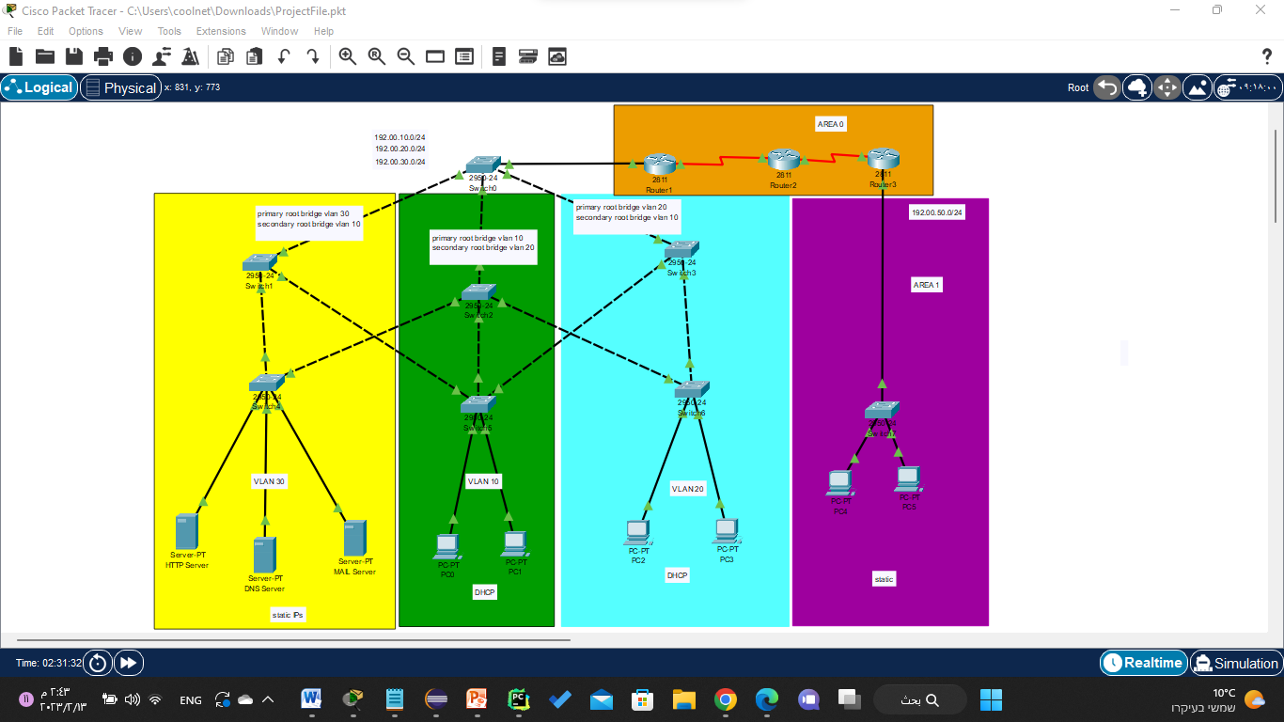

Figure 1: Network topology

|  |  |
| --- | --- |
| Router-PT |  |
| Switch-PT |  |
| PC-PT |  |
| Server-PT |  |

Table 1:Tools

# IP assignment and subnetting

IP addressing and subnetting are two essential concepts in computer networking that play a crucial role in the efficient and effective routing of data between different networks. In this project, you are tasked with assigning IP addresses and creating subnets for routers and end devices in a network topology. The network consists of three routers, several switches, and various PCs and servers.

Assigned IP addresses are based on a student ID in the group, with the ID 1200060 or 1200078 corresponding to the IP 192.00.0.0/24. This IP must be subnetted to create the required number of subnets for the network. The assignment of IP addresses and subnetting will enable the communication between devices in different subnets and will allow the routers to properly route data between networks.

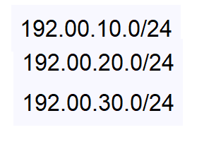

Figure 2:IPs for 3 Networks

# Building the topology

The objective of this part is to assign IP addresses to the routers and end devices and create the required number of subnets using the assigned IP. Further, it includes configuring the interfaces of the routers, switches, and assigning IP addresses to PCs and servers in different VLANs.

Methodology: The following steps were taken to build the topology:

1. IP address assignment: The student ID 1200078 was used to assign the IP addresses to the routers and end devices. The IP address assigned was 192.00.0.0/24.
2. Subnetting: Using the assigned IP address, the required number of subnets was created.
3. Router interface configuration: The interfaces of the three routers were configured as instructed in the figure.
4. Switch Configuration: The switches were configured as instructed in the figure.
5. PC IP address assignment in the home network: PCs in the home network (Purple) were assigned IP addresses in a static manner based on the assigned network IP.

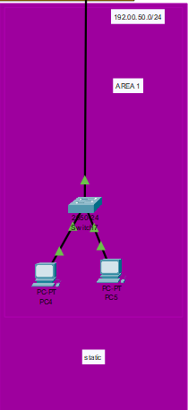

Figure 3: PCs in home

1. PC IP address assignment in VLANs 10 and 20: PCs in VLANs 10 and 20 (Green and Blue) were assigned IP addresses from Router0 using DHCP.
2. Server IP address assignment in VLAN 30: Servers in VLAN 30 (Yellow) in the data center network were assigned IP addresses in a static manner based on the assigned network IP.

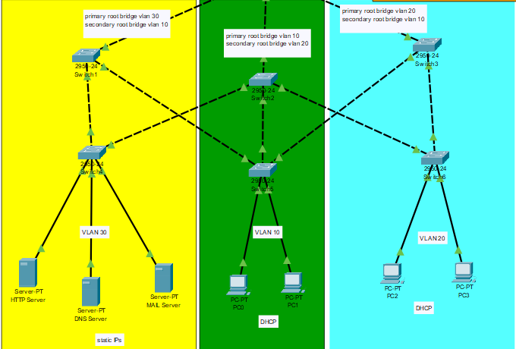

Figure 4: VLANs

Note:

For routers, we should add an extra series interface

A. Click on Router 

Figure 5: power button in router

B. Click on button that shown in figure 4

C. Click on interface from menu in left and drag it to

Empty port on the switch (as figure 5) and then click on button 

Figure 6: empty port

Results: The topology was successfully built using Packet Tracer, with all the required IP addresses assigned, subnets created, and the routers and switches configured as instructed. The PCs and servers were assigned IP addresses in the specified manner, and all the devices were successfully connected.

# Configuring servers and VLANs

In this part of the project, three servers were used in the topology: HTTP/WEB server, DNS server, and Email server. The following are the steps taken to configure these servers and VLANs.

1. Configuring the DNS and WEB servers: The DNS server and WEB server were configured with the domain name www.ENCS3320.com. The DNS server was responsible for resolving the domain name to an IP address, which was then used by the web server to serve the website.

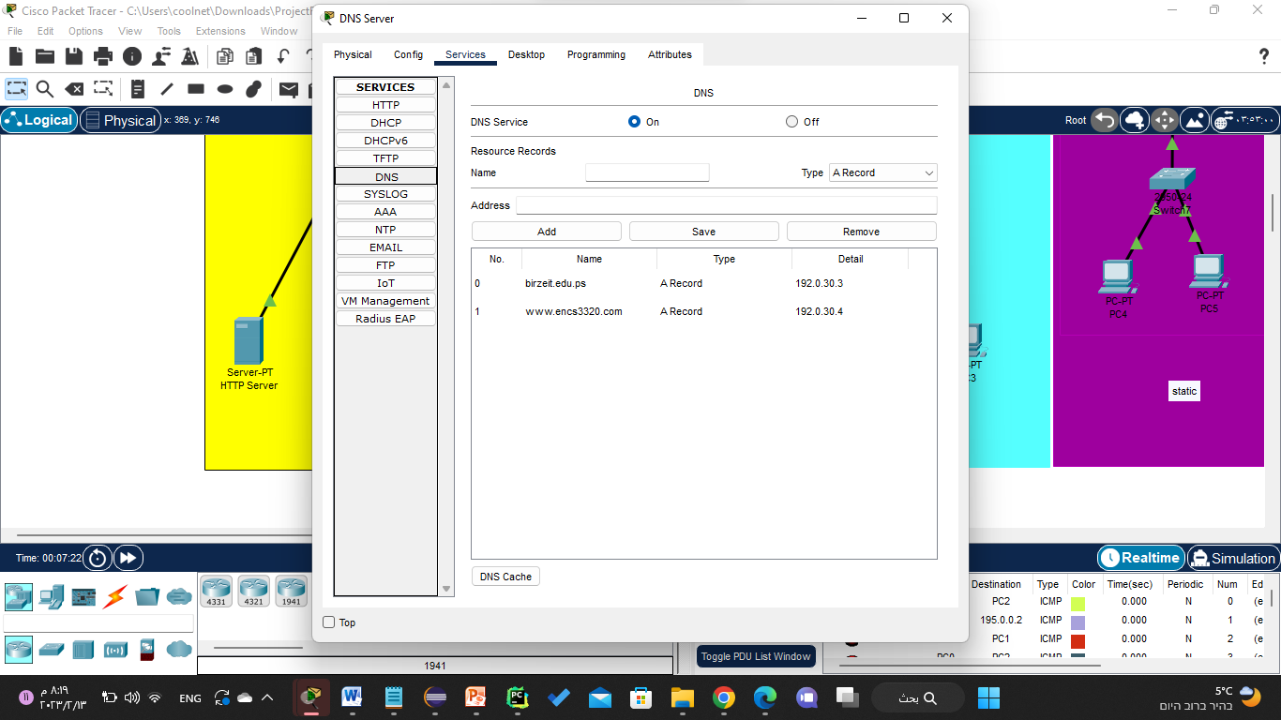

Figure 7: DNS server

1. Creating the website: The index.html file in the HTTP server was modified to create the website. The website contains the following information:

" ENCS3320-My First Website" in the title

" Welcome to our course Computer Networks" (part of the phrase is in Red(

Group members' names and IDs

Information about the group members, including projects completed during different courses (programming, electrical, math, etc.), skills, and hobbies.

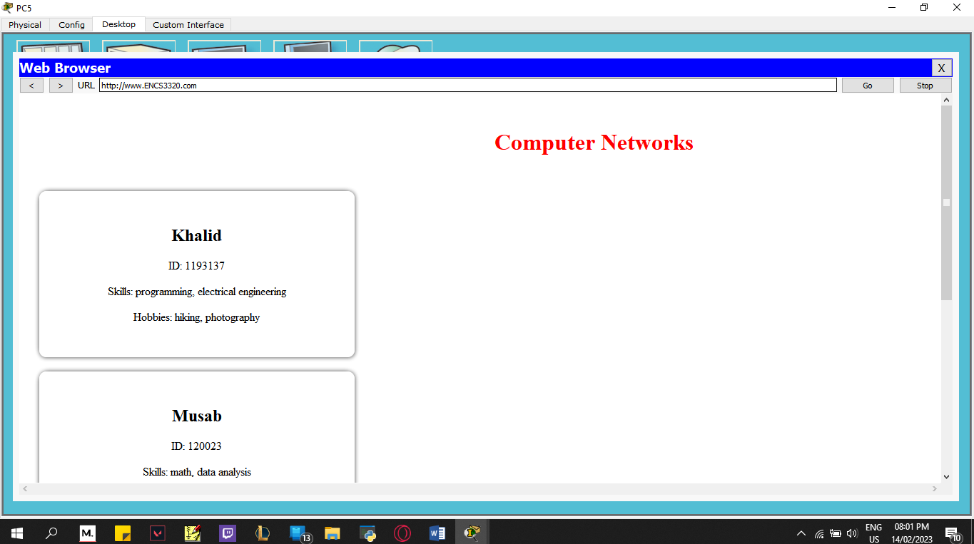

Figure 8: HTML SITE

Note this is Pc5

1. Creating usernames/passwords for email server: Usernames and passwords were created for all PCs (PC0, PC1, PC2, PC3, PC4, and PC5) in the email server (birzeit.edu.ps). The usernames are pc0, pc1, pc2, pc3, pc4, and pc5, and the passwords are 123 for all.

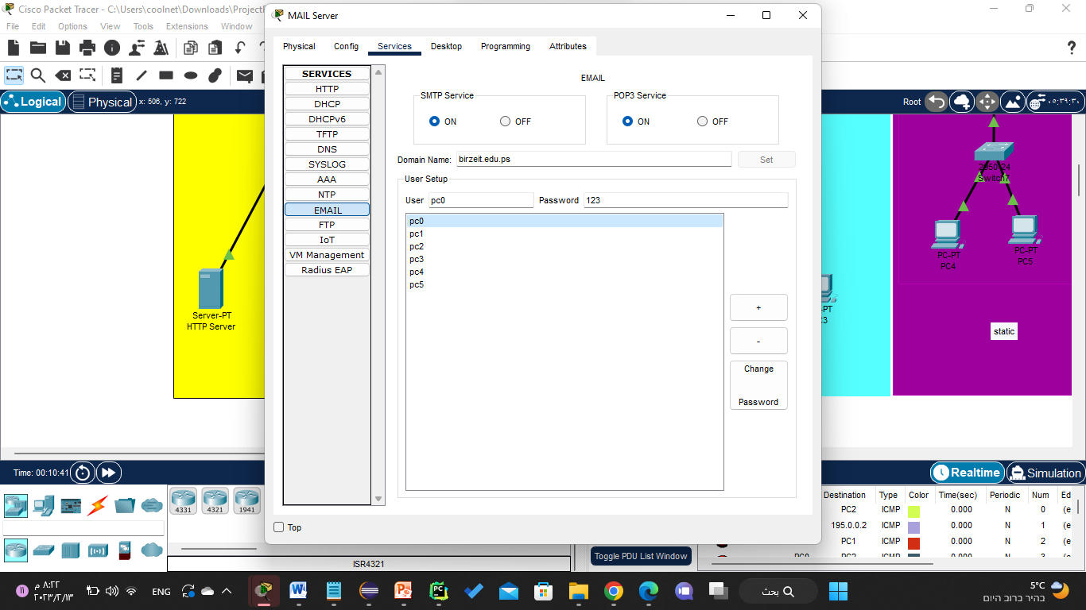

Figure 9: usernames/passwords for email server

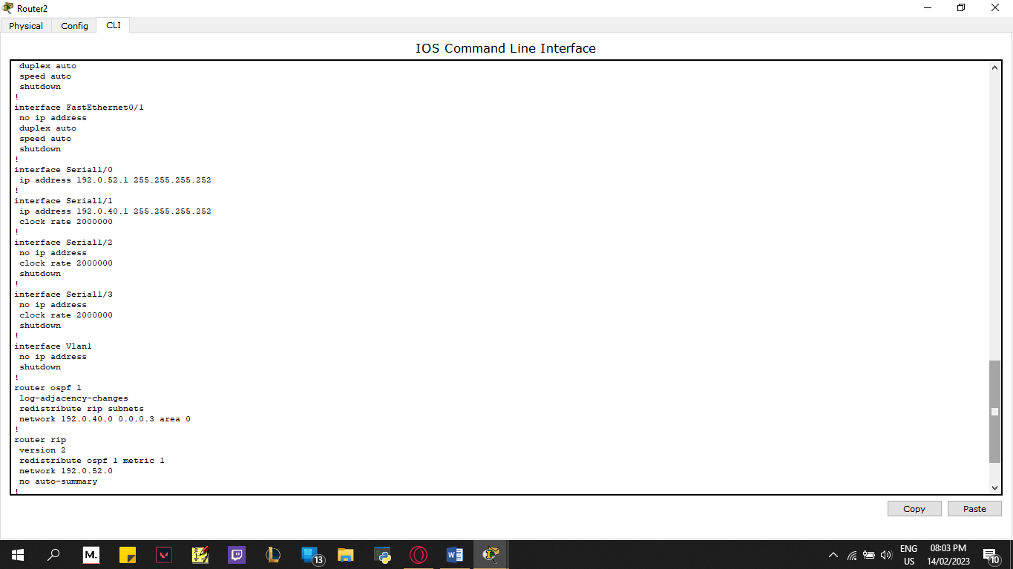

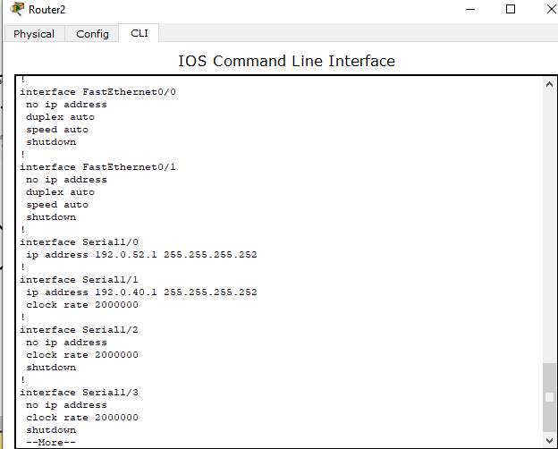 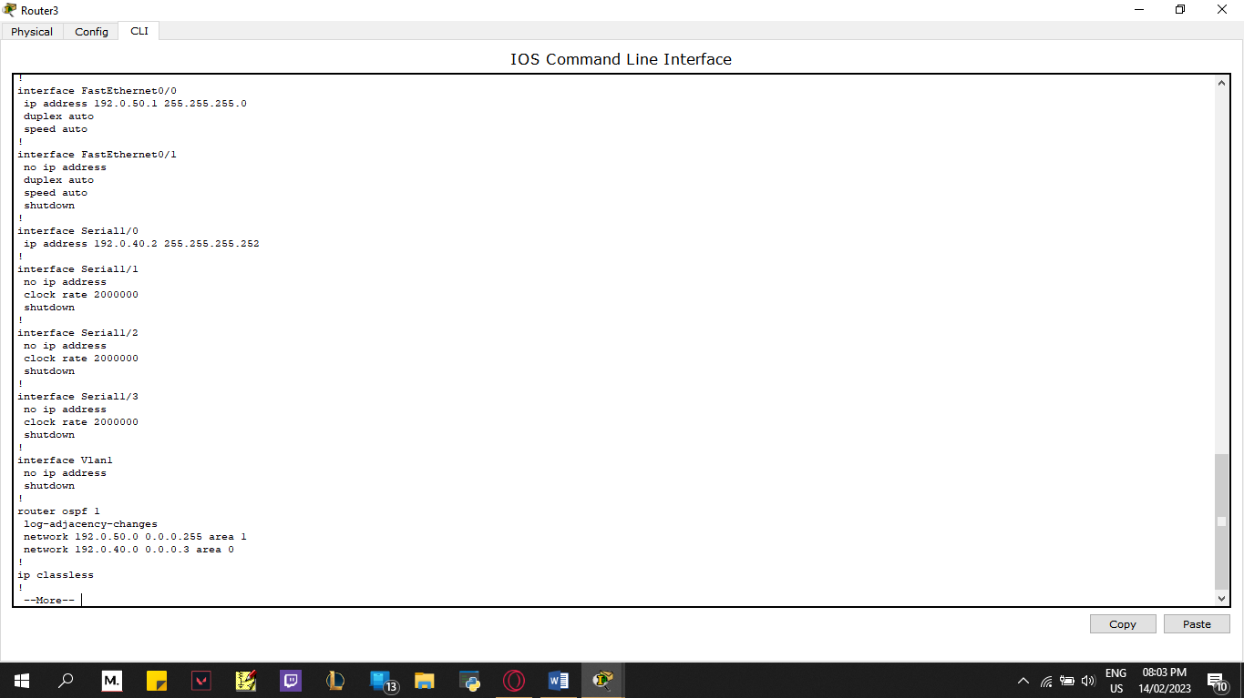

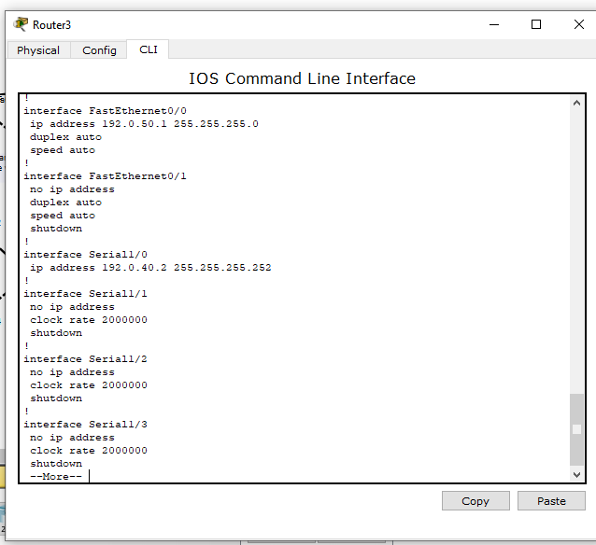

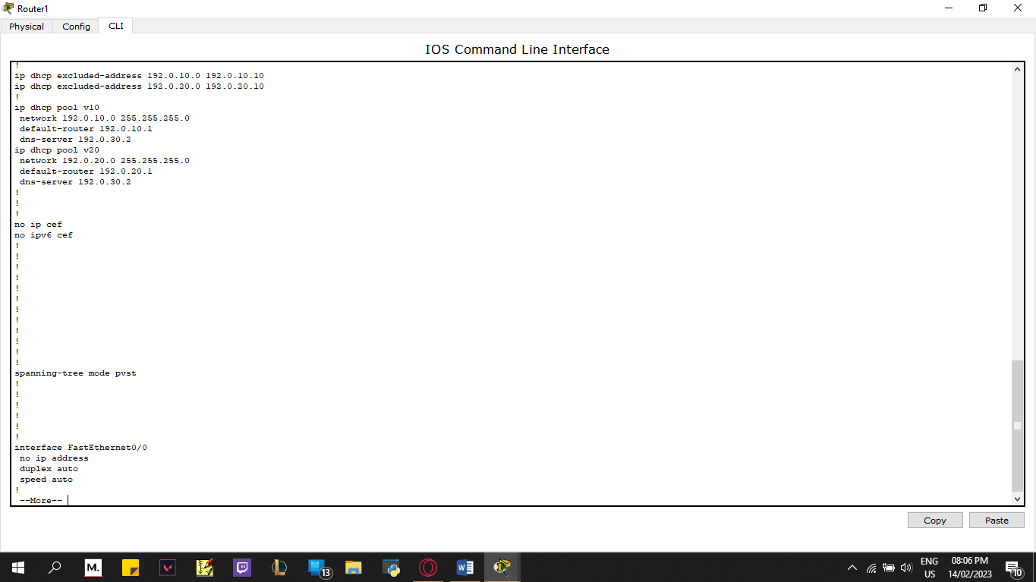 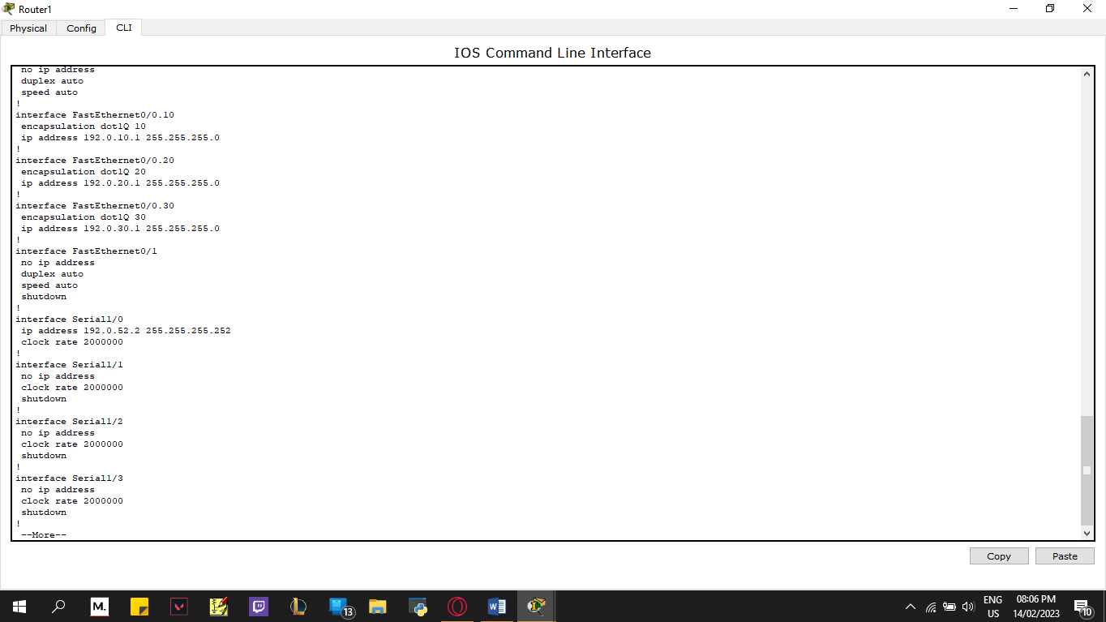

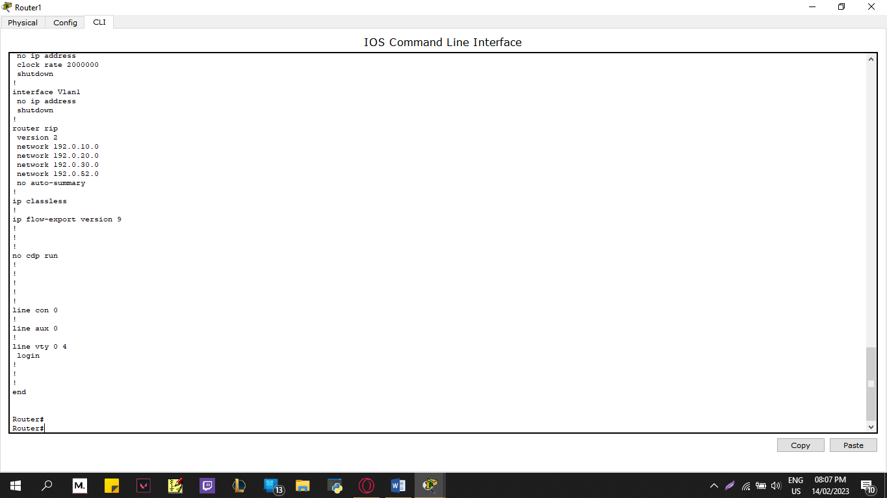

Figure 10: Commands

# Applying the routing protocols

## Configuring OSPF Routing

To configure OSPF we will enter all router configure and open OSPF routing to add all directly

connected networks

Example on Router 3:

A. If the prompt is Router(config-if) # then write: exit

B. Select an PROCCESS-ID for OSPF (can take numbers between <1 - 65535>)

e.g., Router(config)# router OSPF 1

C. Add all networks that connected directly with router

Router(config-router) # network 192.00.50.0 0.0.0.255 area 1

Router(config-router) # network 192.00.40.0 0.0.0.3 area 0

D. Do same for router 2

To set the IPs for all PCs:

A. Click on PC that you want to set IP for it (e.g., PC0)

B. Go to Desktop

C. Select ip configuration

D. Write ip address, subnet mask and default gateway

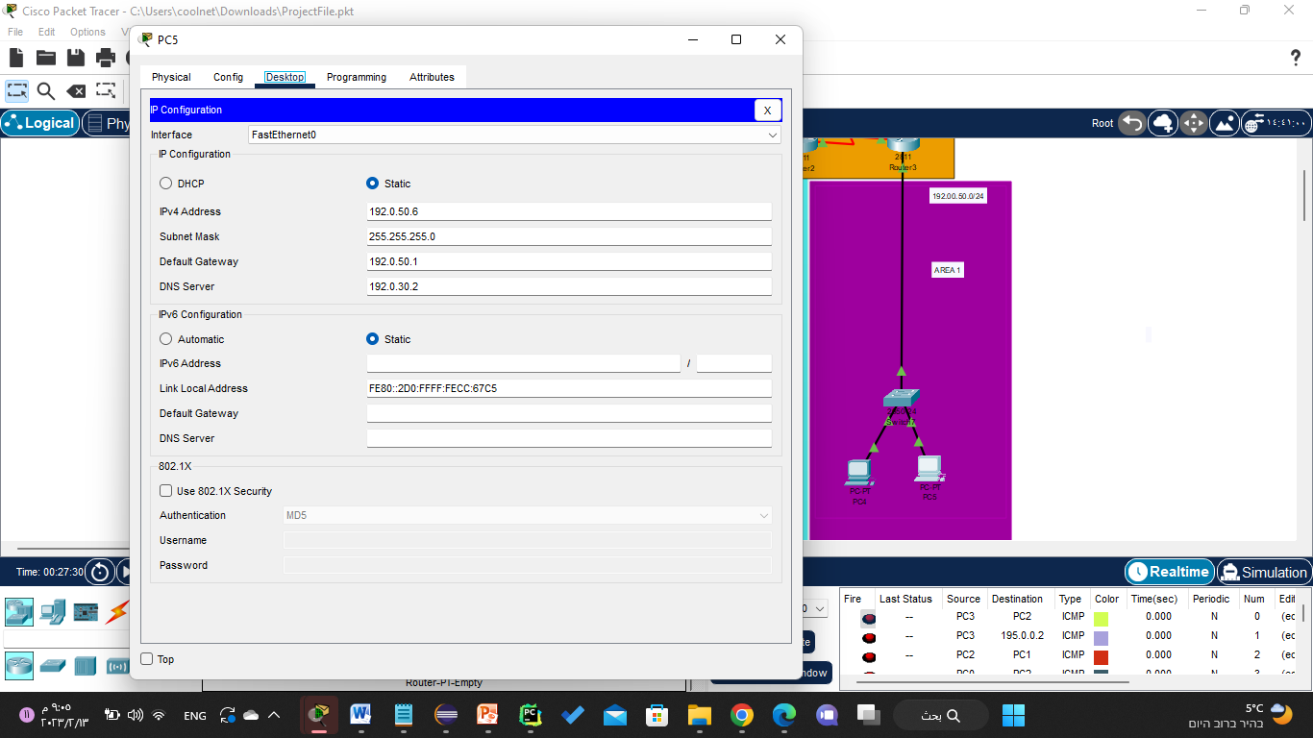

Figure 11: set ip for PC

# Result

## Testing Connectivity between PCs:

1. Open the command prompt on the source PC (e.g. PC0).
2. Type "ping [destination PC's IP address]" and press enter.
3. Take a snapshot of the results and record it in your report.
4. Repeat steps 1-3 for each pair of PCs in the network.

The ping command sends a packet to the destination PC and measures the time it takes to receive a response. If the destination PC is reachable, the ping command will display the response time. If the destination PC is not reachable, the ping command will display an error message. The results of the ping command can help you determine if there are any network connectivity issues between the PCs.

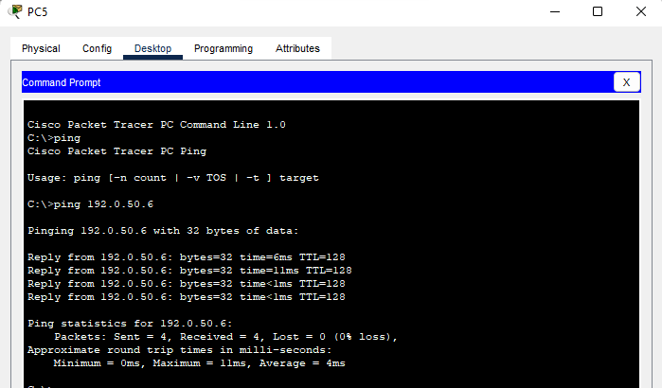

Figure 12: ping PC5

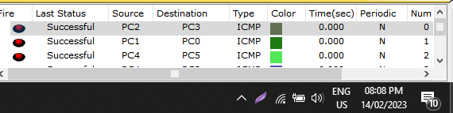

# 

Figure 13: connectivity between PCs

## Accessing [www.ENCS3320.com](http://www.encs3320.com/):

1. Open a web browser on each PC.
2. Type "[www.ENCS3320.com](http://www.encs3320.com/)" in the address bar and press enter.
3. Take a snapshot of the website displayed on the screen and record it in your report.
4. Repeat steps 1-3 for each PC in the network.

Accessing [www.ENCS3320.com](http://www.encs3320.com/) from each PC helps you ensure that the HTTP server is functioning properly and that each PC can access the internet.

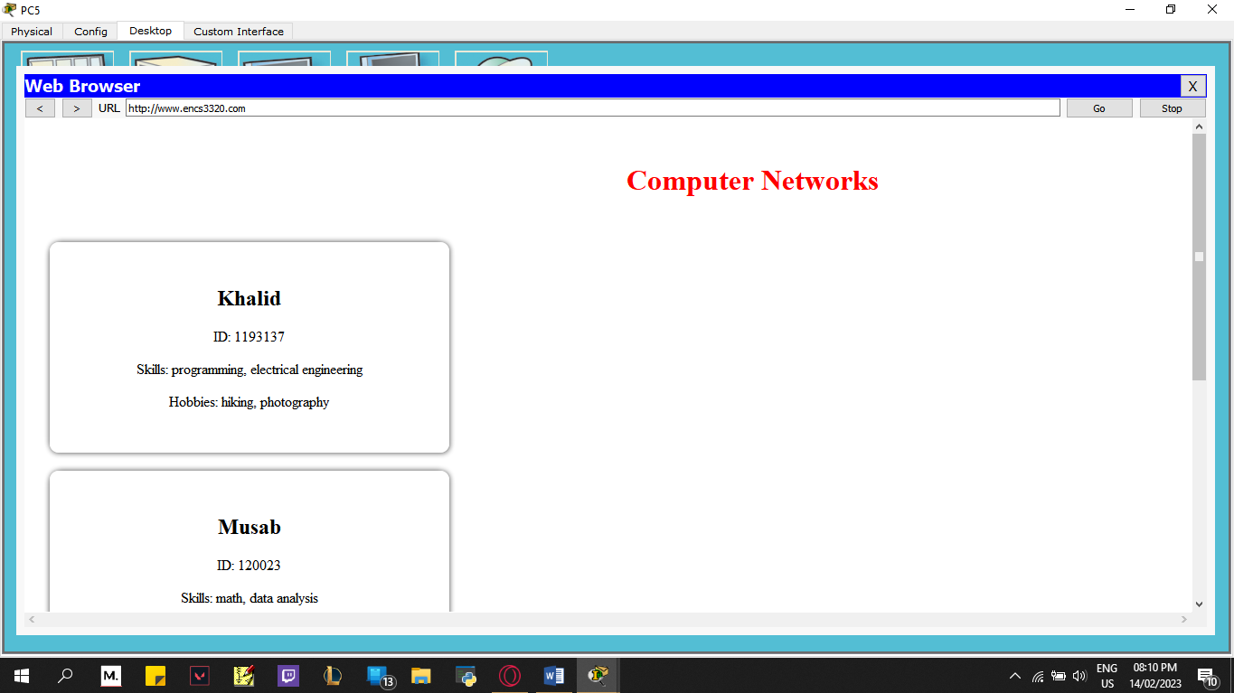

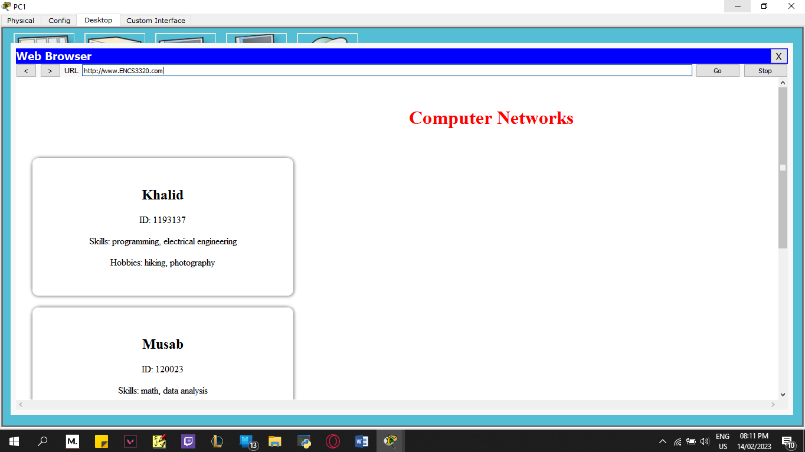

Figure 14: Access www.ENCS3320.com from all PCs, take snapshots for all cases.

## Sending Emails:

1. Open the email client on the source PC (e.g. PC0).
2. Compose an email with the recipient PC's email address.
3. Send the email and take a snapshot of the sent email.
4. Open the email client on the recipient PC and check for the received email.
5. Take a snapshot of the received email and record it in your report.
6. Repeat steps 1-5 for each pair of PCs in the network.

Sending emails between PCs helps you ensure that the email server is functioning properly and that each PC can send and receive emails.



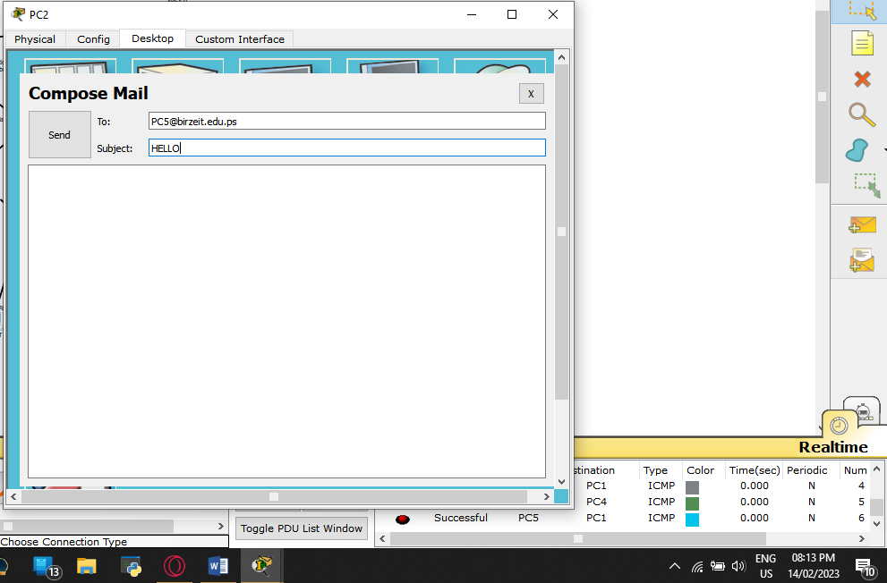

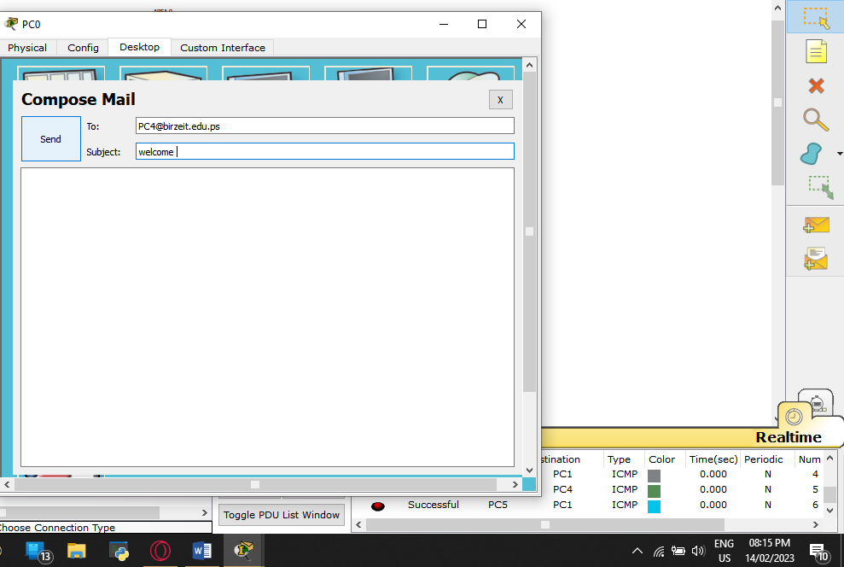

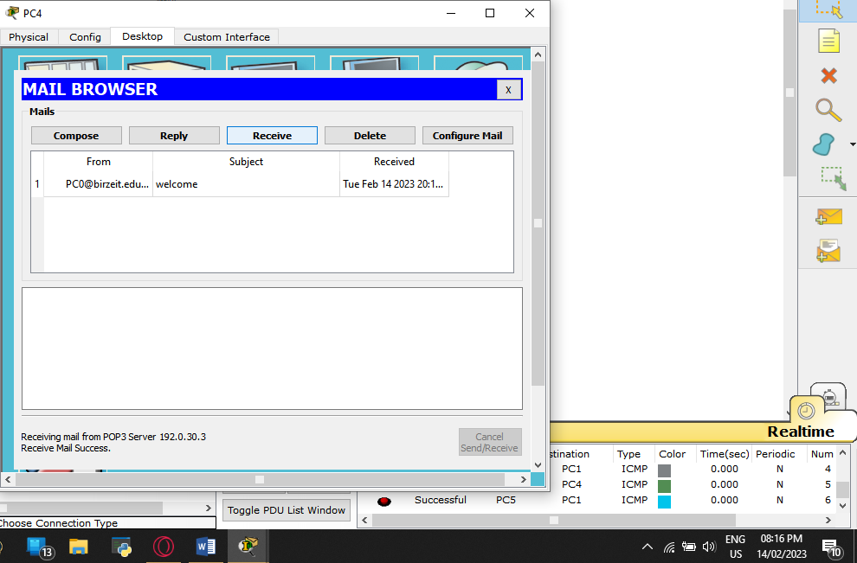

Figure 15: emails from one PC to other PC and take snapshots at the receiving PCs

# Conclusion

In conclusion, this project aimed to design and implement a network topology using the Cisco Packet Tracer tool. The project was divided into four parts, starting with the IP address assignment and subnetting, followed by the building of the topology, configuring the servers and VLANs, and finally, applying the routing protocols. Through this project, the team was able to showcase their knowledge and understanding of computer networks and their components.

The IP address assignment and subnetting were accomplished as per the requirements of the assignment, and the topology was built with three routers and multiple switches. The servers were configured with domain names and usernames/passwords were created for the PCs. The VLANs were established for the different networks, and the routing protocols were successfully applied. The connectivity between the PCs was tested and proven to be functioning effectively.

Overall, this project was a great opportunity to demonstrate the practical application of the concepts learned in the course of computer networks. The final result is a well-designed and functioning network topology that meets the requirements of the assignment and provides a solid foundation for future network projects.