Title: Information Disclosure in Alipay

Business: Alipay

Vulnerability type: sensitive information leaked

Harm: Low Risk

Vulnerability URL：https://docs.open.alipay.com/

Details:  
 Let me first explain that this vulnerability was originally targeted at Nginx servers. But considering that the Tengine server is improved on the basis of Nginx. The essence should not change, so the following attempts have been made.

first step:  
 Let's build the poc first to make it easier to test later.

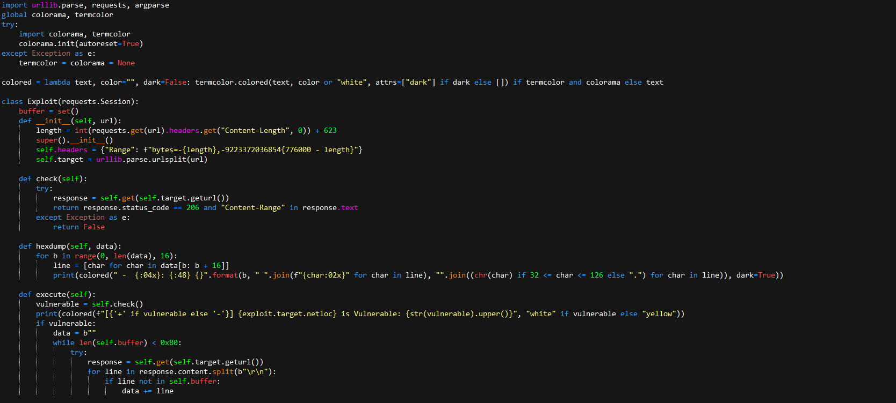

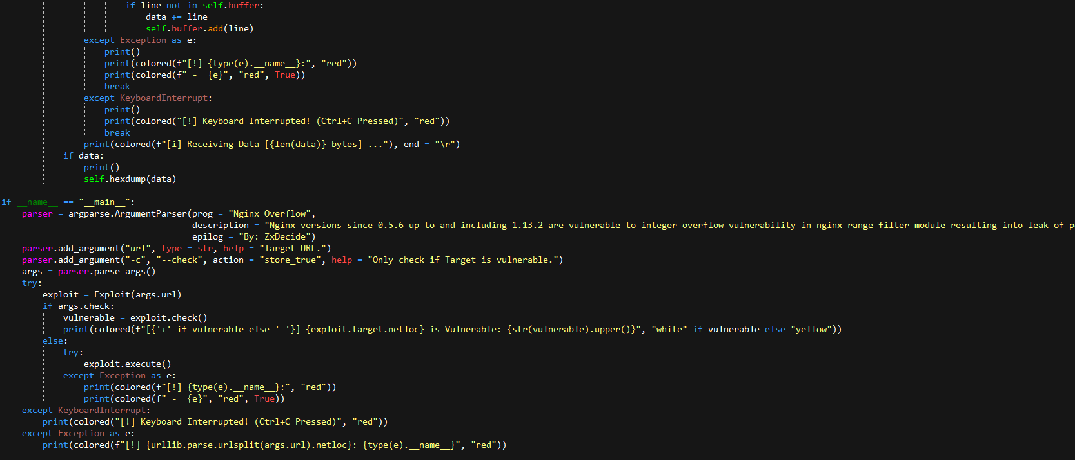

Here I named the script poc.py. Then start testing directly.

second step:

Statement:python poc.py -c https://docs.open.alipay.com/



The result returned to true, proving the vulnerability exists

第三步：

View related content and wait

Statement:python poc.py <https://docs.open.alipay.com/>

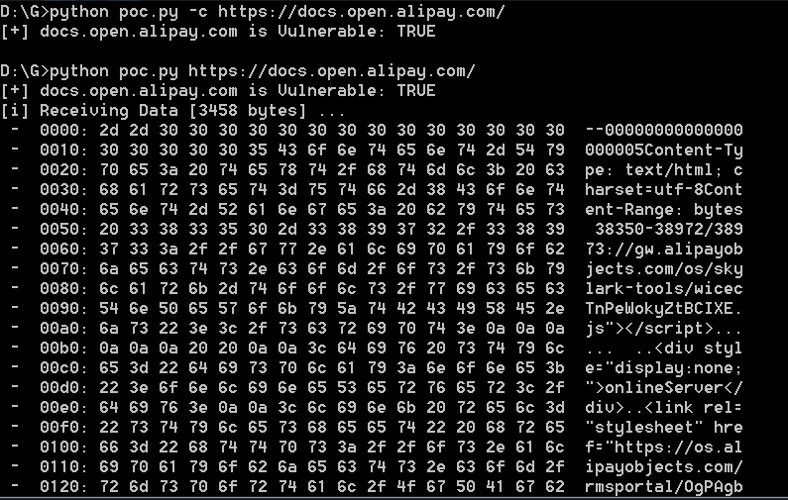

So far the vulnerability has been proven.

Here are some related examples

URL:<https://think.lenovo.com.cn/>

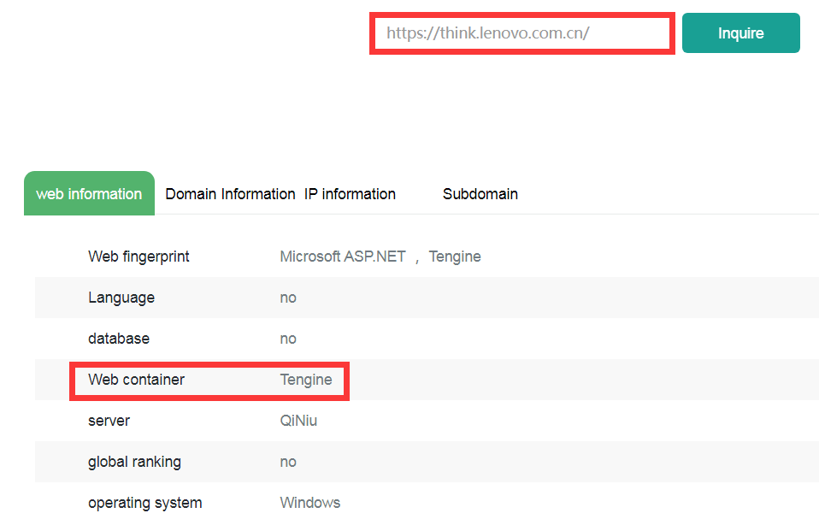

URL:<https://docs.open.alipay.com/>

