Iris Flower Classification using Machine Learning

Objective
The goal of this project is to classify Iris flower species (setosa, versicolor, virginica) using machine learning based on flower measurements.

Dataset Features
- Sepal Length
- Sepal Width
- Petal Length
- Petal Width

Model Used
Random Forest Classifier from Scikit-learn

Model Accuracy
Accuracy Score: 1.00

Classification Report
precision recall f1-score support
Iris-setosa 1.00 1.00 1.00 10
Iris-versicolor 1.00 1.00 1.00 9
Iris-virginica 1.00 1.00 1.00 11
accuracy 1.00 30
macro avg 1.00 1.00 1.00 30
weighted avg 1.00 1.00 1.00 30

Confusion Matrix
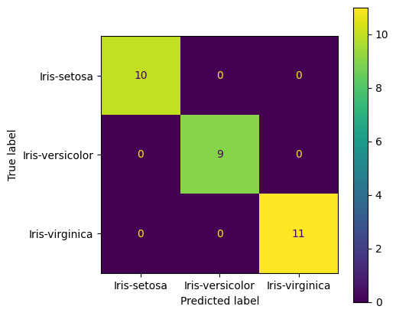

Conclusion
The machine learning model successfully classified Iris flower species with high accuracy. This project demonstrates basic classification concepts using Scikit-learn.

