**Project to download files**

*Link video: <https://drive.google.com/file/d/1fmiryDqli0DvTuErfvB7vCwr-_vYFLKq/view>

**GROUP MEMBER:**

* 21110780_Nguyễn Duy Mạnh
* 21110764_Đỗ Huỳnh Bảo Đăng
* 21110112_Ngô Phạm Quang Vinh

1. **Technology:**

* Fragment
* Tab Layout
* ViewPaper

1. **Service Purpose:**

+ Use Background service

* A service can continue to execute even if the user switches to another application or leaves your application. This ensures file downloads are not interrupted when the user interacts with other parts of the device.
* Downloading files may take time, especially for large files or slow network connections. By running the download operation in a background service, you prevent it from slowing down the main UI thread, ensuring a smooth user experience.
* If the user leaves the app or locks the screen, a background service can continue executing, allowing the download to continue without interruption.
* For tasks that require continued user awareness, like downloading large files, you can use a service that runs in foreground mode. A service running in foreground mode displays a persistent notification to the user, indicating that the application is performing a task, ensuring that the user is aware of the activity taking place.

1. **Step to step:**

+ Open this app in andriod studio

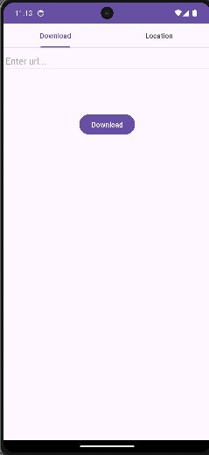

+ Paste link need to download

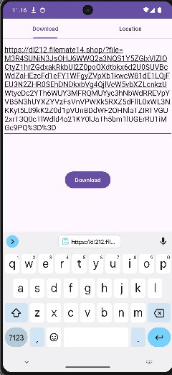

+ Successful

