**Fernandez, Zylene C. IPT-2**

**WMA-4B September 22, 2023**

1. Create a GitHub Account (10 Points)

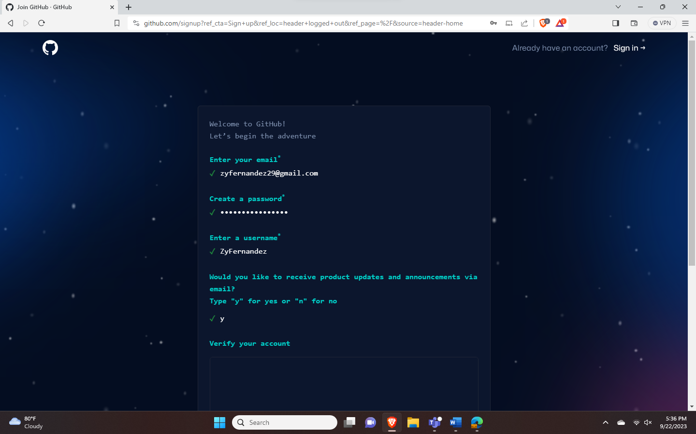

1. On your account, create a repository named Lastname_Firstname_Year&Section (2 Points)

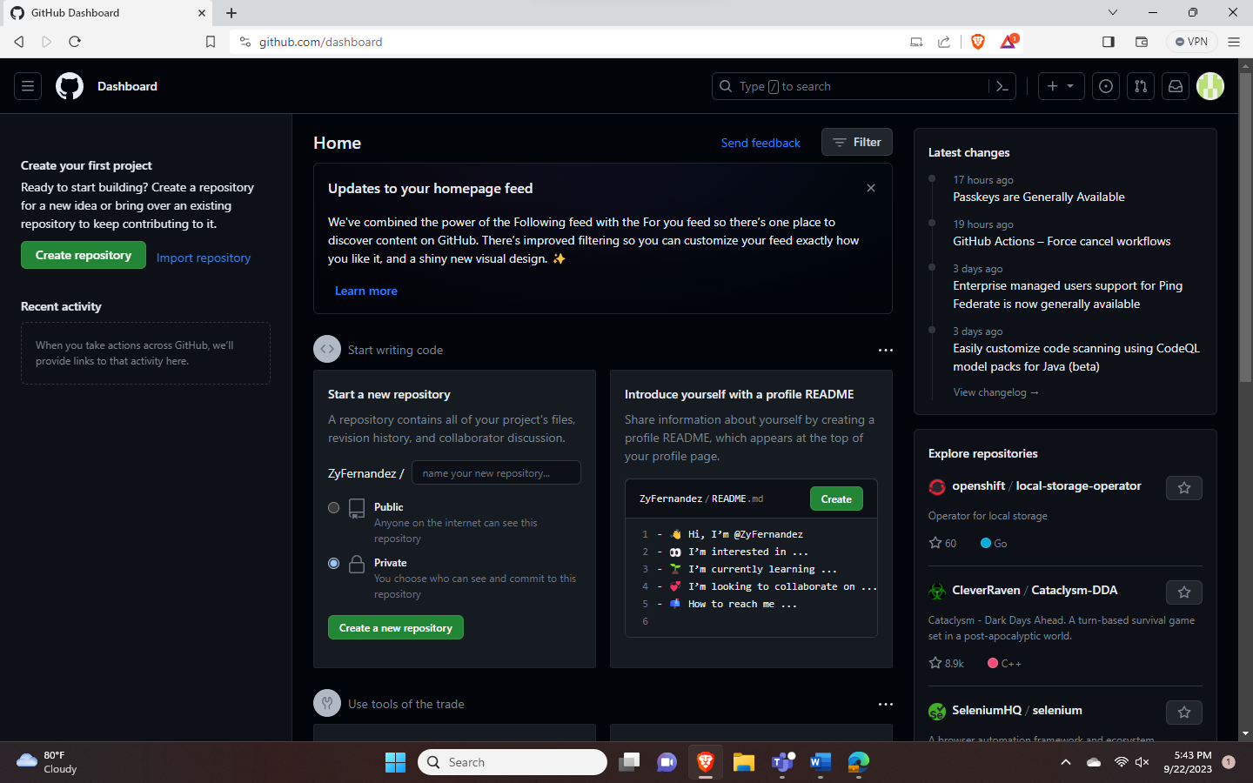

- Your repository should be public (1 Point)

- Add a short description (1 Point)

- Note: Check “Initialize this repository with a README” (1 Point)

1. On the left side, click the “Branch.”

- Branch name should be “September 22 2023, IPT2 Activity” (5 Points)

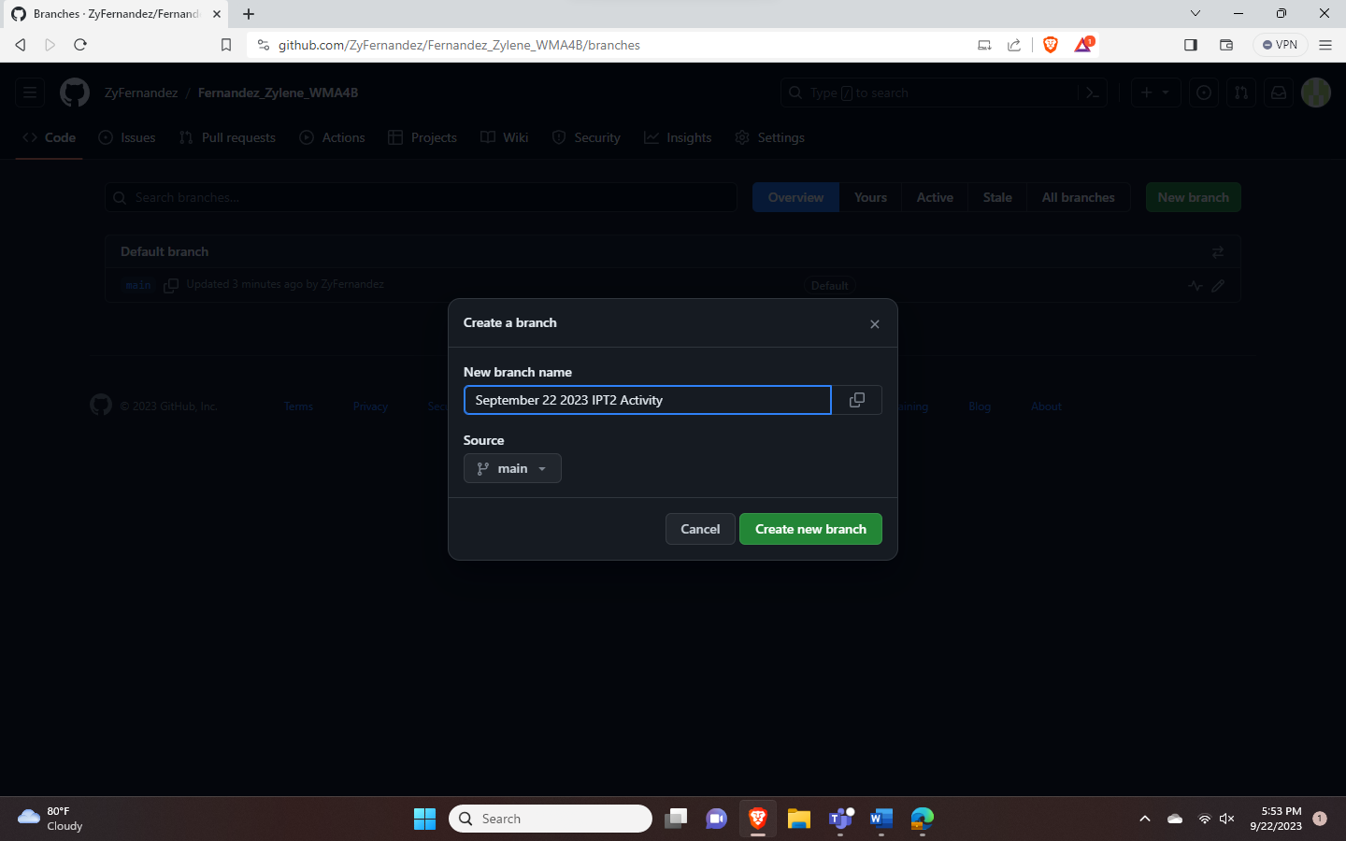

1. Under the September 22 2023 IPT2 Activity

- On the right side, click the “Add file.”

