**Mobile Security Technology (BMT3308)**

**(Lab-3)**

**Yerassyl Sagatbek (30205)**

**SIS-2101**

**Task: Create a Modern Navigation drawer (Side Menu) in android studio**

**Task 1:** Design the dashboard of the App in android studio.

**Paste Screenshot:**

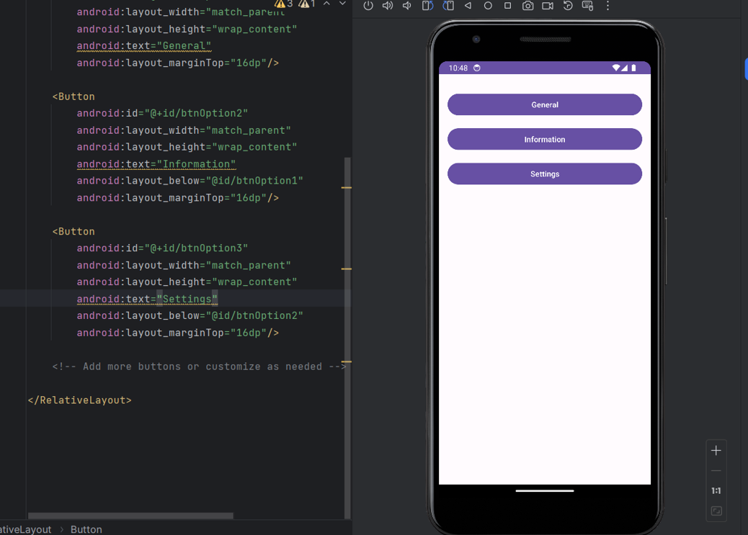

**Task 2:** Design the side-menu of the App in Android studio.

**Paste Screenshot:**

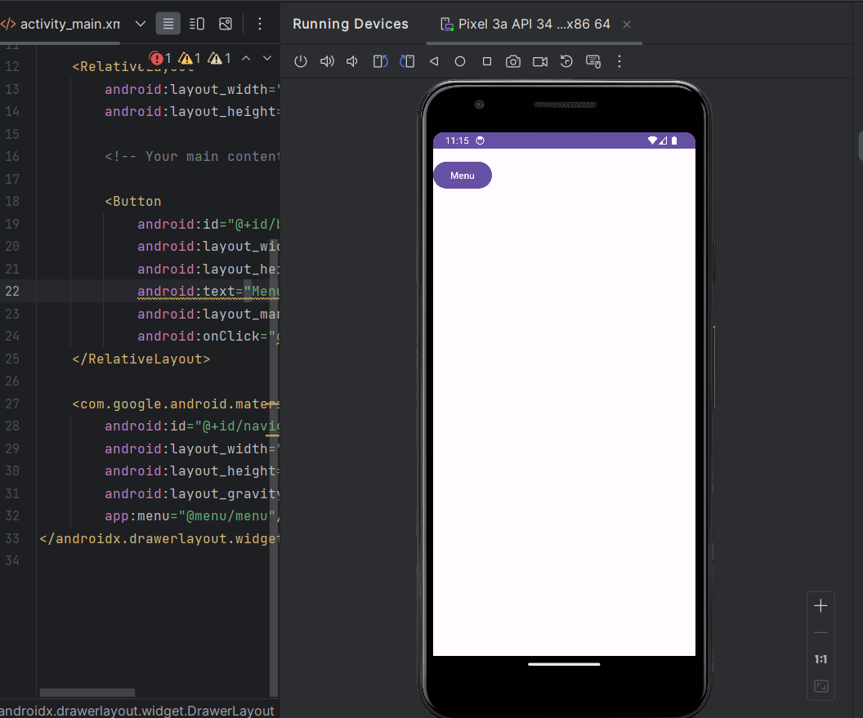 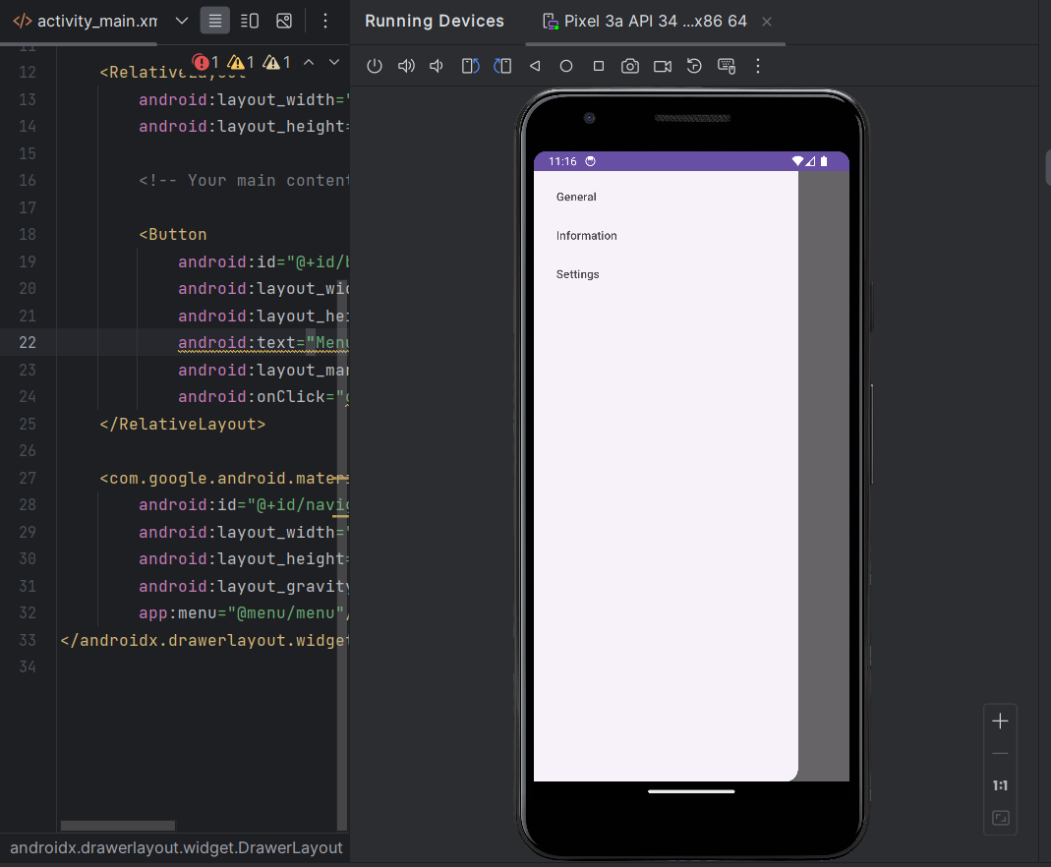

**Task 3:** design the header menu of the App in Android Studio.

**Paste Screenshot:**

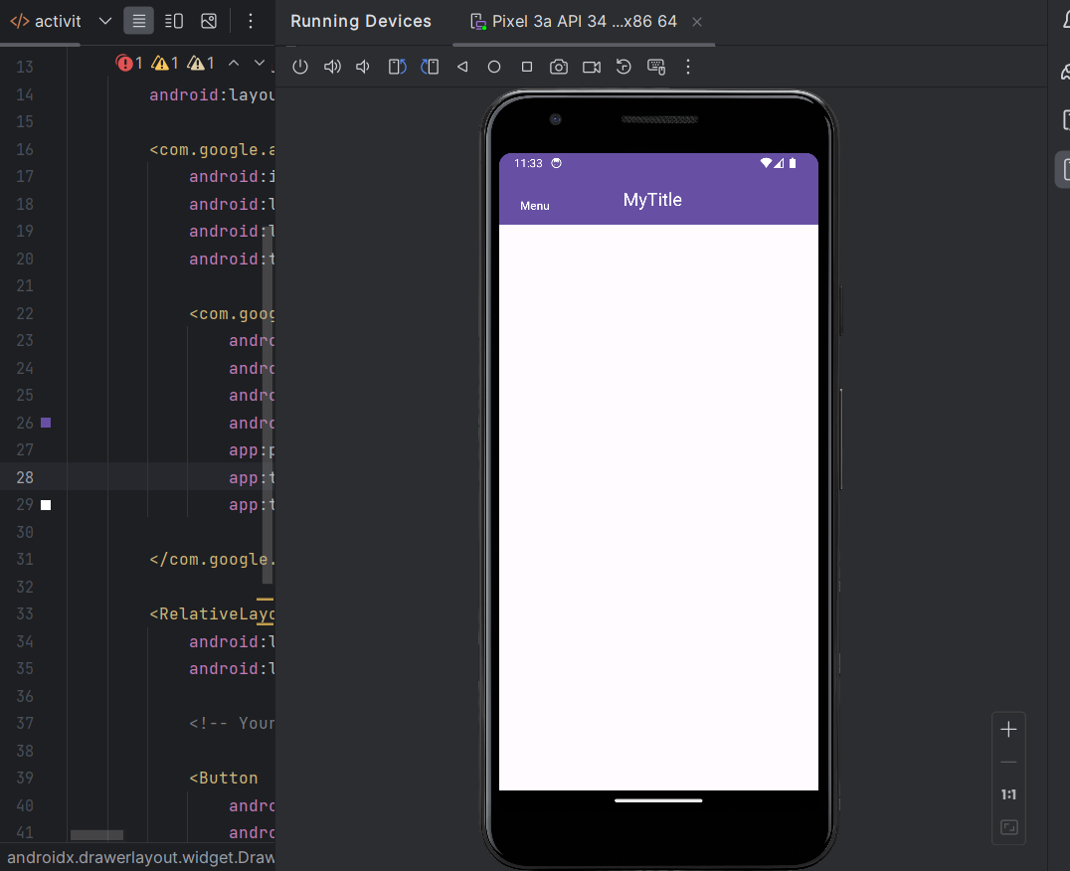

**Task 4: Combine all together and create .APK file and install into your phone**

**Paste Screenshot:**

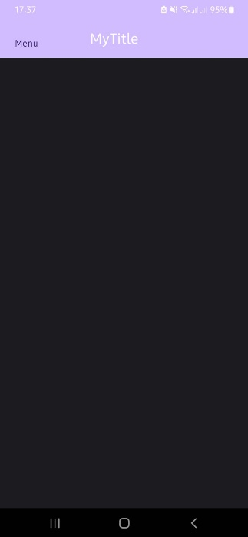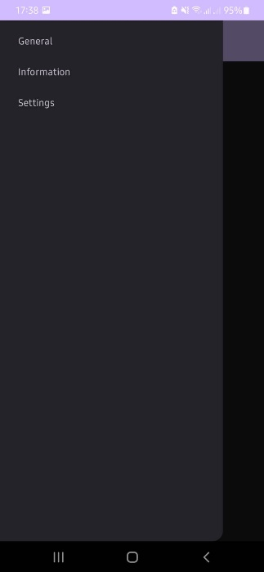

**Task 5:** Upload the project to a repository on your GitHub account.

**Paste Github Link:**

**Paste Screenshot:**

