**Part 1**

Unit test screenshots:

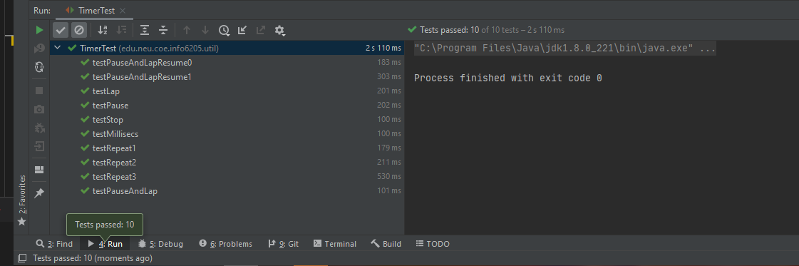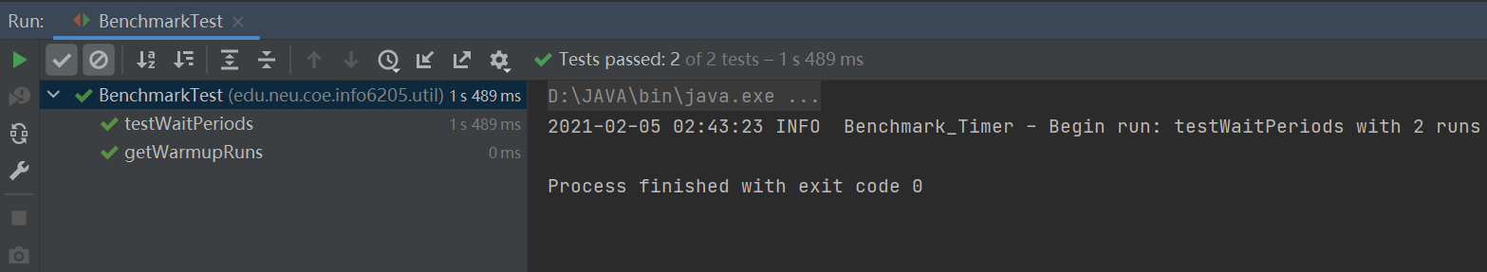

**Part 2**

Unit test screenshots:

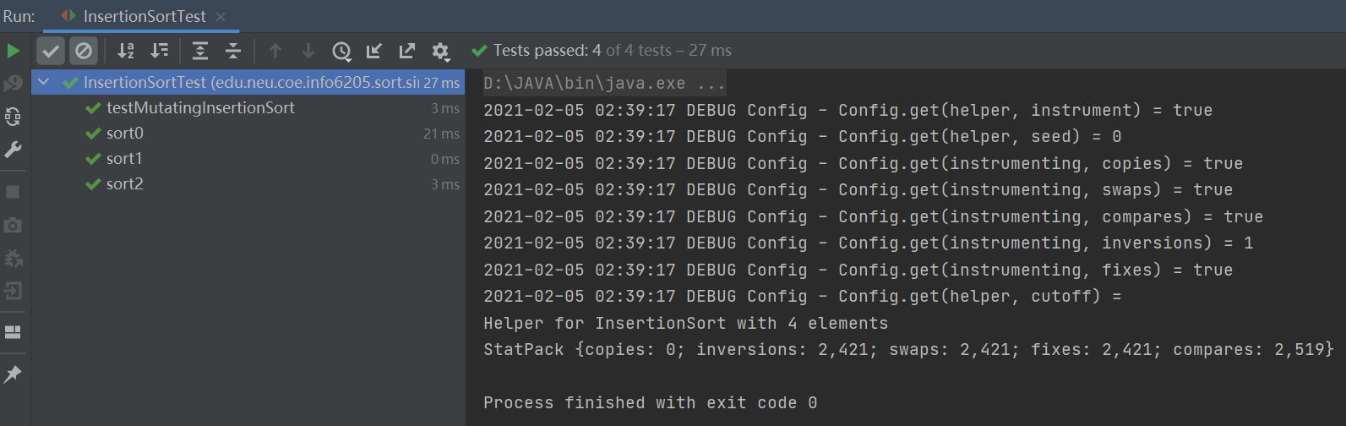

**Part 3**

The time of system spend on each kind of orderlist:

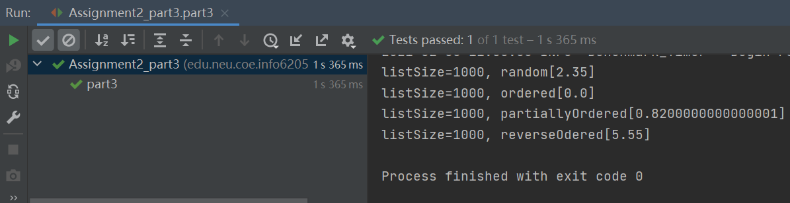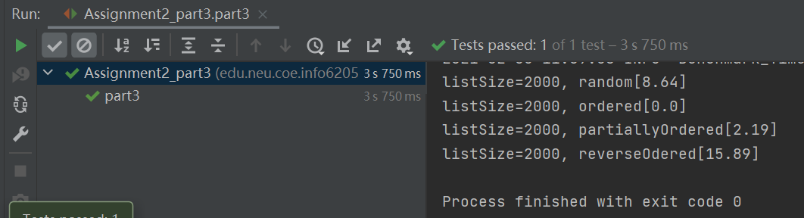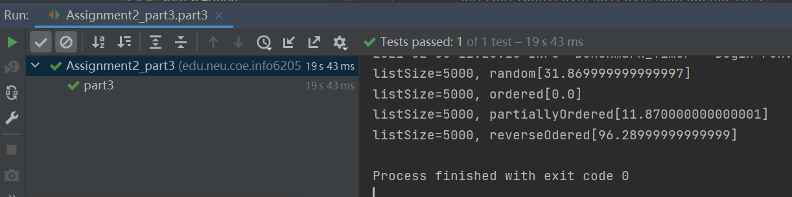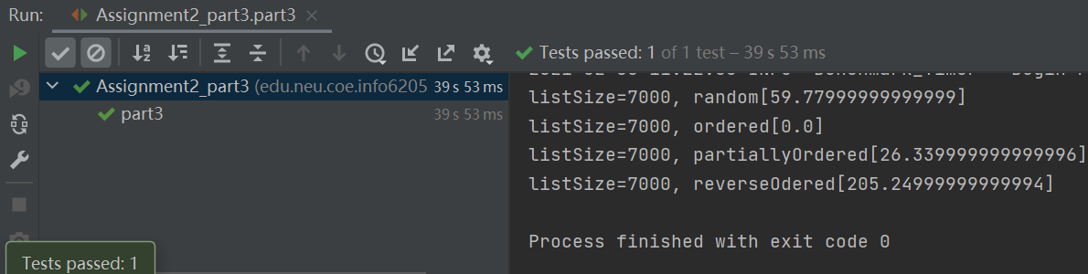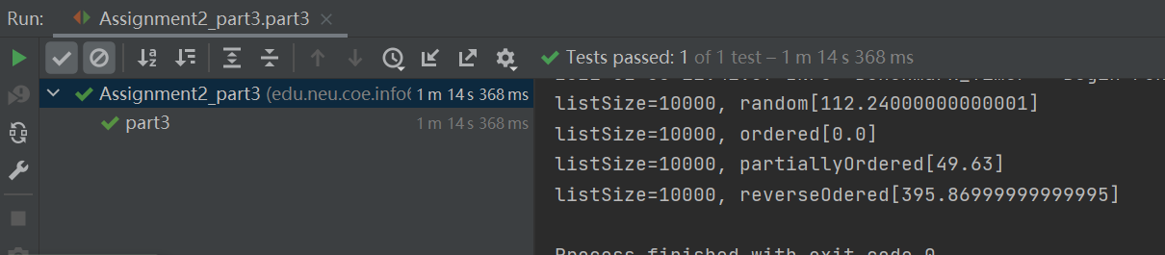

Here we can see that the result was stable in 5 experiments with different n.  
The reverse order list spend the most time, almost apporch to O(N^2)  
Random list has normal performance.  
Partially Random list spend less time than random.  
The ordered list is spend least time, always zero.