Name of project :-

Hospital management system

Team members :

First in the login page :
The user(Doctor ) login in the system by his user name and Password.
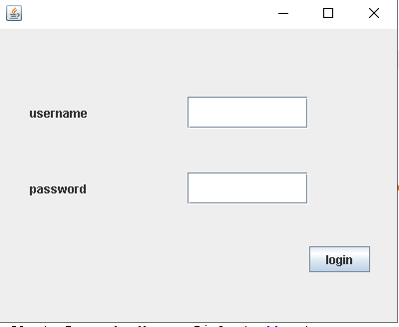

Second page :
After examining the patient ,knowing what he suffers from, prescribing the appropriate
Treatment for him and every thing the patient needs.
The user put all this information as input
And save all this inputs in the data base.
Then when this patient visit the doctor in the hospital again all this information will
Help the doctor to know the history of this patient.
And if the patient didn’t visit the hospital again the admin can easily delete patient’s profile information.
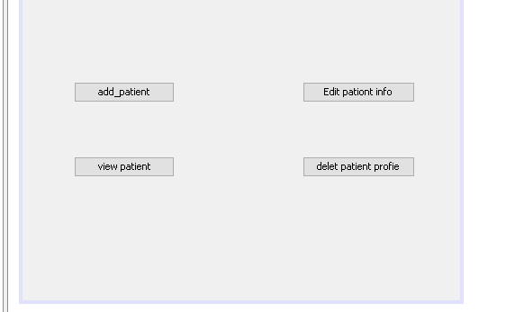

Then all information of the patient will apper to the doctor in this window to know the history of this patient
