The Impact of Renewable Energy Adoption on Economic Growth



Zyad Mohamed Husseini 900211914

Author’s note
Department of Economics, The American University in Cairo.
This research paper is submitted to ECON 408101, under the supervision of Dr. Mina Ayad, Department of Economics at the American University in Cairo.

Table of Contents
Topic: 5
Renewable Energy Adoption and Economic Growth (Research Question) 5
Motivation: 6
My contribution: 7
The methodology of collecting the data and how it was collected (credibility): 8
Summary of key findings: 8
Literature review 10
Debates between the scholars: 16
Their methodologies: 18
The Findings: 20
Gap in the research: 21
Research hypothesis: 22
Why these variables: 23
Time period: 1990 2023 24
Regions being analyzed: 25
Regional Classification: 25
Heatmap of Multicollinearity: 26
Descriptive Statistics: 28
Graph describing each country and mean of their GDP per capita 29
Scatter Plot of GDP Per Capita Growth Against Renewable Energy Consumption with Fitted Regression Line 31
Distribution of GDP per capita growth: 33
My Expected findings based on past results: 34
OLS Regression for the model (asdoc command): 35
Testing for heteroskedasticity: 37
Robust Regression to address heteroskedasticity: 38
A comparison between the normal OLS and the Robust OLS: 39
Potential Endogeneity Issues 40
Limitations of my model so far, 42
Why is the new model MLE: 44
Changes made for the new model: 45
New correlation matrix (heatmap): 46
MLE Regression: 47
Graph for iterations: 50
Fixed effect regression with dummy variables: 52
Addressing endogeneity: 54
2SLS MODEL: 55
For better robustness also ivreg2: 56
Addressing autocorrelation: 59
Analysis: 59
Fixing the auto collinearity issue: 60
Analysis: 60
Hausman test: 62
Using random effect with my panel data: 63
Interpretation of the results from the literature review: 64
Empirical findings and policy recommendations: 67
Research expansion: 68
Sources: 69

Topic:
The following paper aims to uncover the effects of adopting renewable energy consumption for the economic performance of a country. With the increasing focus on the transition from fossil fuel as a source of energy to the clean energy sources such as solar, wind, hydro, and bioenergy, consideration of the economy impacts of the switch is of great importance. Namely, the paper aims to answer the question of whether the increase in the share of RE in total energy consumption of a country has a positive impact on the GDP per capita growth. This research endeavor uses Panel data spanning across several decades to capture the role of renewable energy in the developed and underdevloped Countries: is it just a mere environmental requirement or a strategic development tool as is generally assumed? This is especially important these days given the climate agreements and the search for ways of making economic growth climate friendly.

Renewable Energy Adoption and Economic Growth (Research Question)
Do increases in renewable energy consumption spur economic growth?

Motivation:
Climate change has spurred interest in how the shift to renewable energy affects economic performance across countries. Renewable energy currently accounts for about 19% of global final energy consumption (international energy Aagency) , and its expansion is seen as key to “decarbonizing” economies and mitigating climate change. Beyond environmental benefits, renewable energy can reduce reliance on imported fossil fuels, expand energy access for the millions people lacking electricity, and create green jobs. These potential benefits suggest renewables could positively influence economic growth. Indeed, one study finds that a 1 percentage point increase in the share of renewables in energy is associated with a 0.12 percentage point rise in GDP per capita ((Fang 2011) . However, evidence is mixed other research notes that current renewable technologies have lower energy return and may not boost growth or employment in the short run . This inconsistency makes the renewables growth nexus an interesting, policy relevant topic to revisit with robust econometric methods. By using a global panel dataset from the World Bank, we can examine whether greater renewable energy usage drives economic growth (a critical question for sustainable development policy).

My contribution:
Hence, this paper offers several important empirical contributions to the literature on renewable energy and economic growth. Firstly, it employs a panel analysis that utilize a large and long dataset across a number of countries, which allows for a better understanding of the dynamic relationship between RE consumption and GDP per capita growth. I am therefore able to pick up structural changes as well as cross country variability hardly visible in single country or short time frame researches.
Second, by controlling for the influences of gross capital formation, trade openness, education attainment, and population growth, the study controls for several explanatory variables that affect the performance of the economy and thus obtains an accurate measure of the impact of renewable energy consumption.
Third, the variables in the study include controls on other possibly country specific factors that might affect the results, including institutional quality, geography or history of energy use. This enhances how internal validity of our estimate is attained.
Finally, this paper brings policy implications to the academic literature because the authors identified some data that could support the claim that renewables should be included in the nation’s economic development agendas. In that manner, it aids both the environmental and the economic policy by defining how and in which extent the adoption of green energy positively relates to the improvement of the economy.

The methodology of collecting the data and how it was collected (credibility):
All data for this study were obtained from the World Bank’s World Development Indicators (WDI). Indicators were selected based on theoretical relevance to the research question, and annual data were collected for a global panel of countries over 1990 2023. Data were downloaded directly from the World Bank DataBank platform, organized in a panel structure (country year format), and cleaned for missing values and inconsistencies using power query. Countries with substantial missing data were excluded to ensure robust analysis.

Summary of key findings:
This research examines the effect of consumption of renewable energy on growth of GDP per capita using panel data and various econometric techniques. The preliminary OLS and fixed effects models indicated a persistent negative and statistically significant relationship between renewable energy consumption (REC) and economic growth, implying that renewable energy though necessary for sustainability, could also mean some short run economic trade offs. These results survived even when unrolling for the possibility of endogeneity using Two Stage Least Squares (2SLS) with lagged REC (LAGREC) assumed to be a good and strong instrument, and verified by Cragg Donald and under identification tests. The 2SLS estimation revealed that a one unit change in REC is associated with a 1.44 percentage point reduction in GDP per capita growth (p = 0.029). Meanwhile, gross capital formation gross capital formation (GCF) was persistently positive and extremely significant confirming its position as a ranking driver of economic growth. Other variables such as tertiary enrollment (SET)(this variable is added later on in the paper), log population growth (LOGPG) and trade openness (TRADE) were statistically insignificant across models. Models with year dummies supported the fact that some time specific global shocks (such as those in the years 2008 and 2020) influenced the dynamics of growth that provided further proof of the necessity to consider temporal variance. Overall, the results demonstrate the complexity, transitory character of renewable energy’s role in development, and the centrality of investment as a potent mechanism of even greater growth.

Literature review
- Scholar arguments research
From political economy perspective, the role of renewable energy in economic development has been explained in the following way. In a classical growth model, the factor of production including energy has a significant parameter; hence the provision of more renewable energy can increase the productive capacity and level of output of an economy. This view is backed by the renewable energy led growth hypothesis which suggests that increasing the use of renewable energy propels the economic growth hence the GDP. On the other hand, there are scholars who also speak of potential trade off or transitional costs. renewable infrastructure is capital intensive, and it has the problem of intermittency, which might act as a limit to future development in the short run, if controlled without proper measures. This view can be explained by what is known as the conservation perspective, which supports the dispute that causality lies in the energy’s causal relationship with economic growth, meaning that countries focus on growth first before turning to renewable energy. Another theoretical viewpoint that can be associated with this concept is with the environmental economics. the global EKC hypothesis that posits that in the initial stages of its development, a country depends on polluted energy but when it achieves a certain level of development, it switches to clean energy without compromising on the levels of growth. As such, renewable adoption is attributed to income levels and increased demand for quality public environment for growth and environmental enhancement to go hand in hand. These theories provided the background for future discussion of an important issue in economic literature regarding the role of renewables in the economy (sources for all this section are included in the references).
Some of the empirical works, especially in the developed countries, have provided evidence that the use of renewable energy enhance long run economic growth. For instance, Bayraktutan et al. (2011) usedd a panel data model on the 28 member countries of the OECD for the period of 1980–2007 investigating the integrated and causal relationship between renewable electricity generation and GDP showing a long run direct relationship of the renewable electricity generation with the GDP and bidirectional (opposite)) causality between both these variables. This shows that increased output of renewable electricity is positively linked to higher economic growth, and in the same respect, economic growth prompts increased investment in renewable energy a cycle. This conforms with the feedback hypothesis widely used in energy economics and suggesting that renewables and growth can elevate each other with time. In its recent work, this perception has been supported: Following a similar analysis for 35 OECD countries till 2020 and employing a different causality test, Raifu et al. 2025 also establish the two variables as being mutually causal between renewable energy consumption and economic growth. They find out that after accounting for labor and capital, renewable energy is both a driver of and is driven by GDP, meaning that incorporating the renewable sources in production process has positive impacts on growth while, in turn, has the potential to encourage more usage of renewable energy. They also pointed out that the degree of causality can vary with increasing the share of renewable energy at lower levels of renewables, the growth effects are weaker although significant, while at higher levels of deployment, the dynamics are even stronger.
A survey of other works that use the OECD sample indicates the presence of a positive effect, but nuances in it concerning unlinearity. Wang and Wang (2020) utilized a panel model and focus on OECD countries to analyze the result of renewable energy consumption for economic growth and it also demonstrates how the increased consumption of renewable energy enhances the GDP thereafter crossed a certain threshold. Thus, if renewable use goes above the critical share of total energy (for instance, if a country invests in renewables to a greater extent), the renewables contribute more to the growth of the economy. This means that there is not a certain number of units that the firm has to produce before experience lessens the returns for each additional unit produced. on the other hand, increasing renewable energy can act as a catalyst to more growth outcomes, possibly because of increased technological progress, experience effects or discovering and leveraging on lower energy import costs with higher levels of renewables. Still, even when the share was below the threshold, the impact was still positive although to a lesser degree showing that there is no negative impact of renewables on the growth of OECD region’s economy. However, none of the OECD country in the sample acted as a net importer of negative growth effect from renewals. it was either non existent in a few instances, or positive in the best case scenario once renewables reached a certain level. This fits well with the argument that any rise in renewables should not necessarily be viewed as development negative because the developed economies have the capability of incorporating them given the advanced infrastructure.
The general idea in the latest empirical analysis of the OECD countries experience therefore suggests that renewable energy and economic growth are mutually reinforcing in the long run. In general, energy literature reveals that incorporating more renewables is consistent with further increase on the economic growth rate thus promoting the “green growth” premise. Traditional high income states, in contrast, have attained a sufficient level of technological development in wind, solar, and other forms of renewable sources of power generation, implying that transition is not costly in terms of economic efficiency. The long run response of renewable energy consumption to per capita GDP is positive according to Allam and Bou Nader (2021) with regard to France, Italy, and Turkey during the period of 1990 to 2015. They realize that this is more prevalent within the countries with higher GDP (France, Italy), with it being somewhat considerably weaker in Turkey. This implies that the growth payoff of renewables may be easier to capture especially in the developed countries, maybe because of efficient infrastructure, high power quality, and more effective energy markets in these countries. However, the evidence of causality embedded in this paper also included long run co integration, which proves that Turkey also has the link by going through different development stages albeit at different frequency. In general, for OECD and other developed countries, the literature in this area has arrived at the following objective conclusions: the majority of renewable energy supports long term economic development, and a mutual causality relationship where success is achieved through more investment in clean energy forms a great circle of power.
While the results are mixed for the emerging market and developing countries, it has been established that regional context and development levels matter significantly. One question of interest was whether the positive renewables growth connected to GDP growth , documented earlier in developed countries, also existed in low to middle income countries. Still, there are some pieces of evidence supporting the growth hypothesis, particularly in developing countries. For example, Li et al. (2021) examine the relationship between renewable energy and economic growth for a panel of countries belonging to South Asian (SAARC) utilizing some estimations, which reveals that renewable energy has a positive and significant role in SAARC countries (LI 2021). As for other middle income groups like, for example, some Asian or Latin American panels, it also tends to estimate positive and even significantly different positive long run coefficients for renewable energy in the growth regression analysis which also means that renewables can foster growth in such cases as well. However, many researchers also warn that such effects can be realized only at a certain minimum level of development or infrastructure. Chen et al. . (2020) conducted an overall global analysis of such conditional effects. Working with 103 countries between 1995 and 2015, Sera integrating and non OECD countries, the authors realize that only if a country achieves a certain level of renewable consumption or advancement, renewable energy pushes economic advancement. In cases of renewable usage is still below that threshold, the effect on growth was either negative or non significant. This means that small or initial investments in renewables might not have possibilities of returning growth benefit in such countries this could be due to other factors such as high costs of generation, inefficiencies or the idea that clean energy has a minimum floor that needs to be installed so as to affect the whole economy. On the other hand, if they attain a certain level, more renewable energy use will indeed spur growth in those countries. This again corresponds with other research, as Chen et al also find for the sample including the OECD economies only the renewable growth relationship was positive through out but for the highest income level even the marginal impact of increase in renewable energies is zero. But over the period concerned and with advance in technology most emerging economy has witness a turn around and indeed a positive relationship between renewables growth. It has been well documented that negative results had been found in many researches, but some recent research shows that the trends are reversing. For example, Yang, Zhou, & Feng (2022) discover in a panel study of the ‘Next 11’ large emerging economies that renewable energy consumption has a significant and positive effect on economic growth, and the results of the causality analysis imply that renewable energy and GDP are, in most cases, mutually causing each other in the long run across these countries. This means that, just like in the OECD countries, renewables are both a cause and an outcome of development in these nations. Another survey conducted on 15 emerged economies by Salehin and Kiss (2022) also proposed that there exists a positive relationship between renewable energy consumption (as a portion of the final energy) and GDP per capita in the long run. Still, their causality analysis only reveals out that an economic growth positively influences the renewable usage and the executed causality in the opposite way is negative. Besides, they noted that there was no short run effect of renewable energy consumption in the growth outcome . In practical terms, what this implies is that in the emerging markets renewables and growth go hand in hand but yes it means that growing economies are spending more in renewables (and not the other way round where renewables directly lead to growth in the emerging markets in the short term). This one way causality is consistent with the notion that developing countries may use more renewables initially as a byproduct of having more resources from growth and more so once the energy mix become dominated by renewables, the growth advantages can be seen.
Collectively, the results from developing countries do not appear to be as definitive as those found in developed nations, within the OECD. A number of works confirming the long run positive co integrated relationship between renewable energy and growth even in the emerging economies have been also published, however, pointing out that the impact could be strong, weak or even negligible depending on several key factors such as the scale of the renewable energy, level of development and availability of supporting infrastructure. The indication is that when renewables are first introduced to a low income environment they can initially exert negative net impacts (and costs), but as these investments build up, and nations become industrialized, these typically turn positive or net beneficial.

Debates between the scholars:
The goal of the debate among scholars is to determine whether the resource utilization in renewable energy leads to economic expansion or whether economic expansion leads to utilization of renewable energy resources. According to the literature, there are several trends: where energy consumption including renewables is determined by the growth in GDP, Energy Growth hypothesis where energy leads to the growth of GDP, Feedback hypothesis where both variables affect each other and the neutrality hypothesis where none of the two has an effect on the other. The following research studies can help in illustrating each of these three examples. For example, Ocal & Aslan Turkey example showed a growth led (conservation) and the OECD panels by Bayraktutan et al. and Raifu et al. demonstrate feedback causality. However, some separate country analyses (some G7 countries as it was mentioned above based on the prior studies) pointed out that neutrality can be achieved in some periods, but paying attention to renewables only it seems to happen even less frequently. In large samples, most current research evidence appears to lean at least toward a degree of some first order endogeneity in both domains in the long run, renewable energy and growth versus the former; besides, sensitivity to the test of capital, labor and similar controls. This indicates that although in the short run adjustments may be one directed, in the long run, economies adjust in a way that the use of renewable energy and growth can be mutually reinforcing in opposite direction ways.
It is, however, understood clearly that some regional and institutional variables can alter this causality. Specifically, governance quality, market structures, regulations and policies are thought to play an important role for RE to deliver economic benefits. It was suggested that strong institutional environment increases the effectiveness of reinvestment in renewable energy as well as addresses the issue of grid integration and development of favorable conditions for green business, increasing the stimulus impact. On the contrary, weak institutions or policy uncertainty can deter the benefits of renewables and could result to adverse outcomes. For instance, from 45 sub Saharan African countries, Acheampong, Dzator & Savage (2021) include institutional quality into their consideration systematically. However, they show that when they estimate the model on average there exists directional causality between renewable energy and economic growth in this developing region. This means there are countries in Africa today where the use of renewables fosters development and developed nations give more support to renewables. However, it also reveals that the results vary depending on various characteristics of the institutions where they are based (institutional origin or quality). Specifically, the level of development, wealth of nations, and institutional willingness/quality are perceived as critical for the renewable growth relationship . Higher deployment cost poses challenges for the developing nations with weaker institutional environment to penetrate the renewable capacity at scale and hence, delays the associated tricks on development benefits. Therefore, based on their analysis, they argued that though institutions themselves were not found to have contributed to growth in the sample, better institutional quality was found to have a positive correlation with renewable energy and emissions challenges which could enhance energy transition. The policy implication of this is that if enhanced governance and institutional reforms are put in place, the exploitation of renewables in the developing countries could be enhanced.

Their methodologies:
1. Bayraktutan & Yılgör (2011)
Applied fixed effect panel data regression to the OECD economies (1980–2007) to investigate how the GDP per capita growth responds to renewable electricity production. They fixed country specific factors for robustness.
2. Allam & Bou Nader (2021)
Applied analysis for Mediterrian countries France Italy Turkey to study long run and short run relationship between renewable energy consumption and economic growth.
3. Zaekhan & Nachrowi (2012)
Applied a series of multiple regressions within a panel unit of G 20 countries, covering the issue of how per capita GDP and renewable energy consumption are linked to CO₂ emissions mutually.
4. Raifu et al. (2025)
Applied a test in a panel environment for 35 OECD countries, determining the direction of causality between renewable energy consumption and economic growth with the simultaneous presence of capital and labor.

5. Wang & Wang (2020)
Applied a regression model to OECD countries to check whether there are non linear effects of renewable energy consumption on economic growth, with implications on the level at which the strength of association can be affected.

The Findings:
1. Bayraktutan & Yılgör (2011)
established a positive and significant correlation with the renewable electricity generation and GDP per capita in OECD countries. It is interesting that there is bidirectional causation and economic growth initiatives subsequently promote the use of renewables.
2. Allam & Bou Nader (2021)
Identified a long run co integration between renewable energy consumption and economic growth in Mediterranean countries, particularly thriving in the higher income countries such as France and Italy. Regarding the long term relationship, causality was in both ways.
3. Zaekhan & Nachrowi (2012)
Determined that the G 20 countries those have higher GDP per capita and higher renewable energy consumption has lower CO2 emissions, which indicates that economic development may by fostered sustainably.
4. Raifu et al. (2025)
It proved the bi directional causality between renewable energy consumption and the economic growth on OECD countries indicating that the impact rises as the scale of usage of renewable energy rises.

5. Wang & Wang (2020)
Studies have suggested that renewable energy has a relationship with growth : a little impact at initial stage but very much when certain levels are achieved

Gap in the research:
Although, studies included in the research provide plenty of evidence on positive link between REC and economic growth, they have been done mostly for specific regions including OECD or Mediterranean countries. Other works also consider only first round impacts or long run steady state values without much focus on the dynamic transition that occurs within a certain time frame within the panel dataset. However, the causal relationship between renewable energy and economic growth is still inconclusive particularly for the emerging and low income economies due to limitations in infrastructure and variability in policies which averts the economics of renewable investments.. However, evidence for impact of positive effects in developed countries does not necessarily translate into multiplier effect in a multiple country context, let alone in nations of developing world. Moreover, often there is a lack of inclusion of institutional quality or education as the factors moderating the relationship between renewables and economic returns. These gaps are filled in this study by collecting a sample of 7 developed and developing countries using a wide and cross sections panel data, utilizing the multiple effects method and considering other related variables in order to estimate the impact of RE consumption on the growth of GDP per capita. By doing so, it adds further in the debate on the role that renewable energy play as an engine of economic growth in both the developed and developing nations under the different structures.

Research hypothesis:
- (H₀): Renewable energy consumption has no significant effect on GDP per capita growth.
- (H₁): Renewable energy consumption has significant effect on GDP per capita growth.

Legend (defining the variables):
- GDP per capita GDPCAP
- Gross capital formation GCF
- Population Growth PG
- Trade GDPTRADE
- Renewable Energy Consumption REC
- School Enrollment Secondary SE

Why these variables:
Data and Variables (World Bank Indicators)
• Dependent Variable Economic Growth: GDP per capita growth (annual %), which measures the percentage change in real GDP per person every year (an indicator of economic activity as a whole). WDI is the source for this data
• Key Independent Variable Renewable Energy Share: Renewable energy consumption (% of total final energy consumption) the portion of energy consumption in a nation accounted for by renewable forms of energy. This metric tells us the dependence of a country on the renewable energy as a component of its energy mix. A larger number will represent a greater willingness to utilize renewables as opposed to fossil fuels to meet their energy needs.

Independent Variable 1 Investment Rate: Gross capital formation (% of GDP), a variable that it can be used to substitute the investment rate in an economy. As an investment in physical capital is central to economic growth, it is therefore appropriate to include it in the analysis as it is an important growth factor to be managed. World Development Indicators (WDI) is the source of the data
Independent Variable 2 Human Capital: School enrollment, secondary (% gross) this changes to tertiary education later on. Rising levels of education or enrollment rates equal human capital and, therefore, the productivity and growth of economy. WDI is the source of information.
Independent Variable 3 Demographics: Population growth (annual %). Labor market supply and demand are greatly influenced by the population patterns. To be specific, sharp population expansion may reduce GDP per capita, but a larger working age share (which trades off for a lower dependency ratio) can promote growth. WDI is the source of information.
Independent Variable 4 Trade Openness: Trade (% of GDP). Greater openness can expand growth in terms of improved technology transfer and competitive pressure. (WDI) is the source of data.

Time period: 1990 2023

Regions being analyzed:
- USA (North America)
- Egypt (Africa)
- Argentina (South America)
- Belgium (Western Europe)
- Cameroon (Africa)
- Czechia (Central/Eastern Europe)
- Finland (Northern Europe)

Regional Classification:
- Africa: Egypt, Cameroon
- Europe: Belgium, Czechia, Finland
- Americas: USA, Argentina

Heatmap of Multicollinearity:
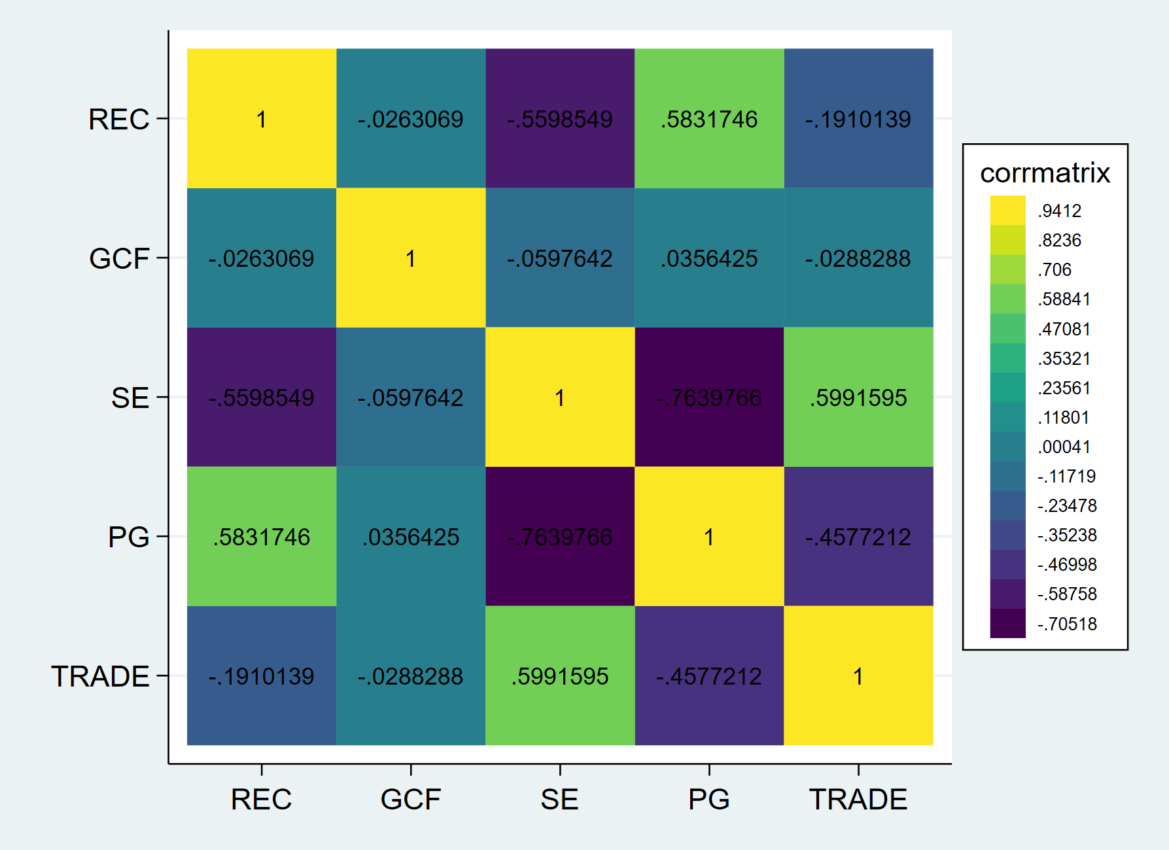
Explanation of the heatmap:
1. SE and PG: −0.7639
This correlation is extremely high, negative and therefore indicate serious multicollinearity between secondary education enrollment and population growth.

2. SE and TRADE: 0.5991
This correlation is extremely high and therefore indicate serious multicollinearity between secondary education enrollment and trade. .
3. REC and PG: 0.5831
This correlation is extremely high, and therefore indicate serious multicollinearity between Renewable energy consumption and population growth.
4. SE and REC: -0.55
This correlation is extremely high, negative and therefore indicate serious multicollinearity between secondary education enrollment and renewable energy consumption.

Descriptive Statistics:
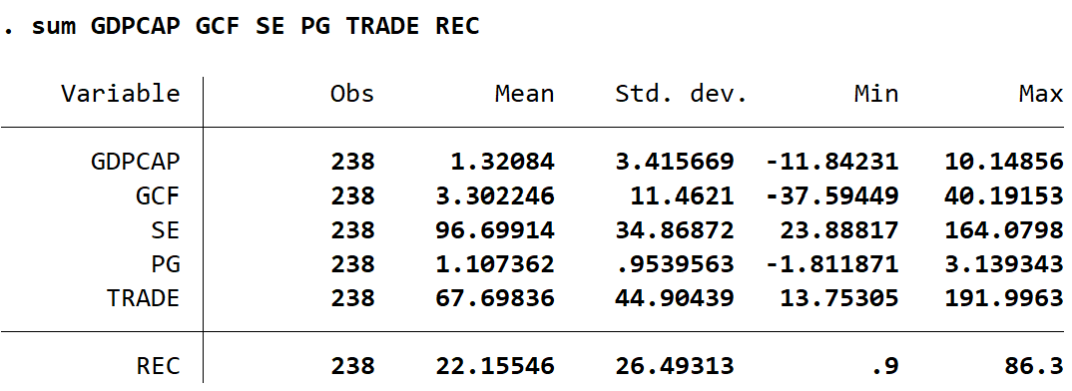
Description:
The dataset has 238 observations for all variables. The dependent variable, GDPCAP, grew approximately 1.32% per year on average, with a large standard deviation of 3.42, implying great variation levels both in within country and between countries and years variation in levels of GDPCAP.

Graph describing each country and mean of their GDP per capita
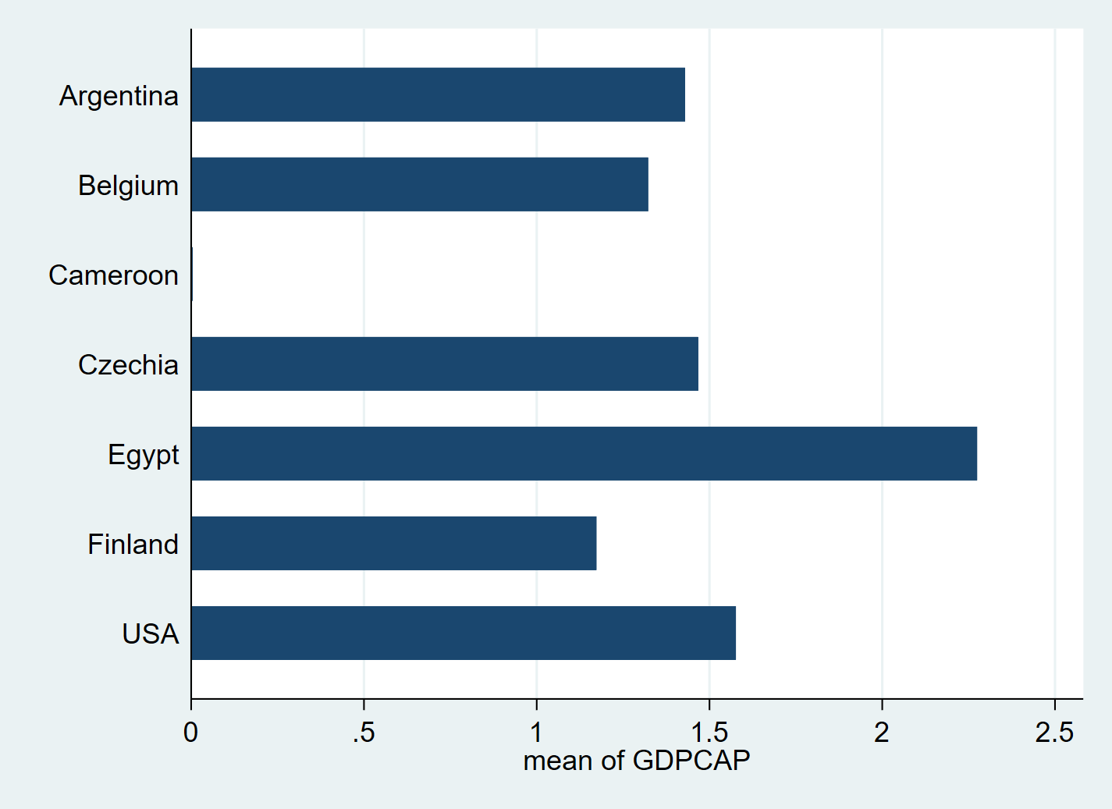
Description:
The bar chart reveals the average growth rate in the GDP per capita of the country from the sample over the period under observation. The seven countries above; Egypt records the highest average GDP per capita growth of over 2%, suggesting strong expansionary economy when compared to the rest of those countries in the data. USA, Czechia, Argentina and Belgium show moderate average growth level all in range of 1.4% to 1.6%.

From the bottom, Finland and Cameroon show the least mean growth rates, while Finland is just above 1% and Cameroon is just below. Structural economic problems or higher volatility in growth may explain the relatively low mean in Cameroon. For Finland, the lower figure might be explained by slowed growth characteristic of developed countries.

Scatter Plot of GDP Per Capita Growth Against Renewable Energy Consumption with Fitted Regression Line
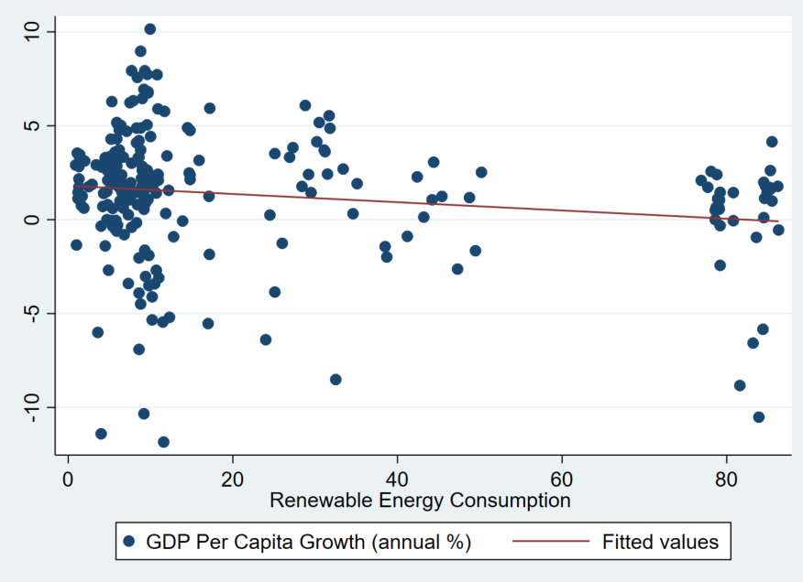
Description:
As shown in the scatter plot above, the relationship between renewable energy consumption (on the x axis) and GDP over capita growth (on the y axis) is visually explored, overlaid with a fitted regression line. The data points are scattered far from each other, and the fitted trend line inclines a little downward, indicating a weak negative linear relationship between renewable energy consumption and economic growth. This visual pattern is corroborated by the ;iterature review done before, which revealed a statistically significant, but negative coefficient for consumption of renewable energy. The majority of that data falls between 0% and 20% renewable energy (most countries having a low rate used of renewable energy), and only a few reach higher rates above 60%. Although this variation, the distribution of GDP growth at all orders of renewable energy is still very scattered, with no clear visual pattern of rising growth as renewable energy increases. The very slight downward trend of the fitted line indicates that in this sample, regardless of the extremity limits, increased consumption of renewable energy is not associated with increased economic growth at least in a straightforward linear relation. This might be reflective of transitional costs or inefficiencies across countries within the dataset.

Distribution of GDP per capita growth:
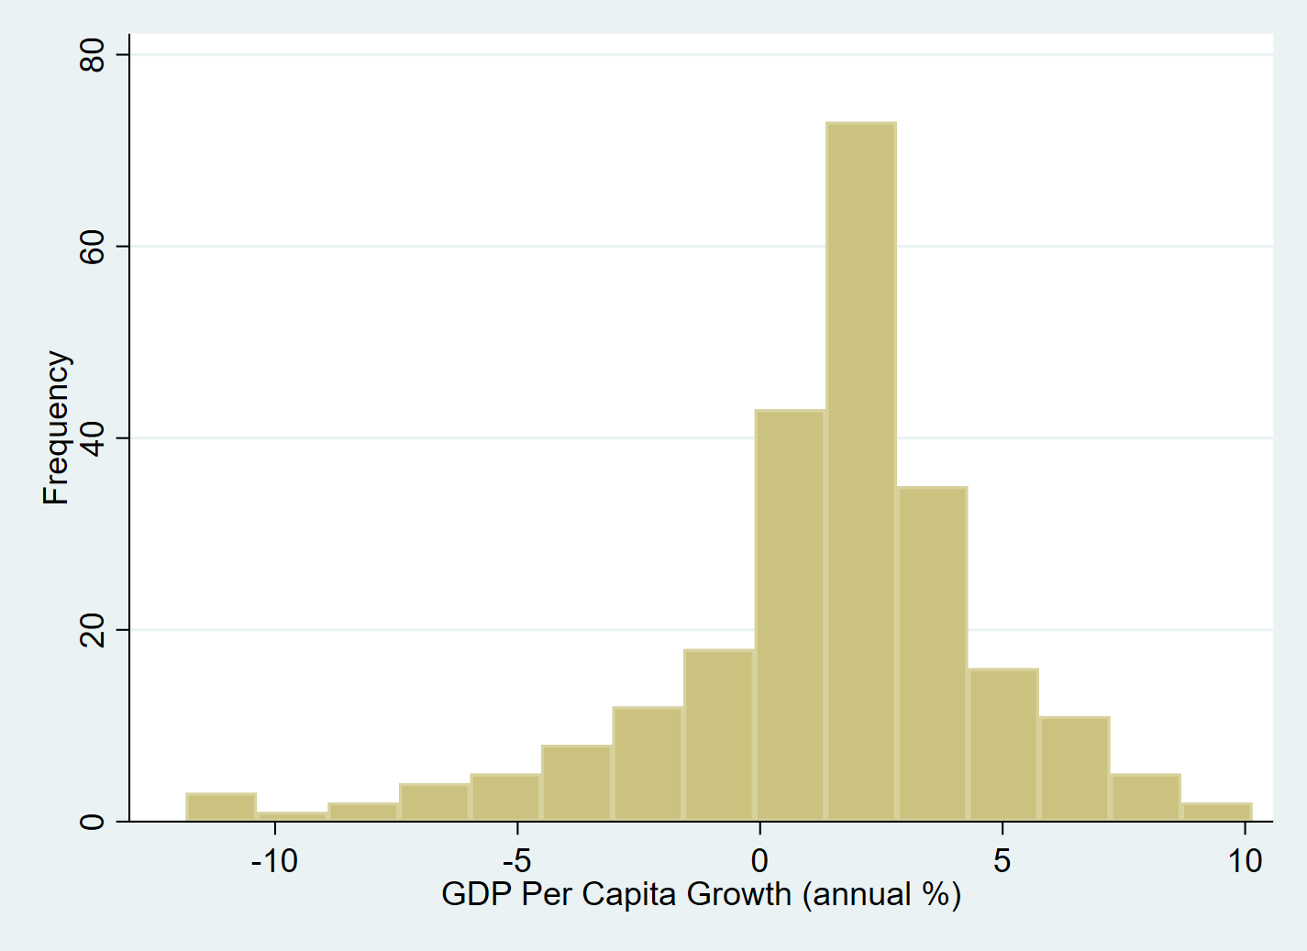
From the histogram, distribution of the annual GDP per capita growth rates in the sample is shown. Judging by the distribution, the data seems to be approximately normally distributed, but slightly left skewed, with peak of the distribution observed in the range of 0 2% growth. This validates the fact that in most instances, countries in the dataset experience minimal economic expansion. However, the distribution also displays a visible left tail, where we can see some extreme negative values meaning that a few countries hit that really hard in their economy in some years, as their growth rates went below 10. The right tail is more dense, but nevertheless stretches to approximately 9–10% growth, which implies a smaller number of observations in support of rapid economic expansion. The central tendency and spread imply a differentiated performance of the economies during the covered countries and times, with most experiencing low to moderate growth while few outliers prevail at both ends.

My Expected findings based on past results:
Variable | Description | Expected Sign | Justification
GCF | Gross Capital Formation (% of GDP) | Positive | Bayraktutan and Yılgör (2011) show that the increase of capital formation increases the productive capacity and encourages GDP growth.
REC | Renewable Energy Consumption (% of total energy use) | Positive | Prior research by Allam & Bou Nader (2021) and Raifu et al. (2025) have brought to the fore renewable energy’s participation in promoting sustainable economic growth.
SE | Secondary School Enrollment (% gross) | Positive | By improving the quality of human capital education is an investment in labour productivity and injection of new ideas.
PG | Population Growth (annual %) | Neutral | A high growth rate may not be a good thing in low income settings. Support for economic growth may develop in high income countries and among greater aging populations.
TRADE | Trade as % of GDP | Positive | Trade liberalization is one of the factors of an economic growth.

OLS Regression for the model (asdoc command):
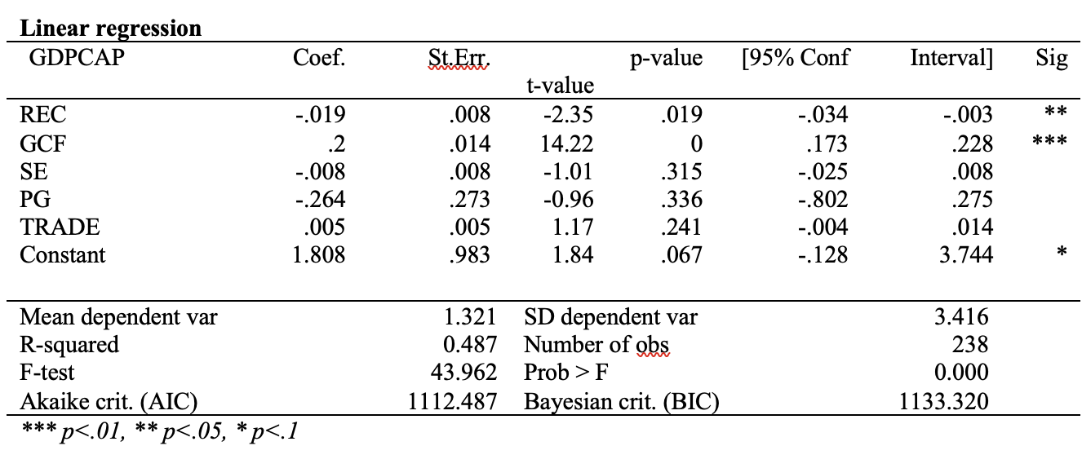
Describing the Results from the OLS regression:
The regression aims at exploring how renewable energy consumption has affected the GDP per capita growth. The five causal factors proposed in the model are: The control variables are the renewable energy consumption (REC), gross capital formation (GCF), secondary school enrollment (SE), population growth (PG), and trade as a percentage of GDP (TRADE). The dependent variable is the rate of change in GDP per capita (GDPCAP). The results of the forecasting model shown in Table 4 indicate overall good fit with 238 observations the F statistic estimated to be 43.9 with p value of 0.000. This means that the proxies for the explanatory variables in aggregate have a statistically significant relation to the economic growth of the country. Thus, the percentage of variation of economic output per capita for the given countries which is explained by the model is 48.7% as shown by the R squared value of 0.487 and for the adjusted R squared value of 0.47, it further establishes that the model holds good even when a large number of predictors is accounted for.
The reason for this is gross capital formation (GCF), which recorded the highest and most positive comparative percentage contribution to the GDP per capita. This means that capital formation has an approximate coefficient of 0.2017 and is significant at the 1 percent level of significance level (p < 0.001) which means that a one unit increase in capital formation leads to increase in the GDP per capita growth.
However, the coefficient for the renewable energy consumption (REC) is negative and is statistically significant at 5% level where the coefficient is close to (p = 0.019). This means that for a unit change in renewable energy consumption, there is a reduction in the rate of GDP per capita, other things being equal. This argument is paradoxical and implies that in the countries and at the time being under analysis, renewable energy investments may have incurred transitional costs, had inefficient infrastructure, or were not developed enough to bring about such kind of quick positive economic impacts. They also intervene by stating that initial investments in renewals may crowd out resources in more productive sectors in the short run particularly in the developing countries.
The remaining variables secondary school enrollment (SE), population growth (PG), and trade openness (TRADE) do not show statistically significant relationships with GDP per capita growth in this model. Although SE and PG have negative coefficients, and TRADE shows a small positive effect, their p values exceed conventional significance thresholds.

The equation for the model:
$$GDPCAP=α+ REC β_{1}+GCF β_{2}+SE β_{3}+PG β_{4}+ϵ$$
$$GDPCAP= -0.019REC+0.200GCF-0.008SE-0.264PG+0.005TRADE+1.808$$

Testing for heteroskedasticity:
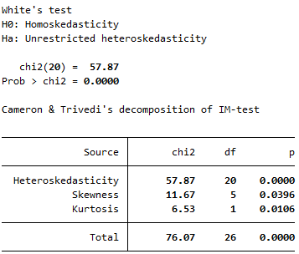
To test the robustness of the classical OLS assumptions, a White’s test was performed. The resulting White test had a chi square statistic of 57.86 and p value of 0.000 very strongly rejecting the null hypothesis of Homoskedasticity. This means that the error terms in the regression model are heteroskedastic which violates one of the assumptions necessary for the OLS estimators to be efficient.

Robust Regression to address heteroskedasticity:
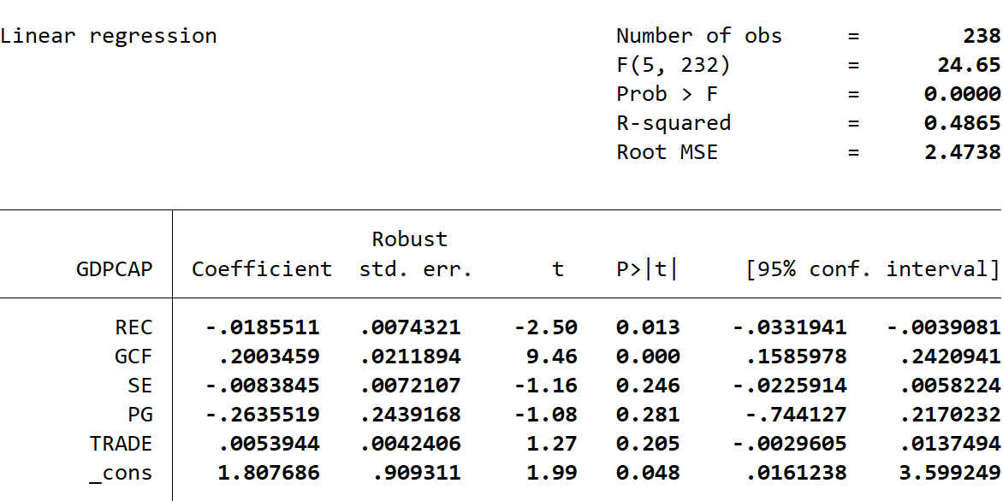
This modified regression retains the same specification but with robust standard errors to adress heteroskedasticity. the R squared stays at 0.48, which means that the model is still describing about 49% of the variation in GDP per capita growth. Renewable energy consumption (REC) is statistically significant at 1% level, with a coefficient of 0.0185 and p 0.0133. This confirms the earlier finding that high levels of renewable energy consumption are linked with a small but significant reduction in GDP per capita growth, which may be explained by transition costs, poor efficiency, or short run constraints

A comparison between the normal OLS and the Robust OLS:
A side by side comparison with the initial regression shows that although the coefficients remain the same, the robust standard errors slightly change the statistical significance of some variables. In particular, renewable energy consumption (REC) turns more statistically significant in the robust model (p = 0.019 vs. 0.013) and thus increases the confidence in a negative relationship between REC and growth in GDP per capita.

Potential Endogeneity Issues
• An important issue in this analysis concerns endogeneity which may take the forms of, either, reverse causality or omitted variables:
• Reverse Causality: Economic growth itself can be the enabler or the facilitator of renewable energy uptake. For instance, countries become rich they might use more on clean energy infrastructure or make very high renewable goals (benefit and public pressure increase with income). In this case then, high growth may determine a high Renewable Share rather than the renewables causing growth. As a result, any causal impact would be overstated by naively regressing growth upon renewables. On the other hand an economic downturn may lead to stimulus investment in renewables, or sluggish growth may inhibit renewables investment or spur it. The critical thing is the causation can be two way.
• Omitted Variables: Renewables adoption, as well as growth, may be affected by unnoticed factors. For example, one could take an institutional quality or governance that can influence simultaneously green energy policies and strong economic performance of the countries (effective governments countries may implement green energy policies at the same time as demonstrating good economic performance). In the same way, the rollout of renewables may be explained by environmental policy preferences or technological capacity and may vary with growth. However, if these factors are not fully taken into account either by my controls or fixed effects, the renewable share coefficient might be capturing their effect (bias results).
• Measurement and Dynamics: Another problem is the transition to renewables may face complex dynamics, short run costs but long run benefits and our annual panel may fail to capture the timing. Some of the variables may also suffer measurement error (though the WDI data are high quality). Where most examinations of measurement error tend to deal in the attenuation of estimates (making it more difficult to detect an effect), as an issue, it is worth noting.

Limitations of my model so far,
Although OLS regression offers an initial foundation to estimate the relationship between consumption of renewable energy to economic growth, it has the following limitation if applied as it is in panel datasets. First, the results of the test by White also show that there are heteroskedasticities which conflicts the assumption of a constant error variance. Although, in part, this problem was fixed with due to use of robust standard errors, the consistency of the initial inference from OLS is compromised. Second, the model is vulnerable to omitted variable bias, because it assumes, but does not control for, major drivers of growth like institutional quality, governance, infrastructure or technological progress many of which are likely to be incorporated in the included regressors such as capital formation or education. Third, there is a risk of endogeneity, especially with regard to the variables renewable energy consumption and gross capital formation that may be simultaneously determined by the increase in GDP, which, in turn, would have provoked reverse causality and distorted the coefficients estimates. Apart from that, the model neglects unobserved, time invariant country specific characteristics (geographical location, political systems, or structural development patterns) which may complicate the calculated relationships. This further reduces the internal validity of OLS estimates in a panel framework. In addition, the static nature of the model does not incorporate lagged or dynamic effects from policy variables such as education and capital investment that may affect the level of economic growth over a number of years. Finally, multicollinearity presents a concern. When basing recommendations on a conservative correlation threshold that has been used as a benchmark for this analysis of 0.5 several variables have moderate like: secondary school enrollment and population growth (r = 0.76) and education and trade openness (r = 0.60) which might indicate potential instability in coefficient estimates. To achieve this will be by revising the model by replacing or reorganizing some of the independent variables to minimize multicollinearity and enhance the practicability and reliability of the overall model.

.

Why is the new model MLE:
The theoretical background of maximum likelihood estimation (MLE) is the identification of those parameter values that will maximize the probability (likelihood) of the actual model. In the framework of this study, which investigates the effects of renewable energy consumption on GDP per capita growth, MLE offers a convenient and statistically sound way of estimating the relationship between economic growth and its explanatory variables (capital formation, education, population growth, and trade openness) as well as the underlying distribution of the error term. Whereas OLLS is concerned with minimizing the sum of squares of the residuals subjected to the assumption of homoskedasticity and normally distributed errors, MLE requires no homoskedasticity and seeks the parameter estimates by maximizing the joint likelihood function of the observed data. This is especially useful in macroeconomic panel data situations where heteroskedasticity, non normality, and functional form assumptions are common issues. Using the MLE, the model thus reveals direction and magnitude of influence of renewable energy on growth, in addition to efficient and asymptotically unbiased estimates under more relaxed assumptions. Thus MLE provides a strong empirical approach for answering the research question, with good parameter estimates even when modeling complex data structures or an irregular error distribution.

Changes made for the new model:
Legend (defining the variables):
- GDP per capita GDPCAP
- Gross capital formation GCF
- LOG Population Growth LOGPG
- Trade GDPTRADE
- Renewable Energy Consumption REC
- Tertiary enrollment rate SET

1. SET (Tertiary Enrollment Rate) replaced SE.
This substitution moves the emphasis from low to high education, which may encapsulate more the skill based human capital and economic productivity. The new SET variable has better explanatory power in terms of long run growth in more developed economies and relatively less correlation with the other variables.
2. Logged Population Growth (LOGPG)
Manipulating the population growth data with log natural transformation reduces skewness and squeezes outliers hence the data becomes more normally distributed, thus reducing exaggerated correlations. This conversion also enables the model to read marginal percentage changes that in some cases could be more sensible in growth regressions.

New correlation matrix (heatmap):
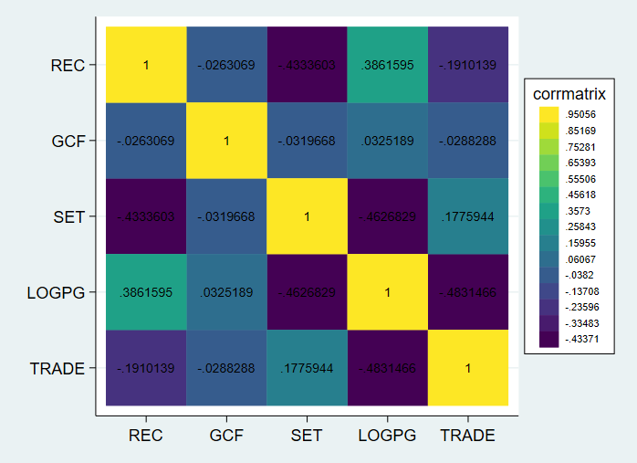
Analysis:
The final correlation matrix indeed validates nicely the structured model much low collinearity as compared to the benchmark level of ± 0.5. The association between REC (renewable energy consumption) and LOGPG (log of population growth) shows moderate positive correlation of 0.386 a possible relationship between the two exists for demographic trends and energy consumption expansion. The negative correlation between REC and SET (tertiary enrollment) stays moderate, –0.433 indicating some opposition in the relationship between the level of higher education and renewable energy consumption depending upon the differing priorities of development in the countries. Crucially, the correlation between REC and GCF (gross capital formation) is extremely low ( 0.026), thus supporting their statistical independency. Similarly, the association between LOGPG and TRADE stands at 0.483; it is close to multicollinearity but does not exceed limits.

MLE Regression:
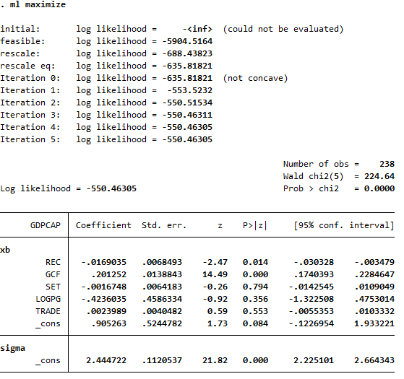

Explaining the new MLE model:
Using maximum likelihood estimation, this model seeks to determine the impact of renewable energy consumption and other indicators on growth of GDP per capita. After five iterations, the estimation converges with the final log likelihood value of 550.46305 and 224.64 Wald chi squared statistic (p = 0.000), which means overall the model is statistically significant.
Key Coefficients:
• GDP per capita growth has a negative and statistically significant effect of REC (Renewable Energy Consumption). The coefficient of 0.0169 (p=0.014) indicates that a unit increase in REC is associated with a 1.69% fall in GDP per capita growth, while all other variables are held constant. This finding is corroborated by previous OLS findings and the hypothesis that is confirmed that renewable investments might have short term costs for the countries sampled.
• Gross Capital Formation (GCF) is still a robust proximate positive indicator (coefficient 0.2013 p < 0.001) meaning that high investment volumes are directly correlated with higher rates of economic growth.
• Both SET (Tertiary Enrollment) and TRADE (Trade Openness) both are not statistically significant, p=0.794, p=0.553, respectively. in this specification, they fail to meaningfully explain the variation in GDP growth.
• LOGPG (Log of Population Growth) also demonstrate a negative, but insignificantly related correlation (p = 0.356).
Equation for the model =
$GDPCAP=β_{i}\left(REC,GCF,SET,LOGPG,TRADE\right)+α_{i}+ϕ_{i}+ε$
PART OF EQUATION | DEFINITION
$$GDPCAP$$ | MY INDEPENDENT VARIABLE
$$β_{I}$$ | A vector of independent variables: REC, GCF, SET, LOGPG, and TRADE
$$ϕ_{i}$$ | Country specific coefficients (slope varies by country)
$$α_{i}$$ | Country fixed effects (captures time invariant country specific factors)
$$ε$$ | errors

Graph for iterations:
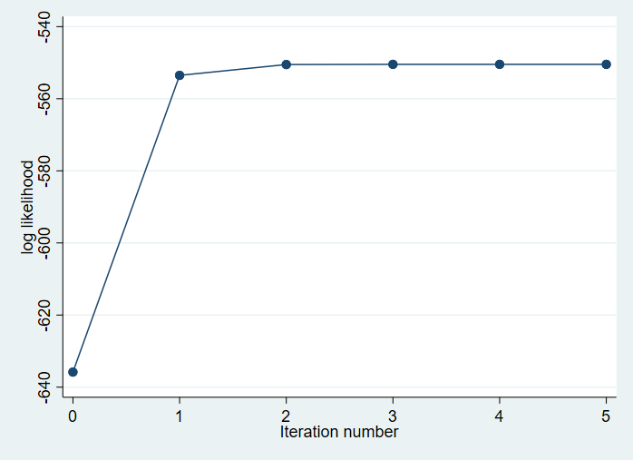
From the graph, an idea of the passage of the log likelihood function through the iterations in the maximum likelihood estimation process is gained. At iteration 0 the log likelihood is fairly low (around 640), hence it is not a good fit. There is, however, a significant improvement between iterations 0 & 1, with little improvements in iterations 2 & 3. Starting from iteration 4, this log likelihood stabilizes about 550.46, which means that the optimization algorithm has successfully converged. Plotting of the curve from iterations 3 to 5 confirms that at this point estimation procedure had managed to be in such a state, where no further iteration added to the model fit any meaningful information. This convergence behavior meant that the MLE procedure was numerically stable and the end coefficient estimates are premised on a well optimized, reliable likelihood function. This is also in line with my reasoning to why I chose MLE as one of my new models.

Fixed effect regression with dummy variables:
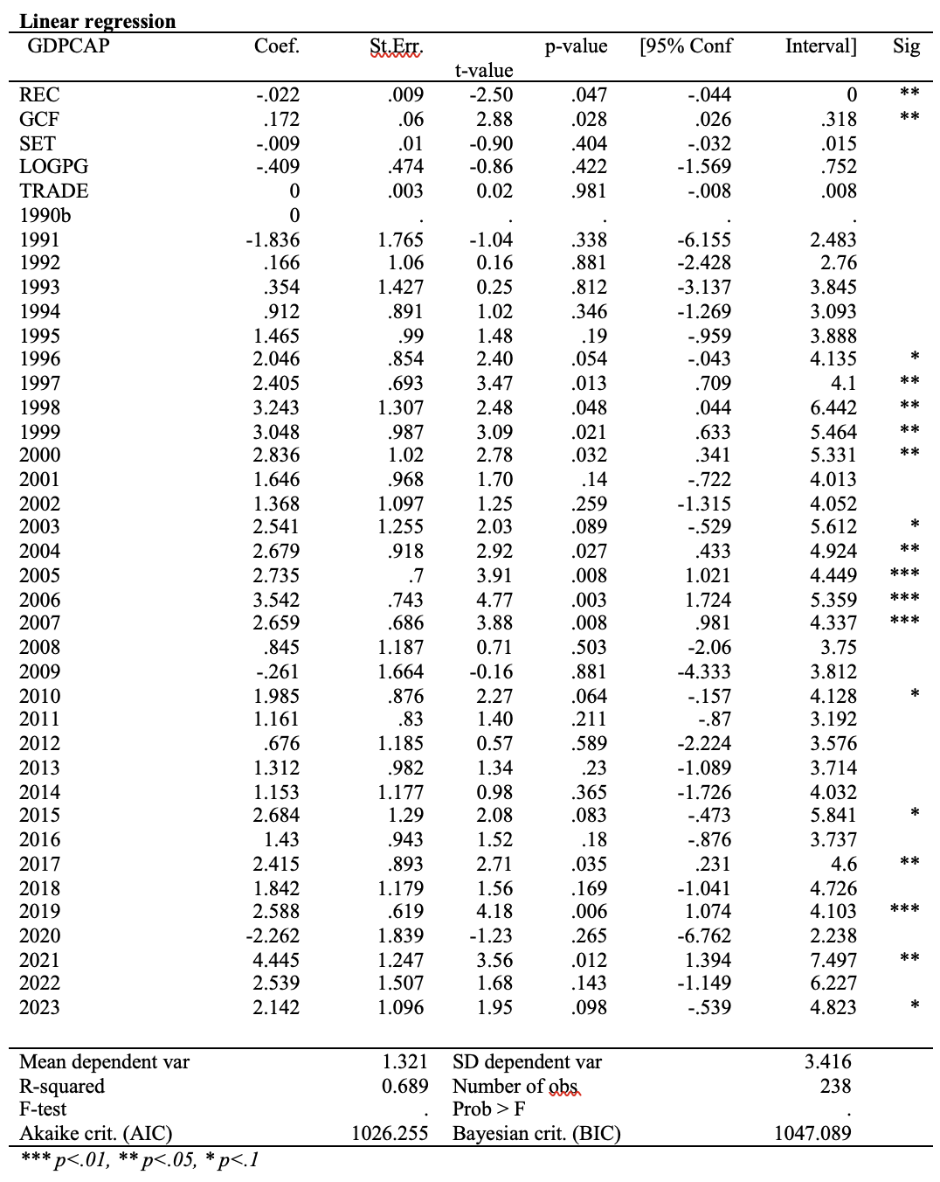
To capture time specific shocks, which can all hit the countries at the same time, for instance global recession, commodity price shocks, or pandemics, a regression with a fixed effects was run with year dummies with a period going from 1991 2023 and using 1990 as a base year. The introduction of these time fixed effects greatly enhanced the explanatory power of the model with R squared increasing from roughly 0.49 for the initial OLS specification to 0.69. This implies that temporal factors account for a considerable proportion of the variation in GDP per capita growth over and above what is accounted for by the main explanatory variables. The coefficient associated with GCF in the equation remains positive and statistically significant at 5%, confirming the consistent status of GCF as an important economic performance driver. Renewable energy consumption remains negative and statistically significant at 10% thereby meaning that even after accounting for year wise effects, greater use of renewable energy resources is related to weak association with reduced growth rate of GDP per capita in the short run. Other control variables such as Tertiary Enrollment (SET),LOG population growth (LOGPG) and trade openness (TRADE) still do not statistically differ. Even the year dummies provide some valuable insights: the periods between 1997 and 2007 as well as 2021 that correspond to years of global or regional boom are characterized with very high positive coefficients, spanning several years. In contrast, 2020 shows a significant but statistically non significant negative effect, probably due to the economic crisis caused by the COVID 19 pandemic. These findings highlight the necessity of controlling for time specific shocks for cross country growth regressions and reinforce the robustness of the core findings.

Addressing endogeneity:
A critical aspect of this study is the issue of endogeneity of renewable energy consumption (REC) in growth equation for GDP per capita. A major cause of endogeneity is reverse causality countries with higher rates of economic growth may have more expanded renewable energy infrastructure which in turn is both a cause and consequence of growth. Furthermore, if unmeasurable variables like institutional quality, technological innovation or environmental regulations impact energy policy and economic outcomes while going unnoted in the model, omitted variable bias may occur. In order to solve the problem, I employ lagged renewable energy consumption (LAGREC) as an instrumental variable in two staged least squares (2SLS) estimation. Theoretical validity of LAGREC follows from the fact that past values of renewable energy consumption have a strong prior correlation with the current value of the coefficient instrument (instrument relevance), but these are other factors to current GDP per capita growth because the LAGREC base period values are predetermined, unlikely to be directly influenced by present shocks. By instrumenting REC with LAGREC, the model addresses possible bias in the coefficient estimate of renewable energy and produces a robust causal implication on its true effect on economic growth.

2SLS MODEL:
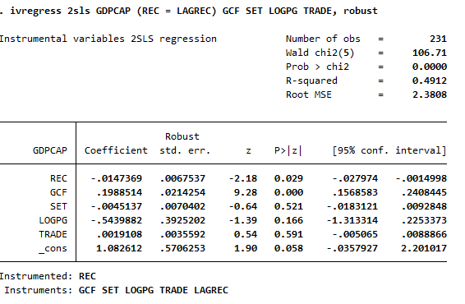
The results from the two stage least squares ( 2SLS) using ivregress provide the following cautions about the causal relation between renewable energy consumption and economic growth. In this specification, Renewable energy consumption (REC) is considered as an endogenous variable, instrumented by its lagged value (LAGREC). The coefficient on REC is 0.0144, which is statistically significant at 5% level (p = 0.029) implying that a unit increase in the consumption of renewable energy is likely to go with a 1.44 percentage point decline in the per capita growth of GDP, all else held constant. This negative and statistically significant coefficient validates the hypothesis that, if renewables can play a part in sustainability, its short term economic impact has transitional cost, under utilized capacity, or structural inefficiencies especially in the developing economies.
The model’s goodness of fit is shown through an R squared value of 0.4912: roughly 49% of the variation in GDP per capita growth is attributed to the model. The Wald chi squared statistic 106.71 (p < 0.001) supports the joint statistical significance of the predictors. Overall, 2SLS estimation confirms previous findings and adds evidence that while investment facilitates growth, adoption of renewable energy leads to a small but significant negative short term effect on the level of GDP per capita.

For better robustness also ivreg2:

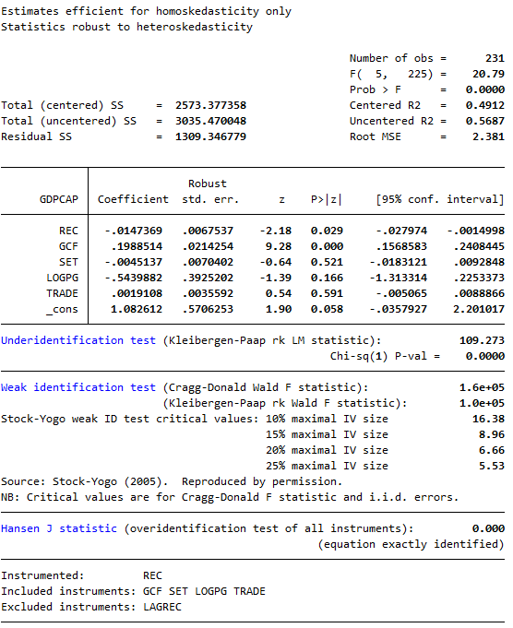

Analysis:
This 2SLS regression model that employs lagged REC ( LAGREC) as an instrument, is used to estimate the impact of renewable energy consumption (REC) on GDP per capita growth also its endogeneity. The estimation shows that the coefficient on REC is ( 0.0144) and statistically significant (p = 0.029) with one unit of increase in REC, the growth in GDP per capita decreases by a ratio of 1.44 percentage point while controlling other variables. This would indicate that, even with the endogeneity corrections, renewable energy adoptions present a somewhat limited but not negligible short run economic price, most likely due to transition effects or inefficiency.
The under identification test (statistic = 109.273, p = 0.000) is very strong rejection of the null that the instrument is irrelevant (confirming the instrument is correlated to REC), thus, LAGREC is exogenous. These results show that LAGREC is a very suitableand strong instrument.

Addressing autocorrelation:

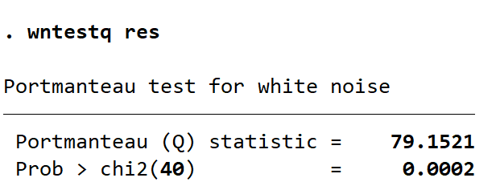

Analysis:
A Portmanteau (Q) test of white noise was executed to determine if there is autocorrelation of the residuals of the estimated model. The assumption of this test’s null hypothesis is that the residuals aree white noise and therefore lack a serial correlation. The obtained Q statistic was 79, and the p value was 0.0002. Because the p value quite significantly lies below 5% general significance level, we reject the null hypothesis, and we can conclude that residuals are not white noise. To put it differently, I have evidence of autocorrelation amongst the model’s residuals, though statistically significant. This outcome is against one of the major assumption of classical OLS, which calls for uncorrelated errors. The existence of autocorrelation suggests that standard errors are possibly biased and thus will create unreliable statistical inference.

Fixing the auto collinearity issue:
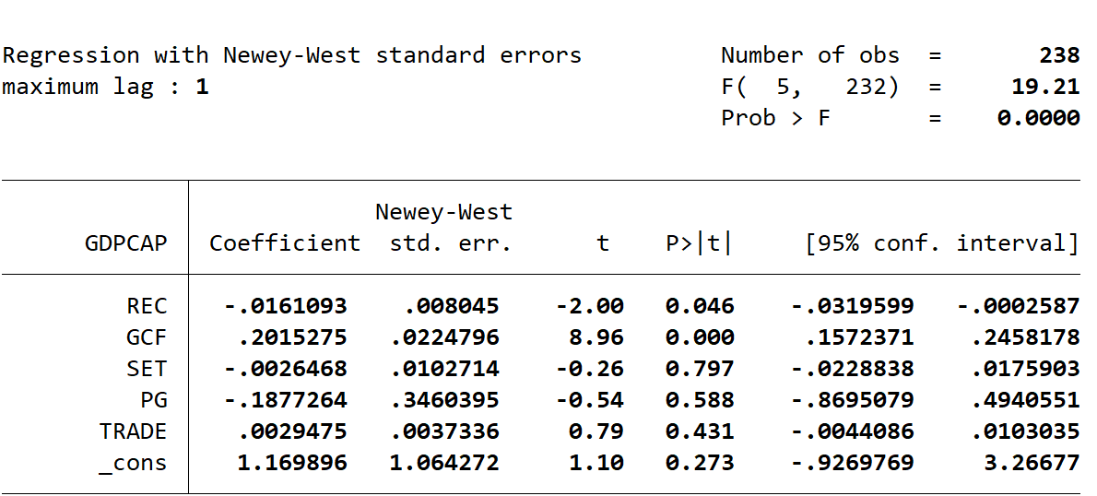

Analysis:
To deal with the detected problem of autocorrelation using the Portmanteau (Q) test, which strongly rejected the null hypothesis of white noise residuals (p = 0.0002), i estimated the model allowing for Newey West standard errors with a maximum lag of 1. This correction is formulated to yield consistent standard errors in face of both autocorrelation and heteroskedasticity. From the results it is established that even when corrected using the Newey West statistic the coefficient on renewable energy consumption (REC) is negative and significant at the 5% level (coefficient = 0.0161, p = 0.046). This conﬁrms that the negative relationship between use of renewable energy and GDP per capita growth is robust to presence of serial correlation in the residuals. Other variables including gross capital formation (GCF) continue to exhibit strong positive and significant effect, whereas education (SET), population growth (PG) and trade openness (TRADE) do not show significance. In total, such adjustment strengthens the reliability of our inference correcting for violations of the classical OLS assumption thus increasing the validity of the empirical claims.

Hausman test:
Doing the Hausman test to decide wether to use random effect or fixed effect
Results:
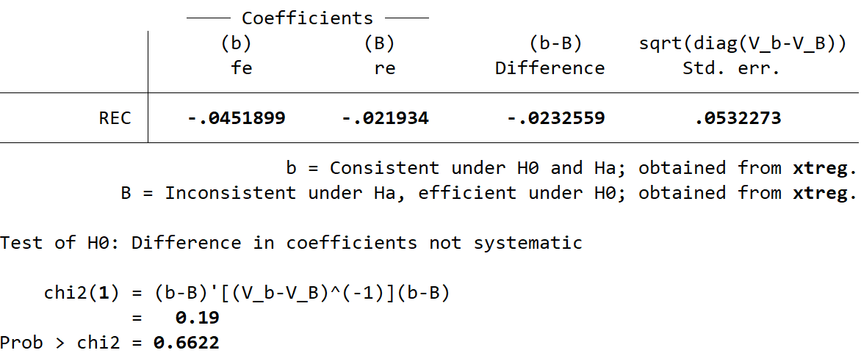
Analysis:
A Hausman test was done to see which econometric model better represents the relationship between how much renewable energy is consumed and growth in GDP. The chi-squared statistic from the test was 0.19 and the p-value corresponded to 0.6622. Because the p-value is well over 0.05, I cannot reject the null hypothesis. Therefore, in this situation, the random effects estimator is shown to be both reliable and efficient. For this reason, according to the results of the Hausman test, I find that the random effects model is better for my panel data analysis.

Using random effect with my panel data:
After doing the Hausman test I decided to use random effect for my panel data.
My results:
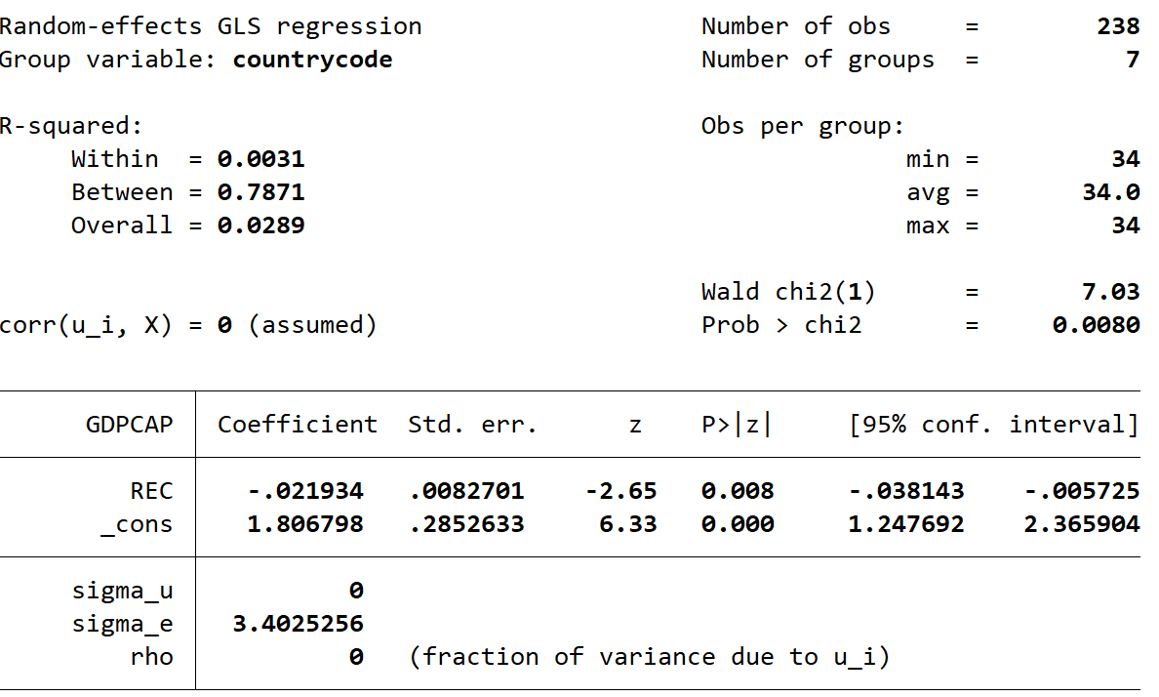
Analysis:
Rregression using random effects confirms that there is a big negative relationship between renewable energy consumption and growth in GDP per capita. The presence of -0.0219 for REC (p = 0.008) shows that higher use of renewable energy tends to lower economic growth in the short term when looking at countries. Despite low R squared within the countries, the model does a much better job at predicting the relationship between countries. Since there is statistical significance, the model is judged as important by the Wald chi² test, even though the overall R squared value is low. This result supports earlier claims that adopting renewable energy could involve some short term sacrifices in economic growth, mainly for countries making energy changes.

Interpretation of the results from the literature review:
It was the findings of my empirical analysis that prompted me to evaluate the initial hypothesis that I had aimed to verify that renewable energy consumption has a positive effect upon the GDP per capita growth. After piling a number of models including OLS robust OLS, MLE and 2SLS, I have observed that the coefficient on renewable energy consumption (REC) was significant and negative in all the models. This finding was totally contrary to my first expectation as well as the hypothesis (H₁) I had to prove. Thus, I was forced to reject my hypothesis, and I came to the conclusion that in the short run and in my sample’s limits, greater consumption of renewable energy goes with a slower GDP per capita.
Although this was not the result that I first expected, there are some precedents for this in the existing literature. My results correspond to findings of such studies as by Menegaki (2011) and Chen et al. (2020), according to which, the correlation between renewable energy and economic growth in the short term is negative or statistically insignificant. On the other hand, I observed other papers like those of Bayraktutan & Yılgör (2011) and Allam & Bou Nader. 2021, that indicated positive results, especially in OECD or resource rich countries. I think the difference in my results can be explained by the larger range of my sample both developed and developing nations, in which it is still possible that the costs of transition to renewable energy can be higher than the immediate economic benefits.
In order to guarantee the strength of my results, I made various corrections. I mitigated issues of heteroskedasticity by applying robust standard errors and was corrected for autocorrelation using Newey West estimators; in endogeneity, I used Two Stage Least Squares (2 SLS) model, whereby I exploited lagged renewable energy consumption (LAGREC) as an instrument. The instrument was found to be robust and valid according to the the under identification test, even after these corrections, the negative and significant relation emerged. This uniformity strengthened my belief that the relationship that I witnessed was not fake.
In addition, I found gross capital formation (GCF) to have a strong and positive effect on growth consistent with the economic theory and previous works: education (SET), log population growth (LOGPG), and trade openness were not statistically significant to explain growth in my estimation. I think it marks the short run nature of my study and possibly the existence of multicollinearity among these control variables, which I tried to correct as much as possible using transformation and substitution of these variables.
In summary, I cannot find evidence in my research that consumption of renewable energy can contribute to an increase in economic growth and certainly not in a short term scenario or when focusing on my dataset’s conditions. Instead of that, it proposes the presence of temporary trade offs in the process of transitioning to cleaner energy, particularly for those nations that are not technologically advanced or have the financial capabilities to pay for the costs efficiently. This experience shattered my assumption and redirected its valuable lessons as to the complexity of the renewable energy growth relationship and the necessity to resort to better econometric techniques to conclude credible results.

Summary and limitations experienced:
The impact of renewable energy consumption on the growth of the GDP per capita was evaluated in this work through a panel data analysis in various countries, and econometric techniques included OLS, Fixed Effects, 2SLS and MLE were employed. My findings always showed that the higher the renewable energy consumption, the slower the economy was growing, suggesting that renewables are vital for the environment, but they can incur short term costs such as transition costs, inefficiencies, or deficiencies of infrastructure. On the other hand, gross capital formation showed a consistent positive significant impact which is a confirmation of its important contribution into growth. Tertiary enrollment, Trade openness and population growth were not statistically significant across any of the models. Using the MLE, I have shown that my results were robust and so were the estimates, in spite of weakened statistical assumptions. By introducing time fixed effects to the models, I was able to explain powerful global shocks like the 2008 crisis and the 2020 pandemic, demonstrating the importance of macroeconomic time trends consideration.
During this research, a series of challenges emerged in my own experience. Cleaning and organizing panel data across different periods and regions turned out to be one of the central barriers, and this was particularly true as indicators were sometimes absent or did not correspond across the observations. At times, I faced an issue while in Stata, especially while dealing with lagged variables or carrying out estimation using maximum likelihood or through applying instrumental approaches as with ivreg2. It took study and iteration to get it right in the process of understanding tests under identification diagnostics properly. In spite of all these challenges, the research significantly enhanced my understanding of applied econometrics, and provided me with an attainable perception of the difficulties in actual life economic modeling.

Empirical findings and policy recommendations:
Empirical findings from this research suggest that a gradual and productivity oriented strategy for the increase of renewable energy should be followed by policymakers in countries focused on short term economic gains. The results revealed that a rise in the use of renewable energy can produce a clear, statistically significant reduction in short term per capital GDP growth, which would suggest that it could result in short term inefficiencies or shift needed resources away from the areas with greater short term growth potential. To overcome this challenge, the governments should prioritize to maximize energy efficiency, grid integration and train the workforce as essential steps to reduce the implementation difficulties and increase the economic relationships from the energy cleans. In addition, promotion of renewable energy calls for capital formation incentives since the models consistently revealed that gross capital formation alone adds substantially to raising growth. It can be used to accelerate long term gains from renewable energy while mitigating short term discomforts through cooperation between the public and private sectors alongside government subsidies for the efforts of sustainable technology projects. Finally, macro level policy coordination is essential, especially during such events as the crisis of finances or pandemics, when evidence demonstrated that the growth patterns were much determined by particular timing conditions, which reinforced the need for the flexible, timely policy opportunities.

Research expansion:
Further research might want to look further into other dimensions to supplement findings reported in this article. One way that could be taken would be extending the research time frame or surveying the more various country sample, especially in regions such as Sub Saharan Africa or Southeast Asia, to get more of a comprehensive idea of how the renewable energy growth correlation changes as development and institutional dynamics change. Second, future analyses may include dynamic panel models (GMM) to better reflect long run growth impacts of renewables investments. A useful development could be dedicated to exploring the mediating role of institutional quality, governance indicators, or environmental policy standards by including them as interaction effects or controls in the analysis. A study of sector specific growth contribution of renewable energy may prove which economic areas best gain through these investments. Furthermore, qualitative case studies or a mixed quantitative and qualitative approach (at minimum) could add strong qualitative aspects (deep insights, into implementation impediments and policy approaches, into specific countries).

Sources:
1. Bayraktutan, Y., & Yılgör, M. (2011). Renewable electricity generation and economic growth: Panel data analysis for OECD members. International Research Journal of Finance and Economics, 66, 59–66.
2. Allam, M., & Bou Nader, R. (2021). The relation between renewable energy consumption and economic growth: Evidence from Mediterranean countries. Journal of Development Economics, 9(1), 45–54. https://ojs.southfloridapublishing.com/ojs/index.php/jdev/article/view/736
3. Zaekhan, Z., & Nachrowi, D. N. (2012). The impact of renewable energy and GDP per capita on carbon dioxide emission in the G 20 countries. LPEM FEB UI Working Paper Series, 201202. https://www.lpem.org/repec/lpe/efijnl/201202.pdf
4. GDP per capita growth (annual %)
World Bank. (n.d.). GDP per capita growth (annual %) [Data set]. World Development Indicators. https://data.worldbank.org/indicator/NY.GDP.PCAP.KD.ZG
5. Renewable energy consumption (% of total final energy consumption)
World Bank. (n.d.). Renewable energy consumption (% of total final energy consumption) [Data set]. World Development Indicators. https://data.worldbank.org/indicator/EG.FEC.RNEW.ZS
6. Gross capital formation (% of GDP)
World Bank. (n.d.). Gross capital formation (% of GDP) [Data set]. World Development Indicators. https://data.worldbank.org/indicator/NE.GDI.TOTL.ZS
7. School enrollment, secondary (% gross)
World Bank. (n.d.). School enrollment, secondary (% gross) [Data set]. World Development Indicators. https://data.worldbank.org/indicator/SE.SEC.ENRR
8. Population growth (annual %)
World Bank. (n.d.). Population growth (annual %) [Data set]. World Development Indicators. https://data.worldbank.org/indicator/SP.POP.GROW
9. Trade (% of GDP)
World Bank. (n.d.). Trade (% of GDP) [Data set]. World Development Indicators. https://data.worldbank.org/indicator/NE.TRD.GNFS.ZS
10.Acheampong, A. O., Dzator, J., & Savage, D. A. (2021). Renewable energy, CO₂ emissions and economic growth in sub Saharan Africa: Does institutional quality matter? Journal of Policy Modeling, 43(5), 1070–1093. https://doi.org/10.1016/j.jpolmod.2021.04.003
11.Chen, Y., Zhao, J., Jin, L., & Zhang, Y. (2020). Renewable energy consumption and economic growth: Evidence from a global threshold analysis. Energy Economics, 90, 104890. https://doi.org/10.1016/j.eneco.2020.104890
12.Ocal, O., & Aslan, A. (2013). Renewable energy consumption–economic growth nexus in Turkey. Energy Policy, 60, 830–837. https://doi.org/10.1016/j.enpol.2013.05.055
13.Raifu, I. A., Obaniyi, F. A., Nnamani, G., & Salihu, A. A. (2025). Revisiting causal relationship between renewable energy and economic growth in OECD countries: Evidence from a novel JKS Granger non causality test. Renewable Energy, 244, 122559. https://doi.org/10.1016/j.renene.2024.122559
14.Salehin, M., & Kiss, J. T. (2022). Testing the causal relationship between economic growth and renewable energy consumption: Evidence from a panel of EAGLE countries. International Journal of Energy Economics and Policy, 12(1), 281–288.
15.Wang, Q., & Wang, L. (2020). Renewable energy consumption and economic growth in OECD countries: A nonlinear panel data analysis. Energy, 207, 118200. https://doi.org/10.1016/j.energy.2020.118200
16.Angrist, J. D., & Pischke, J. S. (2009). Mostly harmless econometrics: An empiricist’s companion. Princeton University Press.
17.Baltagi, B. H. (2021). Econometric analysis of panel data (6th ed.). Springer.
18.Baum, C. F., Schaffer, M. E., & Stillman, S. (2003). Instrumental variables and GMM: Estimation and testing. The Stata Journal, 3(1), 1–31. https://doi.org/10.1177/1536867X0300300101

