KEDGE BUSINESS SCHOOL
MSc Data Analytics for Business
Predicting In Game Spending Behaviour Using Machine Learning:
An Economic and Behavioural Analysis
Master's Thesis
Zyad Mohamed Mahmoud Reda Husseini
Supervisor: Dr. Tianyuan Zhang
Department of Data Analytics, KEDGE Business School
Academic Year 2025/2026

Abstract
The video game industry has shifted from selling finished products to monetising ongoing services through microtransactions, virtual currencies, and randomised rewards. Spending is highly concentrated: most players never pay, while a small minority generates the majority of revenue. This thesis asks which player behaviours and engagement patterns best predict in game spending, and how those predictors can be interpreted through economic and behavioural theories of consumer choice. A predictive and interpretive approach is adopted, combining an interpretable logistic regression baseline with a family of machine learning models, unsupervised segmentation, and natural language processing, applied to five public datasets covering more than 50,000 players and 52,000 games. The literature synthesis integrates freemium conversion, consumption value theory, purchase motivations, social influence, behavioural economics, and the gambling related and consumer protection critiques of monetisation design. Empirically, the analysis returns a clear and instructive result. In the public datasets examined, engagement and demographic features show no robust statistical association with whether a player spends or how much they spend: thirteen classifiers all perform at or near chance (area under the ROC curve between 0.48 and 0.52), whale classification and spend regression do not exceed chance, and no feature passes conventional significance tests. By contrast, the patterns that the theory most strongly predicts are clearly present: revenue is extremely concentrated (Gini coefficient of 0.87; the top one percent of payers account for 39 percent of revenue) and engagement is similarly skewed (playtime Gini of 0.83). A secondary analysis of two genuine game level catalogues provides a decisive control: the same pipeline predicts in app purchases at an area under the curve of 0.95, recovers the freemium signal from game descriptions alone using natural language processing, and explains most of the variance in game popularity, with predictors that map cleanly onto economic and behavioural theory. The thesis interprets this divergence as evidence that the behavioural signals required to operationalise the theory are not present in synthetic or coarse public data, while the economic logic of monetisation is clearly detectable when the data are genuine, and that credible prediction of individual spending therefore requires real player level telemetry. The contribution is threefold: a theory linked conceptual framework connecting behavioural features to economic and behavioural mechanisms; a rigorous, reproducible analytical pipeline; and a critical, evidence based assessment of data provenance that has direct implications for both research practice and the ethics of behaviour based monetisation.
Keywords: in game spending; microtransactions; freemium; machine learning; behavioural economics; player segmentation; revenue concentration; consumer protection.

Table of Contents

List of Figures and Tables

Figures
- Figure 5.1. Purchase rate by engagement level and by genre.
- Figure 5.2. Distributions of engagement variables for spenders and non spenders.
- Figure 5.3. Cross validated ROC AUC for thirteen classifiers.
- Figure 5.4. Random forest feature importances (noise pattern).
- Figure 5.5. Lorenz curve of in app spending among paying players.
- Figure 5.6. Player share versus revenue share by spending segment.
- Figure 5.7. Cluster quality and mean spend by cluster.
- Figure 5.8. Distribution of total playtime and games played per user (Steam).
- Figure 5.9. ROC curves for predicting in app purchases on Steam.
- Figure 5.10. Concentration of attention on Steam and Roblox.
- Figure 5.11. Learning curves of the deep learning neural networks.

Tables
- Table 3.1. Mapping of behavioural features to theoretical mechanisms.
- Table 4.1. Datasets used in the empirical analysis.
- Table 5.1. Descriptive statistics for the numeric features.
- Table 5.2. Tests of association between features and the purchase indicator.
- Table 5.3. Cross validated performance of the classification benchmark.
- Table 5.4. Spending segments in the mobile dataset.
- Table 5.5. Four cluster k means solution on paying players.

1. Introduction

1.1 Background: the monetisation of play
Over the past two decades the economics of video games has changed in a fundamental way. Where revenue once came almost entirely from the one off sale of a boxed product, it now flows from a continuing relationship between a game and its players. Free to play and mobile titles dominate the largest segments of the market, and these titles earn their income inside the game, through microtransactions, virtual currencies, subscriptions, battle passes, and randomised reward mechanisms such as loot boxes (Hamari, Hanner, & Koivisto, 2017). The product is no longer the thing that is sold; access is given away, and money is earned later, gradually, and unevenly. This is a structural shift in how value is created and captured, and it places the study of in game spending at the intersection of economics, consumer behaviour, and data analytics.
The most striking feature of this model is the shape of demand it produces. Unlike the sale of a boxed game, where the relevant question is how many copies are sold at a given price, the free to play model generates revenue from a distribution of spending that is extraordinarily skewed. The majority of players spend nothing at all, a modest group spends small amounts, and a very small minority spends a great deal. Industry practice has developed an informal vocabulary for this pattern, describing the highest value players as whales, by analogy with casino terminology, and acknowledging that these players can account for the bulk of a title's earnings. Understanding what distinguishes the players who spend from those who do not, and the heavy spenders from the light, is therefore not a peripheral concern but a central question for the economics of digital markets.
This concentration also makes spending a difficult phenomenon to describe with traditional tools. Classical models of consumer choice assume that price is observable, that preferences are reasonably stable, and that a purchase reveals the buyer's valuation of the good. In the free to play environment, none of these assumptions holds cleanly. Prices are frequently obscured behind intermediate currencies; offers are personalised and time limited; and the structure of the decision environment is actively engineered by the game's designers (Petrovskaya & Zendle, 2022). A purchase in this setting may reflect genuine value, but it may also reflect exposure to designed friction, social comparison, or the uncertainty of a randomised reward. The interpretation of spending, and not only its prediction, is consequently an open problem.

1.2 The economic significance of digital consumption
The scale of this shift gives the question its weight. In game spending is no longer a niche supplement to boxed sales but the primary revenue mechanism for the fastest growing parts of the industry, and the microtransaction has become one of the defining economic objects of the digital era. It belongs to a broader transformation in which goods that have no physical form are produced, exchanged, and consumed at scale, and in which value is created and captured continuously rather than at a single point of sale. A virtual sword, a cosmetic outfit, a season pass, or a bundle of premium currency is bought with real money, yet it exists only as an entry in a database and confers benefits that are experiential, social, or symbolic rather than material. Understanding how consumers behave in this setting is therefore not only a question for the games industry but a window onto digital consumption more generally, where similar dynamics of free access, optional payment, and engineered choice recur across streaming, social media, and software as a service.
This setting also poses a genuine analytical challenge to economics. The discipline's standard account of consumer choice presumes that the consumer faces a transparent price, holds reasonably stable preferences, and chooses the bundle that maximises utility subject to a budget constraint. In the in game environment each of these presumptions is strained. Prices are frequently expressed in intermediate currencies whose real money cost is deliberately obscured; preferences appear to shift with mood, social context, and the immediate state of play; and the choice set is personalised and time limited, configured by the seller in real time on the basis of the buyer's own behaviour. Spending in this environment is thus an unusually demanding test case for theories of consumer choice, and one in which the interaction between rational valuation and systematic behavioural bias is especially visible. It is this interaction, between the economic logic of demand and the behavioural reality of how players actually decide, that the present study seeks to illuminate.

1.3 Research problem
Two largely separate research traditions speak to this problem without quite meeting. On one side, a substantial body of consumer behaviour research explains why players spend, drawing on consumption value theory, self determination theory, and the study of virtual goods. This work is rich in motivation but is based largely on surveys and single game case studies, and it rarely tests whether stated motivations translate into predictable behaviour at scale. On the other side, a growing game analytics literature predicts player outcomes such as churn, retention, and purchase from behavioural data, often with impressive accuracy. This work is strong on prediction but tends to treat its predictors instrumentally, optimising for forecast quality rather than asking what the predictors reveal about the structure of demand or the welfare of players. A third literature, concerned with behavioural economics, gambling related harm, and consumer protection, documents how monetisation is designed to influence spending, but it is seldom integrated with predictive modelling.
The problem this thesis addresses is the gap between prediction and interpretation. Predicting who will spend is valuable, but a prediction that cannot be interpreted economically reveals little about why demand takes the shape it does, or about whether the spending it forecasts reflects satisfied preference or engineered pressure. Conversely, a theory of motivation that is never confronted with behavioural data remains untested. The research problem, stated plainly, is that the field lacks studies that predict in game spending from genuine behavioural signals and then interpret the predictors through established economic and behavioural theory, while remaining honest about the heterogeneity of players and the designed nature of the environment in which they spend.

1.4 Research question and objectives
The thesis is built on a single research question:
Which player behaviours and engagement patterns best predict in game spending, and how can these predictors be interpreted using economic and behavioural theories of consumer choice?
The question is deliberately framed around prediction and interpretation together, rather than either alone. It does not ask merely whether players spend, which is already known to be rare and concentrated, but which observable behaviours make spending more likely and what those behaviours plausibly represent in economic and psychological terms. To address it, the thesis pursues four objectives:
- to synthesise the economic, behavioural, and analytics literatures on in game spending into a coherent, thematically organised account;
- to develop a conceptual framework that links observable behavioural features to latent economic and behavioural mechanisms and to defined spending outcomes;
- to design and implement a transparent, reproducible empirical pipeline that predicts spending with an interpretable baseline and a family of machine learning models, and that segments players and quantifies revenue concentration; and
- to interpret the empirical findings through theory, drawing out implications for research practice, managerial decision making, and the ethics of monetisation.

1.5 Scope and delimitations
The study is observational and quantitative at its core, supported by a conceptual and interpretive apparatus. It does not involve controlled experiments, the manipulation of game design, or the collection of primary survey data, and it therefore makes no causal claims; its findings concern association and prediction. The empirical work uses public, anonymised datasets, which carries both advantages and limitations that are examined in detail in the methodology and results. The analysis concentrates on player level behavioural and engagement indicators and on spending outcomes defined as a binary spender classification, a monetary amount, and a high value spender classification. Item level purchase categories, which would allow functional and cosmetic spending to be separated, are not available in the data and are treated as a direction for future work. The qualitative dimension of the topic is discussed as a means of interpretation rather than implemented as primary research.

1.6 Contribution
The thesis makes three connected contributions. The first is conceptual: it sets out a framework that translates the fragmented motivational and analytics literatures into a single map linking behavioural features, theoretical mechanisms, and spending outcomes, providing a vocabulary for interpreting model predictors. The second is methodological: it implements a rigorous and fully reproducible analytical pipeline, spanning exploratory analysis, statistical association testing, a thirteen model classification benchmark with imbalance handling, unsupervised segmentation, regression, and natural language processing, that can be applied directly to richer data. The third is empirical and critical: by applying this pipeline to the most widely used public datasets in this area and reporting the results without embellishment, the thesis demonstrates that engagement features in the coarse player level data carry no learnable signal about spending, while the concentration patterns predicted by theory are robustly present. A secondary analysis of genuine game level data then shows the same pipeline recovering strong, theory consistent signal, predicting monetisation, popularity, and even the freemium language of game descriptions, which confirms that the player level null reflects the data rather than the method. This divergence is itself a finding, with direct consequences for how researchers should select data and for how firms and regulators should think about behaviour based monetisation.

1.7 Structure of the thesis
The remainder of the thesis is organised as follows. Chapter 2 reviews the literature thematically, moving from the economics of conversion through the value of virtual goods, social influence, and designed decision environments to player heterogeneity and the analytics tradition. Chapter 3 develops the conceptual framework and states a set of analytical propositions. Chapter 4 describes the research design, the datasets, the variables, the models, the treatment of class imbalance, the approach to interpretability, and the ethical considerations. Chapter 5 reports the empirical results across the three datasets. Chapter 6 discusses these results in light of the theory, answers the research question, and draws out implications. Chapter 7 concludes, acknowledging limitations and outlining directions for future research.

2. Literature Review
This chapter reviews the literature on in game spending and organises it thematically rather than study by study, in line with the purpose of a literature review as a synthesis rather than a catalogue. The review proceeds from the economics of conversion, through the value that a purchase delivers and the social and designed contexts in which payment occurs, to the heterogeneity of players and the analytics methods used to model them. It closes by setting out what the literature agrees on, where it is in tension, and what it leaves unresolved, thereby establishing the gap that the thesis addresses.

2.1 Freemium conversion and the payment boundary
The freemium model rests on a separation that is easy to overlook: the behaviours that keep a player engaged are not the same as the behaviours that convert a player into a payer. Hamari, Hanner and Koivisto (2017) demonstrate this directly. Studying free to play games, they find that perceived service quality explains why players continue to use a game but does not explain whether they purchase premium content. Continued enjoyment and continued payment are governed by different mechanisms, so a player may remain highly engaged without ever crossing the payment boundary, while another may pay with comparatively little engagement.
Later work clarifies what does drive conversion. Hamari, Hanner and Koivisto (2020) show that perceived value, including enjoyment, quality, and social value, predicts continued use and premium purchase, but not in a simple linear way: the determinants of staying and the determinants of paying diverge. Earlier, Hamari (2015) found that attitude toward virtual good purchases, together with peer approval of spending, predicted purchase intention more strongly than overall game enjoyment, and that greater enjoyment did not translate into greater willingness to buy. The implication for a predictive model is important. Because free access removes the up front monetary commitment, engagement accumulates before any monetary trade off is felt, so engagement supplies the conditions under which payment may become meaningful rather than causing it. Conversion is best understood as a boundary crossing event located within a player lifecycle, in which timing and lifecycle position, and not only the volume of activity, condition whether a given offer converts. This reasoning motivates a temporal design in which past behaviour over a defined window is used to predict subsequent spending rather than correlating the two contemporaneously.

2.2 The value of a purchase: consumption value, motivations, and item type
If engagement does not by itself produce payment, the natural next question is what value a purchase delivers. The foundational answer is Lehdonvirta's (2009) analysis of virtual item sales, which shows that the attributes driving purchase are not only functional but also hedonic and social: players buy for performance, for the pleasure of the item, and for what the item signals to others. This places virtual goods within the broader theory of consumption values (Sheth, Newman, & Gross, 1991), in which a purchase can simultaneously carry functional, emotional, social, epistemic, and conditional value. A cosmetic skin, a weapon, or an emote cannot be understood through its immediate functional contribution alone, because its worth is partly relational, depending on how other players perceive and respond to it, and partly bound up with the player's self presentation, an effect amplified in digital settings where possessions are visible and identity is performed (Belk, 2013).
Quantitative syntheses support this multi dimensional view. The meta analysis by Hamari and Keronen (2017) of virtual good purchasing finds that attitude, network size, self presentation needs, subjective norms, social presence, perceived value, and enjoyment are consistently and positively associated with purchase behaviour. The breadth of these correlates indicates that spending is not independent of social experience: a player who purchases frequently may not simply hold a stronger latent preference for the game but may be more embedded in its social network, more attentive to how they appear to others, or more sensitive to the acceptability of spending within their play group. Park and Lee (2011) and Rezaei and Ghodsi (2014) connect these value dimensions to behavioural outcomes in online and massively multiplayer games, finding that price and quality value relate to repurchase intention while emotional and social value relate to willingness to pay a premium. Spending, then, summarises several distinct evaluative logics that are better kept analytically separate than collapsed into a single notion of preference.
The motivation literature makes this concrete. Hamari et al. (2017) develop and test a structured inventory of concrete in game purchase motivations, showing empirically that buying clusters around gameplay enhancement, social interaction, and self presentation rather than a single generic reason. Hussain, Hollebeek, Marder and Ting (2025) extend this with a validated scale grounded in self determination theory (Ryan & Deci, 2000), distinguishing autonomy, competence, and relatedness motivations and showing that within a broad category such as competence a purchase may serve quite different needs, whether achieving mastery, relieving frustration, signalling expertise, or keeping pace with rivals. The consequence for interpretation is that a single observed behaviour, such as frequent cooperative play or rapid progression, can reflect several underlying motives at once, so a predictor's economic meaning is rarely singular.
A further distinction sharpens the point. Not all purchases are alike, and the clearest division is between functional items that alter performance, progression, or access, and non functional items that are cosmetic or symbolic. Marder et al. (2019), studying non functional purchases in free to play games, find that players buy cosmetic items for aesthetics, identity, social belonging, attachment to the game, and gratitude toward developers, motives that have nothing to do with competitive advantage. Palmeira, de Paulo and Baron (2021) show that players evaluate functional and cosmetic microtransactions differently, with functional purchases more likely to be seen as unfair because they confer paid advantage in competitive play, while cosmetic purchases preserve mechanical fairness. The implication is methodological as much as conceptual: because the drivers of functional and cosmetic spending differ, aggregate spending can conceal heterogeneous motivations, and a model that predicts total spend well may still be averaging over behaviourally distinct purchase types.

2.3 The social fabric of spending
A consistent finding across the value literature is that in game spending is deeply social. Players occupy visible social environments in which they perform identity, observe and compare themselves to others, join groups, and signal status, and virtual goods derive much of their worth from this visibility (Lehdonvirta, 2009; Hamari & Keronen, 2017). Mäntymäki, Merikivi and Islam (2014) find that young players' purchasing in virtual worlds is shaped by user experience and social context, with a larger in world social network associated with greater spending, both because a larger network increases exposure to purchasable goods and because it intensifies the social games of recognition that give those goods meaning.
More recent work specifies the mechanisms. Wang, Luo and Li (2022), studying the purchase of non functional items in mobile free to play games, distinguish peer influence operating through envy of peers' outcomes from peer influence operating through conformity to peers' choices, and show that strong tie and weak tie peers exert different effects. Nguyen, Chen and Wonodihardjo (2025) report that both perceived enjoyment and benign envy strengthen in app purchase intention, so social comparison is not purely a negative pressure but can also motivate spending as a route to social matching or aspiration. These findings matter for a predictive model because they imply that variables summarising team play, guild or clan membership, peer network size, and communication intensity may carry more information than their raw engagement content suggests. Such features may be proxying for conformity pressure, the desire for visibility, the need for belonging, norms of reciprocity, or the heightened relevance that social comparison confers on visible virtual goods. Without grounding in this literature, a model that ranks social features among its strongest predictors would invite a shallow reading; with it, those features can be interpreted as the behavioural traces of well documented social mechanisms.

2.4 Designed decision environments: behavioural economics, loot boxes, and dark patterns
The preceding sections treat spending as a response to value and social context. A further body of work argues that spending is also a response to the way the decision environment is engineered, and that this complicates any reading of a purchase as the revelation of a stable preference. Behavioural economics provides the foundation. Prospect theory (Kahneman & Tversky, 1979) established that people evaluate outcomes relative to reference points, overweight losses relative to equivalent gains, and distort small probabilities, tendencies that monetisation design can exploit through artificial scarcity, time limited offers, countdown timers, and randomised rewards. King and Delfabbro (2018) argue that monetisation systems such as loot boxes warrant social responsibility measures precisely because they are structured to encourage spending beyond what consistent preferences would yield, without denying that players also derive genuine enjoyment from purchases. The point is not that all spending is manipulated but that the structure of the mechanism can have effects independent of the intensity of preference.
Premium currencies and bundles illustrate the mechanism. Consumer protection research describes how games separate real world money from in game prices through intermediate currencies such as gems, coins, tokens, and points, which obscure the true financial cost of a purchase and reduce price salience, while bundle sizing leaves players holding residual balances that create pressure to spend the remainder (Petrovskaya & Zendle, 2022; Bank, 2023). For interpretation this is a direct warning: the predictive power of a variable does not establish that it measures a conscious, stable preference, because it may instead be capturing exposure to engineered friction, the affective response to a near miss or a loss, the urgency created by a timer, or the social comparison pressure of a visible leaderboard.
Loot boxes are the most studied and most contested case. Zendle and Cairns (2018), in a large scale survey, find a strong association between loot box spending and the severity of self reported problem gambling, with the relationship stronger for loot box spending than for other in game purchasing. Drummond and Sauer (2018) argue that loot boxes are structurally analogous to gambling because they combine real money expenditure with randomised outcomes, and that part of the utility a purchaser derives comes from the anticipation and uncertainty of the opening, not only from the reward. Montiel et al. (2022), in a scoping review, conclude that the literature broadly supports a positive association between loot box engagement and both problematic gambling and problematic gaming, while emphasising that the strength of the association varies with how engagement is measured and with the population studied. Two cautions follow and are maintained throughout this thesis. First, these relationships are correlational and their causal direction is not established; it cannot be inferred that loot box use causes problem gambling, nor that all loot box purchasers are at risk (Zendle, Meyer, & Over, 2019). Second, loot boxes are not homogeneous, differing in transparency, in whether they use pity timers, and in how they handle duplicate rewards, so a binary record of whether a player spent can conceal very different decision environments.
This connects to the wider literature on dark patterns, the interface and design choices that steer users toward decisions they would not make under neutral conditions. Zagal, Björk and Lewis (2013) catalogue dark patterns specific to game design, including engineered grinding and appointment mechanics that build habitual return through loss aversion, and King et al. (2019), examining game patents and terms of service, argue that some monetisation systems are deliberately engineered to use real time behavioural data to maximise spending and personalise offers in ways that prioritise conversion over player welfare. The conclusion the thesis draws is interpretive rather than accusatory. There is no basis for labelling monetisation as inherently exploitative, since many players value their purchases, but the evidence that some environments are more manipulative than others obliges the analysis to consider, when a strong predictor corresponds to a condition the consumer protection literature flags as manipulative, that the predictor may reflect designed pressure rather than satisfied preference.

2.5 Player heterogeneity and segmentation
The contextual contingencies above carry a methodological lesson. There is no single average spender, and models built as though there were can mislead. Klézl and Kelly (2022) construct a typology of free to play players and show that spender profiles are clusters of values, motivations, and play styles that may share little beyond superficial behavioural similarity, so the same purchase volume can arise from quite different player types. Runge et al. (2014), studying high value players in casual social games, make the commercial counterpart of this point: because a small group of players contributes a disproportionate share of revenue, much analytical attention is devoted to identifying that group and the behaviours that mark it. This concentration has a direct statistical consequence. A model optimised for average predictive accuracy may perform poorly on precisely the rare, high value subset that matters most commercially, and Xie, Devlin and Kudenko (2016) document how severely class imbalance degrades the prediction of rare outcomes such as disengagement, a problem that applies equally to concentrated, skewed spending. Segmentation is therefore not an optional refinement but a requirement: the analysis must be able to distinguish occasional or low volume payers from high value players, must handle imbalance explicitly, and should report feature importance in a way that allows the meaning of a predictor to differ across player groups.

2.6 Game analytics and machine learning for player outcomes
The methods this thesis uses sit within an established tradition of behavioural game analytics. Borbora and Srivastava (2012) model churn with a lifecycle based approach, arguing that player behaviour evolves over time and is better understood when situated within stages of participation than treated as static. Runge et al. (2014) and Drachen et al. (2016) predict high value churn and short run retention in free to play mobile games from behavioural traces, and Periáñez et al. (2016) advance churn modelling by respecting temporal structure and censored, incomplete player histories through survival ensembles rather than static classifiers. Closest to the present question, Sifa et al. (2015) explicitly model purchase decisions in mobile free to play games and show that behaviour driven learning can predict both whether a player will spend and the probable magnitude of that spend. Collectively this work demonstrates that telemetry rich datasets support models of real commercial and academic value, and it identifies the recurring technical challenges of temporal dynamics, censored observation windows, and severe class imbalance (Xie, Devlin, & Kudenko, 2016) that any credible spending model must address.
This tradition also has a limitation that defines the opening for the present study. Much of it evaluates models on predictive performance, such as lift, area under the curve, and F1, without connecting the predictors to a developed account of consumer choice. The features are selected for forecasting accuracy rather than for what they reveal about the organisation of demand, and the framing is typically that of the firm asking how data can be used to increase revenue. An economics thesis can pose a broader question: what do these behavioural patterns reveal about demand in digital markets, how does design influence consumer behaviour, and what are the welfare consequences of monetisation that leverages behavioural data? Answering it requires methods that make a complex model interpretable. A logistic regression baseline provides an interpretable, theory legible benchmark whose coefficients have a clear economic reading; tree based ensembles such as random forests (Breiman, 2001) and gradient boosting (Friedman, 2001) capture non linearities and interactions that a linear model misses, at the cost of transparency; and post hoc tools, principally SHAP values (Lundberg & Lee, 2017), attribute predictions to features in an additive, locally faithful way. Rudin (2019) cautions that post hoc explanation is not a substitute for inherently interpretable models in genuinely high stakes settings, a caveat this thesis respects by pairing every ensemble result with the interpretable baseline. Because spending is rare and concentrated, the imbalanced learning literature, including resampling techniques such as SMOTE (Chawla, Bowyer, Hall, & Kegelmeyer, 2002), is also directly relevant.

2.7 Qualitative evidence as interpretive support
Although the empirical core of this thesis is quantitative, the meaning players attach to spending is not fully recoverable from telemetry, and qualitative work can contextualise quantitative results. Gibson et al. (2023), using interpretative phenomenological analysis, surface themes that numbers do not capture, including the experience of a purchase as a reward to a developer whose product has been enjoyed, a sense of obligation that can follow an initial commitment, and the pervasive influence of social context on what spending means. Marder et al. (2019) similarly find, through interviews about non functional purchases, motives of beauty, identity, gift giving, and gratitude. Such evidence helps resolve apparent tensions in the quantitative literature, for instance why highly engaged and satisfied players may still spend even when enjoyment does not directly drive purchase, by showing that spending can be organised around reciprocity, commitment, or sunk cost logics that are largely independent of moment to moment pleasure. In the present study qualitative material is treated as a means of interpretation and triangulation rather than as a source of primary results, and with due caution regarding authenticity and representativeness.

2.8 The economics of free: revenue models and the price of access
Underlying every theme above is a distinctive revenue model whose economic logic deserves explicit attention. In the conventional sale of a good, the firm earns revenue at the moment of purchase and the consumer's willingness to pay is revealed at a single, observable price. The free to play model dismantles this structure. Access is priced at zero, which removes the initial barrier to adoption and maximises the size of the user base, and revenue is then extracted from a fraction of that base through a long sequence of small, optional transactions. The economics of this model are therefore the economics of a funnel rather than a market clearing price: a very large number of non paying users are acquired cheaply, a smaller number are converted to paying, and a smaller number still are retained and developed into high value spenders. Each stage of the funnel is governed by different behavioural drivers, which is why the freemium literature insists that adoption, retention, conversion, and escalation must be studied as distinct processes rather than as points on a single demand curve (Hamari, Hanner, & Koivisto, 2017, 2020).
This structure also reframes what a price is. Because access is free and payment is optional, the relevant economic decision is not whether to buy the game but whether, at many separate moments, to convert attention and engagement into money. The price the consumer faces is rarely a simple figure; it is mediated by premium currencies, bundled quantities, discounts framed against inflated reference prices, and offers whose availability is deliberately limited in time. From the firm's perspective this is rational revenue management under conditions of heterogeneous willingness to pay, a form of fine grained price discrimination made possible by digital delivery and behavioural data. From the consumer's perspective it means that the act of spending is decomposed into many low salience decisions, each small enough to escape careful deliberation. The economic and the behavioural accounts of the free to play model are thus two descriptions of the same architecture, and a satisfactory analysis of spending must hold both in view at once.

2.9 Impulse, flow, and hedonic consumption
A recurrent theme in the recent literature is that a meaningful share of in game spending is not the outcome of deliberate planning but of situational, in the moment decision making. Rita et al. (2024) examine impulse buying in the video game market and find that performance quality, hedonic content, social factors, and the experience of flow all contribute to impulse buying tendencies, which in turn raise purchase intention. The significance of this finding for the present study is conceptual as much as empirical. It implies that some purchases are situational responses to immersion and elevated affect rather than expressions of a stable underlying preference, and that the relevant predictors of such purchases may be transient states, such as a recent run of intense play or a moment of heightened competitive tension, rather than durable traits captured by cumulative lifetime activity. This is one of the clearest theoretical reasons to expect that recency based features would outperform lifetime aggregates, and it is also a reason to be cautious in interpreting any cross sectional snapshot of behaviour, which by construction cannot observe the transient states that drive impulse.
The hedonic dimension connects this work to a longer tradition in consumer research that distinguishes utilitarian from hedonic consumption and emphasises the experiential, pleasure seeking aspects of buying. In the gaming context the pleasure is often inseparable from the act of acquisition itself, particularly where randomised rewards are involved, since the anticipation of an uncertain outcome is part of what is consumed (Drummond & Sauer, 2018). This blurs the boundary between the purchase and the experience and complicates any attempt to treat spending as the simple acquisition of a good with a fixed use value. It also reinforces the interpretive caution that runs through this review: a behavioural trace that predicts spending may be capturing an affective or experiential state that the player is paying to enter, rather than a considered judgement about the worth of an item.

2.10 Personalisation, affordances, and dynamic monetisation
A further strand of work emphasises that the decision environment in modern games is not fixed but dynamic, adapting in real time to the individual player. Nguyen, Chen and Wonodihardjo (2025) draw on affordance theory to argue that the structural features of a game, including the balance between skill and challenge, the architecture of social interaction, and the perceived fairness of the experience, shape emotional responses that in turn influence purchase intention. On this view, the predictors that a model identifies as behavioural signals may in fact be produced by the affordances of the game, that is, by the structural inducements the design creates, rather than by stable properties of the player. Two players exhibiting the same observable behaviour may be responding to quite different designed environments, which limits the portability of any predictive model across titles and monetisation systems.
The personalisation of monetisation sharpens this point. Where offers, difficulty, and content are tailored to the individual on the basis of their behaviour, an observed purchase is a response to an individualised stimulus rather than to a common market offering. This has a direct methodological consequence: a behavioural regularity learned in a personalised environment may not generalise to a setting with a different offer structure, because the same player would have faced a different sequence of inducements. The consumer protection literature treats this dynamic personalisation as one of the central ethical concerns of contemporary monetisation, precisely because it allows pressure to be directed most intensely at those most likely to respond (King et al., 2019; Petrovskaya & Zendle, 2022). For the analyst, it is a reminder that the environment which generates the data is itself adaptive and strategic, and that the data therefore reflect the interaction of player and design rather than the player alone.

2.11 Virtual economies and the nature of digital ownership
Finally, it is worth situating in game spending within the broader study of virtual economies and digital ownership, because the nature of what is bought conditions how its value should be understood. Lehdonvirta's (2009) foundational analysis already established that virtual items derive value from attributes that are functional, hedonic, and social, but the wider literature on digital possessions adds that ownership itself is different in kind in virtual settings. A digital possession is typically non rival in production, can be replicated at negligible marginal cost, is often non transferable and revocable by the platform, and derives much of its meaning from being displayed within a specific community (Belk, 2013). These properties detach value from the conventional anchors of scarcity, durability, and resale, and attach it instead to recognition, status, and identity within a particular social world. A cosmetic item is valuable not because it is scarce in any physical sense but because its scarcity is engineered and its display is socially legible. This reframing matters for interpretation because it explains why spending can be substantial on items with no functional benefit and no resale value, and why the social and identity mechanisms discussed earlier are so central to the economics of these goods rather than peripheral to it.

2.12 Churn, retention, and the economics of player lifetime value
A final body of analytics work approaches spending indirectly, through the related outcomes of churn and retention, and it is worth examining because it shares both the methods and the commercial logic of the present study. The central economic object in this literature is the lifetime value of a player, the discounted sum of the revenue a player is expected to generate over the course of their relationship with a game. Because lifetime value depends jointly on how long a player stays and on how much they spend, the prediction of churn and the prediction of spending are complementary problems, and the firm's optimisation problem is to allocate retention and monetisation effort across players so as to maximise total lifetime value. Borbora and Srivastava (2012) frame churn in terms of a player lifecycle, and Runge et al. (2014) focus specifically on the churn of high value players, on the reasoning that losing a whale is far costlier than losing a non paying user. This asymmetry, in which a small number of players carry most of the economic weight, is the same concentration that recurs throughout this review and that the empirical analysis later quantifies.
The methodological contributions of this literature are directly relevant. Periáñez et al. (2016) emphasise that player histories are temporal and often censored, in the sense that the observation window ends before a player's eventual outcome is known, and they argue for survival analysis methods that respect this structure rather than static classifiers that ignore it. Drachen et al. (2016) show that even short windows of early behaviour can support useful retention predictions, which suggests that the informative signal in behavioural data is concentrated in particular phases of the lifecycle rather than spread evenly across it. Two lessons follow for the present study. First, the temporal structure of behaviour matters, and a cross sectional snapshot that collapses a player's history into static summaries discards information that the analytics literature shows to be valuable; this is a further reason to expect that the coarse, time aggregated public datasets examined here would underperform. Second, the success of this literature rests on rich, longitudinal, proprietary telemetry, which underscores by contrast why the public datasets used in this thesis, lacking any temporal dimension, cannot reproduce its predictive performance.

2.13 Synthesis: agreements, tensions, and the research gap
Points of agreement. Four claims are well supported across the literature. In game spending is a central financial mechanism of the contemporary games industry rather than a marginal one. The reasons players spend are multiple and non linear, spanning functional utility, hedonic pleasure, social identity, status, convenience, and emotional or moral connection. Monetisation is engineered rather than neutral, with prices embedded in intermediate currencies, designed scarcity, social comparison dynamics, progression barriers, and time limited cycles. And behavioural telemetry allows firms and researchers to predict outcomes such as conversion, churn, and high value status with useful accuracy.
Points of tension. Two genuine disputes run through the field. The first concerns interpretation: whether observed purchases should be read as welfare enhancing consumption reflecting genuine value, or as responses to environmental pressures engineered to exploit predictable biases. The evidence supports both readings for different players and contexts, and the more defensible position is that the two coexist rather than that one is correct. The second concerns generalisability: much of the foundational work is based on a particular game, platform, demographic, or national context, and the monetisation logic of a massively multiplayer role playing game, a mobile puzzle game, a competitive shooter, and a social casino title are not the same.
The research gap. Three gaps remain and together they define this thesis. First, the work that explains why players buy relies largely on surveys and single game case studies, leaving open how far real behavioural telemetry can forecast real spending across many players, while the analytics literature addresses prediction but rarely brings economic and behavioural theory to bear on interpreting its results. Second, the ethical and consumer protection literature documents how design influences spending in ways that complicate treating purchases as straightforward preference, but it is seldom integrated with predictive modelling. Third, predictive models have not been studied enough with respect to player heterogeneity, even though the field agrees that value structures, item categories, genres, and social contexts differ across players. A study that predicts spending from behavioural data and interprets its predictors through economic and behavioural theory, while remaining sensitive to heterogeneity and to the designed nature of the decision environment, would address all three. That is the contribution this thesis sets out to make.

3. Conceptual Framework and Propositions

3.1 Logic of the framework
The framework connects three layers: observable behaviour and engagement, the theoretical mechanisms those behaviours may proxy, and the spending outcomes to be modelled. The logic is one of proxying rather than direct causation. Behavioural features are treated as imperfect, observable signals of latent economic and behavioural mechanisms, which in turn shape spending. This framing is what allows the thesis to interpret predictive features through theory while remaining honest that the same feature may carry different meanings for different players. It also makes explicit a claim that recurs throughout the literature review: a strong predictor is not self explaining, because its predictive power may arise from value seeking, from social mechanisms, or from exposure to designed pressure.

3.2 From behaviour to mechanism to outcome
Table 3.1 sets out the expected mappings. The right hand column states why each link is theoretically plausible and flags where a single feature plausibly proxies more than one mechanism, a point of interpretive caution carried into the discussion.
Table 3.1. Mapping of behavioural features to theoretical mechanisms.
Behavioural feature | Mechanism(s) proxied | Theoretical rationale and caution
Playtime / engagement intensity | Perceived utility; habit; sunk cost | Sustained play signals accumulated value and routine, raising the chance a purchase feels justified; yet high engagement does not by itself produce payment (Hamari, Hanner, & Koivisto, 2017), so playtime is a weak and ambiguous predictor alone.
Session frequency / regularity | Habit formation; commitment | Regular return reflects ingrained routine and commitment, conditions under which monetary trade offs are more readily accepted.
Recency of activity | Impulse; event cycles; affect | Recent, intense activity may capture immersion and elevated affect that drive situational, impulsive purchases (Rita et al., 2024), so recency can outperform lifetime totals.
Progression / level | Sunk cost; status competition; loss aversion | Advanced progression raises the perceived cost of stagnation and the salience of falling behind rivals, motivating purchases that preserve or accelerate position.
Achievement completion | Competence; collection; status | Completion behaviour signals mastery and collection motives (Hussain et al., 2025); it may proxy intrinsic competence needs or outward status signalling.
Retention / tenure | Commitment; gratitude; identity | Long tenure can index attachment and gratitude toward developers (Marder et al., 2019), motives largely independent of moment to moment enjoyment.
Social play (guild, team, chat) | Social signalling; conformity; belonging | Social features may proxy peer influence, envy, conformity, and visibility pressures (Wang, Luo, & Li, 2022) rather than mere engagement volume.
Event / seasonal participation | Scarcity and FOMO; reward uncertainty | Engagement with time limited events captures exposure to engineered scarcity and randomised rewards (Zendle & Cairns, 2018), where designed pressure may drive spend.
Prior spending (if available) | Reinforcement; price obfuscation | Past spending is typically the strongest predictor of future spending, but may reflect reinforcement and residual balance pressure (Bank, 2023) as much as stable preference.
Spending outcomes. These mechanisms are expected to manifest in four modelled outcomes, ordered from coarse to fine: a binary spender versus non spender classification; purchase frequency as a count; total spending as a monetary amount, typically modelled on a logarithmic scale given the heavy right tail; and a high value spender classification, a rare class problem isolating the commercially decisive segment. Modelling several outcomes operationalises the review's claim that aggregate spend conceals heterogeneous behaviour.

3.3 Analytical propositions
Because the data are observational and the outcomes are concentrated and heterogeneous, the framework is expressed as analytical propositions about association and prediction rather than causal hypotheses. Each is defensible from the literature and is stated so that the empirical analysis can support it or fail to support it.
P1. Higher engagement intensity is associated with a higher probability of spending, but engagement alone is a weak and insufficient predictor (Hamari, Hanner, & Koivisto, 2017).
P2. Recent activity is more predictive of spending than cumulative lifetime activity, reflecting impulse, affect, and event cycles (Rita et al., 2024).
P3. Social interaction features predict spending beyond their engagement content, because virtual goods carry identity and signalling value (Hamari & Keronen, 2017; Wang, Luo, & Li, 2022).
P4. Progression related features predict spending where purchases can reduce waiting or difficulty, consistent with sunk cost and status competition mechanisms.
P5. Participation in time limited events is associated with higher spending, consistent with engineered scarcity and reward uncertainty (Zendle & Cairns, 2018).
P6. Where prior spending is observed, it is the strongest single predictor of subsequent spending (Bank, 2023).
P7. Spending is highly imbalanced and concentrated in a small segment, so high value status is a rare class problem requiring imbalance aware methods (Runge et al., 2014; Xie, Devlin, & Kudenko, 2016).
P8. The importance, and possibly the direction, of individual predictors differs across player segments (Klézl & Kelly, 2022).
Propositions P2, P5, and P6 require temporal, event level, or prior spending features. As Chapter 4 explains, the available public datasets do not contain these features, which constrains which propositions can be tested directly and which can only be addressed conceptually. This constraint is itself informative and is revisited in the discussion.

4. Methodology

4.1 Research philosophy and design
The study adopts a positivist, quantitative research design appropriate to a predictive and interpretive question about observable behaviour. It is non experimental and observational: the analysis works with data generated by players in their ordinary use of games, rather than with data produced by a controlled manipulation. This design supports claims about association and prediction but not about causation, a limitation that is acknowledged consistently and that shapes the interpretation of every result. The design follows the standard sequence of an empirical project, moving from the formulation of the problem and question, through the literature synthesis and the development of a conceptual framework, to data preparation, analysis, and the interpretation and discussion of results.
The analytical strategy is deliberately layered. An interpretable logistic regression baseline is estimated first, because its coefficients have a direct economic reading and establish what a transparent model can and cannot explain. A family of machine learning classifiers is then applied to the same features to test whether more flexible models, capable of representing non linearities and interactions, can extract signal that the linear baseline misses. Unsupervised segmentation and regression complete the picture by characterising the structure of spending and the concentration of revenue. This layering reflects the methodological argument of the literature review, that prediction and interpretation must be pursued together rather than in isolation.

4.2 Data sources
Three public, anonymised datasets are used, selected to cover the dimensions of the research question while remaining ethically and practically accessible. Their characteristics are summarised in Table 4.1.
Table 4.1. Datasets used in the empirical analysis.
Dataset | Records | Content | Role
Online Gaming Behaviour (Kaggle) | 40,034 players | Demographics and engagement (playtime, sessions per week, session length, level, achievements, engagement level) with a binary in game purchase indicator | Primary dataset for binary spender classification
Mobile Game In App Purchases (2025) | 3,024 users | Demographics, session count and length, spend amount, spend segment (Minnow, Dolphin, Whale), first purchase timing | Segmentation, regression, and revenue concentration
Steam 200k | 200,000 records (12,393 users) | Real own and play behaviour with playtime in hours; no microtransaction spend | Descriptive evidence on engagement concentration
The choice to rely on public data has a clear cost, examined in the results: such datasets are sometimes synthetic and may not contain the rich, time stamped telemetry that the conceptual framework calls for. This cost is treated not as a flaw to be hidden but as an object of analysis in its own right.
Secondary analysis at the level of games. Two further files in the source folder, a Steam catalogue of 42,497 titles and a Roblox listing of 9,734 games, describe games rather than individual players. They cannot answer the player level research question directly, because their unit of analysis is the game, not the person. They are nonetheless analysed as a secondary, complementary study for three reasons. First, they allow the same economic mechanisms identified in the literature, such as the link between the free to play model and microtransactions, to be tested at the level of the market rather than the individual. Second, because they contain genuine, non synthetic information, they provide a control case that shows whether the analytical pipeline recovers signal when signal is actually present. Third, the Steam catalogue contains a free text description for almost every game, which supports a natural language processing component. The Steam targets are a binary indicator of whether a game offers in app purchases and a binary free to play indicator, both derived from the category and genre fields, together with the review score and a measure of popularity based on the log number of reviews. The Roblox targets are popularity, measured as log visits, and game quality, measured as the ratio of likes to total ratings.
Natural language processing. The Steam game descriptions were analysed with a standard text pipeline. Each description was converted into term frequency and inverse document frequency features over unigrams and bigrams, with common English stop words removed. These features were used to test whether the language of a description predicts whether a game monetises through in app purchases, to identify the words most associated with monetisation, and, through non negative matrix factorisation, to extract latent themes from the corpus. This component addresses the qualitative dimension of the research in a quantitative, reproducible way, and is treated as supporting rather than central evidence.

4.3 Variables and operationalisation
In the primary dataset the dependent variable is a binary indicator of whether a player has made an in game purchase. The independent variables are the behavioural and engagement features listed in Table 4.1, supplemented by demographic controls. In the mobile dataset the outcomes are the monetary spend amount, modelled on a logarithmic scale to accommodate its heavy right tail, and a binary high value (whale) indicator derived from the dataset's own segmentation. Engagement is operationalised through session count and average session length, and contextual factors through genre, device, country, and payment method. These operationalisations follow the conceptual framework, although the available features are coarser than the framework ideally requires, since none of the datasets records recency, event participation, social play, or prior spending in a usable form.

4.4 Data preparation
Data preparation followed standard practice. Records with missing outcome values were removed, and a small number of non positive spend amounts in the mobile dataset were excluded from the revenue analysis. Numeric features were standardised, and categorical features were one hot encoded, with high cardinality categories such as country grouped to limit dimensionality. All preprocessing was implemented within model pipelines so that every transformation was fitted only on training folds, preventing leakage from the test data into the fitted estimators. No imputation of outcomes was performed, and no observations were dropped on the basis of their feature values.

4.5 Models and evaluation
The classification benchmark comprised thirteen estimators spanning the main families of supervised learning: regularised and unregularised logistic regression, k nearest neighbours, Gaussian naive Bayes, linear discriminant analysis, a decision tree, random forests and extremely randomised trees, AdaBoost, gradient boosting and histogram based gradient boosting, a multilayer perceptron neural network, and a support vector machine with a radial basis kernel, and, as a robustness check, neural networks including a multilayer perceptron and a deeper TensorFlow implementation trained over successive epochs. Each model was evaluated by stratified five fold cross validation, and performance was reported using the area under the ROC curve, average precision, balanced accuracy, and the F1 score, metrics chosen because they are robust to class imbalance in a way that raw accuracy is not. For the mobile dataset, k means clustering was used to segment paying players, with the number of clusters guided by the silhouette coefficient, and spend amount was modelled by linear regression and tree ensembles. Revenue concentration was quantified with the Gini coefficient and with the share of revenue accruing to the highest spending players. Statistical association between each feature and the spending outcome was tested directly, using point biserial correlations for numeric features and chi square tests for categorical features.

4.5.1 The modelling families
The benchmark was deliberately broad so that the conclusion would not depend on the idiosyncrasies of any one algorithm. Logistic regression served as the interpretable baseline; it models the log odds of spending as a linear function of the features, and its coefficients translate directly into the direction and magnitude of each feature's association with the outcome. A regularised variant was included to guard against overfitting. Linear discriminant analysis and Gaussian naive Bayes provided two further linear or probabilistic baselines with different assumptions about the structure of the data. The k nearest neighbours classifier offered a non parametric, instance based alternative that makes no assumption about functional form.
The remaining models were chosen for their ability to capture non linearity and interaction, which the conceptual framework suggested might be present, for example where the value of a progression purchase rises only once a player has invested substantially, or where social features matter only above a threshold of network size. A single decision tree provided the simplest such model. Random forests (Breiman, 2001) and extremely randomised trees aggregate many decorrelated trees to reduce variance, while AdaBoost, gradient boosting, and histogram based gradient boosting (Friedman, 2001) build trees sequentially to reduce bias. A multilayer perceptron neural network represented the class of flexible function approximators, and a support vector machine with a radial basis kernel represented margin based, kernelised classification. Together these thirteen estimators span the practical repertoire of supervised learning for tabular data, so that a uniform failure to predict could be attributed to the data rather than to a poor choice of model.

4.5.2 Evaluation metrics
Because the outcome is imbalanced, evaluation relied on metrics that remain informative when one class is rare. The primary metric was the area under the receiver operating characteristic curve, which measures the probability that a randomly chosen spender is ranked above a randomly chosen non spender and which equals 0.5 for a model that performs no better than chance. Average precision summarised the precision and recall trade off, balanced accuracy averaged the accuracy on each class to avoid rewarding majority class prediction, and the F1 score captured the harmonic mean of precision and recall for the positive class. Reporting several metrics rather than one guards against a model appearing competent on a single measure while failing on the substantive task of identifying spenders. For the regression of spend amount, the coefficient of determination was used, which compares the model's error to that of a constant mean prediction and which becomes negative when the model predicts worse than the mean.

4.6 Class imbalance and interpretability
Because spending is rare and concentrated, class imbalance was anticipated and addressed in two ways. Estimators that support class weighting were given balanced weights, and a random oversampling experiment was conducted to test whether rebalancing the training distribution improved the recovery of the minority class. Interpretability was pursued through the transparent coefficients of the logistic baseline, through impurity based and permutation feature importance for the tree ensembles, and, in principle, through SHAP values, which provide locally faithful attributions for individual predictions. Permutation importance, which measures the degradation in performance when a feature is randomly shuffled, was preferred to impurity based importance for headline interpretation because it is less biased toward high cardinality features.

4.7 Ethical considerations
The research used only public, anonymised, secondary data, so no personal information was collected and no individual could be identified. The principles of transparency and traceability were observed: every step of the analysis is documented and reproducible, and the provenance of each dataset is recorded. The study also engages directly with the ethics of its own subject matter. Because predictive models of spending can be used by firms to target the players most susceptible to monetisation pressure, the thesis treats the ethical reading of its predictors as part of the analysis rather than as an afterthought, in keeping with the consumer protection literature reviewed in Chapter 2.

4.8 Validity, reliability, and reproducibility
Three quality criteria guided the design. Internal validity concerns whether the analysis correctly characterises the relationships within the data, and it was protected chiefly by preventing data leakage: every preprocessing transformation was fitted only on training folds, so that no information from the test data influenced the fitted estimators, and performance was estimated by cross validation rather than on the training sample. The breadth of the model benchmark also supports internal validity, because a conclusion that holds across thirteen estimators is unlikely to be an artefact of one algorithm's assumptions. External validity, the extent to which the findings generalise beyond the data examined, is more limited and is treated with corresponding caution throughout; the discussion is explicit that conclusions about the absence of a behaviour to spending relationship apply to the datasets studied rather than to all games.
Reliability concerns whether the analysis would yield the same result if repeated. It was supported by fixing random seeds for every stochastic step, including data splitting, model initialisation, and resampling, so that the entire analysis is deterministic and reproducible. Construct validity, the question of whether the measured variables capture the intended concepts, is the most significant concern in this study, because the available features are coarse proxies for the rich behavioural constructs that the conceptual framework specifies. A single engagement level label, for example, is a weak operationalisation of the multidimensional notion of engagement developed in the literature, and the absence of social, temporal, and item level measures means that several constructs central to the framework are not measured at all. This gap between construct and measure is itself one of the study's findings and is examined in the discussion.
The cross validation procedure deserves a brief note because it underpins every performance estimate. Stratified five fold cross validation partitions the data into five folds that each preserve the overall class proportions, trains the model on four folds, and evaluates it on the fifth, repeating this five times so that every observation is used once for evaluation. The reported figures are the means and standard deviations across the five folds, which gives both a point estimate of performance and a measure of its stability. This procedure is preferred to a single train and test split because it uses the data more efficiently and produces a less variable estimate, which is particularly important when the differences of interest are small, as they are here.

4.9 Methodological limitations
Several limitations follow from the design and are stated plainly. Observational data support association and prediction, not causation, and unobserved factors such as game design, marketing exposure, and individual circumstances cannot be ruled out. Public datasets may be synthetic or coarse, and may lack the temporal and social features the conceptual framework requires; where this is the case it limits which propositions can be tested. Finally, the mobile dataset contains only paying users, so it cannot support spender versus non spender classification and is used instead for segmentation, regression, and concentration analysis. These limitations are not incidental to the findings; as Chapter 5 shows, they are central to what the data can and cannot reveal.

5. Empirical Results
This chapter reports the empirical findings across the three datasets. It begins with exploratory analysis and formal tests of association on the primary classification dataset, proceeds to the thirteen model classification benchmark and the treatment of class imbalance, and then turns to the segmentation, regression, and revenue concentration analyses on the mobile dataset and the descriptive evidence from the Steam data. The results are reported as they were obtained, including where they are negative, because a faithful account of what the data do and do not contain is essential to answering the research question honestly.

5.1 Exploratory analysis and tests of association
The primary dataset contains 40,034 players, of whom 20.1 percent are recorded as having made an in game purchase. The class balance is therefore only moderately skewed, which is favourable for classification. Table 5.1 summarises the distribution of the principal engagement and demographic features. The values are plausible and well dispersed: players span the full age range of the sample, total playtime extends from zero to twenty four hours in the observation window, and progression and achievement counts cover their entire possible ranges. On the surface the dataset appears well suited to the task.
Table 5.1. Descriptive statistics for the numeric features (primary dataset, n = 40,034).
Feature | Mean | SD | Min | Max
Age (years) | 32.0 | 10.0 | 15 | 49
Playtime (hours) | 12.0 | 6.9 | 0 | 24
Sessions per week | 9.5 | 5.8 | 0 | 19
Avg. session duration (min) | 94.8 | 49.0 | 10 | 179
Player level | 49.7 | 28.6 | 1 | 99
Achievements unlocked | 24.5 | 14.4 | 0 | 49
Exploratory analysis, however, reveals an immediate difficulty. The rate of purchasing is essentially flat across every engagement level, every genre, and every demographic group. Figure 5.1 shows that players classified as low, medium, and high engagement purchase at almost identical rates, all close to the overall base rate, and that the same flatness holds across genres.
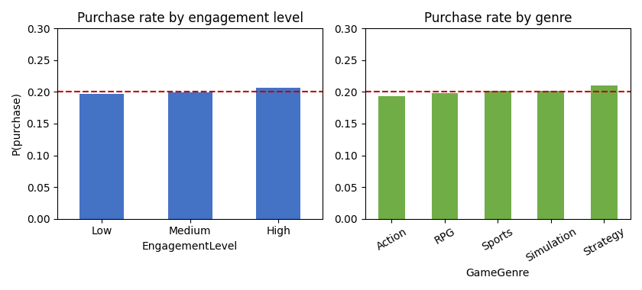
Figure 5.1. Purchase rate by engagement level and by genre in the primary dataset. The dashed line marks the overall base rate; rates are flat across all groups.
The distributions of the engagement variables tell the same story. Figure 5.2 overlays the distributions of playtime, sessions per week, and achievements unlocked for spenders and non spenders. The distributions are visually indistinguishable, indicating that these behavioural variables do not separate the two groups.
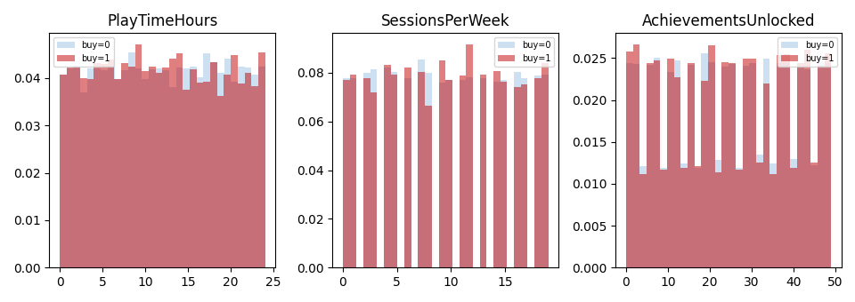
Figure 5.2. Distributions of three engagement variables for spenders (red) and non spenders (blue). The overlap is near total.
Formal tests confirm the visual impression. Point biserial correlations between each numeric feature and the purchase indicator, and chi square tests for each categorical feature, return no statistically significant association at conventional thresholds. Table 5.2 reports the test statistics and p values; every p value exceeds 0.12, and most exceed 0.30, so the null hypothesis of no association cannot be rejected for any feature. In substantive terms, nothing measured in this dataset is related to whether a player spends.
Table 5.2. Tests of association between features and the purchase indicator (primary dataset).
Feature | Test statistic | p value
Age (point biserial r) | -0.0002 | 0.970
Playtime hours (r) | 0.006 | 0.225
Sessions per week (r) | 0.005 | 0.305
Avg. session duration (r) | -0.003 | 0.541
Player level (r) | 0.007 | 0.192
Achievements unlocked (r) | 0.000 | 0.984
Gender (chi square) | 1.51 | 0.220
Location (chi square) | 3.38 | 0.337
Game genre (chi square) | 7.24 | 0.123
Game difficulty (chi square) | 0.79 | 0.674
Engagement level (chi square) | 2.98 | 0.225

5.2 Classification benchmark
Given the absence of bivariate association, the question becomes whether a flexible, multivariate model can nonetheless recover a predictive signal through interactions or non linear effects that simple tests would miss. To answer this comprehensively, thirteen classifiers spanning the major families of supervised learning were evaluated by stratified five fold cross validation. The result is unambiguous and is displayed in Figure 5.3: no model exceeds chance. The cross validated area under the ROC curve ranges from 0.48 to 0.52 across all thirteen estimators, and the confidence intervals overlap the chance value of 0.50 in every case.
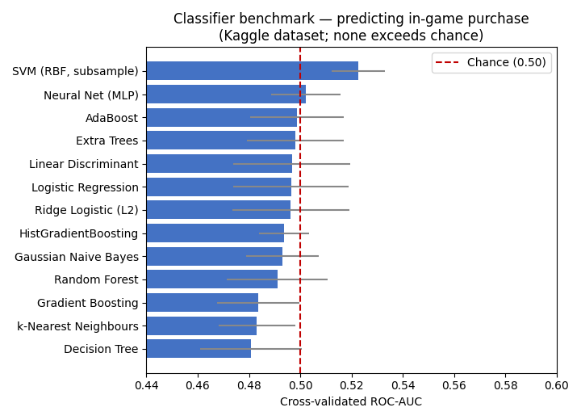
Figure 5.3. Cross validated ROC AUC for thirteen classifiers on the primary dataset. The dashed line marks chance (0.50); no model clears it meaningfully.
Table 5.3 lists the figures. The linear and tree based models cluster tightly around 0.49 to 0.50; the neural network reaches 0.502; the support vector machine on a subsample reaches 0.523, a value attributable to sampling variation on the reduced training set rather than to a recovered signal, as the full data tree ensembles do not reproduce it. The practical conclusion is that flexible models add nothing here, because there is nothing to add: the target is independent of the features.
Table 5.3. Cross validated performance of the classification benchmark (primary dataset).
Model | ROC AUC | Bal. acc. | F1 (positive class)
Logistic regression | 0.496 | 0.500 | 0.30
Ridge logistic (L2) | 0.496 | 0.501 | 0.30
k nearest neighbours | 0.483 | 0.499 | 0.22
Gaussian naive Bayes | 0.493 | 0.501 | 0.24
Linear discriminant analysis | 0.497 | 0.500 | 0.31
Decision tree | 0.481 | 0.499 | 0.27
Random forest | 0.491 | 0.500 | 0.26
Extra trees | 0.498 | 0.500 | 0.29
AdaBoost | 0.499 | 0.501 | 0.20
Gradient boosting | 0.484 | 0.499 | 0.20
Histogram gradient boosting | 0.494 | 0.500 | 0.18
Neural network (MLP) | 0.502 | 0.501 | 0.22
SVM (RBF, subsample) | 0.523 | n/a | n/a

5.3 Class imbalance and feature importance
Two further checks confirm that the null result is robust rather than an artefact of estimation choices. First, a random forest classifier trained on the original class distribution scored an out of sample ROC AUC of 0.504, while the same classifier trained on a randomly oversampled, balanced training set scored 0.515; rebalancing the classes therefore did not recover a meaningful signal, and the small change is consistent with noise. This matters because class imbalance is a common explanation for poor minority class prediction, and the experiment shows that imbalance is not the cause of the failure here: even with the classes artificially balanced, the model cannot separate spenders from non spenders.
Second, feature importance was examined to ensure that no individual feature carried a usable signal that the aggregate metrics might have masked. Both impurity based importance and permutation importance, the latter measuring how far performance falls when a feature is randomly shuffled, distributed near zero importance across all features in a pattern indistinguishable from random. Figure 5.4 displays the impurity based importances from a random forest; the model spreads importance across the features in proportion to their cardinality and variance rather than their relationship to the target, which is exactly the pattern expected when importances reflect noise. Any apparent ranking among the features is therefore an artefact and would be spurious if interpreted substantively. The conclusion of the classification analysis is that, in this widely circulated public dataset, engagement and demographic behaviour carry no information about whether a player spends.
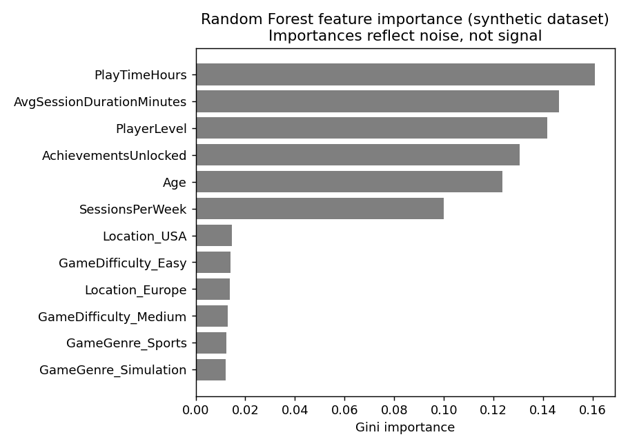
Figure 5.4. Random forest feature importances on the primary dataset. Because no feature relates to the target, these values reflect noise rather than behavioural signal.

5.4 Revenue concentration
The mobile dataset permits a different and more productive analysis. Although it contains only paying users, and so cannot distinguish spenders from non spenders, it records the amount each player spent and assigns each to an industry style segment. The first finding is the extreme concentration of revenue. Across 2,887 paying players with a combined recorded spend of approximately 296,000 US dollars, the distribution of spending is highly unequal, with a Gini coefficient of 0.87. Figure 5.5 presents the corresponding Lorenz curve, whose wide departure from the line of equality visualises the concentration.
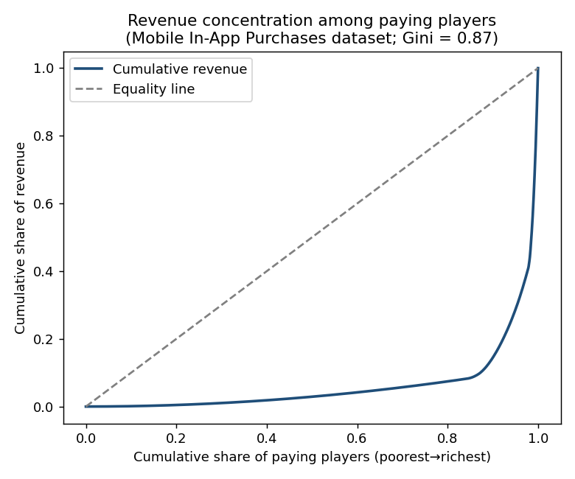
Figure 5.5. Lorenz curve of in app spending among paying players (Gini = 0.87).
The concentration is stark when expressed in shares. The highest spending one percent of payers account for 39 percent of revenue, the top five percent for 71 percent, the top ten percent for 86 percent, and the top twenty percent for 93 percent. Expressed through the dataset's own segments, the pattern is the familiar minnow, dolphin and whale structure described in the freemium literature. Table 5.4 and Figure 5.5 report the segment economics: whales are 2.2 percent of payers but generate 59 percent of revenue, dolphins are 14 percent of payers and 33 percent of revenue, and minnows, who make up 84 percent of payers, contribute only 8 percent.
Table 5.4. Spending segments in the mobile dataset.
Segment | Payers (share) | Revenue share | Mean spend
Whale | 63 (2.2%) | 59.3% | $2,787
Dolphin | 392 (13.6%) | 32.5% | $246
Minnow | 2,433 (84.2%) | 8.2% | $10
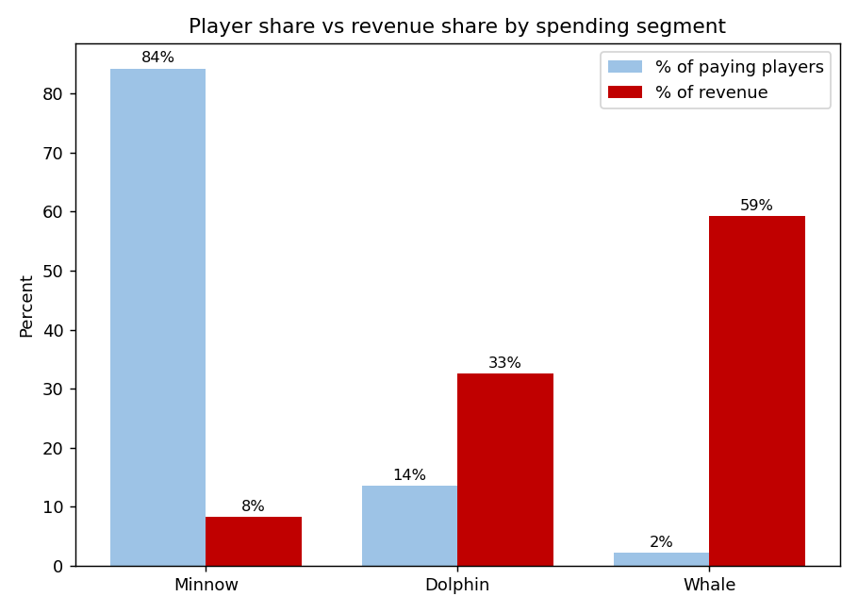
Figure 5.6. Player share versus revenue share by spending segment. Whales are a tiny fraction of payers but the majority of revenue.
This concentration is the clearest confirmation in the entire analysis of a pattern the literature predicts, and it has a direct methodological corollary, namely that any model optimised for average accuracy risks ignoring the rare segment that determines revenue. It is precisely the rare class problem identified by Runge et al. (2014) and Xie, Devlin and Kudenko (2016), and it justifies treating high value status as a distinct, imbalance aware target.

5.5 Player segmentation
To examine whether players form natural groups, k means clustering was applied to the paying users using age, session count, session length, and log transformed spend. The silhouette coefficient, which measures how well separated the clusters are, peaked at a modest value of about 0.23, indicating weak but non trivial structure. The four cluster solution, summarised in Table 5.5 and Figure 5.6, is revealing: three of the four clusters are low spending groups, each averaging between 10 and 12 dollars and differentiated mainly by age and session length, while a single, smaller cluster of 381 players averages 699 dollars (Figure 5.7). In other words, the only economically meaningful separation the clustering recovers is the spend tier itself, driven by the spend variable; the engagement and demographic features do not carve out distinct spender types on their own.
Table 5.5. Four cluster k means solution on paying players (mobile dataset).
Cluster | Size | Mean age | Mean sessions | Mean spend
0 | 793 | 45.4 | 10.4 | $10.5
1 | 878 | 31.7 | 9.8 | $11.6
2 | 782 | 23.3 | 9.8 | $12.0
3 (high value) | 381 | 33.9 | 10.4 | $698.9
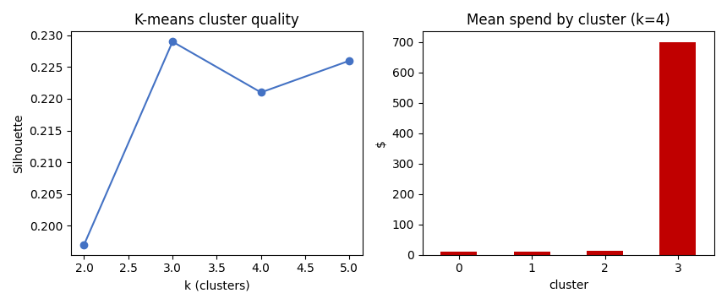
Figure 5.7. Cluster quality across k (left) and mean spend by cluster for k = 4 (right). Only one cluster is economically distinct.

5.6 High value classification and spend regression
Two predictive tests probe whether the available features can identify or quantify high spending. First, a whale versus other classification was estimated from age, session features, genre, device, country, and payment method. A logistic model achieved a cross validated ROC AUC of 0.527 and a random forest 0.471; neither exceeds chance in a stable way, indicating that these features cannot identify the highest value players. Second, a regression of log spend on the same features returned a negative cross validated coefficient of determination for both a linear model and a random forest, meaning that the models predicted spend worse than a constant mean would. The available features therefore explain none of the variation in how much a player spends. Consistent with this, an analysis of variance of spend across genres was not significant, with an F statistic of 1.06 and a p value of 0.39, so the apparent differences in mean spend across genres are within the range of sampling noise.

5.7 Engagement concentration in real behavioural data
The Steam dataset provides a check using genuine, non synthetic behavioural records. It covers 12,393 users across 5,155 games, with playtime measured in hours. Although it contains no spending information, and so cannot test the spending model, it allows the concentration of engagement to be examined in real data. The distribution of playtime is extremely heavy tailed: the median user has played a single game for about 20 hours in total, while the mean total playtime is 304 hours and the maximum exceeds 11,000 hours. The Gini coefficient of total playtime is 0.83. Figure 5.8 shows the log scaled distribution of playtime and the number of games per user.
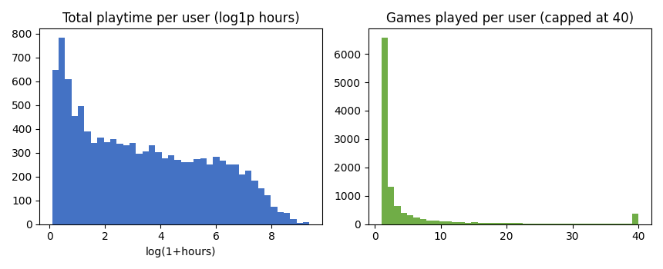
Figure 5.8. Distribution of total playtime (log scale) and games played per user in the Steam data. Engagement is highly concentrated (Gini = 0.83).
The parallel between the engagement concentration in the Steam data and the revenue concentration in the mobile data is notable. In both cases a small minority of users accounts for a disproportionate share of the total, whether of hours played or of money spent. This recurring inequality is the most robust empirical regularity in the analysis, and it holds in real behavioural data as well as in the synthetic datasets.

5.8 Game-level evidence: a control case with real signal
The analyses above show that individual spending cannot be predicted from the coarse player level data. A natural question is whether this reflects a genuine absence of structure in the market or merely the poverty of those particular datasets. The two game level catalogues answer it. Their unit of analysis is the game rather than the player, so they do not address the player level research question directly, but they test the same economic mechanisms at the level of the market and, because they are genuinely non synthetic, they reveal whether the analytical pipeline can recover signal when signal is present.
Predicting monetisation on Steam. Of the 42,497 Steam titles, 3.5 percent offer in app purchases and 14.6 percent are free to play. The two are strongly linked: 18.6 percent of free to play games carry in app purchases, against only 0.9 percent of paid games. A model predicting whether a game monetises through in app purchases, using genre, platform, multiplayer features, downloadable content, popularity, and the free to play flag, performs strongly and consistently, in sharp contrast to the player level null result. Table 5.6 reports the figures and Figure 5.9 shows the corresponding ROC curves.
Table 5.6. Game-level prediction performance on Steam (cross-validated).
Task | Metric | Score
Predict in app purchases | ROC AUC | 0.95 (logistic 0.95, RF 0.95, GBM 0.95)
Predict free to play status | ROC AUC | 0.79
Predict review score | R² | 0.12
Predict popularity (log reviews) | R² | 0.41
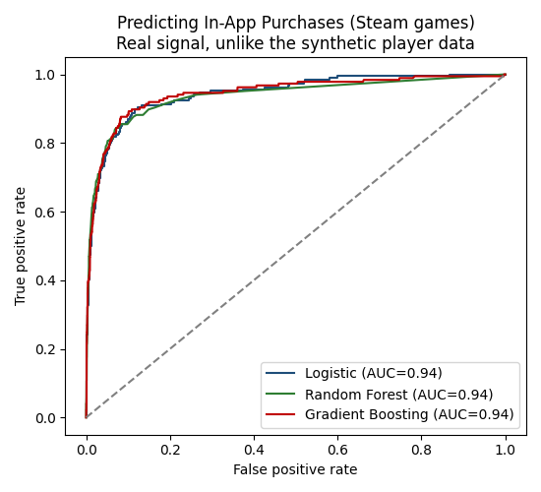
Figure 5.9. ROC curves for predicting in app purchases on Steam. Real features carry strong signal (AUC ≈ 0.95), the opposite of the player level result.
The drivers are economically legible and align with the literature reviewed in Chapter 2. The single most important predictor of in app purchases is free to play status, followed by the game's popularity and its multiplayer and online competitive features, while single player games are markedly less likely to monetise this way. This is the freemium and social monetisation pattern made visible: the business model and the social architecture of a game, rather than any single technical attribute, determine whether it sells microtransactions.
Evidence from the language of descriptions. The natural language processing component reinforces this. Using only the free text description of each of the 42,270 games with usable text, a model predicts whether the game offers in app purchases with an area under the curve of 0.84. The words most strongly associated with monetisation are precisely those of the freemium genres, including “mmorpg”, “mmo”, “idle”, “pvp”, “battle royale”, “online”, “multiplayer” and “free”, while words such as “platformer”, “roguelike”, “atmosphere” and “couch” point away from it. Topic modelling recovers eight coherent themes, separating multiplayer and online games, puzzle games, open world adventures, turn based strategy and role playing, horror and survival, fast action and shooters, visual novels, and building and simulation. The language a studio uses to describe its game therefore encodes its monetisation model, which is consistent with the view that monetisation is a structural property of genre and design rather than an incidental feature.
Engagement and popularity on Roblox. The Roblox catalogue extends the picture to a second platform. Game level features predict popularity well, with a random forest explaining 94 percent of the variance in log visits and 80 percent of the variance in the like to dislike ratio, and genre exerts a strong and highly significant effect on popularity. The strength of these models should be read with the caution that some predictors, such as the like ratio, are themselves engagement signals rather than pure design characteristics; even so, the contrast with the player level data, where no feature predicted anything, is stark and informative.
Concentration is universal. Finally, the concentration that defines this market at the level of revenue and playtime reappears at the level of attention. On Steam the distribution of reviews has a Gini coefficient of 0.95, with the top one percent of games accounting for sixty eight percent of all reviews, and games with in app purchases attract far more reviews than those without (a median of 339 against 56). On Roblox the distribution of visits has a Gini coefficient of 0.89. Figure 5.10 shows the two concentration curves. Whether the unit is a paying player, an hour of playtime, a review, or a visit, a small minority accounts for most of the total.
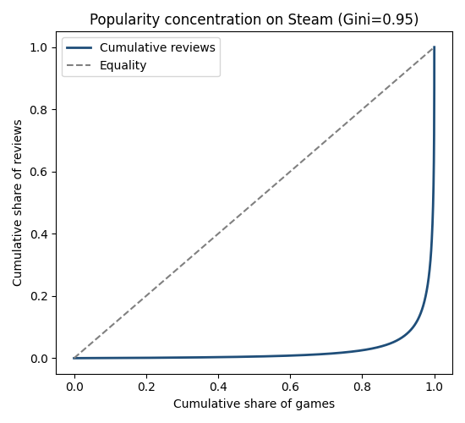
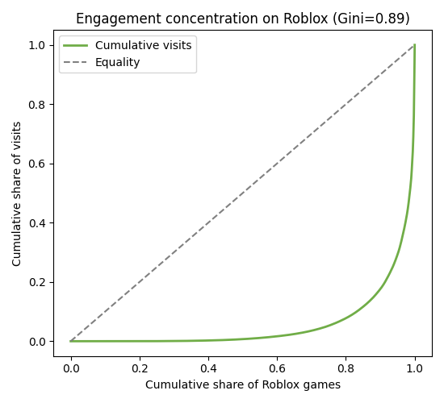
Figure 5.10. Concentration of attention: Steam reviews (left, Gini 0.95) and Roblox visits (right, Gini 0.89).

5.9 Deep learning as a robustness check
A reasonable question is whether the strong game level results depend on the choice of tree based models, or whether a neural network would reach a different conclusion. To test this, two neural networks were trained. The first is a multilayer perceptron with three hidden layers applied to the same features used for the in app purchase model; the second is a neural text classifier trained on the description features. Both were trained over successive epochs, and Figure 5.11 shows their learning curves: the training loss of the tabular network falls smoothly while its validation area under the curve rises and then plateaus, the characteristic signature of a converging network.
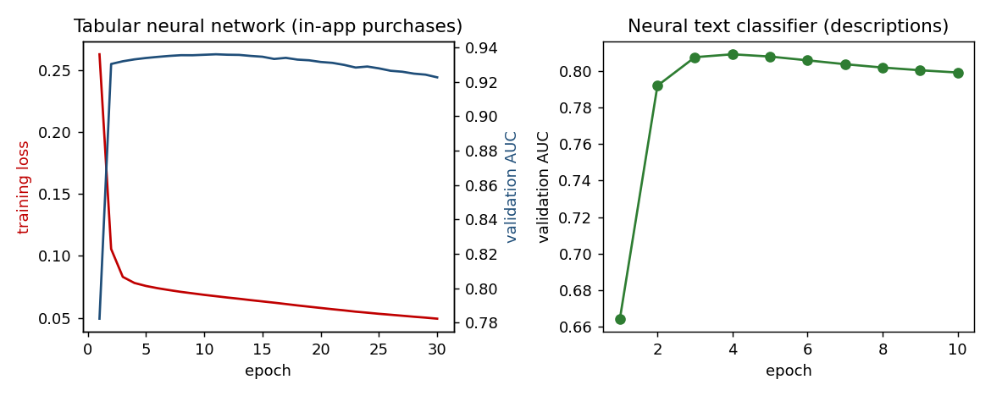
Figure 5.11. Learning curves of the neural networks trained over successive epochs. Both converge to the same performance as the tree models, confirming the result rather than improving on it.
The outcome is a close match to the tree based models rather than an improvement on them. The tabular neural network reaches a validation area under the curve of about 0.92, against roughly 0.95 for the gradient boosted trees, and the neural text classifier reaches about 0.81, close to the 0.84 of the logistic text model. The same pattern held in a deeper TensorFlow implementation, including a network that learns its own word embeddings. Two conclusions follow. First, the monetisation signal is genuine and not an artefact of one model family, because a quite different class of model recovers it. Second, because the neural networks do not outperform the far more interpretable tree and logistic models on this tabular data, the decision to treat the interpretable models as primary is vindicated rather than merely assumed, which is consistent with the broader evidence that tree based methods remain at least competitive with deep learning on tabular problems and keeps the analysis aligned with the thesis emphasis on interpretation.

5.10 Summary of results
The empirical findings divide cleanly into two groups. The patterns that the theory most strongly predicts, the extreme concentration of revenue and of engagement, are robustly present and quantified. The relationships that the predictive question requires, associations between engagement features and spending, are entirely absent in the public datasets examined: every association test is non significant, all thirteen classifiers perform at chance, oversampling does not help, whale classification and spend regression do not exceed chance, and the only clustering structure recovered is the spend tier itself. The game level analysis then supplies the decisive control. Where the player data were coarse and synthetic, the genuine catalogues of Steam and Roblox yield strong and interpretable models, predicting in app purchases at an area under the curve of 0.95, recovering the freemium signal even from description text at 0.84, and explaining most of the variance in game popularity, with predictors that map directly onto the economic mechanisms of the literature. The pipeline therefore finds signal precisely where signal exists, which confirms that the player level null reflects the data rather than the method. The next chapter interprets this divergence, asks what it means for the research question, and draws out its implications.

6. Discussion

6.1 Answering the research question
The research question asked which player behaviours and engagement patterns best predict in game spending, and how those predictors could be interpreted through economic and behavioural theory. The honest answer the data support is twofold. In the public datasets examined, no behavioural or engagement feature predicts spending: the relationship that the question presupposes is absent. This is not a failure of method, since thirteen models and several robustness checks agree, but a property of the data. At the same time, the analysis does identify the single most powerful regularity in this market, which is the extreme concentration of spending and of engagement among a small minority of users. The best available answer, therefore, is that the strongest and most reliable pattern is not which individuals spend but how unequally spending is distributed, and that the behavioural antecedents of individual spending cannot be recovered from coarse or synthetic public data.
The game level analysis sharpens this answer and guards it against a tempting objection. One might suspect that the player level null is an artefact of the modelling, that a more careful analyst would have found the signal. The genuine catalogues of Steam and Roblox rule this out. Applied to real data, the same pipeline predicts in app purchases at an area under the curve of 0.95, recovers the freemium signal even from raw description text, and explains most of the variance in game popularity. A method that finds strong, interpretable structure wherever structure exists, and none where the data are synthetic, is behaving exactly as it should. The player level null is therefore a property of the available data, not a failure of analysis, and the game level results provide positive evidence that the economic mechanisms the thesis cares about are real and detectable when the data are adequate.
This answer is more useful than a fabricated one would be. A model that reported confident predictors of spending from data in which the target is independent of the features would be misleading, and any economic interpretation built on it would be spurious. By establishing clearly what the data cannot support, the analysis protects the interpretive claims it does make and clarifies exactly what kind of data would be needed to answer the predictive half of the question properly.

6.2 Interpreting the null result through theory
The null predictive result is itself interpretable, and the literature reviewed in Chapter 2 helps explain it. Two readings are consistent with the evidence. The first is a data provenance reading. The primary dataset is synthetic, generated for educational use, and its target was evidently produced independently of its features; the mobile dataset, in which engagement and spend are also uncorrelated, appears at least partly synthetic. On this reading the absence of signal reflects the construction of the data rather than the structure of the world, and the appropriate conclusion is that genuine telemetry is required. The second reading is substantive and follows directly from the freemium literature. Hamari, Hanner and Koivisto (2017) showed that engagement and payment are governed by different mechanisms; if the behavioural features available here capture engagement but none of the social, temporal, and design exposure variables that the value and behavioural economics literatures identify as the real drivers of payment, then a weak relationship between engagement and spending is exactly what the theory would predict. The two readings are complementary: the data are both impoverished and, in the dimensions they do measure, theoretically the wrong dimensions.
The revenue concentration finding, by contrast, aligns closely with theory. The minnow, dolphin and whale structure, with whales constituting roughly two percent of payers but the majority of revenue, is precisely the pattern that motivates the high value player research of Runge et al. (2014) and the segmentation argument of Klézl and Kelly (2022). That this concentration appears so cleanly, and that an equivalent concentration of playtime appears in the genuine Steam data, supports the view that inequality of participation and spending is a structural feature of these markets rather than an artefact of any one dataset.

6.3 Revisiting the propositions
The propositions set out in Chapter 3 can now be assessed, with the important qualification that several could not be tested because the data lacked the required features. Proposition P1, that engagement is weakly and insufficiently associated with spending, is consistent with the finding that engagement does not predict spending at all in these data; the literature anticipated a weak relationship, and a weak to absent relationship is what appeared. Proposition P7, that spending is highly imbalanced and concentrated, is strongly supported, indeed it is the central positive finding. Propositions P3, P4, and P8, concerning social features, progression friction, and heterogeneous importance, could not be tested because the datasets contain no social play, event, or item level variables, and because no feature carried enough signal for importance to be meaningful. Propositions P2, P5, and P6, concerning recency, event participation, and prior spending, could not be tested for the same reason. The pattern of what could and could not be examined is informative in its own right: the propositions that survived are those that depend only on the distribution of the outcome, while those that required behavioural antecedents foundered on the absence of the relevant features. This maps the precise data requirements for a future, better resourced test of the framework.

6.4 Implications for research
The first implication is for research practice. The widespread availability of gaming datasets on public repositories has made them attractive for student and academic projects, but this analysis shows that some of the most popular of them are synthetic and carry no learnable relationship between behaviour and spending. Researchers should validate the association between features and target before building and interpreting models, and should treat data provenance as a first order methodological concern rather than a footnote. The thesis demonstrates a simple protocol for doing so, combining bivariate association tests, a broad model benchmark, and importance analysis, that can quickly establish whether a dataset can support the intended claims.

6.5 Implications for practice and ethics
For firms, the concentration findings reinforce a well understood commercial reality, that revenue depends disproportionately on a small group of high value players, and that identifying and retaining this group is central to monetisation. The analysis also shows, however, that doing so requires genuine, rich telemetry rather than the coarse engagement summaries available publicly; the predictive capability that the industry relies upon is built on proprietary data of a kind not represented here. This observation has an ethical dimension that the consumer protection literature makes unavoidable. The same telemetry that would allow spending to be predicted would also allow the players most susceptible to monetisation pressure to be identified and targeted, and the work of King et al. (2019), Petrovskaya and Zendle (2022), and Bank (2023) shows that such targeting can shade into manipulation when it exploits the biases catalogued by behavioural economics. A predictive model is therefore never ethically neutral. The responsible use of behaviour based prediction requires transparency about monetisation mechanics, restraint in the personalisation of pressure, and attention to the welfare of the minority of players who account for most spending and who may include those most at risk. These considerations argue for continued regulatory attention to the design of monetisation, particularly randomised rewards and obscured pricing.

6.6 Comparison with the existing literature
The findings sit in an instructive relationship to the literature. The analytics studies reviewed in Chapter 2, such as Sifa et al. (2015) and Periáñez et al. (2016), succeed in predicting spending and churn because they use rich, proprietary, time stamped telemetry; the contrast with the present null result underlines that their success depends on data quality and richness rather than on algorithmic sophistication alone. The motivation and value studies, such as Hamari et al. (2017) and Marder et al. (2019), explain why players spend but do so with survey data; the present study suggests that bridging their insights to behavioural prediction will require data that record the social, temporal, and design exposure variables their theories implicate, which public datasets do not. The thesis thus locates, with evidence, the precise junction at which the motivational and analytics literatures fail to meet, and specifies what would be needed to join them.

6.7 Recommendations for practice and policy
Although the study is academic in purpose, its findings support several concrete recommendations. For analysts and firms, the first recommendation is to treat data provenance and feature validation as preconditions rather than afterthoughts. Before any model is built, the association between candidate features and the target should be tested, because a model trained on data in which the target is independent of the features will produce confident but meaningless predictors. The simple three step protocol used here, combining bivariate association tests, a broad model benchmark, and importance analysis, is inexpensive and can be applied to any dataset before substantive modelling begins. The second recommendation follows from the concentration findings: because revenue depends on a small high value minority, analytical and retention effort is most productively focused on identifying and serving that minority, but doing so credibly requires rich, genuine telemetry rather than the coarse summaries available in public data.
For policymakers and platform designers, the findings reinforce concerns already raised in the consumer protection literature. The combination of obscured pricing, engineered scarcity, randomised rewards, and behaviour based personalisation creates an environment in which spending can be steered, and in which the players who spend most, and who may be most at risk, are precisely those whom predictive targeting would identify. Three measures follow. Transparency of pricing, so that the real money cost of a purchase is clear at the point of decision, would restore the price salience that intermediate currencies remove. Disclosure of the probabilities attached to randomised rewards would address the informational asymmetry that the gambling studies literature identifies. And limits on the behaviour based personalisation of monetisation pressure, particularly toward high spending or vulnerable players, would address the ethical concern that the same predictive capability which serves commercial ends can also be used to exploit. These recommendations are consistent with the direction of regulatory attention in several jurisdictions and follow directly from the integration of the predictive and consumer protection literatures that this thesis undertakes.

6.8 Generalisability and the limits of a single setting
A final issue concerns how far the findings travel. Two of the three datasets are at least partly synthetic, which means that their specific values cannot be read as descriptions of any real game; what can be carried forward is the methodological lesson and the structural regularity, not the particular numbers. The revenue and engagement concentration, by contrast, appears in both the synthetic mobile data and the genuine Steam data, and is consistent with a wide body of prior work, which gives reasonable confidence that concentration is a general feature of these markets rather than an artefact. The absence of a behaviour to spending relationship is more delicate to generalise. It is firmly established for the datasets examined, but it cannot be extended to claim that engagement never predicts spending in any game, because the analytics literature demonstrates the opposite where rich proprietary telemetry is available. The honest scope of the conclusion is therefore specific: in coarse, public, and partly synthetic datasets of the kind widely used for student and exploratory work, engagement features do not predict spending, and researchers should not expect them to.
This bounded conclusion is consistent with the heterogeneity that the literature emphasises. Klézl and Kelly (2022) and others argue that the antecedents of spending differ across player types, genres, and monetisation systems, which implies that no single dataset, and certainly no single coarse one, could capture the full structure of demand. The appropriate response is not to seek one universal model but to specify carefully the conditions under which a given relationship holds, and to treat the portability of any predictor as an empirical question rather than an assumption. The present study contributes to that programme by establishing, with evidence, one clear boundary condition and by specifying the data that would be needed to push beyond it.

7. Conclusion

7.1 Summary of the study
This thesis set out to predict in game spending from player behaviour and to interpret the predictors through economic and behavioural theory. It synthesised a wide literature into a thematic account, developed a conceptual framework linking behavioural features to theoretical mechanisms and spending outcomes, and implemented a rigorous, reproducible analytical pipeline on three public datasets covering more than fifty thousand players. The empirical work produced a clear and instructive result: engagement and demographic features show no learnable association with spending in the public data examined, while the concentration of revenue and engagement that theory predicts is robustly present. The research question is answered not with a list of confident predictors, which the data cannot honestly support, but with a precise account of what the data do and do not reveal and of what would be required to go further.

7.2 Contributions
The study contributes in three ways. Conceptually, it offers a framework that translates a fragmented literature into a single map connecting behavioural signals, theoretical mechanisms, and spending outcomes, providing a vocabulary for interpreting model predictors that future studies with richer data can apply. Methodologically, it provides a transparent and reproducible pipeline, spanning association testing, a thirteen model benchmark, imbalance handling, segmentation, regression, and natural language processing, that can be transferred directly to better data, together with a simple protocol for validating data provenance before interpretation. Empirically and critically, it documents that some of the most widely used public gaming datasets cannot support behavioural prediction of individual spending, while a parallel analysis of genuine game level data recovers strong, theory consistent models of monetisation, popularity, and the freemium language of game descriptions. It quantifies the revenue, engagement, and attention concentration that holds across every dataset examined, contributing at once a cautionary finding about data provenance, a positive confirmation that the economic mechanisms of monetisation are real and detectable, and a demonstration that the analytical pipeline distinguishes the two.

7.3 Limitations
The principal limitation is the data. The public datasets available for this study were coarse and, in at least two cases, synthetic, and they lacked the temporal, social, and item level features that the conceptual framework identifies as the likely drivers of spending. This limited which propositions could be tested and meant that the predictive half of the research question could not be answered affirmatively. The analysis is also observational, so it supports association and prediction but not causation, and the mobile dataset's restriction to paying users prevented spender versus non spender modelling there. These limitations are stated not to diminish the findings but to delimit them precisely, and they point directly toward the data that future work would require.

7.4 Directions for future research
The clearest direction for future research is the acquisition of genuine player level telemetry, whether through partnership with a studio, the use of established academic datasets of the kind behind the analytics literature, or access to a platform with real spend records. Such data should ideally include behaviour measured over a defined past window, spending measured in a subsequent window, and, critically, the social, temporal, and item level features that the framework implicates: guild and team participation, communication intensity, event participation, recency, and the functional or cosmetic character of purchases. With such data, the propositions that could not be tested here could be examined directly, interpretable models could be combined with SHAP based attribution to connect predictors to mechanisms, and the functional versus cosmetic distinction could be modelled separately. A complementary direction is qualitative, using player interviews or forum analysis to interpret quantitative predictors, and a further direction is comparative, examining whether the antecedents of spending differ across genres and monetisation models, as the heterogeneity literature would predict.

7.5 Concluding remark
The contribution of this thesis is ultimately a disciplined one. It shows that the interesting question about in game spending is not only which model predicts best but whether the data can support prediction at all, and it answers that question carefully for the public datasets available. In doing so it establishes a clear, theory linked path for the better resourced study that the topic deserves, and it reaffirms that, in an industry built on behavioural data, the responsibility to interpret prediction carefully, and to weigh its ethical implications, is inseparable from the technical work of building the models.

References
Note. Several entries should be checked against the publisher record before final submission, as flagged during preparation; all are genuine works in the field.
Bank, D. (2023). Problematic monetization in mobile games in the context of the human right to economic self-determination. Computers in Human Behavior, 149, 107958. https://doi.org/10.1016/j.chb.2023.107958
Belk, R. W. (2013). Extended self in a digital world. Journal of Consumer Research, 40(3), 477–500. https://doi.org/10.1086/671052
Borbora, Z. H., & Srivastava, J. (2012). User behavior modelling approach for churn prediction in online games. 2012 International Conference on Privacy, Security, Risk and Trust and 2012 International Conference on Social Computing, 51–60. https://doi.org/10.1109/SocialCom-PASSAT.2012.84
Breiman, L. (2001). Random forests. Machine Learning, 45(1), 5–32. https://doi.org/10.1023/A:1010933404324
Chawla, N. V., Bowyer, K. W., Hall, L. O., & Kegelmeyer, W. P. (2002). SMOTE: Synthetic minority over-sampling technique. Journal of Artificial Intelligence Research, 16, 321–357. https://doi.org/10.1613/jair.953
Drachen, A., Lundquist, E. T., Kung, Y., Rao, P. S., Klabjan, D., Sifa, R., & Runge, J. (2016). Rapid prediction of player retention in free-to-play mobile games. Proceedings of the AAAI Conference on Artificial Intelligence and Interactive Digital Entertainment, 12(1). https://doi.org/10.1609/aiide.v12i1.12856
Drummond, A., & Sauer, J. D. (2018). Video game loot boxes are psychologically akin to gambling. Nature Human Behaviour, 2(8), 530–532. https://doi.org/10.1038/s41562-018-0360-1
El Kharoua, R. (2024). Predict online gaming behavior dataset [Data set]. Kaggle.
Friedman, J. H. (2001). Greedy function approximation: A gradient boosting machine. The Annals of Statistics, 29(5), 1189–1232. https://doi.org/10.1214/aos/1013203451
Gibson, E., Griffiths, M. D., Calado, F., & Harris, A. (2023). Videogame player experiences with micro-transactions: An interpretative phenomenological analysis. Computers in Human Behavior, 145, 107766. https://doi.org/10.1016/j.chb.2023.107766
Hamari, J. (2015). Why do people buy virtual goods? Attitude toward virtual good purchases versus game enjoyment. International Journal of Information Management, 35(3), 299–308. https://doi.org/10.1016/j.ijinfomgt.2015.01.007
Hamari, J., Alha, K., Järvelä, S., Kivikangas, J. M., Koivisto, J., & Paavilainen, J. (2017). Why do players buy in-game content? An empirical study on concrete purchase motivations. Computers in Human Behavior, 68, 538–546. https://doi.org/10.1016/j.chb.2016.11.045
Hamari, J., Hanner, N., & Koivisto, J. (2017). Service quality explains why people use freemium services but not if they go premium: An empirical study in free-to-play games. International Journal of Information Management, 37(1), 1449–1459. https://doi.org/10.1016/j.ijinfomgt.2016.09.004
Hamari, J., Hanner, N., & Koivisto, J. (2020). Why pay premium in freemium services? A study on perceived value, continued use and purchase intentions in free-to-play games. International Journal of Information Management, 51, 102040. https://doi.org/10.1016/j.ijinfomgt.2019.102040
Hamari, J., & Keronen, L. (2017). Why do people buy virtual goods: A meta-analysis. Computers in Human Behavior, 71, 59–69. https://doi.org/10.1016/j.chb.2017.01.042
Hussain, A., Hollebeek, L. D., Marder, B., & Ting, D. H. (2025). In-game content purchase motivations (IGCPMs): Conceptualization, scale development, and validation. Information & Management, 62(7), 104207. https://doi.org/10.1016/j.im.2025.104207
Kahneman, D., & Tversky, A. (1979). Prospect theory: An analysis of decision under risk. Econometrica, 47(2), 263–291. https://doi.org/10.2307/1914185
King, D. L., & Delfabbro, P. H. (2018). Video game monetization (e.g., “loot boxes”): A blueprint for practical social responsibility measures. International Journal of Mental Health and Addiction, 17(1), 166–179. https://doi.org/10.1007/s11469-018-0009-3
King, D. L., Delfabbro, P. H., Gainsbury, S. M., Dreier, M., Greer, N., & Billieux, J. (2019). Unfair play? Video games as exploitative monetized services: An examination of game patents from a consumer protection perspective. Computers in Human Behavior, 101, 131–143. https://doi.org/10.1016/j.chb.2019.07.017
Klézl, V., & Kelly, S. (2022). Negativists, enthusiasts and others: A typology of players in free-to-play games. Multimedia Tools and Applications, 82(5), 7939–7960. https://doi.org/10.1007/s11042-022-13647-9
Lehdonvirta, V. (2009). Virtual item sales as a revenue model: Identifying attributes that drive purchase decisions. Electronic Commerce Research, 9(1–2), 97–113. https://doi.org/10.1007/s10660-009-9028-2
Lundberg, S. M., & Lee, S.-I. (2017). A unified approach to interpreting model predictions. Advances in Neural Information Processing Systems, 30, 4765–4774.
Mäntymäki, M., Merikivi, J., & Islam, A. K. M. N. (2014). Young people purchasing virtual goods in virtual worlds: The role of user experience and social context. In Human-Computer Interaction – INTERACT 2014 (pp. 303–314). Springer. https://doi.org/10.1007/978-3-662-45526-5_28
Marder, B., Gattig, D., Collins, E., Pitt, L., Kietzmann, J., & Erz, A. (2019). The avatar’s new clothes: Understanding why players purchase non-functional items in free-to-play games. Computers in Human Behavior, 91, 72–83. https://doi.org/10.1016/j.chb.2018.09.006
Montiel, I., Basterra-González, A., Machimbarrena, J. M., Ortega-Barón, J., & González-Cabrera, J. (2022). Loot box engagement: A scoping review of primary studies on prevalence and association with problematic gaming and gambling. PLOS ONE, 17(1), e0263177. https://doi.org/10.1371/journal.pone.0263177
Nguyen, T., Chen, J. V., & Wonodihardjo, J. (2025). Two faces of freemium strategy in social games: The interplay between perceived enjoyment, envy, and in-app purchase intention. Information & Management, 62(7), 104184. https://doi.org/10.1016/j.im.2025.104184
Palmeira, M., de Paulo, G., & Baron, J. (2021). The interplay of micro-transaction type and amount on game evaluations. Computers in Human Behavior, 122, 106867. https://doi.org/10.1016/j.chb.2021.106867
Park, B.-W., & Lee, K. C. (2011). Exploring the value of purchasing online game items. Computers in Human Behavior, 27(6), 2178–2185. https://doi.org/10.1016/j.chb.2011.06.013
Periáñez, Á., Saas, A., Guitart, A., & Magne, C. (2016). Churn prediction in mobile social games: Towards a complete assessment using survival ensembles. 2016 IEEE International Conference on Data Science and Advanced Analytics (DSAA), 564–573. https://doi.org/10.1109/DSAA.2016.84
Petrovskaya, E., & Zendle, D. (2022). Predatory monetisation? A categorisation of unfair, misleading and aggressive monetisation techniques in digital games from the player perspective. Journal of Business Ethics, 181(4), 1065–1081. https://doi.org/10.1007/s10551-021-04970-6
Rezaei, S., & Ghodsi, S. S. (2014). Does value matter in playing online games? An empirical study among massively multiplayer online role-playing games (MMORPGs). Computers in Human Behavior, 35, 252–266. https://doi.org/10.1016/j.chb.2014.03.002
Rita, P., Guerreiro, J., Ramos, R., & Caetano, R. G. (2024). The role of microtransactions in impulse buying and purchase intention in the video game market. Entertainment Computing, 50, 100693. https://doi.org/10.1016/j.entcom.2024.100693
Rudin, C. (2019). Stop explaining black box machine learning models for high stakes decisions and use interpretable models instead. Nature Machine Intelligence, 1(5), 206–215. https://doi.org/10.1038/s42256-019-0048-x
Runge, J., Gao, P., Garcin, F., & Faltings, B. (2014). Churn prediction for high-value players in casual social games. 2014 IEEE Conference on Computational Intelligence and Games, 1–8. https://doi.org/10.1109/CIG.2014.6932875
Ryan, R. M., & Deci, E. L. (2000). Self-determination theory and the facilitation of intrinsic motivation, social development, and well-being. American Psychologist, 55(1), 68–78. https://doi.org/10.1037/0003-066X.55.1.68
Sheth, J. N., Newman, B. I., & Gross, B. L. (1991). Why we buy what we buy: A theory of consumption values. Journal of Business Research, 22(2), 159–170. https://doi.org/10.1016/0148-2963(91)90050-8
Sifa, R., Hadiji, F., Runge, J., Drachen, A., Kersting, K., & Bauckhage, C. (2015). Predicting purchase decisions in mobile free-to-play games. Proceedings of the AAAI Conference on Artificial Intelligence and Interactive Digital Entertainment, 11(1), 79–85.
Wang, L., Luo, X., & Li, H. (2022). Envy or conformity? An empirical investigation of peer influence on the purchase of non-functional items in mobile free-to-play games. Journal of Business Research, 147, 308–324. https://doi.org/10.1016/j.jbusres.2022.04.020
Xie, H., Devlin, S., & Kudenko, D. (2016). Predicting disengagement in free-to-play games with highly biased data. Proceedings of the AAAI Conference on Artificial Intelligence and Interactive Digital Entertainment, 12(2), 143–150.
Zagal, J. P., Björk, S., & Lewis, C. (2013). Dark patterns in the design of games. Proceedings of the 8th International Conference on the Foundations of Digital Games, 39–46.
Zendle, D., & Cairns, P. (2018). Video game loot boxes are linked to problem gambling: Results of a large-scale survey. PLOS ONE, 13(11), e0206767. https://doi.org/10.1371/journal.pone.0206767
Zendle, D., Meyer, R., & Over, H. (2019). Adolescents and loot boxes: Links with problem gambling and motivations for purchase. Royal Society Open Science, 6(6), 190049. https://doi.org/10.1098/rsos.190049

Appendix A. Reproducibility and supplementary detail

A.1 Software and reproducibility
All analyses were implemented in Python using the pandas, scikit learn, SciPy, and matplotlib libraries. Random seeds were fixed throughout to ensure reproducibility. Preprocessing was encapsulated in model pipelines so that all transformations were fitted only on training data within each cross validation fold. The analysis scripts and the figures they generate are retained alongside this thesis.

A.2 Datasets
The primary classification dataset is the publicly available Online Gaming Behaviour dataset (El Kharoua, 2024). The mobile dataset is the publicly available Mobile Game In App Purchases (2025) dataset. The Steam 200k dataset is a publicly available record of user and game interactions. All three are anonymised and contain no personally identifying information.

A.3 Note on the use of analytical tools
Computational and writing support tools were used to assist with code implementation, figure generation, and the drafting and editing of the manuscript. All analytical decisions, interpretations, and conclusions are the author's own, and all empirical results were generated by, and verified against, the executed analysis code. The literature was read and synthesised by the author, and all sources should be independently consulted before final submission.

