**Test Cases:-**

**In a command line of your shell you will be able to exercise any executable programs including the utilities provided in /bin and /usr/bin.**

/bin

* [#]pwd: this command should display the current working directory.

Expected Results:- Should display the current working directory .

Derived Output :- Got the contents of the current working directory.

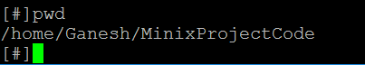

* [#] echo “hi” :- this command should print the contents in the quotes.

Expected Results:- Should display the contents in the quotes i.e “hi”.

Derived Output :- Got the contents in the quotes.

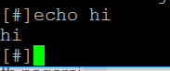

* [#] ls :- this command should print all the file names in the current directory.

Expected Results:- Should display all the filenames in the current directory

Derived Output :- Got the filenames in the current directory.

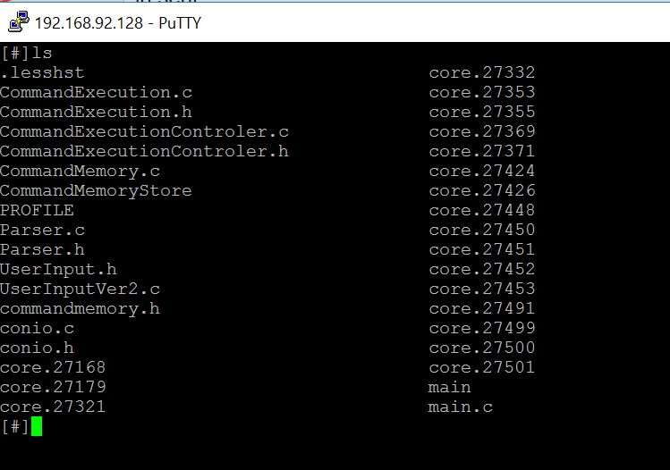

**/usr/bin**

* [#] cal:- this command should print the calendar of the current month.

Expected Results:- Should display the calendar of the current month.

Derived Output :- Got the calendar of the current month.

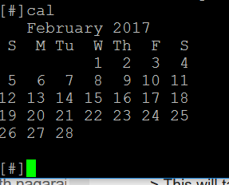

* [#]man ls :- this command should display the man pages of ls command.

Expected Results: - Should display the man pages of ls

Derived Output :- Got the manpages of ls.

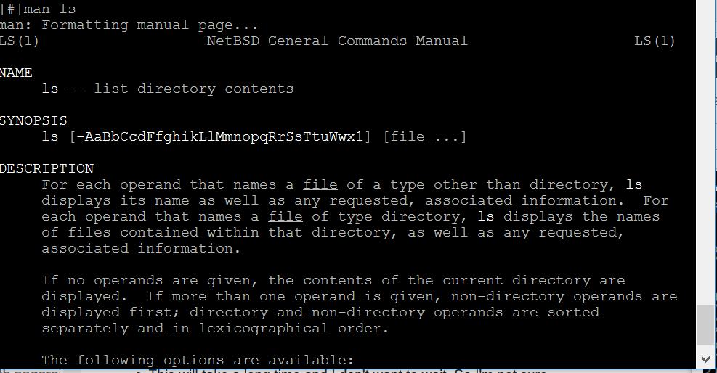

* [#]whoami:- this command should print the effective username of the current user.

Expected Results:- Should print the effective username of the current user.

Derived Output :-Got the effective username of the current user which is “root”.

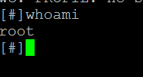

* **Alarm**
* [#] sleep 10 :- this command should sleep for 10s .

Expected Results:- Should prompt the user after 10s saying whether you want to quit or not ?.

Derived Output :- Got as expected above.

* **Remember the commands:**
* **Tab & Up and Down arrow key**

**Expected Results:-**

While entering commands, which have already been executed, you have to press tab and the similar commands will be displayed on screen and if you are not satisfied with the commands, you can press up and down arrow keys and select the desired command.

If you enter a new command, it will be stored in memory after the shell exits.

Eg:- [#] ls

[#] ls -l

[#] ls -la

[#] ls -lr

When the user has executed the above mentioned commands, and then again try to enter these commands, say [#] ls ,and then press tab, the user will be provided with the options “-l ,-la, -lr ” which he choose by using UP and DOWN arrow keys.

**Derived Output** :- Got as expected above.

C:\Users\aishw\AppData\Local\Microsoft\Windows\INetCacheContent.Word\Screen Shot 2017-02-28 at 12.05.59 AM.PNG

C:\Users\aishw\AppData\Local\Microsoft\Windows\INetCacheContent.Word\Screen Shot 2017-02-28 at 12.07.16 AM.PNG

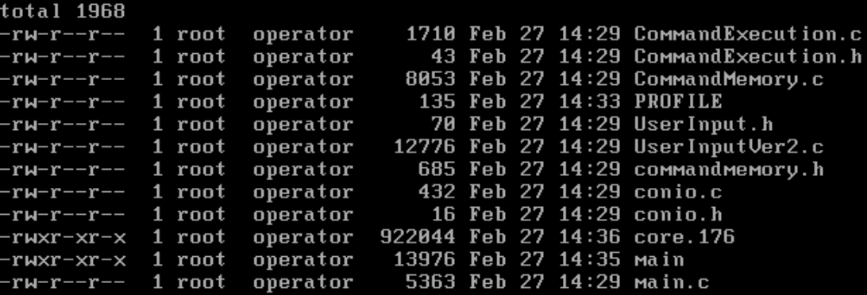

C:\Users\aishw\AppData\Local\Microsoft\Windows\INetCacheContent.Word\Screen Shot 2017-02-28 at 12.09.54 AM.PNG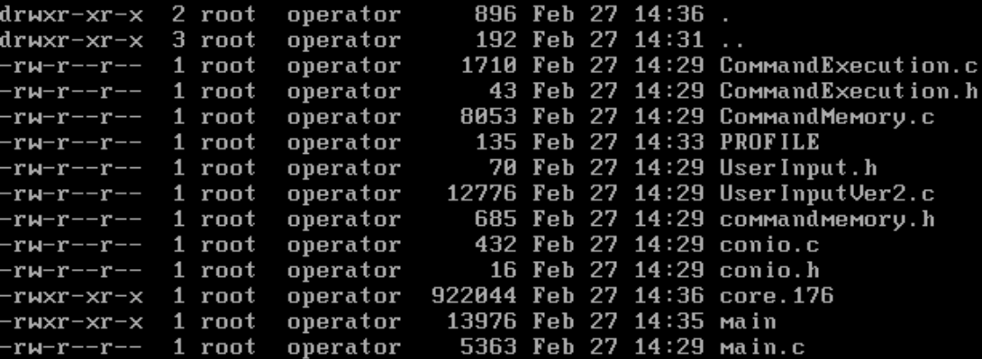

After pressing tab we get as below using up and down arrow

C:\Users\aishw\AppData\Local\Microsoft\Windows\INetCacheContent.Word\Screen Shot 2017-02-28 at 12.10.12 AM.PNG

C:\Users\aishw\AppData\Local\Microsoft\Windows\INetCacheContent.Word\Screen Shot 2017-02-28 at 12.07.58 AM.PNG

* **Sequence and parallel execution operators.**

**Expected results:**

The shell supports a command line with sequence and parallel execution operators [;] and [&] respectively.

Eg:- [#] ls;pwd&whoami

The above example will illustrate both sequence and parallel execution operators where ls and pwd is executed in sequentially while whoami and (ls and pwd) are executed parallely.

**Derived results:** Got as expected.

