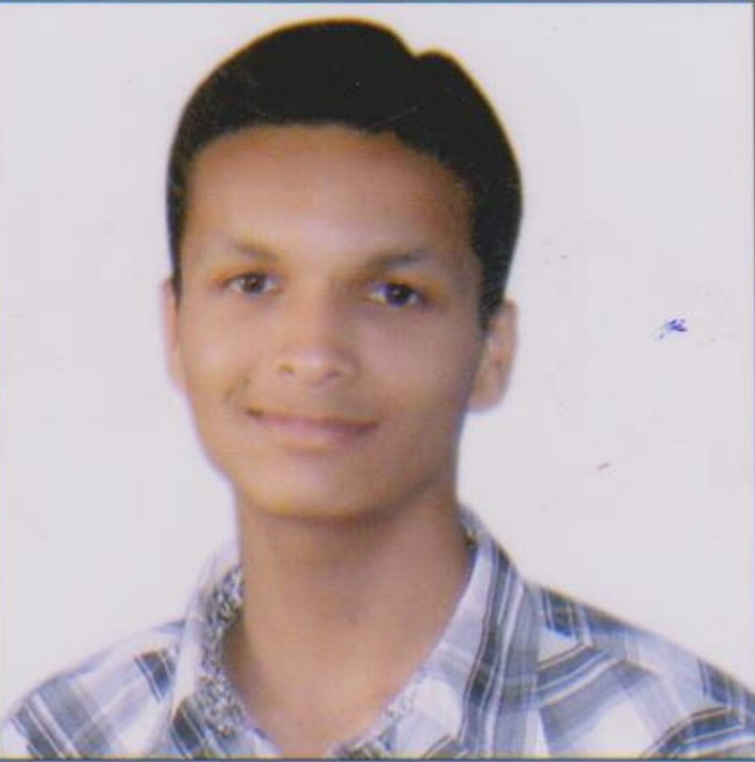
Rajat Kumar Jain

Email: therajat127@gmail.com
Phone (M): +91 9782477452

Professional Experience: Fresher

Objective

In pursuit of challenging assignments that would facilitate the maximum utilization and application of my broad skills and expertise in making a positive difference to the organization.

Academic Credentials

Year | Education | College/School Name | Affiliated to | Aggregate Marks (%)
2016 | B.E.  (Electrical Engineering) | Arya College Of Engineering & I.T., Jaipur (Rajasthan) | Rajasthan Technical University | 62  (upto7thsem)
2012 | Higher Secondary | Government Senior Secondary School, Kota (Rajasthan) | RBSE Board | 58.60
2010 | High School | Adarsh Vidhya Mandir Sec. School, Bhawanimandi (Rajasthan) | RBSE Board | 65.17

Practical Training

Industrial Automation with PLC, Jaipur (Raj.) June 2015

An industrial SCADA & PLCs system is used for the development of the controls of machinery. This paper describes the SCADA & PLCs systems in terms of their architecture, their interface to the process hardware, the functionality and the application development facilities they provide. Some attention is also paid to the industrial standards to which they abide their planned evolution as well as the potential benefits of their use.

Project

Windmill Dec 2015-2016

B.E. Degree Project

Mentor: Mr. Prabhat Kumar/ Professor Department of Electrical engineering
Abstract: A windmill is a mill that converts the wind energy into rotational energy by means of vanes called sails or blades. Windmill were used to mill grain, pump water or both. Windmill takes the form of wind turbines used to generate electricity or wind pumps used to pump water, either for land drainage or to extract groundwater.

Technical Skills

- Language : C, C++
- Software known : PLC, AutoCAD, M.S Office2007 (Word, Excel, Power point)

Achievement
- 1st Prize at College Level ‘Badminton Tournament’ in 2013.

Co-curricular and Extracurricular Activities

- Participation in Quiz Competition on the occasion of Rajiv Gandhi Akshay Urja Diwas - 2013, Arya College of Engg. & I.T. Jaipur (Rajasthan).
- Workshop on Ethical Hacking & Security organized by Linux Community of ACEIT – 2013,
- Jaipur (Rajasthan).
- Participation in Poster Competition on the occasion of Rajiv Gandhi Akshay Urja Diwas - 2013 ,
- ACEIT Jaipur (Rajasthan).
- Coordinator of International Technical Conference organized by ACEIT – 2013,
- Jaipur (Rajasthan).
- Participation in Agrasen Blood Donate Camp organized by Agrasen Blood Bank – 2014,
- Jaipur (Rajasthan).
- Active Participation in Blood Donation camps and NSS.
- Active Participation in Cultural Programs held at college level.

Key Strengths

- Hard work, Positive attitude, Interpersonal Relationship & Leadership skills.

Personal Details

Status Unmarried
Nationality Indian
Date of Birth 15th July’ 1994
Languages Known English & Hindi
Address Paras Kirana Store, Bhawanimandi,
Dist. – Jhalawar, 326502

