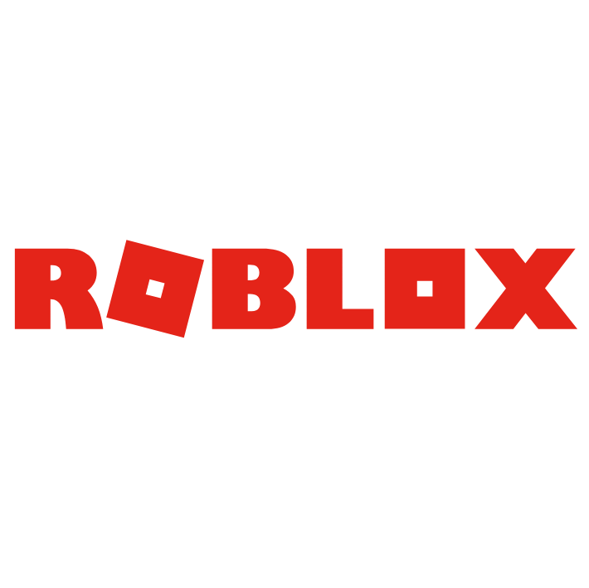

**Roblox – Make a Game**

**Group Project**

**Final Report**

**Members**

Zyrynyl Melendres (Project Manager)

William Smallwood

Euan Sutherland

Thomas Heaton

Niall Swan

Patryk Augusewicz

Table of Contents

Executive Summary 3

Delivered Product 4

Client Approval 5

Closing Audit 6

Lessons Learned 7

Team Contribution 8

Appendix 9

# Executive Summary

Roblox – Make a Game!

The Group Project is all about making a game in Roblox, Roblox is a massively multiplayer online video game and game creation system that allows the users to design their own games and play a wide variety genre of games.

The goal of this project is to make a fun, replayable game and make the users that play this game interested on spending robux, which is another goal of this project. Robux is an in-game currency that can be traded into real life money. We can earn robux by microtransactions in the game for example, customizable weapons and gears.

The product that we are trying to deliver is a class-based combat game, where based on the class the user chooses, it will have different abilities and weapons. There will be objectives like 6v6, 3v3, Attackers vs Defenders, King of the Hill (where a team of players have to capture a point of the map and be able to keep it for a certain amount of time).

For the basic game we plan to have 3 basic classes, Warrior [1], Mage [2], Alchemist [3]. 1 objective and 1 map. We can monetize the game via game passes which shows what cosmetics the player chose.

The requirements of this group project are:

* A game that has a scoring mechanism.
* A game that is fun.
* A game that has a multiplayer function.
* Has sounds.
* Ideally has the new features of the Roblox framework (e.g. terrain vegetation, physics-based rendering).
* A game that can be monetized and be able to get robux.
* A popular game genre that has a chance for growth.
* A game that can be original and popular.

# Delivered Product

Roblox – Make a Game!

# Client Approval

Roblox – Make a Game!

# Closing Audit

Roblox – Make a Game!

# Lessons Learned

Roblox – Make a Game!

# Team Contribution

Roblox – Make a Game!

# Appendix

Roblox – Make a Game!

[1] Warrior Class Design

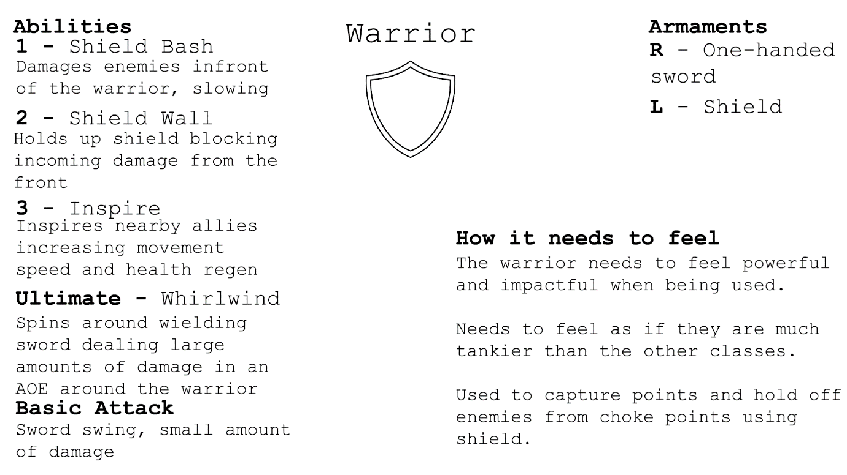

[2] Mage Class Design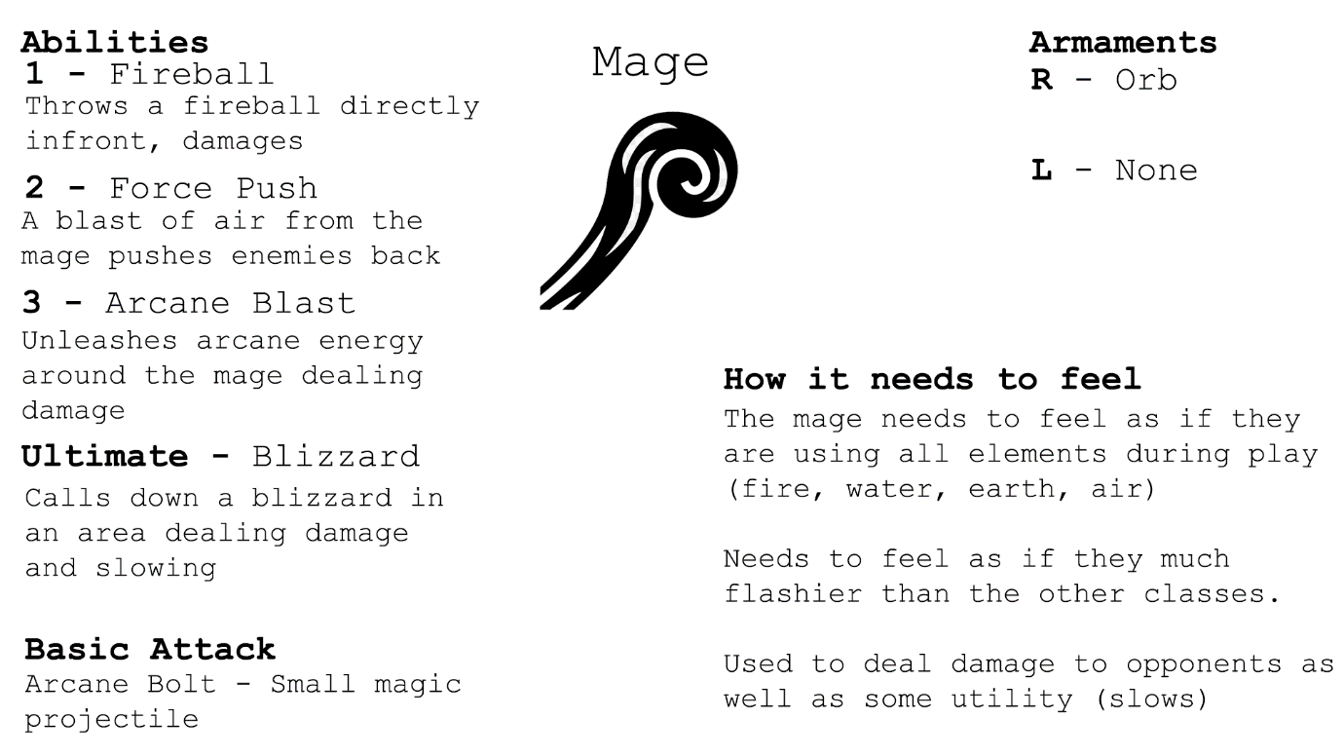

[3] Alchemist Class Design