**Roblox – Make a Game**

**Group Project**

**PMIS**

**Members**

Zyrynyl Melendres (Project Manager)

William Smallwood

Euan Sutherland

Thomas Heaton

Niall Swan

Patryk Augusewicz



Table of Contents

Project Summary 3

Business Case 5

Configuration Map 6

Schedule Model 7

RIC-Register 8

Client sign-off 9

# Project Summary

Roblox – Make a Game!

Dates

|  |  |  |
| --- | --- | --- |
| Sponsor Appointed | Project Authorized | Project Closed |
| 20/01/2019 | 10/01/2019 |  |

Purpose

|  |  |
| --- | --- |
| Goal / Outcome | Making a fun game that can be monetized. So that the client can see how a team works to make a Roblox game. And see the progress of a team and the issues when making a Roblox game. The game also needs to be popular for the people who plays Roblox. |
| Main product | A game that is a class-based combat, where based on what class the player chooses, it will give the player certain weapons and skills. A game that can be monetized, via customizable weapons/look and rewards. There will be objectives in the game like 3v3, 6v6 and King of the Hill. Ideally have some physics-based rendering or shaders to make it more realistic. |
| High-level Requirements | A game that has a scoring mechanism, a game that is fun. A game that has a multiplayer function and has sounds. Ideally has the new features of the Roblox framework (e.g. terrain vegetation, physics-based rendering). A game that can be monetized and be able to get robux, which is real money. A popular game genre that has a chance for growth. A game that can be original and popular. |

Targets

|  |  |
| --- | --- |
| Duration | 12 weeks |
| Budget | Not applicable for this project. |

Major Risks

|  |
| --- |
| Not finishing the game which doesn’t help the purpose of this project. Were overly reliant on everyone making the deadline so we can work together to make a fun project, also affects the progress of the project if the deadline is not met. If classes aren't balanced, or classes aren't fun to play and do not engage the player which makes the game unpopular. Being unpopular means that the game has lower chance of being monetized. |

Roles

|  |  |
| --- | --- |
| Sponsor | John McGowan |
| Consultants | William Smallwood (Scripting), Thomas Heaton (Scripting), Niall Swan (UI and HUD), Patryk Augusewicz (Audio), and Euan Sutherland (Map and Level Design) |
| Project Manager | Zyrynyl Melendres (Also doing Animations) |
| PM Support(s) |  |
| Team Manager(s) |  |
| Supplier PM(s) |  |

# Business Case

Roblox – Make a game.

Business Purpose for doing the project

|  |
| --- |
| So the client can see the progress of how a team of developers make a Roblox game, and maybe see some issues or challenges that comes up when making a Roblox game. Also see how the game can be monetized and be able to get robux, which is a currency that you can buy with real money. |

Expected Benefits

|  |
| --- |
| Learning how to make a game, planning the game and organizing a team. Managing a project and satisfying the customer. After finishing the project, we will also have the chance of earning money if we pass a certain threshold of the robux we earned. |

Expected Dis-Benefits

|  |
| --- |
| We might have to use more time than expected to meet the deadlines, but crunch times are expected when making a game. |

Expected Cost

|  |
| --- |
| Not applicable for this project. |

Major Risks

|  |
| --- |
| Not finishing the game which doesn’t help the purpose of this project. Were overly reliant on everyone making the deadline so we can work together to make a fun project, also affects the progress of the project if the deadline is not met. If classes aren't balanced, or classes aren't fun to play and do not engage the player which makes the game unpopular. Being unpopular means that the game has lower chance of being monetized. |

# Configuration Map

Roblox – Make a game.

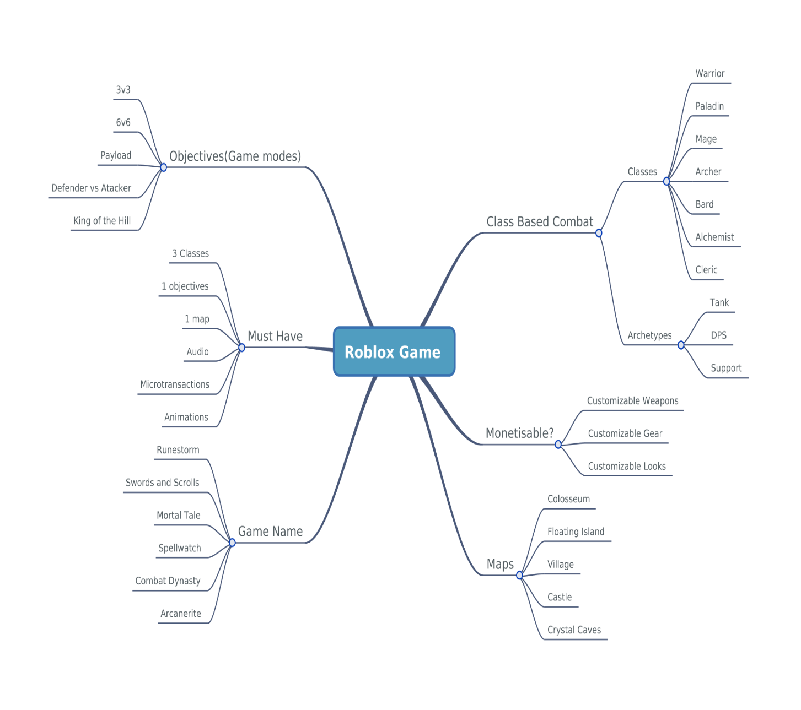

# Schedule Model

Roblox – Make a game.

We schedule a task every week, we also have task that we prioritise the whole project that must be done in the project timeline.

# RIC-Register

Roblox – Make a game.

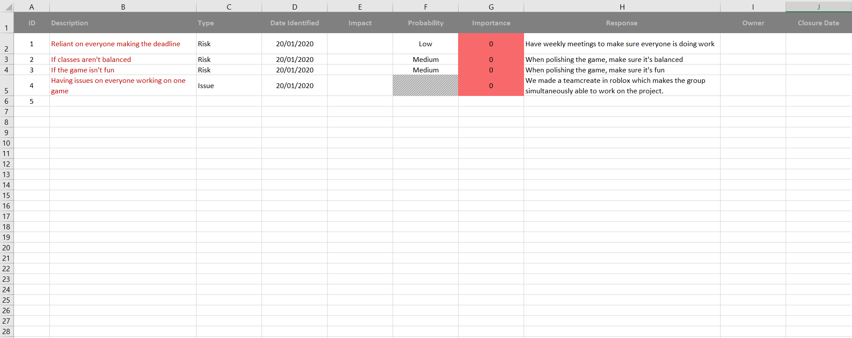

# Client sign-off

Roblox – Make a game.

Documents checked

* Project summary
* Business case
* Configuration map
* Schedule model

I confirm that the content of the project management documents listed above provides an accurate and adequate specification of the project requirements

Signed:

Date: