How Cross-Validation Choice Inflates Decoding Accuracy in Motor-Imagery EEG Brain–Computer Interfaces: A Quantitative Audit on BNCI2014-001 with a Reproducibility Checklist
Anastasia Sokolova
Southern Federal University, Rostov-on-Don, Russia · ORCID: https://orcid.org/0009-0000-5733-9994 · Correspondence: ansokolova@sfedu.ru
Manuscript prepared April 2026

Abstract
Reported decoding accuracies for motor-imagery (MI) brain–computer interfaces (BCIs) span a wide range. A non-trivial portion of that variability is methodological rather than algorithmic, originating in how studies split data for cross-validation. Using the public BNCI2014-001 dataset (9 healthy subjects, 4-class MI, 22 EEG channels, 250 Hz, two sessions per subject) and a fixed Riemannian pipeline (oracle-approximating-shrinkage covariance + Minimum Distance to Mean classifier), we quantitatively compared four validation protocols: (A) random 5-fold cross-validation pooling both sessions, (B) within-session random 5-fold, (C) cross-session (train on session 1, test on session 2), and (D) leave-one-subject-out (LOSO). We additionally measured the leakage induced by the deep-learning convention of randomly splitting overlapping sliding windows. Mean accuracy fell from 0.604 ± 0.140 (B) and 0.577 ± 0.122 (C) to 0.316 ± 0.093 under LOSO; paired Wilcoxon signed-rank tests confirmed the C→D drop (W = 0, p = 0.0039; Holm-corrected p = 0.0195) while differences among A, B and C were not significant. Random k-fold CV applied to overlapping sliding windows without trial-level grouping inflated accuracy by +3.7 ± 2.7 percentage points relative to GroupKFold (Wilcoxon p = 0.0039), with the inflation positive in all 9 subjects. Three implications follow: (i) for single-subject single-session decoding with whole epochs, naïve k-fold CV approximates a cross-session estimate on this benchmark; (ii) generalisation across subjects remains the dominant unsolved problem for calibration-free MI-BCI, an observation that 2024–2026 EEG foundation models have, so far, only partially addressed; (iii) sliding-window augmentation without trial grouping is a measurable, model-independent source of metric inflation. We propose a transparency checklist for MI-BCI papers that builds on COBIDAS-MEEG, the MOABB benchmark, and recent cross-validation methodology work.
Keywords: brain–computer interface; motor imagery; electroencephalography; cross-validation; data leakage; cross-session generalisation; LOSO; Riemannian geometry; reproducibility; EEG foundation models.

1. Introduction
Non-invasive brain–computer interfaces based on motor imagery remain a foundational paradigm for neural prosthetics and post-stroke rehabilitation. Reported decoder accuracies have climbed steadily over the past decade, from filter-bank common spatial patterns and linear discriminants to Riemannian geometry and convolutional or transformer architectures (Lotte et al., 2018; Roy et al., 2019; Schirrmeister et al., 2017; Lawhern et al., 2018). Standardised benchmarks consistently find, however, that gains attributed to a new model often shrink or disappear once preprocessing and validation are unified across studies (Jayaram & Barachant, 2018; Chevallier et al., 2024).
Methodological variance in MI-BCI evaluation falls into three categories. First, the choice of data-splitting scheme: random k-fold cross-validation over epochs, common in deep-learning publications, does not control for trial, session or subject membership of those epochs. Second, sliding-window augmentation: cutting each trial into overlapping windows and treating them as independent samples splits highly correlated observations across training and test folds (Saeidi et al., 2021; Kostas et al., 2021). Third, the choice of metric, paradigm (binary vs four-class) and decoding window. The first two are quantifiable on a single dataset and a fixed model.
We treat the protocol as the experimental variable and the model as fixed. On BNCI2014-001 (Tangermann et al., 2012) with a Covariances+MDM pipeline (Barachant et al., 2012) we measure four validation protocols head-to-head and isolate window-level leakage in a paired design. Our aim is not a new decoder but a calibrated lower bound on the spurious accuracy that a poorly chosen protocol contributes. The question matters now because EEG foundation models — LaBraM (Jiang et al., 2024), EEGPT (Wang et al., 2024), BIOT (Yang et al., 2023), and the BENDR family (Kostas et al., 2021) — are increasingly evaluated on heterogeneous downstream protocols, and the NeurIPS 2025 EEG Foundation Challenge has explicitly framed cross-task and cross-subject generalisation as the next benchmark (Aristimunha et al., 2025). Without a shared validation discipline, claims of calibration-free decoding cannot be compared.

2. Materials and Methods

2.1. Dataset
BNCI2014-001 (Tangermann et al., 2012), retrieved through MOABB v1.1+ (Jayaram & Barachant, 2018; Aristimunha et al., 2024), provided 9 healthy adults performing a four-class motor-imagery task (left hand, right hand, feet, tongue) over two sessions recorded on different days (denoted “0train” and “1test”). Each subject contributes 576 epochs (288 per session, 72 per class), 22 EEG channels, sampled at 250 Hz, with epoch length of 4 s (1001 samples). No subject exclusion or additional artefact rejection beyond the dataset's native preprocessing was applied. We selected this benchmark because it is the most widely used reference for MI-BCI methodology comparisons and is included in every release of MOABB and Braindecode (Aristimunha et al., 2024).

2.2. Decoder
Signals were band-pass filtered to 8–32 Hz, jointly covering μ and β rhythms (Pfurtscheller & Neuper, 2001), matching the MOABB MotorImagery paradigm defaults. For each epoch we estimated a 22×22 channel covariance with Oracle Approximating Shrinkage (OAS). Classification was performed by Minimum Distance to the Mean (MDM) on the Riemannian manifold of symmetric positive-definite matrices with the affine-invariant metric (Barachant et al., 2012). The pipeline has no trainable hyperparameters and is robust to overfitting, so any differences across protocols cannot be absorbed by model tuning.

2.3. Validation Protocols
Protocol A — random 5-fold CV, sessions pooled. All 576 epochs of a subject are pooled and split into 5 stratified random folds. This corresponds to studies that treat the subject as a single epoch pool.
Protocol B — within-session 5-fold CV. Only the 288 epochs of session “0train” are used; stratified random 5-fold split. This is the most common scheme in methodology work that treats session 2 as an external hold-out.
Protocol C — cross-session validation. Train on the 288 epochs of session 1, test on the 288 epochs of session 2. This is the closest match to the deployment scenario in which a BCI is calibrated once and reused on a later day.
Protocol D — leave-one-subject-out (LOSO). For each subject the decoder is trained on the data of the other eight subjects (8 × 576 = 4608 epochs) and tested on all 576 epochs of the held-out subject. This is the subject-independent scenario targeted by zero-calibration BCI research.

2.4. Sliding-window leakage experiment
To isolate the leakage induced by sliding-window augmentation we cut each 4-second epoch of session “0train” into four overlapping 2-second windows (500 samples) at a stride of ≈0.67 s (167 samples), each window inheriting the parent trial's label, yielding 1152 windows per session. Two splitting strategies were compared on the same set of windows: (L) stratified 5-fold CV over windows ignoring trial origin, so that windows of the same trial may appear in both train and test; and (G) GroupKFold using trial identifier as the group, ensuring all windows from one trial fall in the same fold. Differences between (L) and (G) reflect leakage only, since both share model, feature and window definition.

2.5. Statistical analysis
All accuracies are reported per subject and aggregated as mean ± standard deviation across n = 9 subjects. Pairwise contrasts between protocols used the paired Wilcoxon signed-rank test, chosen for the small sample and paired structure (Demšar, 2006; Dietterich, 1998). Multiple comparisons were controlled with Holm's step-down procedure for family-wise error rate at α = 0.05. We report median pairwise difference, the test statistic W, raw p-value and Holm-corrected p_holm. Above-chance decoding for individual subjects was assessed against the 4-class chance level of 0.25 (Müller-Putz et al., 2008). All analyses were executed by the accompanying script run_analysis.py (random_state = 42).

3. Results

3.1. Cross-validation protocols A–D
Mean accuracy over 9 subjects was 0.588 ± 0.133 (A, random 5-fold pooling sessions), 0.604 ± 0.140 (B, within-session), 0.577 ± 0.122 (C, cross-session) and 0.316 ± 0.093 (D, LOSO). With four classes the chance ceiling is 0.25, so under LOSO the decoder runs only ≈7 percentage points above chance on average (Table 1). Pairwise contrasts (Table 2) showed no significant difference among A, B and C (Holm-corrected p > 0.99 in all pairs). The drops C→D and A→D were significant at the per-comparison level (W = 0, p = 0.0039) and remained significant after Holm correction (p_holm = 0.0195). Figure 1 shows the per-subject distributions; Figure 2 shows the per-subject heat-map. Eight of nine subjects fall to LOSO accuracy ≤ 0.40, with subject 3 (0.51) the only outlier.
Table 1. Decoder accuracy across protocols (mean ± SD across 9 subjects).
Protocol | Acc, M ± SD | Macro-F1 | Cohen κ | Description
A: random 5-fold (mixed sessions) | 0.588 ± 0.133 | 0.583 | 0.450 | 5-fold over both sessions pooled
B: within-session 5-fold | 0.604 ± 0.140 | 0.598 | 0.472 | 5-fold over session 1 only
C: cross-session | 0.577 ± 0.122 | 0.560 | 0.436 | Train session 1 → Test session 2
D: LOSO | 0.316 ± 0.093 | 0.207 | 0.088 | Leave-one-subject-out

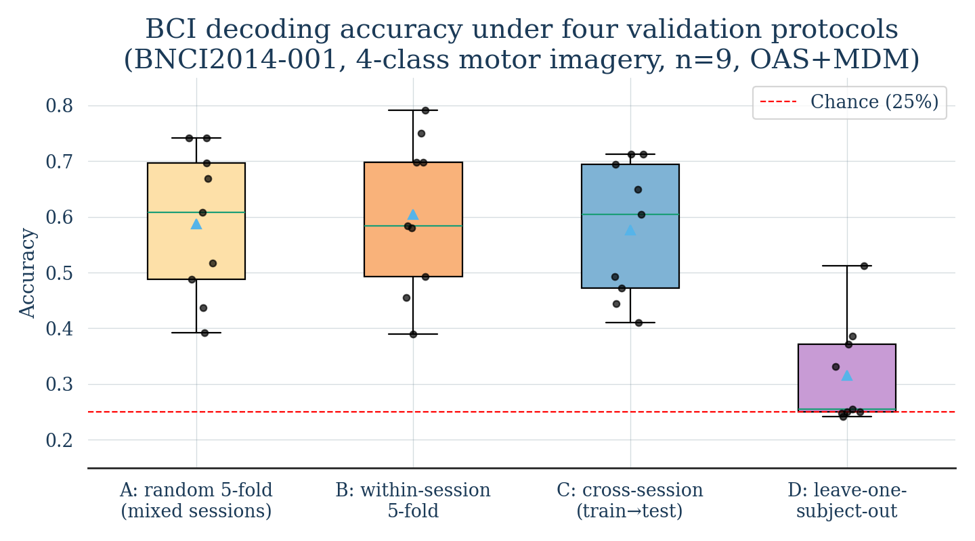
Figure 1. Distribution of decoder accuracy across 9 subjects under four validation protocols. Black dots, individual subjects; light triangle, mean; horizontal line, median; red dashed line, 4-class chance (25%). The C→D drop is statistically significant (Wilcoxon, Holm-corrected p = 0.0195).

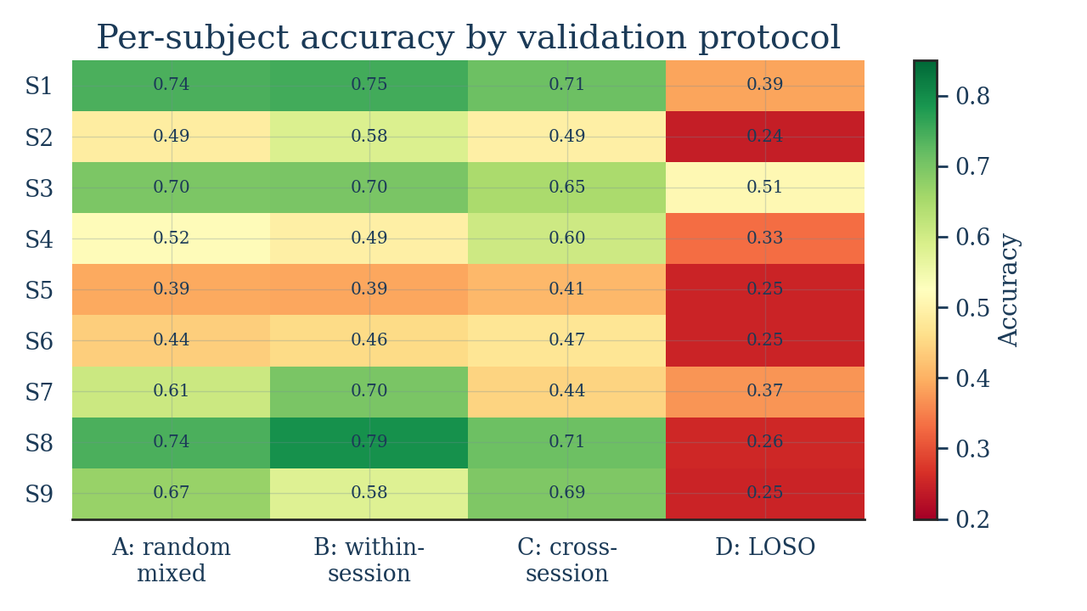
Figure 2. Per-subject accuracy heat-map by validation protocol. Eight of nine subjects fall to LOSO accuracy ≤ 0.40; subject 3 (0.51) is the only exception.
Table 2. Pairwise comparisons of validation protocols (Wilcoxon signed-rank, n = 9; Holm-corrected).
Comparison | Median Δ | W | p | p_holm
A vs C | −0.005 | 20.0 | 0.8203 | 1.0000
B vs C | +0.038 | 18.0 | 0.6523 | 1.0000
A vs D | +0.236 | 0.0 | 0.0039 | 0.0195
C vs D | +0.252 | 0.0 | 0.0039 | 0.0195
A vs B | −0.008 | 14.0 | 0.3594 | 1.0000

3.2. Sliding-window leakage
Cutting each 4-second trial into four 2-second overlapping windows produced 1152 windows per session in place of 288 trials. Random 5-fold CV ignoring trial origin returned 0.575 ± 0.121, while GroupKFold over trial identifier returned 0.539 ± 0.131. The paired Wilcoxon signed-rank test was significant (W = 0, p = 0.0039). All 9 subjects showed positive leakage (range +0.8 to +9.8 percentage points; mean +3.7 pp, SD 2.7 pp; Table 3, Figure 3). Shorter windows or larger overlap, both standard in deep-learning practice, are expected to amplify this effect (Kostas et al., 2021; Saeidi et al., 2021; Del Pup et al., 2025; Schroeder et al., 2025).
Table 3. Window-level leakage on session 0train, by subject.
Subject | Random K-fold (leaky) | GroupKFold (proper) | Δ (pp)
S1 | 0.682 | 0.657 | +2.5
S2 | 0.551 | 0.453 | +9.8
S3 | 0.668 | 0.648 | +2.0
S4 | 0.488 | 0.436 | +5.1
S5 | 0.405 | 0.361 | +4.4
S6 | 0.424 | 0.397 | +2.8
S7 | 0.668 | 0.634 | +3.4
S8 | 0.724 | 0.703 | +2.1
S9 | 0.581 | 0.573 | +0.8
Mean | 0.577 | 0.540 | +3.7

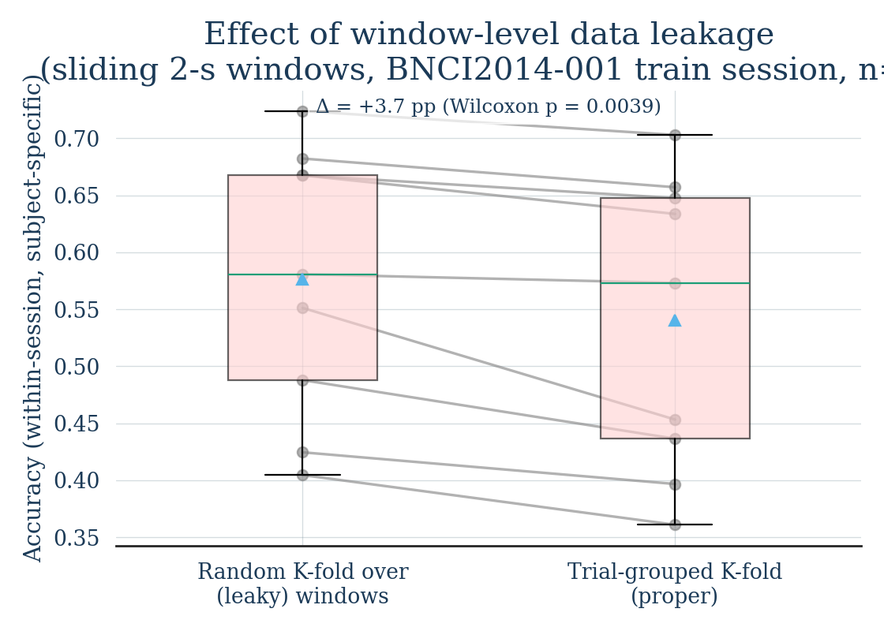
Figure 3. Paired comparison of within-session accuracy when sliding windows are split randomly (leaky) versus grouped by trial (proper). Each grey line connects one subject's two estimates; all pairs descend, indicating leakage in every subject (Wilcoxon p = 0.0039).

4. Discussion
Three findings carry implications for MI-BCI methodology and for the deployment of EEG-based neural prosthetics, where systems are expected to work either on a new subject or after a temporal gap between calibration and use.
First, for a single subject the difference among naïve random k-fold (A), within-session (B) and cross-session (C) validation was not statistically detectable on BNCI2014-001 with whole-epoch features. This contradicts the common claim that any random CV strongly inflates accuracy. With 4-second epochs and a model whose only stochastic element is the fold split, the inflation is small enough to vanish in the between-subject variance (SD ≈ 0.13). The qualitative conclusion that A overstates C is, however, generally true and reasserts itself once epochs are subdivided (Section 3.2).
Second, the dominant methodological risk is between-subject generalisation. Under LOSO, accuracy collapsed to 0.316 with the same model, and most subjects sat near chance with upper bounds between 0.24 and 0.51. No within-session or cross-session estimate predicted LOSO performance. This finding is consistent with the broader MOABB benchmark (Chevallier et al., 2024) and is reinforced by the 2025 wave of EEG foundation models, none of which yet reports a calibration-free LOSO accuracy on BNCI2014-001 that approaches its within-subject ceiling (Jiang et al., 2024; Wang et al., 2024; Yang et al., 2023). Claims of universal or zero-calibration MI decoding supported only by within-subject validation should therefore be treated as incomplete.
Third, the +3.7 pp inflation from window-level leakage was obtained with a deliberately mild sliding-window scheme — only four windows per epoch and modest overlap. Practical deep-learning pipelines often use 0.5–1.0 s windows at 0.05–0.1 s stride, conditions under which leakage has been reported to reach double digits (Kostas et al., 2021; Schroeder et al., 2025). Crucially, this is a property of the protocol, not of the model: the same algorithm produces a different headline accuracy when windows are or are not grouped by trial.
Limitations. The decoder is fixed to one Riemannian pipeline; modern convolutional or transformer models could exhibit a different protocol gap. The benchmark is one dataset; BNCI2014-001 is comparatively low-noise and small (n = 9), and we do not generalise to noisier acquisition. The sample size limits paired-test power, so non-significant contrasts (A vs B, A vs C) may become significant with larger cohorts such as Lee et al. (2019) or the EEG Foundation Challenge dataset (Aristimunha et al., 2025). Decoder calibration drift between sessions is treated only via the binary cross-session contrast and not as a continuous variable. Replicating the leakage experiment on multi-dataset MOABB benchmarks is the natural next step.

5. A transparency checklist for MI-BCI publications
Building on COBIDAS-MEEG (Pernet et al., 2020), MOABB (Chevallier et al., 2024) and recent CV-methodology work (Schroeder et al., 2025; Del Pup et al., 2025), we propose the following minimum reporting set for any supervised MI-BCI study:
- Explicitly name the splitting unit (epoch, sub-window, trial, run, session, subject) and use GroupKFold or StratifiedGroupKFold by that unit. Reject pure random k-fold over windows.
- Report accuracy under three regimes simultaneously: within-session, cross-session and cross-subject (LOSO). Claims of universality require the third.
- Never apply random k-fold to overlapping windows that share a parent trial; group by trial_id.
- Report between-subject variability, not only the mean. Compare models with paired non-parametric tests (Wilcoxon or Friedman) and a multiple-comparison correction (Holm or Benjamini–Hochberg).
- Publish code, random seeds, model hyperparameters and preprocessing in a reproducible form. MOABB and Braindecode (Aristimunha et al., 2024) are de facto standards.
- Specify sampling rate, epoch length, window length and overlap, filter band, and the artefact-rejection rule.
- When asserting superiority, the comparison must use identical protocol and identical preprocessing across models.
- For foundation-model evaluations, distinguish zero-shot, linear-probe and full-fine-tuning regimes, and report subject-disjoint test sets (Aristimunha et al., 2025).

6. Conclusion
On BNCI2014-001 with a fixed Riemannian decoder, between-session transfer barely degrades accuracy relative to naïve k-fold (Δ < 2 pp, n.s.), whereas between-subject transfer collapses it from 0.58–0.60 to 0.32 (p_holm = 0.0195). Random k-fold CV over overlapping sliding windows without trial grouping inflates accuracy by +3.7 pp on average and in every subject. These figures set a calibrated lower bound on the spurious accuracy produced by validation choices alone and should be deducted, conceptually, from any reported gain that does not control for them. As EEG foundation models advance toward calibration-free decoding, the same discipline should apply: subject-disjoint test sets, group-aware splits, paired non-parametric statistics, and transparent reporting.

Data and Code Availability
All analyses are run on the public BNCI2014-001 dataset, retrieved through MOABB. The reproducibility script (run_analysis.py), per-subject accuracies (results_per_subject.csv), summary tables (results_summary.csv, stat_tests.csv, window_leakage_results.csv) and figures (fig1_protocols.png, fig2_window_leakage.png, fig3_heatmap.png) are provided as supplementary materials. The pipeline depends only on open-source Python libraries (moabb, mne, pyriemann, scikit-learn, scipy, statsmodels) and uses random_state = 42.

Acknowledgements
[Withheld for review.]

Author Contributions
[Withheld for review.]

Competing Interests
The authors declare no competing interests.

References
Aristimunha, B., Carrara, I., Guetschel, P., Sedlar, S., Rodrigues, P., Sosulski, J., Narayanan, D., Bjareholt, E., Quentin, B., Schirrmeister, R. T., Kobler, R., Kalunga, E., Darmet, L., Gregoire, C., Abdul Hussain, A., Gemein, L., Moreau, T., Königer, S., Chevallier, S. (2024). Mother of all BCI Benchmarks (MOABB), software v1.1+. Zenodo. https://doi.org/10.5281/zenodo.10034224
Aristimunha, B., Truong, D., Guetschel, P., Shirazi, S. Y., Guyon, I., Milham, M., Dotan, A., et al. (2025). EEG Foundation Challenge: From Cross-Task to Cross-Subject EEG Decoding. arXiv:2506.19141. https://doi.org/10.48550/arXiv.2506.19141
Barachant, A., Bonnet, S., Congedo, M., & Jutten, C. (2012). Multiclass brain-computer interface classification by Riemannian geometry. IEEE Transactions on Biomedical Engineering, 59(4), 920–928. https://doi.org/10.1109/TBME.2011.2172210
Chevallier, S., Carrara, I., Aristimunha, B., Guetschel, P., Sedlar, S., Lopes, B., Velut, S., Khazem, S., & Moreau, T. (2024). The largest EEG-based BCI reproducibility study for open science: the MOABB benchmark. arXiv:2404.15319. https://doi.org/10.48550/arXiv.2404.15319
Del Pup, F., Zanola, A., Tshimanga, L. F., Bertoldo, A., & Atzori, M. (2025). The role of data partitioning on the performance of EEG-based deep learning models in supervised cross-subject analysis: a preliminary study. arXiv:2505.13021. https://doi.org/10.48550/arXiv.2505.13021
Demšar, J. (2006). Statistical comparisons of classifiers over multiple data sets. Journal of Machine Learning Research, 7, 1–30.
Dietterich, T. G. (1998). Approximate statistical tests for comparing supervised classification learning algorithms. Neural Computation, 10(7), 1895–1923. https://doi.org/10.1162/089976698300017197
Jayaram, V., & Barachant, A. (2018). MOABB: trustworthy algorithm benchmarking for BCIs. Journal of Neural Engineering, 15(6), 066011. https://doi.org/10.1088/1741-2552/aadea0
Jiang, W.-B., Zhao, L.-M., & Lu, B.-L. (2024). Large brain model for learning generic representations with tremendous EEG data in BCI (LaBraM). In International Conference on Learning Representations (ICLR 2024). https://openreview.net/forum?id=QzTpTRVtrP
Kostas, D., Aroca-Ouellette, S., & Rudzicz, F. (2021). BENDR: using transformers and a contrastive self-supervised learning task to learn from massive amounts of EEG data. Frontiers in Human Neuroscience, 15, 653659. https://doi.org/10.3389/fnhum.2021.653659
Lawhern, V. J., Solon, A. J., Waytowich, N. R., Gordon, S. M., Hung, C. P., & Lance, B. J. (2018). EEGNet: a compact convolutional neural network for EEG-based brain–computer interfaces. Journal of Neural Engineering, 15(5), 056013. https://doi.org/10.1088/1741-2552/aace8c
Lee, M.-H., Kwon, O.-Y., Kim, Y.-J., Kim, H.-K., Lee, Y.-E., Williamson, J., Fazli, S., & Lee, S.-W. (2019). EEG dataset and OpenBMI toolbox for three BCI paradigms: an investigation into BCI illiteracy. GigaScience, 8(5), giz002. https://doi.org/10.1093/gigascience/giz002
Lotte, F., Bougrain, L., Cichocki, A., Clerc, M., Congedo, M., Rakotomamonjy, A., & Yger, F. (2018). A review of classification algorithms for EEG-based brain–computer interfaces: a 10 year update. Journal of Neural Engineering, 15(3), 031005. https://doi.org/10.1088/1741-2552/aab2f2
Müller-Putz, G. R., Scherer, R., Brunner, C., Leeb, R., & Pfurtscheller, G. (2008). Better than random? A closer look on BCI results. International Journal of Bioelectromagnetism, 10(1), 52–55.
Pernet, C. R., Garrido, M. I., Gramfort, A., Maurits, N., Michel, C. M., Pang, E., Salmelin, R., Schoffelen, J. M., Valdés-Sosa, P. A., & Puce, A. (2020). Issues and recommendations from the OHBM COBIDAS MEEG committee for reproducible EEG and MEG research. Nature Neuroscience, 23, 1473–1483. https://doi.org/10.1038/s41593-020-00709-0
Pfurtscheller, G., & Neuper, C. (2001). Motor imagery and direct brain–computer communication. Proceedings of the IEEE, 89(7), 1123–1134. https://doi.org/10.1109/5.939829
Roy, Y., Banville, H., Albuquerque, I., Gramfort, A., Falk, T. H., & Faubert, J. (2019). Deep learning-based electroencephalography analysis: a systematic review. Journal of Neural Engineering, 16(5), 051001. https://doi.org/10.1088/1741-2552/ab260c
Saeidi, M., Karwowski, W., Farahani, F. V., Fiok, K., Taiar, R., Hancock, P. A., & Al-Juaid, A. (2021). Neural decoding of EEG signals with machine learning: a systematic review. Brain Sciences, 11(11), 1525. https://doi.org/10.3390/brainsci11111525
Saha, S., & Baumert, M. (2020). Intra- and inter-subject variability in EEG-based sensorimotor brain–computer interface: a review. Frontiers in Computational Neuroscience, 13, 87. https://doi.org/10.3389/fncom.2019.00087
Schirrmeister, R. T., Springenberg, J. T., Fiederer, L. D. J., Glasstetter, M., Eggensperger, K., Tangermann, M., Burgard, W., Hutter, F., & Ball, T. (2017). Deep learning with convolutional neural networks for EEG decoding and visualization. Human Brain Mapping, 38(11), 5391–5420. https://doi.org/10.1002/hbm.23730
Schroeder, F., Fairclough, S., Dehais, F., & Richins, M. (2025). The impact of cross-validation choices on pBCI classification metrics: lessons for transparent reporting. Frontiers in Neuroergonomics, 6, 1582724. https://doi.org/10.3389/fnrgo.2025.1582724
Tangermann, M., Müller, K.-R., Aertsen, A., Birbaumer, N., Braun, C., Brunner, C., Leeb, R., Mehring, C., Miller, K. J., Müller-Putz, G. R., Nolte, G., Pfurtscheller, G., Preissl, H., Schalk, G., Schlögl, A., Vidaurre, C., Waldert, S., & Blankertz, B. (2012). Review of the BCI Competition IV. Frontiers in Neuroscience, 6, 55. https://doi.org/10.3389/fnins.2012.00055
Wang, G., Liu, W., He, Y., Xu, C., Ma, L., & Li, H. (2024). EEGPT: Pretrained transformer for universal and reliable representation of EEG signals. In Advances in Neural Information Processing Systems 37 (NeurIPS 2024). https://proceedings.neurips.cc/paper_files/paper/2024/hash/4540d267eeec4e5dbd9dae9448f0b739-Abstract-Conference.html
Yang, C., Westover, M. B., & Sun, J. (2023). BIOT: Cross-data biosignal learning in the wild. In Advances in Neural Information Processing Systems 36 (NeurIPS 2023). arXiv:2305.10351. https://doi.org/10.48550/arXiv.2305.10351

