Project 1: Static Foundations
Feedback for My Gaming Setup
Student: Fernando Contreras (Zyokoji) Course: CSC 436, Fall 2026 Reviewed at: 0061c1f
Repo: github.com/Zyokoji/Project1 Live: mysetup1.netlify.app

Grade: 75 / 100
Category | Points | Earned | One line
Semantic HTML | 20 | 16 | Every element the brief lists, one h1, clean outline; two validator errors, clickable divs
CSS layout | 25 | 21 | Flexbox header, nav and card bars are real; the Grid is one column at every width
Responsive design | 15 | 12 | No horizontal scroll, header stacks on phones; desktop is the same single column
JavaScript interaction | 15 | 12 | Accordion and smooth-scroll both work and are clean; mouse only, no keyboard
Repository and deployment | 15 | 8 | Six days of commits, deploy works; README deleted, messages do not say what changed
Content and polish | 10 | 6 | Real specs, games, you; every image hotlinked, page opens fully collapsed
Total | 100 | 75 | A working, honest site with the rough edges of a first one.

How this review was made
Your instructor reviewed this project with Claude (Anthropic's AI) as a second set of eyes. Claude cloned the repo, read every line, loaded the live site at phone, tablet and desktop widths, ran the W3C validator, clicked every card open and closed, clicked every nav link, and read the Gemini and ChatGPT conversations you shared. Every note and every point in this document was read and approved by your instructor. Same standard, same rubric, just more time spent looking at your code than one human has in a grading week.

The short version
This is a real page about a real setup, and it works. The skeleton is exactly what the brief listed: header, nav, main, four sections, five articles, footer, one h1. The accordion opens and closes, the badge text flips, the nav links scroll smoothly and pop open the right card. No console errors. And your CSS comments say plainly where the AI helped, which is the honesty the brief asks for.
The points came off in the corners. Two validator errors from text sitting directly inside a ul. Card headers that only a mouse can open. A Grid that never has more than one column. All five images pulled live from other companies' servers. A README that you wrote, then deleted in the last commit. Commit messages like "done," "First," and "Im SO LOST." And the whole page loads with every card closed, so a first-time visitor sees five bars and no content. Each of these is small. Together they are the difference between 75 and the high 80s.

What Claude measured
Check | Result
Horizontal scroll at 375 / 768 / 1280 px | None at any width
Console errors | 0
W3C HTML validator | 2 errors: strong directly inside ul (lines 82 and 99)
Heading order | h1 > h2, no skipped levels
Semantic elements | header, nav, main, 4 section, 5 article, footer
Accordion | All 5 cards open and close; badge text updates
Nav links | All 4 scroll to the section and expand its first card
Card header element | div, not focusable, no aria-expanded
Grid columns on main at 375 / 768 / 1280 | 1 / 1 / 1
Media queries | 1, max-width: 600px
Images in the repo | 0 of 5 (all hotlinked: futurecdn, riotgames, epicgames, pinimg)
README at the graded commit | None (deleted in 0061c1f)
Commits | 7, from Sep 9 to Sep 15

The site at three widths
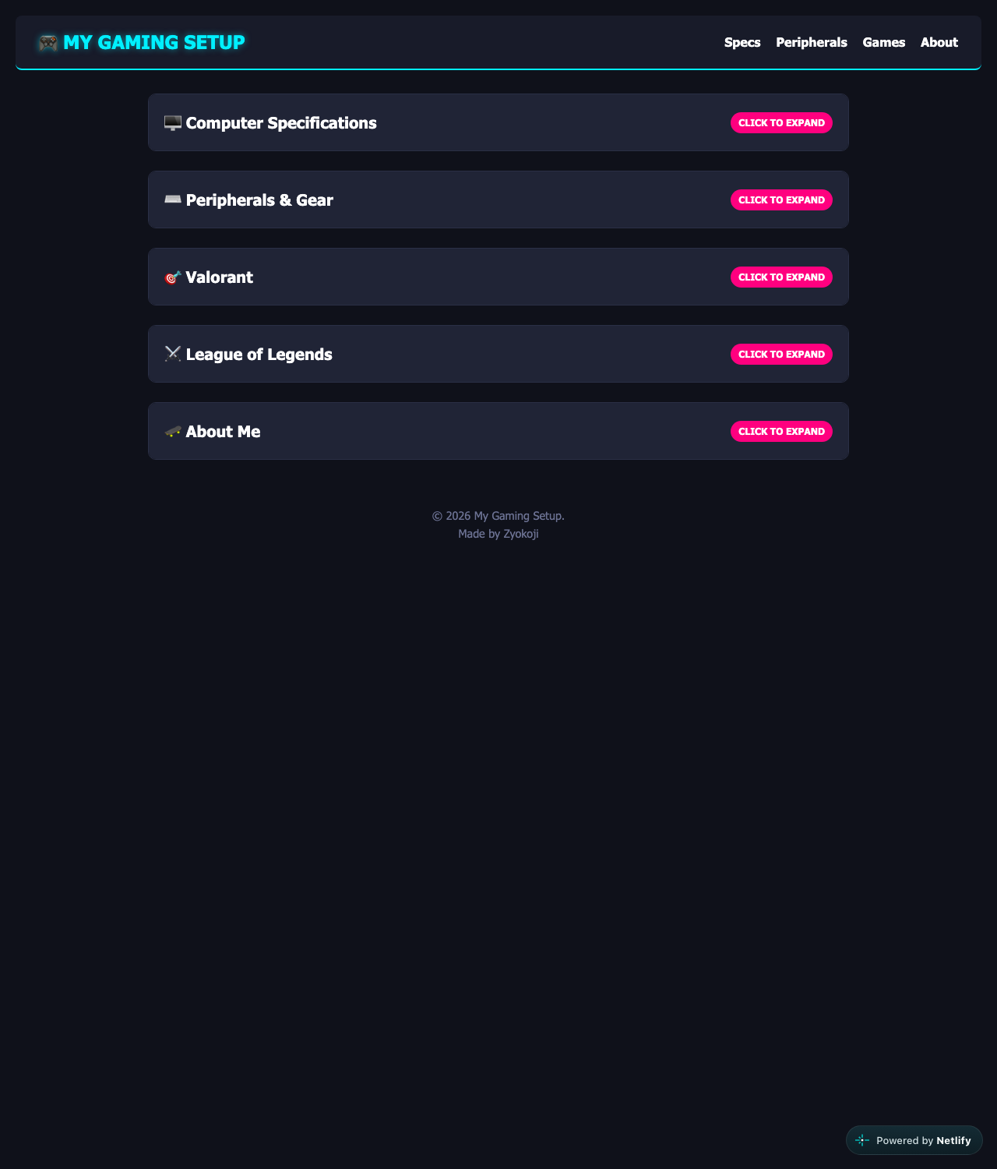
Desktop, 1280px. Five closed cards in a single 900px column.
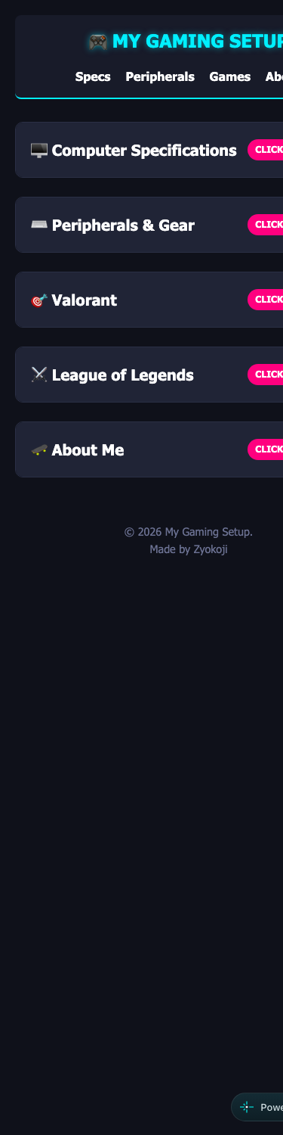  Phone, 375px. Header stacks; no horizontal scroll. | 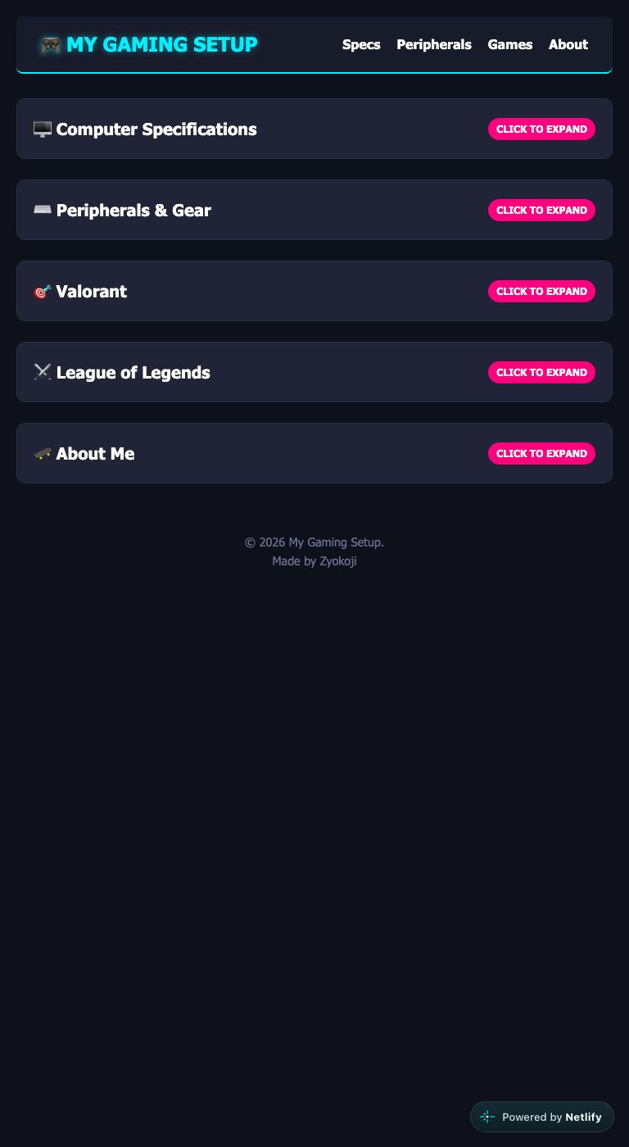  Tablet, 768px. Same single column.

Semantic HTML: 16 / 20

What is working
- The structure is the textbook answer. header holds the h1 and a nav with a real ul > li > a. main holds four sections, each wrapping an article with its own h2. A footer closes it. One h1, no skipped levels. lang, viewport, title. Every image has alt text.

What to change
- Two validator errors. Lines 82 and 99 put a strong paragraph directly inside a ul. A ul may only contain li. Move each description into a p after the list, where it belongs.
- The card headers are divs that you click. Line 26 and four more. A div cannot receive keyboard focus, so someone tabbing through your page can never open a card, and a screen reader announces a heading, not a control. Make the clickable part a button inside the h2, with aria-expanded that your JS flips.
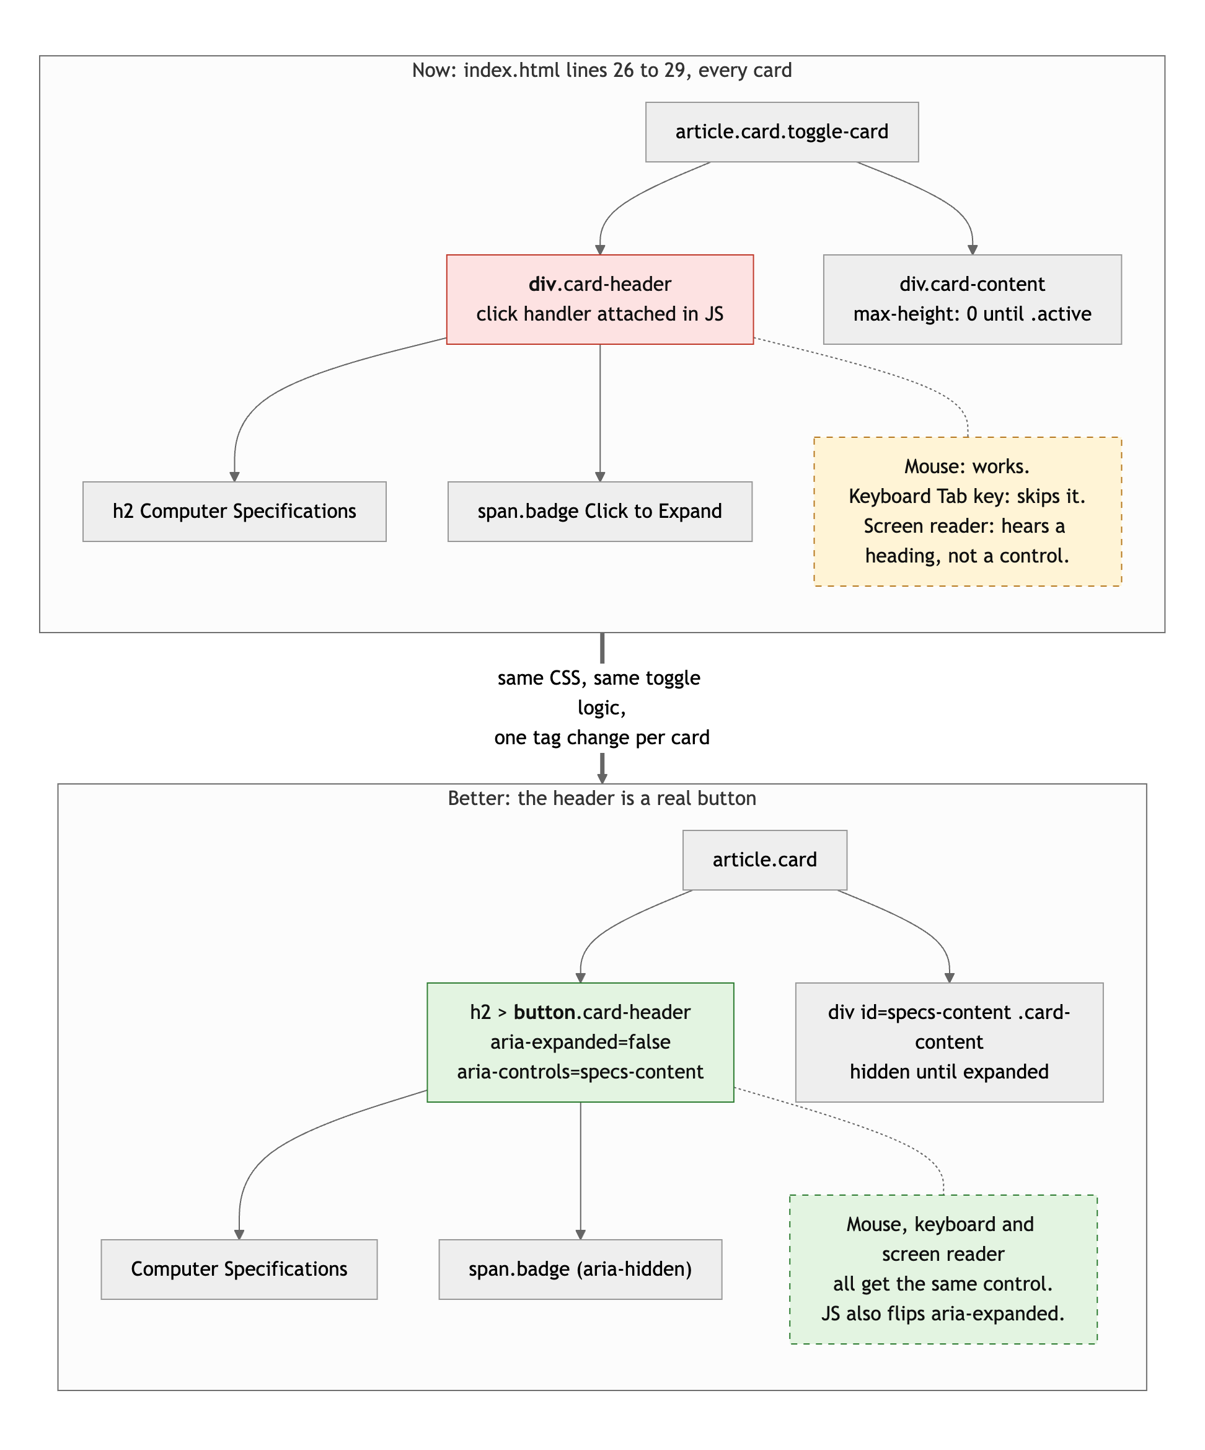
Diagram 1. The card header as a div (top) and as a real button (bottom). Same CSS, same toggle logic.
- Inline style on line 87: style="margin-top: 25px;". That is a CSS rule living in the HTML. #games article + article { margin-top: 25px } in the stylesheet does the same thing and keeps the two files honest.
- Alt text is present but generic: "Peripherals", "Valorant", "Zyokoji." Say what is in the picture: "Mechanical keyboard, mouse and headset on a desk."

CSS layout: 21 / 25

What is working
- Flexbox, yours, three ways: the header (space-between puts the nav on the right), the nav list, and every card header (title left, badge right) (First.css lines 18 to 39 and 77 to 83). Each one is the right tool.
- The theme is consistent: one dark background, one cyan accent, one pink accent, used the same way everywhere. The hover lift and glow on cards, the badge color swap when open, the max-height transition on the accordion. It looks like one person designed it.
- The CSS comments that say where AI helped (lines 8 and 17) are exactly what the brief's AI rule asks for. Keep doing that.

What to change
- The Grid is one column at every width. main { display: grid; grid-template-columns: 1fr } (lines 53 to 59) never has more than one column, so it is a vertical stack with a gap, which display: block and margins already do. Flexbox alone satisfies the layout requirement, so no points lost for that, but if you are going to write display: grid, give it a job: repeat(auto-fit, minmax(400px, 1fr)) would put two cards side by side on a desktop.
- max-height: 800px is a guess. The accordion animates max-height from 0 to 800 (lines 109 to 114). The tallest card is 547px today. Add a longer game description or a second image and the bottom gets clipped with no warning. It works; just know where the cliff is.
- Small: .card has cursor: pointer on the whole card, but only the header toggles. Move cursor: pointer to .card-header.

Responsive design: 12 / 15

What is working
- No horizontal scroll at 375, 768 or 1280. The header stacks its title and nav on phones (lines 148 to 154). Images are max-width: 100%. Text wraps.

What to change
- Desktop is the phone layout with more margin. One column at every width, capped at 900px. Between the phone and a 27 inch monitor, the only thing that changes is the header direction. The brief asked the layout to adapt meaningfully. A two-column card grid above 900px, or the About card beside the Specs card, would do it.
- Desktop-first. The one media query is max-width. The brief asked for mobile-first. Flip it to min-width: 600px and let the stacked header be the default.

JavaScript interaction: 12 / 15

What is working
- Two interactions, both real, both verified. The accordion (First.js lines 3 to 18) uses classList.toggle's return value to set the badge text in one line. The nav handler (lines 21 to 45) prevents the default jump, scrolls smoothly, and opens the target card so the user lands on content instead of a closed bar. That last touch is thoughtful. Everything is wrapped in DOMContentLoaded, uses addEventListener, and there are zero console errors.

What to change
- Mouse only. Because the header is a div, nobody using a keyboard can trigger the click. The fix is in the HTML section: a button. Then add one line to the handler: header.setAttribute("aria-expanded", isActive).
- The badge logic is written twice. Lines 14 to 16 and 40 to 41 both set the badge text. Pull it into a function, setOpen(card, isOpen), and call it from both places.
- On the AI conversations you shared. The ChatGPT thread has you asking it to write the JavaScript ("idk java so i need u to step in"), and the answer was a five-line toggle. What shipped is forty-five lines that do more than that. The brief allows all of this, and your CSS comments are honest about it. The rule that comes with it is that you can explain every line. Be ready to explain these five in office hours: why the code is wrapped in DOMContentLoaded; what classList.toggle returns; what e.preventDefault() stops on line 25; what the selector nav a[href^="#"] matches; and how max-height in the CSS makes the card animate.

Repository and deployment: 8 / 15

What is working
- Seven commits across six days, September 9 to 15. That is the shape the brief asked for: you did not do it all the night before. The live site works in a private window and matches the repo.

What to change
- There is no README. You wrote one on September 14 explaining that you had lost a repository, and the final commit deleted it. At the graded commit the repo has three files and no README. The brief requires one with the title, a description, how to run it locally, and the live URL. Ten minutes.
- The commit messages do not say what changed. "Project1," "done," "Project1," "First," "Im SO LOST." The last one, "Add initial HTML structure for gaming setup page," actually renames First.html to index.html and deletes the README. Someone reading the log, including you in three months, learns nothing. The brief asked for present-tense messages that name the change: "add expandable cards," "stack header on phones."
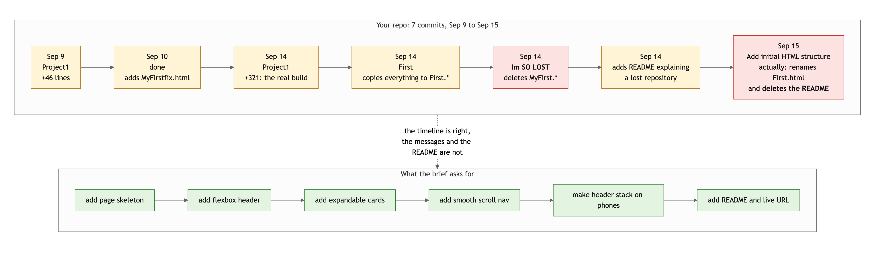
Diagram 2. Your seven commits (top) and the kind of history the brief describes (bottom). The dates are fine; the messages and the deleted README are not.
- "Im SO LOST" deleted every file, and the next two commits put them back under new names. That is what git mv is for, and it is also what a commit message is for. When you are stuck, a commit that says "rename MyFirst to First" is worth more than one that says how you feel. Ask in office hours before you delete things.

Content and polish: 6 / 10

What is working
- It is yours: your parts list, your peripherals, your ranks and champions, a paragraph about you in your own voice. No lorem ipsum. The emoji headings fit the theme. The neon palette is consistent.

What to change
- All five images are hotlinked. The CPU photo is from Tom's Hardware's CDN, the Valorant art from Riot, League from Epic, and the "About Me" picture is a Pinterest image. None are in your repo. Any of those companies can move or delete the file and your page shows a broken icon, and using their bandwidth for your page is generally against their terms. Download them, put them in an images folder, and for the About Me card, use a picture that is actually you or your setup.
- The page opens with everything closed. A first-time visitor sees five bars and the words "Click to Expand" five times. Open the Specs card by default (add active to its class in the HTML and set the badge text to match), or show a short intro above the cards, so the page has content before anyone clicks.
- Spelling. "Agressive," "Bolibear" (Volibear), "anykind," "im," "ill." A spell check pass takes two minutes and recruiters notice.

Your next three moves
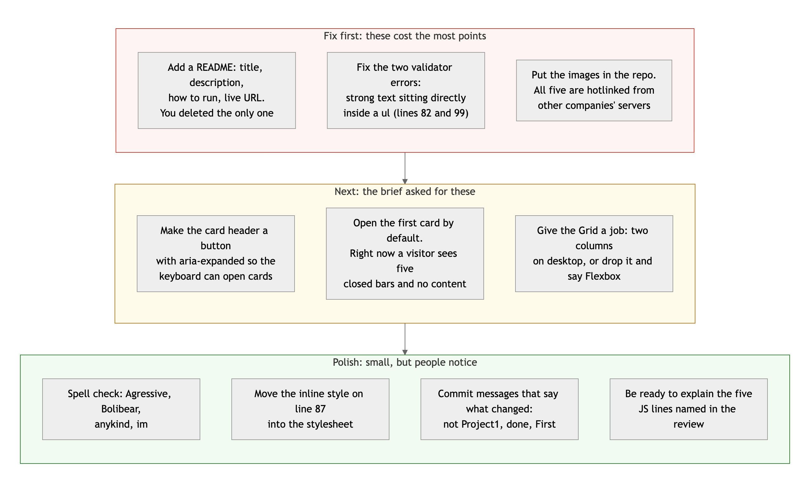
Diagram 3. Priority order. Top row first: it is where the points are.
- Write the README and put it back. Four short sections. It is the cheapest points on the sheet.
- Fix the two ul errors and turn the card headers into buttons. Twenty minutes, and the page validates and works from a keyboard.
- Own your images and open the first card. Download the pictures, replace the Pinterest one with something that is yours, and let the page show content before the first click.

You said in your About Me that you are new to this and you try your best. The site shows that. The next step is the last pass: run the validator, click through with the keyboard, read your own commit messages, and fix what you find before you submit.
This review lives in a pull request on your repo. It only adds feedback files and does not touch your code. Merge it, close it, or just read it. Questions go to office hours or the Brightspace board.

