# Experiment 1

WAP to perform empirical analysis of Iterative algorithm of linear search**.**

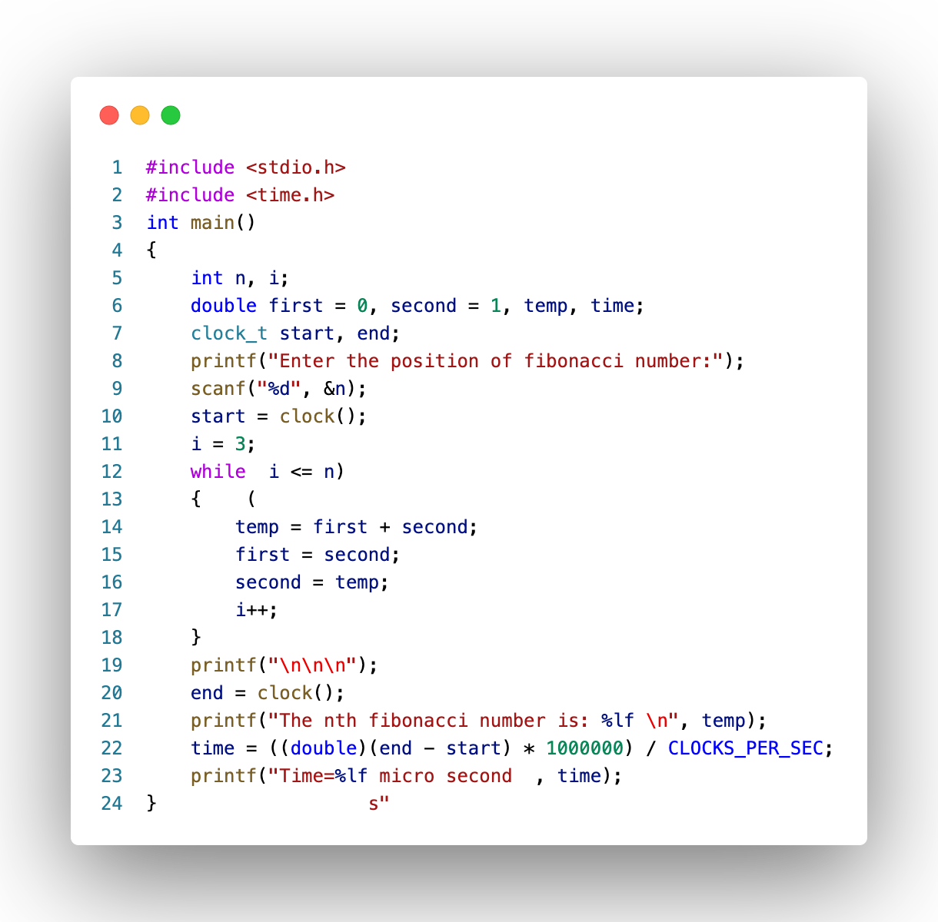

Fig: 1 (Code)

## Result Analysis and Discussion

## This experiment is conducted using following specifications. The algorithm is implemented using C language (clang-1400.0.29.202). During this test all the apps were closed to improve the results of the experiment.

## 

Fig: 2 (PC used in experiment)

In this experiment the algorithm to find the nth Fibonacci number has been implemented and executed for different value of n. During this experiment for different value of n the time taken by the algorithm has been measured and tabulated as shown in table below.

|  |  |
| --- | --- |
| Input size (n) | Time  (micro sec) |
| 100 | 16 |
| 300 | 17 |
| 600 | 18 |
| 900 | 20 |
| 1200 | 22 |
| 1477 | 24 |

The graph shown below is the plot of input n and the time in microseconds taken by the algorithm while running on a system recorded in table above.

Based on the above table and graph it is clearly seen that the array size n has linear relationship with the time taken by the system to find the input number .

## Conclusion:

In this experiment it has been found that the size of input (n) has linear relationship with the time taken by the system to find the nth Fibonacci number. This is equivalent with the asymptotic time complexity of the algorithm. Hence, this experiment proves complexity of the algorithm to find nth Fibonacci number is O (n).