# Experiment 3

WAP to perform comparative analysis of iterative soring algorithm (Bubble , Insertion, Selection)

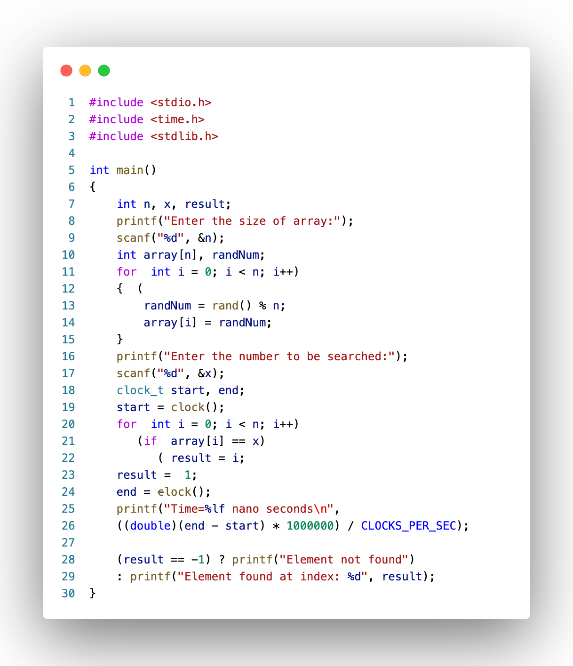

Fig: 1 (Code)

## Result Analysis and Discussion

## This experiment is conducted using following specifications. The algorithm is implemented using C language (clang-1400.0.29.202). During this test all the apps were closed to improve the results of the experiment.

## 

Fig: 2 (PC used in experiment)

In this experiment the linear search algorithm has been implemented and executed for different value of n. During this experiment for different value of n the time taken by the algorithm has been measured and tabulated as shown in table below.

|  |  |
| --- | --- |
| Array size (n)  in lakh | Time(nano sec)  in thousand |
| 1 | 0.308 |
| 5 | 1.422 |
| 10 | 3.03 |
| 15 | 4.222 |
| 20 | 5.686 |
| 20.5 | 5.865 |

The graph shown below is the plot of input n and the time in milliseconds taken by the algorithm while running on a system recorded in table above.

Based on the above table and graph it is clearly seen that the array size n has linear relationship with the time taken by the system to find the input number .

## Conclusion:

In this experiment it has been found that the size of array (n) has linear relationship with the time taken by the system to find the given number. This is equivalent with the asymptotic time complexity of the algorithm. Hence, this experiment proves complexity of the algorithm got is O(n).