# Experiment 4

WAP to perform comparative analysis of iterative soring algorithm (Selection, Merge).

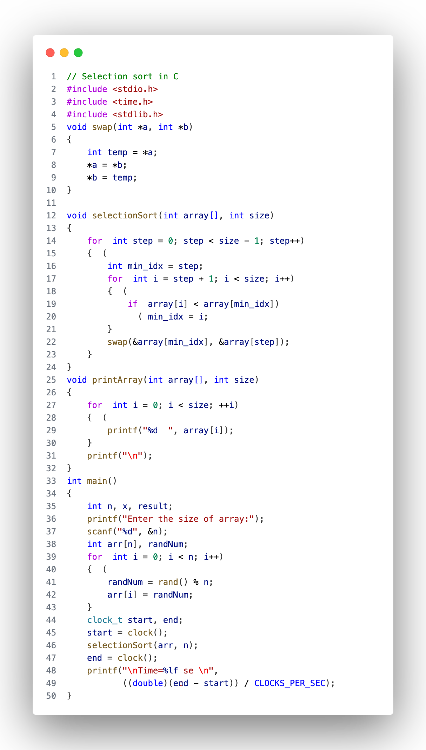

Fig: 1 (selection sort)

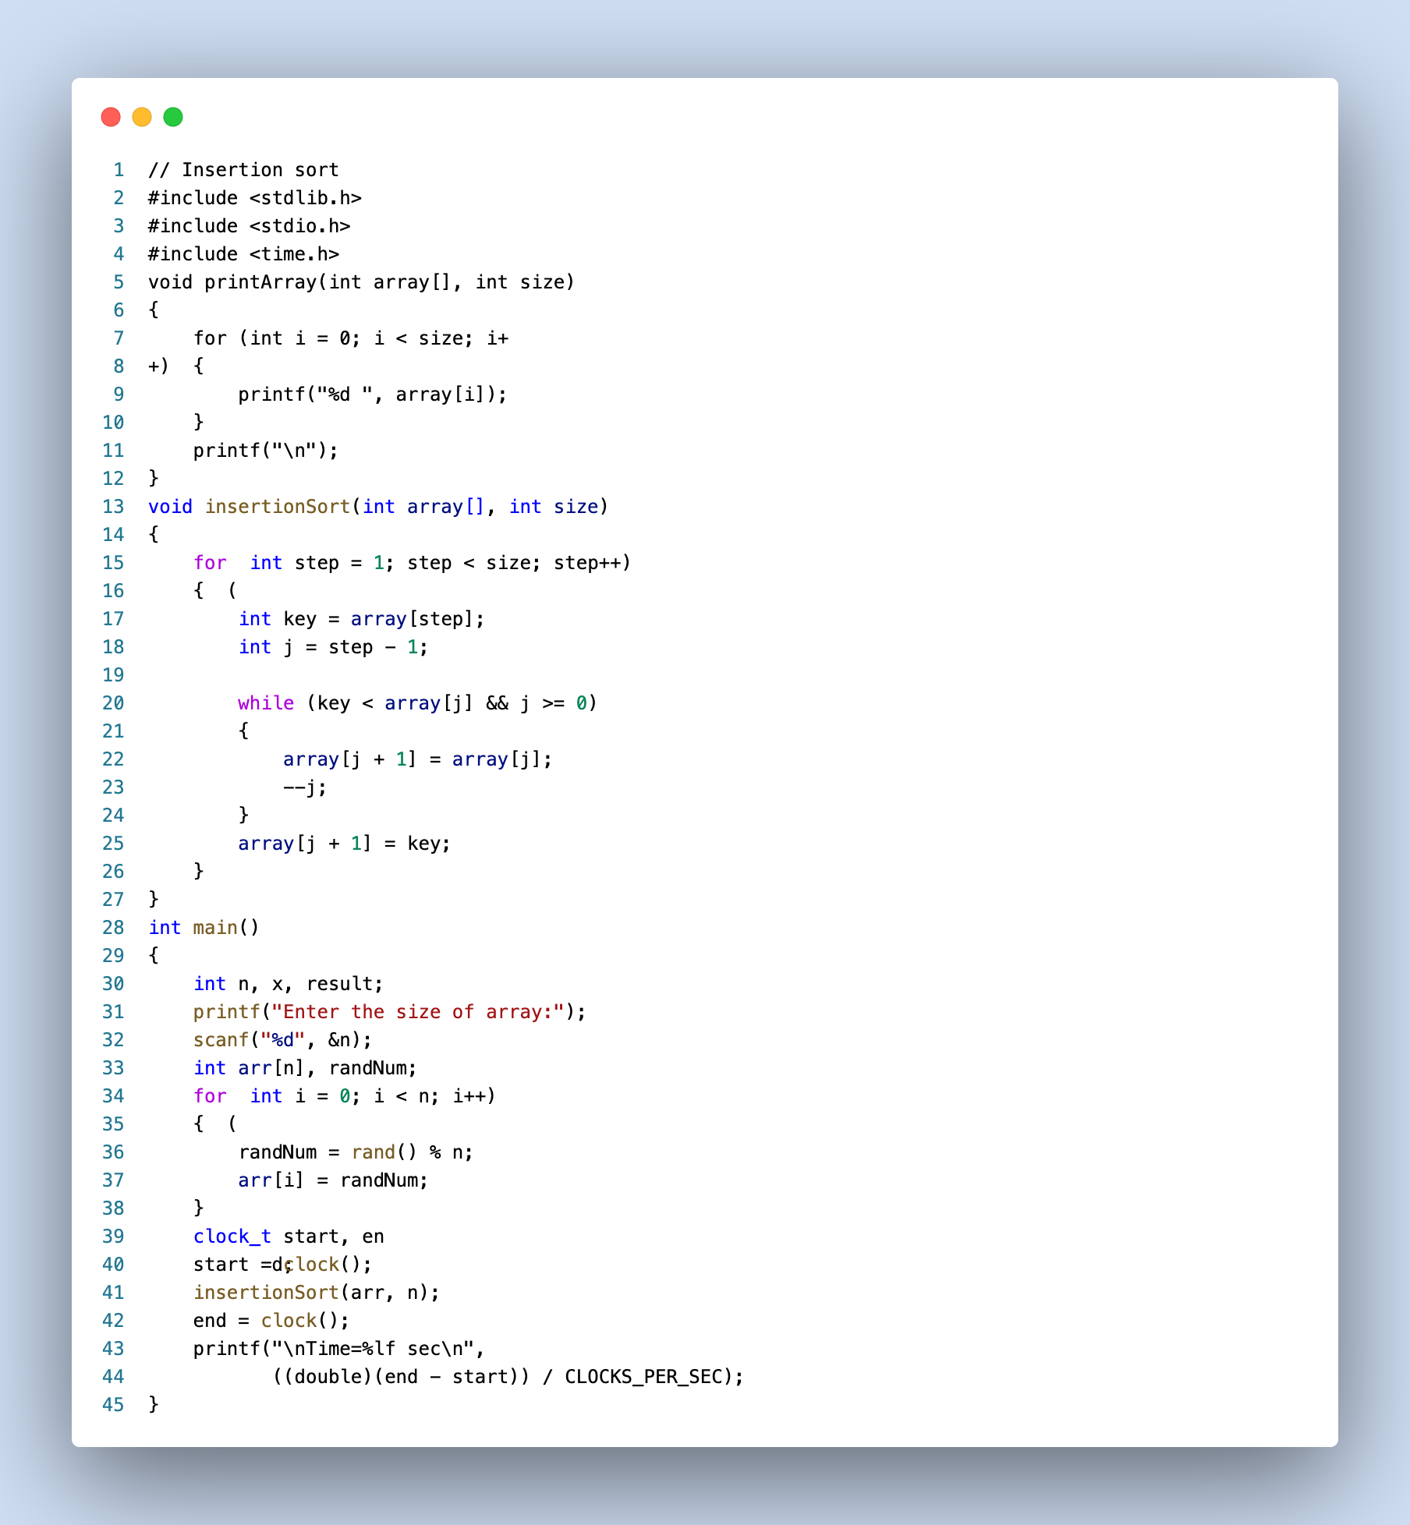

Fig: 2 (Insertion sort)

Fig: 3 (Selection sort)

## Result Analysis and Discussion

## This experiment is conducted using following specifications. The algorithm is implemented using C language (clang-1400.0.29.202). During this test all the apps were closed to improve the results of the experiment.

## 

Fig: 4 (PC used in experiment)

In this experiment the comparative analysis of iterative sort algorithms has been implemented and executed for different value of n. During this experiment for different value of n the time taken by the algorithm has been measured and tabulated as shown in table below.

|  |  |  |
| --- | --- | --- |
| arr size  (in thousand) | time (sec)  (bubble sort) | time (sec)  (merge sort) |
| 30 | 3.1929 | 0.006428 |
| 50 | 8.9243 | 0.010648 |
| 70 | 17.514 | 0.013842 |
| 100 | 41.62 | 0.020631 |

**Comparative Analysis**

1. **Selection Sort:**

Selection Sort exhibited the highest execution times among the two algorithms for all array sizes.

It demonstrated poor performance, especially as the array size increased, with a substantial increase in execution time. Selection Sort is not recommended for sorting large datasets efficiently.

1. **Merge Sort:**

Merge Sort outperformed Selection Sort for all array sizes. It consistently had significantly lower execution times than Selection Sort. Although execution times increased as the array size grew, Merge Sort remained the faster choice.

**Conclusion:**

Based on the experimental data, we can recommend the following insights:

* For small to moderate-sized arrays (e.g., 30,000 to 100,000 elements), Merge Sort is the more efficient sorting algorithm among the two considered (Merge Sort and Selection Sort).
* Selection Sort is not suitable for sorting large datasets efficiently, as its performance significantly deteriorates with increasing array size.
* For significantly larger datasets, Merge Sort or similar advanced sorting algorithms should be considered to achieve better performance.
* This analysis confirms that Merge Sort is a more efficient sorting algorithm compared to Selection Sort for a wide range of array sizes, and it remains a viable choice even as the dataset size increases.