Poke Wordle
Site Plan

Zachary Purser

WDD 130

Overview

Purpose
To make a simple pokemon guessing game based on many different factors, just to give some enjoyment each day.

Audience

Pokemon fans of all ages.

Branding

Website Logo


Style Guide

Color Palette
Primary | Secondary | Accent 1 | Accent 2
#f6e9d0 | #d52115 | #fcc709 | #\0d5798

Typography

Heading Font: Vend Sans

Paragraph Font: Source Serif 4

Navigation
Home Daily Puzzle Infinite Mode

Content

Im putting this link because it’s the best source of the sprites that will be used https://pokemondb.net/sprites#gen9
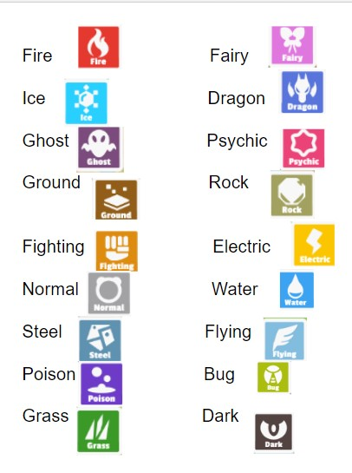
Lists of the different pokemon regions:
Kanto
Johto
Hoenn
Sinnoh
Unova
Kalos
Alola
Galar
Hisui
Paldea

Wireframes

Home

