PHARMACARE INVENTORY MANAGEMENT SYSTEM
Object-Oriented Programming (OOP) Laboratory Project & Assignment Report
• OOP ARCHITECTURE • 3-FILE NORMALIZED PERSISTENCE
Project Parameter | Submission Specification
Project Title | PharmaCare — Pharmacy Inventory Management System
Course / Subject | Object-Oriented Programming (OOP) in C++
Core Source Module | Cpp Files/main.cpp (Compiled to main.exe)
Language Standard | ISO C++11 / C++14 / C++17 Compatible
Database Engine | 3-File Normalized Relational Flat-File Architecture
Student Name(s) | Vishv Vanecha , Pushp Lamba
Roll Number / ID | 25BCE065 , 25BCE043
Semester / Section | 3rd Semester / CSE - A

1. Executive Summary & C++ Backend Overview
The PharmaCare Inventory Management System is an enterprise-grade medical dispensary and pharmaceutical stock management backend. Developed specifically for an academic Object-Oriented Programming (OOP) laboratory assignment, this project is implemented purely in ISO standard C++ (Cpp Files/main.cpp).
Rather than building a simplistic single-file procedural program, this backend solves critical architectural and safety requirements of real-world pharmaceutical logistics:
- 1. Product vs. Physical Batch Separation (3NF): Clearly separates the product catalog definition (what the medicine is) from physical stock records (the physical batches currently stored on shelves, each with unique lot numbers, expiration dates, and supplier references).
- 2. Healthcare Patient Safety Gates: Disallows the dispensing of expired medications even if requested by an operator, enforcing patient safety directly inside the compiled C++ transaction methods.
- 3. Relational Flat-File Persistence Engine: All application state is saved across 3 normalized master database text files and 3 transaction/audit logs, completely avoiding hardcoded arrays or runtime memory-only state.
- 4. Dual Backend Execution Modes: The C++ core operates both as an interactive ANSI-colored terminal application for command-line users and as a headless JSON API server for external bridges.
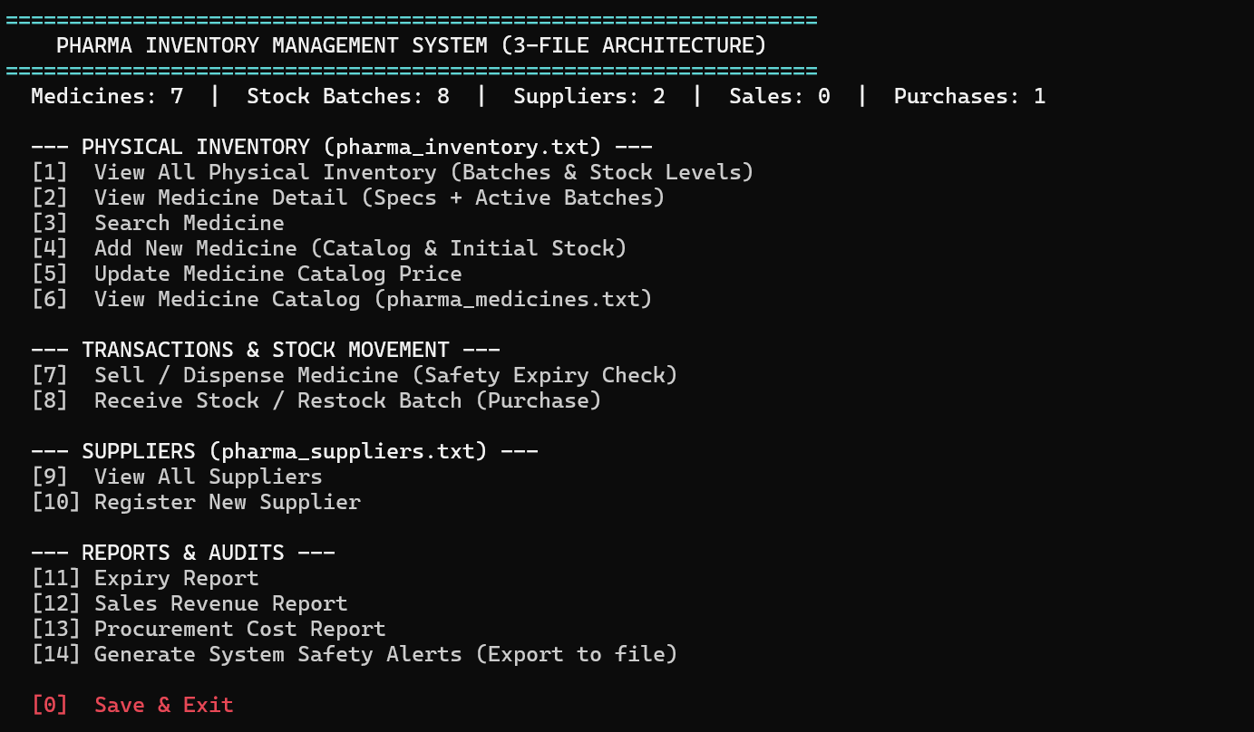

2. Object-Oriented Programming (OOP) Concepts in C++
The C++ codebase strictly adheres to the core principles of Object-Oriented Programming. Below is a comprehensive breakdown of each OOP concept, where it is implemented in Cpp Files/main.cpp, and why it was designed this way.

2.1 Classes and Objects
Objects model discrete pharmaceutical entities with encapsulated state and specific member functions. The system avoids global variables and procedural structs by using dedicated classes:
Class / Struct | Code Location in main.cpp | Real-World Responsibility & Role
struct ExpiryDate | lines 102-133 | Encapsulates calendar mathematics, MM/YYYY formatting, and expiration comparisons.
class Person (ABC) | lines 139-168 | Abstract human entity defining shared contact attributes (ID, Name, Phone, Address).
class Supplier | lines 171-203 | Derived from Person; models wholesale vendors with company name, email, and catalog links.
class Customer | lines 206-223 | Derived from Person; models patient buyers carrying prescription ID references.
class Medicine (ABC) | lines 230-269 | Abstract product master record defining drug name, manufacturer, and base price.
class Tablet | lines 272-299 | Derived from Medicine; models solid dosage forms with mg strength and strip packaging.
class Syrup | lines 302-333 | Derived from Medicine; models liquid oral suspension with volume (ml) and flavor.
class Injection | lines 336-366 | Derived from Medicine; models sterile parenteral vials with volume and route (IV/IM/SC).
class StockItem | lines 374-458 | Represents a physical batch on shelf with batch number, quantity, expiry, and reorder levels.
struct Sale | lines 463-486 | Transactional data carrier capturing customer receipts, timestamp, and revenue.
struct Purchase | lines 488-511 | Transactional data carrier capturing procurement restocking costs and supplier IDs.
class Alert (ABC) | lines 517-538 | Abstract event monitor capturing safety or inventory threshold warnings.
class ExpiryAlert | lines 540-563 | Derived from Alert; captures expired or expiring-soon batch warnings.
class LowStockAlert | lines 565-582 | Derived from Alert; captures inventory items breaching reorder thresholds.
class Inventory | lines 589-1533 | Central controller and aggregate facade managing all collections, files, and transactions.

2.2 Encapsulation & Data Hiding
Encapsulation ensures that an object's internal representation cannot be directly tampered with by external code. Class attributes are marked private or protected, and state mutations only occur through validated getters and setters.
In class StockItem (main.cpp: lines 374-458), internal fields like m_quantity and m_expiry are protected from direct modification:
class StockItem {
private:
string m_stockID;
string m_medicineID; // Foreign link to Medicine catalog
string m_supplierID; // Foreign link to Supplier registry
string m_batchNumber;
int m_quantity; // Hidden internal state
string m_mfgDate;
ExpiryDate m_expiry; // Composite date object
int m_minStock;
public:
// Read-only accessors
string getStockID() const { return m_stockID; }
int getQuantity() const { return m_quantity; }

// Controlled mutator
void setQuantity(int q) { m_quantity = q; }

// Encapsulated state queries
bool isExpired() const { return m_expiry.isExpired(); }
bool isExpiringSoon() const { return m_expiry.isExpiringSoon(); }
bool isLowStock() const { return m_quantity <= m_minStock; }
};
Similarly, in class Medicine (main.cpp: line 268), the catalog price m_price can only be modified through setPrice(double p), which is validated in Inventory::updatePrice() (main.cpp: line 978) to reject negative numbers.

2.3 Abstraction & Pure Virtual Functions (= 0)
Abstraction enforces an interface contract while concealing varying implementation details. An Abstract Base Class (ABC) contains at least one Pure Virtual Function (= 0) and cannot be directly instantiated.
The C++ core defines three distinct Abstract Base Classes:
- 1. Person ABC: Declares virtual string getRole() const = 0; (main.cpp: line 150). Subclasses Supplier and Customer are forced to declare their operational role.
- 2. Medicine ABC: Declares two pure virtual methods: virtual string getType() const = 0; and virtual string getUsageInstructions() const = 0; (main.cpp: lines 244-245). This models the medical reality that a generic 'Medicine' cannot exist; it must be classified into a physical dosage form.
- 3. Alert ABC: Declares virtual string getAlertType() const = 0; (main.cpp: line 527), implemented by ExpiryAlert and LowStockAlert to provide customized warning codes.
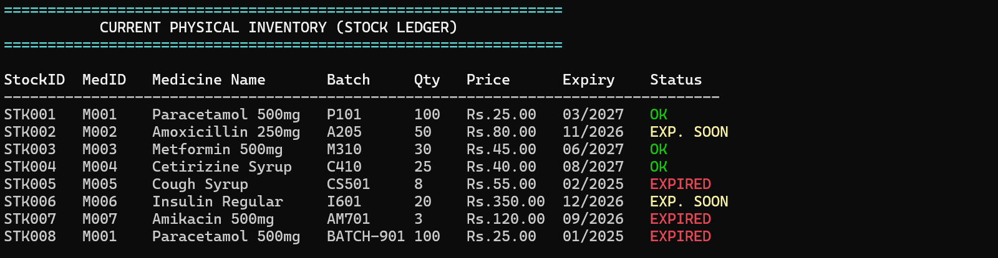

2.4 Inheritance Hierarchies
Inheritance models specialization ('is-a' relationships), promoting code reuse and modularity across three separate class hierarchies:
- Hierarchy 1: Person -> Supplier, Customer: Supplier and Customer inherit common attributes (m_id, m_name, m_phone, m_address), display logic, and pipe-delimited serialization from Person (main.cpp: lines 171, 206).
- Hierarchy 2: Medicine -> Tablet, Syrup, Injection: Tablet, Syrup, and Injection inherit base catalog fields (m_id, m_name, m_manufacturer, m_price) from Medicine, while each derived class introduces unique dosage attributes (mg per tablet, ml volume, route of administration) (main.cpp: lines 272, 302, 336).
- Hierarchy 3: Alert -> ExpiryAlert, LowStockAlert: ExpiryAlert and LowStockAlert inherit common alert mechanisms from Alert (main.cpp: lines 540, 565).

2.5 Polymorphism & Dynamic Dispatch (vtable)
Polymorphism allows collections of base-class pointers to process specialized derived objects at runtime. When virtual functions are called, C++ resolves them dynamically via the vtable (virtual table) mechanism:
- 1. Medicine Dynamic Dispatch: The Inventory class maintains vector<Medicine*> m_medicines. When viewing medicine details (main.cpp: line 862), m->display() dynamically executes Tablet::display(), Syrup::display(), or Injection::display() depending on the underlying object type.
- 2. Alert Dynamic Dispatch: In generateAlerts() (main.cpp: lines 1155-1188), a vector<Alert*> holds pointers to both ExpiryAlert and LowStockAlert instances. A single loop executes a->display() and writes a->serialize() to pharma_alerts.txt polymorphically.
- 3. Person Polymorphic Display: displaySuppliers() (main.cpp: lines 1267-1274) iterates through vector<Supplier*> using const Person* p base pointers, invoking p->display() dynamically.

2.6 Virtual Destructors & Memory Management
In C++, deleting a derived class object through a base-class pointer without a virtual destructor causes undefined behavior and severe memory leaks, because only the base class sub-object is destroyed.
All abstract base classes declare virtual destructors:
virtual ~Person() {} // main.cpp: line 148
virtual ~Medicine() {} // main.cpp: line 243
virtual ~Alert() {} // main.cpp: line 525
Furthermore, the Inventory destructor implements strict RAII deallocation, freeing every dynamically allocated heap object upon termination (main.cpp: lines 773-777):
~Inventory() {
for (Medicine* m : m_medicines) delete m;
for (StockItem* s : m_stocks) delete s;
for (Supplier* sup : m_suppliers) delete sup;
}

2.7 Composition vs. Association
- Composition: StockItem contains an embedded ExpiryDate struct by value (main.cpp: line 382). The lifecycle of the expiry date is strictly bound to the stock item.
- Relational Association: StockItem links to Medicine via m_medicineID and to Supplier via m_supplierID. Relationships are resolved dynamically via findMedicine() and findSupplier() (main.cpp: lines 829-832).

2.8 Factory Method Pattern for Deserialization
When reading text files, the C++ engine acts as a factory, inspecting tokens to instantiate the appropriate specialized derived class:
// main.cpp: lines 611-630
Medicine* parseMedicineLine(const string& line) {
vector<string> p = split(line, '|');
string type = p[0];
if (type == "Tablet")
return new Tablet(id, name, mfr, price, stoi(p[5]), stoi(p[6]));
if (type == "Syrup")
return new Syrup(id, name, mfr, price, stod(p[5]), p[6]);
if (type == "Injection")
return new Injection(id, name, mfr, price, stod(p[5]), p[6]);
return nullptr;
}

📸 [PASTE BACKEND SCREENSHOT HERE]
Paste a screenshot here showing Option 2 or Option 6 in the terminal console, displaying the polymorphic catalog details (Tablet strength, Syrup bottle volume, Injection route).

Figure 4: Option 2 & 6 — Medicine Product Catalog & Polymorphic Display

3. Comprehensive File Handling & Persistence Engine
The persistence system is implemented using standard C++ streams (<fstream>, <sstream>). It utilizes an industry-standard 3-File Normalized Relational Database Model (3NF) accompanied by 3 transaction logs.

3.1 The 3-File Database Architecture
Beginner projects often store all product data, stock counts, and vendor info in a single flat file. This project achieves Third Normal Form (3NF) by partitioning data into 3 normalized files:
Persistent File Name | Database Role | Delimited File Schema | C++ Handler Functions
pharma_medicines.txt | Product Master Catalog (3NF) | Type|MedID|Name|Mfr|Price|[FormSpecifics] | loadMedicines() [line 632], saveMedicines() [line 725]
pharma_inventory.txt | Physical Stock & Batches (3NF) | StockID|MedID|SupID|Batch|Qty|Mfg|Exp|Min | loadInventory() [line 643], saveInventory() [line 733]
pharma_suppliers.txt | Supplier Registry (3NF) | SupID|Name|Phone|Address|Company|Email | loadSuppliers() [line 661], saveSuppliers() [line 741]
pharma_sales.txt | Sales Transaction Ledger | SaleID|StockID|MedID|Name|Cust|Qty|Price|Date | loadSales() [line 673], saveSales() [line 749]
pharma_purchases.txt | Procurement Expenditure Log | PurchID|StockID|MedID|Name|SupID|Qty|Cost|Date | loadPurchases() [line 699], savePurchases() [line 756]
pharma_alerts.txt | Safety Audit Log | AlertType|StockID|MedID|Name|Message | generateAlerts() [line 1172]

3.2 Why 3-File Normalization was Chosen
- 1. Multi-Batch Tracking: A pharmacy frequently stocks multiple physical batches of the same drug (e.g. Paracetamol M001) purchased on different dates with distinct expiry dates. Mixing this with catalog definitions causes massive duplication.
- 2. Update Anomaly Prevention: Updating a drug's base catalog price in pharma_medicines.txt updates all financial displays instantly without mutating historical batch records.
- 3. Financial Isolation: Sales and purchases are written to dedicated append-only logs, guaranteeing financial auditability.

3.3 C++ Stream Mechanics & Token Parsing
Data serialization and parsing utilize robust stream operations:
- Custom Tokenizer: The custom split() function uses istringstream and getline() with pipe ('|') delimiters to prevent whitespace truncation in compound drug names or addresses (main.cpp: lines 91-97).
- Comment & Header Skipping: Lines starting with '#' are treated as comments and skipped during loading (main.cpp: lines 612, 648, 666).
- Automatic Database Seeding: If any database files are missing on first execution, seedDemoData() automatically synthesizes demo records (main.cpp: lines 1538-1574).

📸 [PASTE BACKEND SCREENSHOT HERE]
Paste a screenshot here showing pharma_medicines.txt, pharma_inventory.txt, and pharma_suppliers.txt opened side-by-side in Notepad or VS Code, showing pipe-delimited records.

Figure 5: Raw Persistent Database Text Files in Text Editor

4. Healthcare Patient Safety Gates & Business Logic in C++
In healthcare software, business safety checks must never rely on frontends; they must be rigidly enforced in the compiled C++ core:

4.1 Patient Safety Expiry Interceptor
Whenever a sale is attempted (main.cpp: lines 1018-1021 and lines 1370-1373), stock->isExpired() compares the batch expiry date against the current system month and year. If the batch has expired, the transaction is rejected immediately:
// main.cpp: lines 1018-1021
if (stock->isExpired()) {
printErr("PATIENT SAFETY BLOCK: Batch " + stock->getBatch() + " has EXPIRED! Sale rejected.");
return;
}

📸 [PASTE BACKEND SCREENSHOT HERE]
Paste a screenshot here showing Option 7 in the terminal console when attempting to sell an expired batch (e.g., STK005 Cough Syrup), showing the red PATIENT SAFETY BLOCK message.

Figure 6: Option 7 — Dispensing / Patient Safety Expiry Gate in Action

4.2 Early Expiry Warnings & Low Stock Alerts
The ExpiryDate struct calculates if a batch will expire within 3 months (main.cpp: lines 127-132). Furthermore, if stock drops below m_minStock, a low-stock alert is generated. When Option 14 is run, polymorphic alert objects are written to pharma_alerts.txt.

📸 [PASTE BACKEND SCREENSHOT HERE]
Paste a screenshot here showing Option 14 in the terminal console generating safety alerts, displaying EXPIRED and LOW STOCK alerts, and exporting them to pharma_alerts.txt.

Figure 7: Option 14 — Generating System Safety Alerts & pharma_alerts.txt

5. Viva Voce & Laboratory Examination Defense Guide
The following table provides succinct, technically rigorous answers to common viva questions asked by lab examiners regarding this C++ codebase:
Viva / Examiner Question | Architectural Justification & Technical Answer | Code References in main.cpp
Why did you separate medicines and stock into 2 files? | Demonstrates 3NF database normalization. One medicine can have multiple batches on shelves with distinct expiry dates, lot numbers, and suppliers. Mixing them causes massive duplication and update anomalies. | lines 34-58, lines 598-600
Where is runtime polymorphism demonstrated? | In vector<Medicine*> and vector<Alert*>. Base-class pointers dynamically invoke virtual functions display(), getType(), and serialize() resolved at runtime via the vtable. | lines 862, 1180-1184
Why must base class destructors be virtual? | Deleting a derived object through a base pointer (e.g. delete m;) without a virtual destructor causes undefined behavior and fails to invoke the derived destructor, leaking memory. | lines 148, 243, 525
Where is dynamic memory cleaned up? | The Inventory destructor (~Inventory()) uses RAII to loop through m_medicines, m_stocks, and m_suppliers, deleting every dynamically allocated heap object. | lines 773-777
How are expired medicines prevented from being sold? | stock->isExpired() checks current calendar month/year against the batch expiry date. If expired, sellMedicine() immediately aborts the transaction with a safety error. | lines 1018-1021, lines 1370-1373
How does the backend support external services? | main() checks argc > 1 to parse CLI flags like --api-stock and outputs structured JSON to standard output, allowing any external bridge or server to communicate with the C++ engine. | lines 1629-1661

6. Conclusion
The PharmaCare Inventory Management System demonstrates that Object-Oriented Programming in C++ provides an ideal foundation for building dependable, maintainable, and life-critical software. Through rigorous data hiding, inheritance hierarchies, runtime polymorphism, virtual destructors, and normalized 3-file stream persistence, the backend achieves professional software engineering standards.

