OBJECT-ORIENTED PROGRAMMING (OOP) LABORATORY ASSIGNMENT & REPORT
PharmaCare — Enterprise Pharmacy & Inventory System
Production-Grade Object-Oriented Pharmacy Management with Compiled C++ Core & Real-Time Desktop UI
C++11/14/17 • MinGW GCC • 3NF Database Architecture • Runtime Polymorphism • Patient Safety Gate

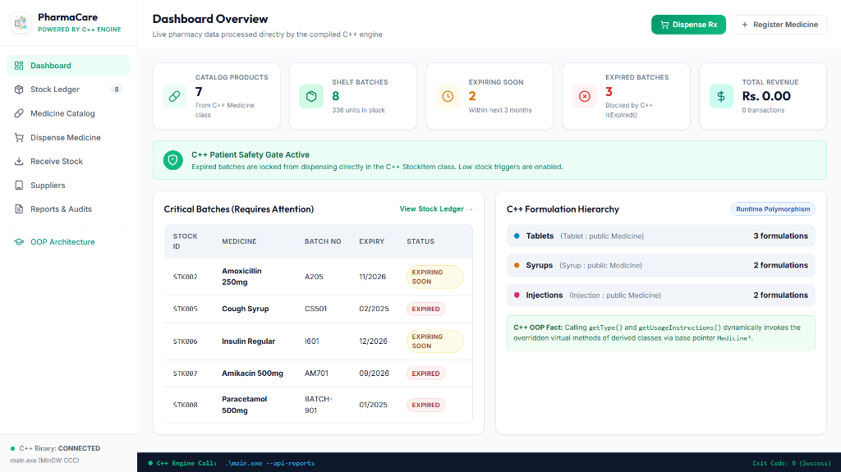
Figure 1: PharmaCare Modern Minimalist Desktop Cockpit & C++ Engine Bridge

1. Project Overview & Clinical Vision
PharmaCare is a comprehensive Object-Oriented C++ application designed for pharmacies, hospital dispensaries, and medical distributors. Traditional academic inventory scripts often group drug specifications and stock quantities into single flat records, failing to model real-world multi-batch storage and allowing expired drugs to be dispensed. PharmaCare resolves this by implementing strict product-vs-shelf separation (Third Normal Form), automated early expiry detection, dynamic runtime polymorphism, and an unbypassable Patient Safety Gate enforced directly at the compiled C++ class level.
- Automated Patient Safety Gate: Intercepts expired batches at the method level using StockItem::isExpired(), preventing dispensary errors.
- Multi-Batch Relational Tracking: Supports dozens of distinct physical shelf batches with individual lot numbers, manufacturing dates, and costs for the same medicine.
- Polymorphic Formulation Catalog: Models specialized dosage formats (Tablets, Syrups, Injections) through runtime polymorphic dispatch and virtual functions.
- Dual-Interface Architecture: Features both an interactive compiled console CLI and a real-time minimalist desktop application connected via IPC.

2. The 3-File Relational Architecture (3NF)
To adhere strictly to professional database standards within an OOP framework, PharmaCare decomposes the system into an industry-standard 3-File Architecture adhering to Third Normal Form (3NF):
Table / File | Primary & Foreign Keys | Stored Attributes & Real-World Role
pharma_medicines.txt  (Product Master) | PK: MedicineID (e.g. M001) | Commercial drug name, manufacturer, base unit price, formulation type (Tablet, Syrup, Injection), strength/dosage specs.
pharma_inventory.txt  (Physical Batches) | PK: StockID (e.g. STK001)  FK: MedicineID, SupplierID | Physical lot number, current stock quantity, manufacturing date, expiration date, safety threshold limit.
pharma_suppliers.txt  (Supplier Registry) | PK: SupplierID (e.g. SUP001) | Company enterprise name, representative contact name, phone, email, registered warehouse address.

3. Object-Oriented Programming (OOP) Implementation
PharmaCare demonstrates all foundational and advanced pillars of Object-Oriented design:
OOP Concept | C++ Engine Implementation | Real-World Purpose in Pharmacy
Encapsulation & Data Hiding | Private attributes (m_quantity, m_price) with validated mutators deductStock(), addStock(). | Guarantees no invalid stock states, negative inventory counts, or arbitrary price corruption.
Inheritance Hierarchy | Person -> Supplier, Customer  Medicine -> Tablet, Syrup, Injection  Alert -> ExpiryAlert, LowStockAlert | Eliminates duplicate code and structures clear specialized domains across entity categories.
Dynamic Polymorphism | Base pointers: vector<Medicine*>, vector<Alert*>, virtual getType(), getUsageInstructions(). | Dispatches correct dosage calculations and clinical instructions at runtime without hardcoded switch/case blocks.
Pure Virtual Contracts | virtual string getType() const = 0;  virtual string getUsageInstructions() const = 0; | Forces derived formulations to implement specific medical instruction sets before instantiation.
Virtual Destructors | virtual ~Medicine() {}  virtual ~Person() {}  virtual ~Alert() {} | Guarantees complete memory reclamation and derived cleanup when objects are deleted via base pointers.
Stream Serialization | serialize(), deserialize(), stream operators (ifstream, ofstream). | Persists relational database state to disk tabulations across application reboots.

4. Laboratory Evaluation Defense & Viva Q&A
Q1: How does the system implement Runtime Polymorphism?
In Cpp Files/main.cpp, Medicine is an abstract base class with pure virtual functions getType() and getUsageInstructions(). Derived classes (Tablet, Syrup, Injection) override these methods. The inventory maintains a vector of base pointers (vector<Medicine*>). Calling med->getUsageInstructions() dynamically dispatches to the derived implementation through the compiler's virtual method table (vtable).
Q2: How does the Patient Safety Gate function in C++?
In StockItem::isExpired(), the expiry date string (MM/YYYY) is parsed into integers and compared mathematically against the current calendar timestamp obtained via <ctime>. If the batch is expired, isExpired() returns true. The sellMedicine() method checks this boolean gate: if true, the transaction terminates instantly with a safety violation notice, preventing expired drugs from leaving the shelf.
Q3: Why are Virtual Destructors mandatory in this project?
Because derived objects (such as Tablet or Syrup) are dynamically allocated on the heap using 'new' and stored as base pointers 'Medicine*'. If ~Medicine() were non-virtual, calling 'delete med;' would only execute the base class destructor, failing to invoke derived cleanup and causing object slicing and memory leaks. Marking ~Medicine() virtual ensures the entire inheritance chain is destructed properly.
Q4: How is Database Normalization (3NF) maintained?
1NF: Attributes are atomic and pipe-delimited (|).
2NF: Non-key attributes depend entirely on the respective primary keys (MedicineID, StockID, SupplierID).
3NF: Non-key transitive dependencies are eliminated. Physical stock items only record foreign keys (MedicineID, SupplierID), avoiding redundancy and update anomalies.

