Business Process Modeling
Football Club Performance & Transfer Management System — Player Transfer Workflow
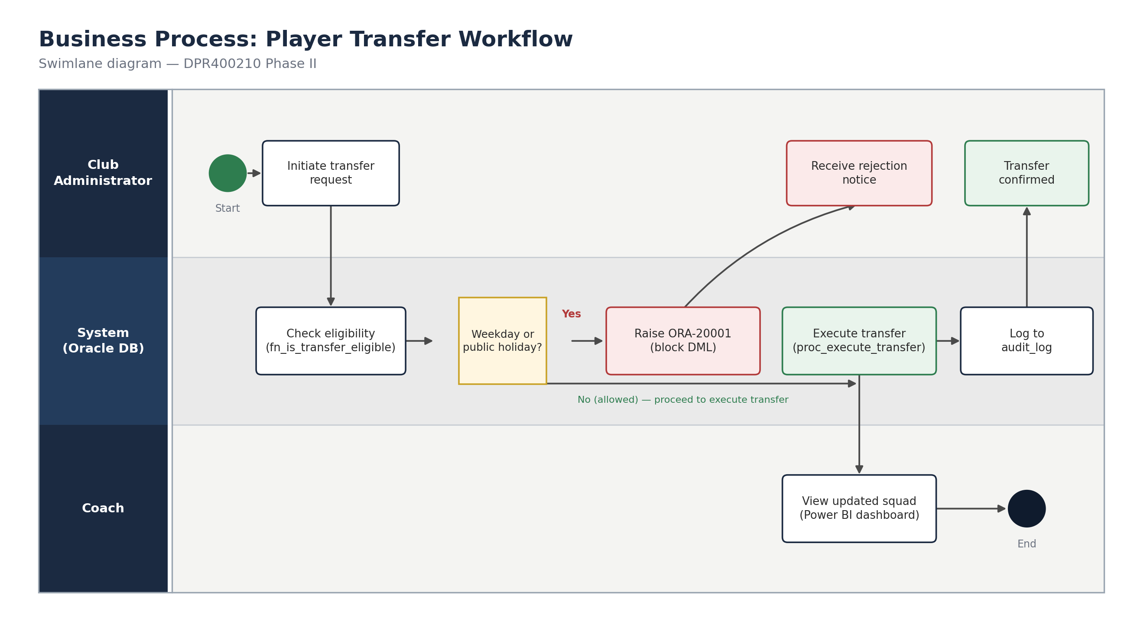
System Scope
The process covers the end-to-end handling of a player transfer request: from initiation by a club administrator, through automated eligibility and business-rule checks performed by the Oracle database, to confirmation and visibility for the coaching staff.
Actors & Processes
Club Administrator — initiates the transfer request and receives either a rejection notice or a confirmation.
System (Oracle DB / PL-SQL) — validates transfer eligibility via fn_is_transfer_eligible, checks whether the current date is a blocked weekday or public holiday, either raises a custom exception (ORA-20001) or executes the transfer via proc_execute_transfer, and logs the outcome to audit_log.
Coach — views the updated squad and transfer activity through the Power BI dashboard once a transfer is confirmed.
Workflow Summary
The workflow begins when an administrator initiates a transfer request. The system first checks contract-based eligibility, then evaluates the weekday/public-holiday business rule. If the request falls on a blocked day, the system raises a custom exception and the administrator receives a rejection notice — no data is changed. If the request is allowed, the system executes the transfer, updates the player's club, and writes a full audit record before the administrator receives confirmation and the coach sees the updated squad on the dashboard.

