Zachary Job

5/10/15

P2 – Runge Kutta – Lotka Volterra

**1**

See Code in folder 1. This is an RK4 implementation.

**2**

See the data and code contained in folder 2. This is derived off of the previous code.

**3**

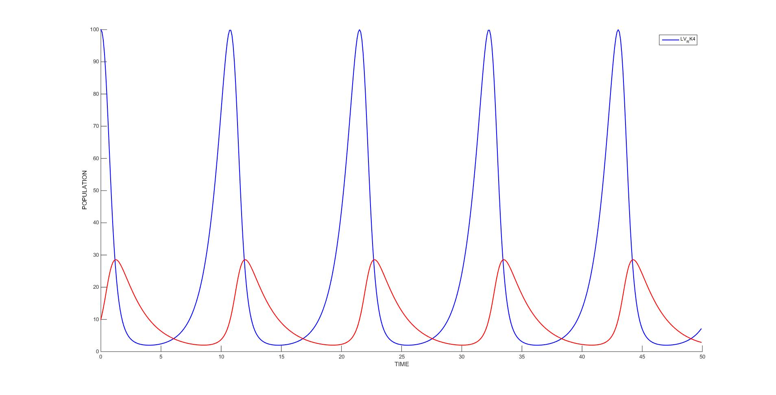

**4**

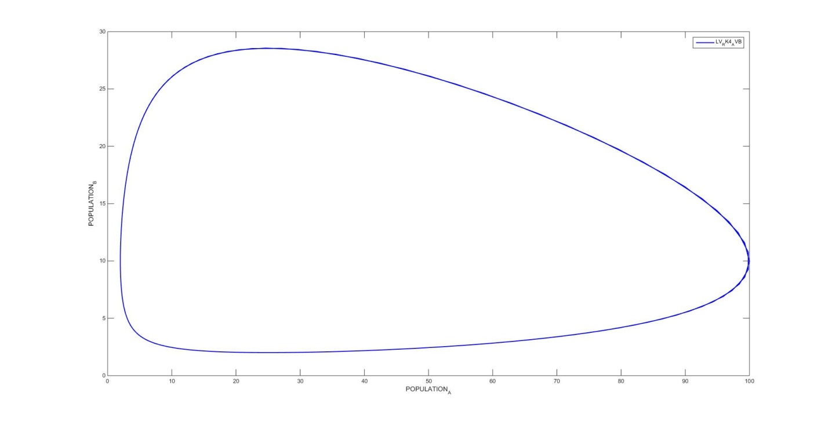

These results are expected. As prey increases, an increase can be seen in predators. As prey spikes predators begin to eliminate prey and sharply increase in number. As this continues prey decreases and eventually so do predators with prey exhaustion. This brings both back to a minimum population where the cycle repeats as the prey repopulates. This is a continuous cycle which is why the function can be represented as graphed.

**5**

The primary summary will follow. This is using the specified parameters and only varying populations

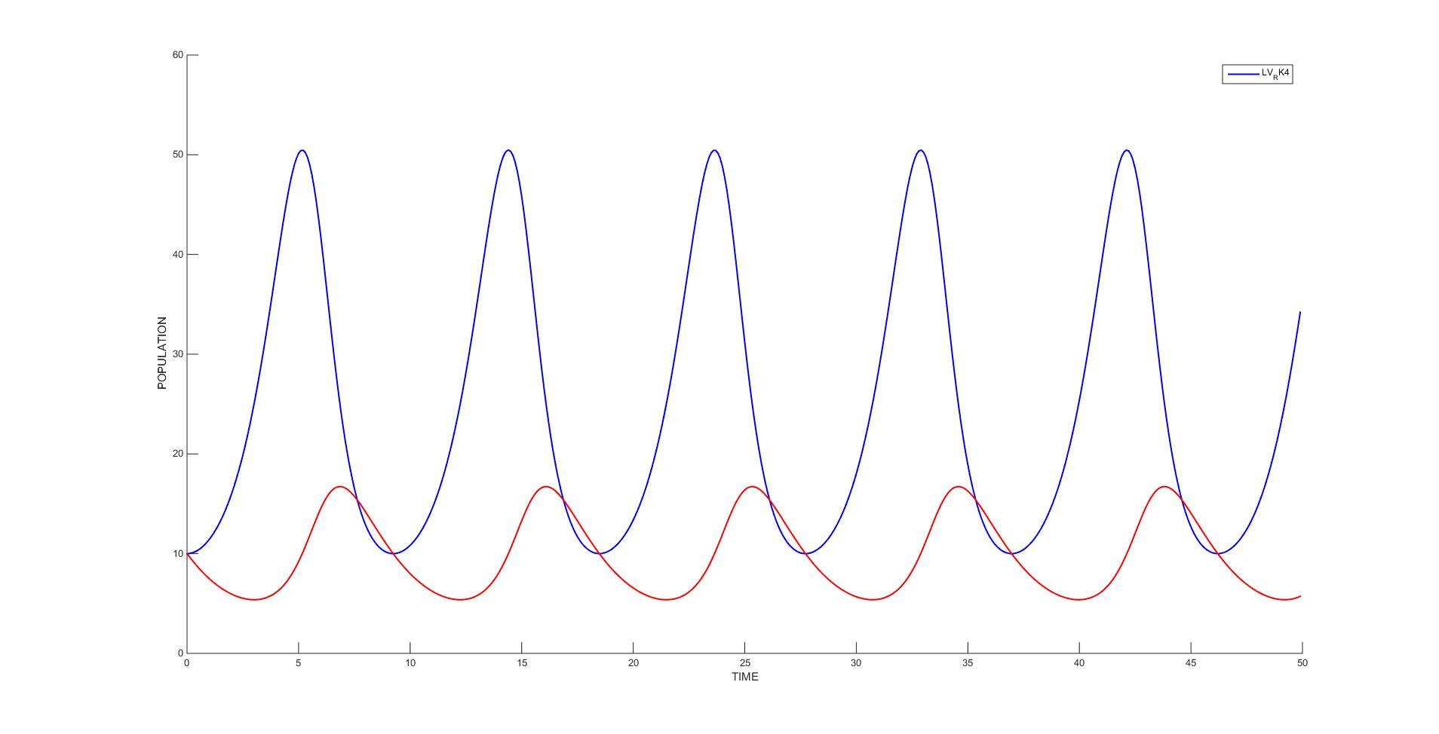

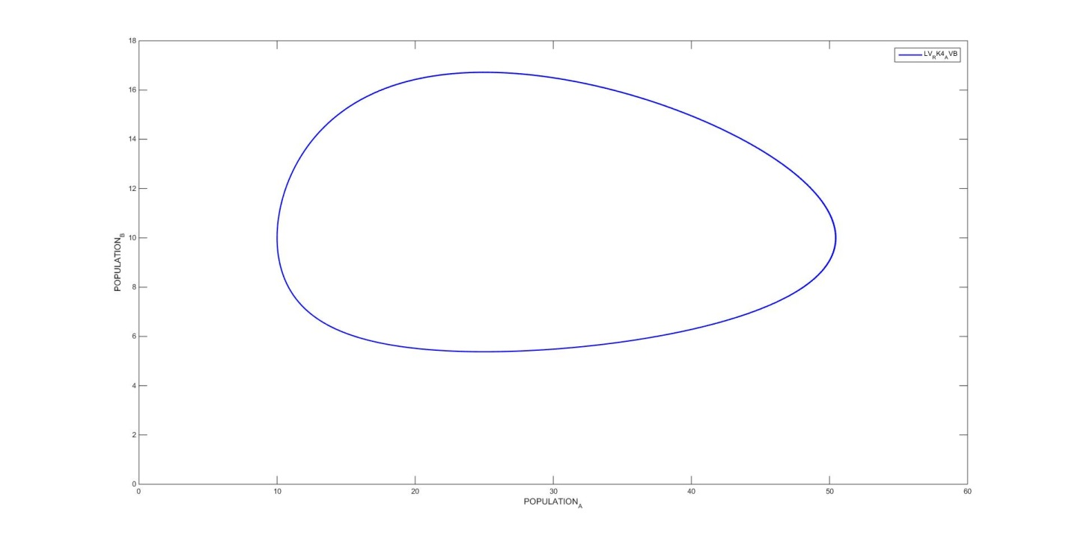

Prey: 10 Predator: 10

This appears to generate a shift in the cycle. Instead of prey immediately decreasing with predator increase, there is a lag. This can be attributed to the fact that less predators exist at the beginning of a cycle.

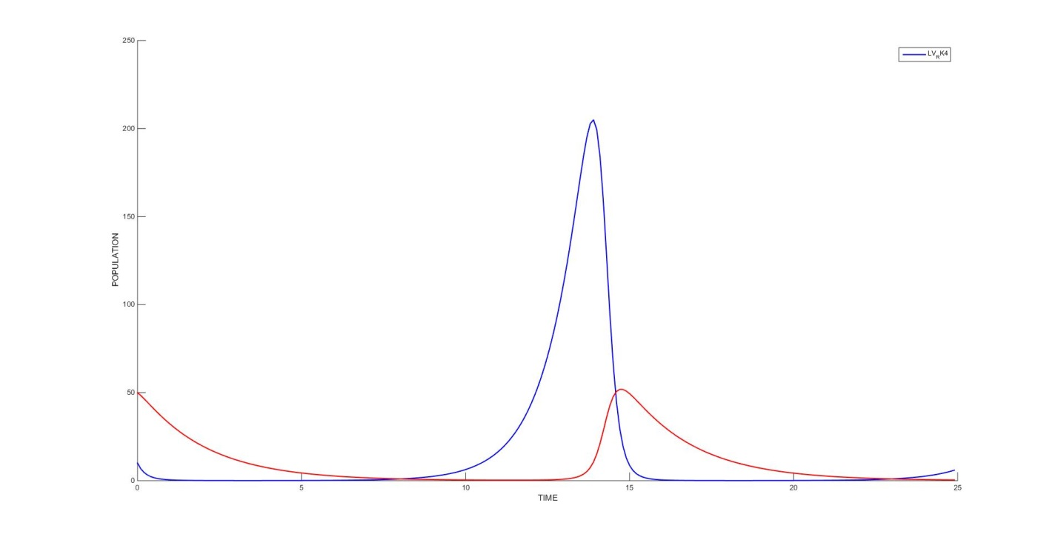

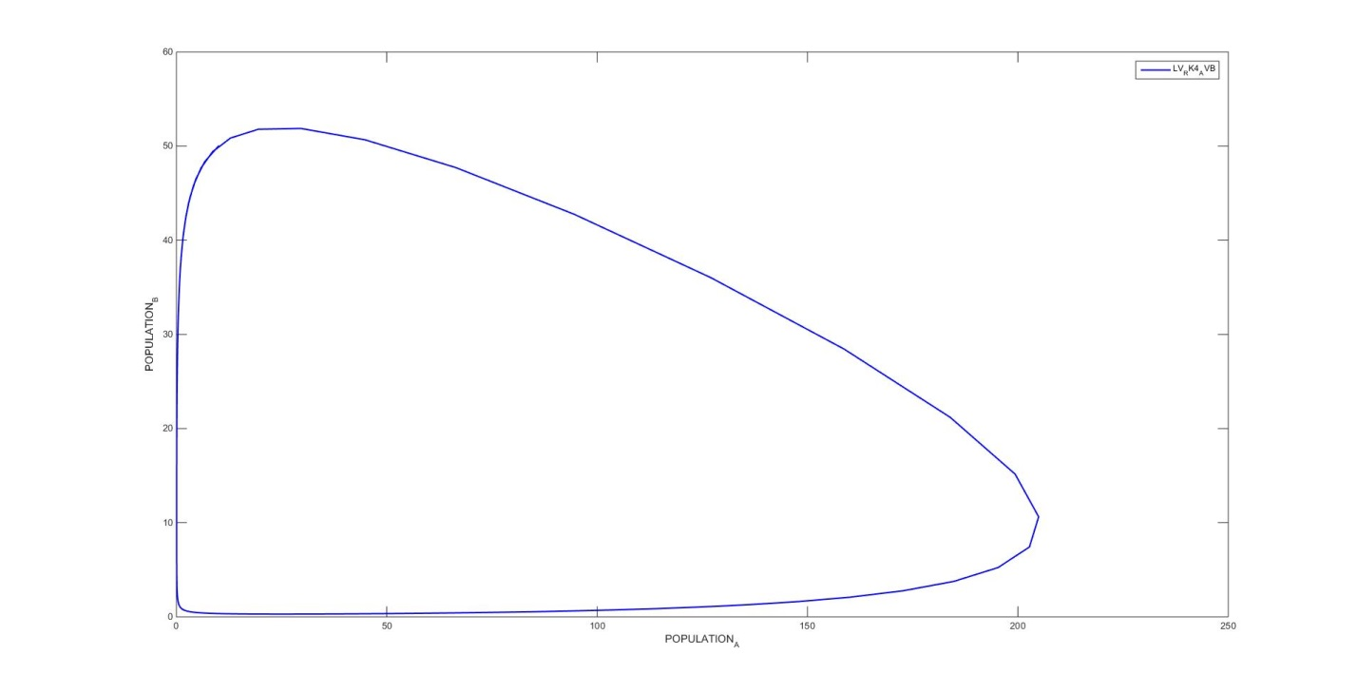

Prey: 10 Predator: 50

The pattern suggests that for more predators there exists a more rapid and vicious cycle. Numbers will decay fast with the large influx of predators. The cycle takes longer to repeat given the continued presence of predators near the end.

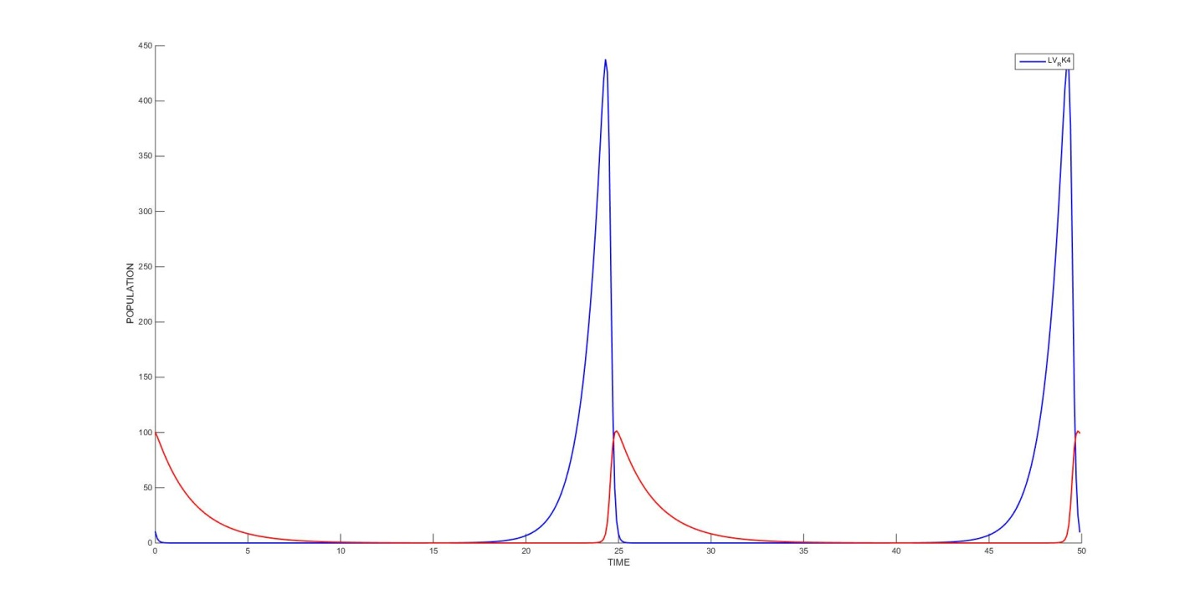

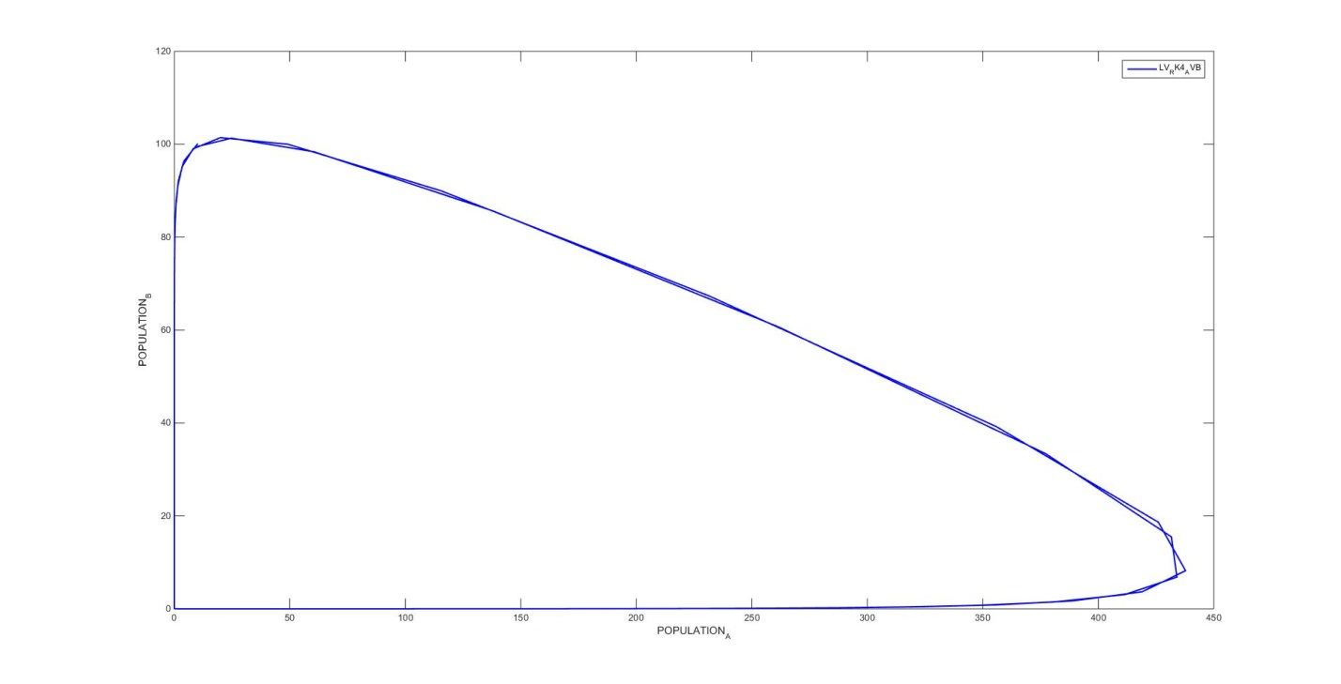

Prey: 10 Predator: 100

A similar result can be seen, although it is more pronounced. The change is not significant enough to cause anything dramatically different.

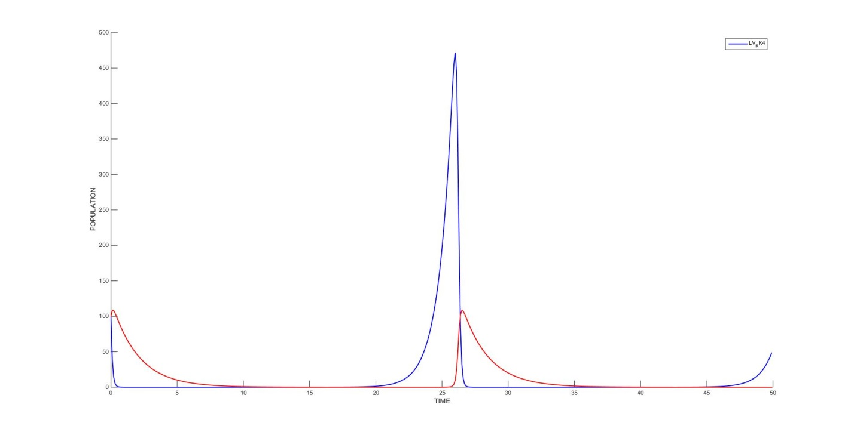

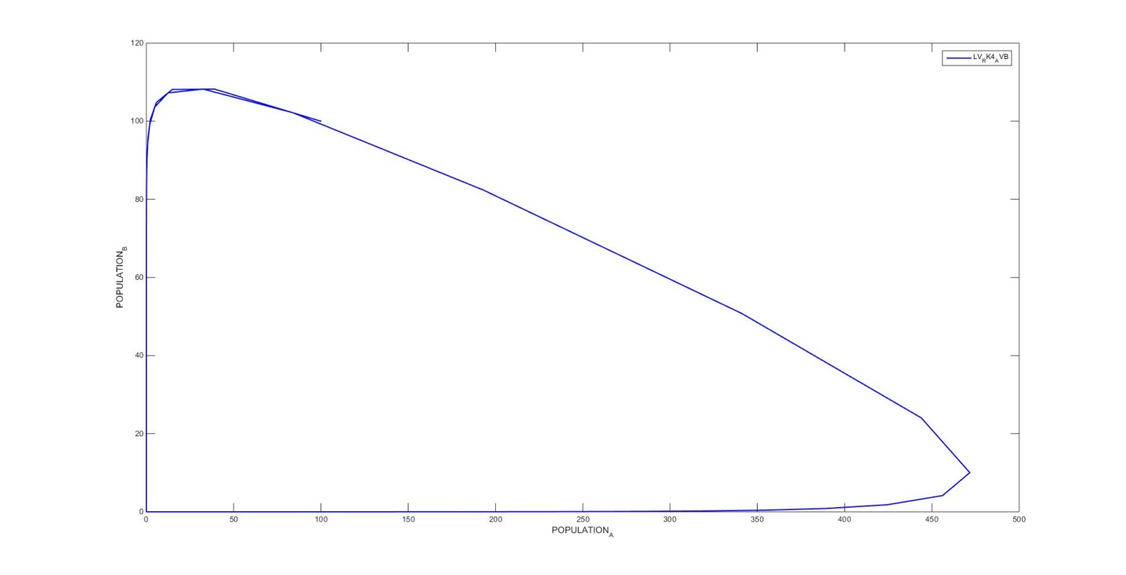

Prey: 100 Predator: 100

A similar behavior is exhibited again. it can be assumed that for a certain volume of prey there can only be N predators. The difference from 10 to 100 is not significant enough to weigh the results, although the knowledge is useful towards generating future test cases and understandings.

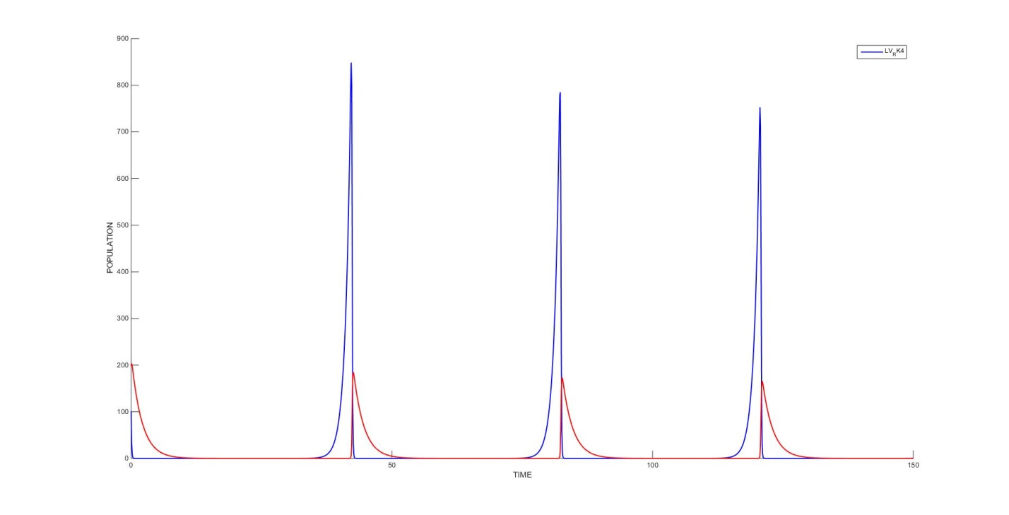

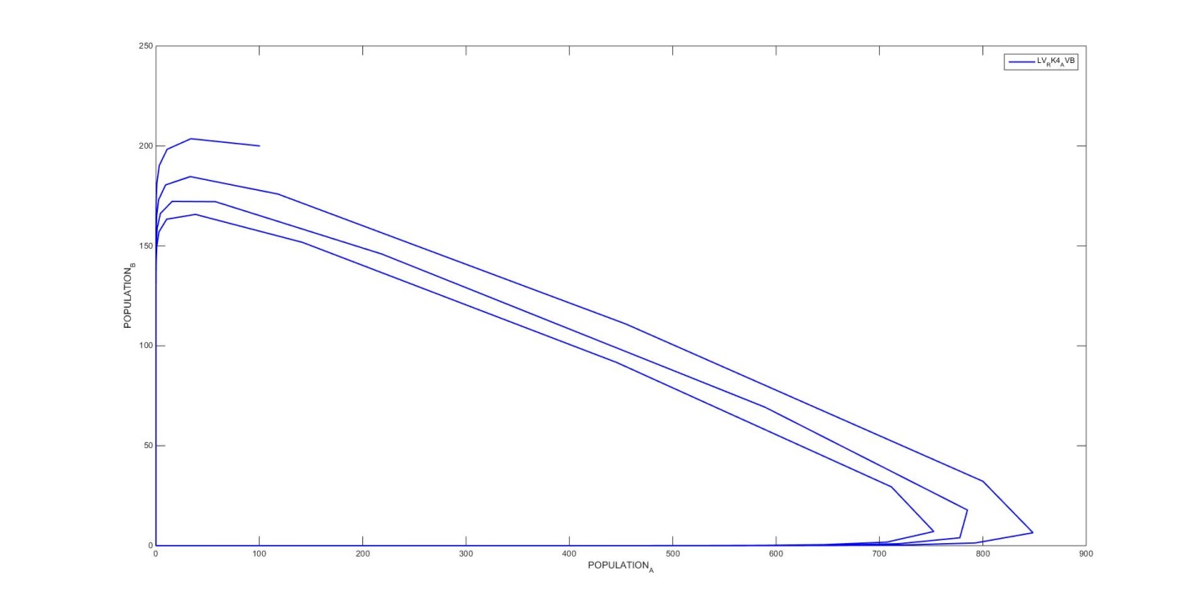

Prey: 100 Predator: 200

Finally a definite change can be seen with notable increase in predators. The peak point of this cycle is not finding equilibrium therefore the peak slowly converges towards a more stable point. At this point it can be assumed that there will be a more normal cycle.

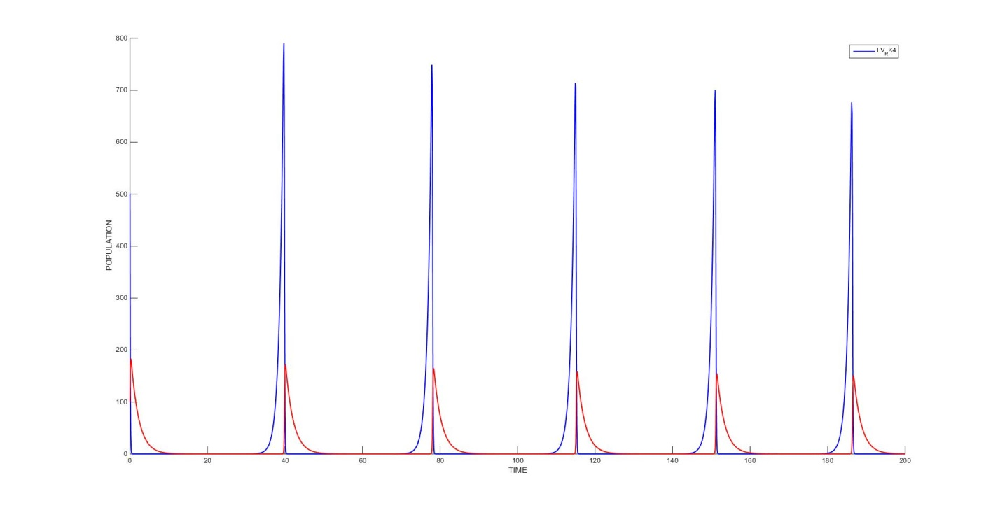

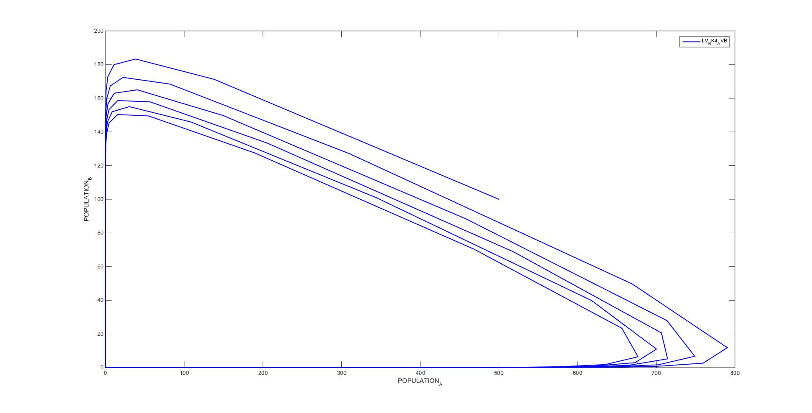

Prey: 500 Predator: 100

This was a confirmation for the idea that predator growth may spike given a large prey population. This leads to the same deviation from equilibrium as the above sample. Eventually this too seeks to find a more stable peek at which predator and prey numbers will flux more stably.

*Summary:*

The basic pattern that can be found by varying population is that the flux in population will generally favor a persistent pattern. For example introduce too many predators, the predator and prey amount will decrease until the ratio or new combination permits a sustainable pattern. Other notable patterns are that cycles of growth can be shifted and that some patterns will hold for a certain amount of change between the predators or prey. Drastic increase in either however will likely lead to a noticeable change.

**6**

In order to find which results may lead to stability, an upper and lower sample were taken independently from each of the variables. Again the primary summary will trail the samples.

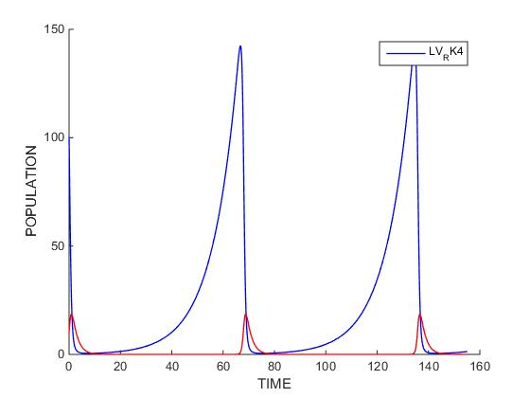

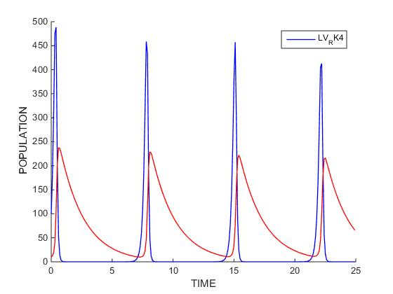

A 0.1 to 7

It can be obtained that alpha has an effect on the growth rate of the prey. This is important since consumption of prey must be balanced by prey growth.

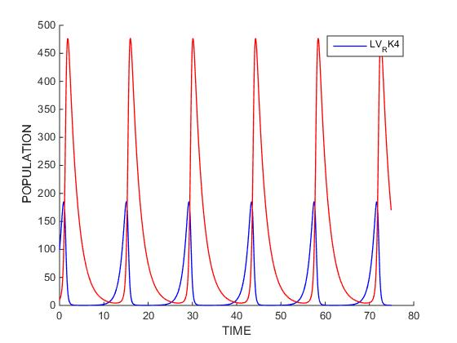

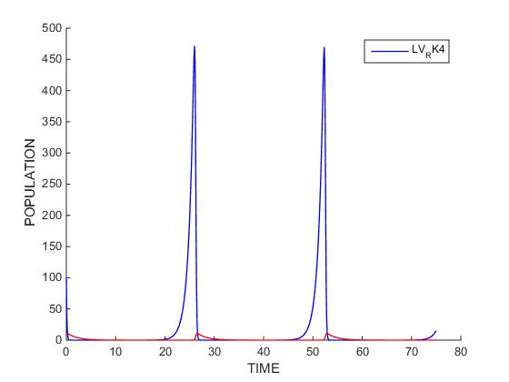

B 0.01 to 1

Beta appears to correlate with the consumption requirements of the predator. This relation is steep. This could be used if the predator count could be sustainably limited as it could be made capable of maintaining the prey growth rate without tripping other factors that increased predator population may affect.

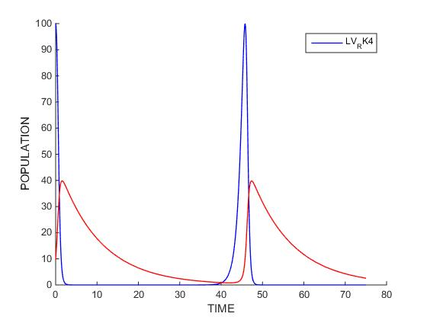

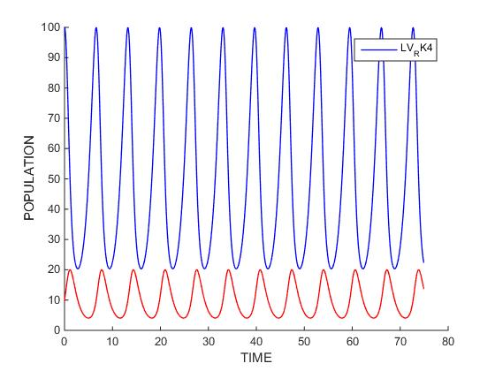

G 0.1 to 1

Gamma can be seen as a means to limit the reproduction speeds. This likely is due that gamma could represent the dependence of the predator on prey. The less dependent the predator is on the prey, the longer the predator will survive. This would limit the rebound of the prey. This is useful for separating populations to better adjust either.

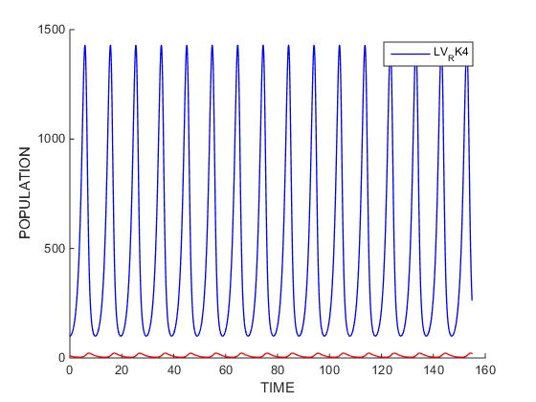

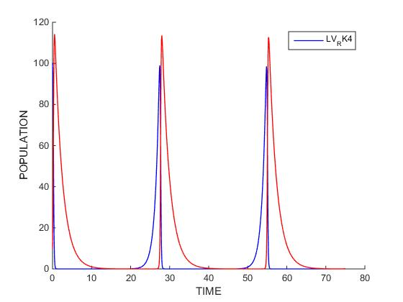

D 0.001 to 0.1

Delta seems to have a large effect on consumption requirements. This appears as though it roots from modifying the predator reproduction rates.

*Summary*

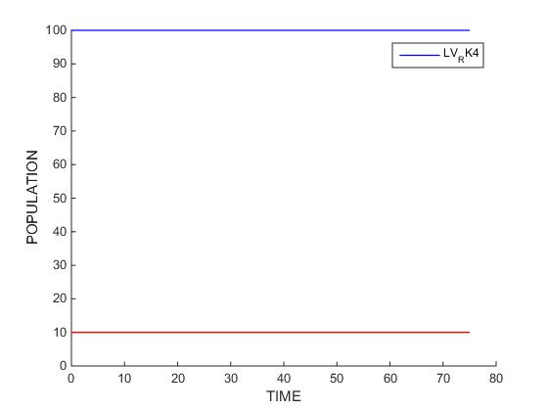

The provided settings almost provided the ample setup. The alpha of 1 provided ample time for the prey to repopulate combined with a gamma of 0.5. The beta of 0.1 limited the predator amount by increasing consumption requirements, and balanced by implementing a delta of 0.005. This ensured less reproduction in turn providing equilibrium by providing the existing population enough resources to co-exist.

This is verifiable through checking the known derivatives for Lotka-Volterra models

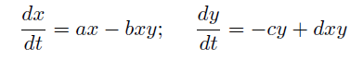

dx/dt: 1 * 100 – 0.1 * 100 * 10 = 0

dy/dt: -0.5 * 10 + 0.005 * 100 * 10 = 0

There is no change verifying the settings.

**7**

With the combined information a solution is obtainable.

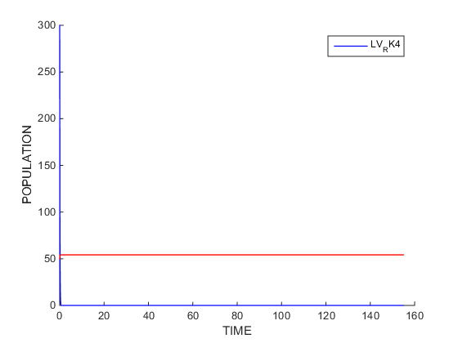

The configuration is an alpha of 7, a beta of 0.5, a gamma of 0, and a delta of 0.005 with 300 prey and 50 predators. The logic is simple. Without dependence on prey (gamma of 0) the predators could eliminate the prey and continue thriving. This would ensure extinction of the prey given the predator would always exist in large enough numbers. This appeared to be the simplest solution as the models had previewed the effectiveness of this phenomenon. The only requirement would be that predators did not dwindle, and this already was solved in finding how to achieve constant populations. An assumption must also be made that predators mustn’t extinguish other resources so the predator count was capped. To ensure the predators remained at equilibrium a beta of 0.5 was combined with a delta of 0.005 as done before. Finally, an alpha of 7 was applied to attempt and break the model since it should not have had any negative effect on the predator. Various alphas yielded insignificant virtually zero values as did 7. All the assumptions made appear to stand making this model possible through all the prior logic.