Student Borrowing Habits in Academic Libraries: Analysis and Strategic Recommendations

The aim of the essay is to analyze the library's borrowing status and students’ reading preferences by using library borrowing records, self-designed questionnaire data and online information, and give corresponding improvement suggestions.
Data processing:
We choosed the full dataset. We used python libraries(pandas, numpy, matplotlib, scipy) to process and analysis the dataset. For distribution analysis, we transfer the xlsx to dataframe, extract the two factors we're going to anaylze, and use the regular expression extraction to clean the data(such as removing the "页" in the pages column).

Correlation analysis:
Price vs. Average Borrowing Duration (days) :
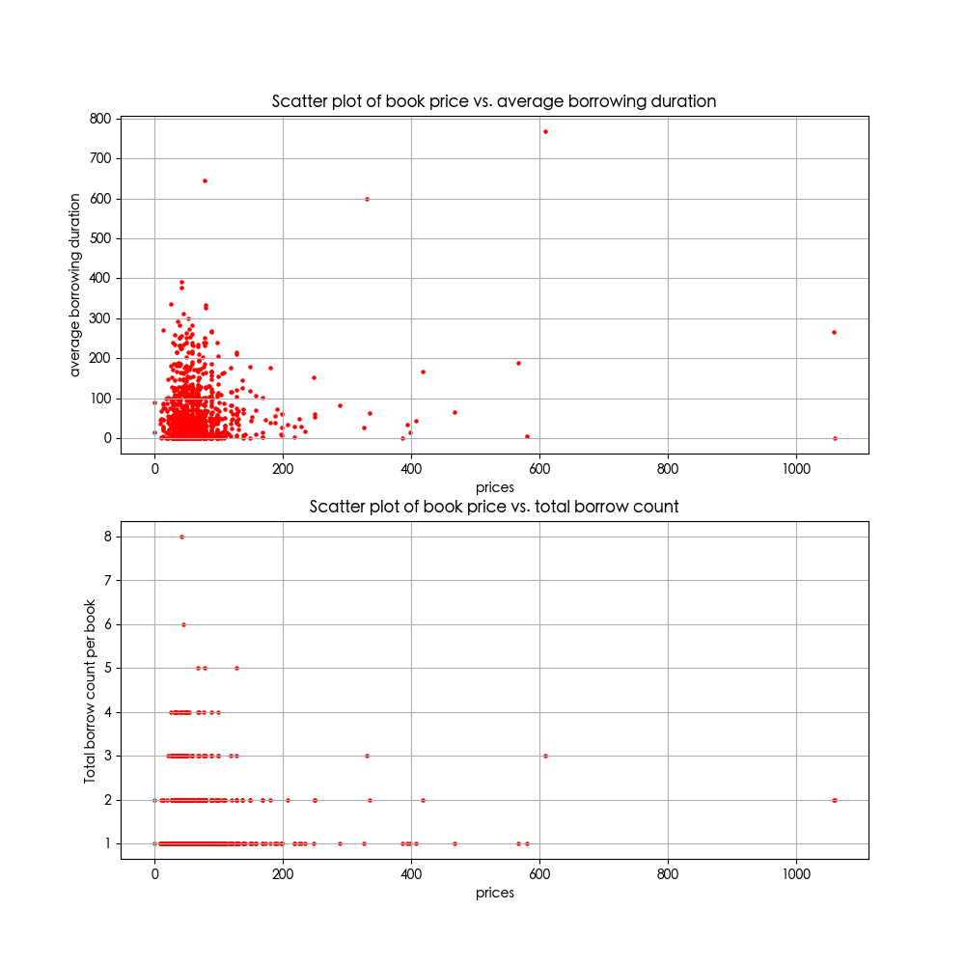
This graph shows the relationship between book price and the average time a book is kept (in days). There is no clear correlation between the two variables. Across all price ranges, most data points are concentrated between 0 and 100 days, with no systematic increase or decrease as price rises. Low-priced books (0–200 RMB) dominate the dataset and exhibit the widest variation in borrowing duration. In contrast, highpriced books (>300 RMB) are very few and tend to have shorter borrowing periods. The distribution is heavily skewed to the left (low prices), and the effective spread of borrowing duration remains narrow regardless of price. We can use the Pearson correlation coefficient to measure the strength of the correlation of two values. For prices(P) and average borrowing duration(T),

which shows the correlation is weak. This suggests that price alone does not determine how long students keep a book, which is obvious since we won't check the book's price when we borrow it. other factors such as book type or academic purpose are likely more influential.
Price vs. Total Borrowing Count:

This graph illustrates the relationship between book price and total borrowings plus renewals. No obvious correlation exists between this two variables. The vast majority of points cluster in the lowprice region (0–200 RMB), with borrowing frequencies mostly between 1 and 4 times. Books priced above 200 RMB are sparse and show very low circulation. The distribution is rightskewed, meaning students predominantly borrow lowpriced books. The mode appears in the 20–50 RMB interval, where borrowing frequency is highest. Although prices extend beyond 700 RMB, the effective range of frequent borrowing is limited to 0–200 RMB.
r=0.0097
Overall, the scatter plot suggests that price is not a meaningful predictor of borrowing frequency, which is expected since students so not consider price when choosing books to borrow.

Correlation between books' rating and borrowing statistic:
Rating data collection: We used AI to search the douban rating for each book then merge them into our book_info.csv.
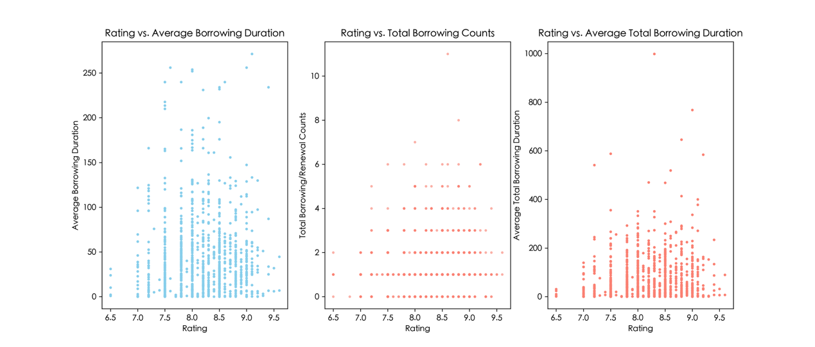

Graph 1: Rating vs Average Borrowing Time
The first scatter plot shows the relationship between book ratings and average borrowing time. The data points are widely spread, so there is no strong correlation between the two variables.
However, most books are concentrated between ratings of 7.5 and 9.0, suggesting that students generally borrow books with relatively high ratings.
The distribution is not uniform because most data points are clustered near shorter borrowing times, especially below 100 days, suggesting that most books are returned within a moderate period regardless of rating.
Based on this graph, rating alone does not appear to strongly affect how long students keep a book.

Graph 2: Rating vs Total Borrowing and Renewal Frequency
The second scatter plot shows a weak positive correlation between ratings and total borrowing and renewal frequency. In general, books with higher ratings tend to have slightly higher circulation counts.
Most books with ratings above 8.0 have more borrowing and renewal records compared to books with lower ratings. There is also a clear cluster between ratings of 7.5 and 9.2, but a few books with very high circulation counts can be considered potential outliers.
This graph suggests that highly rated books are generally more popular among students, although rating is not the only influence factor.

Graph 3: Rating vs Total Borrowing Time
The third scatter plot shows a weak positive correlation between ratings and total borrowing time because books with ratings above 8.0 are more likely to have higher total borrowing times.
Most data points are concentrated below 300 days, while a few books ----including one point close to 1000 days----have extremely high total borrowing times and can be treated as outliers.
The data is also clustered around ratings between 7.5 and 9.0, showing that books within this rating range contribute most of the total circulation time.
This suggests that higher-rated books are generally borrowed for longer total periods, likely because they are borrowed more frequently by students.

When the three graphs are analyzed together, ratings appear to have a weak positive relationship with circulation activity. Higher-rated books are usually borrowed more often and for longer total periods, but rating does not strongly affect the average borrowing time of each individual loan.

From the analysis above, we can notice that both pages and price have a very low correlation to borrowing frequency and average borrowing duration. From common sense, most library users already have a clear borrowing goal when they visit, and they generally pay little attention to book attributes such as page count or publication details. Therefore, we expect that, in our analysis, most book attributes will exhibit relatively low correlation with borrowing frequency or borrowing duration.To prove this, we can use the correlation matrix to mearsure different kinds of correlation among variables.
Correlation matrix is a way to summarize pairwise statistical associations between multiple variables. Its nature depends on the association metric adopted, in our analysis, we used Pearson correlation coefficient, Spearman correlation coefficient and Mutual information correlation coefficient to measure the correlation among varaibles. We selected a set of appropriate variables for correlation analysis:
{Price, Pages, Total Borrowings, Total Renewals, Average Borrowing Duration, Unique_user(the number of distinct borrowers), unique_grade(number of distinct borrower grades), return_count, active_days(last return date- earliest borrow date), publication_year}
Note that certain categorical variables (such as Publisher, Author, Place of publication) cannot be readily transformed into continuous numeric forms, so we ignored them in matrix calculation.
Pearson correlation matrix:
It calculates Pearson correlation coefficient(r) for each of the pairwise variable combinations, Which can show the strength and direction of linear associations between pairs of continuous variables. We used heatmap to visualize matrixes.
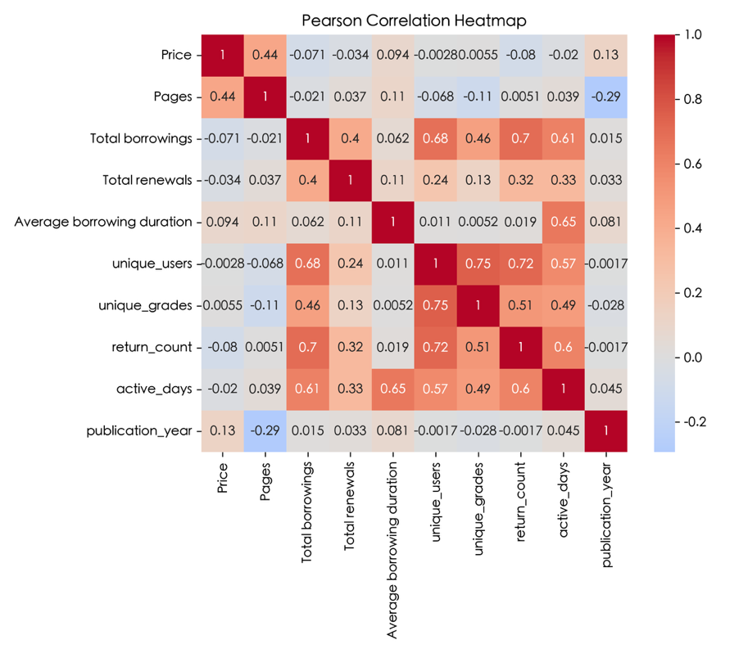
Spearman correlation matrix:
It calculates Spearman correlation coefficient (ρ) for each of the pairwise variable combinations, which can show the strength and direction of monotonic and rank-based associations(not only linear associations) between pairs of variables (no strict requirement for continuous normally-distributed data).
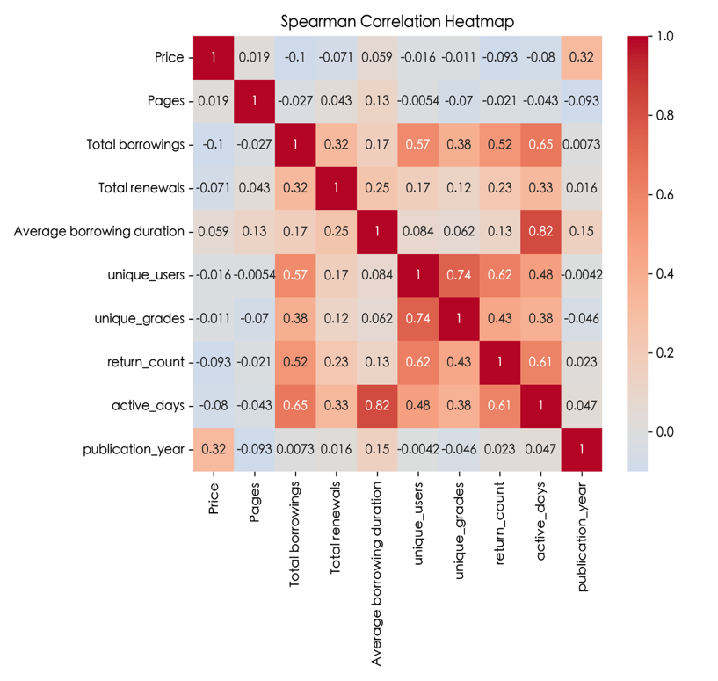
Mutual Information Matrix:
It calculates mutual information (MI) value for each of the pairwise variable combinations, which quantifies how much information one variable (X) can reveal about another variable (Y), without assumptions of linearity or monotonicity.
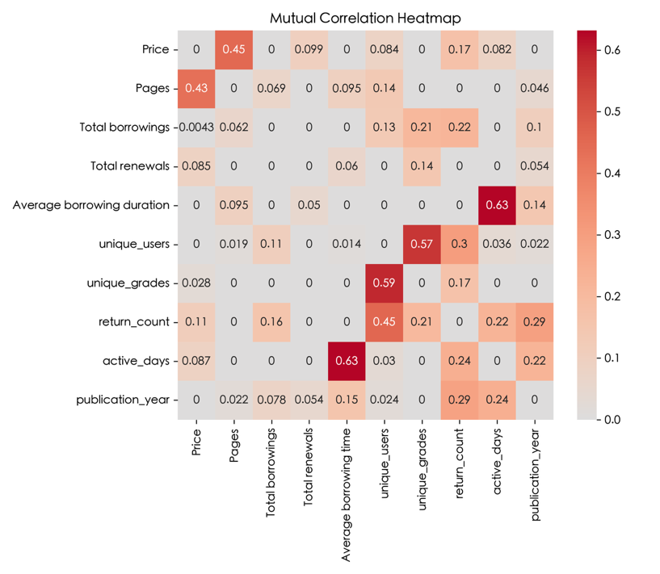

We can notice that most varaible pairs have a low correlation with others. Some high related varaibles, such as return_count and total borrowings, they are conceptually related variables，reflecting natural internal consistency rather than meaningful external correlations. Overall, the weak statistical associations across most variables indicate that linear or monotonic analysis provides limited explanatory power for the research topic. Therefore, alternative analytical perspectives are required for further exploration.

Classification rules:
In order to further anaylze students' reading preferences, we need to separate books in to different categories. Books in the dataset contains 3 category, which are Chinese Library Classification, Dewey Decimal Classification and Relative Index and IB textbooks classification used by Jinding Library. After searching about each of the classification methods, we decide to use the following categories:
{General / Misc, Social Sciences, Language, Science, Arts, Literature}
We further determine the category mappings for each classification methods:
Init Classification Number | Mapping Classification | DDC
IB |  | 700–799 | Arts
IB-1-CH | Literature | 800–899 | Literature
IB-2-E | Language | 900–999 | Social Sciences
IB-3-AS | Social Sciences | CLC
IB-3-EB | Social Sciences | I | Literature
IB-3-H | Social Sciences | J | Arts
IB-4-BI | Science | K | Social Sciences
IB-4-CH | Science | D | Social Sciences
IB-4-PH | Science | F | Social Sciences
IB-4-SC | Science | O | Science
IB-5-M | Mathematics | Q | Science
IB-7-R.B | General / Misc | T | Science
IB-7-TOK | General / Misc | H | Language
DDC |  | Z | General / Misc
0–99 | General / Misc | E | Language
100–199 | General / Misc | B | Social Sciences
200–299 | Social Sciences | C | Social Sciences
300–399 | Social Sciences | N | Science
400–499 | Language | R | Science
500–599 | Science | S | Science
600–699 | Science | E | General / Misc
 |  | G | General / Misc

figure2
figure1
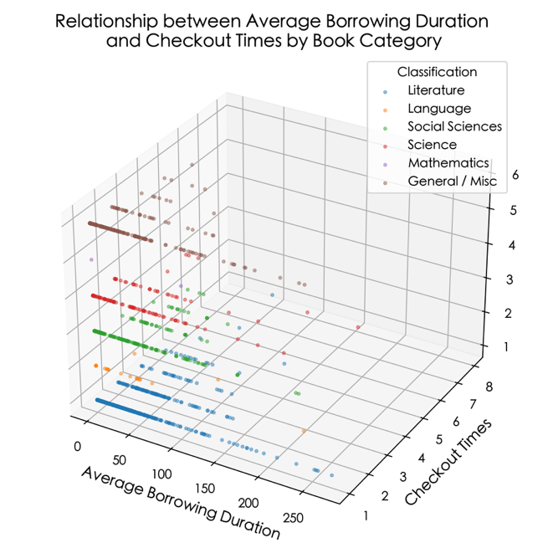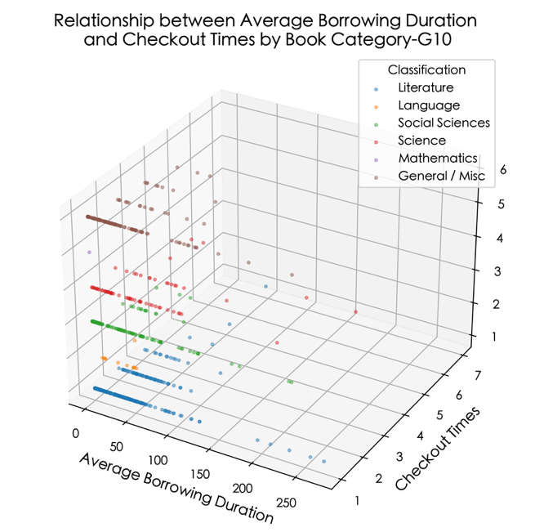

Figure1: Overall– Relationship between Average Borrowing Duration and Checkout Times by Book Category
This 3D scatter plot shows no clear linear correlation between average borrowing duration and checkout frequency across all categories. Literature dominates in long borrowing durations (many >100 days) but with low checkout times (1–3 times). General/ Misc books have moderate durations (0–100 days) but the highest checkout times (up to 8 times). Science and Social Sciences show wide spread in both duration (0–200 days) and frequency (1–6 times). Language and Mathematics are sparse, with short durations (<50 days) and low checkout times. Most categories show right-skewed distributions with outliers at longer durations. Significant overlap between categories indicates no strict separation of borrowing behaviour by subject overall.

Figure2: Grade 10 – Relationship between Average Borrowing Duration and Checkout Times by Book Category-G10
Grade 10 shows a more balanced pattern: Literature still dominates long durations (up to 250 days, 1–3 checkouts), but General / Misc books have higher frequency (up to 6 checkouts) for moderate durations (0–100 days). Science and Social Sciences show wider spread than in Grade 12, with durations up to 150 days. Language and Mathematics remain sparse with short durations. The skew toward Literature is less extreme than in Grade 12, reflecting broader borrowing behaviour.

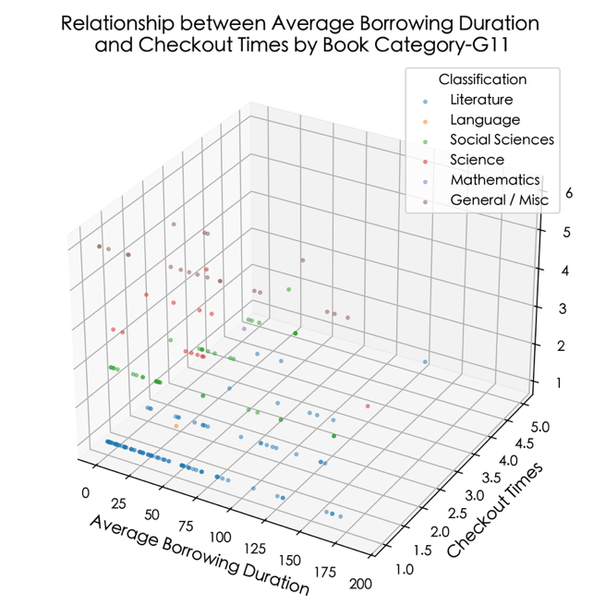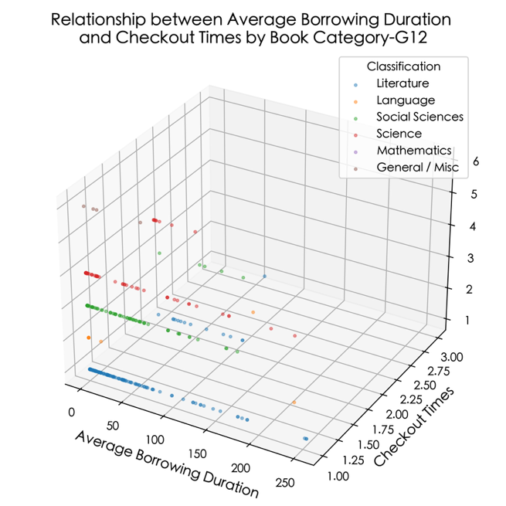
Figure 3 Figure 4

Figure3: Grade 11 – Relationship between Average Borrowing Duration and Checkout Times by Book Category-G11
Grade 11’s pattern is more consistent: Literature remains the primary long-duration category (up to 175 days, 1–2 checkouts) but with fewer outliers than Grade 12. General / Misc books have moderate durations (0–100 days) and lower maximum checkout times (up to about 5 times). Science and Social Sciences show reduced spread, with most points in the middle range. Language and Mathematics have very few data points. Behaviour across categories is more stable than in other grades.

Figure4: Grade 12 – Relationship between Average Borrowing Duration and Checkout Times by Book Category-G12
For Grade 12, Literature shows the strongest skew, with durations up to nearly 250 days and checkout times of 1–2 times, indicating long-term, low-frequency loans. Science and Social Sciences cluster in the middle range (0–150 days duration, 1–3 checkouts), while General / Misc, Language, and Mathematics have few points with short durations and low frequency. The distribution is heavily skewed toward Literature, showing Grade 12 students focus their long loans almost exclusively on this category.

Questionnaire analysis:
In order to further analyze students' borrowing preferences and their suggestions for imporving the library, we made a questionnaire based on our analysis above(the full version of the questionnaire is in the Appendix Section) and distribute the questionnaire to our classmates. We received 21 valid responses. Please note that the sample size is relatively small, so the result is lack of statistical representativeness and can't represent the whole school.

Students' Weekly Reading Time:
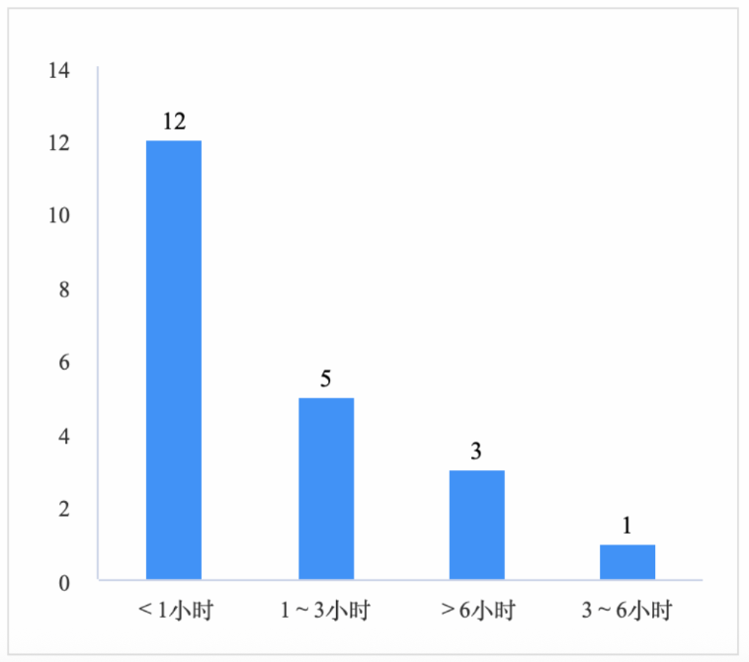
According to the graph, 63% of students read less than an hour, while only 1 student read 3~6 hours per week. This indicates that most students read very less or don't have the habit of reading, which is consistent with the result mentioned above.

Monthly book borrowing amount:
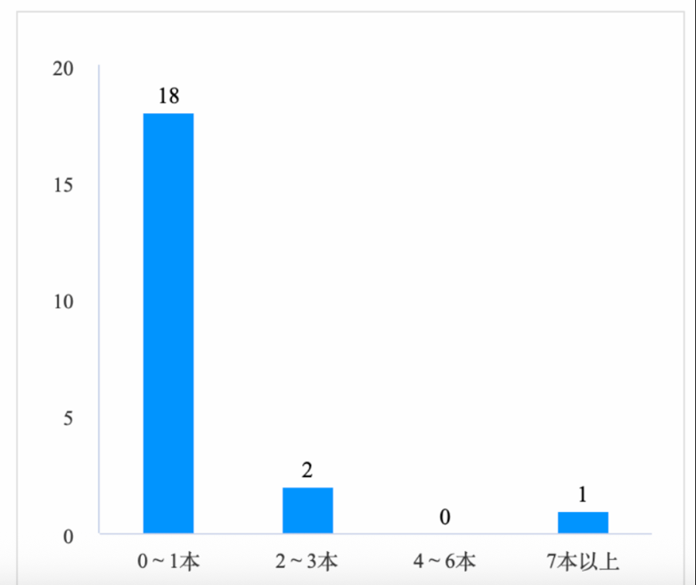
Up to 85% students only borrow 0~1 book per month. The graph shows that most students exhibit low-frequency borrowing behaviour, with only one student has a relatively more frequent borrowing. This maybe the same people in the last graph who reads 3~6 hours per week.

Book Types Students Hope the Library to Purchase:

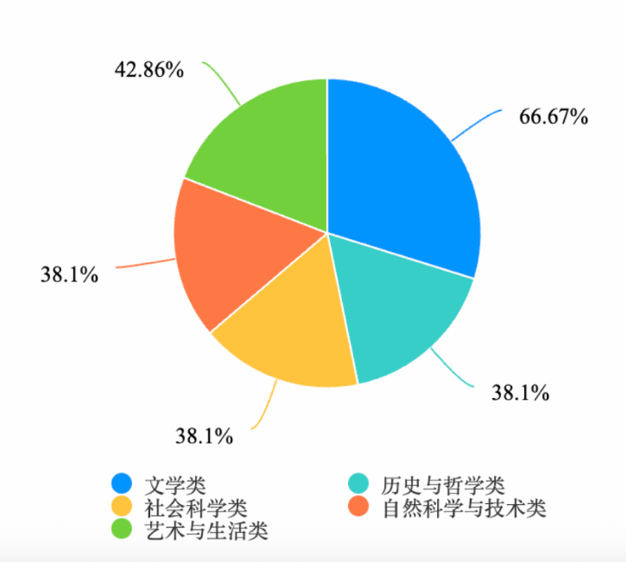

According to the pie charts, 66.7% of students has a strong demand on literary-related books, which is consistent with the high borrowing frequency and long borrowing duration of literary books shown in the 3d scatter charts above.

Appendix:

Questionnaire:

第1题：你平均每周花多少小时阅读课外书？[单选题]
选项 | 小计 | 比例
＜1小时 | 12 | 63.16%
1～3小时 | 5 | 26.32%
3～6小时 | 1 | 5.26%
＞6小时 | 1 | 5.26%
本题有效填写人次 | 19
第2题：你一个月大约借几本书（含续借）？[单选题]
选项 | 小计 | 比例
0～1本 | 16 | 84.21%
2～3本 | 2 | 10.53%
4～6本 | 0 | 0%
7本以上 | 1 | 5.26%
本题有效填写人次 | 19
第3题：你一般多久去图书馆借一次书？[单选题]
选项 | 小计 | 比例
每周 | 3 | 15.79%
半个月 | 2 | 10.53%
一个月 | 2 | 10.53%
三个月 | 5 | 26.32%
＞三个月 | 7 | 36.84%
本题有效填写人次 | 19
第4题：你一般花多久时间阅读一本书？[单选题]
选项 | 小计 | 比例
＜一周 | 0 | 0%
一周 | 3 | 15.79%
半个月 | 4 | 21.05%
一个月 | 3 | 15.79%
＞一个月 | 9 | 47.37%
本题有效填写人次 | 19
第5题：你平时更愿意借阅页数多的书还是页数少的书？[单选题]
选项 | 小计 | 比例
＜250页 | 10 | 52.63%
251～500页 | 6 | 31.58%
501～800页 | 2 | 10.53%
＞800页 | 1 | 5.26%
本题有效填写人次 | 19
第6题：你是否会因为封面或装帧而借一本书？[滑动条]
本题答卷总分值：90 平均值为：4.74
第7题：你希望图书馆引进什么类型的书？[多选题]
选项 | 小计 | 比例
文学类 | 12 | 63.16%
历史与哲学类 | 7 | 36.84%
社会科学类 | 8 | 42.11%
自然科学与技术类 | 8 | 42.11%
艺术与生活类 | 9 | 47.37%
本题有效填写人次 | 19
第8题：你更喜欢看中文书还是英文/外文书？[滑动条]
本题答卷总分值：49.8 平均值为：2.62
第9题：你觉得图书馆最需要增加完善的资源是？[多选题]
选项 | 小计 | 比例
更多新书 | 8 | 42.11%
更多电子资源 | 3 | 15.79%
更多自习座位 | 13 | 68.42%
更长的开放时间 | 16 | 84.21%
更安静的区域 | 12 | 63.16%
其他 | 3 | 15.79%
本题有效填写人次 | 19

https://arxiv.org/pdf/2008.03545
https://www.jstor.org/stable/2982096?seq=19

Division of Work | 黄诗淇 | Name 2 | Name 3 | 朱致瑜
Data cleaning / Data processing |  |  |  | √√
Interesting Facts (involve everyone) | √ | √ | √ | √
Analysis on factors related to borrowing duration / frequency | √ |  |  | √
Questionnaire design / analysis | √ |  |  | √
Improvement Plan Design
Library operation analysis
Presentation File Preparation

Use of AI:
We used AI to generate code for data processing and graph making, all the prompts can be found in the "prompt" directory at https://github.com/Zzyyio/Math-3rd-Monthly.

