Experiment04 Basic Syntax of Python (3)
Student ID | 2202130037 | Name | Walid El Hamdaoui
1. Purpose
(1) To master the use of string
(2) To master the data type conversion
2. Procedure
(1) Complete the following exercise on strings, observing and understanding the output:
In: s = 'I am in Nanchang.'
In: s.lower()
In: s.upper()
In: s.capitalize()
In: s.title()
In: s.swapcase()
In: s.replace('I am', 'You are')
In: s.startswith('I')
In: s.startswith('I am')
In: s.endswith('.')
In: s.endswith('Nanchang')
In: 'Nanchang'.islower()
In: 'ABC'.isupper()
In: 'ABC'.isdigit()
In: '0123'.isdigit()
In: s1 = 'He has 100 Yuan'
In: s1 = s1.replace(' ', '')
In: s.isalnum()
In: s.isalpha()

(3) Input the number of dollars from the keyboard, convert it to the equivalent number of RMB and print it out, keeping 2 decimal digits in the result. Assuming that the exchange rate of RMB to USD is 6.868, the program runs as follows:
Please enter the number of dollars you have, ending with $: 3.5$
3.5 USD can be exchanged for 24.04 RMB.
[Please note: user input ends with $ and output requires formatting using the format() method]

(4) The following is a sentence from the ancient Chinese book "The Analects of Confucius", please supplement the program in square brackets to output the number of Chinese characters and the number of punctuation marks in the string s respectively. (Do not use loop or if statement)
s = '学而时习之，不亦说乎？有朋自远方来，不亦乐乎？人不知而不愠，不亦君子乎？'
n = 0 # number of Chinese characters
p = 0 # number of punctuations
[Please insert your codes here. You can write multiline.]
print('There are {} Chinese characters, and {} punctuations in the string.')

3. Screenshot of your experiment procedure
(Including your code and running result) [Please fill this cell]
1
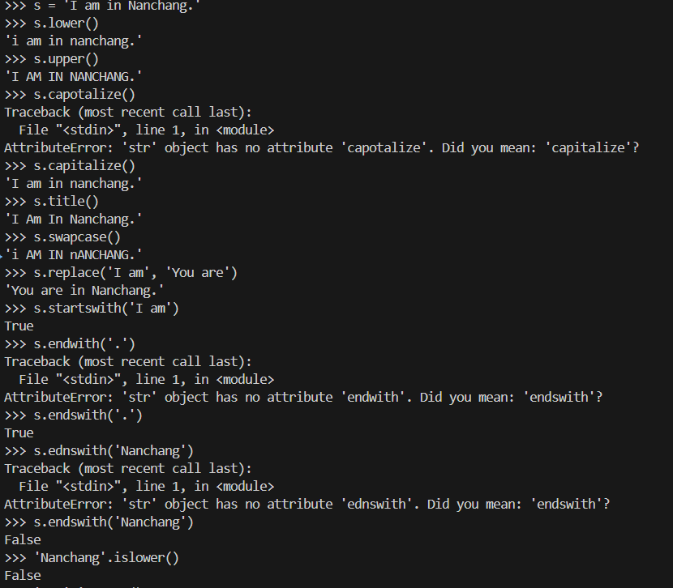
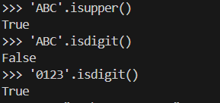
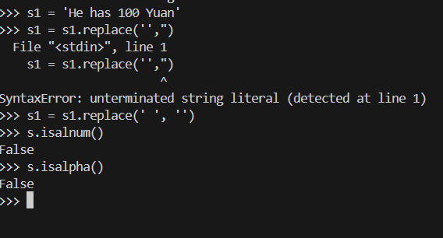
3
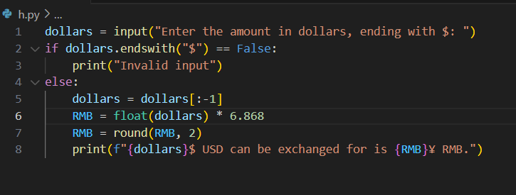

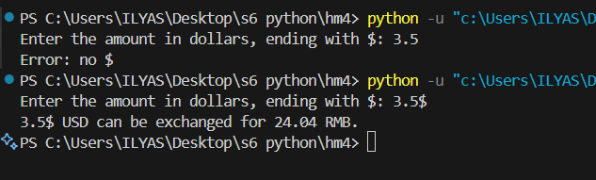

4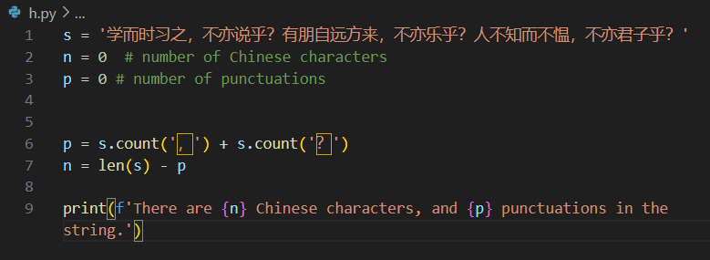

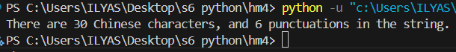

4. Discussions
(You can discuss what you think you need to pay attention to in this experiment, problems you encountered, and your solutions) [Please fill this cell]
This experiment was definitely a challenging but rewarding experience in problem-solving. The restrictions we were given in class actually served a good purpose—they pushed us to think more critically instead of just going for the easiest solution. As long as students stick to the required approach, solving the experiment shouldn’t be too difficult, since the first question already lays out most of the syntax needed for the rest. From there, it’s all about thinking creatively and tackling each part step by step.
One of my main challenges was understanding how different string methods behaved, since functions like swapcase() and title() didn’t always work exactly how I expected. The currency conversion task was simpler but required close attention to details like removing the dollar sign before calculating and formatting the result correctly to two decimal places.
The ancient Chinese text analysis was one of the most interesting parts—it forced me to find a way to count characters and punctuation marks without using loops or conditionals. That led me to explore helpful built-in functions like isalpha() and ispunct(). The bank account program felt more like a review of class material, but implementing it on my own really helped solidify what I’d learned.
The IPv4 validation task was probably the toughest, since it involved splitting the string, checking each section, validating ranges, and handling tricky cases like leading zeros or missing numbers. Still, by taking it one step at a time, I was able to solve it. Overall, this experiment was a great exercise in working within constraints and finding logical, efficient solutions through patience and problem-solving.

