## Synthetic Biology Popular Science Month

## 1. activity background

In the process of research, we found that the Chinese people still have a big misunderstanding of synthetic biology technology, and the popular science activities need to be more interesting and diversified. In order to popularize the knowledge of synthetic biology, improve the public's interest in and cognition in life science, and promote the wide application of synthetic biology technology in the society, our team planned and organized the synthetic biology Science popularization month activity.

## All parties involved and the media

In order to solve the problem of funding and promotion degree, we to China cell biology society, Hubei cell biology society, Hubei popular science education base, Hubei university college of life science, provincial and state key laboratory of biological catalysis and enzyme engineering, Hubei university of chemistry and biology engineering technology national experimental teaching demonstration center, the communist youth league of Hubei university art college committee for the funding or activity platform.

In the middle of the activity, we released the personal blog of the activity (/ small program: / / XRgtKOnIQIrdINx), which was widely praised by netizens. The editorial department of Changjiang Daily immediately began to close our activities and carried out media promotion for us

（http://h5.jp.cjn.cn/#/h5/news?informationId=3978908&sourceType=0&type=android&isDetail=0）。After the event, the official WeChat official account of the Chinese Society of Cell Biology, also released a tweet, expressing our recognition of the effectiveness of the event.（https://mp.weixin.qq.com/s/XJUPsEvEXwGu3zgAbBCxtQ）

## Activity preparation

We invited the iGEM team HuBuLoong-CHN, CHINA-HUBU-WUHAN, TJUSLS-China, and CUG-China to jointly organize the activity. They brought their laboratory research and iGEM project to the activity, broadening the popular science field of the activity.

**Plug in 3 posters**

## Content and form of the activities

The activity takes the form of carnival, the whole process lasts for about one month, including online training, laboratory Open Day, biological art creativity competition, children's Day popular science garden party

May 8 and May 10:3020:30-22:30 online training

Audience: all those who will enter the laboratory and the students from the Art College of Hubei University who will sign up for the Biological Art Creativity Competition

**Plug in photos**

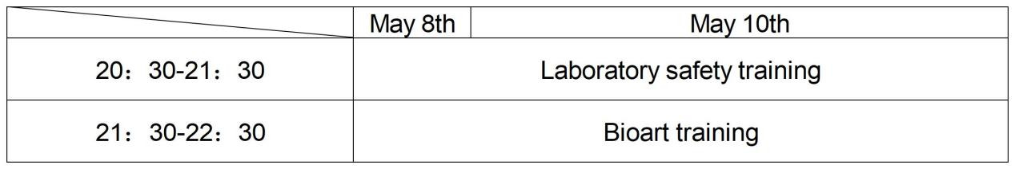

May 18,14:00-18:00 laboratory Open Day

The first part of the multimedia classroom popular science lecture (photo insertion)

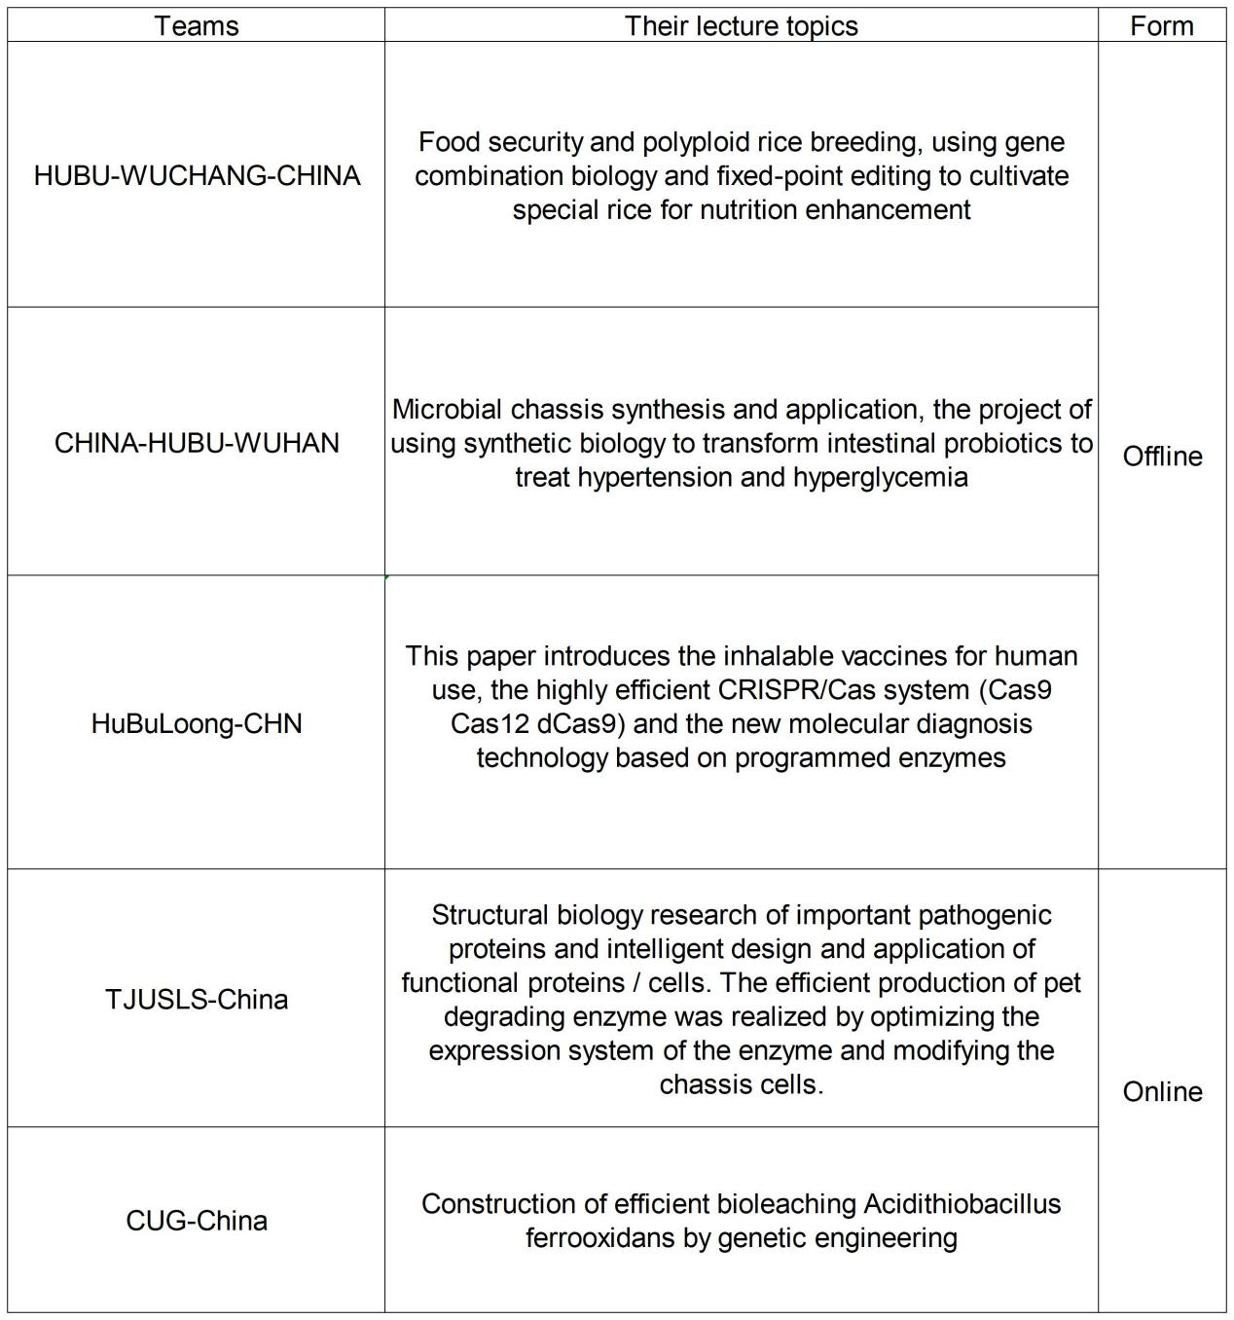

The second part is to visit the laboratory (insert photos)

Members of each team introduced the instruments in the laboratory to the visitors, and demonstrated the use of simple instruments such as pipetting guns.

The third part, the workshop experience (insert photos)

Experience the project

Make butterfly specimens

Observe for microbial permanent mounting

Plant tissue sections were observed in Yongjie slides

Make Paramecium pieces and observe their movements with a dark field microscope

Make a brown algae fashion piece, observe its cytosolic circulation with a phase-contrast microscope, and then observe its spontaneous fluorescence with a fluorescence microscope

During the experience process, the members of each team teach the operation.

May 18-May 24 Biological art Creativity Competition

aim:

1, we hope to be able to lead the art professional college students crossover from their professional teaching interpretation of their attitude to synthetic biology change the world, we will contest held a "campus art crossover iGEM", hope the creation and we think about the global human face or potential survival problems, how we make our contribution from the perspective of synthetic biology.

2. We set up the track according to the iGEM Village, and require the participants to reflect their solutions or reflections in their works. We know that for them, is likely to give scientific feasible solution will be more difficult, but this is we hope they can be led to do it, in order to encourage them, we have been in close contact with them, we for them to answer any synthetic biology knowledge, and we set the solution will score higher than the reflection review criteria (jump to the next part of the scoring criteria). We hope to find college students majoring in art who are interested in biological art in the competition. If they can enter the field of biological art in the future and further communicate and learn with synthetic biology, then we think that our competition has achieved a real success.

3. We will set the competition in the opening future and hope that all participants can take the competition as the practice of science popularization harvest of the laboratory Open Day, help them understand and master scientific knowledge, apply what they have learned to their creation, and cultivate rigorous scientific spirit.

From May 24 to May 28,6 teachers from the School of Life Science and the School of Art of Hubei University reviewed their works (insert the selected works and the corresponding theme introduction)

It was a serious interdisciplinary exchange, not a child's play, and we hope that the teachers from both colleges can also experience the charm of biological art in the work review.

Scoring criteria: comprehensive score =25% scientific score + 25% speculative score + 25% artistic score + 25% creative score

Scientific: The theme of the work is in line with the principle of biological art. In theory, the biological art works can be made according to the design in the future

Specitative: The depth of the author's solution or reflection on the current or potential survival problems facing the global existence. In this dimension, the work proposing the solution needs to score 30% higher than the reflective work

Artistic quality: color, meaning discussion, open thinking

Creativity: the work reflects the innovation and independence of the author's thinking

June 1 Children's Day science garden party (photo)

Audience: community residents, parent-child group, a retired teacher of the School of Life Science, Hubei University

Biological art creative exhibition area: Works exhibition, herbarium exhibition, interactive games  
Science science exhibition area: iGEM team project and Challenge Cup project interactive exhibition area, herbarium exhibition, interactive games  
The plant specimens were provided by students from the School of Life Sciences of Hubei University who went to field practice in Lushan Scenic Area of Jiangxi Province

Interactive game project

Virus, DNA ultralight clay model manual teaching

Base-complementary pairing ring

Graphic pairing of synthetic biology nouns

Read a popular science article

Biological you draw I guess

## 4. Participants will work with the team

This laboratory Open Day activity attracted primary and middle school students, parents, college students, graduate students, educators, science and technology enthusiasts, etc. At the same time, we have also received the support and help from several cooperative units, including schools, social academic groups, media and so on. In the process of the activity, the volunteer team played an important role, they were responsible for the reception, guide and other work, providing warm and thoughtful service for the tourists. The team members cooperated closely to complete the task of the activity together, which played a good educational role for the various audiences of the activity.

## Activity effect and reflection

We collected the feedback from the event audience through questionnaires and random interviews at the event site, and we are very happy that they have gained something from the event.**(Pie chart of questionnaire statistical results and live interview video)**

After the activity, our experimental group and art group members also together to visit the Hubei academy of fine arts experimental art college graduation exhibition, and in August to Shenzhen by Shenzhen advanced institute of Chinese Academy of Sciences and the central academy of fine arts cooperation biological art BBS, lectures, and visit the exhibition, discuss and reflect on the application of synthetic biology in the field of biological art and development prospects. Due to the planning time and equipment limitations, we regret not to provide the participants in this event use and transform biological opportunity to create, according to the declaration of biological art we will plan to hold campus biological art competition again next year, at that time, we will provide experimental space for participants, and invite the college of life science students cooperate with them to experiment scheme, help them create the real meaning of biological art works!