**RANSOMWARE**

**Introduction:**

Ransomware is a type of malware that encrypts a victim’s files. The attacker then demands a ransom from the victim to restore access to the data upon payment. While ransomware has technically been around since the 90’s, its only in the past five years or so that it has really taken off, largely because of the availability of untraceable payment methods like Bitcoins.

Here I’ve created a PHP file that will encrypt all the files and directories from the server’s root directory and only inside the server’s web root directory.

It is purely made for educational purpose to make technocrats understand how the ransomware actually works.

**It is tested on the following:**

**Operating System:** Windows 10 Pro (64-bit)

**Web Server:** XAMPP v7.3.7(64-bit)

**HOW TO EXECUTE:**

**Note:** Backup your server files before executing the ransomware. Care not to lose your Data!!!

* Copy encrypt.php to the Server’s web root directory (xampp/htdocs).
* Open your preferred browser(Mozilla Firefox) and navigate to the encryption.
* Decryption file will automatically be created once the encryption phase is completed.

**Note:**

Incase you forget your encryption key, you can find it inside the decryption page. All you need to do is view the source code of the decrypt.php in the web browser and search for Keyword, there you will find your encryption/decryption key.

**Encryption Pic:**

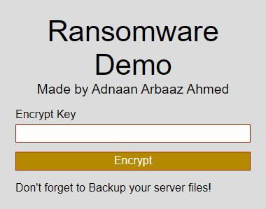

**Decryption Pic:**

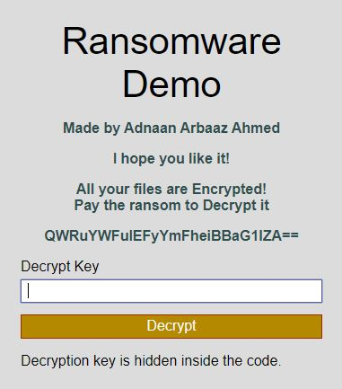

**Encrypted Files:**

