**BUG REPORT**

**Bug ID:** 1

**Bug Summary:**  The discount change message is incorrect.

**Environment/URL:** [**https://exam-qwallity.herokuapp.com/**](https://exam-qwallity.herokuapp.com/)

**Operation System:** Windows 64x

**Model:** Sony Vaio

**Version**: 1

**Browser:** Google Chrome, Version 104.0.5112.81

**Submit Date:** 11/08/2022

**Reporter:** Anna Armenakyan

**Steps**

1. Open the [**https://exam-qwallity.herokuapp.com/**](https://exam-qwallity.herokuapp.com/) link
2. Fill the security fields (email` qwallitymanual05052022@gmail.com, code` 619643156)
3. Log in with admin user (username` mmanukyan, password` 123456789)
4. Click on the user profile name(mmanukyan)
5. Click on Change Discount button
6. Choose course type fundamental
7. Write 50 in the discount field
8. Write 6 in the course count field
9. Click Change discount button
10. The notification ‘Discount is changed’ is shown

**Expected Result:** User should see the notification ‘Discount changes’

**Actual Result:** The notification ‘Discount is changed’ is shown

**Screenshot/video:** 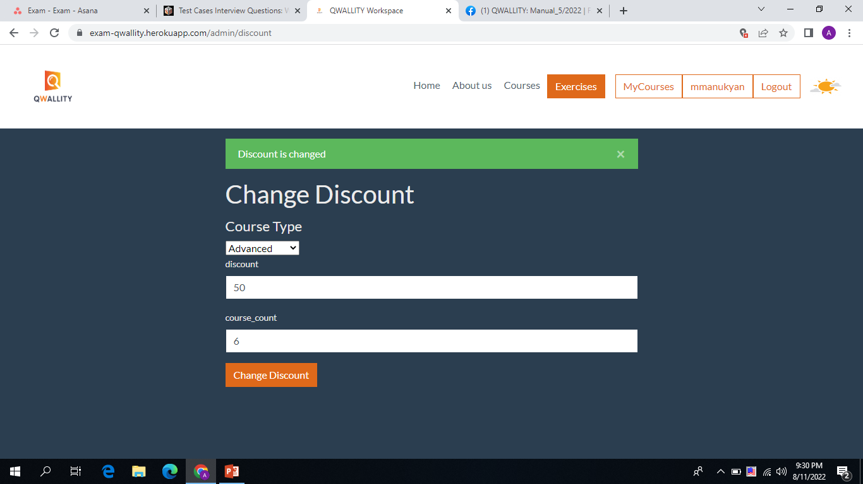

**Notes:**

**References:**

**Severity:** low

______________________________________________________________________________

**Bug ID:** 2

**Bug Summary:**  The discount field accepts symbol and letter

**Environment/URL:** [**https://exam-qwallity.herokuapp.com/**](https://exam-qwallity.herokuapp.com/)

**Operation System:** Windows 64x

**Model:** Sony Vaio

**Version**: 1

**Browser:** Google Chrome, Version 104.0.5112.81

**Submit Date:** 13/08/2022

**Reporter:** Anna Armenakyan

**Steps**

1. Open the **https://exam-qwallity.herokuapp.com/admin/discount**  link
2. Choose course type advanced
3. Write <<+*/a>> in the discount field
4. Write 2 in the course count field
5. Click Change discount button
6. The notification ‘Discount is changed’ is shown

**Expected Result:** User should see the notification ‘Fill the fields correct.

**Actual Result:** The notification ‘Discount is changed’ is shown.

**Screenshot/video:** 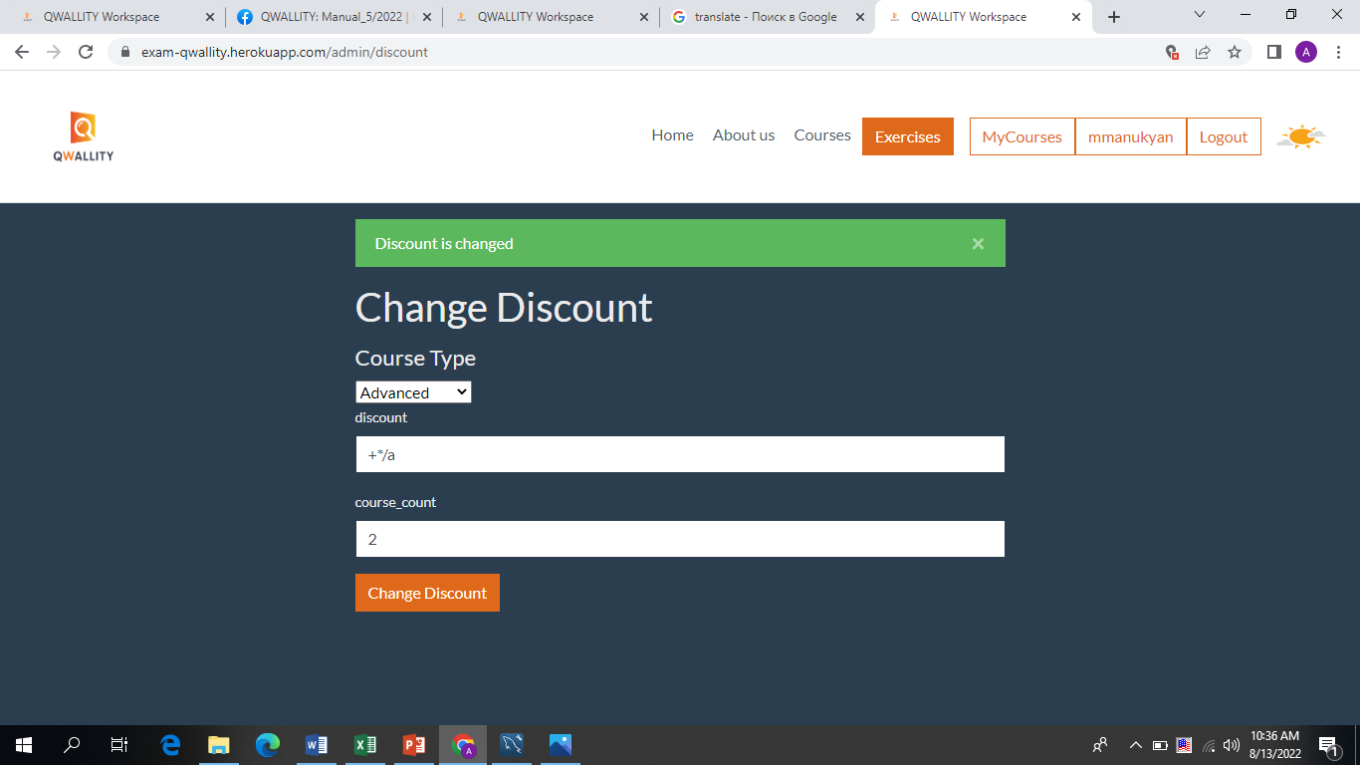

**Notes:**

**References:**

**Severity:** high

______________________________________________________________________________

**Bug ID:** 3

**Bug Summary:**  The course_count field accepts symbol and letter

**Environment/URL:** [**https://exam-qwallity.herokuapp.com/**](https://exam-qwallity.herokuapp.com/)

**Operation System:** Windows 64x

**Model:** Sony Vaio

**Version**: 1

**Browser:** Google Chrome, Version 104.0.5112.81

**Submit Date:** 12/08/2022

**Reporter:** Anna Armenakyan

**Steps**

1. Open the **https://exam-qwallity.herokuapp.com/admin/discount**  link
2. Choose course type fundamental
3. Write 10 in the discount field
4. Write <<a*+>> in the course count field
5. Click Change discount button
6. The notification ‘Discount is changed’ is shown

**Expected Result:** User should see the notification ‘Fill the fields correct.

**Actual Result:** The notification ‘Discount is changed ’ is shown.

**Screenshot/video:** 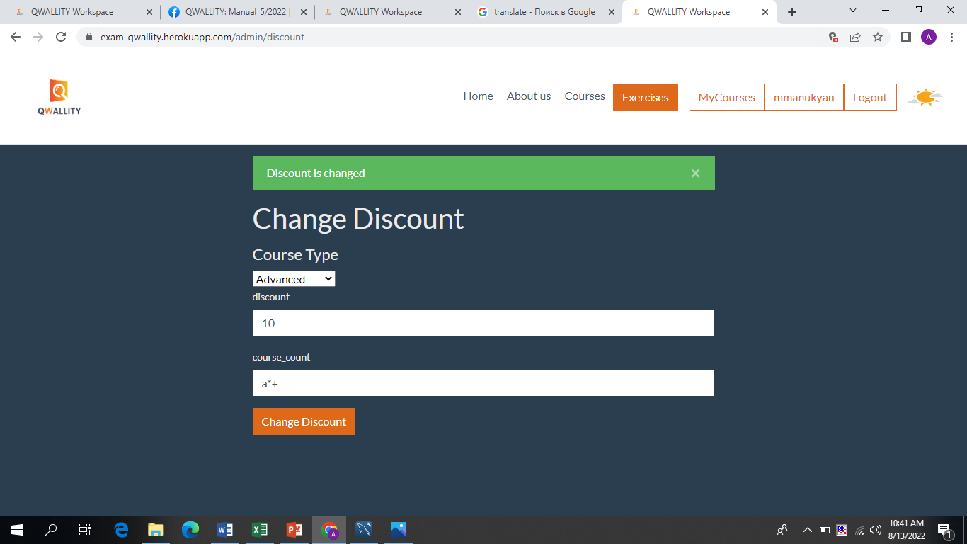

**Notes:**

**References:**

**Severity:** high

______________________________________________________________________________

**Bug ID:** 4

**Bug Summary:**  The discount is changed when the discount field is empty.

**Environment/URL:** [**https://exam-qwallity.herokuapp.com/**](https://exam-qwallity.herokuapp.com/)

**Operation System:** Windows 64x

**Model:** Sony Vaio

**Version**: 1

**Browser:** Google Chrome, Version 104.0.5112.81

**Submit Date:** 12/08/2022

**Reporter:** Anna Armenakyan

**Steps**

1. Open the **https://exam-qwallity.herokuapp.com/admin/discount**  link
2. Choose course type advanced
3. Leave the discount field empty
4. Write 5 in the course count field
5. Click Change discount button
6. The notification ‘Discount is changed’ is shown

**Expected Result:** User should see the notification ‘Fill the field or the field is empty.

**Actual Result:** The notification ‘Discount is changed ’ is shown.

**Screenshot/video:** 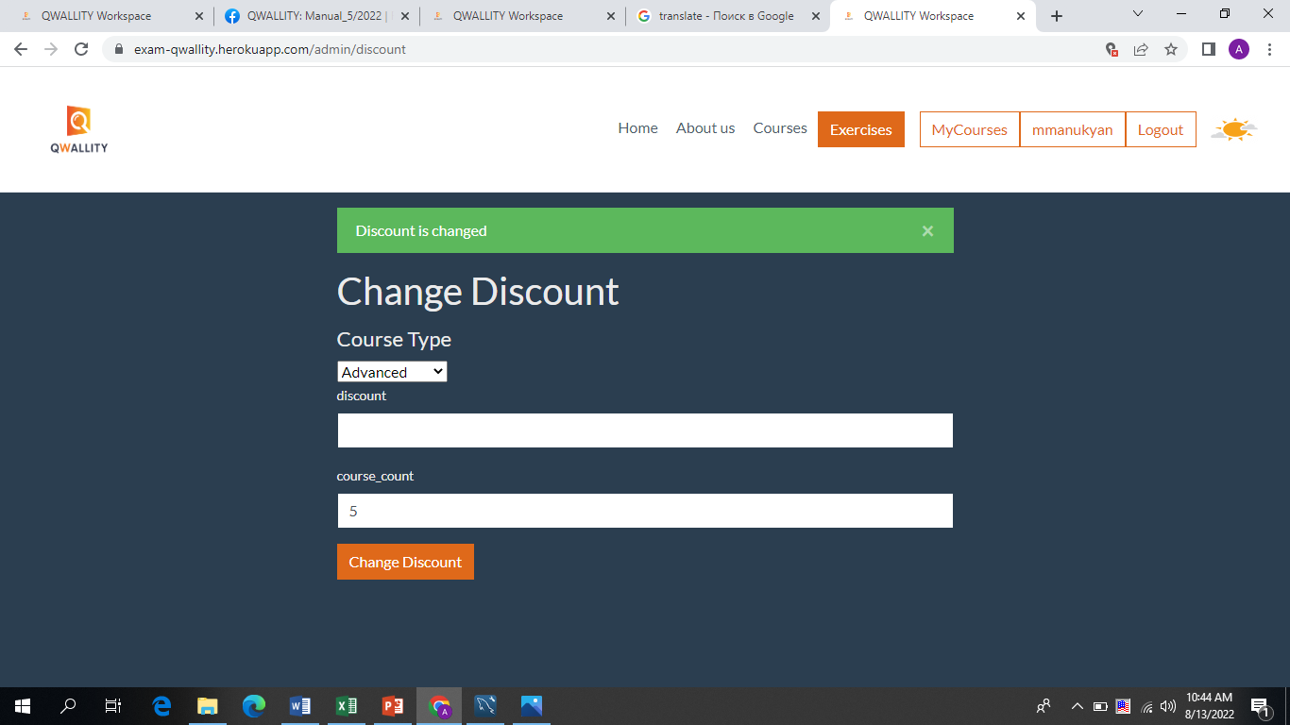

**Notes:**

**References:**

**Severity:** high

______________________________________________________________________________

**Bug ID:** 5

**Bug Summary:**  The discount is changed when the course_count field is empty.

**Environment/URL:** [**https://exam-qwallity.herokuapp.com/**](https://exam-qwallity.herokuapp.com/)

**Operation System:** Windows 64x

**Model:** Sony Vaio

**Version**: 1

**Browser:** Google Chrome, Version 104.0.5112.81

**Submit Date:** 12/08/2022

**Reporter:** Anna Armenakyan

**Steps**

1. Open the **https://exam-qwallity.herokuapp.com/admin/discount**  link
2. Choose course type advanced
3. Write 2 in the discount field.
4. Leave the course_count field empty.
5. Click Change discount button
6. The notification ‘Discount is changed’ is shown

**Expected Result:** User should see the notification ‘Fill the field or the field is empty.

**Actual Result:** The notification ‘Discount is changed ’ is shown.

**Screenshot/video:** 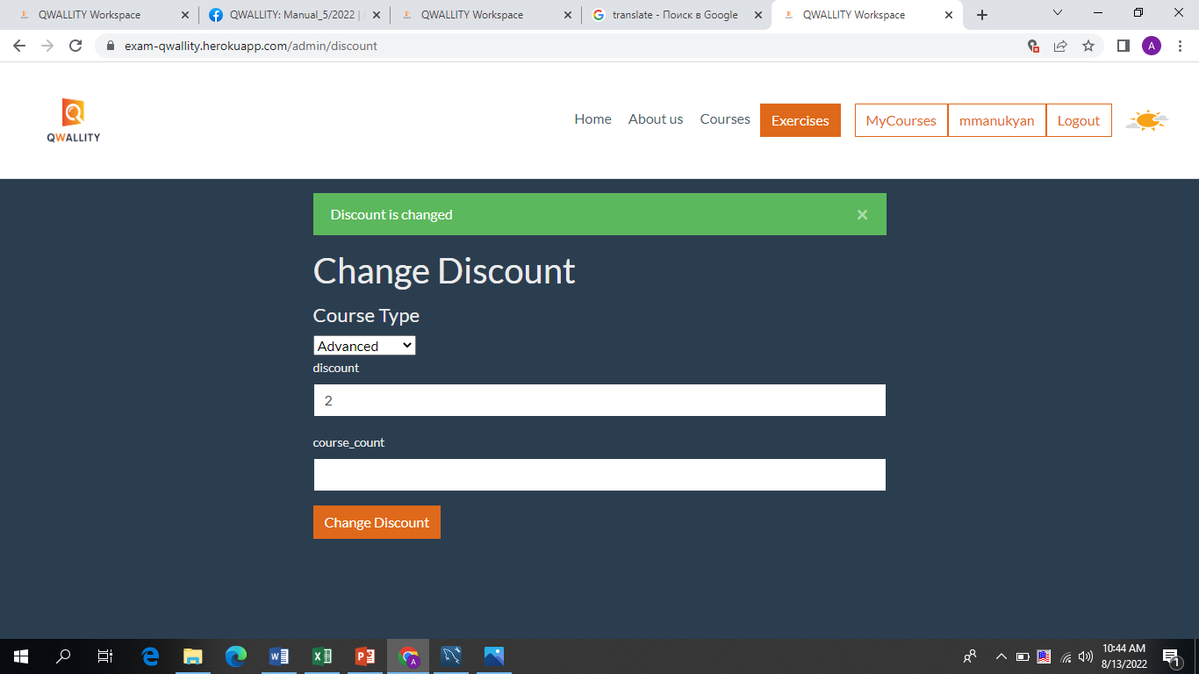

**Notes:**

**References:**

**Severity:** high

______________________________________________________________________________

**Bug ID:** 6

**Bug Summary:** The message when buying course with discount is incorrect.

**Environment/URL:** [**https://exam-qwallity.herokuapp.com/**](https://exam-qwallity.herokuapp.com/)

**Operation System:** Windows 64x

**Model:** Sony Vaio

**Version**: 1

**Browser:** Google Chrome, Version 104.0.5112.81

**Submit Date:** 13/08/2022

**Reporter:** Anna Armenakyan

**Steps**

1. Open the [**https://exam-qwallity.herokuapp.com/**](https://exam-qwallity.herokuapp.com/) link
2. Fill the security fields (email` qwallitymanual05052022@gmail.com, code` 619643156)
3. Log in with non admin user (username` qa12082022, password` 123456789)
4. Click on courses
5. Click Fundamental/Advanced
6. Buy courses until a discount notification message appears

**Expected Result:** User should see the notification ‘’*You have xxx discount. Discounted price displays”*.

**Actual Result:** The user sees this notification ’*You have xxx discount. Discounted price is displayed”*.

.

**Screenshot/video:** 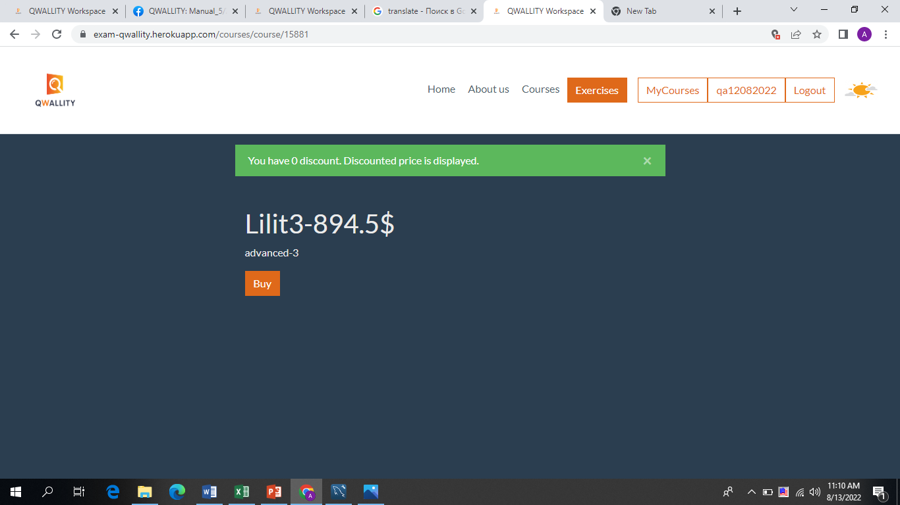

**Notes:**

**References:**

**Severity:** low

______________________________________________________________________________