**GitHub Repository:** <https://git.txstate.edu/Central-Texas-Poverty-Patterns/central-texas-poverty-patterns.github.io/tree/master>

**GitHub Project Website:** <https://pages.git.txstate.edu/Central-Texas-Poverty-Patterns/central-texas-poverty-patterns.github.io/>

Central Texas Poverty Patterns

An Interactive Web Map

**Carlos A Soto**

**Alexander West**

**Jacob Cano**

**Introduction**

The purpose of this project is to provide a demonstration web mapping interface and user-friendly GIS analysis tool that allows users to also view the upper and lower estimates of statistically uncertain data. A typical source of local United States demographic data is the U.S. Census Bureau’s (USCB) American Community Survey (ACS) (Sanderson et al., 2017). Since the ACS consists of a sample of the US population, the USCB provides uncertainty information with every ACS table. These are the margins of error (MOE), provided at a 90% confidence interval, included with every estimate. Research recommends that planners should report corresponding MOEs of ACS estimates, and that web resources for demographic data report corresponding MOE values (Jurjevich et al., 2018).

Margins of error of ACS data increase in magnitude as data is disaggregated into smaller geographic levels, or smaller subsets of the population that are less frequent for that geography. Attribute data uncertainty, as this type of uncertainty is called, is an issue that has interested researchers for a long time. Uncertain data may lead to certain challenges in its precise and accurate visualization, especially in maps (Koo et al., 2017). For example, values within the confidence bounds of an estimate (calculated by adding or subtracting the MOE to or from the estimate) that fall within the confidence bounds of another estimate may not be considered significantly different.

Poverty is a demographic characteristic that is of particular interest to a variety of individuals, organizations, and stakeholders. The ACS is a popular source of poverty data in the United States. As with other ACS data, MOE information is provided with every poverty estimate. Appendices II, III, and IV include a series of maps showing poverty rate by census tract in Travis County, Texas, the upper estimate within the MOE, and the lower estimate within the MOE, respectively. This project is intended to be a proof-of-concept tool to provide interested researchers with an ability to toggle between map layers showing the estimate and its corresponding upper and lower estimates. We believe it may help users get a better understanding of the potential geographic extent of poverty. All source code and development information for this project is available on our project GitHub page (<https://git.txstate.edu/Central-Texas-Poverty-Patterns/central-texas-poverty-patterns.github.io>).

This kind of tool may help organizations allocate resources more effectively by showing areas where data may be unreliable and secondary corroborative data may be necessary to optimally determine if a need for services may exist in the area. Additionally, users will be presented with a feature layer showing Austin Travis County Health and Human Services (HHS) provider locations. Since poverty is a well-known social determinant of health, including the location of HHS providers can help illustrate how our tool can be used in an exploratory analysis. One can imagine somebody in charge of researching potential new HHS provider locations using the tool to see where poverty may be over or underestimated, and better data may be needed.

**Application Design**

**Data**

This project defines poverty rate as “percent of the population with income below the federal poverty level”. The source of this data is Table C17002 of the United States Census Bureau’s 2015-2019 American Community Survey, “Ratio of Income to Poverty Level”. This data is in vector format, displayed by census tract for the 5-County Austin Metropolitan Statistical Area consisting of Bastrop, Caldwell, Hays, Travis, and Williamson County in Texas. As is the case with ACS estimates, this data includes a margin of error. This margin of error is used to derive the two other layers used in the web mapping application’s main component. These two other layers are the “upper estimate” and “lower estimate” layers. The data for the Austin Travis County Health and Human Services (HHS) provider locations originates from the City of Austin Open Data Portal. It shows all locations where the Austin/Travis County Health and Human Services Department provides services. The data for the primary and secondary components of our web mapping application required preparation and analysis prior to its utilization. This included a geospatial join between the demographic component and the geographic component for the ACS poverty data. The HHS data required a unit conversion for the location coordinate data. The analysis for both datasets will be discussed in a subsequent section.

**Project Components**

Our tool is presented on a website that is openly accessible to the public. This way no proprietary software is required, facilitating access to individuals or groups with limited budgets. The website was developed using a combination of HTML, CSS, and JavaScript. Interactive layer data is provided through the ArcGIS API. Additionally, the layer data were created and manipulated using the ESRI ArcGIS PRO software suites. The main component of our web mapping application utilizes a combination of the Swipe, LayerList, and Popup widgets to allow the user to interactively visualize and compare the estimate for a census tract with the corresponding upper and lower estimate within its MOE. Our map’s secondary component is intended to show how users could perform exploratory analysis when point-based data (in this case, HHS provider location) is layered over the upper or lower census tract estimates.

**Usage**

This map is intended to allow the user to visually explore estimates from the ACS that have been mapped, along with the corresponding upper and lower estimates within the margin of error (MOE). In this proof-of-concept, the map features data showing the percent of the population living with income below the federal poverty rate, at the census tract level. A user may click on the legend icon on the upper left-hand corner of the map to expand the legend (figure 1). The legend will show symbology for every layer contained in the map. The query box on the upper right-hand corner of the map may be utilized to search for the location of an address. Clicking on the LayerList icon below the query box expands the LayerList widget (figure 2). The LayerList widget allows the user to select which layers are visible or invisible by clicking on the eye icon.

Figure 1, collapsed legend button. Figure , collapsed LayerList button and Swipe widget.

The swipe widget appears as a thin vertical line with a button at the center, towards the right of the map (figure 2). The swipe tool can be utilized to reveal the next layer below the top-most activated layer in the LayerList. The estimated poverty rate will show on the left side of the swipe tool. If the estimated poverty rate layer is deactivated in the LayerList widget, it will not show on the map. In this case, only the layer with the poverty MOE lowest estimate will show. The upper and lower estimate will display on the right of the swipe tool unless the layers are deactivated in the LayerList widget. Users may click on a census tract to view a popup showing a table with the census tract’s name, the poverty estimate, the MOE, the upper poverty estimate (calculated by adding the MOE to the poverty estimate), and the lower poverty estimate (calculated by subtracting the MOE from the poverty estimate). Figure 3 shows the map with the legend and LayerList expanded, the swipe tool halfway revealing the lowest estimates within the MOE, and the popup showing the values for a Travis County census tract.

Figure 3, expanded legend and LayerList, swipe tool partially revealing lowest estimates layer, and popup showing census tract name and data.

**Analysis**

This project required analysis to prepare the data (as provided by the US Census Bureau) for our interactive web mapping application. Analysis consisted of deriving the estimated poverty rate, MOE, and corresponding upper and lower estimates. The poverty data, available to the public as ACS table C17002, includes estimate and MOE data broken into several categories. For our project, two of these categories had to be aggregated before the percent of the population with incomes below the federal poverty level per census tract could be derived. To calculate the aggregated MOE and the MOE for the derived estimate (percent poverty per census tract), for this project our group utilized the methods outlined in Understanding and Using American Community Survey Data: What all Data Users Need to Know (US Census Bureau, 2020).

**Discussion and Conclusion**

**Communicating ACS Data Uncertainty**

In a set of recommendations for planners, Jurjevich et al. (2018) include a list of five guidelines for working with statistical uncertainty of ACS estimates. Topping their list are suggestions to (1) report the MOEs of ACS estimates, and (2) include a footnote when the MOEs are not reported. Planners may choose from a variety of methods to communicate uncertainty of ACS data that fit within the guidelines proposed by Jurjevich et al. (2018). These can range, for example, from footnotes that include general cautions or caveats, to detailed tables, overlays on maps, and more. Showing the different possible patterns that may emerge using the maximum and minimum estimates within the MOE in maps created using unreliable data sources, such as the ACS, is of particular interest in this project. Census tract level ACS data reliability has been an issue of interest to researchers for years. As some researchers put it, shortly after the ACS replaced the census Long Form in 2010, “clearly the ACS presents an inaccurate view of the neighborhood” (Bazuin and Fraser, 2013). If so, the same could be said of maps created with that data.

Maps created with ACS data could be useful tools, but important limitations arise because of the MOE associated with every ACS estimate. Although researchers have proposed techniques for visualizing uncertainty of ACS data (Sun and Wong, 2010), these techniques remain untested and do not appear to have been adopted by any community indicator initiatives. Although, in a later collaboration, Wong and Sun (2013) share their method as part of an ArcGIS functionality for GIS researchers, this functionality still requires access to ArcGIS. This puts their tool out of reach of researchers working with small or nonexistent budgets. Some community indicator initiatives, such as Community Information Now, recognize the importance of including the MOE with ACS estimates. They share margin of error information with their interactive maps. For example, adjacent to the map showing percent of the population with income below the poverty level, the Community Information Now Viz-a-Liyzer includes a table showing values for the zip code, poverty rate, and MOE (Figure 4). A user may choose to click on a zip code polygon and the selected zip code will be highlighted in the table. Although this is a promising sign in terms of making clear the limitations of the data, it does not show how the pattern shown on the map may change if the upper estimate or lower estimate within the MOE are also mapped.

Figure 4, Community Information Now's Viz-a-Lyzer showing percent of the population in poverty. The margin of error for the poverty estimate of the selected zip code is highlighted on the table on the right.

In contrast, our tool allows the user to visually inspect the different patterns that may emerge when the upper or lower estimates are mapped. Our map also includes a similar table showing the census tract name, the estimated poverty rate, and the MOE, but our table includes the upper and lower estimates as well. The swipe widget encourages users to swipe back and forth between the estimate and the maximum or minimum, creating a striking contrast that highlights census tracts with highly uncertain data. Most importantly, our proof of concept can easily be extended to dynamically access, derive, and render data from the US Census Bureau American Community Survey API.

**Contributions and Limitations**

Visual overlays, such as those proposed by Sun and Wong (2010), can be difficult to understand and use. Our group was interested in providing an intuitive tool to visualize the uncertainty of census tract level estimates. The goal was to leverage the human eye’s capacity to detect movement in a way that highlighted census tracts that, due to their associated margin of error, could fall within different choropleth map categories. If users have a basic understanding of the concept of margin of error, they should be able to understand this application’s main component. For more advanced users, the HHS provider location component serves as a demonstration of this tool’s potential exploratory analysis capabilities.

Potential limitations of this web mapping application include technical and user constraints. This project utilizes ACS data, which is provided at the 90% confidence interval. Our application shows the upper and lower estimates, but the actual value for that census tract may be within those two extremes. An understanding of this aspect of ACS data is necessary to use our web application to its fullest potential. Conversely, little to no understanding of statistical uncertainty and margin of error could lead to a misunderstanding of what is represented in the map. This constitutes another potential user constraint that could limit the effective use of our web mapping application.

**Changes From Proposal**

Although the main web mapping component of our interactive application remained relatively unchanged from the idea we submitted in our proposal, the secondary component of our web mapping application changed significantly. Originally, we had proposed including drug overdose and crime incident layers. Since accurate data was unavailable, our group looked for other interesting data to share and HHS provider locations were found to be an appropriate replacement data set for this proof-of-concept. One minor change to the main web mapping component that made it into our final submission is related to the widget that makes this functionality possible. In our group’s project proposal presentation, we may have initially discussed or mentioned using a modification of the time slider widget to create the desired functionality. Considering the time frame of the project and our group’s capacity, we found the combination of Swipe and LayerList widgets would be appropriate for this proof-of-concept. Appendix I lists the contributions to this project made by each individual group member.

**Suggestions for Future Work**

The main goal of this project is to create an interactive tool that may help planners, community leaders, or other stakeholders visualize one of the limitations of a map created with one type of uncertain data. A secondary goal is to allow users to compare the maps of the Austin MSA poverty estimates (and corresponding upper and lower poverty estimates) to Austin/Travis County Health and Human Services provider locations. This brings two important benefits to users. First, it allows users to develop a better idea of what areas may require additional data to make accurate judgments regarding poverty levels. Second, allowing users to overlay the HHS service provider locations over the upper poverty estimate helps planners see where there may be areas of higher poverty that may be lacking easy access to services. This may help organizations better target limited funds and achieve a greater impact. However, our web map application’s extent is limited to the 5-county Austin Metropolitan Statistical Area consisting of Bastrop, Caldwell, Hays, Travis Williamson counties. It currently visualizes data that was downloaded from the Census Bureau, processed, and uploaded to ArcGIS online. This application can be improved if it is connected to the US Census Bureau ACS API to dynamically generate the estimated poverty layer and it’s corresponding upper and lower estimate layers. Doing so would extend the tool’s utility to anywhere there is data available.

**References**

Caruso, G. 2017. Public Health and Safety: The Social Determinants of Health and Criminal Behavior. Rochester, NY: Social Science Research Network. https://papers.ssrn.com/abstract=3054747 (last accessed 27 October 2021).

Jurjevich, J. R., A. L. Griffin, S. E. Spielman, D. C. Folch, M. Merrick, and Nagle. 2018. Navigating Statistical Uncertainty: How Urban and Regional Planners Understand and Work With American Community Survey (ACS) Data for Guiding Policy. Journal of the American Planning Association 84 (2):112–126.

Koo, H., Y. Chun, and D. A. Griffith. 2018. Geovisualizing attribute uncertainty of interval and ratio variables: A framework and an implementation for vector data. Journal of Visual Languages & Computing 44:89–96.

Sanderson, K., R. Elwell, H. Williamson, E. Eaves, S. Barger, C. Hepp, K. Elwell, K. Winfre, and R. Trotter II. 2017. Advancing Wellbeing in Northern Arizona: A Regional Health Equity Assessment.

US Census Bureau. Understanding and Using American Community Survey Data: What All Data Users Need to Know. Understanding and Using American Community Survey Data: What All Data Users Need to Know. https://www.census.gov/programs-surveys/acs/guidance/handbooks/general.html (last accessed 18 November 2021).

**Appendix I – Individual Group Member Contributions**

Alexander West conducted research, contributed to the report and presentation, and led the development of the web map application and website.

Carlos A Soto conducted research, carried out data analysis and preparation, contributed to the development of the web map application and website, and led the development of the report and presentation.

Jacob Cano conducted research, helped prepare the HHS data for web mapping, and created the secondary web pages.

**Appendix II**

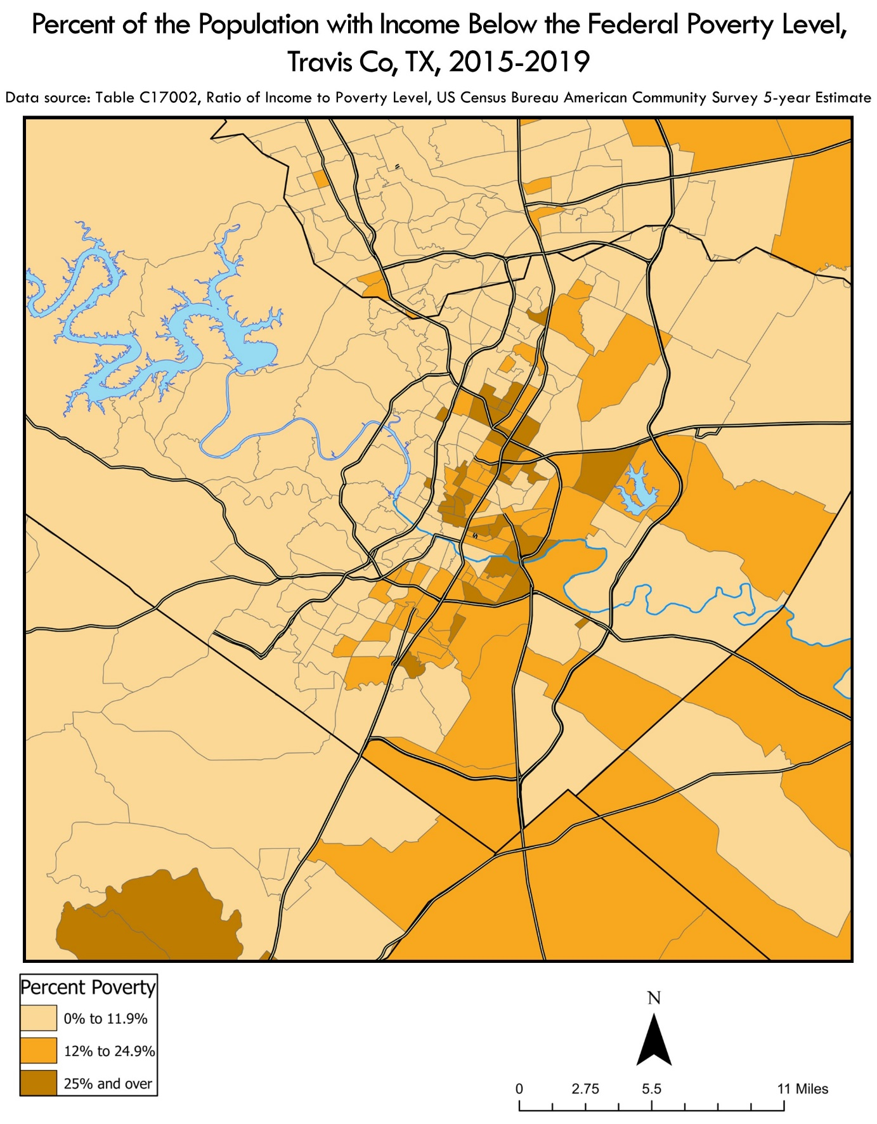

Appendix II, Poverty rate estimate. Source: Table C17002, 2015-2019 American Community Survey 5-Year Estimates.

**Appendix III**

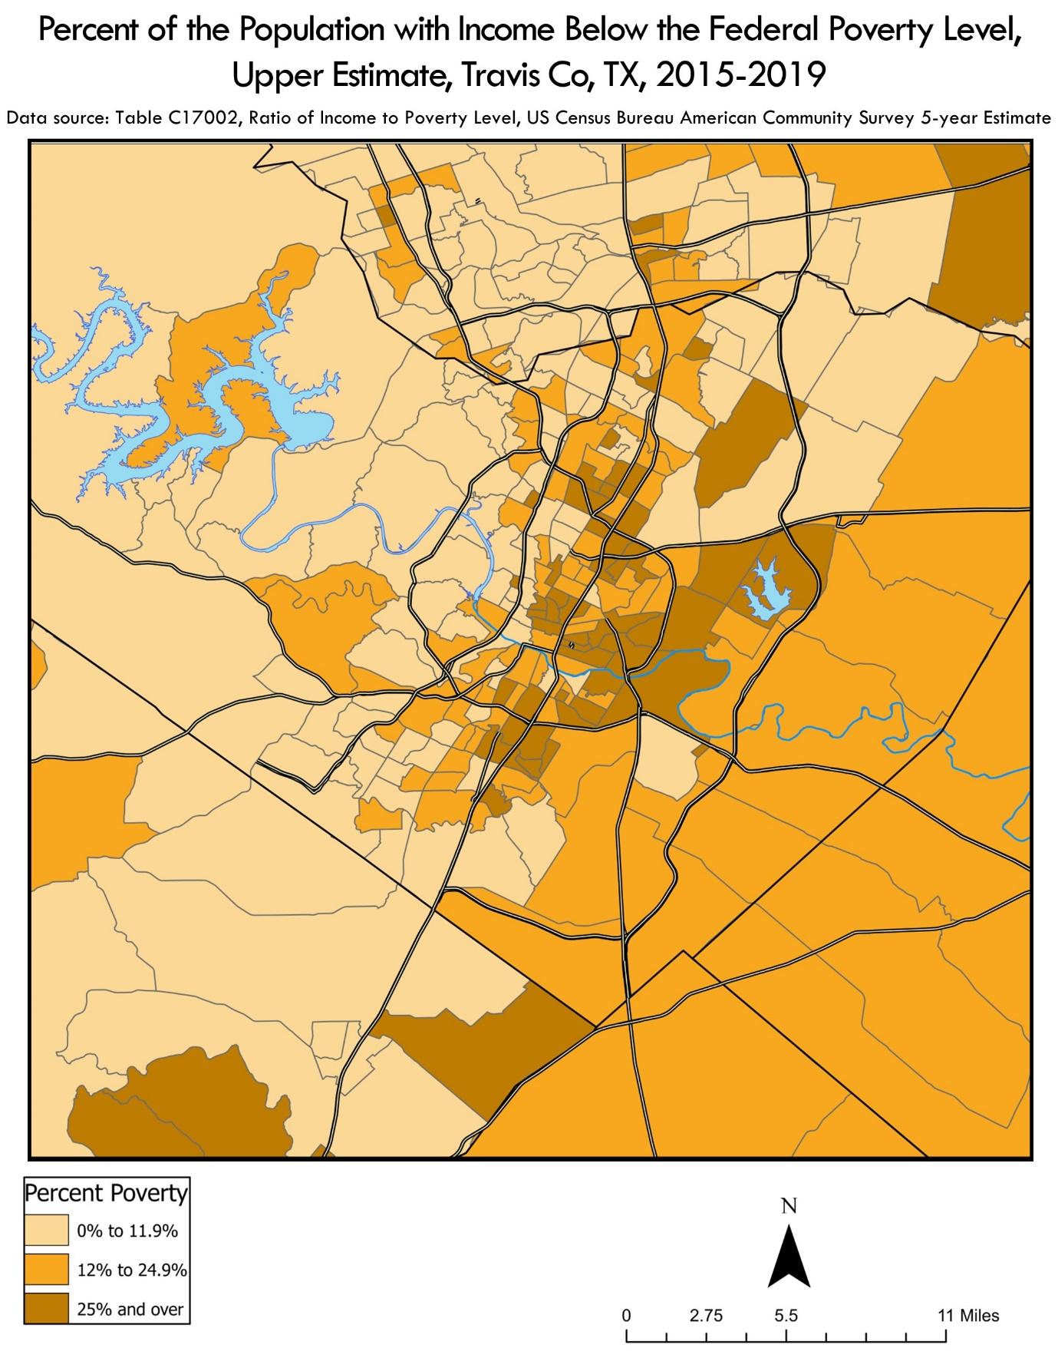

Appendix III, Poverty rate, upper estimate. Source: Table C17002, 2015-2019 American Community Survey 5-Year Estimates.

**Appendix IV**

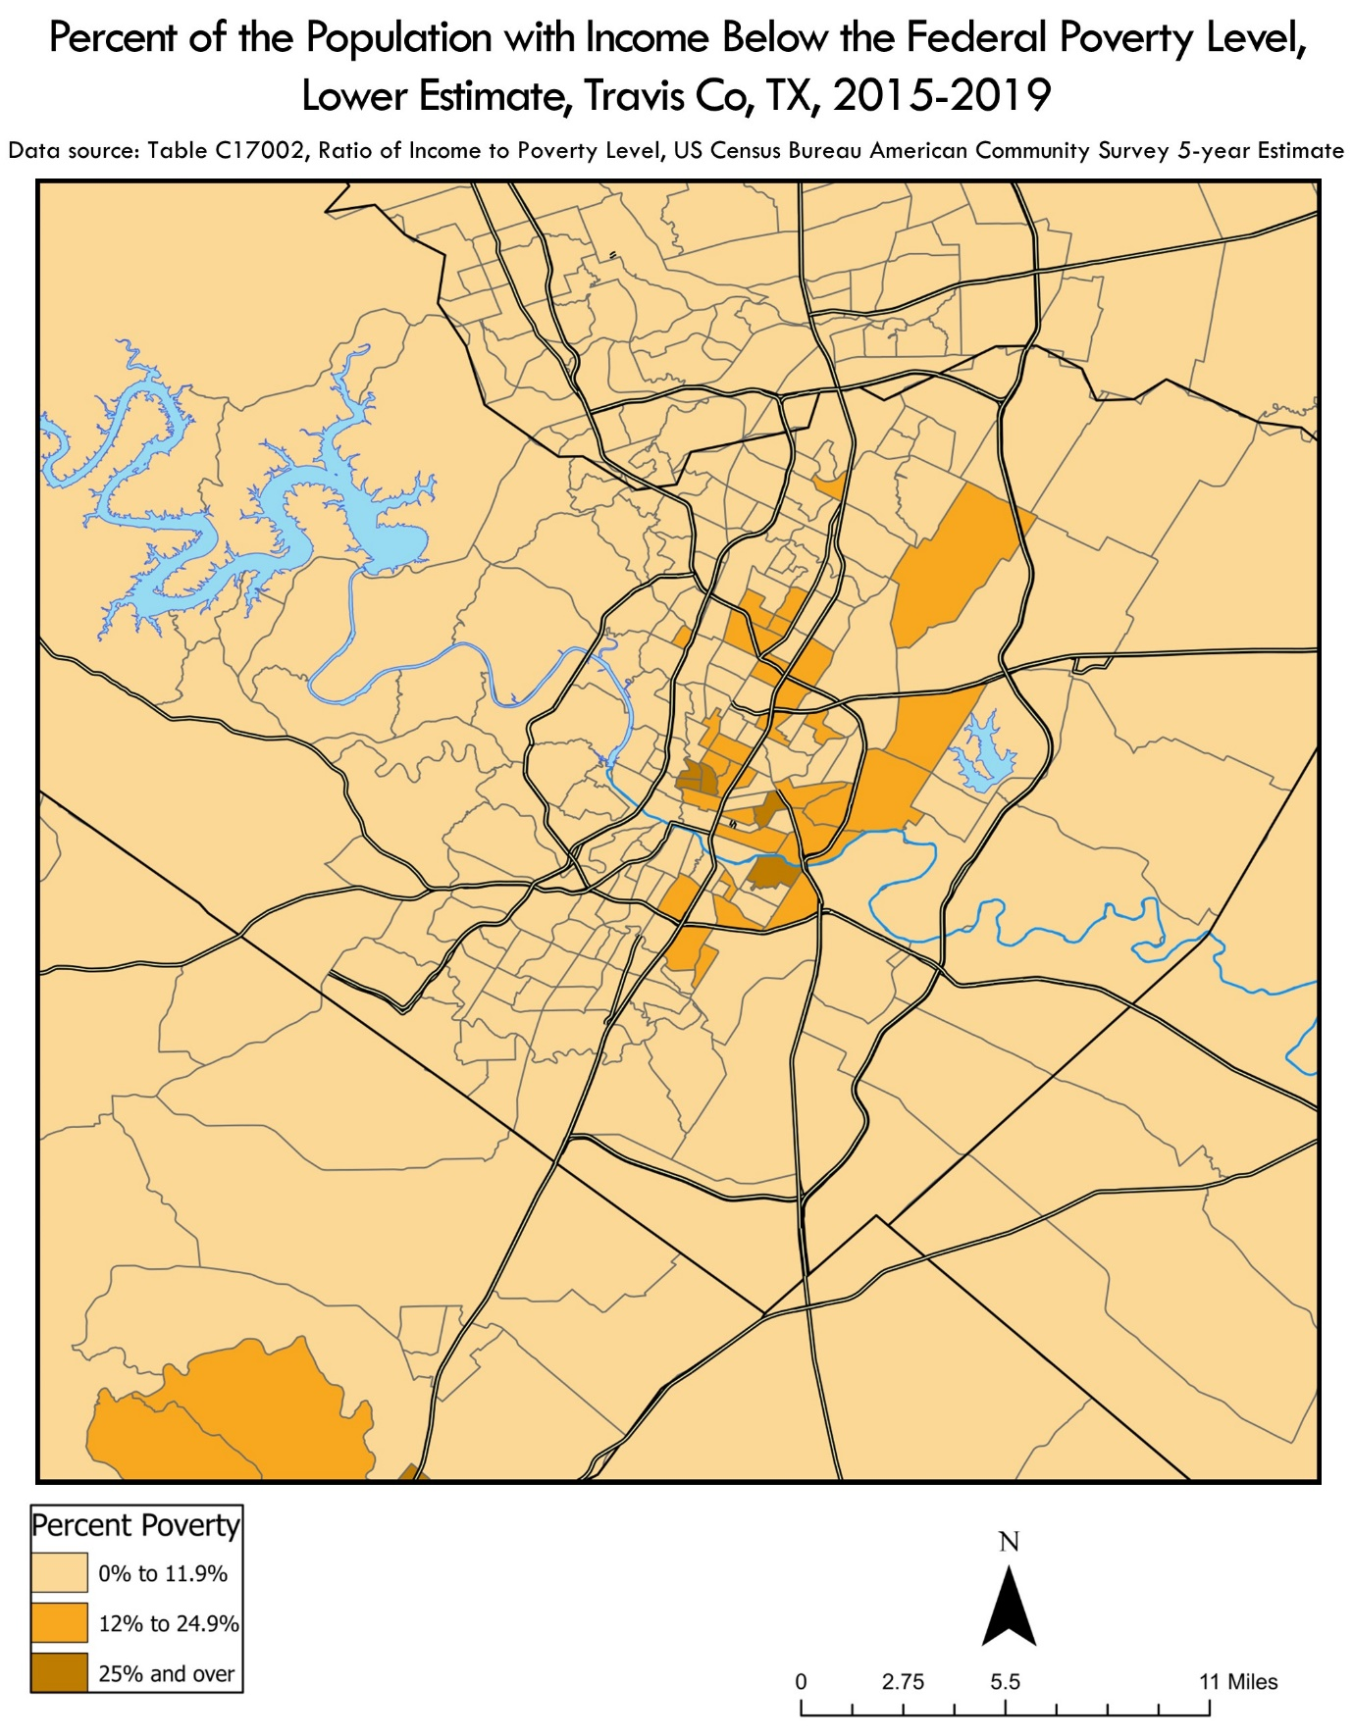

Appendix IV Poverty, lower estimate. Source: Table C17002, 2015-2019 American Community Survey 5-Year Estimates.