MIPS Architecture Design
Course Name: T225-EGC 121-SecA, Computer Architecture

Anamitra Basu (BC2025008)
Aaronya Chakraborty (IC2025003)
Aatraya Mukherjee (IC2025004)

Introduction

MIPS (Microprocessor without Interlocked Pipelined Stages) is a family of reduced instruction set computers (RISC) Instruction Set Architectures (ISA) developed by MIPS Computer Systems, now MIPS Technologies, based in the U.S.
There are multiple versions of MIPS, including MIPS I, II, III, IV, and V, as well as five releases of MIPS32/64 (for 32- and 64-bit implementations, respectively). The early MIPS architectures were 32-bit; 64-bit versions were developed later.
Computer Architecture courses in universities and technical schools often study the MIPS architecture.The architecture greatly influenced later RISC architectures such as Alpha. In March 2021, MIPS announced that the development of the MIPS architecture had ended as the company is making the transition to RISC-V.

Processor
We have implemented three programs in MIPS assembly, namely : Selection Sort, Bubble Sort and Binary Search. We have coded the processor in Python, implementing 16 MIPS commands/instructions, including syscalls.
We have used the Mars4_5 compiler to compile the MIPS assembly code and have stored the binary text and data in separate text files. Our processor reads these files during execution. We have assumed the base address of the instructions as 0x00400000 and data as 0x10010000 respectively.
We have divided the processor into mainly three components or classes namely : i) Register (ii) Memory and (iii)CPU. The CPU class contains the functions to trace the the 5 stages of MIPS architecture for any instruction namely: IF, ID, EX, MEM, WB. The file containing the processor is named Processor.py.

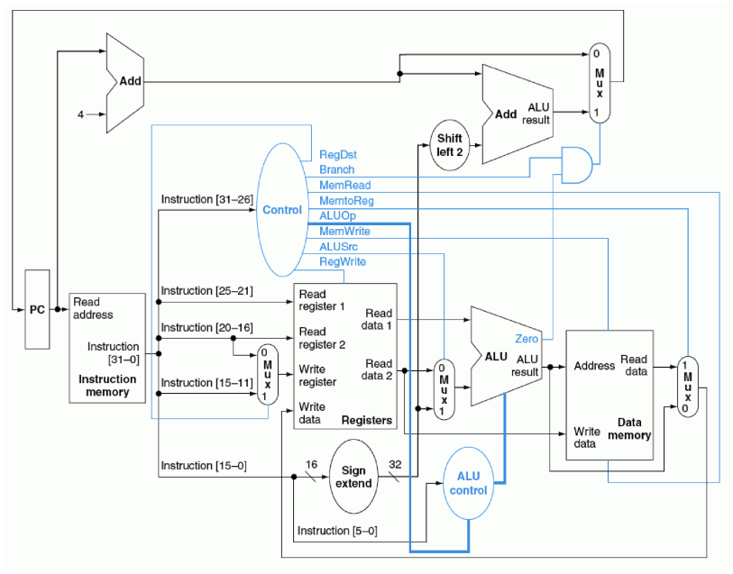Figure : MIPS Architecture

Selection Sort
This program takes a sequence of n integers and sorts the array in ascending order.
Best case time complexity- O(n^2)

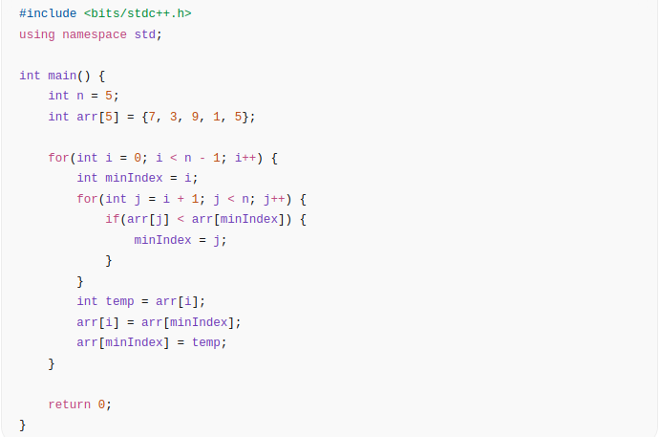

Binary Search
This program takes a sorted array and a target element. It searches for the target in the array and returns the index ( 0 indexed) if found, otherwise returns –1.

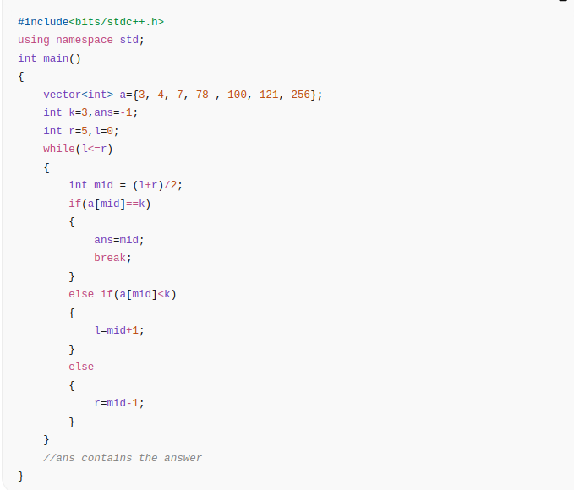
Bubble Sort
This program takes a sequence of n integers and sorts the array in ascending order.
Best case time complexity – O(n)

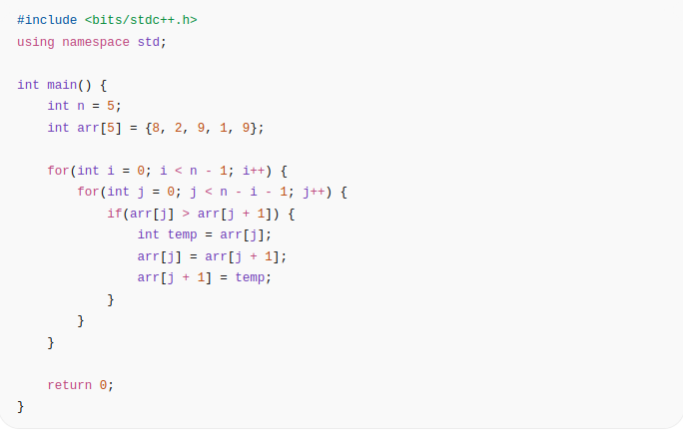

Definitions of Components used

1. Opcode Dictionary
The Opcode Dictionary is responsible for instruction decoding within the processor. It maps each MIPS instruction mnemonic to its corresponding opcode, function field (for R-type instructions), and associated control signals. In this implementation, two separate dictionaries are maintained: one for R-type instructions and another for I-type and J-type instructions. During the Instruction Decode (ID) stage, the opcode and function bits are extracted from the 32-bit instruction and matched with entries in these dictionaries. Once a match is found, the corresponding control signals are activated. This mechanism enables structured and accurate instruction execution.

2. Register Class
The Register class simulates the MIPS register file and maintains the processor state. It includes storage for general-purpose registers such as $t0–$t9, $s0–$s7, $a0–$a3, $v0–$v1, $at, and $ra. The program counter (PC) is also maintained within this class and is initialized to the base address of the text segment. The $zero register is hardwired to always return zero. Register values are read during the Execute stage and updated during the Write Back stage. This class ensures proper storage and retrieval of intermediate and final computational results.

3. Memory Class
The Memory class simulates both instruction memory and data memory using external files. Instruction memory stores 32-bit machine code instructions, while data memory stores 32-bit data words. Address translation is performed relative to predefined base addresses for text and data segments. The class provides methods to read and write instructions and data in binary format. All values are stored as 32-bit representations to maintain architectural consistency. This implementation follows a Harvard-style separation of instruction and data memory.

4. Arithmetic Logic Unit (ALU)
The Arithmetic Logic Unit (ALU) performs all arithmetic and logical operations during the Execute (EX) stage of the processor. It receives operands either from registers or immediate fields depending on control signals. The ALU supports operations such as addition, subtraction, logical AND, logical OR, shift operations, and set-less-than comparisons. It also calculates effective addresses for load and store instructions. For branch instructions, it performs comparisons to determine whether a branch condition is satisfied. The ALU output is forwarded to either the memory stage or the write-back stage as required.

5. Control Dictionary
The Control Dictionary defines the control signal configuration for each supported instruction. It specifies signals such as RegDst, ALUSrc, MemtoReg, RegWrite, MemRead, MemWrite, Branch, Jump, and ALUOp. These signals determine how data flows through the datapath during execution. During the Instruction Decode stage, the appropriate set of control signals is selected based on the instruction opcode. This structured approach simplifies control logic implementation. The Control Dictionary effectively represents the processor’s control unit behavior.

6. Control Lines
Control lines are binary signals generated during the Decode stage to manage processor operations. These signals control multiplexers, memory access, register writing, and program counter updates. For example, RegWrite enables register updates, while MemRead and MemWrite manage data memory access. The Branch and Jump signals modify control flow by updating the program counter when necessary. ALUSrc and RegDst determine operand selection and destination register selection. Together, these control lines coordinate the functioning of all five stages: IF, ID, EX, MEM, and WB.

Processor
Processor code:
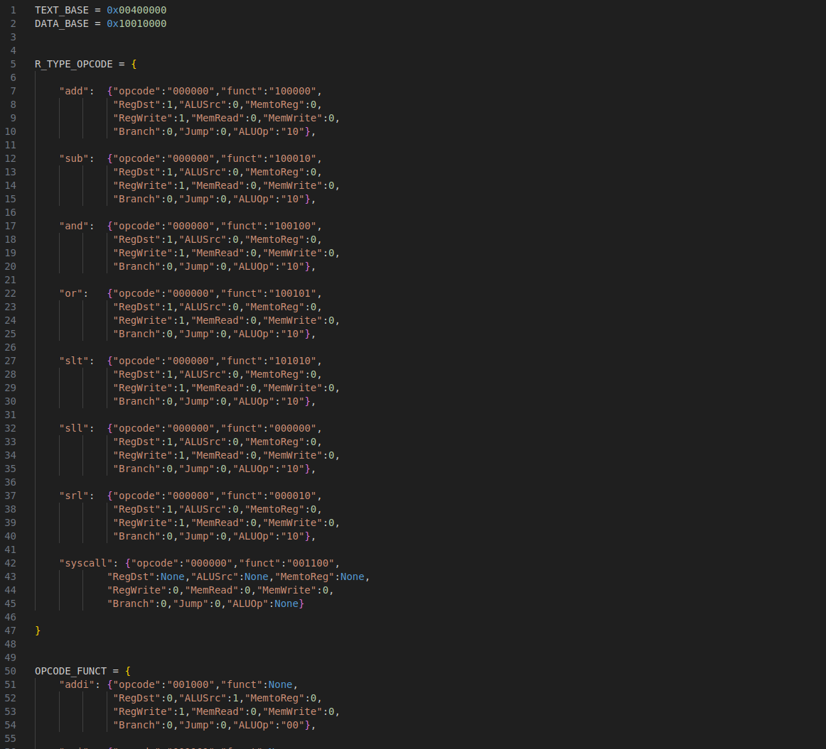

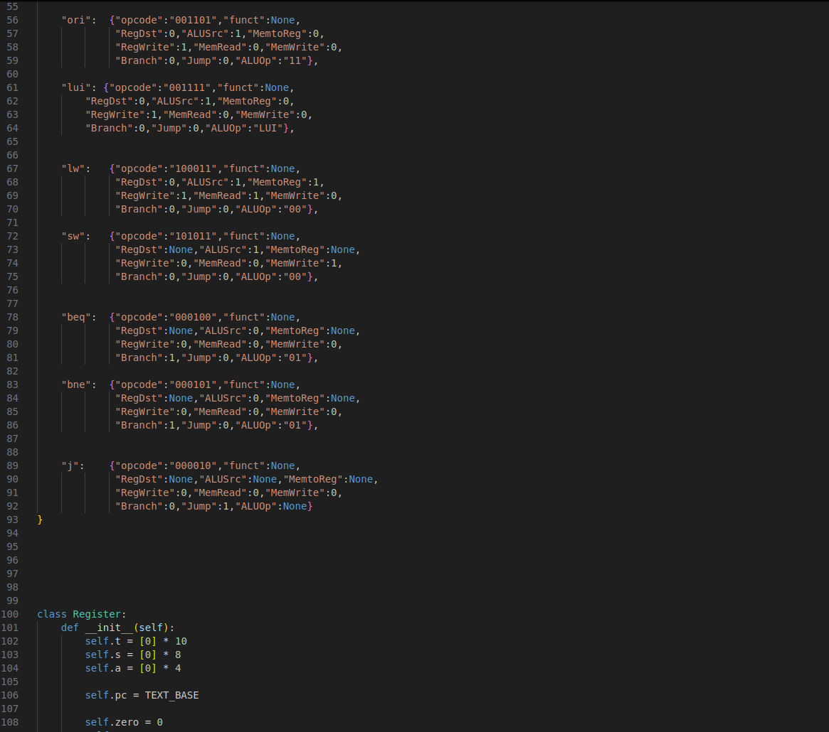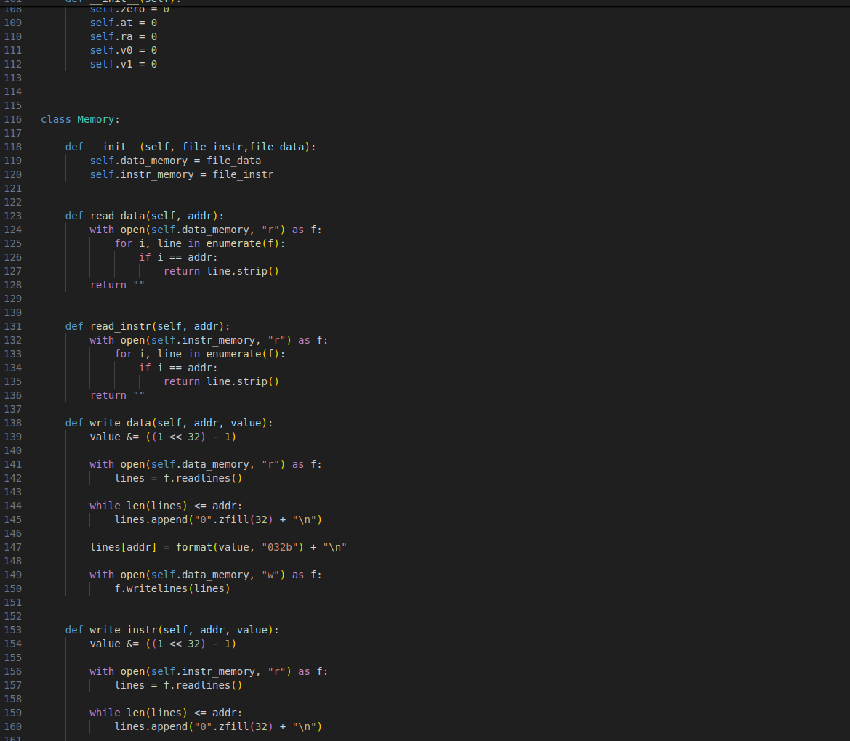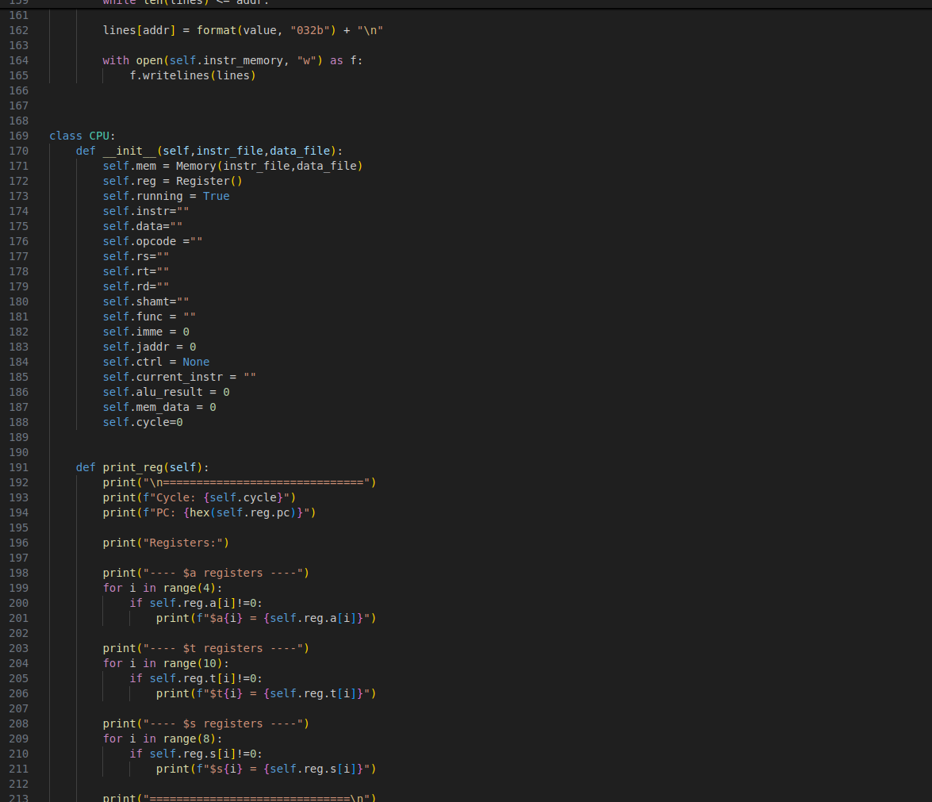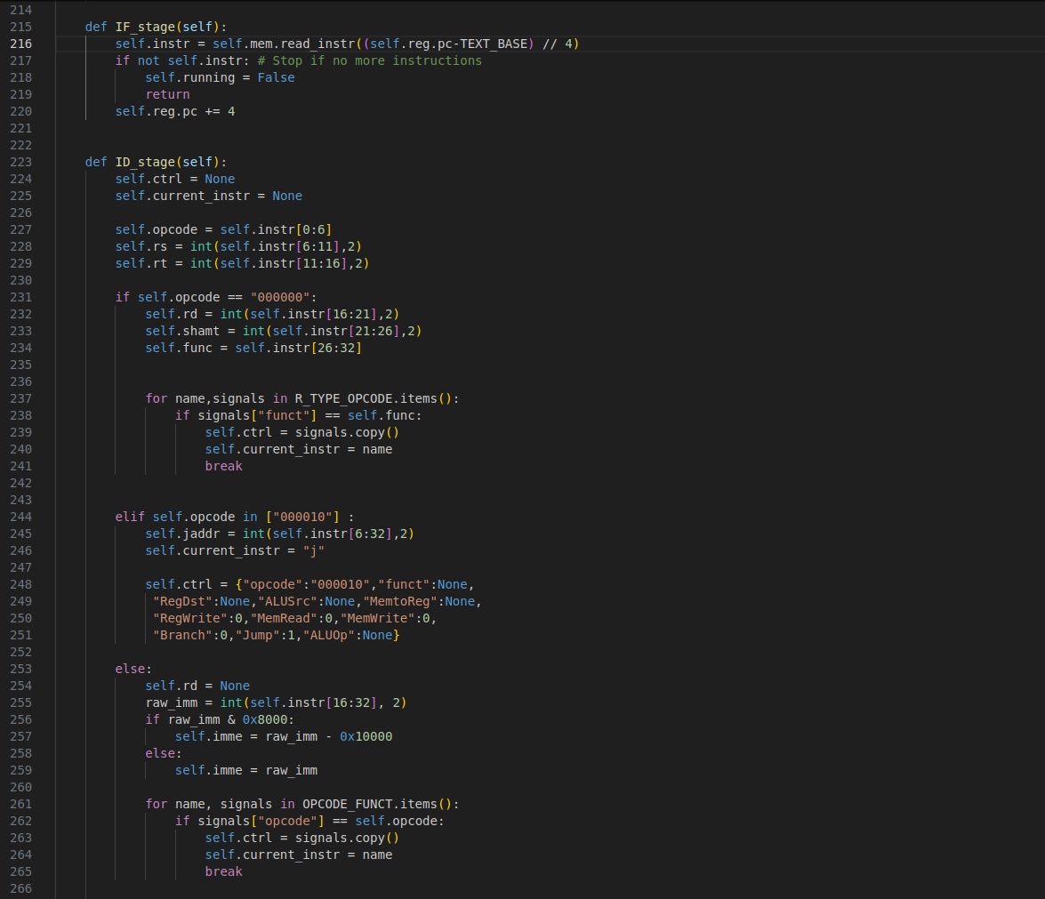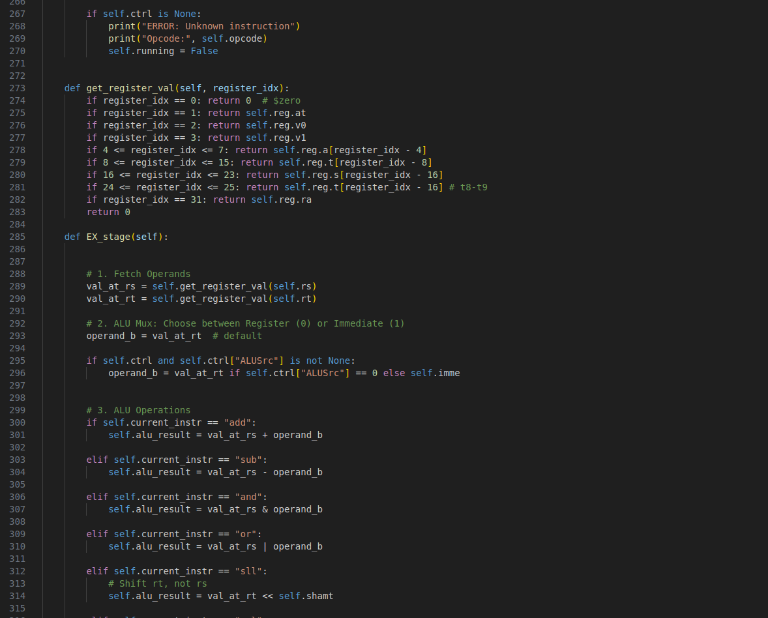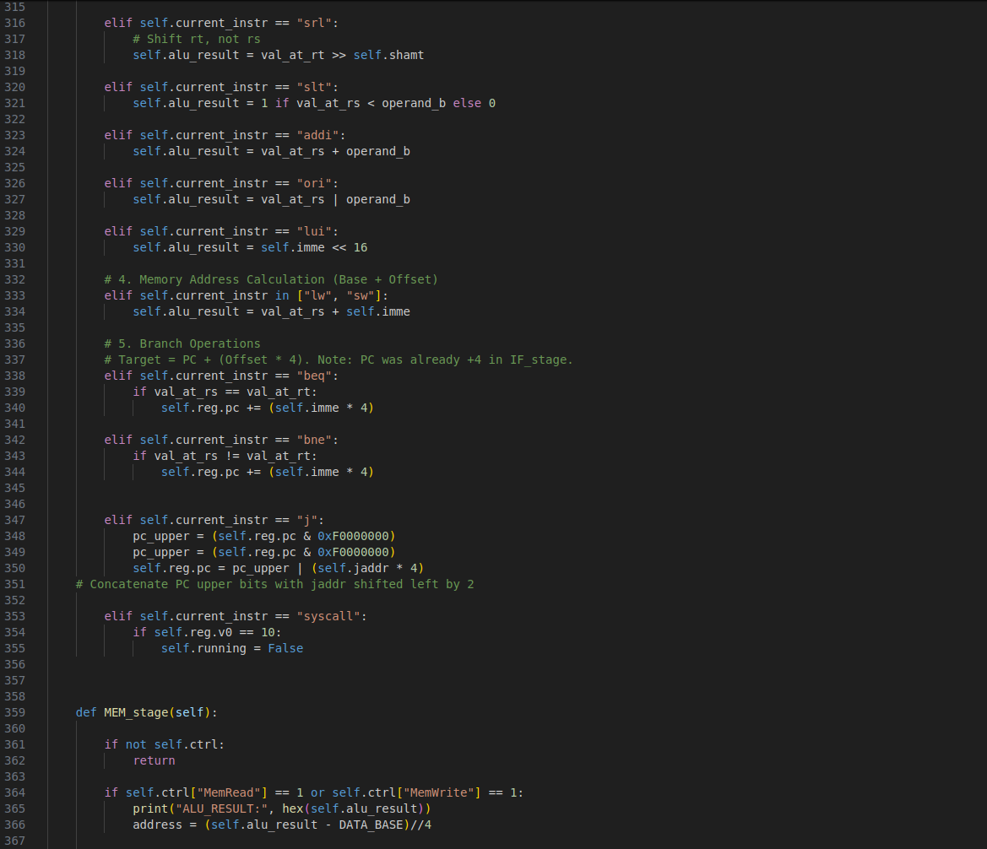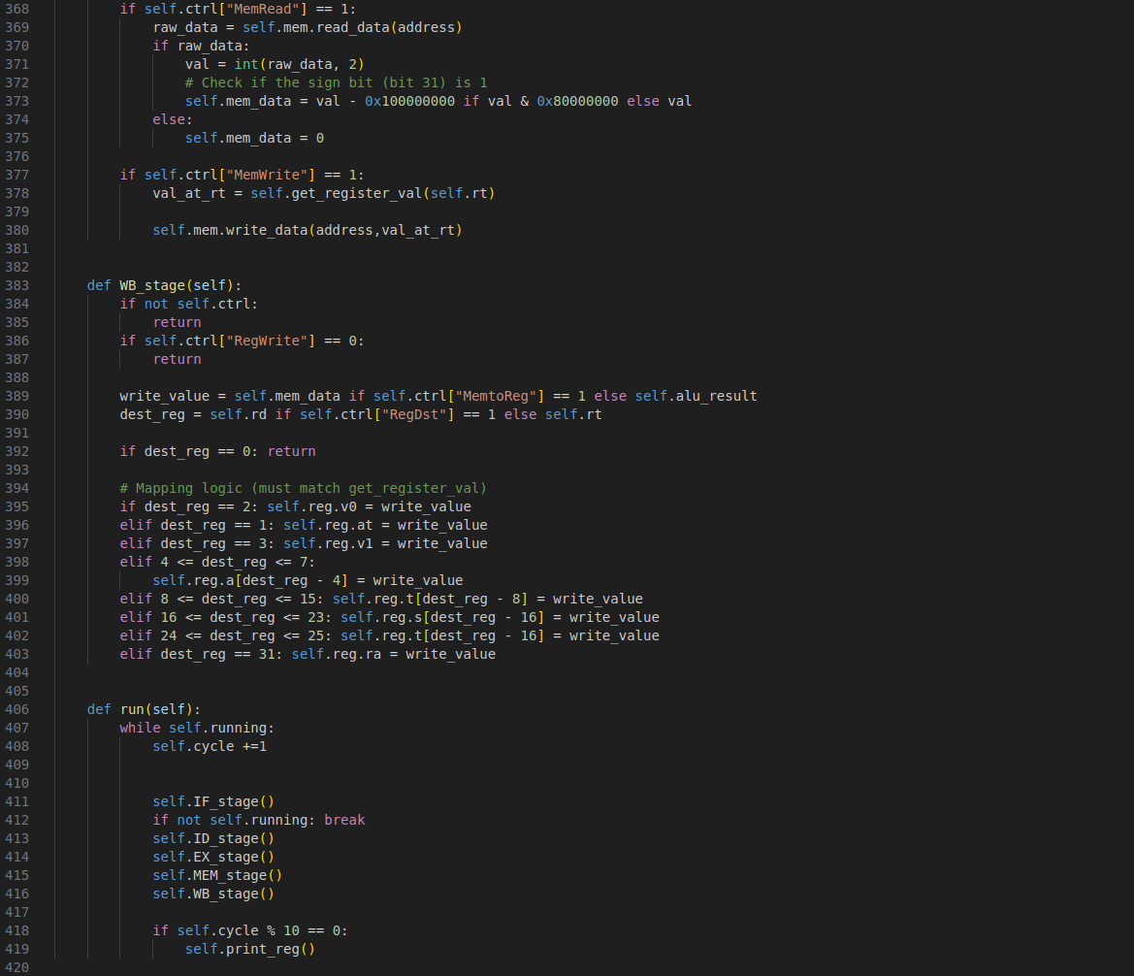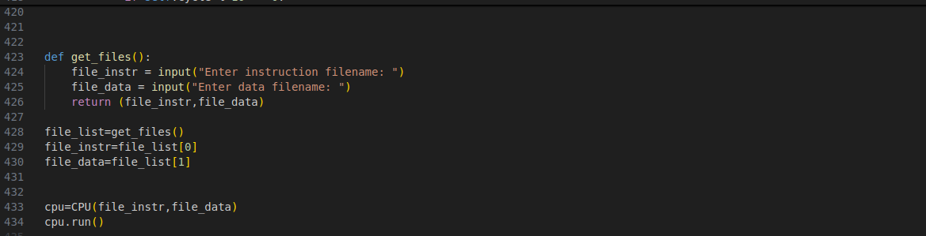

MIPS Assembly Codes:
1.Selection Sort

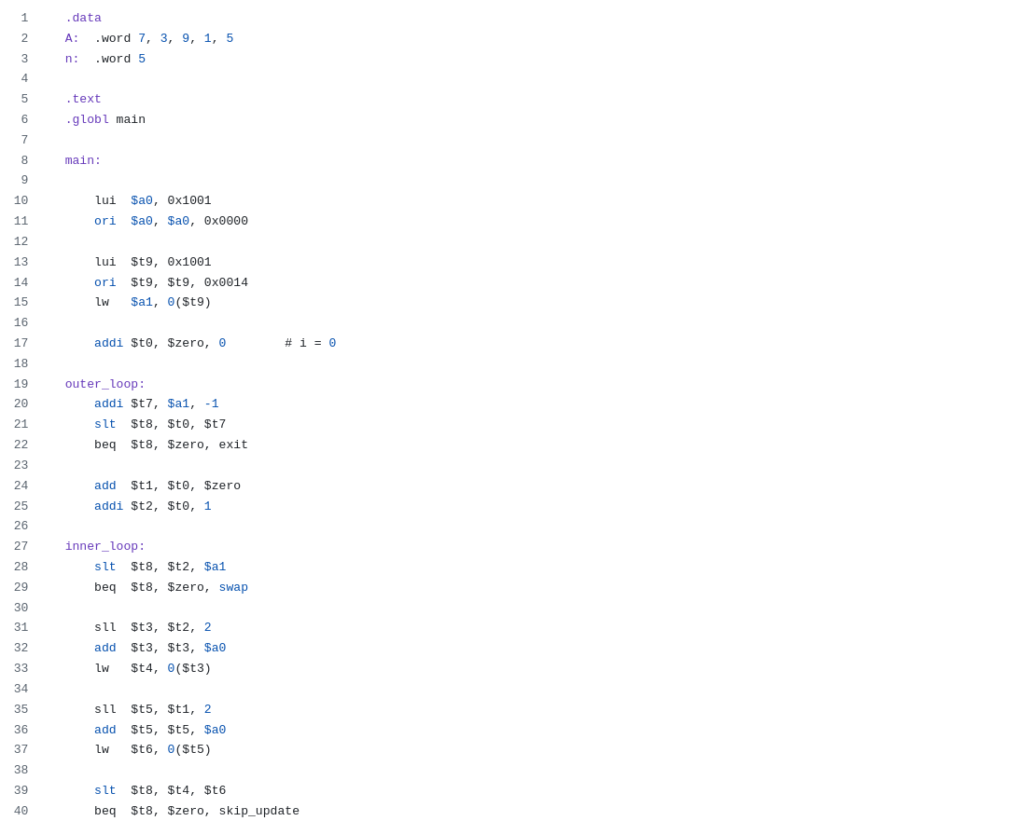

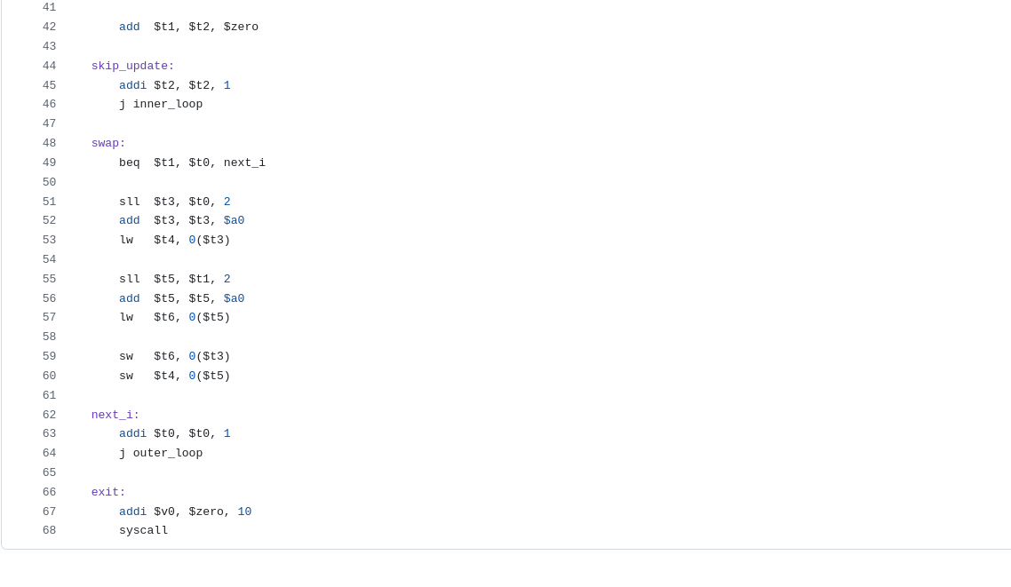

2. Binary Search

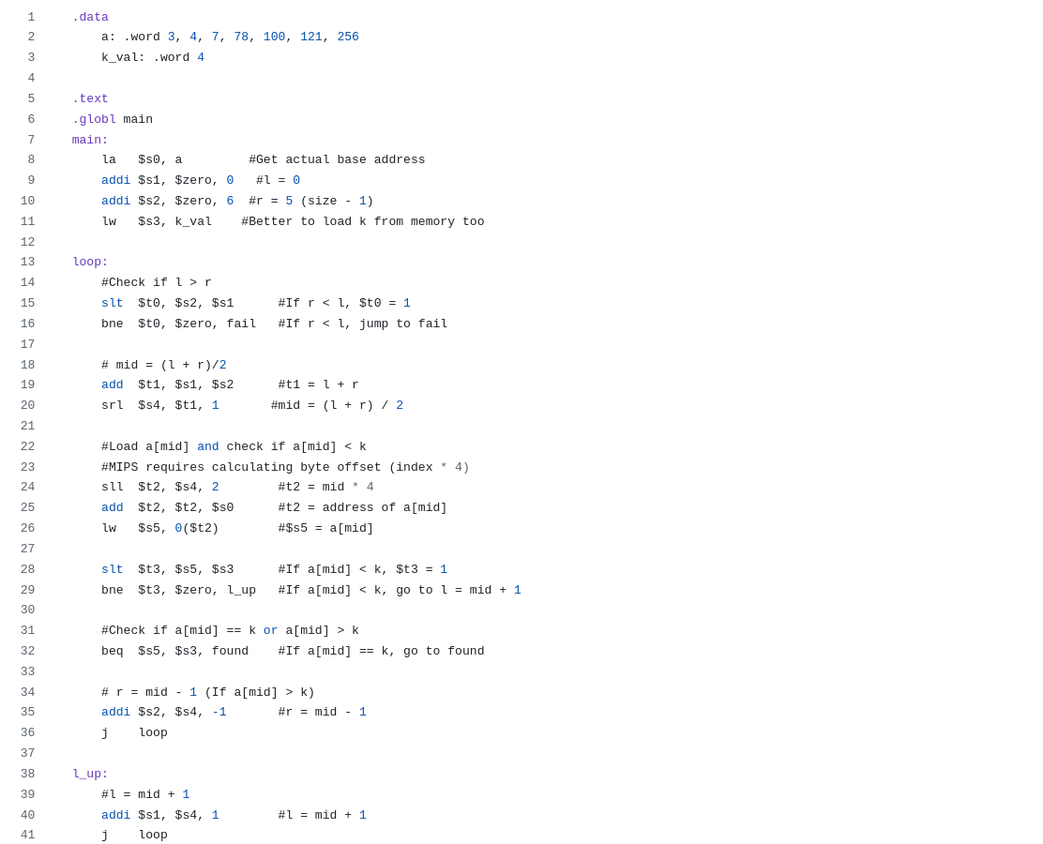

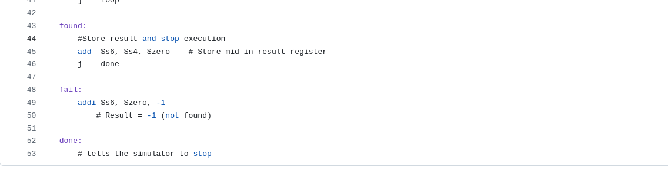

3. Bubble Sort
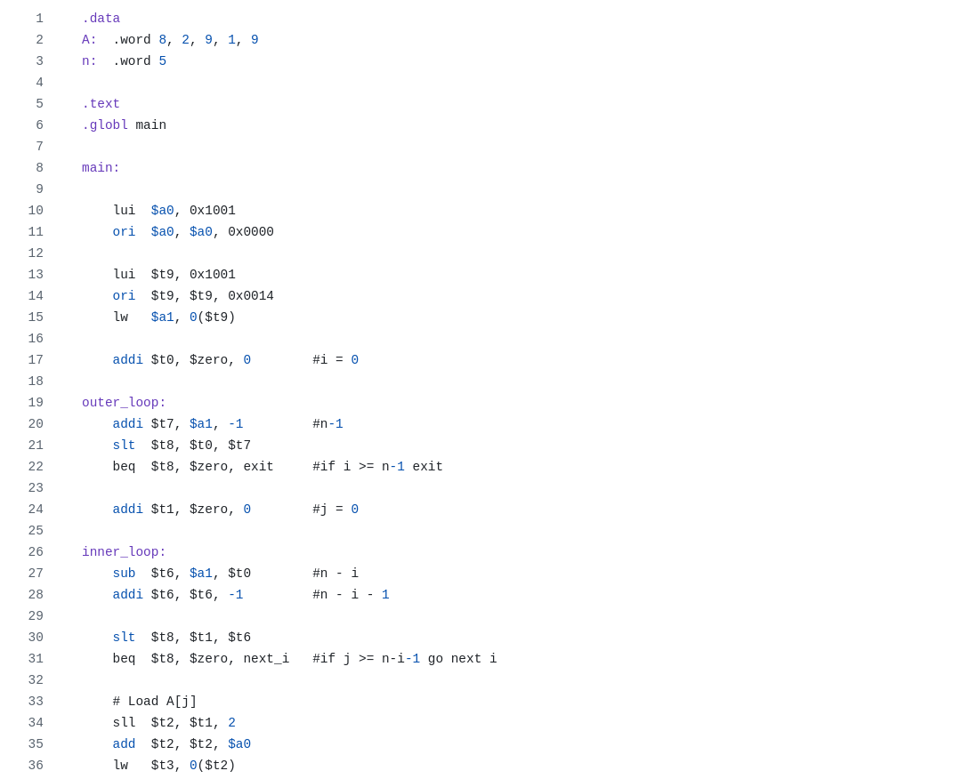

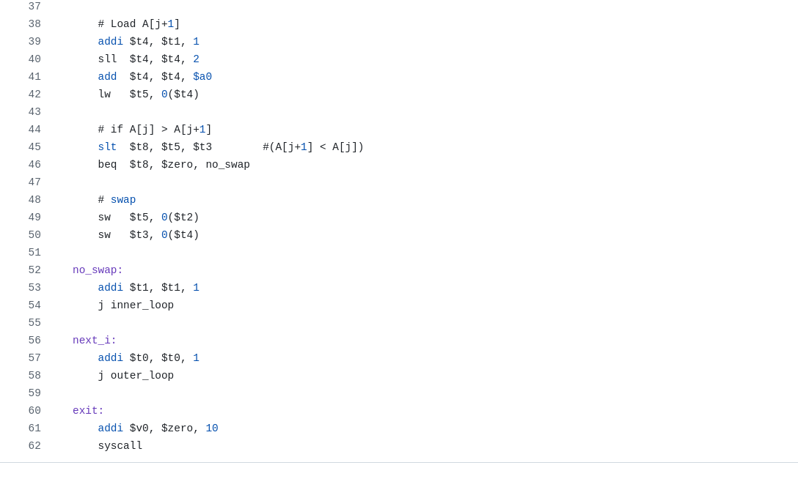

Execution Results

The below screenshots show the result after running the processor.py , using only the binary files for the instruction and data segment.

Selection Sort
Before Sorting (the data segment):
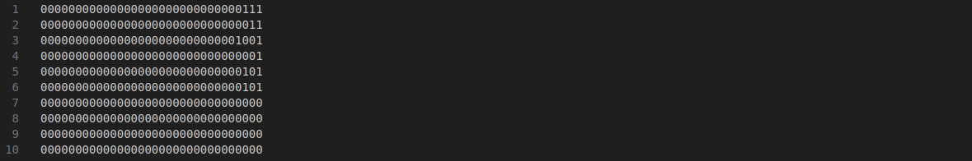
After Sorting( the data segment):

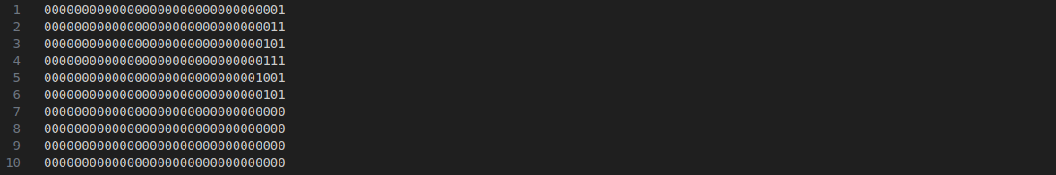Figure: Result of Selection Sort.

Binary Search:
We search on the array [3, 4, 7, 78, 100, 121, 256] for the element 4.
$s6 should contain the index of the element.
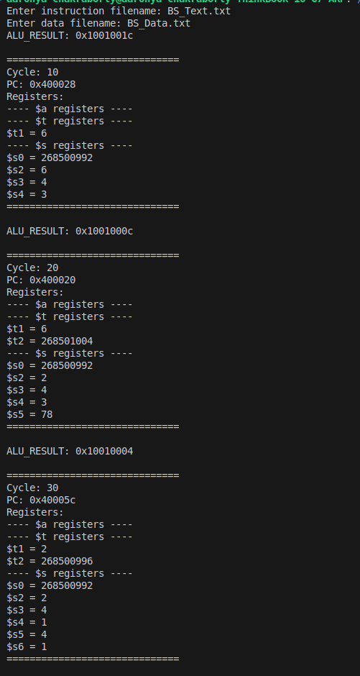
Figure: Result of Binary Search.

Bubble Sort:

Before Sorting( the data segment)

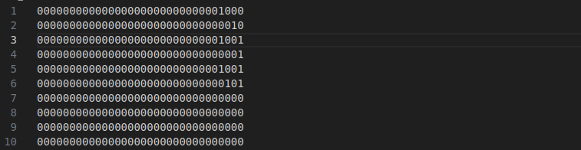
After Sorting( the data segment)

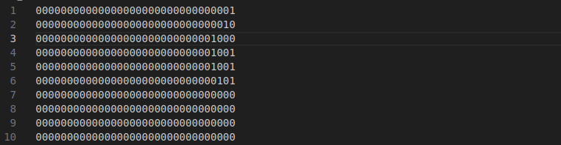Figure: Result of Bubble Sort

References:
- https://en.wikipedia.org/wiki/Stanford_MIPS
- Computer organization and design MIPS Edition, Henessey and Patterson (H&P). 5th edition
- Digital design and computer architecture, Harris and Harris.

