# Kathmandu University

Department of Computer Science and Engineering

Dhulikhel, Kavre



COMP 202

Mini Project

Submitted By:

Amir Bhattarai

ROLL NO: 10

CE 2**nd** Year/1**st** Semester

Submitted To:

Rajani Chulyadyo

Department of Computer Science and Engineering

**Graph Data Structure**

A Graph Data Structure is a collection of vertices and edges where the vertices are connected via edges.

DFS and BFS are used for traversing all the vertices present in a graph or a tree. Here, I have applied these traversing techniques to some graphs.

The major difference between BFS and DFS is that BFS proceeds level by level while DFS follows first a path form the starting to the ending node (vertex), then another path from the start to end, and so on until all nodes are visited. Furthermore, BFS uses the queue for storing the nodes whereas DFS uses the stack for traversal of the nodes.

In this mini-project I have represented Graph as Adjacency List. This report is focused mainly on two traversing techniques i.e. Depth First Search (DFS) and Breadth First Search (BFS).

Here are some examples.

1.

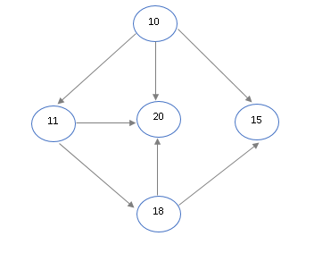

Result

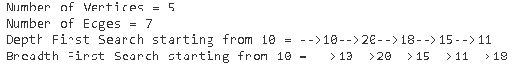

2.

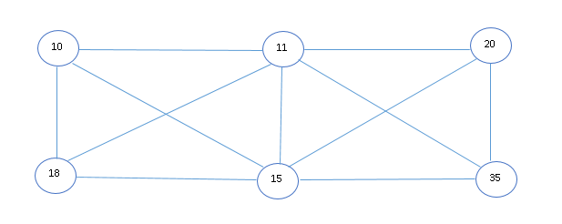

Result

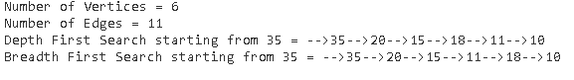

3.

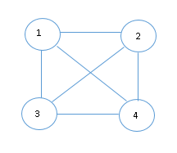

Result

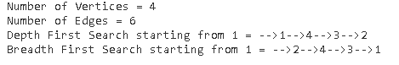

4.

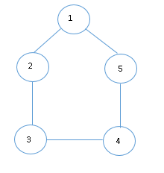

Result

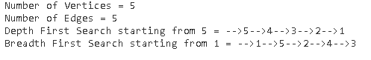

5.

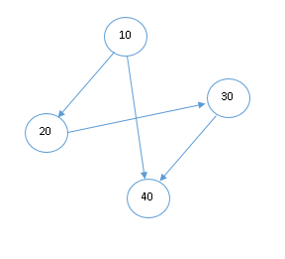

Result

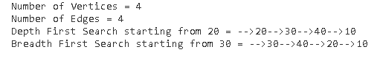

Hence, we have successfully applied DFS and BFS in these connected graphs, complete graph (graph 3), some directed graphs and undirected graphs as well.

DFS have many applied cases. Some Applications of DFS are:

* If we perform DFS on unweighted graph, then it will create minimum spanning tree for all pair shortest path tree
* We can detect cycles in a graph using DFS. If we get one back-edge during BFS, then there must be one cycle.
* Using DFS we can find path between two given vertices u and v.
* We can perform topological sorting is used to scheduling jobs from given dependencies among jobs. Topological sorting can be done using DFS algorithm.
* Using DFS, we can find strongly connected components of a graph. If there is a path from each vertex to every other vertex that is strongly connected.

Like DFS, the BFS is also used in different situations. These are like below

* In peer-to-peer network like bit-torrent, BFS is used to find all neighbor nodes
* Search engine crawlers are used BFS to build index. Starting from source page, it finds all links in it to get new pages
* Using GPS navigation system BFS is used to find neighboring places.
* In networking, when we want to broadcast some packets, we use the BFS algorithm.
* Path finding algorithm is based on BFS or DFS.
* BFS is used in Ford-Fulkerson algorithm to find maximum flow in a network.

Github Link: https://github.com/a-b365/mini-project