**Methodology**

We have chosen to do **incremental** development because:

The advantages are:

* Easier management
* Can get user feedback earlier
* Can avoid crises by be alerted to problems earlier
* Can respond easier to changing user requirements
* Earlier exchange of functionality

The disadvantages are:

* Can be harder to manage, with more steps and crucial decencies and overall progress monitoring
* Version & configuration control is crucial and can be complex

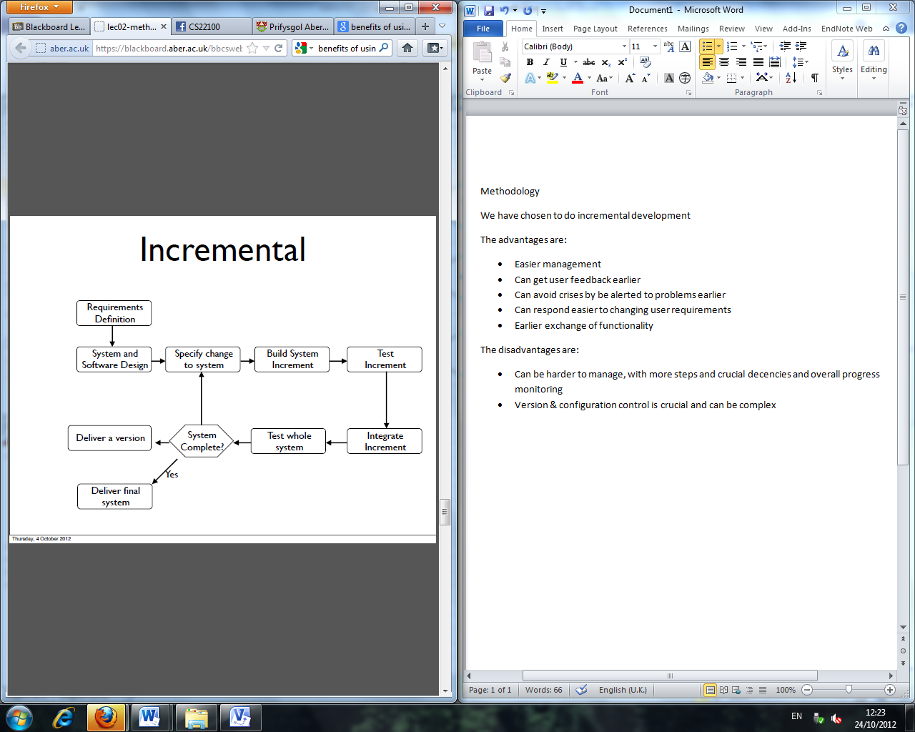

**Requirements Definition**

We have been given the requirements for the monster mash game.

**System and software design**

We will design how the system will carry out the requirements and how it will look.

**Specify change to the system**

If there is any to any change to either the requirements or there needs to be change in design.

**Build system increment**

We will build a part of the system.

**Test Increment**

We will then test that part of the system on its own.

**Integrate increment**

We will then integrate that part of the system with another part.

**Test whole system**

When all parts have been done and tested, we will then test the system as a whole.

**System complete**

If there are no more changes needed to be made, the system is complete.

**Deliver a version**

A version then gets delivered when the system has been tested. This version then needs to get tested by using other group’s monsters.

**Deliver final system**

When we are happy that no more changes need to be made, the final system can be delivered.