Methodology
We have chosen to do incremental development because:
The advantages are:
- Easier management
- Can get user feedback earlier
- Can avoid crises by be alerted to problems earlier
- Can respond easier to changing user requirements
- Earlier exchange of functionality
The disadvantages are:
- Can be harder to manage, with more steps and crucial decencies and overall progress monitoring
- Version & configuration control is crucial and can be complex
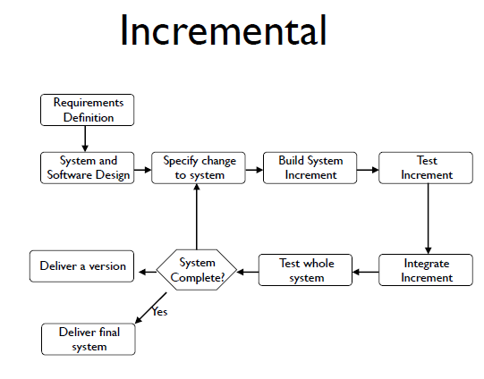
Requirements Definition
We have been given the requirements for the monster mash game.
System and software design
We will design how the system will carry out the requirements and how it will look.
Specify change to the system
If there is any to any change to either the requirements or there needs to be change in design.
Build system increment
We will build a part of the system.
Test Increment
We will then test that part of the system on its own.
Integrate increment
We will then integrate that part of the system with another part.
Test whole system
When all parts have been done and tested, we will then test the system as a whole.
System complete
If there are no more changes needed to be made, the system is complete.
Deliver a version
A version then gets delivered when the system has been tested. This version then needs to get tested by using other group’s monsters.
Deliver final system
When we are happy that no more changes need to be made, the final system can be delivered.

