**COURSE PROJECT REPORT**

Name: B. Mukund Sai – Roll No. MDM15B036

18 April 2018

Objective:

I developed a program in C language to find nodal displacements of structures formed using 1D elements i.e. Bar, Beam, Frame and Truss in presence of point loads.

Input:

* Number of nodes
* Number of elements
* Coordinates of nodes
* Material Properties of each element
* Type of element
* Number and Positions of point loads
* Boundary Conditions

Output

* Stiffness Matrices of each element
* Global Stiffness Matrix
* Global Force Vector
* Nodal Displacements

Sample Problem Solved:

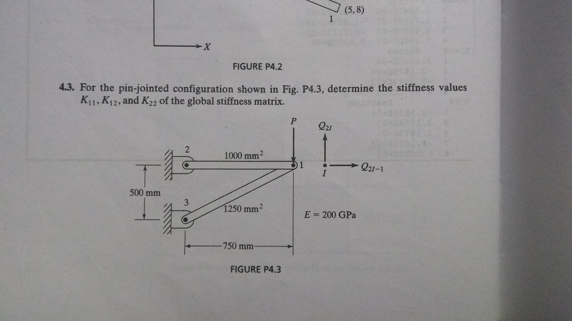

I took P=1000 N

And solved using my program.

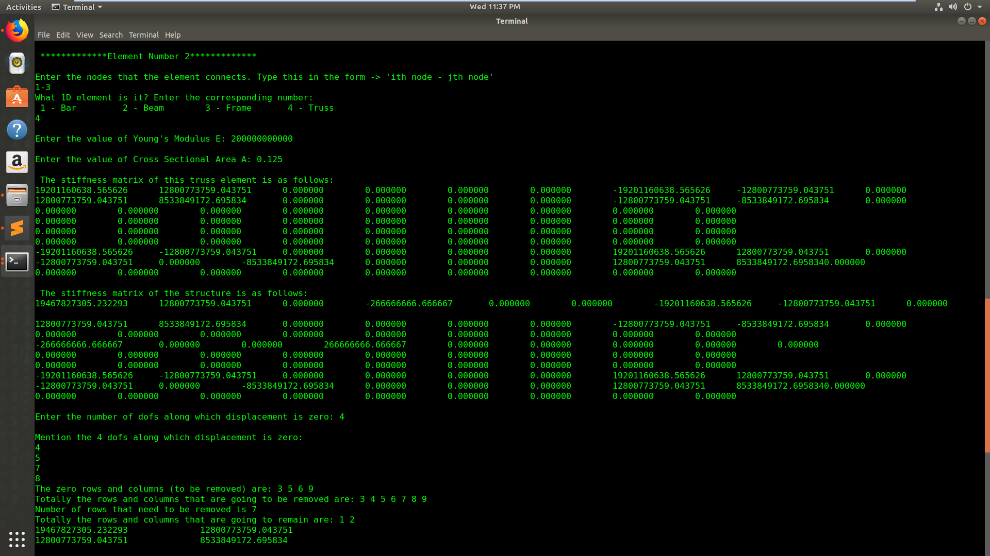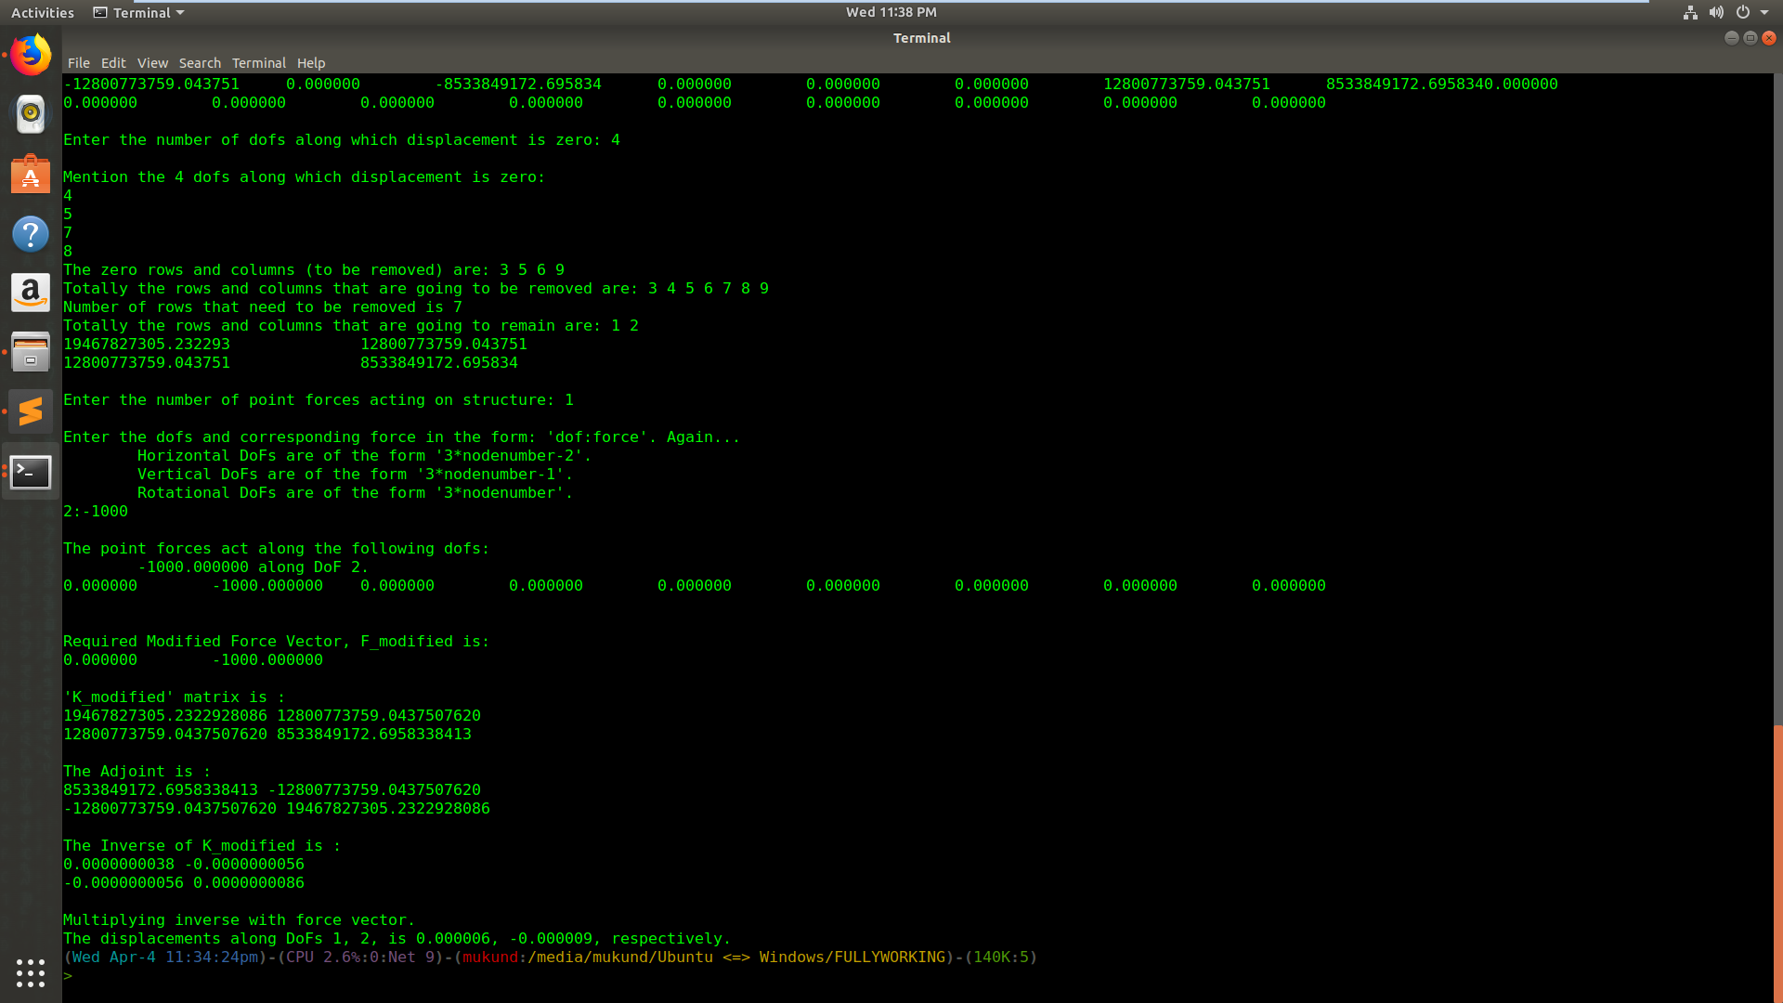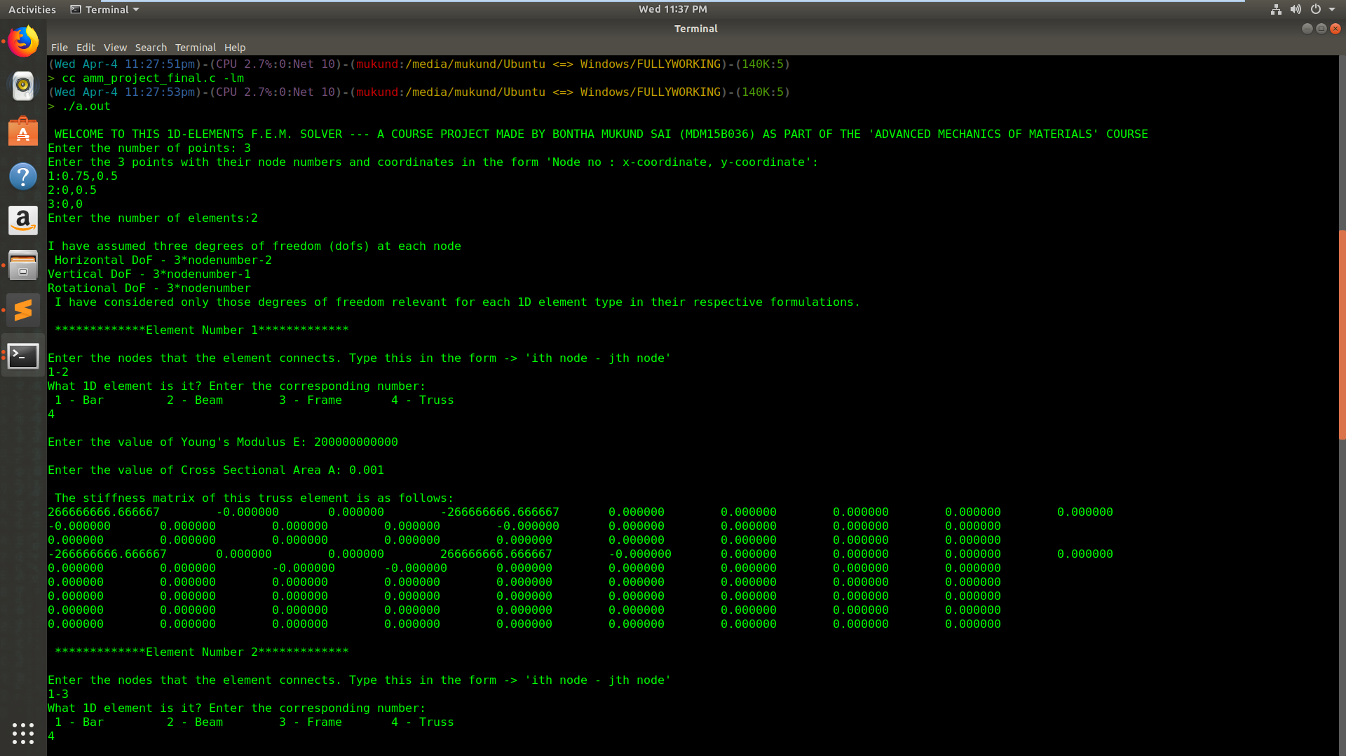Output:

Hence, Displacements obtained for node 1 in above example are:

0.006mm along x direction

-0.009mm along y direction

Limitations of my program:

* May/may not solve problems with multiple element types.
* Need to restart if wrong input is given