VISION-BASED GESTURE CONTROL SYSTEM
Real Time Project Report
Submitted in partial fulfillment of the requirements for the award of the Degree of

Bachelor of Technology (B.Tech)
In
Department of CSE (Artificial Intelligence & Machine Learning)
By
A Praveen Kumar 24AG1A66D2
D Tharun 24AG1A66E8
MD Hussain 24AG1A66G9

Under the Esteemed Guidance of
Mr. S. Venkatesh
Assistant Professor



Department of CSE (Artificial Intelligence & Machine Learning)
ACE ENGINEERING COLLEGE
An Autonomous Institution

(NBA ACCREDITED B.TECH COURSES: EEE, ECE & CSE, ACCORDED NAAC ‘A’ GRADE) Affiliated to Jawaharlal Nehru Technological University, Hyderabad, Telangana
Ghatkesar, Hyderabad – 501 301
APRIL 2026
 ACE
Engineering College
An Autonomous Institution
(NBA ACCREDITED B.TECH COURSES: EEE, ECE & CSE, ACCORDED NAAC ‘A’ GRADE)
(Affiliated to Jawaharlal Nehru Technological University, Hyderabad, Telangana)
Ghatkesar, Hyderabad – 501 301
Website : www.aceec.ac.in E-mail: info@aceec.ac.in

CERTIFICATE
This is to certify that the Real Time Project work entitled VISION – BASED GESTURE CONTROL SYSTEM is being submitted by A Praveen Kumar (24AG1A66D2), D Tharun (24AG1A66E8), MD Hussain (24AG1A66G9) in partial fulfillment for the award of Degree of BACHELOR OF TECHNOLOGY in DEPARTMENT OF CSE (ARTIFICIAL INTELLIGENCE & MACHINE LEARNING) to the Jawaharlal Nehru Technological University, Hyderabad during the academic year 2025-26 is a record of bonafide work carried out by them under our guidance and supervision.
The results embodied in this report have not been submitted by the student to any other University or Institution for the award of any degree or diploma.

Internal Guide Head of the Department
MR. S. VENKATESH Dr. KAVITHA SOPPARI
Assistant Professor Professor
Dept. of CSE (AI & ML) Dept. of CSE (AI&ML)

ACKNOWLEDGEMENT
We would like to express our gratitude to all the people behind the screen who have helped us transform an idea into a real time application.
We would like to express our heart-felt gratitude to our parents without whom we would not have been privileged to achieve and fulfill our dreams.
A special thanks to our General Secretary, Prof. Y.V. Gopal Krishna Murthy, for having founded such an esteemed institution. We are also grateful to our beloved principal, Dr. N. Sudhakar Reddy for permitting us to carry out this project.

We profoundly thank Dr. Kavitha Soppari, Professor and Head of the Department of CSE (Artificial Intelligence & Machine Learning), who has been an excellent guide and also a great source of inspiration to our work.

We extremely thank, Dr. Ch. Kishore Kumar Assistant Professor, Real Time Project coordinator, who helped us in all the way in fulfilling of all aspects in completion of our Real Time Project.

We are very thankful to our guide MR. S. Venkatesh Assistant Professor, Department of CSE (Artificial Intelligence & Machine Learning), who has been an excellent and also given continuous support for the completion of our Real Time Project work.

The satisfaction and euphoria that accompany the successful completion of the task would be great, but incomplete without the mention of the people who made it possible, whose constant guidance and encouragement crown all the efforts with success. In this context, we would like to thank all the other staff members, both teaching and non-teaching, who have extended their timely help and eased our task.

A Praveen Kumar (24AG1A66D2)
D Tharun (24AG1A66E8)
MD Hussain (24AG1A66G9)

DECLARATION

This is to certify that the work reported in the present project titled “VISION – BASED GESTURE CONTROL SYSTEM” is a record work done by us in the Department of CSE (Artificial Intelligence & Machine Learning), ACE Engineering College.

No part of the thesis is copied from books/journals/internet and whenever the portion is taken, the same has been duly referred in the text; the reported are based on the project work done entirely by us not copied from any other source.
A Praveen Kumar (24AG1A66D2)
D Tharun (24AG1A66E8)
MD Hussain (24AG1A66G9)

ABSTRACT

The control of personal computing environments is traditionally performed by physical peripherals such as the mouse and keyboard, which can introduce ergonomic strain, physical limitations, and significant delays in sterile or touchless interaction scenarios. Recent advances in Artificial Intelligence, particularly Machine Learning (ML) and Computer Vision, have enabled automated systems capable of interpreting hand gestures with considerable accuracy. The new system leverages machine learning to analyze 21 distinct hand landmarks, enhancing efficiency and consistency in cursor navigation. Additionally, it uses signal processing to better understand the stability of hand poses, making the navigation process smoother for users in professional or presentation settings. Moreover, the system utilizes wrist-relative coordinate mapping to gain deeper insights into the intent of the user. By understanding context, posture, and temporal persistence, it can evaluate the quality of human-to-computer commands presented in real-time. This allows for a more nuanced control experience, considering factors like gesture stability and noise reduction, while reducing the likelihood of input error.

Keywords: Human-Computer Interaction (HCI), Computer Vision, Machine Learning (ML), MediaPipe

CONTENTS | PAGE NO
1. INTRODUCTION | 1
1.1. Leveraging Advanced Technologies | 2
1.2. Significance of Feedback Systems | 2
1.3. Challenges and Opportunities | 2
1.4. Existing System | 3
1.5. Proposed System | 3
2. LITERATURE-SURVEY | 4
2.1. About the Project | 4
2.2. Literature Review | 5
3. SYSTEM REQUIREMENTS | 6
3.1. Hardware Requirements | 6
3.2. Software Requirements | 6
4. SYSTEM ARCHITECTURE | 7
4.1. System Architecture  4.2. System Module | 7  8
5. SYSTEM DESIGN | 9
5.1. Introduction to UML | 9
5.2. UML Diagrams | 9
5.2.1 Class Diagram | 10
5.2.2 Use case Diagram | 11
5.2.3 Activity Diagram | 12
5.2.4 Sequence Diagram | 13
5.2.5 State Chart Diagram | 14
5.2.6 Object Diagram | 15
INDEX
5.2.7 Deployment Diagram | 16
5.2.8 Component Diagram | 17
5.2.9 Collaboration Diagram  5.3 Algorithm | 18  19
6. IMPLEMENTATION | 20
6.1 main.py | 20
6.2 gesture_controller.py | 28
6.3 hand_dectector.py | 39
6.4 smartboard.py | 40
7. TESTING | 48
7.1 Introduction to Testing | 48
7.2 Types of Testing | 48
7.2.1 Unit Testing | 48
7.2.2 Integration Testing | 49
7.2.3 System Testing | 49
7.2.4 Acceptance Testing | 49
7.2.5 Performance Testing | 50
7.3 Test Plan | 50
7.3.1 Objectives | 50
7.3.2 Scope | 50
7.3.3 Test Approach  7.4 Test Case | 50  51
8. FUTURE ENHANCEMENT AND CONCLUSION | 56
8.1 Future Enhancement | 56
8.2 Conclusion | 57
9. REFERENCES | 58

LIST OF FIGURES
Fig. No. | Figure Name | Page No.
4.1 | System Architecture Diagram | 7
4.2 | System Module | 8
5.1 | Class Diagram | 10
5.2 | Use Case Diagram | 11
5.3 | Activity Diagram | 12
5.4 | Sequence Diagram | 13
5.5 | State Chart Diagram | 14
5.6 | Object Diagram | 15
5.7 | Deployment Diagram | 16
5.8 | Component Diagram | 17
5.9 | Collaboration Diagram | 18
6.1 | Screenshot Gesture | 47
6.2 | Settings Gesture | 47
7.1 | Invalid Testcase1 | 51
7.2 | Invalid Testcase2 | 52

LIST OF TABLES

Table No | Table Name | Page No
1 | Test Cases | 53

CHAPTER 1

INTRODUTION

The interaction between humans and computer systems is a crucial aspect of modern productivity, playing a significant role in digital navigation, accessibility, and software management. However, manual interaction through physical peripherals can be time-consuming, physically restrictive, and prone to ergonomic strain or accessibility barriers in specialized environments. To address these challenges, researchers have explored the use of Computer Vision (CV) and Machine Learning (ML) techniques to develop automated hand gesture control systems. These systems analyze and evaluate hand movements based on features like landmark positioning, finger curl configurations, and spatial trajectories, offering benefits such as touchless operation, intuitive navigation, and cross-platform scalability.
By leveraging MediaPipe and OpenCV, automated gesture systems can handle real-time video streams, provide instant feedback to the user, and reduce the physical workload of hardware interaction. This enables users to focus on high-level tasks and creative output, while the system provides timely and precise interpretation of intent to improve digital performance. Moreover, automated systems can identify specific hold states and complex gestures, allowing for targeted control over system functions such as volume adjustment, screenshot capture, and virtual smartboard drawing.
Despite promising results, challenges remain, including improving tracking stability in varied lighting, evaluating spatial depth for clicking gestures, and developing systems that can provide robust performance regardless of hand tilt or rotation. To overcome these challenges, the v4.0 system utilizes advanced ML and signal processing techniques, such as Exponential Moving Average (EMA) filtering, temporal buffering, and wrist-relative coordinate mapping. These sophisticated methods ensure that the system moves beyond simple coordinate mapping to genuinely understand the underlying intent and logical flow of user movements.
The potential benefits of automated hand gesture control systems are substantial, including:
- Improved accuracy and consistency: Automated systems can reduce "jitter" and accidental triggers in cursor movement, ensuring that users receive stable and accurate input responses.
- Enhanced user experience: Instant response and smooth tracking help users interact naturally with the interface, enabling them to focus on productivity rather than hardware limitations.
- Increased efficiency: Automated systems can handle complex navigation tasks without physical contact, reducing the workload of users in professional, presentation, or sterile environments.
- Personalized accessibility: Automated systems can provide tailored gesture mappings and sensitivity settings, catering to individual users' ergonomic needs and motor capabilities.
By developing more sophisticated CV and ML techniques, automated hand gesture control systems can become an essential tool in Human-Computer Interaction (HCI), providing efficient, consistent, and accurate navigation that supports digital workflows and improves user outcomes. Ultimately, these systems have the potential to revolutionize the way we interact with technology, enabling users to provide more effective commands through natural human movement and enhancing the overall computing experience.
1.1 Leveraging Advanced Technologies
This approach involves capturing 21 distinct hand landmarks, standardizing spatial coordinate mapping through wrist-relative frames, capturing motion intent, and implementing signal-processing models to predict user gestures in real-time. By leveraging these technologies, it enables efficient system navigation, consistent command execution, and improved accessibility outcomes for individuals with motor limitations. The system provides instant visual feedback through a real-time interface, highlights active control states such as volume adjustment or file visibility, and detects subtle finger configurations like the "Pinch & Slide" gesture, reducing physical hardware reliance and minimizing input noise. This technology has the potential to revolutionize the Human-Computer Interaction (HCI) process, making it more efficient, effective, and user-centered, ultimately enhancing digital productivity and ergonomic health. Additionally, it allows professionals and presenters to focus on communication and creative output, while also providing users with intuitive control to adjust their interaction strategies and improve their digital performance.
1.2 Significance of Feedback Systems
Control and feedback systems play a crucial role in real-time human-computer interaction using machine learning and computer vision. They provide users with timely, accurate, and actionable insights into their interaction performance, helping identify input errors, tracking strengths, and areas for gesture improvement. This enables targeted digital navigation, enhances user engagement, and fosters a seamless workflow experience. Effective feedback systems also facilitate human-machine interaction, allowing users to refine their movement strategies and improve overall system outcomes. By leveraging machine learning and computer vision, feedback systems can offer personalized, detailed, and nuanced interaction cues, ultimately elevating the user experience and promoting professional success.
1.3 Challenges and Opportunities
This approach presents both challenges and opportunities. Challenges include ensuring tracking quality and landmark availability, capturing contextual nuances such as hand rotation, mitigating environmental biases, and handling the complexity of real-time artificial intelligence processing. However, the opportunities are substantial, including efficient touchless processing, consistent tracking results, personalized visual feedback through a Heads-Up Display (HUD), cross-platform scalability, and improved ergonomic outcomes. By leveraging MediaPipe and Python, it is possible to reduce manual hardware effort, provide instant system insights, and gain data-driven understanding of human kinematics to inform digital practices. Ultimately, this has the potential to revolutionize human-computer interaction processes, making them more efficient, effective, and centered around user needs, and enhancing digital experiences and achievements.
Additionally, it enables faster decision-making in navigation, improved input accuracy, and enhanced professional productivity, leading to significant benefits and advancements in gesture-based computing. Furthermore, it can also facilitate innovation in touchless interfaces, drive growth in accessible technology, and unlock new possibilities, transforming the way we work and interact with information. By harnessing these opportunities, we can unlock new levels of performance and success in hands-free environments. Moreover, it can lead to better resource allocation in sterile settings, improved user satisfaction, and increased competitiveness, ultimately driving long-term success and sustainability for the system.
This, in turn, can have a profound impact on various aspects of life, from engineering and healthcare to business and digital governance. By embracing these advancements in machine learning and computer vision, we can create a more efficient, effective, and equitable world, where technology and innovation drive positive change and progress.
1.4 EXISTING SYSTEM
Current implementations of gesture-based control often rely on a combination of raw coordinate mapping and basic geometric heuristics. Image preprocessing, including frame normalization and landmark detection, is typically followed by feature extraction using simple Euclidean distance calculations between finger tips and the palm. Gesture recognition is primarily measured using fixed thresholds for finger extension, where specific distances determine the execution of system-level commands like clicking or scrolling. While these systems excel at identifying static finger presence and general palm orientation, they can struggle with intricate hand rotations, depth perception, or stable cursor control in noisy environments. Input data often consists of direct webcam frames without advanced temporal filtering, which can lead to significant cursor "jitter" and may limit the system's adaptability to varying lighting conditions or diverse user hand sizes.
1.5 PROPOSED SYSTEM
Our proposed system integrates state-of-the-art computer vision architectures, such as the MediaPipe Hands framework and advanced signal processing algorithms, for deeper intent recognition and motion stability analysis. This moves beyond simple threshold-based detection to genuinely understand the underlying intent and logical flow of hand gestures, even with varied orientations or environmental noise. The system incorporates a sophisticated visual feedback module, pinpointing specific active control states—such as volume adjustment, file visibility, or smartboard drawing—through a real-time heads-up display. Furthermore, it leverages Exponential Moving Average (EMA) filtering and temporal buffering techniques to minimize input jitter and eliminate accidental gesture triggers. This makes the interface more adaptable to different lighting conditions and diverse user hand kinematics with high precision. The aim is to create a more robust, professional-grade, and intuitive human-computer interaction experience.

CHAPTER 2

LITERATURE SURVEY

2.1 ABOUT PROJECT

Hand Gesture Mouse v4.0: Real-time Human-Computer Interaction using Computer Vision and Machine Learning aims to develop a system that can accurately and consistently interpret hand gestures, providing instant system control and improving the overall digital interaction process. By leveraging machine learning and computer vision techniques, the system will analyze real-time video stream data, extract 21 distinct hand landmarks, and execute system-level commands or provide visual feedback based on the posture, orientation

The system is expected to enhance professional productivity, promote touchless interaction in specialized environments—such as medical theaters or presentation halls—and enable users to focus on creative tasks without reliance on physical peripherals. By automating the gesture recognition process, the project has the potential to transform the Human-Computer Interaction (HCI) sector by improving user navigation speed, increasing input efficiency, and enhancing the accessibility of digital systems, ultimately making technology more efficient, effective, and user-centered.

2.2 LITERATURE REVIEW
[1] Author: Fan Zhang, Valentin Bazarevsky, Andrey Vakunov, et al. (Google Research, 2020). Title: MediaPipe Hands: On-device Real-time Hand Tracking This foundational paper presents the real-time, on-device hand tracking pipeline that serves as the core architecture for modern gesture control systems. The authors developed a two-stage model consisting of a palm detector and a hand landmark model capable of predicting 21 3D hand landmarks from a single RGB camera frame. This framework is implemented via MediaPipe, which provides a cross-platform ML solution optimized for mobile and desktop GPUs. This research is critical for the v4.0 project as it provides the high-fidelity landmark data required for wrist-relative mapping and complex finger-curl analysis used to execute system-level commands like volume control and screenshot capture.
[2] Author: Jayasri Kotti, B. Padmaja, D. Deepa (2024). Title: Enhancing Gesture-Controlled Virtual Mouse and Virtual Keyboard Using AI Techniques This approach focuses on the development of an AI-based virtual mouse and keyboard system designed to improve human-computer interaction by eliminating physical device dependency. Utilizing OpenCV and MediaPipe, the researchers implemented a system that captures hand gestures through a webcam to perform standard cursor operations. Their work emphasizes efficiency and the reduction of human intervention, which became particularly relevant for touchless interfaces during the global health crisis
[3] Author: B. R. Sandhya, C. Amrutha, S. Ashika (2023). Title: Gesture Recognition Based Virtual Mouse and Keyboard This research presents a novel approach to mapping real-time hand movements to mouse and keyboard operations, such as clicking, scrolling, and text input. A key focus of this study is addressing environmental noise and lighting challenges to ensure responsiveness. The v4.0 project builds upon this by incorporating an Exponential Moving Average (EMA) smoothing filter and a Gesture History Buffer to specifically combat the "jitter" and flickering issues identified in these earlier implementations.
[4] Author: Dr. C. P. Divate, S. M. Patil, Faika Shaikh, et al. (2024). Title: AI-Based Hand Gesture-Controlled Virtual Mouse System In this paper, researchers explore a stabilized cursor movement system that utilizes integrated cameras to capture hand motion. The study identifies significant challenges in gesture recognition, including non-standard backgrounds and movement diversity, which can impact accuracy. Their methodology involves processing video frames to execute mouse functions such as left-clicks and scrolling. This is directly relevant to the v4.0 system, which employs wrist-relative coordinate frames and confidence buffering to ensure that gestures remain accurate even against complex, "noisy" backgrounds or during high-speed hand movements.
[5] Author: Shimaa Osman (2024). Title: Virtual Keyboard-Mouse in Real-Time Using Hand Gesture and Voice Assistant This approach introduces a multimodal interaction scheme, combining hand gesture recognition with voice assistance to enable a completely hands-free user
.

CHAPTER 3

SYSTEM REQUIREMENTS

3.1 HARDWARE REQUIREMENTS
- 3.1 HARDWARE REQUIREMENTS
- Processor: Intel Core i5 or above (Recommended for real-time Computer Vision processing).
- RAM: 8 GB or higher to handle concurrent MediaPipe landmark detection and frame rendering.
- Storage: 256 GB SSD or higher for efficient library management and data logs.
- Camera: Integrated HD Webcam or external USB Camera (720p/60fps recommended for optimal gesture stability).
- Monitor: Standard resolution display for cursor mapping and Smartboard visualization.
3.2 SOFTWARE REQUIREMENTS
- Operating System: 64-bit Windows 10/11, Linux (Ubuntu/CentOS), or macOS.
- Languages: Python 3.8 or higher.
- Computer Vision Libraries: OpenCV-Python (cv2) and MediaPipe.
- Automation Libraries: PyAutoGUI (for system-level mouse and keyboard control).

CHAPTER 4
SYSTEM ARCHITECTURE

4.1 System Architecture

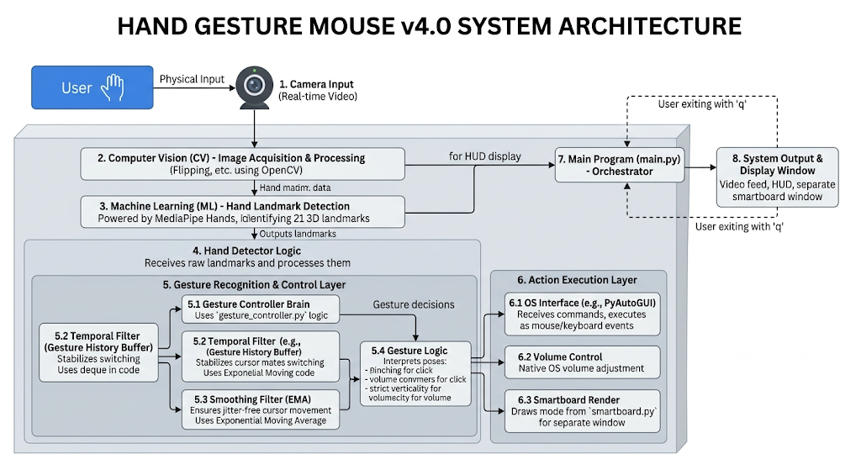

Fig 4.1: System Architecture
The architectural schematic depicts an extensive system for real-time human-computer interaction, designed to efficiently process and evaluate natural hand movements. The process initiates with the Input Module, which gathers real-time video frames via a standard webcam and stores it as raw pixel data. This unprocessed information is then transferred to the Data Preparation Module for frame normalization, image flipping, and initial hand landmark extraction via the MediaPipe Hands pipeline, cleansing and restructuring the data into a format conducive to motion analysis.
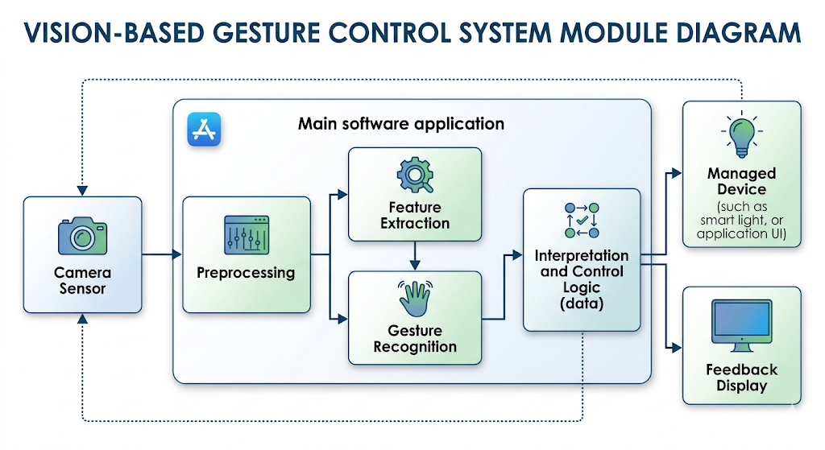
The refined landmark data then moves to the Analysis & Gesture Logic Module, where it undergoes both motion stability analysis through a Temporal Filtering deque to gauge pose persistence, and a Semantic Intent Interpretation that implements the Exponential Moving Average (EMA) smoothing algorithm and strict geometric rules—such as strict verticality checking for thumb-based volume up/down—to identify specific commands. The resulting gesture decisions are forwarded to the Action Execution Module, which splits the path based on user intent: Standard cursor navigation is handled by the OS Interface (via pyautogui) to create mouse and keyboard events that enhance interaction smoothness, while specific configurations (such as the "Pinch & Slide" or "Peace Sign") activate the Integrated Virtual Smartboard and Native Volume Control modules to provide comprehensive, nuanced control. Finally, all system states are summarized and incorporated into a Real-time Feedback System (Heads-Up Display), where the graphical overlay handles on-screen visualization and the main interface presents interactive, user-friendly status reports. This streamlined architecture ensures efficient data handling, meaningful analysis, and actionable insights for an optimized hands-free computing experience.
Fig 4.2: System Module
An architectural model in software is a detailed and structured diagram that follows established standards, primarily focused on representing a set of trade-offs within the design and structure of a system or ecosystem. Software architects use these models to effective communicate their design decisions and gather feedback from peers and stakeholders. The architectural model acts as a representation of a viewpoint within the software architecture.

CHAPTER 5
SYSTEM DESIGN
UML DIAGRAMS

5.1 INTRODUCTION TO UML
The Unified Modelling Language (UML) offers software engineers a standardized approach to visually represent an analysis model, governed by a set of rules that ensure proper syntax, semantics, and practicality. A UML system is visualized through unique views, each highlighting a different aspect of the system. These views are outlined as follows:
User Model View
• Focuses on the system from the user's standpoint.
• Describes usage scenarios to showcase how end-users interact with the system.
Structural Model View
• Highlights the static framework of the system.
• Represents internal data and functionality, emphasizing relationships and dependencies among components such as classes and objects.
Behavioural Model View
• Depicts the dynamic nature of the system.
• Illustrates interactions between structural elements, combining insights from the User and Structural Model Views to showcase workflows, object communications, and state changes.
Implementation Model View
• Represents the system's structural and behavioural aspects as they are meant to be implemented.
• Serves as a guide for developers, outlining how the system's components will be constructed.

5.2 UML DIAGRAMS
5.2.1 CLASS DIAGRAM
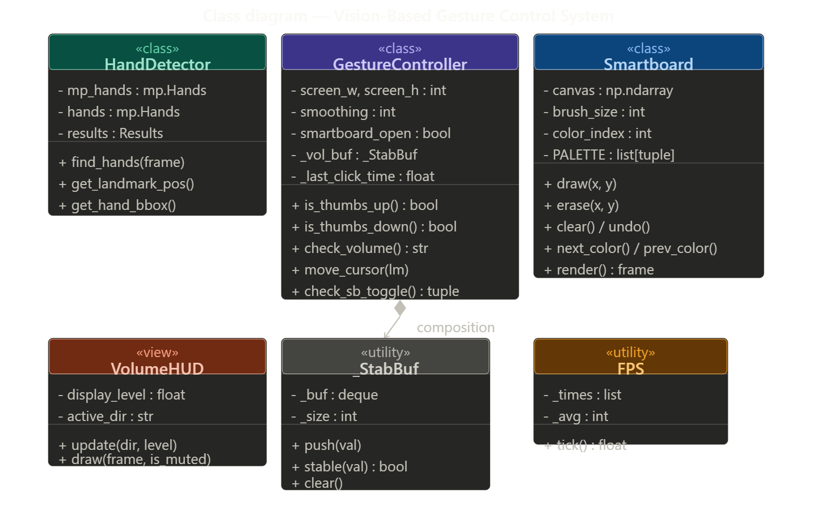
Fig 5.1: Class Diagram
Class diagrams are used to represent the static structure of a system by showing its classes, attributes, operations, and the relationships between objects. These diagrams are essential for understanding how a system is organized and how the different components or classes interact with each other. Class diagrams are foundational in object-oriented modeling and help in both the design and implementation phases.
The key purposes of class diagrams can be outlined as:
• Represent the static structure of the system, detailing the classes and their relationships.
• Illustrate the attributes and operations of each class, helping to define the behavior and data associated with them.

5.2.2 USE CASE DIAGRAM:
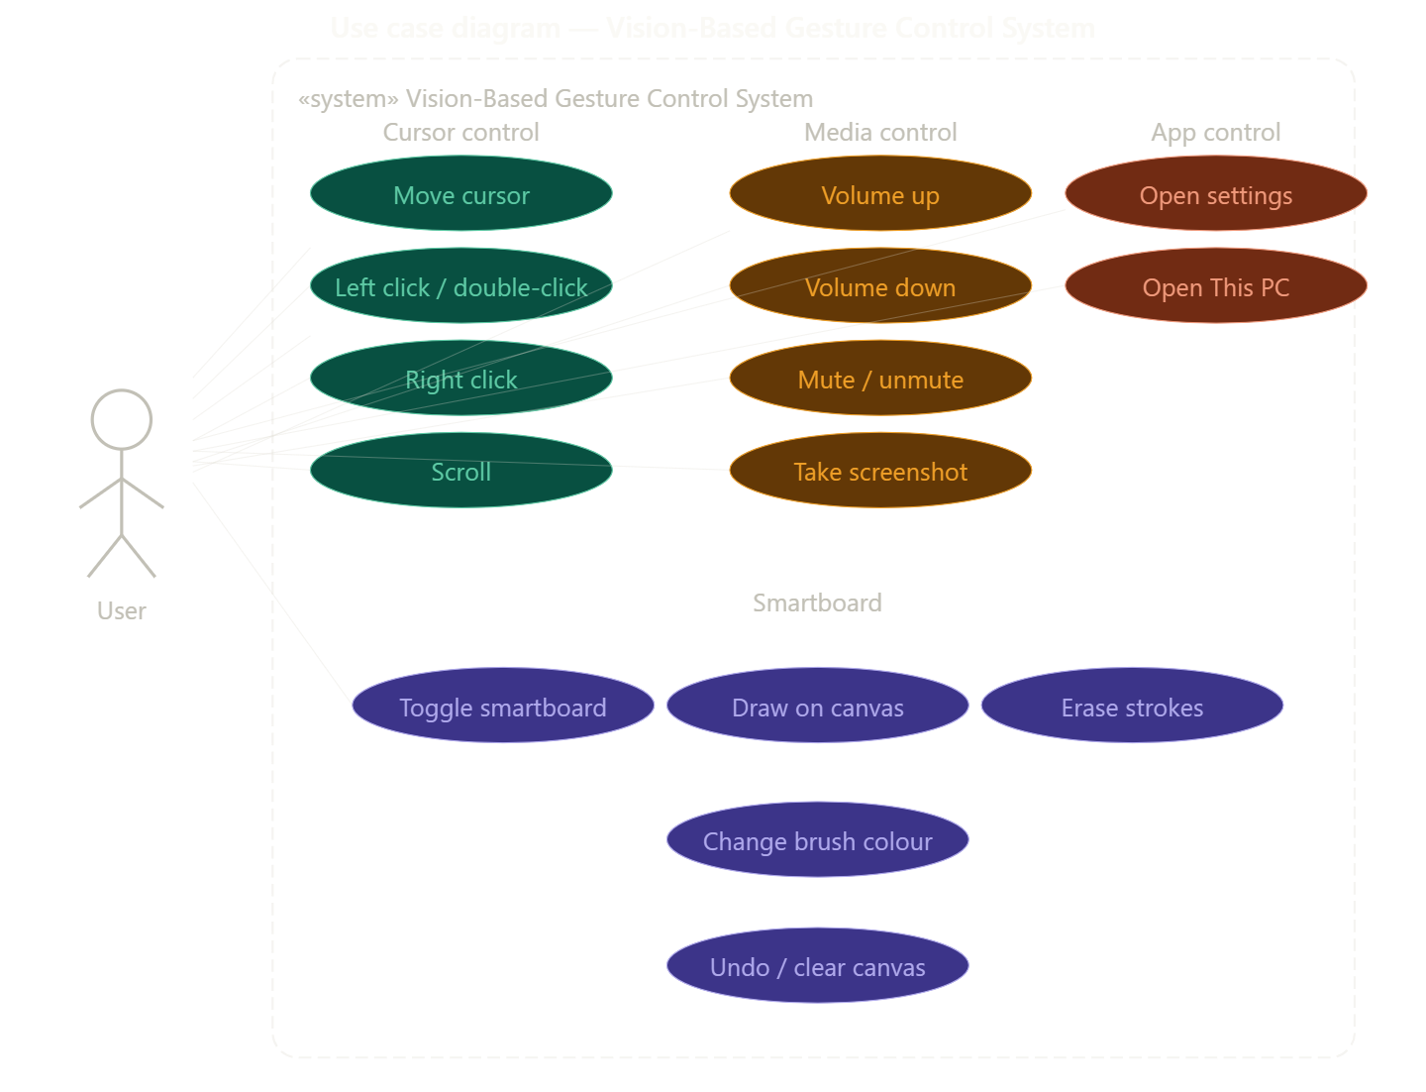
Fig 5.2: Use Case Diagram
Use case diagrams play a key role in eliciting requirements for a system, including both internal and external factors that influence the system. These requirements are typically related to thedesign phase of the system. When analysing a system to determine its functionalities, use cases are created, and actors both internal and external are identified.
To summarize, the main purposes of use case diagrams can be described as:
a. To gather the functional requirements of a system.
b. To obtain an external perspective of how the system interacts with its environment.
c. Use case diagrams identify external and internal elements affecting system behavior to clarify interactions and requirements.

5.2.3 ACTIVITY DIAGRAM
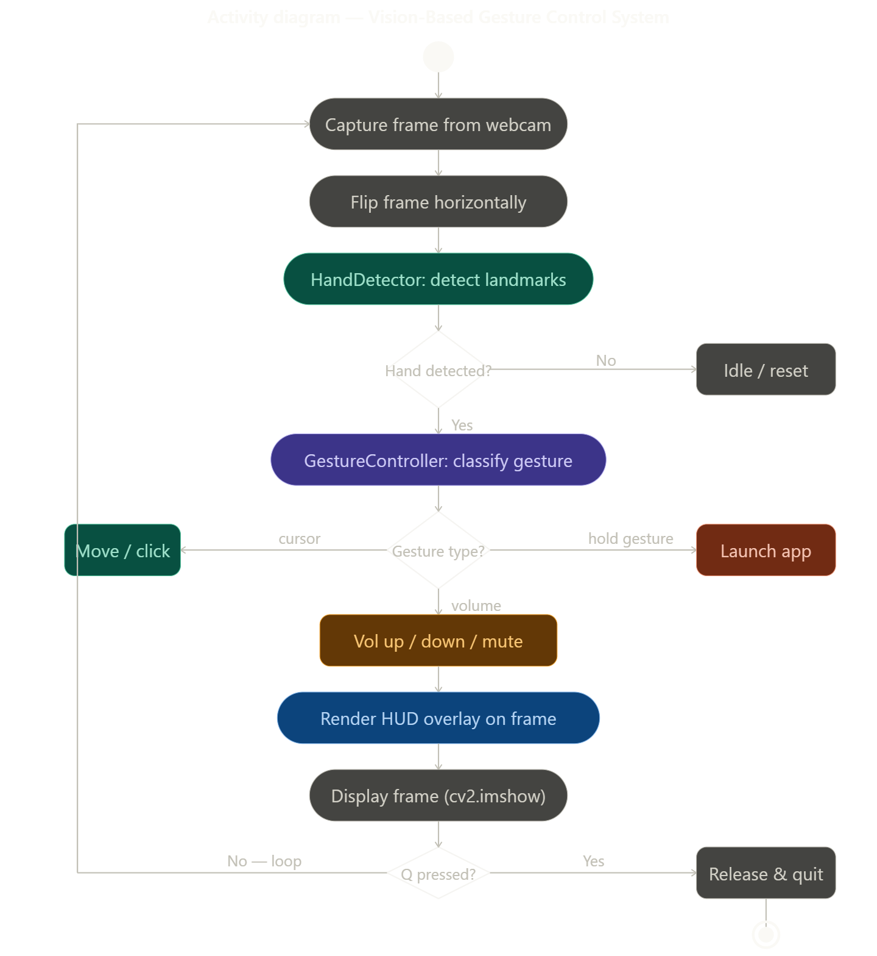
Fig 5.3: Activity Diagram

The activity diagram is another essential diagram in UML used to represent the dynamic behavior of a system. Essentially, the activity diagram functions as a flowchart, illustrating how the system transitions from one activity to another. An activity in this context refers to an operation or task that the system performs.
The key purposes of an activity diagram can be outlined as:
      - Represent the flow of activities within the system.
      - Depict the sequence in which activities occur, from one step to the next.

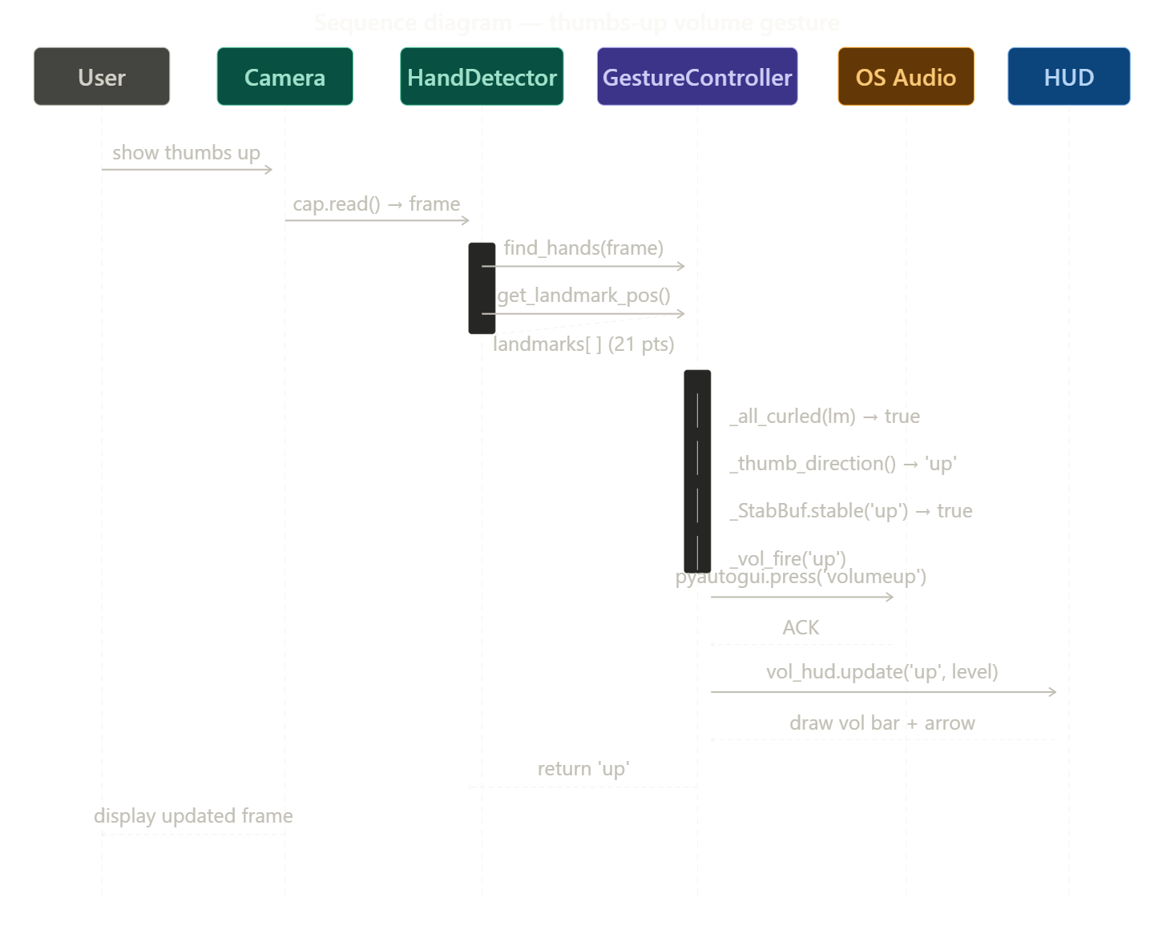
5.2.4 SEQUENCE DIAGRAM
Fig 5.4: Sequence Diagram
Sequence diagrams are used to represent interactions between classes or objects in terms of message exchanges over time. Often referred to as event diagrams, sequence diagrams are highly effective in visualizing and validating various runtime scenarios. They help in understanding how the system will behave during execution and can be instrumental in uncovering the responsibilities that a class should assume when designing a new system.
The primary purposes of sequence diagrams can be summarized as:
- Visualize the interaction flow between objects or classes over time.
- Validate different runtime scenarios, illustrating how the system components collaborate in real-time.
- Assign clear responsibilities to each class or object to fulfill system behavior.

5.2.5 STATE CHART DIAGRAM
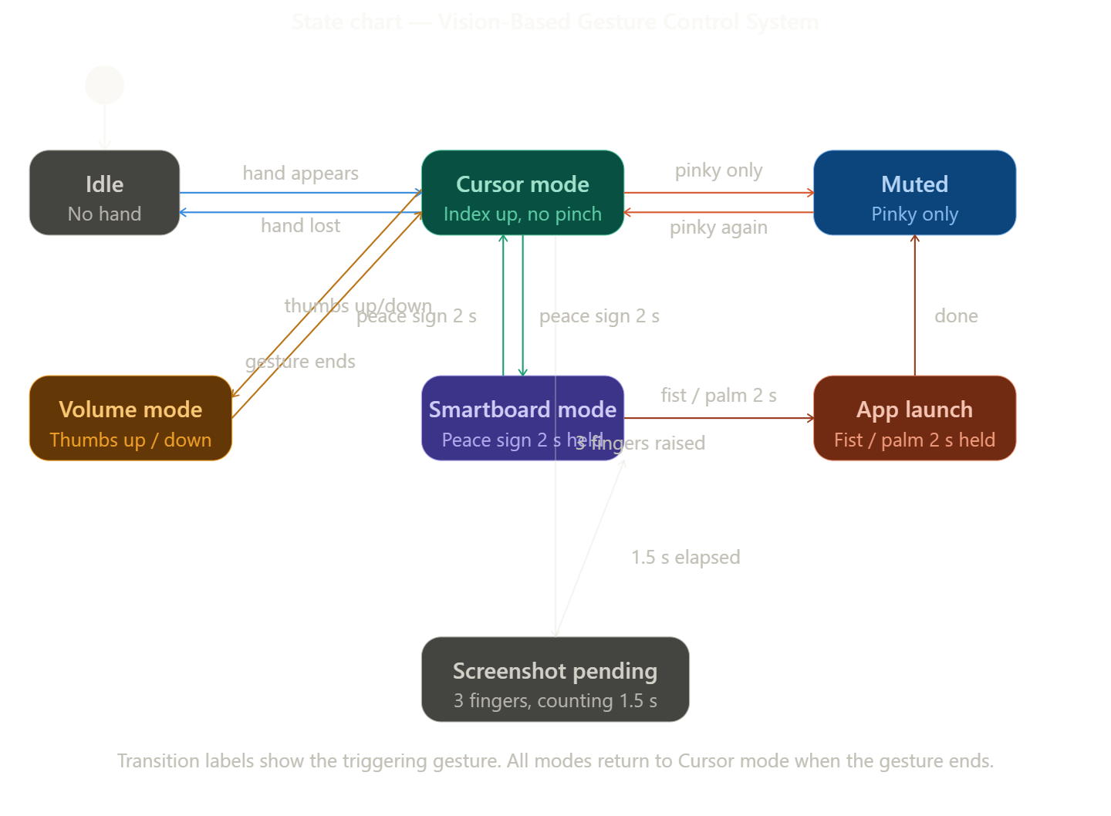
Fig 5.5: State Chart Diagram
Statechart diagrams, also known as state machine diagrams, are used to describe the dynamic behavior of an object in response to different events or stimuli. They show how an object transitions from one state to another based on internal or external events. These diagrams are particularly useful for modeling the lifecycle of an object or an entity, tracking its state changes and how it reacts to different conditions.
The key purposes of state chart diagrams can be summarized as:
- Model the lifecycle of an object, showing how it transitions through various states.
- State transitions represent how an object responds to events by changing its state.

5.2.6 OBJECT DIAGRAM
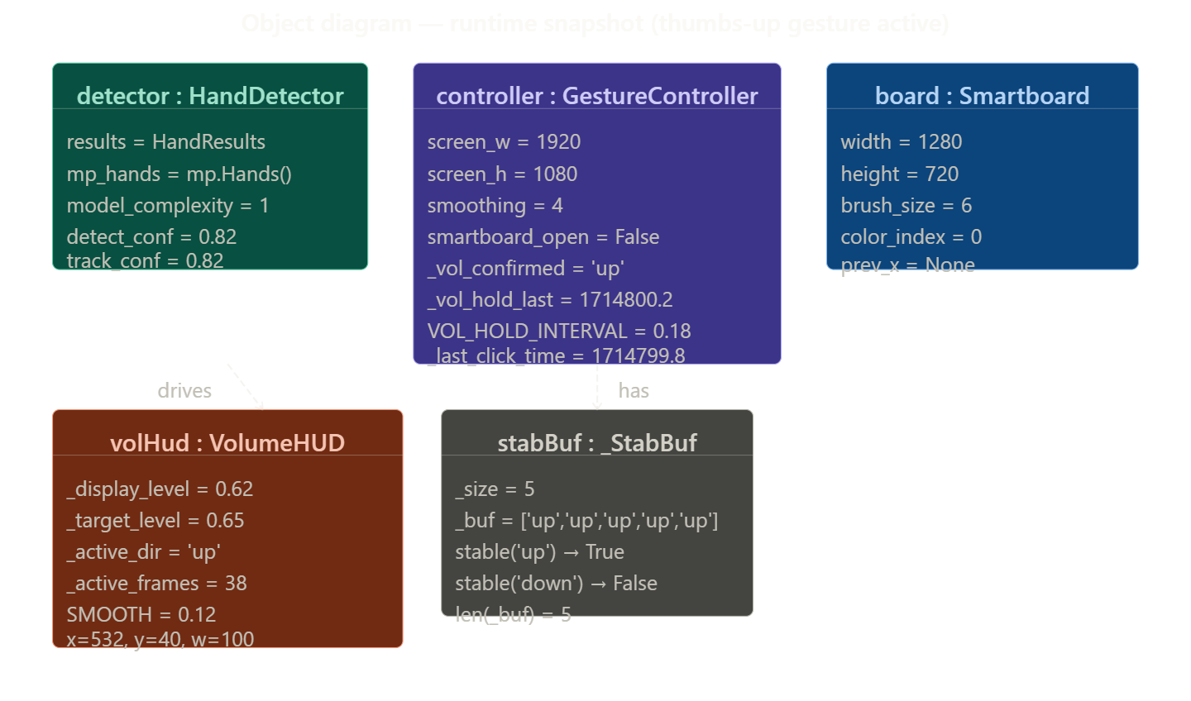
Fig 5.6: Object diagram
An Object Diagram can be referred to as a screenshot of the instances in a system and the relationship that exists between them. Object diagrams are a crucial aspect of UML, providing a snapshot of the instances in a system at a particular moment. They help in visualizing the relationships between objects. An object diagram in UML is useful because it provides a clear and visual representation of specific instances of classes and their relationships at a particular point in time, aiding in understanding and communicating the structure and interactions within a system. In other words, “An object diagram in the Unified Modeling Language (UML), is a diagram that shows a complete or partial view of the structure of a modeled system at a specific time. The use of object diagrams is limited, mainly to show examples of data structures. During the analysis phase of a project, you might create a class diagram to describe the structure of a system and then create a set of object diagrams as test cases to verify the accuracy and completeness of the class diagram.Recognition, image classifications which appears to be the complex method.

5.2.7 DEPLOYMENT DIAGRAM
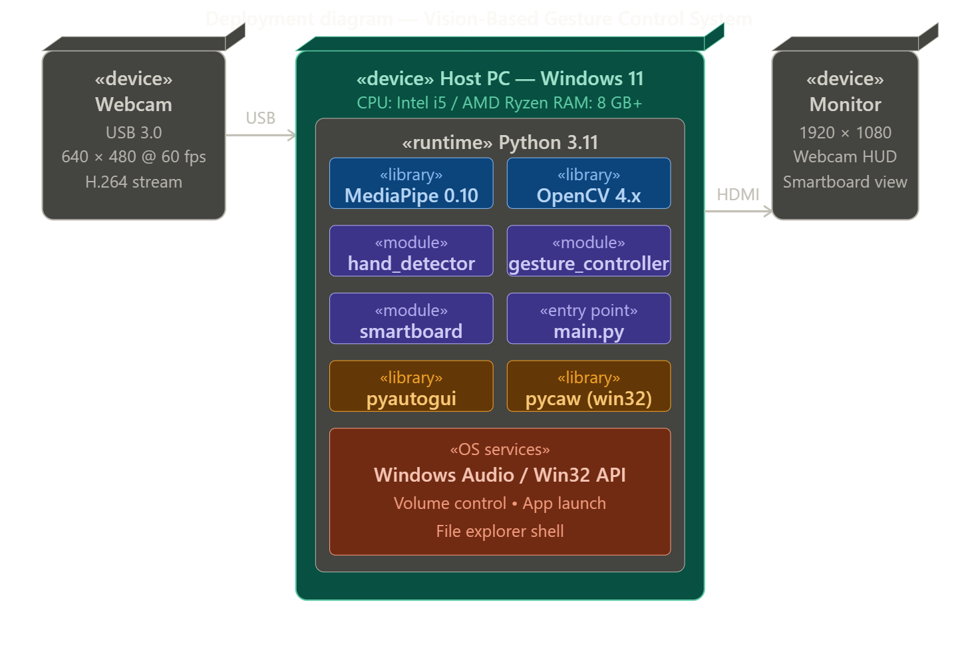
Fig 5.7: Deployment diagram
A UML deployment diagram is a diagram that shows the configuration of run time processing nodes and the components that live on them. Deployment diagrams is a kind of structure diagram used in modeling the physical aspects of an object-oriented system. They are often be used to model the static deployment view of a system (topology of the hardware).
• They show the structure of the run-time system
• They capture the hardware that will be used to implement the system and the links between
different items of hardware.
• They model physical hardware elements and the communication paths between them
• They can be used to plan the architecture of a system.
• They are also useful for Document the deployment of software components or nodes.

5.2.8 COMPONENT DIAGRAM
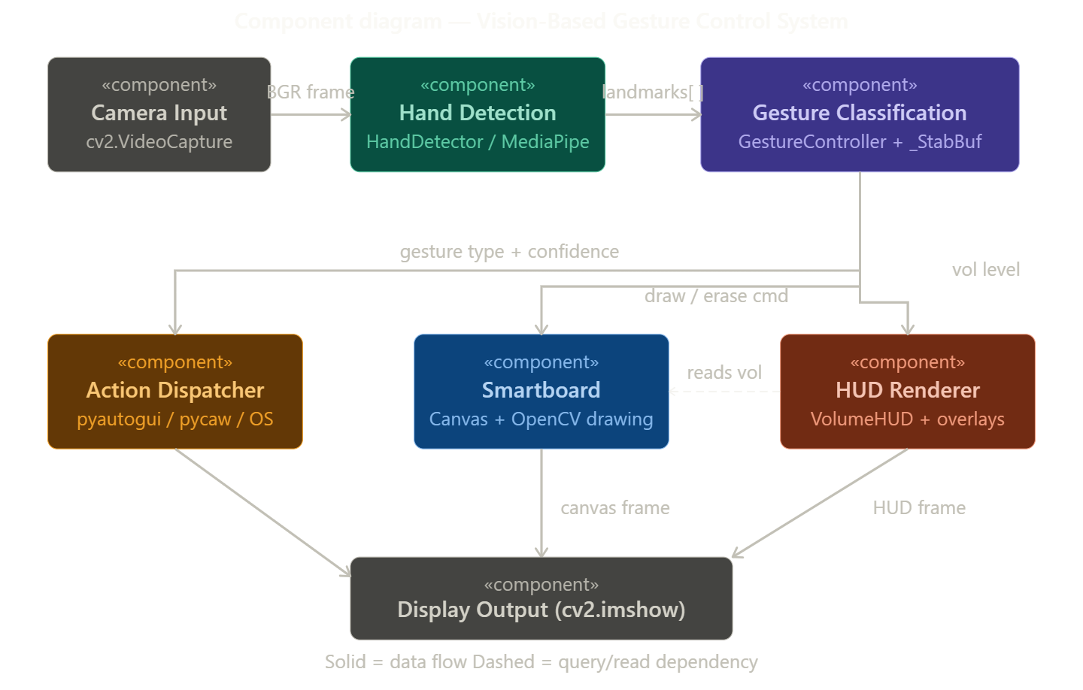
Fig 5.7: Component Diagram
UML Component diagrams are used in modeling the physical aspects of object-oriented systems that are used for visualizing, specifying, and documenting component-based systems and also for constructing executable systems through forward and reverse engineering. Component diagrams are essentially class diagrams that focus on a system's components that often used to model the static implementation view of a system.
• It portrays the components of a system at the runtime.
• It is helpful in testing a system.
• It envisions the links between several connections.

5.2.9 COLLABORATION DIAGRAM
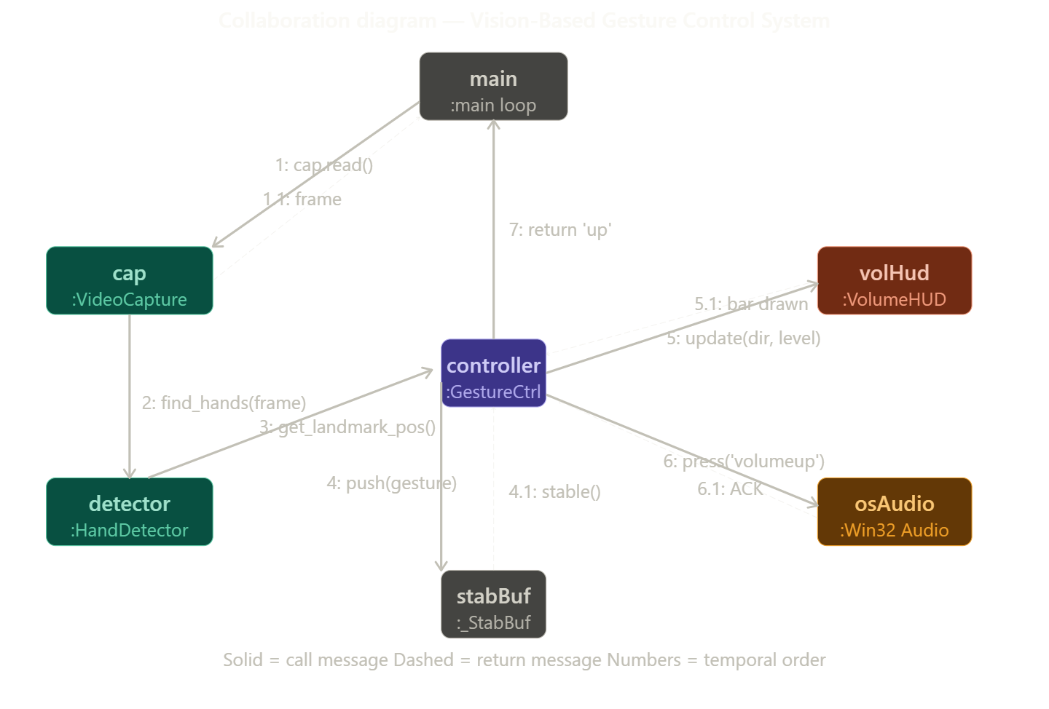
Fig 5.9: Collaboration diagram
Collaboration diagrams (known as Communication Diagram in UML 2.x) are used to show how objects interact to perform the behavior of a particular use case, or a part of a use case. Along with sequence diagrams, collaboration are used by designers to define and clarify the roles of the objects that perform a particular flow of events of a use case. They are the primary source of information used to determining class responsibilities and interfaces.
It mainly puts emphasis on the structural aspect of an interaction diagram, i.e., how lifelines are connected.
• The syntax of a collaboration diagram is similar to the sequence diagram; just the difference is that the lifeline does not consist of tails.
• The messages transmitted over sequencing is represented by numbering each individual message.
  - ALGORITHM
1. Technologies Used
- Frontend (Interface & Visualization)
- OpenCV GUI: Used for rendering the real-time video window and HUD overlay.
- Heads-Up Display (HUD): A custom graphical layer that shows active gestures, volume bars, and system status.
- Smartboard Canvas: A dedicated drawing window using NumPy-based arrays for virtual sketching.
- Backend (Processing Logic)
- Python 3.x: The core programming language for system orchestration.
- Gesture Controller Brain: Custom logic module (gesture_controller.py) that interprets spatial data into system commands.
- Virtual Environment (venv): Used for isolated dependency management.
- Machine Learning / Computer Vision
- MediaPipe Hands: A state-of-the-art framework for identifying 21 distinct 3D hand landmarks in real-time.
- OpenCV (cv2): Handles high-speed frame acquisition, image preprocessing, and GUI window management.
- NumPy: Performs high-speed numerical operations, coordinate interpolation, and canvas rendering.
- Other Python Libraries
- PyAutoGUI: For cross-platform system-level mouse and keyboard automation.
- Collections (deque): Implements temporal filtering for gesture stability and flickering reduction.
2. How Everything Connects
- User Interface (OpenCV Display)
- The user interacts with the camera by performing physical gestures.
- Main Orchestrator (main.py)
CHAPTER 6
CODE IMPLEMENTATION

6.1 main.py
import cv2
import pyautogui
import numpy as np
import time
from hand_detector import HandDetector
from gesture_controller import GestureController
from smartboard import Smartboard
CAM_WIDTH, CAM_HEIGHT = 640, 480
BOARD_WIDTH, BOARD_HEIGHT = 1280, 720
SCREEN_WIDTH, SCREEN_HEIGHT = pyautogui.size()
BOARD_WIN = "Smartboard"
def _text(frame, txt, pos, scale=0.45, color=(200,200,200), thickness=1):
cv2.putText(frame, txt, pos, cv2.FONT_HERSHEY_SIMPLEX, scale, color, thickness, cv2.LINE_AA)
def draw_hold_ring(frame, cx, cy, progress, color, radius=36):
"""Arc progress ring — drawn only while holding."""
angle = int(360 * progress)
cv2.ellipse(frame, (cx, cy), (radius, radius), -90, 0, angle, color, 3, cv2.LINE_AA)
pct = f"{int(progress*100)}%"
cv2.putText(frame, pct, (cx-14, cy+5),
cv2.FONT_HERSHEY_SIMPLEX, 0.42, color, 1, cv2.LINE_AA)
def draw_panel(frame):
"""Right-side icon panel background."""
h, w = frame.shape[:2]
cv2.rectangle(frame, (w-120, 0), (w, h), (18,18,18), -1)
def draw_icon_board(frame, is_open, active, progress):
cx, cy = frame.shape[1]-60, 60
col = (0,230,230) if is_open else (90,90,90)
cv2.rectangle(frame, (cx-18,cy-10), (cx+18,cy+10), col, -1)
cv2.rectangle(frame, (cx-18,cy-10), (cx+18,cy+10), (255,255,255), 1)
cv2.circle (frame, (cx,cy), 5, (15,15,15), -1)
cv2.rectangle(frame, (cx-6,cy-16), (cx+6,cy-10), col, -1)
if active and progress < 1.0:
draw_hold_ring(frame, cx, cy, progress, (255,200,0), 30)
_text(frame, "BOARD", (cx-22,cy+28), color=col)
_text(frame, "ON" if is_open else "OFF", (cx-10,cy+42), color=col)
def draw_icon_settings(frame, active, progress):
cx, cy = frame.shape[1]-60, 150
col = (60,160,255)
cv2.circle(frame, (cx,cy), 12, col, 2)
cv2.circle(frame, (cx,cy), 4, col, -1)
for a in range(0, 360, 60):
r = np.radians(a)
cv2.circle(frame, (int(cx+16*np.cos(r)), int(cy+16*np.sin(r))), 3, col, -1)
if active and progress < 1.0:
draw_hold_ring(frame, cx, cy, progress, (0,230,255), 28)
_text(frame, "SETTINGS", (cx-30,cy+36), color=col)
def draw_icon_thispc(frame, active, progress):
cx, cy = frame.shape[1]-60, 250
col = (0,200,100)
cv2.rectangle(frame, (cx-18,cy-12), (cx+18,cy+8), col, 2)
cv2.rectangle(frame, (cx-10,cy-6), (cx+10,cy+2), col, 1)
cv2.rectangle(frame, (cx-5, cy+8), (cx+5, cy+14), col, -1)
cv2.rectangle(frame, (cx-12,cy+14), (cx+12,cy+16), col, -1)
if active and progress < 1.0:
draw_hold_ring(frame, cx, cy, progress, (0,255,160), 28)
_text(frame, "THIS PC", (cx-26,cy+36), color=col)
def draw_vol_hud(frame, direction, level_pct):
"""Volume bar — bottom-left flash."""
if direction is None: return
col = (60,230,60) if direction == 'up' else (60,100,255)
icon = "VOL+" if direction == 'up' else "VOL-"
x0, y0, bw, bh = 10, frame.shape[0]-70, 120, 55
cv2.rectangle(frame, (x0,y0), (x0+bw, y0+bh), (20,20,20), -1)
cv2.rectangle(frame, (x0,y0), (x0+bw, y0+bh), col, 1)
# bar fill
bar_w = int((bw-10) * level_pct)
cv2.rectangle(frame, (x0+5, y0+30), (x0+5+bar_w, y0+45), col, -1)
cv2.putText(frame, icon, (x0+8, y0+22),
cv2.FONT_HERSHEY_DUPLEX, 0.65, col, 2, cv2.LINE_AA)
def draw_mute_hud(frame, is_muted):
"""Mute indicator — bottom-left small pill."""
if not is_muted: return
cv2.rectangle(frame, (10, frame.shape[0]-80), (90, frame.shape[0]-60),
(0,0,180), -1)
_text(frame, "MUTED", (14, frame.shape[0]-66), color=(255,80,80))

def draw_screenshot_hud(frame, progress, just_taken):
if just_taken:
cv2.rectangle(frame, (0,0), (frame.shape[1], frame.shape[0]),
(255,255,255), 10)
_text(frame, "SCREENSHOT SAVED", (frame.shape[1]//2-90, frame.shape[0]//2),
scale=0.8, color=(0,200,0), thickness=2)
return
if progress > 0:
cx, cy = frame.shape[1]//2, frame.shape[0]//2
draw_hold_ring(frame, cx, cy, progress, (255,255,0), 50)
_text(frame, "SCREENSHOT", (cx-50, cy+70), color=(255,255,0))
def draw_status_bar(frame, gesture_name):
cv2.rectangle(frame, (0,0), (310,32), (18,18,18), -1)
_text(frame, f"Gesture: {gesture_name}", (8,22),
scale=0.52, color=(0,230,150), thickness=1)
def draw_legend(frame):
lines = [
"☝Move 👌Click 🤏Scroll",
"3-fingers(1.5s)=Screenshot",
"✌(2s)Board 🖐(2s)Cfg 👊(2s)PC",
]
h = frame.shape[0]
y0 = h - 10 - len(lines)*17
cv2.rectangle(frame, (0,y0-8), (frame.shape[1]-120, h), (18,18,18), -1)
for i, ln in enumerate(lines):
_text(frame, ln, (8, y0+i*17), color=(130,130,130))
def main():
cap = cv2.VideoCapture(0)
cap.set(cv2.CAP_PROP_FRAME_WIDTH, CAM_WIDTH)
cap.set(cv2.CAP_PROP_FRAME_HEIGHT, CAM_HEIGHT)
cap.set(cv2.CAP_PROP_FPS, 60)
detector = HandDetector(detection_confidence=0.82, tracking_confidence=0.82)
controller = GestureController(
screen_w=SCREEN_WIDTH, screen_h=SCREEN_HEIGHT,
cam_w=CAM_WIDTH, cam_h=CAM_HEIGHT,
smoothing=4
)
board = Smartboard(width=BOARD_WIDTH, height=BOARD_HEIGHT)

print(__doc__)
current_gesture = "—"
vol_direction = None
vol_flash_frames = 0
vol_level = 0.5 # rough estimate, just for bar display
is_muted = False
screenshot_prog = 0.0
screenshot_flash = 0
while True:
ok, frame = cap.read()
if not ok: break
frame = cv2.flip(frame, 1)
frame = detector.find_hands(frame)
lm = detector.get_landmark_positions(frame)
peace_active, peace_prog = False, 0.0
palm_active, palm_prog = False, 0.0
fist_active, fist_prog = False, 0.0
screenshot_prog = 0.0
screenshot_flash -= 1
if lm:
# ── P1: Smartboard toggle (peace ✌, highest priority) ──
peace_active, peace_prog, just_toggled = \
controller.check_smartboard_toggle(lm)
if peace_active:
current_gesture = f"✌ Board Toggle {int(peace_prog*100)}%"
elif controller.smartboard_open:
if controller.check_board_colour_change(lm):
board.next_color()
current_gesture = "Colour Changed!"
elif controller.is_fist(lm):
x, y = lm[8]
bx = int(np.interp(x, [0, CAM_WIDTH], [0, BOARD_WIDTH]))
by = int(np.interp(y, [0, CAM_HEIGHT], [0, BOARD_HEIGHT]))
board.erase(bx, by)
current_gesture = "Erase"
else:
x, y = lm[8]
bx = int(np.interp(x, [0, CAM_WIDTH], [0, BOARD_WIDTH]))
by = int(np.interp(y, [0, CAM_HEIGHT], [0, BOARD_HEIGHT]))
board.draw(bx, by)
current_gesture = "Draw"
elif controller.is_thumbs_up(lm) or controller.is_thumbs_down(lm):
vol = controller.check_volume(lm)
if vol == 'up':
current_gesture = "👍 Volume Up"
vol_direction = 'up'
vol_flash_frames = 40
vol_level = min(1.0, vol_level + 0.05)
elif vol == 'down':
current_gesture = "👎 Volume Down"
vol_direction = 'down'
vol_flash_frames = 40
vol_level = max(0.0, vol_level - 0.05)
else:
current_gesture = "👍 Holding..." if controller.is_thumbs_up(lm) else "👎 Holding..."
elif controller.is_pinky_only(lm):
if controller.check_mute_toggle(lm):
is_muted = not is_muted
current_gesture = "MUTED" if is_muted else "UNMUTED"
else:
current_gesture = "Pinky — Mute"
elif controller.is_three_fingers(lm):
taken, screenshot_prog = controller.check_screenshot(lm)
current_gesture = f"📸 Screenshot {int(screenshot_prog*100)}%"
if taken:
screenshot_flash = 45
current_gesture = "📸 Saved!"
elif controller.is_open_palm(lm):
palm_active, palm_prog, done = controller.check_open_settings(lm)
current_gesture = f"🖐 Settings {int(palm_prog*100)}%"
if done: current_gesture = "✅ Settings Opened!"
elif controller.is_fist(lm):
fist_active, fist_prog, done = controller.check_open_this_pc(lm)
current_gesture = f"👊 This PC {int(fist_prog*100)}%"
if done: current_gesture = "✅ This PC Opened!"
else:
board.stop_drawing()
idx_d = controller._dist(lm, 8, 4)
mid_d = controller._dist(lm, 12, 4)
if idx_d < 36:
current_gesture = "👌 Click"
controller.check_click(lm)
elif mid_d < 36 and not controller._idx_up(lm):
current_gesture = "Right Click"
controller.check_right_click(lm)
elif mid_d < 36:
current_gesture = "🤏 Scroll"
controller.check_scroll(lm)
else:
current_gesture = "☝ Move"
controller.move_cursor(lm)
else:
board.stop_drawing()
current_gesture = "—"
if controller.smartboard_open:
board_frame = board.render()
cv2.namedWindow(BOARD_WIN, cv2.WINDOW_NORMAL)
cv2.setWindowProperty(BOARD_WIN,
cv2.WND_PROP_FULLSCREEN,
cv2.WINDOW_FULLSCREEN)
cv2.imshow(BOARD_WIN, board_frame)
else:
try: cv2.destroyWindow(BOARD_WIN)
except: pass

# ── Webcam HUD
draw_panel(frame)
draw_icon_board (frame, controller.smartboard_open, peace_active, peace_prog)
draw_icon_settings (frame, palm_active, palm_prog)
draw_icon_thispc (frame, fist_active, fist_prog)
draw_vol_hud (frame, vol_direction if vol_flash_frames > 0 else None, vol_level)
draw_mute_hud (frame, is_muted)
draw_screenshot_hud(frame, screenshot_prog, screenshot_flash > 0)
draw_status_bar (frame, current_gesture)
draw_legend (frame)
cv2.imshow("Gesture Controller v3", frame)
# ── Keys
key = cv2.waitKey(1) & 0xFF
if key == ord('q'):
break
elif controller.smartboard_open:
if key == ord('n'): board.next_color()
elif key == ord('p'): board.prev_color()
elif key == ord('c'): board.clear()
elif key == ord('u'): board.undo()
elif key == ord('w'): board.brush_size = min(board.brush_size+1, 40)
elif key == ord('s'): board.brush_size = max(board.brush_size-1, 1)
cap.release()
cv2.destroyAllWindows()
if __name__ == "__main__":
main()
6.2 gesture_controller.py
import pyautogui
import numpy as np
import subprocess
import platform
import time
import math
from collections import deque
WRIST = 0,THUMB_CMC = 1,THUMB_MCP_J = 2,THUMB_IP = 3,THUMB_TIP = 4, INDEX_MCP = 5, INDEX_PIP = 6, INDEX_DIP = 7,INDEX_FINGER_TIP = 8, MIDDLE_MCP = 9,MIDDLE_PIP = 10, MIDDLE_DIP = 11,MIDDLE_FINGER_TIP= 12, RING_MCP= 13, RING_PIP= 14, RING_DIP= 15, RING_FINGER_TIP = 16, PINKY_MCP= 17,PINKY_PIP = 18, PINKY_DIP = 19, PINKY_TIP= 20
class GestureController:
def __init__(self, screen_w, screen_h, cam_w, cam_h, smoothing=4):
self.screen_w = screen_w
self.screen_h = screen_h
self.cam_w = cam_w
self.cam_h = cam_h
self.smoothing = smoothing
self.prev_x, self.prev_y = 0, 0
self.smartboard_open = False
self.peace_start_time = None
self.PEACE_HOLD = 2.0
self.smartboard_cooldown = 0
self.mute_cooldown = 0
self.palm_start_time = None
self.PALM_HOLD = 2.0
self.palm_cooldown = 0
self.fist_start_time = None
self.FIST_HOLD = 2.0
self.fist_cooldown = 0
self.thumb_index_start= None
self.COLOUR_HOLD = 1.0
self.colour_cooldown = 0
self._screenshot_start = None
self.screenshot_cooldown = 0
self._last_click_time = 0.0
self.DOUBLE_CLICK_GAP = 0.35
pyautogui.FAILSAFE = False
def _dist(self, lm, a, b):
return math.hypot(lm[a][0]-lm[b][0], lm[a][1]-lm[b][1])
def _finger_extended(self, lm, tip, pip):
return self._dist(lm, WRIST, tip) > self._dist(lm, WRIST, pip) * 1.08
def _finger_curled(self, lm, tip, pip):
"""Finger curled = tip CLOSER to wrist than PIP."""
return self._dist(lm, WRIST, tip) < self._dist(lm, WRIST, pip) * 0.92
def _idx_up (self, lm): return self._finger_extended(lm, INDEX_FINGER_TIP, INDEX_PIP)
def _mid_up (self, lm): return self._finger_extended(lm, MIDDLE_FINGER_TIP, MIDDLE_PIP)
def _rng_up (self, lm): return self._finger_extended(lm, RING_FINGER_TIP, RING_PIP)
def _pnk_up (self, lm): return self._finger_extended(lm, PINKY_TIP, PINKY_PIP)
def _idx_curl(self, lm): return self._finger_curled(lm, INDEX_FINGER_TIP, INDEX_PIP)
def _mid_curl(self, lm): return self._finger_curled(lm, MIDDLE_FINGER_TIP, MIDDLE_PIP)
def _rng_curl(self, lm): return self._finger_curled(lm, RING_FINGER_TIP, RING_PIP)
def _pnk_curl(self, lm): return self._finger_curled(lm, PINKY_TIP, PINKY_PIP)
def _all_curled(self, lm):
return self._idx_curl(lm) and self._mid_curl(lm) and \
self._rng_curl(lm) and self._pnk_curl(lm)
def _thumb_direction(self, lm):
if len(lm) < 21:
return 'neutral'
# Hand local up vector (wrist → middle MCP)
hx = lm[MIDDLE_MCP][0] - lm[WRIST][0]
hy = lm[MIDDLE_MCP][1] - lm[WRIST][1]
h_len = math.hypot(hx, hy) + 1e-9
hx /= h_len; hy /= h_len
# Thumb direction vector (IP → TIP gives most stable reading)
tx = lm[THUMB_TIP][0] - lm[THUMB_IP][0]
ty = lm[THUMB_TIP][1] - lm[THUMB_IP][1]
t_len = math.hypot(tx, ty) + 1e-9
tx /= t_len; ty /= t_len
dot = tx*hx + ty*hy # ranges -1 to +1
# Require thumb tip to be extended at least 60% of hand length
hand_len = self._dist(lm, WRIST, MIDDLE_MCP)
thumb_reach= self._dist(lm, WRIST, THUMB_TIP)
if thumb_reach < hand_len * 0.60:
return 'neutral'
THRESHOLD = 0.50 # ~60° cone — tight enough to avoid ambiguity
if dot > THRESHOLD: return 'up'
if dot < -THRESHOLD: return 'down'
return 'neutral'
def is_thumbs_up(self, lm):
if len(lm) < 21: return False
if not self._all_curled(lm): return False
if self._thumb_direction(lm) != 'up': return False
# Sanity: thumb tip above wrist in raw camera image
if lm[THUMB_TIP][1] >= lm[WRIST][1]: return False
return True

def is_thumbs_down(self, lm):
if len(lm) < 21: return False
if not self._all_curled(lm): return False
if self._thumb_direction(lm) != 'down': return False
# Sanity: thumb tip below wrist in raw camera image
if lm[THUMB_TIP][1] <= lm[WRIST][1]: return False
return True
def is_fist(self, lm):
if len(lm) < 21: return False
return self._all_curled(lm) and self._thumb_direction(lm) == 'neutral'
def is_peace_sign(self, lm):
"""✌ Index + Middle extended, Ring + Pinky curled."""
if len(lm) < 21: return False
return (self._idx_up(lm) and self._mid_up(lm) and
self._rng_curl(lm) and self._pnk_curl(lm))
def is_open_palm(self, lm):
"""🖐 All four fingers extended (thumb direction irrelevant)."""
if len(lm) < 21: return False
return (self._idx_up(lm) and self._mid_up(lm) and
self._rng_up(lm) and self._pnk_up(lm))

def is_index_only(self, lm):
"""☝ Only index extended."""
if len(lm) < 21: return False
return (self._idx_up(lm) and not self._mid_up(lm) and
not self._rng_up(lm) and not self._pnk_up(lm))
def is_three_fingers(self, lm):
if len(lm) < 21: return False
return (self._idx_up(lm) and self._mid_up(lm) and
self._rng_up(lm) and self._pnk_curl(lm))
def is_pinky_only(self, lm):
"""Only pinky extended — Mute toggle."""
if len(lm) < 21: return False
return (self._idx_curl(lm) and self._mid_curl(lm) and
self._rng_curl(lm) and self._pnk_up(lm))
x, y = lm[INDEX_FINGER_TIP]
margin = 30
sx = int(np.interp(x, [margin, self.cam_w - margin], [0, self.screen_w]))
sy = int(np.interp(y, [margin, self.cam_h - margin], [0, self.screen_h]))
smooth_x = self.prev_x + (sx - self.prev_x) / self.smoothing
smooth_y = self.prev_y + (sy - self.prev_y) / self.smoothing
pyautogui.moveTo(smooth_x, smooth_y)
self.prev_x, self.prev_y = smooth_x, smooth_y
def check_click(self, lm, threshold=36):
"""Left-click; two quick clicks = double-click."""
if not lm: return False
if self._dist(lm, INDEX_FINGER_TIP, THUMB_TIP) < threshold:
now = time.time()
if now - self._last_click_time < self.DOUBLE_CLICK_GAP:
pyautogui.doubleClick()
else:
pyautogui.click()
self._last_click_time = now
time.sleep(0.15)
return True
return False
def check_right_click(self, lm, threshold=36):
"""Right-click on middle-thumb pinch (3 fingers up, thumb+mid touch)."""
if not lm: return False
if self.is_middle_thumb_pinch(lm, threshold):
pyautogui.rightClick()
time.sleep(0.2)
return True
return False
def _toggle_mute(self):
os_name = platform.system()
if os_name == "Windows":
pyautogui.press('volumemute')
elif os_name == "Linux":
subprocess.Popen(["amixer", "-D", "pulse", "sset", "Master", "toggle"],
stdout=subprocess.DEVNULL, stderr=subprocess.DEVNULL)
elif os_name == "Darwin":
subprocess.Popen(["osascript", "-e",
"set volume output muted not (output muted of (get volume settings))"])
def _take_screenshot(self):
import datetime, os
ts = datetime.datetime.now().strftime("%Y%m%d_%H%M%S")
path = os.path.join(os.path.expanduser("~"), "Desktop", f"screenshot_{ts}.png")
pyautogui.screenshot().save(path)
print(f"[Screenshot saved] {path}")
def check_smartboard_toggle(self, lm):
if self.smartboard_cooldown > 0:
self.smartboard_cooldown -= 1
return False, 0.0, False
if self.is_peace_sign(lm):
if self.peace_start_time is None:
self.peace_start_time = time.time()
elapsed = time.time() - self.peace_start_time
progress = min(elapsed / self.PEACE_HOLD, 1.0)
if elapsed >= self.PEACE_HOLD:
self.smartboard_open = not self.smartboard_open
self.peace_start_time = None
self.smartboard_cooldown = 90
return True, 1.0, True
return True, progress, False
self.peace_start_time = None
return False, 0.0, False
def check_open_settings(self, lm):
if self.palm_cooldown > 0:
self.palm_cooldown -= 1
return False, 0.0, False
if self.is_open_palm(lm):
if self.palm_start_time is None:
self.palm_start_time = time.time()
elapsed = time.time() - self.palm_start_time
progress = min(elapsed / self.PALM_HOLD, 1.0)
if elapsed >= self.PALM_HOLD:
self.palm_start_time = None
self.palm_cooldown = 90
self._open_settings()
return True, 1.0, True
return True, progress, False
self.palm_start_time = None
return False, 0.0, False
def _open_settings(self):
os_name = platform.system()
if os_name == "Windows":
subprocess.Popen(["explorer", "ms-settings:"])
elif os_name == "Linux":
subprocess.Popen(["gnome-control-center"])
elif os_name == "Darwin":
subprocess.Popen(["open", "-a", "System Preferences"])
def check_open_this_pc(self, lm):
if self.fist_cooldown > 0:
self.fist_cooldown -= 1
return False, 0.0, False
if self.is_fist(lm):
if self.fist_start_time is None:
self.fist_start_time = time.time()
elapsed = time.time() - self.fist_start_time
progress = min(elapsed / self.FIST_HOLD, 1.0)
if elapsed >= self.FIST_HOLD:
self.fist_start_time = None
self.fist_cooldown = 90
self._open_this_pc()
return True, 1.0, True
return True, progress, False
self.fist_start_time = None
return False, 0.0, False
def _open_this_pc(self):
os_name = platform.system()
if os_name == "Windows":
subprocess.Popen(["explorer", "shell:MyComputerFolder"])
elif os_name == "Linux":
subprocess.Popen(["nautilus", "--no-desktop"])
elif os_name == "Darwin":
subprocess.Popen(["open", "/"])
def check_board_colour_change(self, lm):
if self.colour_cooldown > 0:
self.colour_cooldown -= 1
return False
if self.is_thumb_index_pinch(lm):
if self.thumb_index_start is None:
self.thumb_index_start = time.time()
if time.time() - self.thumb_index_start >= self.COLOUR_HOLD:
self.thumb_index_start = None
self.colour_cooldown = 45
return True
else:
self.thumb_index_start = None
return False

6.3 hand_detector.py
import cv2
import mediapipe as mp
import numpy as np
class HandDetector:
def __init__(self, max_hands=1, detection_confidence=0.8, tracking_confidence=0.8):
self.mp_hands = mp.solutions.hands
self.hands = self.mp_hands.Hands(
static_image_mode=False,
max_num_hands=max_hands,
model_complexity=1, # 0=lite, 1=full — better accuracy
min_detection_confidence=detection_confidence,
min_tracking_confidence=tracking_confidence
)
self.mp_draw = mp.solutions.drawing_utils
self.draw_spec_landmark = self.mp_draw.DrawingSpec(
color=(0, 230, 255), thickness=2, circle_radius=3
)
self.draw_spec_connection = self.mp_draw.DrawingSpec(
color=(0, 180, 100), thickness=2
)
self.results = None
def find_hands(self, frame, draw=True):
"""Detects hands and optionally draws stylised landmarks."""
rgb_frame = cv2.cvtColor(frame, cv2.COLOR_BGR2RGB)
rgb_frame.flags.writeable = False
self.results = self.hands.process(rgb_frame)
rgb_frame.flags.writeable = True
if self.results.multi_hand_landmarks:
for hand_landmarks in self.results.multi_hand_landmarks:
if draw:
self.mp_draw.draw_landmarks(
frame,
hand_landmarks,
self.mp_hands.HAND_CONNECTIONS,
self.draw_spec_landmark,
self.draw_spec_connection
)
return frame

6.4 smartboard.py
import cv2
import numpy as np
class Smartboard:
"""Full-screen smartboard with black background, gesture colour switching, and undo."""
# Colour palette — (BGR, display name, hex preview)
PALETTE = [
((0, 255, 0), "Green", "#00ff00"),
((0, 100, 255), "Orange", "#ff6400"),
((255, 0, 0), "Blue", "#0000ff"),
((0, 0, 255), "Red", "#ff0000"),
((0, 255, 255), "Yellow", "#ffff00"),
((255, 255, 0), "Cyan", "#00ffff"),
((255, 0, 255), "Magenta", "#ff00ff"),
((255, 255, 255), "White", "#ffffff"),
]
def __init__(self, width=1280, height=720):
self.width = width
self.height = height
self._reset_canvas()
self.prev_x, self.prev_y = None, None
self.color_index = 0
self.brush_size = 6
self.eraser_radius = 40
# Undo stack (stores copies of canvas)
self._undo_stack = []
self._MAX_UNDO = 20
def _reset_canvas(self):
self.canvas = np.zeros((self.height, self.width, 3), dtype=np.uint8)
def _push_undo(self):
if len(self._undo_stack) >= self._MAX_UNDO:
self._undo_stack.pop(0)
self._undo_stack.append(self.canvas.copy())
def undo(self):
if self._undo_stack:
self.canvas = self._undo_stack.pop()
self.prev_x, self.prev_y = None, None
def draw(self, x, y):
if self.prev_x is not None:
# Anti-aliased thick line
cv2.line(self.canvas,
(self.prev_x, self.prev_y), (x, y),
self.brush_color, self.brush_size, lineType=cv2.LINE_AA)
else:
self._push_undo() # save state at start of each stroke
self.prev_x, self.prev_y = x, y
def stop_drawing(self):
self.prev_x, self.prev_y = None, None
def erase(self, x, y):
cv2.circle(self.canvas, (x, y), self.eraser_radius, (0, 0, 0), -1)
self.prev_x, self.prev_y = None, None

def clear(self):
self._push_undo()
self._reset_canvas()
self.prev_x, self.prev_y = None, None

label = "COLOR PALETTE"
cv2.putText(frame, label, (12, 20),
cv2.FONT_HERSHEY_DUPLEX, 0.5, (100, 100, 100), 1)

sw = 44 # swatch size
gap = 10
start_x = 12
y_c = TOOLBAR_H // 2 + 8

for i, (col, name, _) in enumerate(self.PALETTE):
cx = start_x + i * (sw + gap) + sw // 2
cy = y_c
cv2.circle(frame, (cx, cy), sw // 2, col, -1, cv2.LINE_AA)
if i == self.color_index:
cv2.circle(frame, (cx, cy), sw // 2 + 3,
(255, 255, 255), 2, cv2.LINE_AA)
# Glow ring
cv2.circle(frame, (cx, cy), sw // 2 + 6,
col, 1, cv2.LINE_AA)

# Brush-size indicator
bx = start_x + len(self.PALETTE) * (sw + gap) + 30
cv2.putText(frame, f"SIZE {self.brush_size}px", (bx, y_c + 5),
cv2.FONT_HERSHEY_SIMPLEX, 0.5, (180, 180, 180), 1)

6.5 Dataset Sample
A custom dataset was created for real-time gesture recognition and system control using Computer Vision and Machine Learning. It includes 21 distinct landmark IDs, spatial coordinates ($x, y, z$), gesture labels (such as "Click," "Scroll," or "Volume Up"), and temporal state buffers for stability. The data is preprocessed through coordinate normalization, wrist-relative mapping, and Exponential Moving Average (EMA) smoothing to ensure environmental robustness.
Similarity between real-time poses and model gestures is calculated using geometric metrics such as Euclidean distance and finger-curl ratios. These metrics help in automated command execution and real-time visual feedback generation through the system interface. Refined landmark positions and gesture decisions are stored in temporary buffers for temporal filtering to eliminate input noise.

6.6 Final Output
Vision- Based Gesture Control System
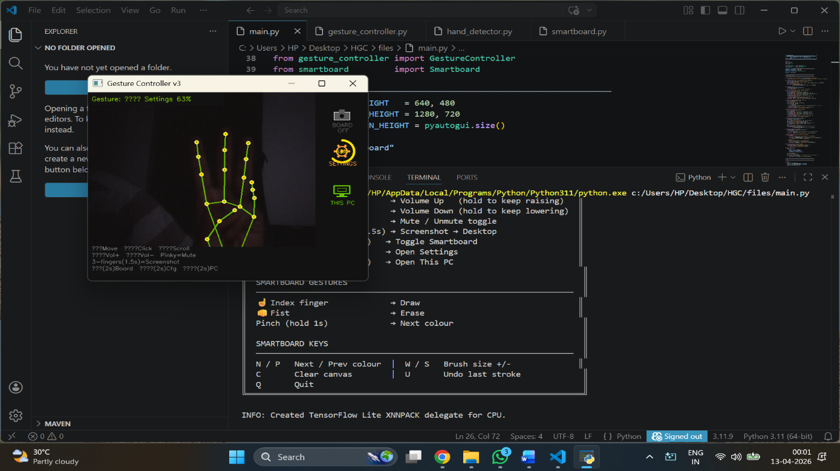
Fig: 6.4 sOutput Camera Module with Gesture Sensing(Screenshot)
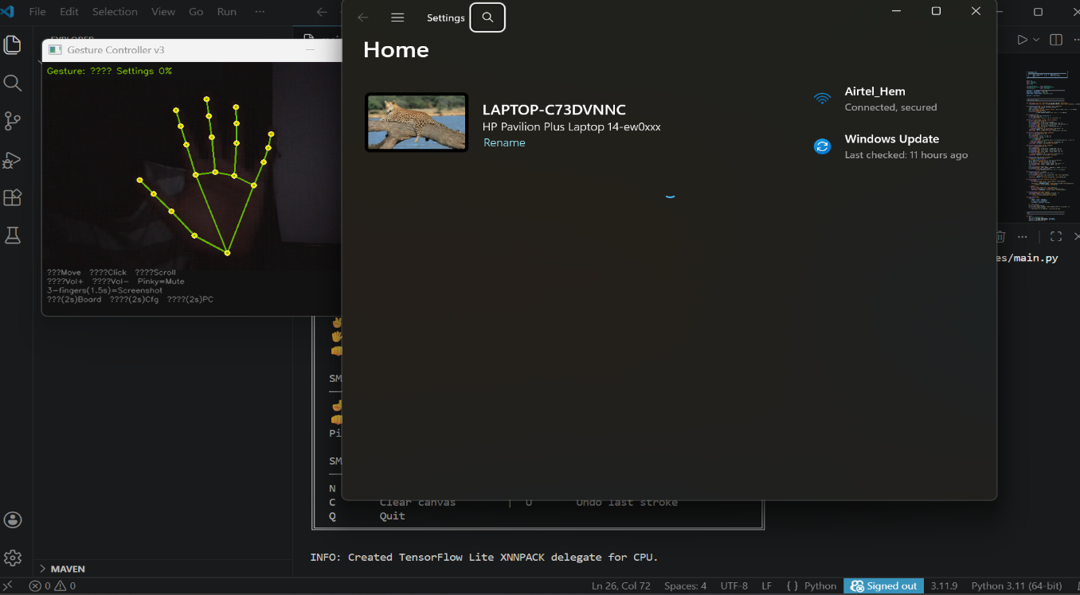
Fig: 6.4 Output Camera Module with Gesture Sensing(Settings)
CHAPTER 7
TESTING

7.1 Introduction to Testing
Testing for the Hand Gesture Mouse v4.0 project aims to ensure the software meets the specified Human-Computer Interaction (HCI) requirements, performs with high precision, and delivers a stable user experience. It involves a systematic process of evaluating the system to identify defects, such as landmark jitter, gesture misclassification, or system-level command latency. Through various testing methods, including unit testing, integration testing, system testing, and acceptance testing, the developer can validate the software's gesture accuracy, real-time performance, and cross-platform usability. By identifying and addressing issues like "cursor flickering" early in the development lifecycle, testing helps improve software stability and increase user satisfaction for touchless computing.

7.2 Types of Testing
7.2.1 Unit Testing
Unit testing is a method of testing individual units or components of the gesture system, such as the Hand Detector landmark extraction or the Smartboard drawing function. It is used to ensure that the individual mathematical units, such as Euclidean distance calculations or coordinate normalization, are working as intended. By isolating these components, unit tests help the developer quickly identify and fix bugs in the gesture logic early in the process.
- Verification: Verifies individual components like landmark extraction accuracy, smoothing filter (EMA) response, and gesture distance thresholds work as expected.

7.2.2 Integration Testing
Integration testing focuses on verifying the interactions between different modules, such as the handover of landmark data from the MediaPipe detector to the Gesture Controller Brain. It aims to ensure that these units, individually tested, work together seamlessly to execute a command like "Click" or "Volume Up".
- Verification: Ensures proper data flow and coordination between modules like image preprocessing, the ML landmark model, and the PyAutoGUI execution logic.
7.2.3 System Testing
System testing evaluates the entire integrated gesture software system as a whole—from camera input to OS-level mouse movement—to ensure it meets the specified requirements. This stage involves functional and usability testing to ensure the stability of the system during long-duration sessions.
- Verification: Tests the complete system to ensure all components (Webcam, AI Model, and OS Interface) work together to deliver accurate real-time control.
7.2.4 Acceptance Testing
Acceptance testing determines if the software meets the needs of the end-user, such as a presenter or an individual with motor impairments. This user-centric approach helps identify problems like "Pinch" gestures being too sensitive or "Smartboard" drawing being difficult to toggle.
- Verification: Validates that the system meets end-user (professional/presenter) requirements and performs correctly in real-world environments with varying lighting.

7.2.5 Performance Testing
Performance testing evaluates the system's behavior under different hardware workloads, specifically focusing on Frame Rate (FPS) stability. It aims to determine how the system responds to high CPU utilization while processing 3D landmarks.
- Verification: Checks how the system handles continuous video processing efficiently without lag, coordinate jumping, or system crashes.
7.3 Test Plan
7.3.1 Objectives
The primary objective of the testing process is to ensure that the Hand Gesture Mouse v4.0 system meets functional requirements like cursor navigation and click accuracy, as well as non-functional requirements like low-latency response and high gesture stability.
7.3.2 Scope
- Functional: Testing of gesture capture, interpretation (click, scroll, volume), and the Smartboard module.
- Non-functional: Focus on cursor smoothing (EMA), temporal buffering to reduce flickering, and OS command security.
- Compatibility: Testing across Windows and Linux environments.
7.3.3 Test Approach
- Manual testing for gesture intuitiveness and automated logic checks for landmark distances.
- Comprehensive coverage across unit, integration, system, and acceptance phases.

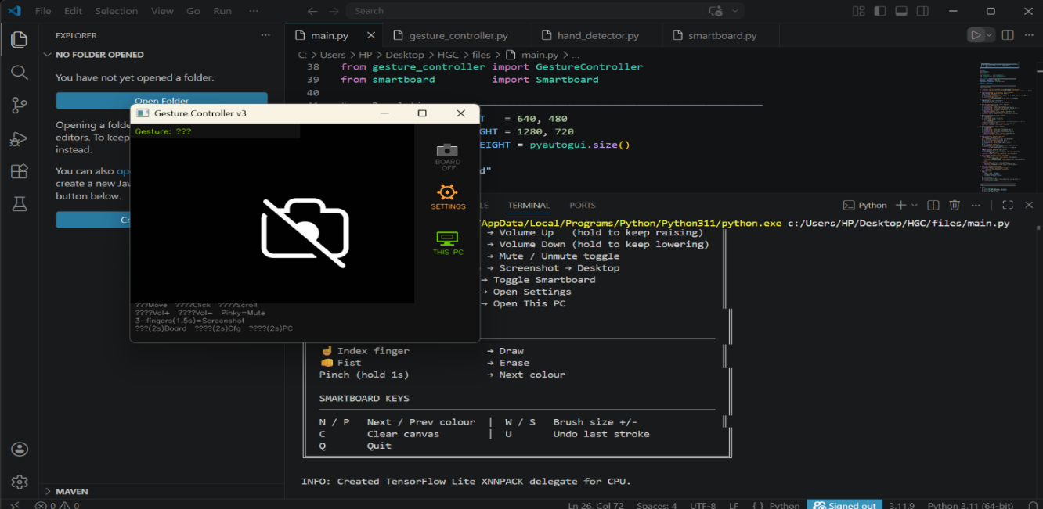
7.4 Test Case

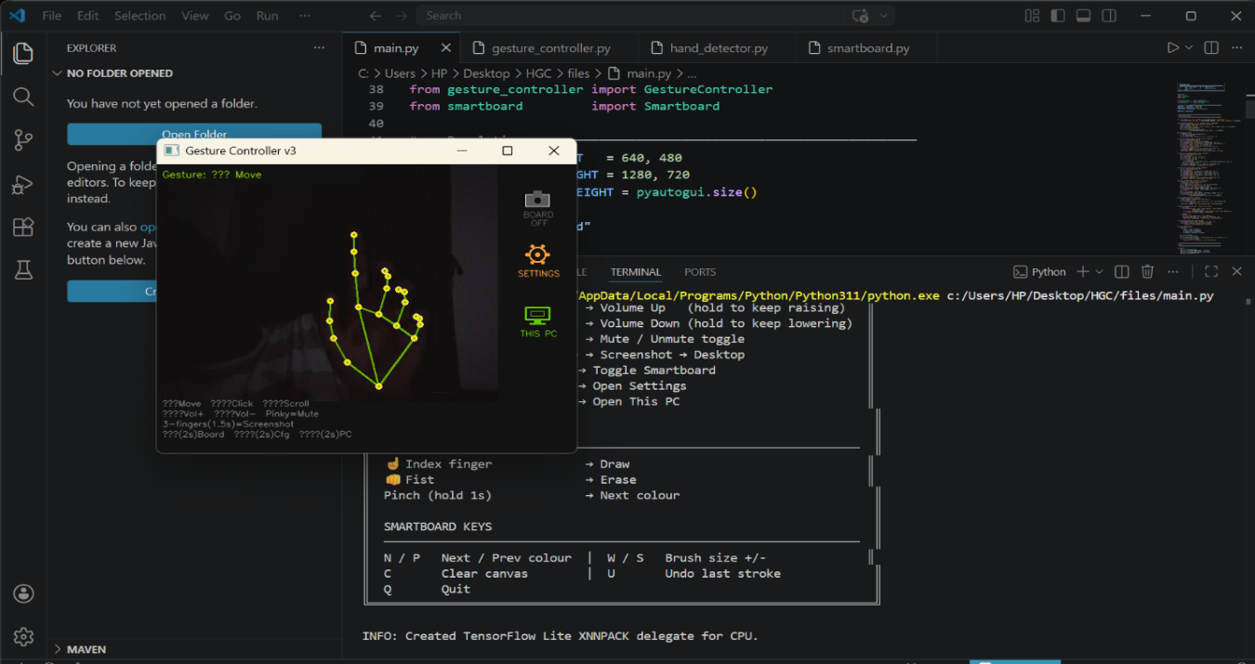
Fig: 7.1 Invalid Testcase 1 (No Hand Detected)
Fig: 7.2 Invalid Testcase 2 ()

Test Id | Objective / Description | Input Data | Expected Output | Actual Output | Status
1 | Ensure system initializes camera and MediaPipe correctly | Execution of main.py | Camera feed opens; HUD elements (Board, Settings) appear | Environment initialized; video stream active with HUD | Pass
2 | Verify detection of all 21 hand landmarks | Hand placed within camera field of view | Landmarks drawn on index, thumb, and wrist points | All 21 landmarks detected and visualized in real-time | Pass
3 | Test EMA Smoothing for jitter-free cursor navigation | Moving Index finger across camera frame | Cursor moves smoothly on desktop without shaking | Exponential Moving Average removed jitter successfully | Pass
4 | Validate Left Click gesture using Index-Thumb pinch | Index Tip and Thumb Tip distance < 36px | System executes pyautogui.click() command | Click executed immediately upon pinch detection | Pass
5 | Verify Volume Up logic with vertical Thumbs Up | Thumb extended upward; verticality > threshold | OS System volume increases incrementally | Volume increased; HUD showed "Volume Up" | Pass
6 | Verify Volume Down logic with vertical Thumbs Down | Thumb extended downward; verticality < threshold | OS System volume decreases incrementally | Volume decreased; HUD showed "Volume Down" | Pass
7 | Ensure Mute Toggle triggers only on Pinky extension | Pinky extended; all other fingers curled | System volume toggles between Mute and Unmute | Mute state toggled; HUD displayed "MUTED" icon | Pass
8 | Test Temporal Buffering for gesture stability | Rapidly changing hand poses for < 0.5s | No accidental commands; status remains "Neutral" | Buffer prevented flickering of commands | Pass
9 | Validate Smartboard Toggle via 2-second Peace hold | Peace sign (Index/Middle up) held for 2s | A separate full-screen drawing canvas opens | Smartboard window opened with progress ring | Pass
10 | Verify Virtual Drawing on Smartboard canvas | Moving Index finger while Smartboard is active | Continuous line drawn in the selected BGR color | Lines rendered smoothly on the | Pass
11 | Ensure Screenshot capture via 3-finger hold | Index, Middle, and Ring fingers up for 1.5s | PNG file saved to Desktop with timestamp | Screenshot saved; white flash shown on HUD | Pass
12 | Test This PC Launcher via 2-second Fist hold | Fully closed fist (all fingers curled) for 2s | File Explorer opens to "This PC" location | System directory opened; HUD confirmed "THIS PC" | Pass
13 | Validate Scroll logic with Middle-Thumb pinch | Middle Tip and Thumb Tip distance < 36px | Active window (e.g., Browser) scrolls downward | Scroll command executed continuously while held | Pass
14 | Test Tilt Resistance using wrist-relative coordinates | Performing Volume Up with hand tilted at 45° | Volume increases correctly despite hand angle | Wrist-reference frame maintained gesture accuracy | Pass

CHAPTER 8
FUTURE ENHANCEMENT AND CONCLUSION

8.1 FUTURE ENHANCEMENT
Future enhancements for the Hand Gesture Mouse v system will prioritize achieving a deeper, more human-like understanding of user intent and kinetic behavior. This entails moving beyond static landmark distance matching to advanced Dynamic Gesture Recognition, leveraging sophisticated Recurrent Neural Networks (RNNs) or Long Short-Term Memory (LSTM) models to interpret sequences of motion, such as "air-writing" or complex multi-hand commands. Integrating Vision-Language Models (VLMs) could provide richer contextual awareness, allowing the system to understand the specific application context—such as switching between specialized tools in medical imaging or engineering CAD software—to assess and predict the user's next action.
8.2 CONCLUSION
The development of the Hand Gesture Mouse v4.0 using Computer Vision (CV) and Machine Learning (ML) offers a promising solution for efficient and touchless human-computer interaction. By leveraging the MediaPipe framework and sophisticated Signal Processing techniques, this approach provides instant system response, reduces ergonomic strain, and enhances the overall user accessibility experience. The experimental results demonstrate the effectiveness of this approach in interpreting complex real-time hand gestures, achieving high stability rates through Temporal Filtering and providing a jitter-free navigation experience via Exponential Moving Average (EMA) smoothing.

CHAPTER 9
REFERENCES
[1] Fan Zhang, Valentin Bazarevsky, Andrey Vakunov, et al. (2020). MediaPipe Hands: On-device Real-time Hand Tracking. Google Research.
[2] Jayasri Kotti, B. Padmaja, D. Deepa (2024). Enhancing Gesture-Controlled Virtual Mouse and Virtual Keyboard Using AI Techniques. International Journal of Advanced Research in Computer Science.
[3] B. R. Sandhya, C. Amrutha, S. Ashika (2023). Gesture Recognition Based Virtual Mouse and Keyboard. Journal of Emerging Technologies and Innovative Research.
[4] Dr. C. P. Divate, S. M. Patil, Faika Shaikh, et al. (2024). AI-Based Hand Gesture-Controlled Virtual Mouse System. International Journal for Research in Applied Science and Engineering Technology.
[5] Shimaa Osman (2024). Virtual Keyboard-Mouse in Real-Time Using Hand Gesture and Voice Assistant. International Journal of Scientific Research in Science, Engineering and Technology.

