Ajoneuvovero 1990-2005

https://statfin.stat.fi:443/PxWeb/sq/45280d66-78e8-4a71-992d-b0510422294d

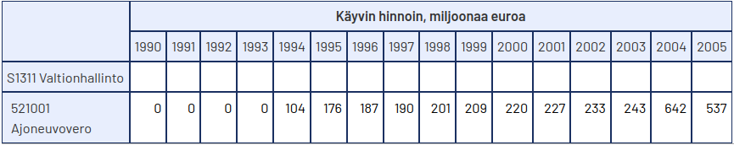

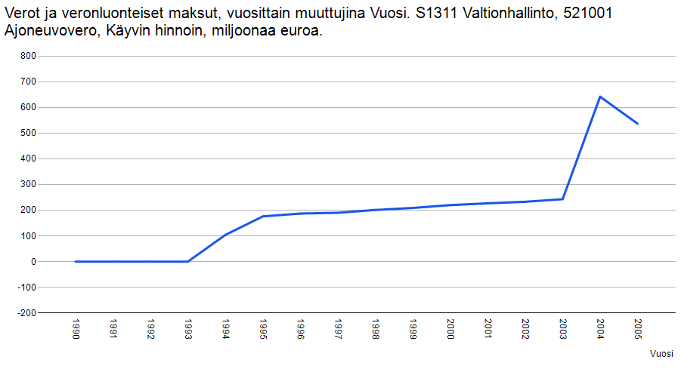

{"dataset":{"dimension":{"Sektori":{"label":"Sektori","category":{"index":{"S1311":0},"label":{"S1311":"S1311 Valtionhallinto"}},"link":{"describedby":[{"extension":{"Sektori":"SCALE-TYPE=nominal"}}]},"extension":{"show":"value"}},"Verolaji":{"label":"Verolaji","category":{"index":{"521001":0},"label":{"521001":"521001 Ajoneuvovero"}},"link":{"describedby":[{"extension":{"Verolaji":"SCALE-TYPE=nominal"}}]},"extension":{"show":"value"}},"Tiedot":{"label":"Tiedot","category":{"index":{"cp":0},"label":{"cp":"Käyvin hinnoin, miljoonaa euroa"},"unit":{"cp":{"base":"Miljoonaa euroa","decimals":0}}},"extension":{"show":"value"}},"Vuosi":{"label":"Vuosi","category":{"index":{"1990":0,"1991":1,"1992":2,"1993":3,"1994":4,"1995":5,"1996":6,"1997":7,"1998":8,"1999":9,"2000":10,"2001":11,"2002":12,"2003":13,"2004":14,"2005":15},"label":{"1990":"1990","1991":"1991","1992":"1992","1993":"1993","1994":"1994","1995":"1995","1996":"1996","1997":"1997","1998":"1998","1999":"1999","2000":"2000","2001":"2001","2002":"2002","2003":"2003","2004":"2004","2005":"2005"}},"link":{"describedby":[{"extension":{"Vuosi":"SCALE-TYPE=None"}}]},"extension":{"show":"value"}},"id":["Sektori","Verolaji","Tiedot","Vuosi"],"size":[1,1,1,16],"role":{"metric":["Tiedot"],"time":["Vuosi"]}},"label":"Verot ja veronluonteiset maksut, vuosittain muuttujina Sektori, Verolaji, Tiedot ja Vuosi","source":"Tilastokeskus, verot ja veronluonteiset maksut","updated":"2024-09-18T05:00:00Z","value":[0,0,0,0,104,176,187,190,201,209,220,227,233,243,642,537],"extension":{"px":{"tableid":"statfin_vermak_pxt_127f","decimals":0}}}}

Moottoriajoneuvovero 1990-2005

https://statfin.stat.fi:443/PxWeb/sq/2b21579d-9e9d-4b5b-9ca5-45e1f0956cf0

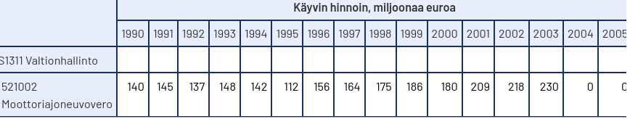

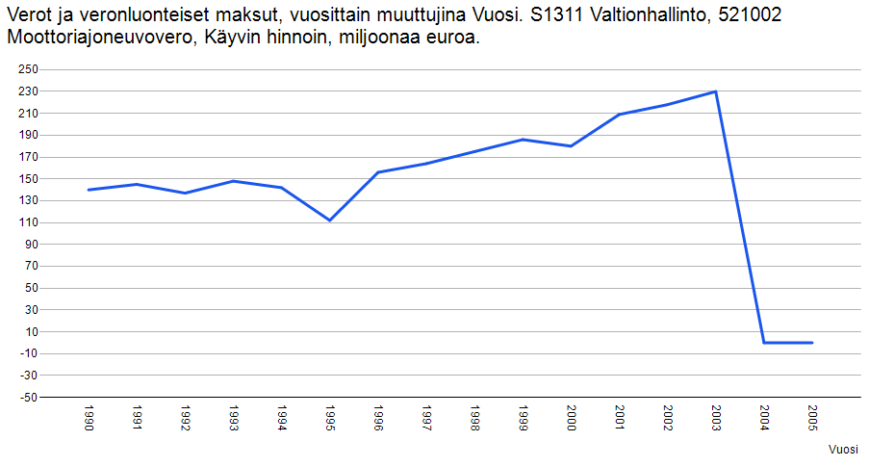

{"dataset":{"dimension":{"Sektori":{"label":"Sektori","category":{"index":{"S1311":0},"label":{"S1311":"S1311 Valtionhallinto"}},"link":{"describedby":[{"extension":{"Sektori":"SCALE-TYPE=nominal"}}]},"extension":{"show":"value"}},"Verolaji":{"label":"Verolaji","category":{"index":{"521002":0},"label":{"521002":"521002 Moottoriajoneuvovero"}},"link":{"describedby":[{"extension":{"Verolaji":"SCALE-TYPE=nominal"}}]},"extension":{"show":"value"}},"Tiedot":{"label":"Tiedot","category":{"index":{"cp":0},"label":{"cp":"Käyvin hinnoin, miljoonaa euroa"},"unit":{"cp":{"base":"Miljoonaa euroa","decimals":0}}},"extension":{"show":"value"}},"Vuosi":{"label":"Vuosi","category":{"index":{"1990":0,"1991":1,"1992":2,"1993":3,"1994":4,"1995":5,"1996":6,"1997":7,"1998":8,"1999":9,"2000":10,"2001":11,"2002":12,"2003":13,"2004":14,"2005":15},"label":{"1990":"1990","1991":"1991","1992":"1992","1993":"1993","1994":"1994","1995":"1995","1996":"1996","1997":"1997","1998":"1998","1999":"1999","2000":"2000","2001":"2001","2002":"2002","2003":"2003","2004":"2004","2005":"2005"}},"link":{"describedby":[{"extension":{"Vuosi":"SCALE-TYPE=None"}}]},"extension":{"show":"value"}},"id":["Sektori","Verolaji","Tiedot","Vuosi"],"size":[1,1,1,16],"role":{"metric":["Tiedot"],"time":["Vuosi"]}},"label":"Verot ja veronluonteiset maksut, vuosittain muuttujina Sektori, Verolaji, Tiedot ja Vuosi","source":"Tilastokeskus, verot ja veronluonteiset maksut","updated":"2024-09-18T05:00:00Z","value":[140,145,137,148,142,112,156,164,175,186,180,209,218,230,0,0],"extension":{"px":{"tableid":"statfin_vermak_pxt_127f","decimals":0}}}}

